1-The following are abbreviations for certain words (In alphabetic order)

ANN artificial neural network

BPNN backpropagation Neural Network

Cl- Chloride ions concentration

Ecorr corrosion potential

f frequency

icorr corrosion current

MLP Multilayer perceptron

P applied stress

SO2 Sulfur dioxide

T temperature

TOW time of wetness

RH relative humidity

Rp polarization resistance

RBFNN radial basis function neural network

S strain

SR strain rate

WV wind velocity

2-The different expression of the same object

1 Exposure time = duration of exposure = exposure time = time of exposure

2 Chloride solution = Chloride ion = Aqueous chloride= Chloride ions concentration = Cl-

3

3-Classification of application environment type

According to the ISO 9223(http://www.doc88.com/p-5069541354768.html), the type of atmosphere can be classified as Rural Urban Industrial Marine Chemical. And the type of location can be classified as Expousure in the open air Under shelter In a closed space.

4-

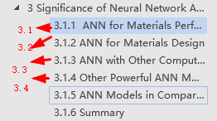

5-About the content in your 3.1.1 (ANN for Materials Performance Prediction)

(d) Electrochemical Property should be included in (a) Corrosion property

6-Title

“Significance of Artificial Neural Network Analytical Models in metallic Materials Performance Prediction”

Be more specific, otherwise, it might contain plastic and biological materials and etc