# Material service term/condition

<https://books.google.com/books?id=3K7BDAAAQBAJ&pg=PA11&lpg=PA11&dq=%E2%80%9Cmaterial+service+condition%E2%80%9D&source=bl&ots=koOw244RUQ&sig=ACfU3U2CrDT6QldXuKUHEhamdHuAXI6tVA&hl=en&sa=X&ved=2ahUKEwi1orS628rjAhUinOAKHRO6AYMQ6AEwAHoECAgQAQ#v=onepage&q=%E2%80%9Cmaterial%20service%20condition%E2%80%9D&f=false>

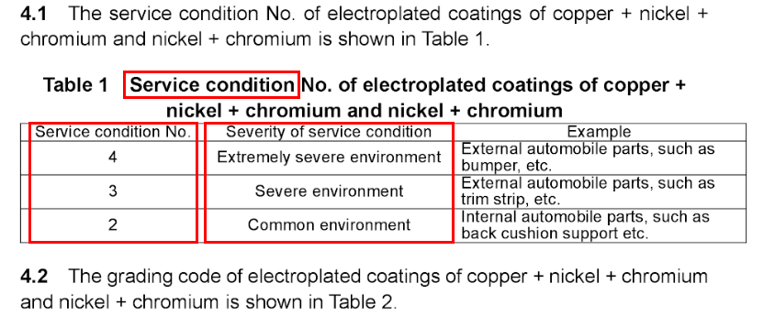

www,ChineseStandard.net

# 溶液离子浓度表示方法

https://wenku.baidu.com/view/bf90a1ec998fcc22bcd10dbd.html

