**[How to use]**

1. Place the ***VMwareCertSetup_MTY_v1.6.exe*** on the jump server
2. Double click on ***VMwareCertSetup_MTY_v1.6.exe***
3. Select an option from the list based on your need

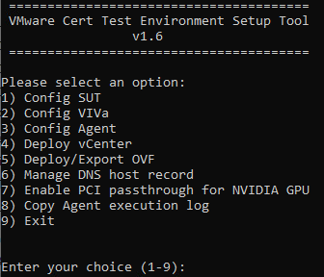

**Config SUT**

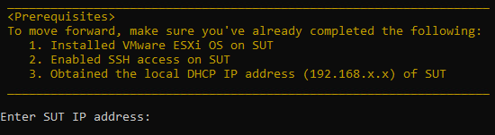

This option does the following:

1. Enable ESXi shell
2. Display system information, including security and network
3. Set up a static network (IP/Netmask/Gateway) based on the user’s input
4. Set up the DNS and DNS hostname based on the user’s input

The default hostname will use the last digit of your IP as the trailing character. For example, if you set IP to 192.168.1.**10**, then the hostname will be set to esxi**10**. This is designed for multiple users.

1. Turn off the network firewall

[Note]   
The tool requires SSH connection to access your SUT. Since the default setting of SSH is disabled, you need to **manually enable SSH** after installing the OS. The setting is in System Customization -> Troubleshooting Options -> Enable SSH

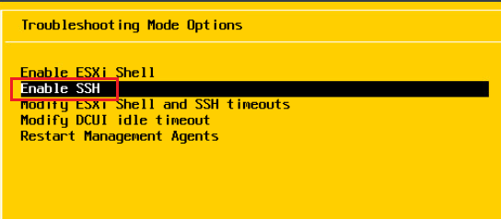

**Config VIVa**

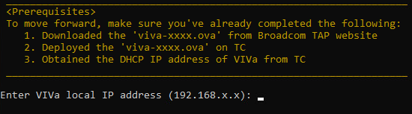

This option does the following:

1. Set hostname to “photon-viva”
2. Disable password expiration
3. Add the string “127.0.0.1 photon-viva” to /etc/hosts
4. Add input IP and “cert-viva-local” string to /etc/hosts file
5. Verify Internet connectivity
6. Update VIVa service
7. Configure /etc/systemd/network/99-dhcp-en.network file

**Config Agent**

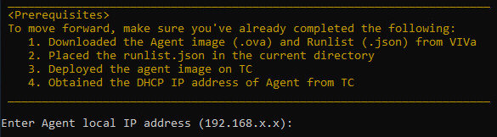

This option does the following:

1. Upload the runlist.json to the agent
2. Verify Internet connectivity
3. Execute AgentLauncher and pull docker image

**Deploy vCenter**

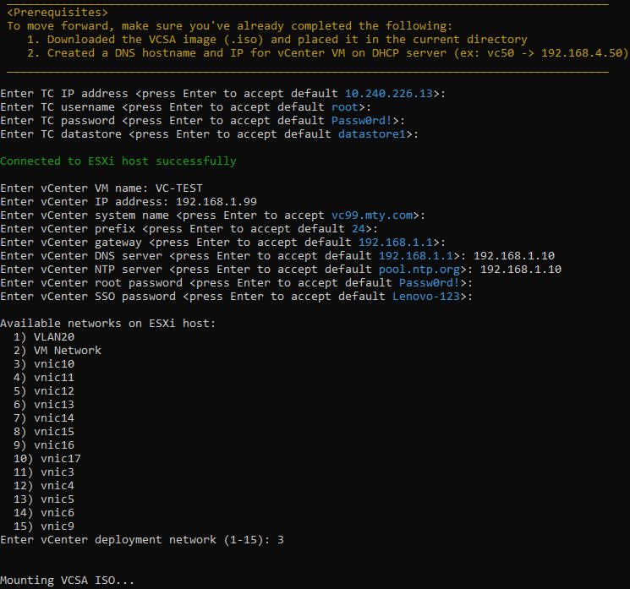

This option does the following:

1. Create a deployment template based on the user’s input
2. The default hostname will use the last digit of your IP as the trailing character. For example, if you set IP to 192.168.1.**50**, then the hostname will be set to vc**50**. This is designed for multiple users.
3. When prompted to enter **vCenter deployment network**, be careful to enter the network name which is tied with your local network **192.168.x.x**.
4. When prompted to enter **vCenter** **NTP server**, be careful to

enter the NTP server which matches your actual environment.

1. Mount the VCSA ISO on the jump server
2. Deploy vCenter on the TC
3. Unmount the VCSA ISO from the jump server

[Note]   
The vCenter deployment may take a long time to complete. Do NOT interrupt the process when the command stays at ‘**VCSA Deployment is still running**’. A successful deployment should look like below:

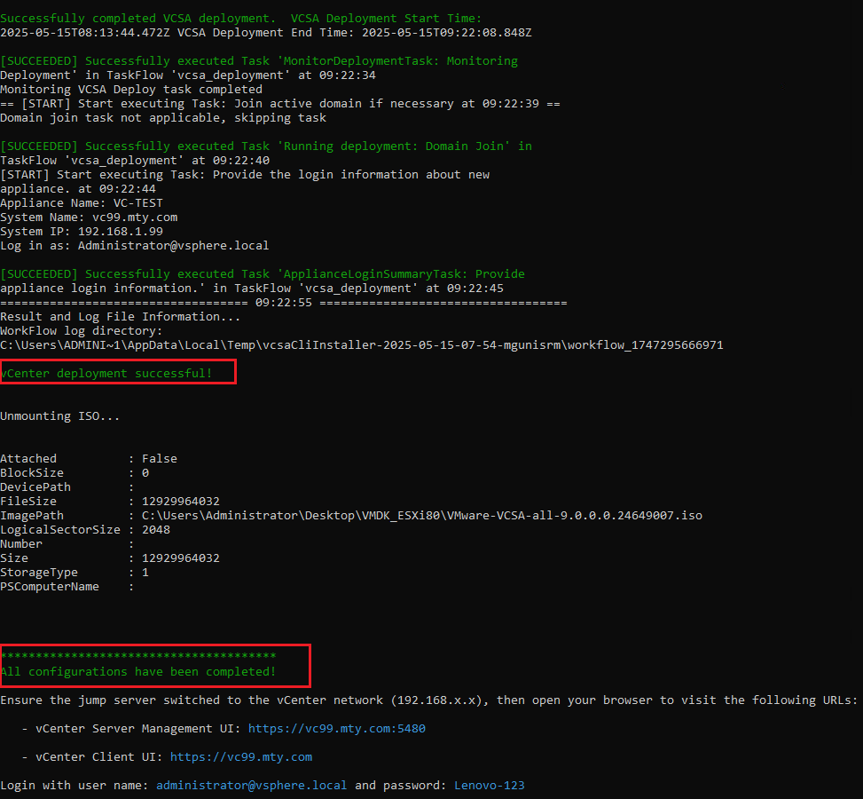

**Deploy/Export OVF**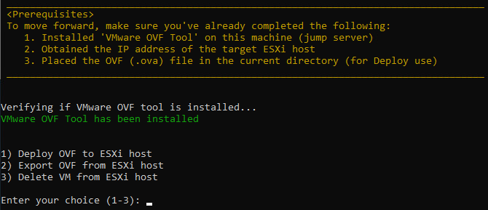

This option does the following:

1. Deploy the targeted .ova file on the ESXi host

You can also use this option to deploy **VIVa** or **Agent** as long as the .ova file is available and present in the same directory as the tool.

1. Export a .ova file from the targeted ESXi host
2. Delete a VM from the targeted ESXi host

[Note]   
To use this function, you must install VMware OVF Tool on the jump server. The tool can be downloaded [here](https://developer.broadcom.com/tools/open-virtualization-format-ovf-tool/latest) (*OVF Tool MSI Windows installable)

**Manage DNS host record** 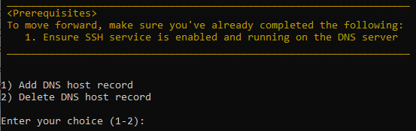

This option does the following:

1. Add a new DNS host record to the targeted zone of DNS server
2. Remove an existing DNS host record from the targeted zone of DNS server

**Enable PCI passthrough for NVIDIA GPU**

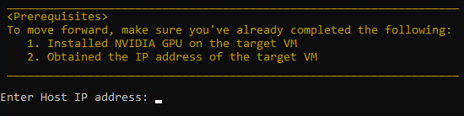

**(*For GPU Cert only)**

This option does the following:

1. Search for NVIDIA GPUs/NVLinks and enable PCI passthrough function
2. Add the NVIDIA GPUs/NVLinks to the targeted VM
3. Add VM options below to the target VM
   * pciHole.start=’2048’
   * pciPassthru.use64bitMMIO=’TRUE’
   * pciPassthru.64bitMMIOSizeGB=’256’
   * pciPassthru.64bitMMIOSizeGB=’2048’ (for HGX GPUs only)
   * pciPassthru.allowP2P=’TRUE’ (for HGX GPUs only)
4. Lock memory reservation

**Copy agent execution log** 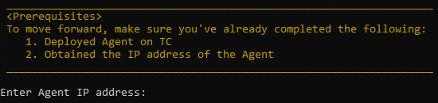

This option does the following:

1. Copy the latest test result from Agent to the current directory

**[Q & A]**

**Q1**: **How can I obtain the VM IP without accessing it?**

**A1**: On your ESXi host, ensure the VM is powered on. Click on the virtual machine and **refresh** the page. Look for the IP addresses under **Networking**

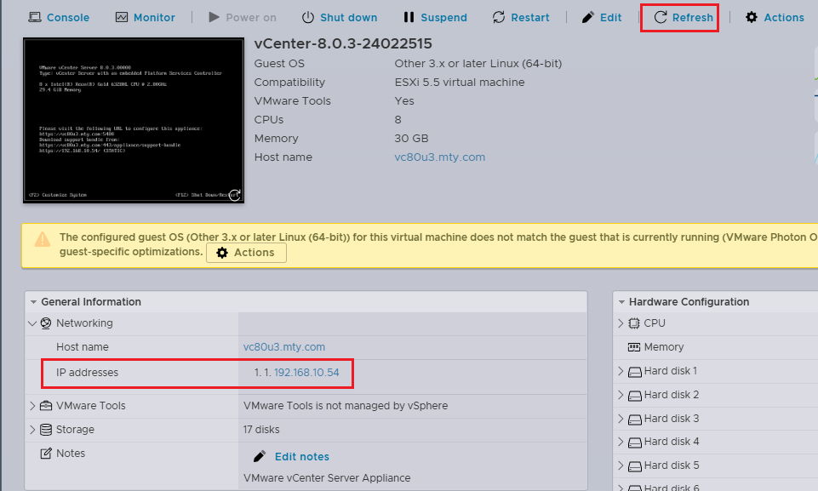

**Q2**: **Can I use the Deploy/Export OVF function to deploy the current NFS VM on another jump server?**

**A2**: Sure, you can. Just export the NFS VM to the .ova file. Transfer the .ova file to the new jump server and deploy it using the same tool. After the deployment is complete, you may need to enter the OS to modify the network IP settings to fit your new environment.

**Q3**: **What can I do if I find a bug or have some good ideas?**

**A3**: Feedback is welcome! Please send an email to Mike Lu [klu7@lenovo.com](mailto:klu7@lenovo.com)