实验一

一、

1. t=linspace(-10,10,1000);
2. f=t;
3. 工程绘图, 折线图

   描述已自动生成subplot(2,2,1),plot(t,f);
4. title('f(t)=t');
5. b0=0;
6. ut=stepfun(f,b0);
7. ff=ut.\*t;
8. subplot(2,2,2),plot(t,ff);
9. title('f(t)=tu(t)');
10. fff=ut.\*(t-1);
11. subplot(2,2,3),plot(t,fff);
12. title('f(t)=(t-1)u(t)');
13. b0=1;
14. ut=stepfun(f,b0);
15. ffff=ut.\*(t-1);
16. subplot(2,2,4),plot(t,ffff);
17. title('f(t)=(t-1)u(t-1)');

二、

1. 图表, 折线图

   描述已自动生成
2. t=linspace(-5,5,1000);
3. n=linspace(-5,5,10);
4. f=cos(2\*t);
5. F=cos(2\*n);
6. subplot(2,1,1),plot(t,f);
7. title('f(t)=cos(2t)');
8. subplot(2,1,2),stem(n,F);
9. title('f[n]=cos(2n)');

三、

1. f=linspace(1,9,9);
2. n=linspace(1,9,9);
3. subplot(3,1,1),stem(n,f);
4. 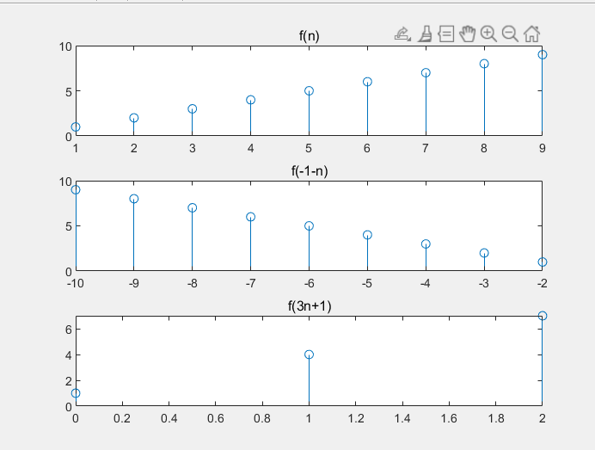title('f(n)');
5. nn=-1-n;
6. subplot(3,1,2),stem(nn,f);
7. title('f(-1-n)');
8. flag=1;
9. for i=1:9
10. if mod((n(i)-1),3)==0
11. x(flag)=(n(i)-1)/3;
12. flag=flag+1;
13. end
14. end
15. nnn=3\*x+1;
16. subplot(3,1,3),stem(x,nnn);
17. title('f(3n+1)');

四、

1. t=linspace(-10,10,1000);
2. 日程表

   中度可信度描述已自动生成b0=0;
3. ut=stepfun(t,b0);
4. b0=-3;
5. utt=stepfun(t,b0);
6. f=utt-ut;
7. dif=diff(f);
8. dif(1000)=0;
9. subplot(3,1,1),plot(t,dif);
10. title('u(t+3)-u(t)的导数');
11. ff=t.\*ut;
12. dif2=diff(ff)\*50;
13. dif2(1000)=1;
14. subplot(3,1,2),plot(t,dif2);
15. title('tu(t)的导数');
16. b0=1;
17. uttt=stepfun(t,b0);
18. fff=(t-1).\*uttt;
19. dif3=diff(fff)\*50;
20. dif3(1000)=1;
21. subplot(3,1,3),plot(t,dif3);
22. title('(t-1)u(t-1) 的导数');
23. syms x;
24. y=exp(2\*1i\*x);
25. difz=diff(y,x);
26. intz=int(y,x);

五、

1. 图表

   描述已自动生成t=linspace(-10,10,21);
2. b0=0;
3. ut=stepfun(t,b0);
4. utt=stepfun(t,b0);
5. subplot(2,1,2),stem(t,ut);
6. title('u(t)');
7. y=[0,0,0,0,0,0,0,0,0,0,
8. 1,0,0,0,0,0,0,0,0,0,0];
9. subplot(2,1,1),stem(t,y);
10. title('△(t)');