Dataset: Kaggle MNIST

Train data: 33600 items

Test data: 8200 items

SVM:

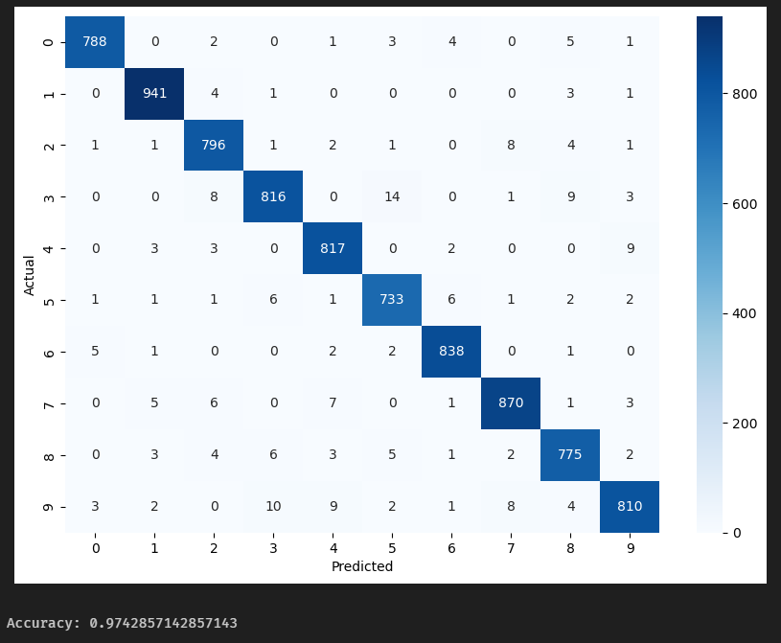

The confusion matrix shows that the SVM model performed exceptionally well on the Kaggle MNIST dataset. The model achieved an accuracy of 0.9743, meaning that 97.43% of the test images were correctly classified. The diagonal line in the confusion matrix represents the number of images that were correctly classified for each category. We can see that the values on the diagonal are relatively high, indicating that the model’s predictions are very accurate for most categories. Overall, this SVM model demonstrated high accuracy and robustness in the task of handwritten digit classification.

Naïve Bayes：

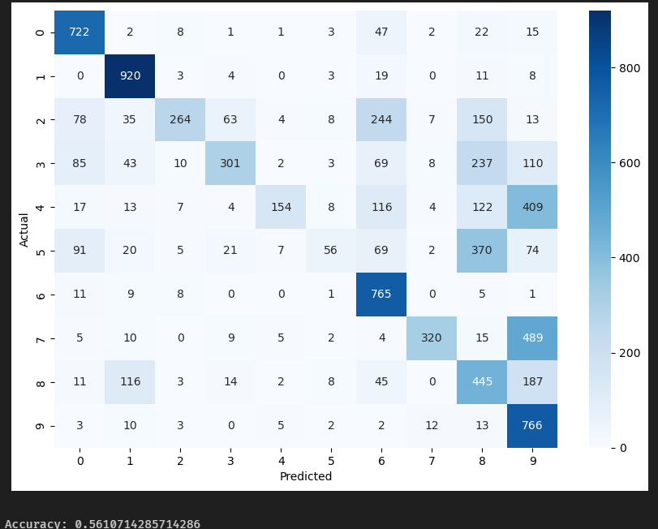

The confusion matrix shows that the Naïve Bayes model performed on the Kaggle MNIST dataset with a degree of success. The model achieved an accuracy of 0.5617, meaning that 56.17% of the test images were correctly classified. The diagonal line in the confusion matrix represents the number of images that were correctly classified for each category. We can see that the values on the diagonal vary, indicating that the model’s predictions are more accurate for some categories than others. Overall, while the Naïve Bayes model did not perform as well as some other models might, it still managed to correctly classify more than half of the images in the test set.

Random Forest：

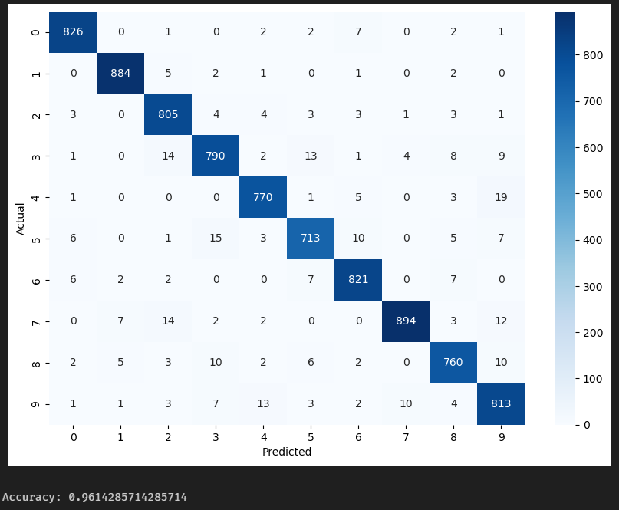

The confusion matrix shows that the Random Forest model performed exceptionally well on the Kaggle MNIST dataset. The model achieved an accuracy of 0.9614, meaning that 96.14% of the test images were correctly classified. The diagonal line in the confusion matrix represents the number of images that were correctly classified for each category. We can see that the values on the diagonal are relatively high, indicating that the model’s predictions are very accurate for most categories. Overall, this Random Forest model demonstrated high accuracy and robustness in the task of handwritten digit classification.