**Anitha Rajasekaran**

**Lab Assignment Visualization and storytelling**

**MA661E,VT21**

**6. Story Telling:**

**6.1 Big Idea and 3- minute story**

Big Idea:

Period: Furniture category in IKEA Saudi Arabian as of 4/20/2020

Purpose of analysis: The dataset meant for the manufacturer to understand the product size and price that available in each category and to predict the development of the product.

What feature makes the manufacturer fix the price of the furniture.

**1. Articulate your point of view.**

The point of view is that the price of the product is dependent on the measure values i.e height, depth, and width, or all of the three measures.

**2. Convey what’s at stake.**

This isn’t clear to me currently. I’m going to want to ask some targeted questions to better understand what is at stake for the audience.

**3. Be a complete (and single!) sentence.**

It’s difficult to summarize our view in a single sentence. Need some sentences to explain what exactly with the dataset.

**Big Idea from the IKEA dataset which contains the information**,

When comparing the size of each production item gives the idea about the price. The price increases when the size of the product increases eg: corner sofas, but some of the product shows the difference in the price eg: wardrobe. So this means that some other factor also makes them fix the price. Analyzes the dataset with depth, height, and width.

While analyzing the size and price, the width and depth are highly correlated with price.

But we can predict the furniture item which can be a product in the future, with the available measure values(depth, height, and width).

**Visual display:**

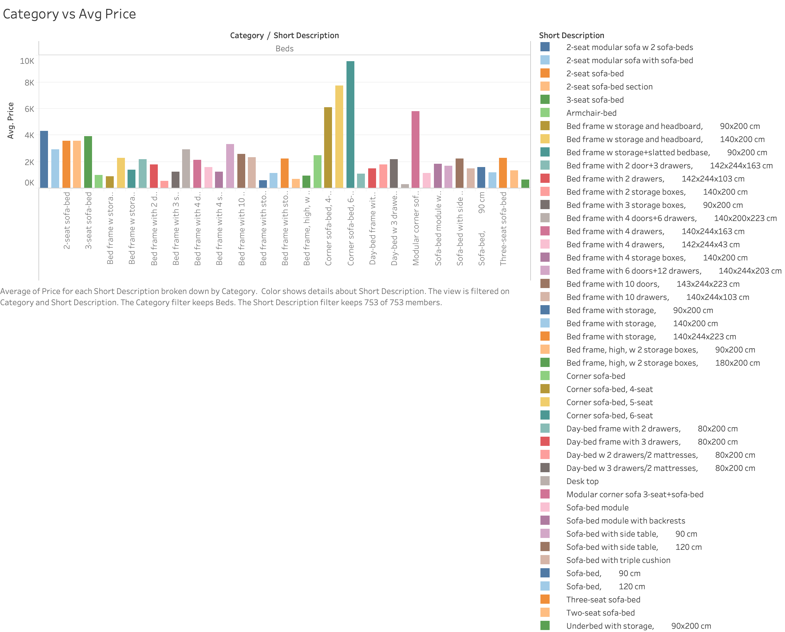

This figure shows the variance in price with an increase in the size of the product.

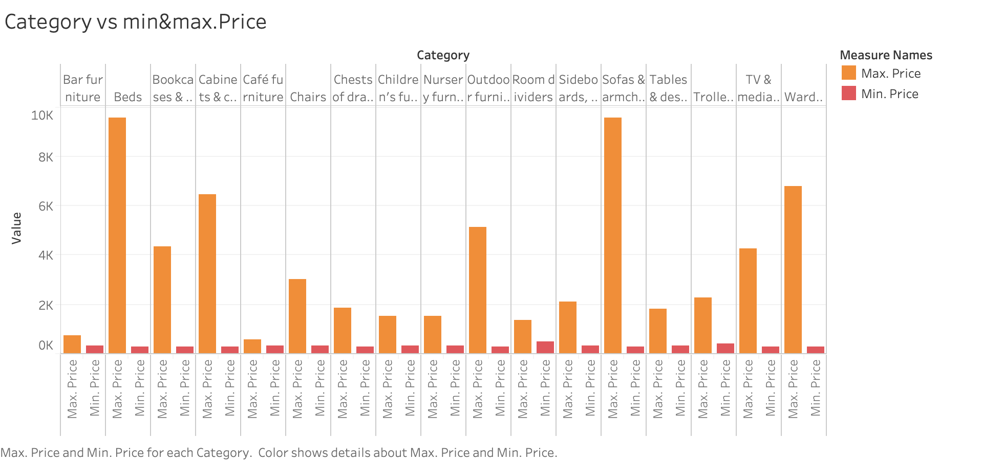

Here shows the minimum and maximum price of each category of items.

The analyses of the two bar graph help the manufacturer fixing the price when the new product, produced in the future.

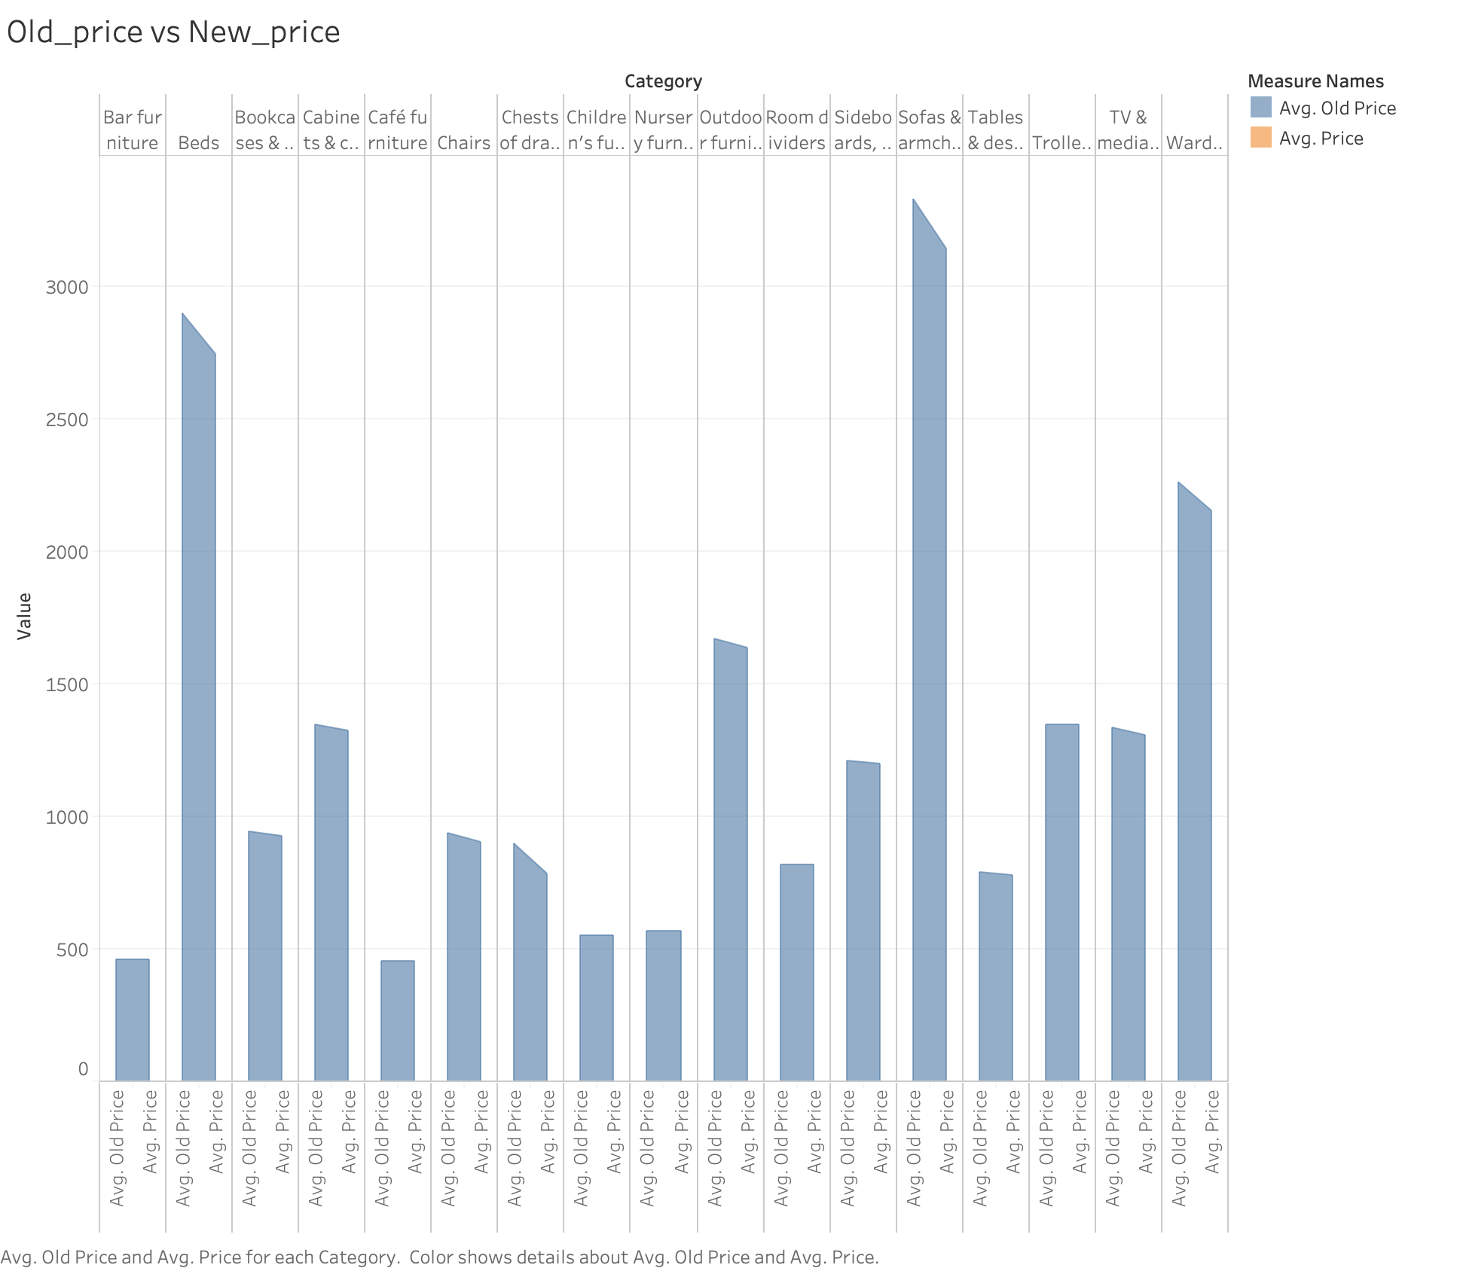

The discount given to the product which produced in large amounts. For instance, sofas & armchairs, beds, and wardrobe. And few products are also with less discount which produced in small amount for instance, chest of drawer, TV & media table.

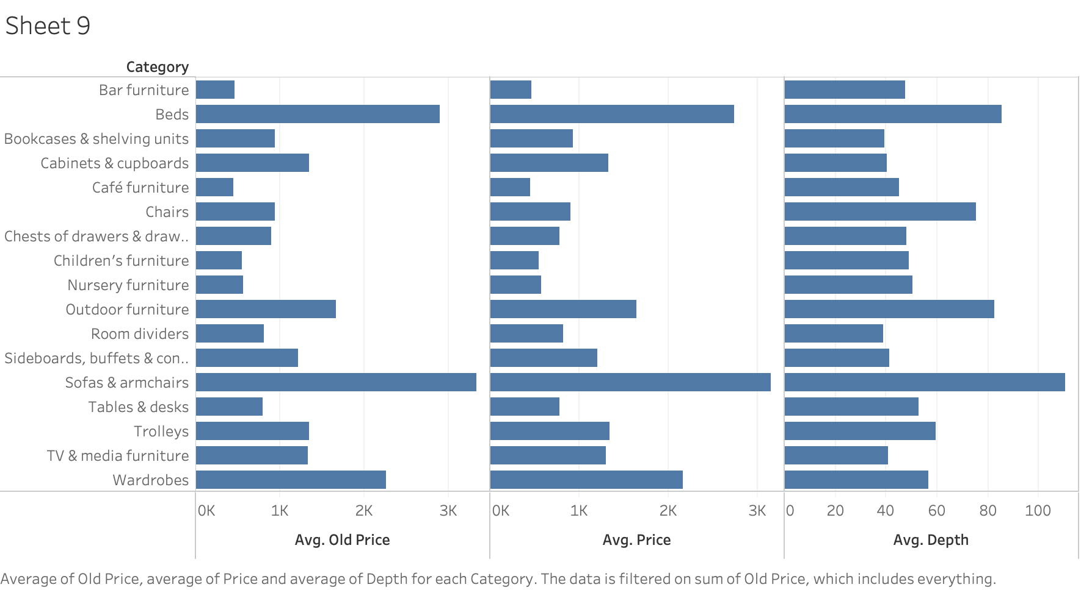

Here, Price has a positive correlation with depth.

**Eliminate clutter:**

Some elements don't increase understanding and contribute to cognitive load.

When we add these visual elements, it makes our visuals appear more complicated than necessary. So, reducing these items is the necessary part.

For instance

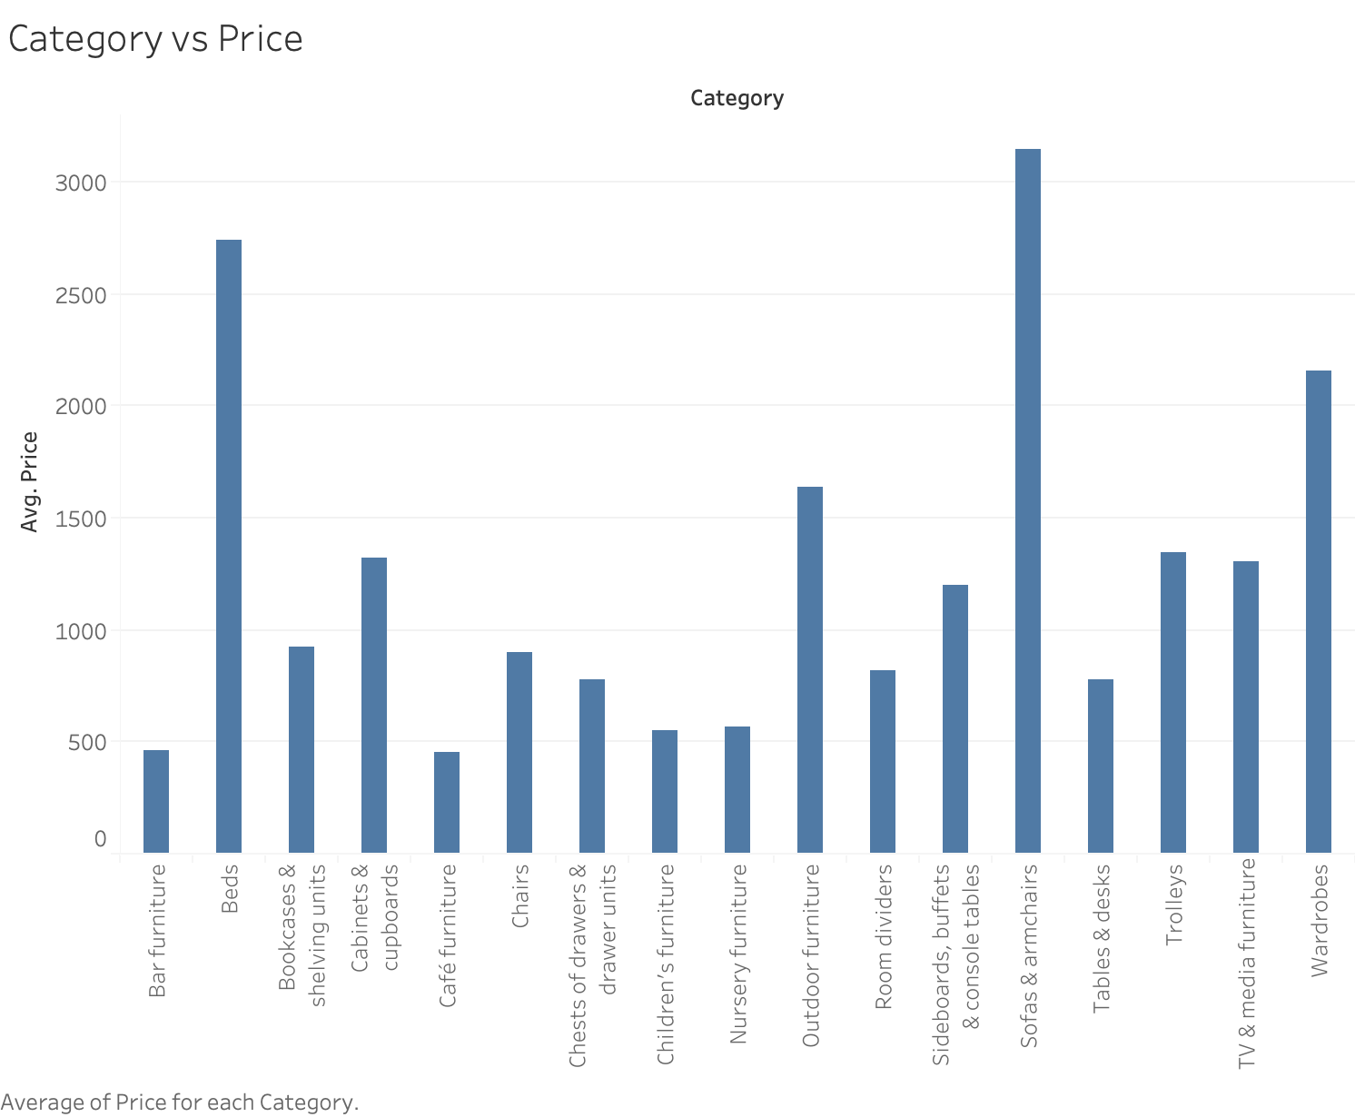

Here are few visual element i have come with to reduce

Instead of bars:

While mentioning the particular value for the particular product the bar is not needed we can plot the circle for that instead of bar chart.

Use color:

Attention is scattered when the graph is with many colors. The effective focus to a particular point is must.

Title Axis representation:

The axis representation must be readable for the audience.

**6.2 Storyboarding and crafting the story:**

IKEA Dataset for manufacture to predict the size of the furniture that has to be produced in the future.

Showing the dataset containing all the items and price.

Showing the varies among the products.

Identifying how the prices are fixed and giving discounts.

Showing the available sizes.

From this we can predict the new product to be produced and fix the price and the discounts for the items.

**6.3 Creating the story in Tableau:**

The dataset consists of the feature, these data were collected from by the technique called web scraping.

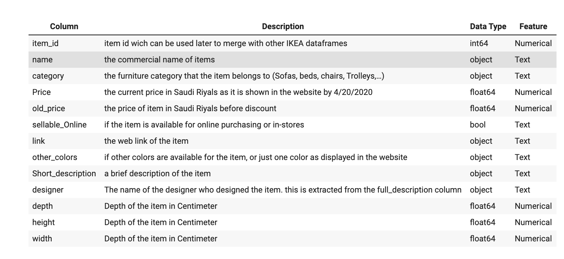

The furniture category contains the different item, price column given the discount price for some of the item, the discounted item can be found out from the old_price column, sellable_online detail about the item is available for the online purchase or not. Depth, width, height gives the sizes of the item.

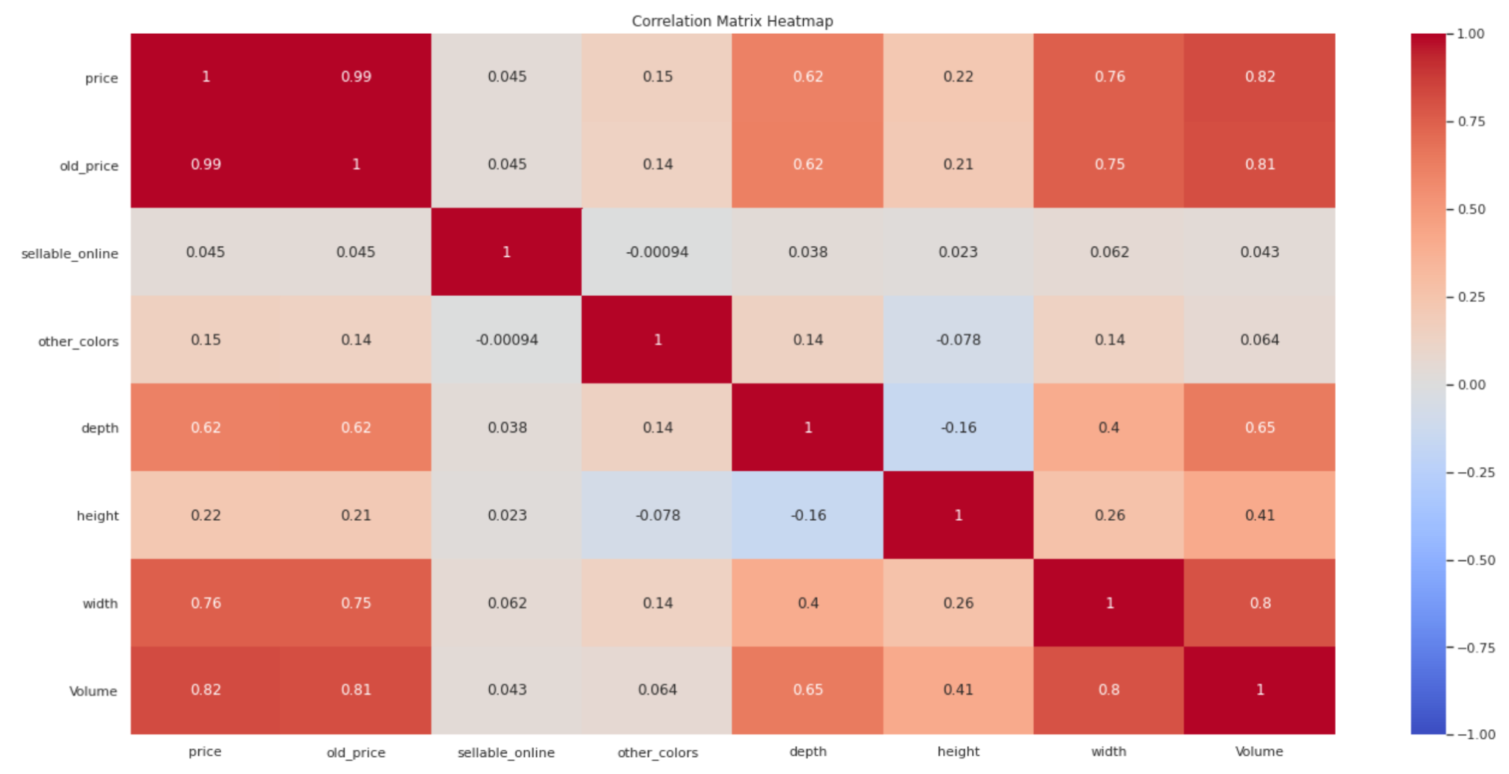

* Depth and height have a clear inverse correlation.
* Price has a positive correlation with width and depth.

