AZURE AI SOLUTION
Cost Model: Fixed vs. Variable
Social Study App · Multi-tenant AI study platform

Fixed ~$580/mo · Variable ~$0.35/active user · Per-user $0.36–$0.48 at scale

Subscription: Azure subscription 1 (7697a402…)
Live data: Cost Management API — rg-ssa2-dev, 30-day rolling 2026-05-24 → 06-23
Model basis: Confirmed product assumptions (moderate usage, blended mini+4o, right-sized Cosmos)
Pricing: Public pay-as-you-go (USD); fixed SKUs calibrated to dev actuals
Confidence: HIGH on actuals & fixed · MEDIUM on token volume per user
Prepared: 2026-06-23

1 The Four Answers (at a glance)
This model separates costs that are paid regardless of users from costs that grow with usage. Current dev spend cannot be used to derive per-user cost (no production traffic), so the variable model is built from confirmed product assumptions and validated against live fixed-cost actuals.
Question | Answer | Notes
What is the fixed cost? | ~$580 / month | Paid 24/7 regardless of user count
Variable cost per user? | ~$0.35 / active user / mo | Blended GPT-4o-mini + GPT-4o
What increases per user? | GPT tokens + moderation (linear) | Cosmos/compute sub-linear; Search/Redis flat
Cost based on usage/user? | $0.0006–$0.010 per generation | Unit rates — compute from real telemetry
Per-user at 5,000 MAU | ~$0.48 / student / mo | Falls toward ~$0.36 marginal floor

WHY THE CURRENT BILL IS MISLEADING
Live dev spend is $733.63/mo, of which Cosmos DB is $598 (82%). That Cosmos figure was OVER-PROVISIONING — per-tenant databases carried far more provisioned RU/s than the tiny dev workload needed. Right-sized to shared autoscale it drops to ~$60/mo (~$540 recovered).
Also: dev runs Basic SKUs and (despite scaling drift) carries no user traffic — so GPT-4o spend is only $5.55/mo today. Per-user economics must therefore be modeled, not read off the dev bill.

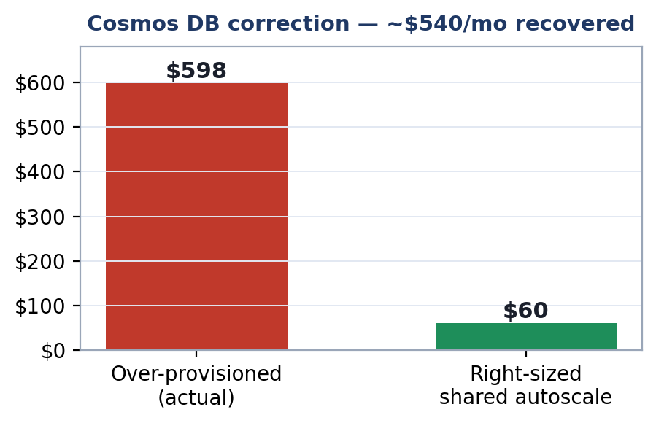

2 Fixed Cost — what you pay regardless of users
~$580/month for the production posture (AI Search S1, Redis Standard C1, min-replica=1 always-on, GRS storage), with Cosmos right-sized to shared autoscale. Fixed SKUs are calibrated against real dev actuals (e.g. dev AI Search Basic billed $73.12 → S1 ≈ $245; dev Container Apps 2 vCPU billed $35.50 → prod 4 vCPU ≈ $75).
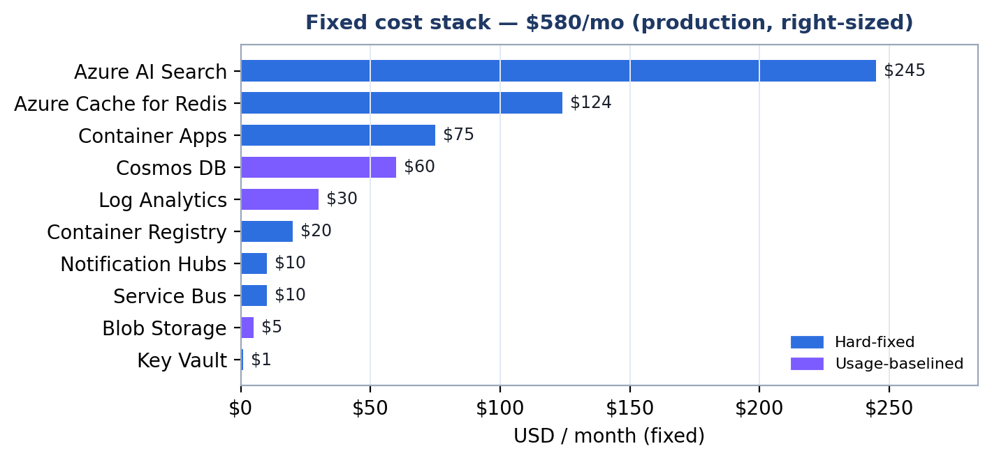

Service | SKU / config | Type | $ / mo
Azure AI Search | Standard S1 | Hard-fixed | $245
Azure Cache for Redis | Standard C1 (1 GB) | Hard-fixed | $124
Container Apps | 5 apps, min-replica=1 idle | Hard-fixed | $75
Cosmos DB | shared autoscale (right-sized) | Usage-baselined | $60
Log Analytics | baseline ingest | Usage-baselined | $30
Container Registry | Standard | Hard-fixed | $20
Service Bus | Standard | Hard-fixed | $10
Notification Hubs | Basic | Hard-fixed | $10
Blob Storage | Standard GRS (base) | Usage-baselined | $5
Key Vault | Standard | Hard-fixed | $1
FIXED TOTAL | ~$485 hard + ~$95 baselined |  | $580

Hard-fixed (~$485) does not move at all. Usage-baselined (~$95: Cosmos autoscale floor, Log Analytics, storage base) carries a small baseline that grows slowly with aggregate load.

3 Variable Cost — what each active user adds
~$0.35/active student/month under the chosen BLENDED model (GPT-4o-mini for simple MCQ/T-F/short-answer, GPT-4o for complex long-answer & math). For comparison, GPT-4o-only would be ~$0.98/user — the blend cuts variable cost ~63%.
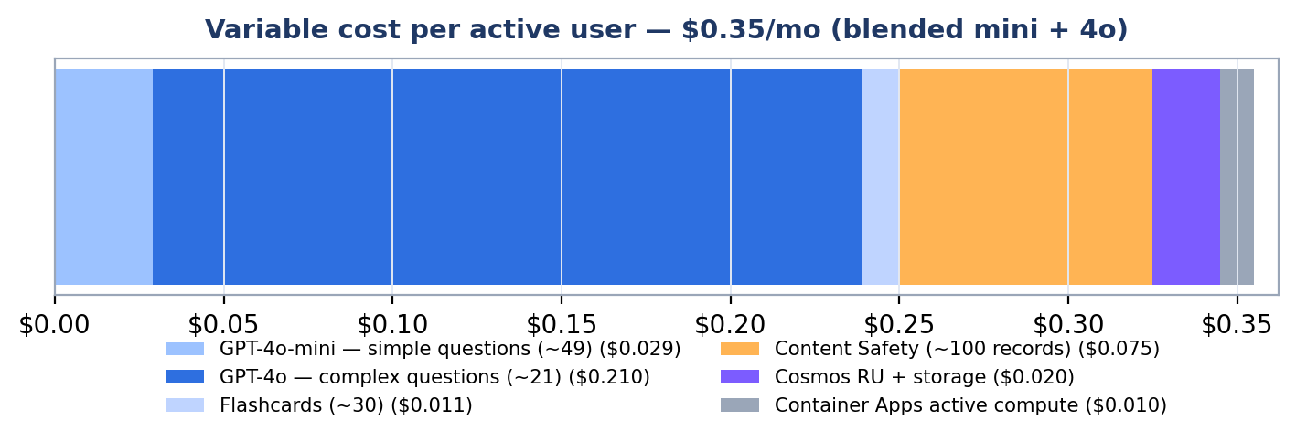

Assumptions — per active student / month (moderate usage)
Assumption | Value
Questions answered | ~270 (15/day × 18 active days)
Freshly AI-generated | ~70 (25%; rest reused from bank)
Simple vs complex split | ~70% mini / ~30% GPT-4o
Tokens per generation | ~2,000 in / ~500 out
Flashcards generated | ~30 (mini)

Component | Model | $ / user / mo
GPT-4o-mini — simple questions (~49) | mini | $0.029
GPT-4o — complex questions (~21) | 4o | $0.210
Flashcards (~30) | mini | $0.011
Content Safety (~100 records) | per-record | $0.075
Cosmos RU + storage | autoscale | $0.020
Container Apps active compute | per-request | $0.010
MARGINAL COST / USER | blended | $0.35

4 What Increases With Each User
Linear — true per-user variable (~$0.33 of the $0.36)
- GPT tokens (mini + 4o): every fresh question/flashcard costs tokens; scales directly with how much each student generates.
- Content Safety: per-record moderation on generated content; one charge per item.
Sub-linear — consumption / autoscale (~$0.03 of the $0.36)
- Cosmos DB: autoscale RU + storage rise with reads/writes, but share capacity across users.
- Container Apps active compute & Log Analytics: grow with aggregate request and log volume, not 1:1 per user.
Step functions — capacity jumps, NOT per-user
- AI Search replica/partition (~+$245): added only when the index outgrows the S1 unit.
- Container App replicas: scale out under burst load, then back down.
Flat — does NOT increase with users
- Redis, Container Registry, Service Bus, Notification Hubs, Key Vault.

RULE OF THUMB
Each additional average active student adds ~$0.35/mo. The fixed ~$580/mo is shared across all of them, so blended per-user cost falls as you grow — the variable rate is the floor.

5 Cost Based on Each User's Actual Usage
Once production telemetry is live, compute any individual user's cost from their real activity using these unit rates:
Activity | Unit cost | Per
Simple question generated (mini) | $0.0006 | each
Complex question generated (4o) | $0.0100 | each
Flashcard generated (mini) | $0.0004 | each
Content-safety moderation | $0.00075 | each
Cosmos read/write activity | $0.02 | / user / mo

Formula
user cost ≈ $0.0006×(simple Qs) + $0.010×(complex Qs) + $0.0004×(flashcards) + $0.00075×(moderations) + ~$0.02
Example: a student generating 49 simple + 21 complex questions + 30 flashcards + 100 moderations ≈ $0.35/mo, matching the ~$0.35 average. A light user costs less; a power user more — the rates make it exact.

6 Per-User Cost at Scale
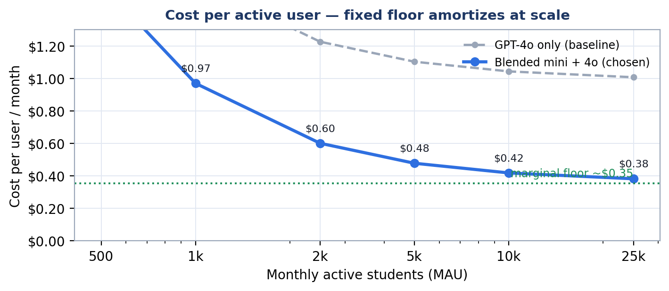

MAU | $ Fixed | $ Variable | $ Total/mo | $ / user
1,000 | $580 | $390 | $970 | $0.97
5,000 | $580 | $1,810 | $2,390 | $0.48
10,000 | $600 | $3,585 | $4,185 | $0.42
25,000 | $650 | $8,910 | $9,560 | $0.38

Blended per-user cost falls from ~$0.98 at 1,000 students to ~$0.39 at 25,000, asymptoting to the ~$0.35 marginal floor as the fixed ~$580/mo amortizes across the base.
7 Actions & Assumptions
Immediate cost actions
- Right-size Cosmos now. Move per-tenant DBs to shared autoscale — recovers ~$540/mo at the current stage; the over-provisioned RU/s served no real demand.
- Confirm the blended routing. Route simple item types to GPT-4o-mini in question_generation — the ~63% variable saving depends on it.
- Cache & reuse questions. Holding fresh-generation at ~25% (vs higher) is what keeps the variable rate at ~$0.36.
Assumptions & confidence
- Fixed cost: HIGH confidence — calibrated to live dev actuals + public prod SKU pricing.
- Variable cost: MEDIUM — depends on the ~70 fresh-gen/user and 70/30 simple/complex split; validate against real OpenAI metrics once live.
- Cosmos right-sized floor (~$60): estimate for shared autoscale 100–1000 RU/s; confirm against actual RU consumption after migration.
- Excluded: Azure AD B2C MAU billing, Firebase/FCM, egress (immaterial today), dev/staging duplication.

Estimates use public pricing and confirmed product assumptions — not a quote. Fixed costs are validated against live Cost Management actuals; per-user variable is a model to be trued-up against production telemetry.

