AZURE AI SOLUTION
Monthly Cost Estimate
Social Study App · Multi-tenant AI study platform

Live actuals: $733.63 / month · Projected at scale: ~$1.06–$1.20 / user

Subscription: Azure subscription 1 (7697a402…)
Resource Group: rg-ssa2-dev (the only deployed environment)
Region: Central US
Data source: Azure Cost Management API — 30-day rolling, 2026-05-24 → 06-23
Pricing basis: Public pay-as-you-go (USD) for projections
Confidence: HIGH on actuals · MEDIUM on per-user projection
Prepared: 2026-06-23

1 Executive Summary
This estimate is grounded in LIVE Azure billing data pulled from the Cost Management API, cross-checked against the infrastructure-as-code (infra/bicep) and the backend's actual token configuration. Only one environment is deployed today — the dev resource group rg-ssa2-dev — and it currently carries no production user traffic.
The headline numbers
Metric | Value | Notes
Actual spend (last 30 days) | $733.63 / mo | Real billed cost, no user traffic
Dominant cost | Cosmos DB — $598 (82%) | Provisioned per-tenant throughput
Monthly trend | May $173 → June ~$830 (annualized) | Cost ramped as tenant DBs were added
Projected per-user (at scale) | $1.06 – $1.20 / student / mo | Driven by GPT-4o once users arrive
Fixed infra floor | ~$1,080 / mo (prod posture) | Runs 24/7 before any usage
Marginal cost / active user | ~$0.98 / mo | Almost entirely GPT-4o tokens

KEY FINDING — the bill today is NOT the AI; it is idle database throughput
Cosmos DB is 82% of current spend ($598/mo) even though there are no real users. The backend provisions one Cosmos database per tenant (get_database(tenant_id)); each carries provisioned RU/s that is billed 24/7 whether or not anyone studies.
Once real users arrive, GPT-4o question generation becomes the dominant variable cost — but the Cosmos provisioned floor is pure waste at the current pre-launch stage and should be fixed first.

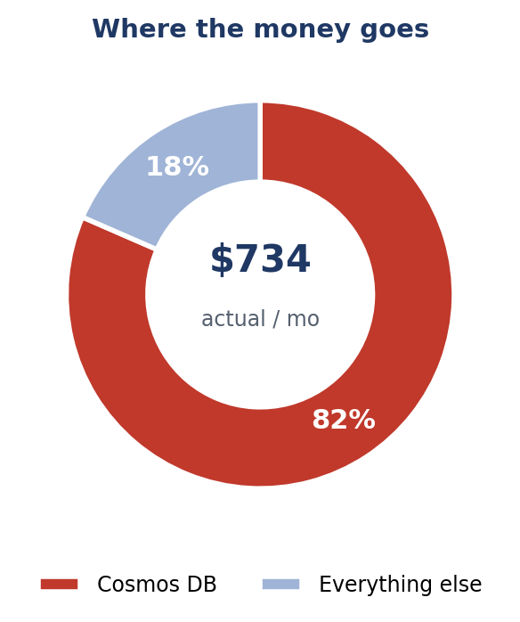

2 Live Actual Cost Breakdown
Source: Azure Cost Management ActualCost query, resource group rg-ssa2-dev, 30-day window 2026-05-24 → 2026-06-23. These are real billed amounts.
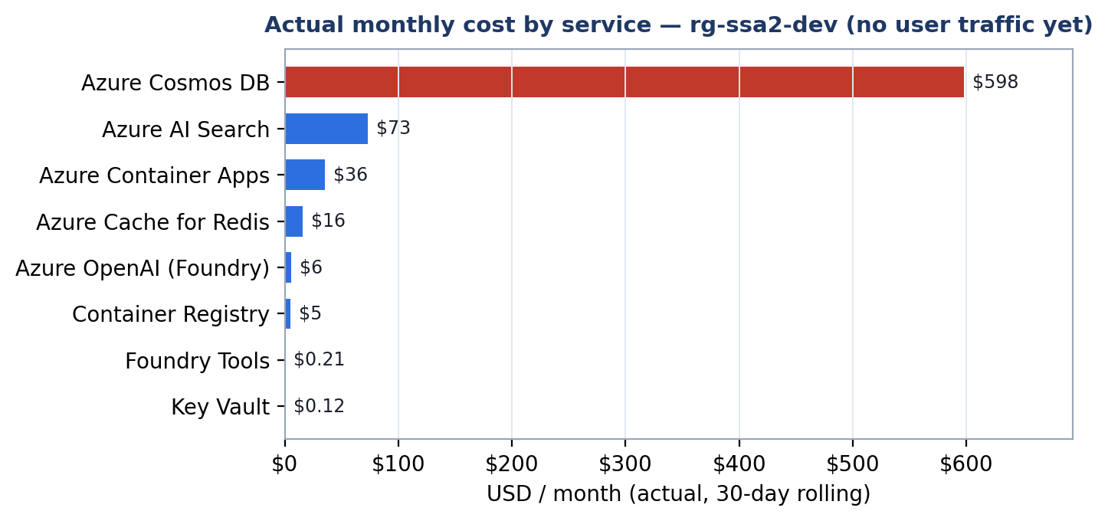

Service | SKU / config | Pricing model | Share | $ / month
Azure Cosmos DB | Cosmos DB (Mongo API) | Provisioned RU/s | 81.5% | $598.13
Azure AI Search | Cognitive Search | Basic, fixed hourly | 10.0% | $73.12
Azure Container Apps | 5 apps, min-replicas=1 | vCPU/GiB-seconds | 4.8% | $35.50
Azure Cache for Redis | Basic C0 | Fixed hourly | 2.2% | $15.93
Azure OpenAI (Foundry) | GPT-4o + embeddings | Token consumption | 0.8% | $5.55
Container Registry | Basic | Fixed daily | 0.7% | $5.03
Foundry Tools | Doc Intel / Content Safety | Per-operation | 0.0% | $0.21
Key Vault | Standard | Per-operation | 0.0% | $0.12
Service Bus | Basic | Per-operation | 0.0% | $0.04
Storage | Standard LRS, Hot | Per-GB | 0.0% | $0.00
Log Analytics | PerGB2018 (under free cap) | Per-GB ingest | 0.0% | $0.00
Notification Hubs | Free tier | Per-push | 0.0% | $0.00
Bandwidth (egress) | — | Per-GB | 0.0% | $0.00
TOTAL — rg-ssa2-dev | 13 services |  | 100% | $733.63

Note: Azure OpenAI ("Foundry Models") is only $5.55/mo today because dev has almost no generation traffic — this line will grow fastest once users are onboarded. Storage, Log Analytics, and Notification Hubs are effectively free at current volume.

3 Live Resource Inventory
21 resources enumerated via az resource list. Grouped by FinOps category.
AI / ML
Resource | SKU / size | Detail
oai-ssa-dev — Azure OpenAI | S0 | GPT-4o (10K TPM) + text-embedding-3-small (30K TPM)
srch-ssa-dev — AI Search | Basic | 1 replica / 1 partition, semantic=free
di-ssa-dev — Document Intelligence | S0 | prebuilt-read OCR (FormRecognizer kind)
cs-ssa-dev — Content Safety | S0 | document + question moderation

Compute
Resource | SKU / size | Detail
ca-api-dev | 0.5 vCPU / 1 GiB | min=1, max=3 (NOT scaling to zero — see drift)
ca-worker-dev | 0.5 vCPU / 1 GiB | min=1, max=3 document ingestion
ca-topic-extractor-dev | 0.5 vCPU / 1 GiB | min=1, max=2
ca-chunker-dev | 0.25 vCPU / 0.5 GiB | min=1, max=2
ca-vectorizer-dev | 0.25 vCPU / 0.5 GiB | min=1, max=2
cae-socialstudyapp-dev | Managed Env | Container Apps environment (consumption)

Storage / Data
Resource | SKU / size | Detail
cosmos-ssa-dev — Cosmos DB | Provisioned | Mongo API; 5 DBs (platform 1000 RU/s + per-tenant 400 RU/s)
redis-ssa-dev — Redis | Basic C0 | 250 MB auth/session cache
stssadev… — Storage | Standard LRS | Hot tier, document blobs
acrssadev… — Container Registry | Basic | Docker images

Integration / Messaging
Resource | SKU / size | Detail
sb-ssa-dev — Service Bus | Basic | 5 queues (ingestion/topic/chunk/vector/knowledge)
nh-ns-ssa-dev — Notification Hubs | Free | FCM push (1M/mo free)

Security / Ops
Resource | SKU / size | Detail
kv-ssa-dev — Key Vault | Standard | runtime secrets (2 vaults present)
id-socialstudyapp-dev — Managed Identity | — | ACR pull + KV secrets user (free)
log-socialstudyapp-dev — Log Analytics | PerGB2018 | Container Apps logs, 30-day retention

4 Per-User Cost Model (Projection)
Current actuals reflect a pre-launch system with no users. To answer "what does each student cost?", we model the production posture: the fixed always-on infrastructure floor plus the marginal AI cost each active student adds.
Usage assumptions — per active student per month
Assumption | Value | Basis
Questions answered | 270 | 15/day × 18 active days
Freshly AI-generated | ~70 (25%) | rest reused from bank / spaced repetition
Input tokens / generation | ~2,000 | prompt template + retrieved source chunk
Output tokens / generation | ~500 | weighted: MCQ 600 / short 400 / long 1200 / T-F 300 caps
Flashcards generated | ~30 | smaller prompts
GPT-4o price | $2.50 / 1M in · $10 / 1M out | public PAYG
→ Marginal cost / student | ~$0.98 / mo | GPT-4o + flashcards + content safety

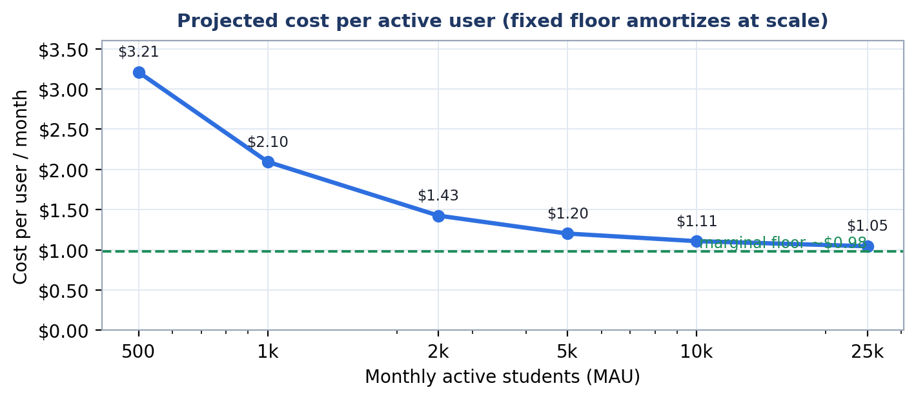

Per-user cost falls from ~$3.21 at 500 students toward the ~$0.98 marginal floor as the fixed ~$1,080/mo infrastructure amortizes across the user base. At a 5,000-student baseline the blended cost is ~$1.20 / student / month; by 25,000 students it approaches ~$1.06.

5 Key Cost Drivers
#1 DRIVER (today) — Cosmos DB provisioned throughput: $598 / mo
Five databases run provisioned RU/s: platform (1,000) + three tenant '_shared' DBs (400 each) + dedicated per-collection throughput. Enumerated throughput (~2,600 RU/s ≈ $152/mo at manual rates) accounts for only part of the $598 — the remainder points to autoscale billing and/or additional dedicated-throughput collections across tenant DBs.
Root cause: one provisioned database PER TENANT. Cost grows with every tenant onboarded, independent of actual usage. ACTION: drill into the Cosmos cost blade and migrate tenant DBs to serverless or shared autoscale (see §6).

#2 DRIVER (at scale) — Azure OpenAI GPT-4o: projected ~$4,500 / mo @ 5,000 MAU
Only $5.55/mo today (no traffic) but becomes ~75% of the bill once users arrive. Pure token spend; scales linearly with active students. This is the single biggest lever on unit economics.

Other notable drivers
- AI Search — $73/mo today (Basic), ~$245/mo at prod (S1). Fixed hourly; runs 24/7 regardless of query volume.
- Container Apps — $35/mo today. DRIFT: all 5 apps run min-replicas=1 in dev, though the Bicep specifies min=0. They never scale to zero, so dev pays for idle compute around the clock.
- Content Safety — ~$420/mo projected. Per-record moderation grows with every generated item; easy to over-call.
- Redis — $16/mo (Basic C0 today), ~$124/mo at prod (Standard C1).

6 Optimization Opportunities
Immediate (dev / pre-launch — recover ~$550/mo now)
- Fix the Cosmos tenant model. Move per-tenant DBs to serverless or shared autoscale (400–1000 RU/s max). Removes the largest line and the per-tenant minimum tax. Highest-impact action.
- Restore scale-to-zero in dev. Set min-replicas=0 on the 4 workers (matches the Bicep intent). Saves most of the $35/mo Container Apps cost when idle.
- Pause / downsize AI Search in dev if it sits unused — recovers ~$73/mo (it does not scale to zero).
At scale (production unit-economics levers)
- Cache & reuse generated questions. Generation is ~75% of the at-scale bill. Raising bank reuse 75%→90% cuts GPT-4o spend ~60% (~$2,700/mo @ baseline). Reuse the existing Redis as a (topic, difficulty, source-hash) cache.
- Batch + model-route. Use the Batch API (50% off) for non-interactive generation; route simple MCQ/T-F to a cheaper model and reserve GPT-4o for long-answer. 40–70% on generation tokens.
- Provisioned Throughput (PTU) + reservations once GPT-4o spend is steady above ~$3–4k/mo — typically 20–40% cheaper than PAYG.
- Scope Content Safety to ingest-time + sampled output rather than every item — roughly halves the ~$420/mo.
- Cap Log Analytics daily ingestion and drop verbose debug logs in prod.

7 Scaling Projection
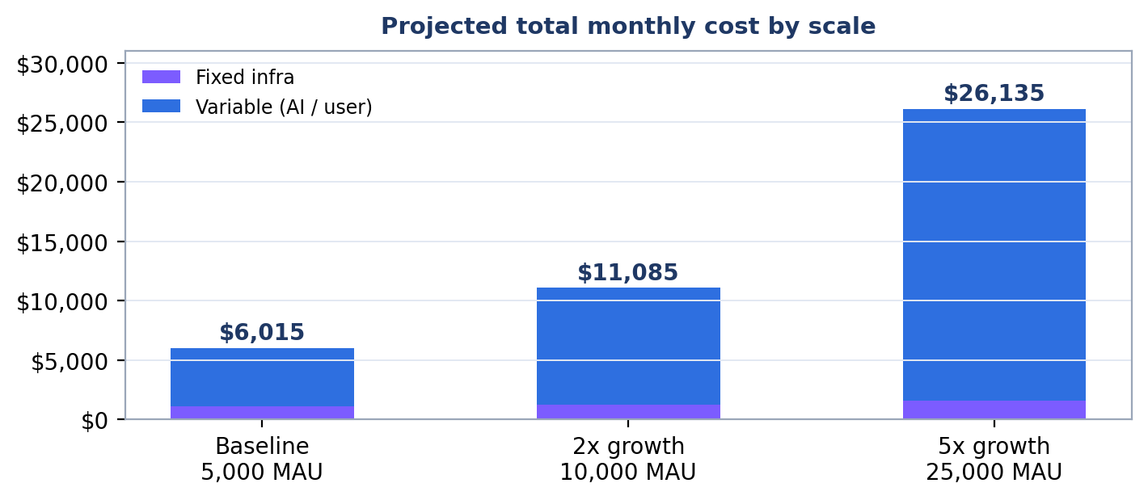

Scenario | MAU | $ Fixed | $ Variable | $ Total/mo | $ / user
Baseline | 5,000 | $1,080 | $4,935 | $6,015 | $1.20
2x growth | 10,000 | $1,250 | $9,835 | $11,085 | $1.11
5x growth | 25,000 | $1,600 | $24,535 | $26,135 | $1.05

Variable AI spend grows linearly with users; fixed infrastructure grows sublinearly. With the caching + model-routing optimizations in §6, the variable line can drop 40–60%, pushing per-user cost toward ~$0.45–$0.60 at scale.
8 Assumptions & Methodology
- Actuals are real billed costs from the Azure Cost Management API (30-day rolling window). HIGH confidence.
- Projections use public pay-as-you-go pricing (East US) with no reserved/PTU discounts applied. MEDIUM confidence on token volume.
- Production posture assumes prod SKUs from the Bicep (AI Search S1, Redis Standard C1, GRS storage, min-replicas=1) — no prod RG is deployed yet.
- Baseline = 5,000 monthly active students across ~20 tenants.
- Document Intelligence & embeddings are ingest-side (admin) costs that scale with content volume, not user count.
- Excluded: Azure AD B2C MAU billing, Firebase/FCM, network egress (~$5–15/mo, immaterial today at $0), and dev/staging duplication.
- Lowest-confidence item: the exact Cosmos $598 composition — confirm via the Cosmos DB cost-analysis blade before optimizing.

Reproducible from infra/bicep/modules/*.bicep + the live Cost Management queries documented above. Estimates use public pricing and conservative assumptions — not a quote. Validate token volumes against real Azure OpenAI metrics once production traffic is live.

