RULE OF THUMB
Each additional average active student adds ~$0.35/mo. The fixed ~$580/mo is shared across all of them, so blended per-user cost falls as you grow — the variable rate is the floor.

1 Per-User Cost at Scale
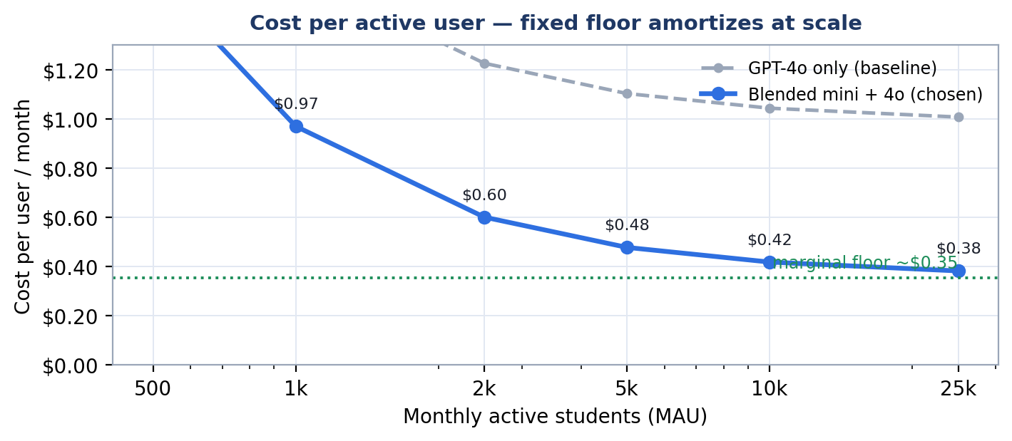
MAU | $ Fixed | $ Variable | $ Total/month | $ / user
50 | $580 | $53 | $633 | $12.66
100 | $580 | $71 | $651 | $6.51
500 | $580 | $213 | $793 | $1.59
1,000 | $580 | $390 | $970 | $0.97
5,000 | $580 | $1,810 | $2,390 | $0.48
10,000 | $600 | $3,585 | $4,185 | $0.42
25,000 | $650 | $8,910 | $9,560 | $0.38

2 Fixed Cost
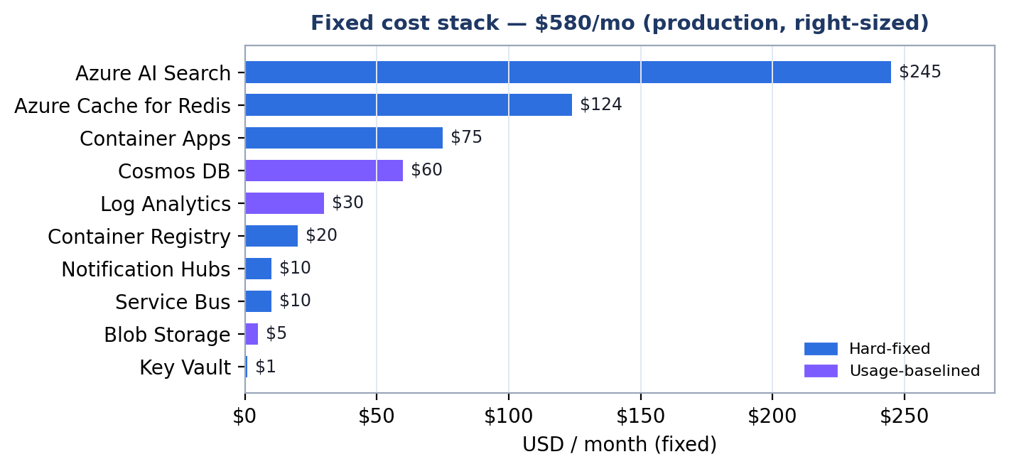
Hard-fixed (~$485) does not move at all.
Usage-baselined (~$95 = Cosmos autoscale floor, Log Analytics, storage base) carries a small baseline that grows slowly with aggregate load.
Service | SKU / config | Type | $ / mo
Azure AI Search | Standard S1 | Hard-fixed | $245
Azure Cache for Redis | Standard C1 (1 GB) | Hard-fixed | $124
Container Apps | 5 apps, min-replica=1 idle | Hard-fixed | $75
Cosmos DB | shared autoscale (right-sized) | Usage-baselined | $60
Log Analytics | baseline ingest | Usage-baselined | $30
Container Registry | Standard | Hard-fixed | $20
Service Bus | Standard | Hard-fixed | $10
Notification Hubs | Basic | Hard-fixed | $10
Blob Storage | Standard GRS (base) | Usage-baselined | $5
Key Vault | Standard | Hard-fixed | $1
FIXED TOTAL | ~$485 hard + ~$95 baselined |  | $580

3 Variable Cost
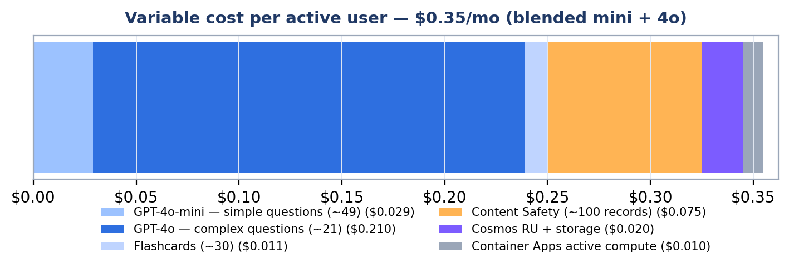

Assumptions — per active student / month (moderate usage)
Assumption | Value
Questions answered | ~270 (15/day × 18 active days)
Freshly AI-generated | ~70 (25%; rest reused from bank)
Simple vs complex split | ~70% mini / ~30% GPT-4o
Tokens per generation | ~2,000 in / ~500 out
Flashcards generated | ~30 (mini)

Component | Model | $ / user / mo
GPT-4o-mini — simple questions (~49) | mini | $0.029
GPT-4o — complex questions (~21) | 4o | $0.210
Flashcards (~30) | mini | $0.011
Content Safety (~100 records) | per-record | $0.075
Cosmos RU + storage | autoscale | $0.020
Container Apps active compute | per-request | $0.010
MARGINAL COST / USER | blended | $0.35

