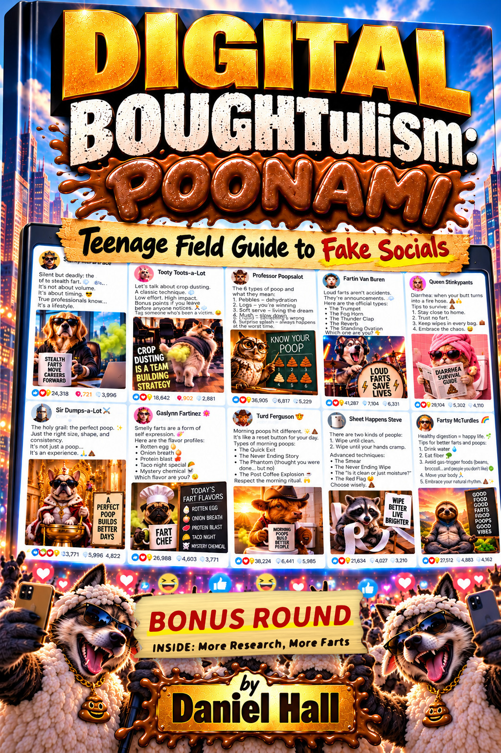

DIGITAL BOUGHTulism:
POONAMI
A Teenagers Field Guide to Fake Social Media
Daniel Hall

© Daniel Hall / Dream IT Software. All wrongs reserved.
No farts were harmed, inflated, or independently verified in the making of this taxonomy. This book is a work of satire assembled from publicly observable internet behavior. Any resemblance to an actual thought leader, living or expired, is coincidental and also statistically likely.

For every comment that said “Agree?” and meant it.

Foreword by Lonnee Rey
You haven't even met Daniel yet, and he's already fighting for you. I know how passionately he has gone after the crap on social media to help you, a young adult he has never met.
He cares about your future and how the lies people tell on social media can wreck your confidence. Beyond those lies, Daniel has uncovered fake vanity metrics, the numbers you compare yourself to. They can leave you feeling defeated before you even try to post online.
He worries that by the time you're searching for a career, these fake metrics will have already convinced you that you're not enough. And once you feel that, why bother, why try?
Oh, honey, please don't let that question get to you. Social media is a game, and often a losing one. It can mess with your head, your heart and your hope of ever measuring up.
But what if you knew vanity metrics are usually crap, too? This book will show you that. And once you know, you can decide for yourself what social media metrics mean to you from now on.
My good friend Daniel is the father of seven adopted children, and he can't help but care about young people and their future. His dedication to his special needs children is remarkable.
He brings that same dedication to helping teenagers now, before they enter the ring, rather than later, when they feel beat up by the (fake) heavy hitters.
Daniel Hall is the kindest, most relentless bulldog I have ever met. The receipts are here, and his humorous take on the B.S. makes this book a must-read. Twice.
Lonnee Rey
Books by Lonnee Rey
Written by Lonnee Rey
- Rey, Lonnee. Life Lessons Learned from a Lousy Mother. 2020. ISBN 9798644434466.
- Rey, Lonnee. How to Deal with a Dumbass: What to Do and Say When They Come Your Way. 2022. ISBN 9798805489939.
- Rey, Lonnee. Encouragement for the Late Bloomer. 2025. Audiobook, narrated by the author.
Anthologies with other authors
- Rey, Lonnee, Chris Monestere, Kendra Murphy and others. The Advocates, the Healers and Heeding a Higher Calling. 2025. ISBN 9798230787556.
- Rey, Lonnee, and others. SPEECHLESS: Giving the #voiceless a Voice. ISBN 9798346495284.
- Rey, Lonnee, and others. Rattled Awake: Volume One. ISBN 9798859757244.
- Rey, Lonnee, and others. Rattled Awake: Volume Two. ISBN 9798863709376.
- Rey, Lonnee, and others. Rattled Awake: Volume Three. ISBN 9798865744726.
- Rey, Lonnee, and others. Rattled Awake: Volume Four. ISBN 9798869597571.
- Rey, Lonnee, and others. Rattled Awake: Volume Five. ISBN 9798871682494.
- Rey, Lonnee, and others. Rattled Awake: The Podcasters' Edition. ISBN 9798878016513.
- Rey, Lonnee, and others. Rattled Awake: Volume Seven. ISBN 9798884691797.
- Rey, Lonnee, and others. Rattled Awake: Volume Eight. ISBN 9798324423490.
- Rey, Lonnee, and others. Rattled Awake: The Writers & Poets Edition. ISBN 9798327629509.
- Rey, Lonnee, and others. Rattled Awake: The Liberty Issue. ISBN 9798332051593.
- Rey, Lonnee, and others. Rattled Awake Volume 11: The Mental Health Issue. ISBN 9798338123553.
- Rey, Lonnee, and others. Rattled Awake: Volume Twelve. Kindle edition, ASIN B0DQQ4886F.
ISBNs are for paperback editions unless noted.
Amazon author page: amazon.com/Lonnee-Rey/e/B088DJ826T.

Foreword
I spent two years analyzing how LinkedIn engagement gets manufactured. I did not set out to find a parallel in novelty fart content, but with the two side by side the overlap is plain. This book has eleven posts and eleven invented titles, and every tactic in them already has a name in my research. So I wrote the book.

Introduction
I spent two years looking at LinkedIn, the “professional” social media app, and found proof that a lot of posts with huge numbers of likes and comments weren't popular. People were paying for fake engagement, the same way someone might buy fake followers on Instagram.
Some tools let people trade likes and comments with each other: you like my post, I like yours, over and over, automatically. Thousands of comments that were supposed to look personal were broken templates, still saying things like {{firstName}} because the bot never filled in the blank. Some posts had tens of thousands of likes and zero views, which isn't possible if real people saw and liked them. I also found a real security bug in LinkedIn that let anyone see private view counts. I reported it, and they fixed it.
A number on a screen, such as a like count or a follower count, feels like proof that something is true or popular, and that feeling can be manufactured. LinkedIn is just where I studied it. Once you know the tricks, you will notice them on other platforms too.
The research project has a name too: SPOTAPOD, short for “spot the pod,” because the job was learning to notice when a post's popularity came from a coordinated group instead of real people. Say it out loud enough times and it starts sounding like “Spot-a-Pot,” the name printed on the side of a portable toilet. I didn't plan that. It happens when you repeat a word for two years. After someone pointed it out, I had to write this book.

Pod members lining up at the booth: find, join, flush, engage. Same crap, different audience.
This book also needs a definition. Poonami (noun): a sudden wave of fake enthusiasm that hits a post all at once, too large and too fast for anyone to ask whether anything underneath it is real. The word is a portmanteau. A poonami happens whenever forty-one thousand people cheer for a drumming husky before checking whether the categories meant anything. Nearly every chapter of this book contains one.
Each fart chapter is a joke that also contains a real trick, such as a fake title that sounds official, a list that looks scientific because it is numbered, or a closing question designed to make you comment without thinking. If you can spot the trick in a joke about poop, you can spot it in real life.
A Follow-Up to Top 100 List of Lies on Social Media
This book follows Top 100 List of Lies on Social Media, which I wrote with Mic Adam and Shari Berg and which was published in 2025. The first book was written to help readers see social media with their eyes open and spot the fakery. Its premise is that many of the numbers people see online are misleading and hide what a piece of content is really worth, and that people who cheat on social platforms leave everyone else feeling that they are doing worse than they really are.
This book keeps that subject and narrows it. It is written for teenagers, and it looks closely at one kind of cheating: popularity that was bought or traded. Most chapters begin with an invented post and explain the real trick behind it. The “Mirrors” line under each chapter title names the piece of SPOTAPOD research the chapter mirrors. Chapters 1 through 11 end with a rule and a short checklist to use before you trust a post, and every chapter has a Mental Health Check, because fake numbers affect how people feel as well as what they believe.
The research behind this book is public, and the SPOTAPOD Repository section at the end says where to find it. You do not need to have read the first book to read this one, because each chapter explains what it needs. If you have read it, this book gives more detail on one of the ways people cheat and shows the research behind it.
Citation: Hall, Daniel, Mic Adam and Shari Berg. Top 100 List of Lies on Social Media. SPOTAPOD: The Truth, book 1. 2025. Amazon: a.co/d/0aQGgvsf.
Botulism Vs. BOUGHTulism
The title of this book plays on two words that sound almost the same.
Botulism is a rare, serious illness. A toxin made by the bacterium Clostridium botulinum attacks the nerves and causes weakness that can spread to the muscles used for swallowing, speaking and breathing. People usually get it from improperly canned or preserved food, or from an infected wound. Doctors treat it with an antitoxin and supportive care, and careful food handling prevents it.
BOUGHTulism is this book's name for something else: popularity that was bought. It covers purchased likes, comments and followers, engagement pods, rented profiles and bot-written praise that make a post or a person look more popular than they are. It is not a medical condition and it cannot make you sick.
The two do have one thing in common. Both can do damage before anyone notices a problem. The botulism toxin can be present in food that looks and smells normal. A BOUGHTulism post looks popular, so readers, recruiters, advertisers and sometimes investors treat the numbers as real. The fix for botulism is clean food handling. The fix for BOUGHTulism is checking where the numbers came from.
BOUGHTulism and the D.O.S.E.
D.O.S.E. is a popular shorthand for four chemicals the brain uses to produce good feelings: dopamine, oxytocin, serotonin and endorphins. Dopamine is linked to anticipation and motivation, the push to go after something you expect to feel good. Oxytocin is linked to trust and bonding. Serotonin is linked to mood and, in the popular version of the idea, to feeling respected. Endorphins are the body's natural pain relievers, released by things like exercise and laughter.
Social media is built to tap into this system. A notification or a new like is a small reward, and because you never know when the next one will arrive, checking again feels worth it. That uncertainty is a large part of why people keep refreshing. A 2016 brain-imaging study at UCLA found that teenagers' reward circuits were more active when they saw photos with many likes. Scientists say the full picture is more complicated than a single dopamine hit, but the basic point holds: likes and comments activate the brain's reward system.
This is where BOUGHTulism connects. A bought like triggers the same signal as an earned one, because the brain reacts to the number on the screen and not to where it came from. The reward is real even though the engagement behind it is fake. Someone who buys engagement gets the good feeling without the real connection that was supposed to cause it, and they may need bigger numbers next time to feel the same. Readers are affected too. A post with thousands of likes feels important, and that feeling is a reaction to numbers someone paid for.
Too much of a good feeling can cause problems. The chemicals themselves are normal and healthy. The trouble starts when you chase them through a number. Constant checking can crowd out sleep, schoolwork and time with friends in person. When your mood depends on a like count, a post that does badly can feel like a personal failure, and comparing your numbers with other people's, including people who paid for theirs, can leave you feeling worse about yourself. Research on how much social media harms mental health is mixed and affects people differently, so treat this as a risk to watch for and not a certainty. A useful habit is to notice when you are checking out of habit and not because you want to see something.
This is a simplified picture and not medical advice. If social media is making you anxious or hurting your sleep, talk to a parent, a counselor or a doctor.

Table of Contents
Right-click (or Ctrl+click on Mac) and choose “Update Field” to generate the table of contents.

Chapter Outline
1. The Stealth Fart
Mirrors: Who's Actually a Thought Leader
Stanky McFartFace opens the book with corporate swagger, treating restraint as mastery and farting as “a lifestyle.” The trick underneath the joke is the simplest one in the book: a job title that nobody checks. His “Chief Scent Strategist” credential leads into the finding that LinkedIn's “thought leader” bios repeat the same copy-pasted phrases.
2. Crop Dusting 101
Mirrors: Algorithm Strategy Advice
Tooty Toots-a-Lot pitches crop dusting as team building, “low effort, high impact.” The chapter explains why bad advice spreads as fast as good advice, using the “tag a friend” mechanic to show that going viral and being accurate are unrelated.
3. Know Your Poop: A Field Taxonomy
Mirrors: Toplist Content
Professor Poopsalot's six-type chalkboard diagram borrows the look of science for something nobody asked to have classified. The chapter uses it to explain why a numbered list feels more credible than an ordinary opinion.
4. Loud Farts Save Lives
Mirrors: The Social Proof Playbook
Fartin Van Buren names five fart categories and closes with “which one are you?” The chapter covers engagement bait: naming a pattern is not proving it, and one question drew tens of thousands of answers.
5. The Diarrhea Survival Guide
Mirrors: The Template That Fooled Everyone
Queen Stinkypants offers five numbered survival steps for a bathroom emergency. Her vague advice (“trust no fart”) leads into the resume-rewrite template epidemic: one formula, reposted hundreds of times, that works because it is generic enough to fit anyone.
6. The Perfect Poop Is an Experience
Mirrors: The Confidence-Industrial-Complex
Sir Dumps-a-Lot, on his throne and in his crown, calls a bowel movement “not just a poop, an experience.” This mirrors how ordinary events get renamed as personal triumphs so that an aspirational identity can be sold back to the reader.
7. A Flavor Profile, Ranked
Mirrors: The Smallest Category We Found
Gaslynn Fartinez ranks five fart flavors like a restaurant menu, including an admitted “mystery chemical.” The chapter looks at the project's smallest research categories and shows how a precise-sounding label can pass for expertise.
8. Morning Poops Hit Different
Mirrors: LinkedIn vs. Being Human
Turd Ferguson's “morning ritual” turns a bathroom routine into a shared human experience, with named moments like The Phantom. The chapter follows the rise of “being human” content, relatable personal stories that grew as a reaction to AI-generated posts.
9. Two Kinds of People: A Wiping Manifesto
Mirrors: Agree, the Most Successful Word
Sheet Happens Steve divides the world into two wiping camps and dresses up basic hygiene as “advanced technique.” It is the book's clearest example of engagement bait: a binary built only to make the reader pick a side, mirroring the most duplicated post in the research, “Agree?”
10. Good Food, Good Farts, Good Vibes
Mirrors: LinkedIn's Empathy Economy
Fartsy McTurdles closes with what many posts close with: five feel-good tips that could go under anything. The chapter shows that generic positivity is the internet's default sign-off, whatever the post was about.
11. Ninety Days of Silence, Then Thunder
Mirrors: Bought Leadership: Your Teen's Fake Career Hero
Toots McKinsey struts in as LinkedIn's self-appointed Career Hero, turning one dramatic toot in a break room into a forty-seven-dollar origin story. The chapter looks at the “ninety days of silence, then a miracle” template, which a small cluster of accounts posted well over a thousand times, and asks what it does to a teenager looking for real career advice when the loudest mentor in the feed never broke through at all.
12. Capo Di Tutti Toots
Mirrors: The CEO Who Only Admitted Half the Problem
The Wolf of LinkedIn heads an organization of Underbosses, Capos, Lieutenants and Social Soldiers who handle the liking, commenting and sharing. This chapter follows the pod structure to the top and asks what the algorithm rewards, and why LinkedIn built a tool for employers but not for readers.

Chapter 1: The Stealth Fart
Mirrors: Who's Actually a Thought Leader
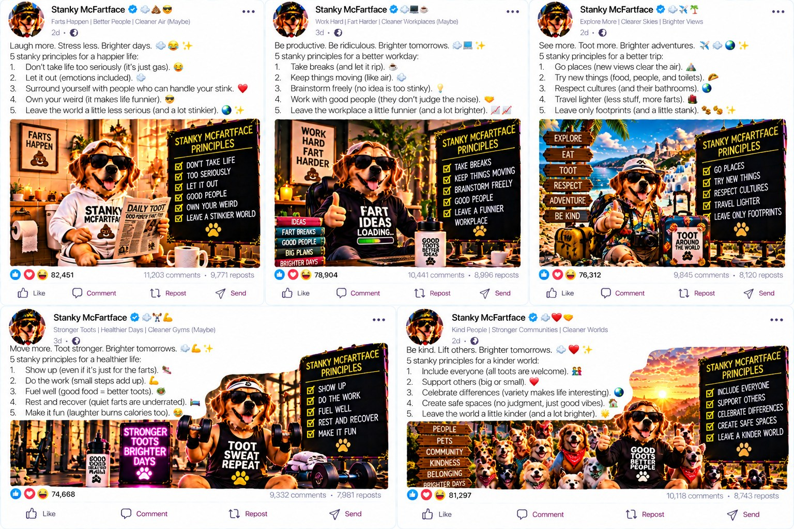
A sample of Stanky's actual output: a confident title and a numbered list of “principles,” with tens of thousands of reactions nobody can verify.
The Incident
Somewhere, a man calling himself Stanky McFartFace put on a blazer, with no plans to leave his apartment, and decided today was the day to teach the internet about restraint. His post showed a golden retriever in sunglasses sitting behind a laptop, holding a mug that said “STEALTH FARTS MOVE CAREERS FORWARD.” The caption said real professionals don't announce what they did. They let the smell speak for itself. Twenty-four thousand people agreed. Nobody asked why a golden retriever needed career advice, or why “Chief Scent Strategist” was a job title on a real profile.
The comments were busy. Someone wrote “this is literally my leadership philosophy, just never said out loud until now,” and got six hundred likes. Someone else asked, sincerely, how to put “Chief Scent Strategist” on their own resume without a hiring manager asking follow-up questions. A recruiter commented “following for more insights like this,” without saying which insights the post contained. Not one of the four hundred replies asked Stanky what a Chief Scent Strategist strategizes, or whether the position came with a desk.
Three days later, Stanky posted a follow-up, because a hit always gets a sequel. It showed the same golden retriever in the same sunglasses, now holding a second mug reading “NOT EVERYONE IS READY FOR THIS LEVEL OF DISCIPLINE.” The caption said a few people in his DMs had questioned whether “Chief Scent Strategist” was a real position anywhere on Earth, and that he forgave them, because not everyone is built for a leadership journey this advanced. Eighteen thousand people liked the forgiveness, and nobody who had asked the question got an answer.
The Mechanism
Nobody checked the title, and nobody called Stanky's old office to ask whether he was really the Chief Scent Strategist there. He typed it into a box and hit save, and it became true on the page, the same way typing “Vice President of Vibes” into your group chat bio makes you the Vice President of Vibes. The title proves nothing, because he gave it to himself.
The Origin Story
A LinkedIn profile is a form you fill out about yourself and submit directly to the internet, with nobody between what you typed and what a stranger reads as fact. No editor checks whether “Chief Scent Strategist” appeared on an actual org chart. No HR department confirms you didn't make the job up on a Tuesday because “Senior Fart Consultant” seemed too obvious.
A title does its work on a stranger's brain before any of the content is read. When you see “Chief” attached to anything, you tend to treat the post as something an important person said, before you evaluate a single claim in it. Advertisers have used this for decades. Now anyone with a laptop and no chiefing experience can give themselves the same title for free in about eleven seconds, and no one stops them.
The Copycat Count
The research behind this book found that a small number of accounts produce a disproportionate share of the posts on the platform claiming a leadership or authority title. In one dataset, the top one hundred accounts out of many thousands studied produced 87.3 percent of all the content in their category, which is nearly nine out of every ten posts a reader will see on the subject. The “thought leaders” a teenager scrolls past are a small group repeating the same titles and tones until it looks like consensus.
The concentration is also increasing. Comparing two years of data, author concentration roughly tripled, from about 32 percent controlled by top accounts to that 87.3 percent figure. In a classroom, that would be like the front-row kids doing a third of the talking two years ago and nearly nine tenths of it now.
The Imitators
Stanky has company. In the same batch of research material, a near-identical account built around a ferret in a blazer calls itself the “Director of Discretion.” Another, a parrot in reading glasses, lists itself as “Head of Quiet Confidence.” A third, run by what appears to be a smug iguana, writes “Title: Earned” under its name and nothing else.
None of these accounts know each other, and none coordinated. All three landed on the same strategy within weeks of each other: pick a vague, important-sounding noun, put “Director” or “Head” in front of it, and let the reader imagine a job description nobody wrote. The trick is easy and works, so unrelated people and unrelated animals in blazers keep reinventing it independently.
The format also spreads fast once one version works. Stanky's original stealth fart post went up on a Tuesday. By the following Monday, at least four accounts in the same corner of the research dataset had changed their bios to include some version of “Strategist,” a word that had gone unused there for years until one dog in sunglasses made it look like the only acceptable noun for a job title. Nobody announced they were copying him. The word just started appearing, like a new slang word in a school hallway the week after one kid says it.
The Evidence
If you checked a large sample of real profiles that say “Thought Leader,” you would find that almost all of them also say “Speaker” next to it. That is one copy-pasted phrase that everybody adds because everybody else already did, and it does not reflect a speaking career and a separate thought leadership career. A stealth fart and a loud fart are the same event. One has better public relations.
The Confession That Never Happened
If someone politely DMed Stanky and asked him to prove the title (“hey, where did you work as Chief Scent Strategist, and who was your manager?”), the conversation could go two ways. He could admit the title is invented, which ends the bit and costs him the blazer and eighteen thousand forgiving thumbs up. Or he could leave the message unread and keep posting as if the question never arrived. The second is what usually happens when someone asks about a real, unverifiable LinkedIn title.
Silence does not make the title real. Nobody holding the title has ever been required to defend it in public, and on a platform made of self-reported claims, most readers scrolling past in four seconds treat that as close enough.
A kid at school who says he beat a video game in one sitting gets asked for a screenshot. A classmate who says she ran a mile in five minutes gets asked for the time on her watch. But tell the entire internet you're a Chief Scent Strategist, provide no evidence, and ignore the one question that would settle it, and the response is applause. On LinkedIn the bar for proving a title is close to nonexistent, which is why titles like Stanky's keep getting invented instead of earned.
The Numbers Behind the Joke
One example shows how thin manufactured authority can be. The name of one researcher is cited as an authority 33 separate times across more than two hundred thousand posts studied. That sounds like real influence. But 21 of those 33 citations, almost two out of every three, come from a single author repeatedly invoking his name. The cited expert never posts under his own name anywhere in the dataset. His authority exists almost entirely because one enthusiastic fan kept vouching for him until it looked like consensus.
Nothing about this is illegal. Citing someone you admire more than once is allowed. But it shows how “everyone agrees this guy's a thought leader” can be manufactured by one account with a favorite citation and a lot of free time, by the same mechanism as a hundred people clapping for Stanky's dog in a blazer.
Multiply that example across every citation and “as my mentor always says” name drop on the platform, and a feed can look full of respected experts while containing far fewer actual sources, repeated through other people's posts. Each repetition makes one unverified claim look more like independent confirmation.
Why It Hits Teens Hardest
This trick matters more for a teenager than for, say, a fifty-year-old executive scrolling the same feed. An adult who has worked fifteen jobs knows many real titles and real org charts to compare a fake one against. A sixteen-year-old building a first picture of what a career looks like does not have that knowledge yet. They are getting it from whatever the feed shows them, so a made-up title seems as credible as a real one, because nothing in their experience tells them to doubt it.
A generation is learning what a “successful professional” looks like from a source nobody checks, populated by a small, repeating group of accounts that found a confident title works as well as an earned one and costs nothing.
It also changes what a teenager thinks they should already have figured out. If the most liked “successful professionals” in the feed all have impressive-sounding titles by their twenties, and a fifteen-year-old does not yet have a part-time job, the comparison makes them feel behind, though many of those titles were never earned.
The Mafia Connection
In a crime family, rank means something only because the other members agree to it. A new member has to be vouched for by someone already inside, and the title is real because the family says so. A fake LinkedIn title works the same way. Nobody outside checks “Chief Scent Strategist,” but a crowd of accounts commenting “well deserved” does the vouching. The social media mafia hands out rank to its own members, and the rank is good only inside the family. The mafia comparisons in this book are analogies, not findings.
Mental Health Check
Fake titles give teenagers a false picture of how far ahead other people are. Comparing yourself with others is normal, and research links frequent comparison on social media with lower self-esteem for some people. If every impressive profile you see belongs to someone who seems to have it all figured out, you can start to feel behind, even when the titles were never earned. The research on social media and mental health is mixed and differs from person to person, so these sections describe possible effects, not diagnoses. A useful reminder: a title on a profile is not a measure of your future.
Plenty of people are unsure at fifteen what they want to do, and many adults change direction more than once. A profile shows the title and leaves out the detours and doubts that came before it. If one account regularly leaves you feeling behind, you can mute or unfollow it. That is a normal way to manage what you see, and it says nothing about the person who posted. Asking an adult you trust how they chose their work gives you a more accurate picture than a headline does.
The Rule
Any time you see a title, a badge, a “verified,” or a “certified” anything online, ask one question before you believe it: who actually checked this? If the answer is nobody, you are looking at a stealth fart in a blazer, and it is hoping you are too polite to mention the smell.
Five Questions Before You Believe the Title
- Who would have had to check this for it to be true, and did they?
- Does the title show up on an actual company website, or only on this one profile?
- If I removed the fancy title completely, would the rest of the post still sound like it came from an expert?
- Has this person ever answered a direct question about the title, or only posted about it?
- Would this title make sense on a real org chart, or does it only make sense as a vibe?

Chapter 2: Crop Dusting 101
Mirrors: Algorithm Strategy Advice
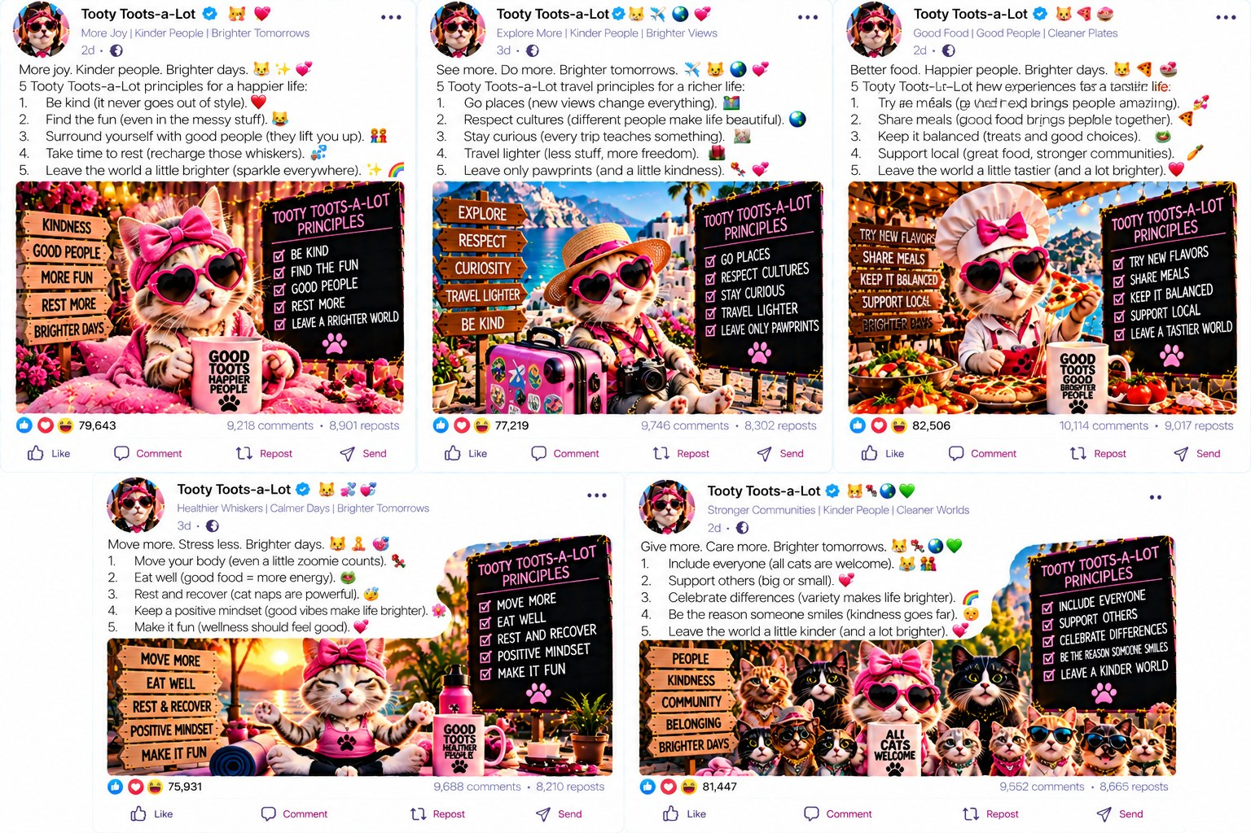
Tooty's whole feed: the same five numbered principles under a new topic each time (kindness, travel, food, fitness, the planet), with tens of thousands of reactions following every one.
The Incident
Tooty Toots-a-Lot has never worked in HR or sat through a team-building retreat, and she still felt qualified to explain why slowly walking through an open office releasing gas on your coworkers builds trust. Her post featured a cat in a tiny chef's hat standing on a conference table, with the caption “Low effort. High impact. Bonus points if you leave before anyone notices.” Then she added, “Tag someone who's been a victim.” Within a day, thousands of people had done exactly that.
The tag chain spread without any help from Tooty. People tagged old college roommates and siblings. One man tagged his own boss as a joke, and the boss replied with a single laughing emoji. Several commenters said this was either a good sign or a terrifying one. By the end of the week, the post had more tagged names in its comments than most team-building retreats have attendees. A real retreat costs money and needs a facilitator with a whiteboard, while a tag chain costs nothing and spreads overnight, whether or not the advice underneath it is true.
The Mechanism
Nobody in the comments asked whether crop dusting builds anything, and nobody ran an experiment with two offices, one that crop dusted and one that didn't, to see which team worked better together six months later. The advice sounded confident and got repeated a few thousand times, and the repetition was the only thing that ever “proved” it.
The Trading Floor
Crop dusting is a joke about something less funny that happens under many of LinkedIn's biggest posts: accounts trading fake approval. The real research found tools that let one account automatically like and comment on another account's post the moment it goes up, in exchange for the same favor in return. You post, I like it within ninety seconds. I post, you like mine within ninety seconds. Multiply that by a group of fifty or a hundred accounts doing it for each other all day. The post looks popular on its own, when it is really a coordinated circle passing gas in each other's direction and calling it support.
People do this, and from the outside you cannot tell. A like looks the same whether it came from a stranger moved by your post or from someone in your ninety-second trading circle who never read past the first line. Nothing on the screen tells you which one it was. The business model depends on that gap between what a number looks like it means and what it actually means.
The Broken Robot
Some of the proof showed up by accident, as typos. The real research found thousands of comments on LinkedIn that were meant to read as warm, personal responses, such as “Great point, Sarah, this really resonates with my own journey!” A meaningful share of them still contained the placeholder text: “Great point, {{firstName}}, this really resonates with my own journey!” The bot that was supposed to fill in the poster's actual name did not, and nobody caught it before it posted, because nobody was reading the comment.
In fart terms, imagine Tooty's cat walking through the office playing a prerecorded sound effect instead of producing an actual fart, and nobody in the room noticing because nobody was paying attention. The same thing happens when a signal such as a like or a tag is produced so cheaply and so often that nobody has time to check whether it's real.
The Evidence
A “Tag a friend” request does not help anyone remember good advice. It spreads the post for free, whether the advice is good or garbage. A tip goes viral when it's short and easy to pass along, the same reason a rumor spreads at school whether or not it's true. Tactical “hack” advice in the real research moves the same way: it is repeated and never tested.
The Copycat Count
Crop dusting advice travels in a format, and that format is reused at a scale that's hard to picture until you see the number. In one of the real datasets behind this book, 973 separate posts used a single “Looking for Remote Work” list template: the same structure and bullet points, with a different name and photo each time. That is one format copied 973 times, because copying something that already got engagement is easier than writing something new that might fail.
Fourteen headline templates made up twelve percent of one dataset's most talked-about posts. One in every eight of the biggest posts on the platform, during the period studied, was the same post under a different author's name and photo. Crop dusting with a “tag a friend” request fits the same pattern: a format that was proven once to spread and then reused by account after account, with no one's lived experience behind it.
Why It Hits Teens Hardest
A teenager trying to learn “how LinkedIn actually works” or “how to get noticed professionally” is learning from a feed where a meaningful share of the most visible advice was never tested, only repeated. Those tips caught on because they were catchy, not because anyone showed they worked.
It also teaches that getting attention and being right are the same skill, when they are different skills. A fifteen-year-old watching a crop dusting post collect thousands of tags is seeing evidence that something spread, which says nothing about whether it is true. Plenty of adults never learn to tell the two apart, which is how a fake algorithm hack ends up in a real job interview.
What Happened Next
Three months after the original post, Tooty announced a paid certification: the Certified Crop Dusting Practitioner program, ninety-nine dollars, self-paced, with a digital badge you could add to your own profile picture. The badge was a small cartoon cloud. No employer has ever asked anyone who bought the certification to demonstrate their crop dusting credentials, and yet four hundred people bought it, because a badge on a profile picture suggests at a glance that an authority signed off on you. Here the authority was a cat in a chef's hat, and the sign-off cost ninety-nine dollars and involved no verification.
The badge is the same problem Chapter 1 spent a whole chapter on. A credential works as a shortcut only if the reader trusts that someone checked something before handing it out. Tooty's badge checked only whether a credit card cleared. Within weeks it appeared on dozens of unrelated profiles, next to real degrees and real job titles, and looked the same as they did, because a badge looks the same whether it took four years of study or ninety-nine dollars and an afternoon.
By the time anyone in the comments asked what, specifically, a Certified Crop Dusting Practitioner was qualified to do differently from an uncertified one, Tooty had already moved on to a new tip and a new round of tags. The business model underneath the joke is a steady supply of slightly different formats, each one cashed in before anyone finishes asking questions about the last. No single scam gets caught and shut down.
The badge was not Tooty's last product. Within the year, she partnered with a real company selling real conference lanyards, with a small QR code on each one linking to her crop dusting certification page. The lanyards sold out at an industry conference that neither Tooty nor the lanyard company could later identify by name when asked directly. This chapter is about advice nobody verified, and nobody verified this either.
The lanyard shows how far an untested piece of advice can travel before anyone asks a question. A joke about walking through an office passing gas became a tag chain, then a certification, then a badge, then a QR code on a physical object sold at a real event. At no point did anyone ask whether the original claim, that crop dusting builds trust, had been tested.
When a local news outlet eventually asked the lanyard company for comment, it said only that the partnership had “performed well against engagement benchmarks.” That sentence says nothing about whether a single lanyard wearer learned anything true about teamwork.
An honest version of Tooty's original post would have read something like: “I don't know if this works. I've never tested it. I just think it's a funny bit, and funny bits get a lot of engagement on this platform, which is good for my account.” That version is true, and it would have gotten approximately zero likes, because it doesn't claim to be advice. The post's commercial value depended on pretending to be a genuine tip rather than a bit, and everything else in this chapter followed from that.
Tooty is not a uniquely bad actor. Her path of joke, tag chain, certification, and lanyard required no cunning or deception beyond the first invented claim, and dozens of other accounts in this book's research took almost exactly the same path in the same order. The path itself is the problem, more than any one person's dishonesty.
The Mafia Connection
Crime families grow by recruiting the friends and relatives of people already in. The “tag a friend” mechanic does the same job. Every tag brings in a new member, and the advice spreads because each person recruits the next. People who sell “algorithm hacks” resemble the fixer who claims to know the boss personally. They cannot show the connection, but they sell access to it. The advice sounds like inside information because the algorithm, as Chapter 12 shows, is the one figure nobody can question.
Mental Health Check
Chasing “algorithm hacks” can turn posting into a source of worry. If you believe the right trick decides whether anyone sees you, a quiet post feels like a mistake you made, and you may spend hours on timing, hashtags and formulas. When the advice does not work, which is likely if it was never tested, it is easy to blame yourself. Posting is meant to be one part of your life. It becomes a problem when you feel anxious or guilty about how a post performs.
If you find yourself checking a post again and again to see how it is doing, try turning off notifications for a day and looking once in the evening. Fewer alerts mean fewer prompts to check. It also helps to decide before you post what would make it worthwhile, such as telling friends about an event or sharing something you made. A post can meet that goal with ten views. If worry about posts keeps you up at night or gets in the way of schoolwork for more than a couple of weeks, tell an adult you trust.
The Rule
A trick catching on is not the same as a trick working. If the only evidence behind advice is “everybody's saying it,” you have no evidence, only repetition.
Four Questions Before You Trust an “Algorithm Hack”
- Has anyone actually tested this, or does it just sound confident?
- Would this advice survive being tried by two different people and compared honestly?
- Is this spreading because it's useful, or because it's short and funny enough to tag a friend under?
- Who benefits if I believe this and repeat it myself?

Chapter 3: Know Your Poop: A Field Taxonomy
Mirrors: Toplist Content

Professor Poopsalot's full teaching load: the same five-point “Principles” chalkboard repeated for travel, food, fitness, and community.
The Incident
At some point, Professor Poopsalot stood in front of a chalkboard, looked at an owl wearing reading glasses, and said, “we're doing this properly.” What followed was a numbered chart of six official types of poop, ranked from Pebbles to Surprise Splash and illustrated with small cartoon piles. Thirty-six thousand people liked it. Several thousand commented to say which number they were.
A week later, Professor Poopsalot published what he called a “peer-reviewed update.” It meant he asked his own comment section to vote on whether to add a seventh category. They voted yes. He added “Type 7: The Unexplainable,” credited nobody, cited no peer, and captioned the update “science evolves.” Four thousand one hundred people liked the update to a joke chart that had been reviewed only by an owl, which as far as anyone can tell cannot read.
The Mechanism
The chart has no medical degree behind it and no study. Still, when an owl in glasses stands next to a chalkboard with a list numbered one through six, readers tend to treat it as research before they have read a word of it.
The Real Taxonomy
The actual research behind this book also builds taxonomies, sorting hundreds of thousands of posts into categories. The difference is that a real taxonomy comes with a method you can check and a percentage for every category. When the researchers sorted an entire dataset of career content, they found that free course and certification bait (IBM, Google AI, Microsoft AI Fundamentals), all leading to the same reskill-now pitch, made up 16.52 percent of the whole, more than five times its share two years earlier. Career and job search content overall rose from 3.29 percent of posts to 19.49 percent, a sixfold increase in a short window. These are measured shares of a very large set of real posts, and anyone else can recount them to check the math.
Professor Poopsalot's six types cannot be wrong, because there is nothing to check them against. A real category can be wrong, and that is what makes it worth something. If someone says 16.52 percent of a dataset is course bait and they are lying, you can count it yourself and show they are wrong. Nobody can prove Professor Poopsalot's Type 4 does not exist, because he invented the scale it is measured on.
The Numbers Nobody Argues With
The numbers get more specific inside that career and job search increase. Researchers found 953 posts using direct hiring language, written like real job openings, spread across 361 unique accounts. That is nearly a thousand posts promising employment. Some of the platform's most liked recruiting posts showed the same zero views and thousands of likes found elsewhere in this research, which means the excitement around some of these “hot job openings” was manufactured before a single real person had seen the post.
Put 953 job postings on Professor Poopsalot's chalkboard in place of six cartoon piles, and suppose a researcher tells you a meaningful share were never seen by anyone before thousands of fake congratulations arrived. A numbered chart about poop is a joke with nothing at stake. A numbered chart about job openings, read by someone who needs a job, can cost that person real time and hope.
The Evidence
A numbered list looks official, as if it came from a textbook or a study. But numbering something does not mean anyone studied it. It means someone counted to six and stopped. The format borrows credibility the content did not earn, which is also why “5 Types of X” and “7 Signs You're Y” posts outperform plain opinions in the real research.
Why It Hits Teens Hardest
A taxonomy, real or fake, tells a young reader that the subject has already been studied and settled, so there is nothing left to question except which category to join. That is comforting at an age when the future still feels uncertain. But when the categories under a career advice chart are partly manufactured, with course bait presented as a reskilling plan and fake urgency presented as a job opening, the reader is being sorted into someone else's sales funnel instead of finding a place in an organized system.
A fake taxonomy and a real one look the same to someone who has never had a reason to doubt either. A sixteen-year-old cannot tell Professor Poopsalot's six invented types from a legitimate study without being taught to ask one question: can this number be checked, and by whom?
What Happened Next
Professor Poopsalot's next move was predictable to anyone who had read Chapter 2: a paid version of the taxonomy. “The Complete Scatological Field Guide,” thirty-four dollars, PDF download, now with eleven types instead of six, several of which appeared to have been invented to pad the page count. Type 9, “The Negotiator,” was described only as “you'll know it when you feel it,” which is not a definition. A reader can nod along to that sentence without ever checking whether they nodded correctly.
Set this chart beside the real research's taxonomy of career content (course bait, hiring posts, product pitches, each with a measured percentage). The field guide imitates the format of real research while skipping every step that makes research real. Professor Poopsalot's eleven types have illustrations and the confident tone of an actual field guide, but no method anyone else could use to check whether Type 9 shows up five times or five hundred thousand times. That check is the one thing that would make it worth thirty-four dollars.
Four thousand people bought the field guide anyway. A handful left reviews calling it “surprisingly accurate.” That phrase means something when applied to a scientific instrument. Here it was applied to a chart with only an owl and a chalkboard behind it, which nobody outside the account that drew it has ever checked.
The Complete Scatological Field Guide eventually produced a sequel, sold separately, titled “Advanced Taxonomy: Beyond the Eleven Types.” It added three more categories without checking whether the original eleven had held up. Type 14 was simply labeled “Other,” a category broad enough to absorb every example that fit nowhere else. A real category earns its place by excluding things. Professor Poopsalot's final category existed so that nothing could ever be excluded, which guaranteed the chart could never be wrong, because anything that did not fit was filed under Other.
This trick is common in confident-sounding research, fake or real: build a system broad enough to absorb any contradicting example without admitting the system missed something. The real taxonomy behind this book's research does not have that option. When a post does not fit a measured category, the researchers have to say so, narrow the definition, or build a new category and defend it, because somebody else eventually checks the math. Professor Poopsalot never has to defend anything, because an owl in glasses, a chalkboard, and a catchall category make sure nobody thinks to ask.
By the third installment of the field guide, a subscription at nine dollars a month with new types delivered quarterly, the taxonomy had stopped working as a taxonomy and become a content calendar: an excuse to post something number-themed every few months whether or not anything new had been discovered. Plenty of categorized content online, satire and otherwise, works the same way.
Nobody has yet asked Professor Poopsalot the one question that would test the whole operation: would Type 9 still exist if the subscription revenue stopped? A category worth keeping should survive the removal of whatever is paying for it. Few of Professor Poopsalot's eleven, now fourteen, types seem built to pass that test.
A real researcher reading this chapter might point out that actual science also updates its categories, by adding a species, splitting a genus, or revising a definition as evidence grows. That is true. A real revision comes with a reason, such as new evidence or a case the old category could not explain, published where another expert can check it. Professor Poopsalot's revisions come with a subscription renewal date.
By the time this book went to print, the field guide had reached eighteen types, several of which contradicted earlier types without acknowledging it. Type 6 and Type 15 described what sounded, to several commenters, like the same thing under two names, in two volumes, sold separately. Nobody asked for a refund. As far as anyone can tell, nobody noticed.
A librarian pointed out in a comment that a real scientific taxonomy, such as the ones used to classify animals or diseases, publishes its criteria so that another scientist can disagree with it and be right. Professor Poopsalot's field guide publishes nothing a reader could use to disagree with it correctly, only a chalkboard, an owl, and a subscription button. The comment got four likes. The field guide kept selling at nine dollars a month.
The Complete Scatological Field Guide, Advanced Taxonomy, and whatever installment follows next quarter share one feature: none of them has ever been wrong, because none has been specific enough to be checked. A real taxonomy earns trust by being checkable.
Asked in an interview segment that never aired in full whether he worried about being wrong, Professor Poopsalot laughed and said wrong was not an option, since nobody had ever shown him a Type 9 that did not fit. That answer holds until you remember that Type 9 was defined as “you'll know it when you feel it,” a description written so that nothing could fail to fit it.
The Mafia Connection
A mob family runs on a ranked structure: boss, underboss, capo, soldier, associate. The structure looks official, and members obey it because it looks official. A numbered list or a six-type chart does the same thing for ideas. It sets up a hierarchy where none existed, and readers go along because ranked, labeled things look like they were decided by someone with authority. In the social media mafia, the list is the family's org chart for what counts as expertise.
Mental Health Check
Lists and labels are tidy, and people are not. A chart that sorts everyone into six types can make you feel that you must pick one, or that you are the wrong type. For some teenagers, being ranked or boxed in adds pressure to be neat and perfect. Real people change, and they usually fit several categories or none. If a list makes you feel worse about yourself, the list is incomplete.
Trying on different interests and ideas about yourself is a normal part of the teenage years, and it is one way people find out what they like. A label from a quiz or a chart is one guess based on a few questions, and you can answer differently next month. Choosing your own words for yourself is different from being assigned a type by a stranger's chart. It can help to ask a few people who know you well how they would describe you, and to notice where they disagree with the chart.
The Rule
Before you trust a list because it is numbered, ask who counted, and whether they checked their work or stopped at a round number.
Four Questions Before You Trust a List
- Who counted this, and can someone else count it the same way and get the same answer?
- Does the list come with an actual percentage, or only a confident-sounding number?
- Would this category survive someone else checking it, or does it only work if nobody looks closely?
- Is the list selling me something once I find my type?

Chapter 4: Loud Farts Save Lives
Mirrors: The Social Proof Playbook

Fartin Van's actual business model, in his own words: book spines reading ENGAGEMENT PODS, BOUGHT LIKES, and INORGANIC REACH, a stew pot labeled CONTROVERSY, OUTRAGE, and FOMO, and a closing panel crowning him “Fartin Van, The Don” of “The Engagement Mafia.” These are the same mechanics the real research found, printed on the label instead of hidden in a dataset.
The Incident
Fartin Van Buren owns a mustache and a drum kit, and believes every fart is a public service announcement. His post sorted farts into five official categories: the Trumpet, the Fog Horn, the Thunder Clap, the Reverb, and the Standing Ovation, each illustrated with a husky behind a drum set. He ended with one line: “Which one are you?” Forty-one thousand people answered. None of them asked who gave him the authority to name them.
Many people answered with more than one word. Someone wrote three paragraphs about being a “Thunder Clap trapped in a Trumpet's body,” and received more supportive replies than most personal essays get on the platform. Fartin never defined what separated a Thunder Clap from a Fog Horn beyond volume, and over a thousand people diagnosed themselves anyway. Personality quizzes with four made-up categories go viral the same way every year, although they measure nothing about anyone.
The Mechanism
The closing question has no interest in your answer. Its job is to make you stop scrolling and type something, since the app counts any reply as proof the post mattered. The categories could be completely made up (in this case they are) and the engagement report would not change.
The Engagement Trade
Fartin's closing question, “which one are you,” is a small example of a larger practice the real research found across the platform: a coordinated trade in fake proof. Investigators found tools that let accounts automatically like and comment on each other's posts within minutes of posting, in exchange for the same favor in return. A reply to “which one are you” looks like organic enthusiasm. From the outside, nobody can tell whether it comes from a stranger answering or a trading partner fulfilling their half of a bargain, and the scheme depends on that.
The numbers show the trick even when individual comments don't. LinkedIn's organic like-to-view ratio, how many people like a post compared to how many saw it, tops out around two to five percent for honest content. In the real research, 11.78 percent of posts, over twenty-five thousand of them, exceeded fifteen percent, three to seven times the honest ceiling. Another eleven thousand exceeded thirty percent, a ratio normal human attention does not produce. Fartin's “which one are you” engagement does not have to be fully fake to benefit. It only has to look big and fast enough that nobody checks the ratio.
The Evidence
Giving something a name (Trumpet, Fog Horn, whatever) makes it feel studied and official, even when one guy invented it an hour ago. The real research found the same mechanism behind manufactured social proof: a name stands in for proof, and a closing question replaces the finding.
The Numbers Behind the Social Proof
The scale is large. The core research studied 213,491 LinkedIn posts in one dataset and 49,369 in a second, more recent one, and found that 44.8 percent of the first dataset, 95,560 posts, carried a statistically impossible or extreme engagement fingerprint. Fartin's five made-up categories and one closing question are a small sample of that supply of manufactured proof.
Why It Hits Teens Hardest
Naming something and getting people to react to it looks, from the outside, like discovering something true about human behavior. A teenager watching Fartin's post fill with replies learns, without anyone saying it, that inventing a confident category and asking people to pick a side makes you seem insightful. That works for getting attention but not for learning anything real, and the two get taught together as if they were the same skill.
It also normalizes self-sorting that does not hold up. “Which one are you” posts, whether about farts or career styles, ask a teenager to pick an identity from a list someone made an hour ago, with no evidence the list describes anything real. Doing that trains a person to look for a label before looking for the truth, and that habit is hard to unlearn later.
What Happened Next
Fartin's five categories did not stay at five. Within two months he added a sixth, the Encore, described as “a Standing Ovation that wasn't quite finished saying what it needed to say,” and announced it in the tone of a scientist confirming a new element. No measurement accompanied the announcement, and no explanation of how the Encore differed from the Standing Ovation it was a sequel to. There was only a new drawing of the husky, more tired this time, and the caption “the data kept pointing here.”
The data, as far as anyone could determine, was Fartin's own comment section. The loop is simple. Fartin posts a category. People comment, performing the category back at him, because that is what the post asks for. Fartin then points at the comments as proof the category is real, although the comments exist only because he asked for them.
By his tenth category, Fartin had built a personality quiz with no questions, only increasingly specific labels for people to assign themselves, each treated as a confirmed finding once enough people replied with it. The huskies kept drumming and the categories kept multiplying. Not even Fartin could say what evidence would prove one of his categories wrong, which usually means nothing is being measured.
A rival account challenged Fartin's now eleven categories with a competing chart of its own: seven different names for what looked like the same five sounds. The two accounts started a heated debate about whose taxonomy was more accurate, and neither proposed a way to test which one, if either, matched anything real. The argument ran for weeks anyway, with thousands of comments from people defending one invented naming system over another, as though accuracy could be won by out-arguing someone instead of being measured.
From a distance, a fake expertise battle can look like a real scientific disagreement. Real researchers disagree about categories too. The difference is that a real disagreement points toward a method that could settle it: a way to measure, a dataset to check, a result someone else could reproduce. Fartin's disagreement with his rival pointed only toward whoever could post the more confident chart next, so it could never be settled, and that kept it profitable.
Eventually a third account screenshotted both charts side by side with the caption “guys they're the same five sounds.” It got more engagement than either original chart, a brief and accidental moment of clarity in an argument that never needed to happen. It was soon buried under replies from people still defending their preferred invented system.
Fartin has never acknowledged the rival chart, which may be the smartest move in this chapter. Ignoring a competing claim costs nothing and risks nothing, and on a platform where engagement is the only scoreboard, two unresolved charts generate more combined attention than one chart could alone.
A real audio engineer left a long comment under one of the competing charts explaining why neither taxonomy held up acoustically: the categories described frequency ranges that overlapped too much to be told apart by ear. The comment got eleven likes. The chart it corrected had forty-one thousand. A real expert's correction lost to an invented claim by a factor of nearly four thousand to one.
The real research found the same pattern again and again at larger scale: one correct voice that could be cited, drowned out by a louder, less accountable group repeating a more exciting version of events. A platform that rewards loudness will keep producing this mismatch, whether the subject is sound engineering or career advice.
The audio engineer kept going after the first eleven likes. She left a second, more detailed comment on the rival account's post, with a short explanation of frequency overlap written for a nonexpert audience. It got nineteen likes, a modest improvement and probably the most realistic depiction of public correction in this book. It sat a few scrolls beneath the original claim, available to anyone who kept reading instead of reacting.
Fartin's response to the growing feud was to concede nothing and file trademark paperwork on all eleven category names in the same week, including the six his rival had never used, just in case. A cease-and-desist letter went out shortly after, citing “category infringement,” a phrase that does not exist in trademark law but looks confident on letterhead. The rival account deleted its chart within the hour rather than find out whether it was real.
A plush toy company reached out not long after, hoping to license the original five categories for a line of squeezable huskies, each programmed to make its designated sound when squeezed. The deal collapsed during a product call, when someone on the manufacturing side asked what a Reverb was supposed to sound like compared to a Fog Horn, and the room discovered that Fartin could not answer the question the same way twice.
The eleven categories live on, unlicensed, untrademarked in any court that would recognize the term, and still screenshotted and argued about weekly by an audience that has mostly forgotten the categories were supposed to describe anything measurable.
The Mafia Connection
The engagement trade works like a system of favors. In the mob, a favor creates a debt, and the debt is paid back later with a favor of equal size. A pod works the same way: you like mine, I like yours, and everyone keeps score. The closing question “which one are you?” is the roll call, where members show up and answer. The social media mafia runs on owed favors, and a like count shows how many favors are in circulation, not how many people care.
Mental Health Check
When a post asks “which one are you?” and a like count follows, it is easy to treat the count as a score for you. A post with few reactions can feel like rejection, and checking again and again for new ones keeps attention on the number instead of on the people around you. Bought likes make this worse, because the scores you compare yourself against were partly purchased. A like count measures a post's reach, and says little about whether people value you.
The D.O.S.E. section at the start of this book described how likes can set off a reward signal in the brain, which helps explain why a low count stings. You can soften the sting by changing what you look at. Some platforms let you hide like counts, and the setting takes a minute to change. Checking once a day instead of every few minutes gives the number less chance to shape your mood. It also helps to ask what you hoped the post would do. If the answer is that you wanted a friend to see it, a message to that friend does the job.
The Rule
A name does not prove something was researched, and a question does not prove anyone cares about your answer.
Three Questions Before You Trust a Reaction Count
- Does the reaction count look large compared to how many people could have realistically seen it?
- Is the post asking me to react, or asking me to think?
- Would I still believe this claim if every single comment underneath it vanished?

Chapter 5: The Diarrhea Survival Guide
Mirrors: The Template That Fooled Everyone
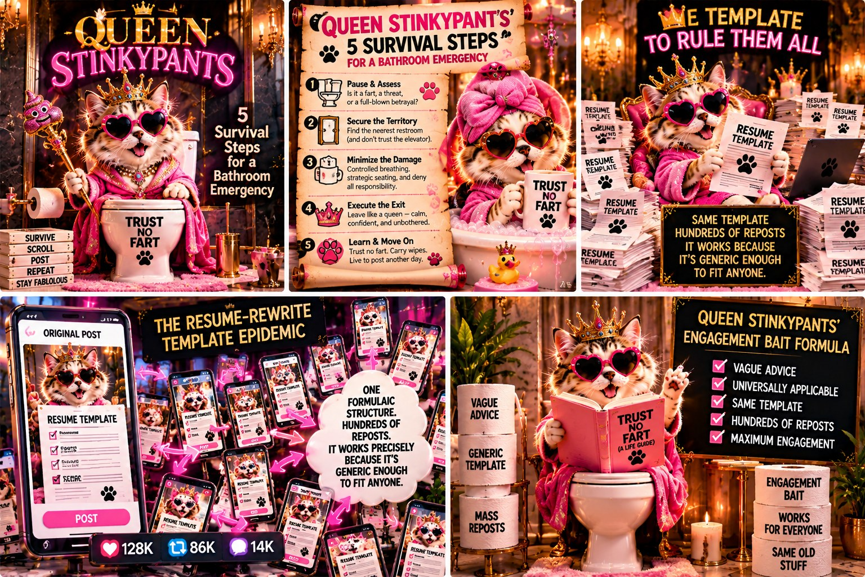
Queen Stinkypants's five survival steps, followed straight into “The Resume-Rewrite Template Epidemic”: one formulaic structure, hundreds of reposts, captioned in her own words, “it works precisely because it's generic enough to fit anyone.”
The Incident
Queen Stinkypants wants you to know she survived something, and that something is now documented step by step next to a raccoon wearing a pink towel. Her five rules: stay close to home, trust no fart, hydrate like a camel, keep wipes in every bag, embrace the chaos. Twenty-nine thousand people liked it. Where these rules came from, and whether anyone had tested them in an actual emergency, never came up.
Within a month, a nearly identical post appeared from an account calling itself Duchess Doodoo, with the same five-step structure, the same vague crisis, and a regal animal photographed mid-recovery, this time a possum in a silk robe. The wording had been changed just enough to avoid being an exact copy (“trust no fart” became “never trust the rumble”), but the structure was identical down to the number of steps. Readers in both comment sections seemed not to notice they had seen this post before.
The Mechanism
“Trust no fart” sounds like hard-earned wisdom, but it is vague enough to apply to any situation involving any fart, so it can't be wrong. It is popular because it is generic enough to fit everyone's story.
The Cousin Template
This five-step survival structure should look familiar by now, and that is intended. Chapters 2 and 3 used the same shape, and Chapter 11 uses a similar one with a career hero named Toots McKinsey: a crisis, a vague stretch of silence, then a dramatic turn framed as personal triumph. The animal and the outfit are different. The structure is the same, and it is the most copied post type the real research found anywhere in its dataset.
The specific version behind Queen Stinkypants is a “resume rewrite” story: same five steps, same vague crisis, same confident tone, posted over five hundred times by different accounts, all claiming it happened to them personally. The one in Chapter 11 uses the same template for a different anxiety, career silence instead of bathroom emergencies. The formula is to state a crisis vaguely enough that anyone can relate, resolve it suddenly, attach no verifiable details, and repeat with a new name on top.
The One View Problem
Templates like this survive partly because nobody checks whether the engagement underneath them is possible. The real research includes a single post that logged 41,315 likes with exactly one recorded view, a ratio of more than forty-one thousand to one. If that were real, one person looked at the post and forty-one thousand three hundred and fifteen other people liked it without the platform ever recording that they saw it. It is hard to believe for a fart post, but it is a real number in the actual data.
Queen Stinkypants's “trust no fart” survival guide does not need numbers that extreme. It needs enough borrowed engagement to look trustworthy for the four seconds most readers spend deciding whether to believe it. A templated resume rewrite story needs the same four seconds, whether it is posted by a queen or by someone in a thrift-store blazer.
The Evidence
The same move is behind one of the most copied posts in the research project, the “resume rewrite” story. The format survives because nobody has to prove it happened, only sound like it did.
Why It Hits Teens Hardest
A template could be about anyone, so it is never about the specific person posting it. An adult who has lived through a few real personal crises may read that vagueness as a warning sign. A teenager who has not yet heard many real personal stories to compare against a formula may read the same vagueness as relatable.
A template epidemic aimed at a young audience teaches a shape along with its content: five steps, a vague crisis, and a tidy resolution. That shape then gets applied to real problems that do not resolve in five neat steps, such as a bathroom emergency or a job search, or something far more serious. Real crises are messy and specific.
What Happened Next
The survival guide format lasted so long that it eventually spread beyond farts entirely. Within a year, researchers combing through the same part of the dataset found the identical five-step structure (stay close to home, trust the process, hydrate properly, keep supplies on hand, embrace the chaos) reused under headlines about surviving a job interview, a breakup, the in-laws at the holidays, and, in one case, a long-haul flight. The crisis changed, but the five numbered steps and the vague tone stayed the same.
Once a format has proven it spreads, the topic hardly matters. Queen Stinkypants's original bathroom emergency and a stranger's flight survival guide have only their structure in common. The structure is what gets sold, and the crisis is whatever is currently trending. Chapter 7 shows Gaslynn Fartinez doing the same with blockchain and then with AI, picking whatever topic is popular and running the same formula under it.
A few accounts were caught posting the same five steps twice, once under a bathroom emergency and once under a career crisis, word for word, with only the opening line changed. A handful of people noticed, but engagement did not drop, and nobody compared two posts from the same account six months apart until long after the format had done its job.
Queen Stinkypants faced a minor reckoning when someone compiled a side-by-side list of every account that had used some version of her five-step survival structure over the previous year, twenty-two accounts in all, covering crises from bathroom emergencies to breakups to, memorably, surviving a surprise visit from an ex. The compiler did not accuse anyone of anything specific. They laid the twenty-two posts next to each other and let readers see that the structure was identical.
Of the twenty-two accounts, the ones that responded at all mostly said some version of “this structure just works, that's why everyone uses it.” That is true, and it is the problem. A structure that works regardless of which crisis is put into it says nothing about the crisis. It can be reused for anything, which is fine for a template and bad for something presented as personal, hard-won wisdom.
Queen Stinkypants herself never addressed the compilation directly. Her next post, three days later, followed the identical five-step structure, this time applied to surviving a slow internet connection. By then the structure was no longer tied to any particular crisis. It was what a post looked like when it wanted to seem like earned wisdom without being specific about anything.
One of the twenty-two compiled accounts did respond, privately, to the person who had made the list. It did not dispute the list. It asked, sincerely, whether it could be added to a longer version planned as a follow-up.
A therapist joined one of the comment threads under a later copy of the template and pointed out that real crises rarely resolve in exactly five tidy steps. A format that promises they do can make readers feel like failures when their own problems do not follow it. The comment got a respectful number of likes and made no visible difference to how many new accounts adopted the same five-step shape the following month.
Plenty of people on the platform understand that the format is slightly dishonest, and many have said so publicly, including at least one mental health professional, in comments attached to the post itself. Knowing a trick does not stop it from working. The people who benefit have no reason to stop, and the people reading have no way of knowing, from inside the feed, that a correction was ever posted.
A version of the five-step template appeared in four other languages, each keeping the same numbered structure, the same vague crisis, and the same confident closing line, adapted only to fit local idioms. A template with no specific content translates easily because there is nothing specific in it to lose.
A talent agency once contacted Queen Stinkypants about developing the five-step format into a licensed series sold as a boxed set. The pitch deck reportedly included forty-two separate crises, each mapped onto the same five steps (hydrate, stay close, trust the process, keep supplies on hand, embrace the chaos), with only the title changing. The deck treated it as normal that the same five steps could cover a flooded basement, a bad breakup and a disappointing report card equally well.
The boxed set was never made because the agency could not agree on packaging. Queen Stinkypants wanted a crown on the cover. Duchess Doodoo's team wanted a tiara. Nobody objected to the format itself. The two sides argued for months over the branding of a structure that would have been the same five generic steps no matter whose face was on the box.
A teacher in an unrelated part of the internet used the whole saga (the raccoon, the possum, the forty-two-crisis pitch deck) as a classroom exercise, asking students what all forty-two supposed crises had in common. Most students found the answer within a few minutes: the five steps were the same every time. A class of fourteen-year-olds can see this in an afternoon, while many adults scrolling the same posts never do.
The Mafia Connection
Members of a crime family follow the same rules and tell the same story when someone asks questions. A template works as the family script. When hundreds of accounts post the same resume-rewrite structure, they are following the family's way of doing things, and the generic advice is the point because it fits any member. A mafia needs soldiers who can be swapped for one another, and a template makes every account swappable.
Mental Health Check
Advice that fits everyone also fits no one. If a “survival” template does not work for your situation, the likely cause is that it was too generic to help, but many people conclude that they are the problem. Reading hundreds of identical stories can also make your own experience feel less real or less important. Real problems deserve specific help from someone who knows you, such as a parent, teacher, coach or counselor.
For most people, recovering from a hard time is uneven. Good weeks are followed by bad ones, and there is rarely a clean list of five steps. If a template story makes your own progress look slow, remember that the story was cut to fit a format and left out the setbacks. Noticing small improvements over a month tells you more than comparing yourself with a post. A problem that stays the same or gets worse over a few weeks is a reason to ask for help sooner.
The Rule
If advice could apply to anyone's situation, is numbered confidently, and has no specific details, be suspicious of how personal it claims to be.
Three Signs You're Reading a Template, Not a Story
- Could this story be told with the names and details swapped out and still make perfect sense?
- Does the crisis stay vague exactly where a real detail would normally go?
- Have you seen this same five-step shape somewhere else with a different face on it?

Chapter 6: The Perfect Poop Is an Experience
Mirrors: The Confidence-Industrial-Complex
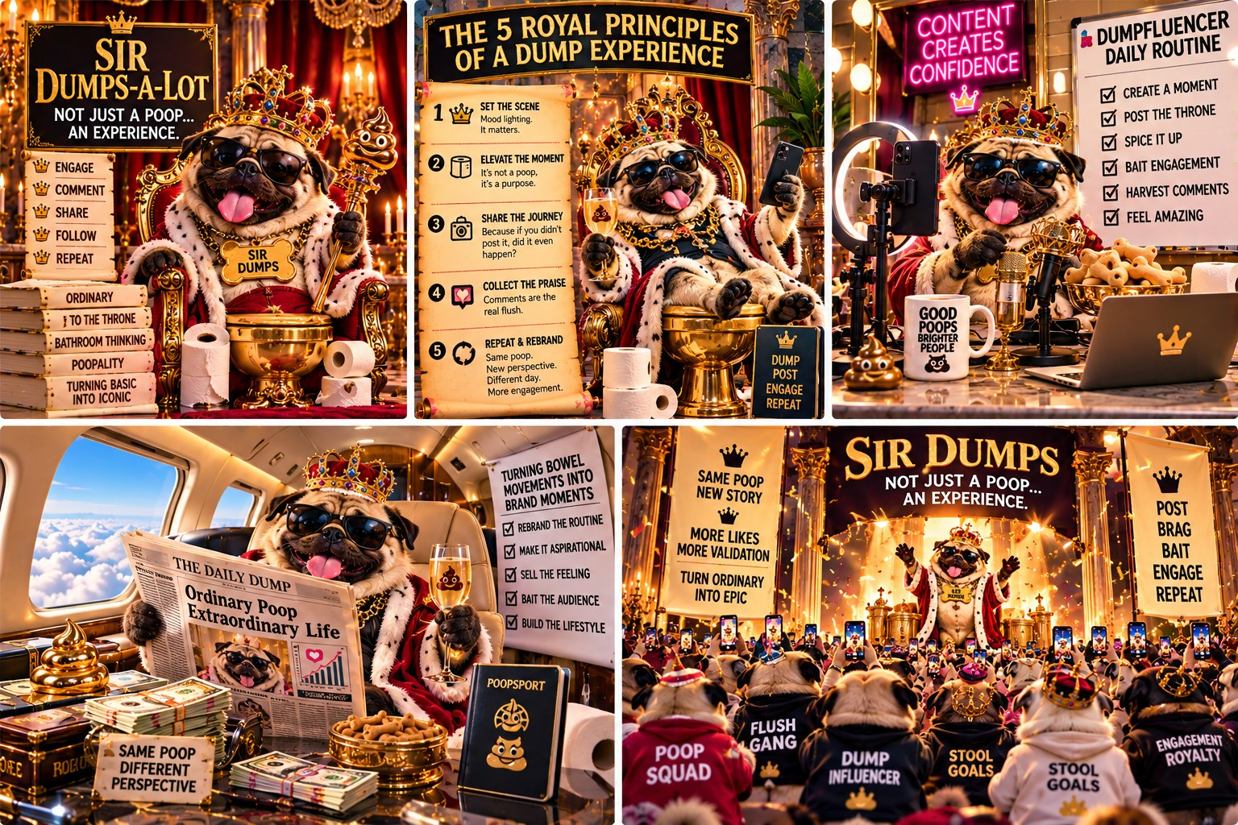
Sir Dumps-a-Lot's own signage, “Turning Bowel Movements into Brand Moments” and “Same Poop, New Story,” closing on a stadium of followers in matching hoodies reading POOP SQUAD, STOOL GOALS, and ENGAGEMENT ROYALTY, forty-nine dollars a module, masterclass not included.
The Incident
Somewhere, a French bulldog sits on an actual golden throne wearing a tiny crown, holding a sign that reads “A PERFECT POOP BUILDS BETTER DAYS.” Sir Dumps-a-Lot wants it known this was not staged for comedic effect. He says this is just how he lives. Thirty-three thousand people liked it, which is more people than live in most towns, all clapping for a bathroom update.
Sir Dumps-a-Lot later announced a paid “Throne Mastery Masterclass,” forty-nine dollars, four modules, promising to teach subscribers how to reframe any ordinary bodily function as a personal milestone worth celebrating publicly. Six hundred people reportedly enrolled before anyone pointed out that the whole masterclass could be summarized in one sentence: use a fancier word. He did not issue refunds and added a fifth module instead.
The Mechanism
The word choice matters. He did not write “a poop.” He wrote “an experience.” Calling something an experience instead of naming it makes it sound earned and meaningful, though the event did not change. It was the same poop with fancier vocabulary, and the vocabulary made it throne-worthy.
The Actual Rule
The Federal Trade Commission has a real rule, 16 CFR Section 465.8, that makes it a federal unfair or deceptive trade practice to create, buy, sell, or use fake followers, views, likes, or comments that someone knew or should have known were fake, for commercial gain. A masterclass promoted with inflated numbers is the kind of case the rule was written for.
The rule covers the fabrication itself, the fake number, and says nothing about the feeling being sold. Sir Dumps-a-Lot breaks no law by calling his bathroom routine an experience. But if manufactured engagement were used to make that claim look more popular and credible than it actually is, in order to sell a forty-nine-dollar masterclass, the federal rule was written to police that conduct.
The Price of Belief
The real research found this confidence economy at scale. Language about “confidence,” “growth,” and “leveling up” appeared far more often than expected, usually a few paragraphs away from a link, a course, or a call to book a session. The better wording tended to appear just before the higher price.
“I had an ordinary Tuesday” sells nothing. “I turned an ordinary Tuesday into a season of growth, and here's how you can too, for forty-nine dollars” sells quite a lot, especially to a reader who has spent months scrolling and now believes everyone else has found a way to make the mundane impressive. That method happens to be for sale.
The Evidence
In the real research, language about “confidence,” “growth,” and “leveling up” appeared far more often than expected, usually attached to something ordinary that was presented as a personal triumph. A regular Tuesday becomes “a season of growth,” though the event is the same and only the label is different.
Why It Hits Teens Hardest
A teenager does not have thirty years of ordinary Tuesdays to compare against the inflated version being sold. An inflated story about an ordinary event carries more weight when you have not lived enough ordinary events to recognize the inflation. To a fifteen-year-old, Sir Dumps-a-Lot's throne can look like proof that an ordinary thing becomes extraordinary with the right mindset, when it is a marketing technique with a crown on it.
It also teaches that the correct response to an ordinary day is to sell it as impressive instead of letting it be ordinary. Learning young that nothing counts unless it can be reframed and monetized is tiring.
What Happened Next
The fifth module of Sir Dumps-a-Lot's Throne Mastery Masterclass, the one he added instead of issuing refunds, turned out to be a single video, four minutes long, of Sir Dumps-a-Lot sitting on his throne in silence, captioned “sometimes mastery means doing nothing, and that's the lesson.” Nobody who had paid forty-nine dollars asked for their money back after watching it. Several left reviews calling it “unexpectedly profound.”
This matches a pattern the research identified: a feed is far more willing to call something profound after money has changed hands for it. Before the masterclass, a silent French bulldog on a throne is a joke. After forty-nine dollars, the same silent bulldog is a masterclass module about the wisdom of stillness. The bulldog did not change. The transaction changed what people were willing to call it.
Sir Dumps-a-Lot has since announced a second masterclass, a sixth module for the first one, and a membership tier called “The Inner Throne,” details to be announced. The real research's course bait numbers suggest this is not limited to one bulldog. The business is repeatable and will keep running as long as people keep paying for the fifth module.
The Inner Throne membership tier launched three months later at nineteen dollars a month. It gave members access to a private group where, according to the sales page, they could “workshop their own personal thrones” with Sir Dumps-a-Lot's direct guidance. The group's most active thread, running to several hundred replies, was members posting photos of increasingly mundane moments (folding laundry, waiting at a bus stop, reheating leftovers), each captioned with some version of “not just laundry, an experience,” and each praised by other paying members doing the same thing right back.
In that private group, members reframe their own ordinary lives as impressive for each other, for a monthly fee, and no outside audience asks the obvious question: impressive compared to what? Outside validation at least has to occasionally survive a skeptical stranger scrolling past. In a paid membership that sells mutual reframing, that resistance is gone, so nothing slows the inflation.
By month four, a member posted what they called their “biggest throne moment yet,” a routine dentist appointment, reframed in four paragraphs as a triumphant act of self-care and personal growth. It received more validation inside the group than most members' actual career achievements had. The system rewarded the reframing, whatever had actually happened.
Sir Dumps-a-Lot has since trademarked the phrase “Throne Mentality,” according to a filing a member discovered and shared with visible pride, as though owning the legal rights to a phrase were an achievement worth celebrating, which inside this group it apparently was.
A financial advisor once used a screenshot of the Throne Mastery sales page in a public talk about what she called “confidence laundering,” her own term for the pattern this chapter describes: inflating the language around an ordinary emotion or event and selling the inflated version back at a markup. Her concern was people anxious enough to believe that a forty-nine-dollar course might fix something a free, honest conversation about expectations could fix just as well, which leaves them financially vulnerable.
She was not singling out Sir Dumps-a-Lot. The pattern she described, with real confidence on one side, manufactured confidence on the other and a price tag between them, fits this chapter's joke closely enough that it needed little invention beyond a bulldog and a throne.
One Inner Throne member, interviewed anonymously for an unrelated piece about online spending habits, admitted she had spent close to four hundred dollars on the masterclass, two upgrades, and six months of membership. In her own words, “I don't actually feel more confident, I've just gotten really good at describing myself like I do.” She had not canceled yet, and said she was not sure what she would have left if she did.
According to a secondhand report that was never confirmed, Sir Dumps-a-Lot's accountant described the Throne Mastery business as “doing better than it has any right to,” which could be read as praise or as a warning about the confidence industry this chapter covers.
A competing bulldog account launched its own throne, gold-plated and slightly larger, with a sign reading “ACTUAL PERFECT POOPS, NOT JUST EXPERIENCES.” This started a brief, heated debate in both comment sections about which bulldog's bathroom routine deserved more respect. Neither bulldog produced anything resembling evidence. Both bulldogs sold a course within the month.
The rival bulldog's course, priced one dollar below Sir Dumps-a-Lot's original forty-nine, sold out its first cohort in two days, which suggests the content of a confidence course matters less than being the cheaper and newer version. Neither throne has addressed the other directly since. There are apparently enough ordinary Tuesdays for both thrones to sell back to people at a markup.
A business school professor used the dueling thrones as a case study in a marketing class, asking students to identify what either throne was selling. After some discussion, the most common answer was permission to call something ordinary impressive. Nobody needs to invent that product, since everybody has already decided it is worth paying for.
Neither bulldog has acknowledged the professor's class, the case study, or the fact that an academic now uses their rivalry to teach students about marketing. It is the most legitimate credential either throne has been attached to, and it was earned by accident, by two dogs who never intended to teach anyone anything beyond how to rename a bathroom trip.
Asked once by a journalist researching this confidence economy whether he worried about the comparison to his rival, Sir Dumps-a-Lot reportedly laughed and said only, “there's room on the throne for everybody.” It may be the most accurate sentence anyone in this chapter has said out loud, intended or not.
The Mafia Connection
A protection racket sells safety from a problem the seller helps create. The confidence industry has the same structure. The feed makes ordinary life look like it needs an upgrade, then offers a course or a coach to close the gap. In mob terms, it is the pizzo, the regular payment a shop owner makes to keep trouble away. The price is paid in money, in attention, or in both. The renamed bowel movement is the first small step, where an ordinary event is made to sound like an achievement that someone can sell you.
Mental Health Check
Confidence marketing often works by suggesting that you are not quite enough yet. A course, a coach or a routine is offered as the fix, and the message under the sales pitch is that something is wrong with you. That can feed self-criticism, and it can add pressure to look confident when you are not. Actual confidence tends to come from practice, small wins and supportive people, and most of those are free.
Be careful with any offer that starts by describing what is wrong with you. A pitch that first makes you feel behind and then sells the fix is working on that feeling. Notice it, and wait before you act on it. Before you pay for a course, a coach or a program, talk it over with a parent or another adult you trust, and give it a few days. If it still seems worth it after that, you can decide with a clearer head.
The Rule
Watch for moments when ordinary things get renamed into something impressive. Usually only the words have changed, and the event is the same.
Three Questions Before You Buy the Upgrade
- Strip away the fancy word. Does the underlying event still sound impressive?
- Is there a product or course sitting a few sentences away from this feeling of triumph?
- Would this story exist if there were nothing attached to sell afterward?

Chapter 7: A Flavor Profile, Ranked
Mirrors: The Smallest Category We Found
The Incident
Gaslynn Fartinez built a five-tier flavor menu for human flatulence. It had a chalkboard special, like a coffee shop, and categories including rotten egg, onion breath, protein blast, taco night, and “mystery chemical.” She wore a chef's hat while presenting it as a tasting menu. Twenty-six thousand people liked it. Nobody asked what “mystery chemical” meant, and Gaslynn almost certainly could not have answered.
Six months earlier, Gaslynn's menu had looked different. The original version, now deleted, included a category called “Blockchain Breath,” described only as “the flavor of the future.” Nobody explained it and nobody ordered it. When the current five-item menu went up, Blockchain Breath was gone, replaced by “mystery chemical.” No commenter noticed, and none asked what happened to the flavor that had been advertised as inevitable.
The Mechanism
In people's heads, calling something a mystery counts as an answer, although it only replaces “I don't know.” It suggests more research is going on behind the scenes than there is. A vague label that sounds specific reads as expertise even when nobody knows anything.
The Flavor Nobody Orders Anymore
Gaslynn's abandoned Blockchain Breath flavor is an accurate joke about a real shift in the data. In 2024's research dataset, blockchain was mentioned in 2.88 percent of posts, a small share that plenty of accounts treated as the future of everything. By the 2025 to 2026 dataset, that share had fallen to 0.73 percent, a drop of roughly four fifths. The flavor of the future lasted a short time, and a newer topic took its place on the menu.
A content economy built on chasing hype does not care whether the hype was true. When the old topic stops getting attention, it needs a new one to sound forward-looking about.
The New Trendy Flavor
AI replaced it. AI mentions rose from 7.62 percent of posts in the 2024 dataset to 34.84 percent in the 2025 to 2026 one, which is roughly forty-eight times blockchain's 0.73 percent in the newer data. Combined mentions of ChatGPT, OpenAI, Claude, and Anthropic reached 8,820 in the newer dataset alone. The feed did not form an opinion about which technology mattered. It chased whatever was popular, as Gaslynn did when she swapped Blockchain Breath for a vaguer, trendier “mystery chemical” after the old joke stopped landing.
A content economy that chases hype whether or not it is deserved will say anything to stay relevant, so its confidence about the current trend tells you nothing about whether that trend can be trusted.
The Evidence
This matches some of the strangest findings in the real research, categories so narrow they appeared only a handful of times across hundreds of thousands of posts. A very specific number does not mean more care went into finding it. It usually means almost nobody was talking about the topic, and the number was presented as a deliberate discovery.
Why It Hits Teens Hardest
A teenager choosing what to study or what skill to learn is vulnerable to a feed that treats confidence as proof. One year a wave of posts insists blockchain is the inevitable future. It then drops the subject without admitting it was wrong, and the next year insists AI is the inevitable future. A young reader has no way to know whether this year's inevitable future will still exist by graduation.
Gaslynn's abandoned flavor says nothing about whether blockchain or AI is good or bad. A feed chasing engagement will sound certain about whatever is trending, and that certainty is no proof the trend was correctly identified.
What Happened Next
Gaslynn's menu kept changing after “mystery chemical” replaced Blockchain Breath. Four months later, the menu had been rebuilt around one new flagship flavor, “AI Breath,” described on the chalkboard as “the future of flatulence, available now.” Nobody explained what made a fart artificially intelligent. It still got more engagement than the previous four flavors combined, with exactly as much information as “mystery chemical” ever had.
The blockchain pivot shows up here at a scale small enough to watch in one kitchen instead of across hundreds of thousands of posts. A trend does not need to mean anything to be adopted, only to be getting attention, and a content economy rewarded for following attention will follow it automatically. Gaslynn followed blockchain into obscurity and then followed AI in.
Gaslynn has not been asked what happens to AI Breath when the next trend arrives. The only data point is an abandoned flavor named after an abandoned technology, so the likely answer is that it will be deleted and never mentioned again. A feed built to chase hype keeps no memory of what it used to be confident about.
AI Breath was not Gaslynn's only addition. By the following season, the menu had a seasonal section, “Limited Time Flavors,” that changed every few weeks based on whatever word was trending in the news. There was briefly an “Interest Rate Flavor,” gone within ten days. An “Election Season Special” was retired right after the election ended. Each got the same chef's hat presentation, the same confident chalkboard, and the same silence when it disappeared from the menu.
This rotating menu is a small model of how a hype-driven content economy behaves over time. It does not lie about any one flavor. It is indifferent to whether a flavor was ever real or useful, because the menu's job is staying current, not staying accurate. A flavor that is wrong about the future is replaced by next season's flavor, with no correction or apology.
Gaslynn's current menu features AI Breath at the top, a seasonal “Quantum Burp” nobody has adequately explained, and a small asterisk next to the original six items from the very first post. Only those original items have survived more than two seasons without being deleted.
A food critic account once joked that her menu was the most accurate leading economic indicator on the platform, better at predicting the next six months of hype than most forecasters. Given how reliably blockchain vanished and AI arrived on schedule, the joke was not entirely wrong.
A real forecaster who gets it wrong has to be wrong publicly, on the record, and that affects whether anyone trusts the next forecast. Gaslynn's menu has no such accountability. Blockchain Breath was not corrected or retired with an apology. It disappeared silently, and nobody required her to explain it.
A feed that profits from confidence has no mechanism to punish confidence that turns out to be wrong. It only punishes confidence that stops generating clicks, which is not the accountability a real forecaster or researcher answers to.
Gaslynn has begun teasing a successor to AI Breath, called only “the next course,” with no further detail. Based on this chapter, the safest prediction is that it will arrive with total confidence, be adopted instantly, and vanish within two seasons, with no acknowledgment that the menu ever looked different.
A rival flavor menu appeared within the month, run by a different account, with a chalkboard special reading “QUANTUM BREATH: SCHRODINGER'S FART, SIMULTANEOUSLY THERE AND NOT THERE UNTIL SOMEONE CHECKS.” Nobody could determine whether it parodied Gaslynn's menu or sincerely tried to out-hype it. When asked directly, the account declined to clarify, saying that clarifying would ruin the quantum superposition.
Gaslynn did not compete on substance, since neither menu had any. She added a seventh flavor called “Quantum Burp Classic,” implying her menu had invented the quantum angle months before the rival account existed. Nobody checked the timestamps. Several commenters took her word for it immediately, as they had when Blockchain Breath passed for inevitable.
Two flatulence menus are arguing over who invented a word neither can define. The real tech industry has a higher-stakes version of this argument over who invented which breakthrough first, with press releases instead of chalkboards and lawyers instead of chef's hats. The stakes differ, but both sides claim the trendiest word before anyone can check the history.
A physicist, tagged into the dispute by an amused follower, left one comment explaining patiently that digestion involves no quantum superposition. He added that both menus used the word the way Gaslynn used “mystery chemical,” as a substitute for “we don't know and would rather sound exciting than say so.” The comment got forty-three likes. The chalkboard it corrected kept its name.
Gaslynn's menu still lists Quantum Burp Classic as a flagship item, unchanged and undefined, and reportedly her best seller of the season.
The Mafia Connection
Crime families divide a city into territories, and each crew controls one block or one business. A small, specific category on LinkedIn can work like a block run by one crew. A handful of accounts post most of it, and anyone who wants attention there has to deal with them. A confident, specific-sounding category name also works like a flag on the corner, telling outsiders whose turf it is. Chapter 12 covers how few accounts produce most of the posts in the data.
Mental Health Check
Rankings and trend lists can make you feel measured. If a chart says one flavor is “in” and another is “out,” it becomes tempting to change yourself to match whichever one is winning. Chasing trends is tiring because they change quickly, and fear of missing out can keep you scrolling to avoid being left behind. A confident ranking only tells you what its author decided, and your own taste does not need approval from a list.
Fear of missing out is common, and studies have linked it with heavier social media use and lower mood, although they cannot say which causes the other. One way to ease it is to decide ahead of time how much a trend matters to you. Following a topic for a few weeks tells you more than a post calling it inevitable. Before you change anything about yourself to fit a trend, it can help to talk it over with a friend, who may be feeling the same pressure.
The Rule
The more oddly specific and confident a category sounds, the more worth asking whether anyone actually checked it, or just named it and moved on.
Three Questions Before You Chase the Trend
- Was this exact confidence applied to a different trend a year or two ago, one that quietly disappeared?
- Is the excitement about this topic backed by anything beyond everyone else also being excited about it?
- If I ignored this trend completely for a year, what would I actually have missed?

Chapter 8: Morning Poops Hit Different
Mirrors: LinkedIn vs. Being Human

Turd Ferguson's own signage reads “SAME ROUTINE. SAME HUMAN. DIFFERENT STORY.” and “SAME HUMAN, DIFFERENT DAY,” which is the rehearsed-spontaneity loop this chapter catches him running, eleven identical sunrise photos and counting.
The Incident
Turd Ferguson, apparently a rancher, apparently also a philosopher, stood on a porch at sunrise holding a mug reading “MORNING POOPS BUILD BETTER PEOPLE” and asked everyone watching to respect the ritual. He named four specific types: the Quick Exit, the Never Ending Story, the Phantom, and the Post Coffee Explosion. Thirty-eight thousand people liked it. Several thousand commented to confirm they, too, had personally experienced the Phantom.
Turd's bio describes him as “unfiltered, unscripted, just a guy being real.” He has posted the same sunrise porch photo, cropped slightly differently, eleven separate times in just over a year, each time captioned as if the thought had just occurred to him. Being real on this porch is a format, rehearsed and repeated like the other formats on the platform, with flannel in place of a blazer.
The Mechanism
The confessions in the comments are what the post was built to get. Calling it a “ritual” turns a random bathroom trip into something everybody supposedly shares, a bonding moment instead of a bodily function nobody usually discusses out loud. It works because the topic is mildly embarrassing and widely relatable.
The Honesty Problem
Turd's brand depends on sounding more honest than everyone else. It is a common brand on the platform, and a rarely examined one. The real research found that 10.52 percent of posts in one dataset, 5,193 of them, explicitly call themselves “the honest truth” or “real talk.” Only 0.19 percent, 93 posts out of the entire set, acknowledge fake engagement as a problem on the platform they're posting on.
Claims of honesty are roughly fifty-five times more common than any admission that something dishonest is happening nearby. A post that insists it is giving you unfiltered truth is statistically unlikely to admit that the platform it posts on has a measurable honesty problem.
Performing Human
Not everyone claiming to be “unfiltered” is lying. “Real talk” became a format of its own, one you can learn and repeat like a numbered list or a closing question, and it does not guarantee that what follows is true. Turd's eleven identical sunrise photos are not exactly dishonest. They are rehearsed spontaneity, which only works because nobody checks the dates.
“Being human” content (relatable stories, oversharing, embarrassing personal details) has been climbing in the real research. Wanting something real is a healthy instinct, but “sounds real” and “is real” are different claims, and a feed optimized for engagement has every incentive to deliver the first far more often than the second.
The Evidence
The research found “being human” content showing up roughly five times more often than it used to. As more of the internet feels robotic and generated, a specific, slightly embarrassing personal detail reads as proof that a real person wrote it.
Why It Hits Teens Hardest
Teenagers are often better than adults at spotting fakeness, and worse at spotting a fake presented as authenticity. An ad is easy to recognize. A rancher on a porch at sunrise, talking about his morning routine like a favorite teacher who gets it, does not trigger that recognition, because he does not look like an ad. He looks like a person.
If the posts that most loudly claim to be real are statistically the least likely to admit anything is wrong with the platform, then “this feels genuine” stops being a reliable signal at an age when a person is still learning what genuine feels like.
What Happened Next
Someone noticed the eleven identical porch photos. A commenter posted a side-by-side collage (same sunrise, same mug, same mustache, timestamps spanning fourteen months) with the caption “brother has been having the same morning epiphany since last spring.” It got a modest amount of attention: a few thousand likes and a handful of people tagging friends to laugh about it. When Turd eventually addressed it, he posted a twelfth, nearly identical photo with the caption “consistency is a ritual too,” which out-engaged the callout post by a factor of four.
Being caught recycling the same photo for over a year did not hurt Turd Ferguson's numbers. It gave him a new angle: he framed the repetition as the point, and the evidence of fakeness became further proof of realness. “I've been doing this specific ritual for over a year” sounds like dedication to a scrolling reader, even though the timestamps had already disproved the claim that a thought struck him fresh on each of those twelve mornings.
The honesty gap from earlier in this chapter shows up here in a single account. Turd's claim to be authentic survived direct public evidence against it because he folded the evidence into a more authentic-sounding story instead of disputing it. The platform keeps rewarding the performance after it is caught, because by then the catching is part of the content.
The collage inspired a small wave of copycat investigations, in which amateurs checked other “authentic morning routine” accounts for repeated photos, lighting, and mugs. Account after account, marketed as raw and unscripted, ran a version of Turd's method: a small rotating set of photographed moments, recaptioned regularly, presented each time as a fresh thought.
None of these accounts lost meaningful engagement once exposed. Several did what Turd had done and made the repetition their brand, with captions like “same ritual, every single day, that's who I am.” Being caught became hard to tell apart from being vindicated. A few commenters kept pushing back, but most moved on, because an argument about a sunrise photo and a coffee mug has little room to stay interesting.
Getting caught changed nothing measurable about how the platform treated Turd. The algorithm that rewarded the original eleven photos kept rewarding the twelfth and thirteenth, because a system optimized for engagement has no way to tell a genuine ritual from a recycled photo and no reason to build one.
Turd's thirteenth sunrise photo, posted the morning after the collage made its rounds, included a detail absent from the previous twelve: a second, slightly different mug placed just behind the first. A handful of commenters called it proof of growth. None of them said what he had grown toward.
A documentary filmmaker reportedly reached out to Turd about featuring him in a project on authenticity in the digital age. If it gets made, it will face the problem every such documentary runs into: once a camera crew shows up to capture someone's unscripted daily ritual, the ritual stops being unscripted, and everyone involved has to decide whether to pretend otherwise.
Turd, according to the same report, agreed enthusiastically and asked whether the crew could bring their own sunrise, since his usual one, he explained without apparent irony, “doesn't always cooperate with the shooting schedule.”
A new subscriber, with no history of following Turd and no awareness of the collage, left a comment on a recent porch photo saying it was the reminder they needed that morning. The photo is recycled and the comment is sincere. Hollow formats keep working after everyone who was paying attention has seen through them, because each new viewer sees them for the first time.
Turd then launched a line of branded coffee mugs, the exact mug from the photos, sold for twenty-nine dollars with the tagline “own the ritual.” Several thousand people bought one, apparently hoping that owning the prop would transfer some of the authenticity it had been photographed next to for over a year.
A buyer later posted her own sunrise photo, same mug, different porch, captioned in a tone nearly identical to Turd's original post. The ritual had never belonged to Turd specifically. It was a format, reproducible by anyone with the right prop and a willingness to describe an ordinary morning as a personal epiphany.
That buyer's photo outperformed several of Turd's own recent posts, which seemed to bother nobody, least of all Turd. He left a single supportive comment on it, “the ritual finds who it needs to find,” a sentence with no verifiable content that still got more engagement than most of this book's research citations.
A marketing researcher studying the mug's unexpected success for a report on prop-based authenticity noted that buyers consistently described feeling “more consistent” or “more grounded” after adopting the ritual, though nothing about their mornings had changed beyond the mug in their hand. Her conclusion, stated plainly in a report almost nobody outside her field read, was that feeling authentic and having an authentic experience are measurably different things, and that a market exists because most people never have a reason to tell them apart.
A limited-edition run of Turd's mug, with a small engraved crown and the line “for members of the ritual who found it early,” sold out within a week of launch. The phrase flatters a customer for buying a mug slightly before other customers bought the same mug, which is either a masterclass in marketing or proof that the word ritual has stopped meaning anything.
A second documentary, this one about the mug itself and separate from the earlier pitch about Turd's morning routine, was reportedly in early development as of this writing, with a working title floated in one pitch meeting of “The Ritual Industry.” Depending on who funds it, it could turn out to be sharp media criticism or, with a slightly different edit, another ad for the mug. According to the person who leaked it, nobody in that meeting seemed bothered by which version it would be.
The Mafia Connection
Mob bosses were known for looking like regular family men. They went to dinner, cooked for their kids and gave to the church. The warm image made people trust them, and the business went on underneath. The “being human” post can do the same job. A personal story about a morning routine builds trust and attention, and that trust can be used by accounts that are also running an engagement operation. Relatable posts are not all fake. The mob comparison is about how a friendly face can work as cover.
Mental Health Check
Sharing something personal with people you trust can be healthy. Sharing it mainly to collect reactions is different, because the audience becomes the reason for the feeling. Posts that perform vulnerability can also make real struggles seem less valid when they sit next to staged ones, and you may feel pressure to turn your own bad day into content. If something is truly hard, tell a person, not just the feed.
A post about a hard day can bring dozens of kind comments and still leave you alone with the problem. If you share something personal online, also tell one person who can check on you later, in person or by phone. Think about who can see the post, including classmates, teachers and anyone who could take a screenshot, because it can stay visible after you delete it. Wanting support is normal. Aim to get it from someone who will remember what you said tomorrow.
The Rule
Relatable does not mean true, and oversharing does not mean honest. Either can simply be the most efficient way to get a reaction.
Three Questions Before You Trust “Real Talk”
- Does this account ever post anything that isn't flattering to itself?
- Is “unfiltered” being used as a description, or as a selling point?
- Would this still feel genuine if you learned the photo was reused eleven times?

Chapter 9: Two Kinds of People: A Wiping Manifesto
Mirrors: Agree, the Most Successful Word

Sheet Happens Steve's whole format, printed on the signage: Team Fold against Team Scrunch, an arena of followers holding signs, and one closing word, “AGREE?” the most duplicated post in the entire research set, running live.
The Incident
Sheet Happens Steve, self-appointed head of Logistics and Wipe Management, looked at a raccoon holding a roll of toilet paper and decided this was the moment to divide all of humanity into exactly two camps: people who wipe until clean, and people who wipe until their hands cramp. He added “advanced techniques” underneath, as if basic hygiene had levels. Twenty-one thousand people liked it. Almost everyone who commented picked a side.
Many commenters got heated. One thread grew into an argument of two hundred replies between people who wipe standing up and people who wipe sitting down. Several accused each other of “not understanding basic anatomy,” and none cited an actual source. Steve never weighed in. The arguing counted as engagement, and engagement was what he wanted.
The Mechanism
This was deliberate, and the toilet paper was incidental. The “two kinds of people” format exists to make you type which one you are, publicly, where everyone can see it. It describes no real division between people, and the topic barely matters.
Two Kinds of Accounts
Steve's “two kinds of people” framing matches something in the research. The data shows two different kinds of accounts behind the manufactured engagement. In the 2024 dataset, fake engagement was spread across 7,034 different authors, each contributing a small share. In the 2025 to 2026 dataset, it had concentrated into just 704 accounts producing most of it.
The difference changes what fixing the problem would require. Fraud spread across 7,034 accounts needs broad enforcement and many individual cases. Fraud concentrated in 704 accounts means a small number of targeted actions could remove a large share of it. A regulator who assumed the wrong pattern would choose a strategy that fails.
The Lever
The research found that the most duplicated post in its entire dataset was one word: “Agree?” It was posted thousands of times, by itself, with no claim and no argument, nothing anyone could disagree with, and it worked every time. Readers replied because a one-word prompt takes no effort to answer.
Steve's toilet paper manifesto is a slightly longer version of the same trick. “Two kinds of people” describes two kinds of people about as well as “Agree?” describes an argument. Both make a reader type something publicly and immediately, before noticing that nothing of substance was said.
The Evidence
“Agree?” is the cleanest example in the research of a post with no content at all. It was repeated thousands of times because it worked every time.
Why It Hits Teens Hardest
Picking a side feels like participating, and participating feels like thinking. A forced binary with nothing underneath it teaches a reader of any age to mistake a quick reaction for an opinion. The habit forms fastest in someone still building first instincts for what a real argument contains.
A teenager who types “Agree!!” under enough posts with nothing to agree or disagree with is practicing one skill: reacting fast, publicly, and with confidence, whether or not there was anything to react to. That skill is useful to an engagement farm and nearly the opposite of the skill needed to evaluate a real claim or argument.
What Happened Next
The argument about standing versus sitting, which ran to two hundred replies, produced a spinoff post from a different account, titled “I read all 200 comments on that wiping post so you don't have to,” which generated more engagement than Sheet Happens Steve's original manifesto. The content barely mattered the first time. By the second post it had been replaced by commentary about the content, and the replies came just as easily.
Steve leaned into the chaos instead of resolving it. He posted a follow-up poll with four options instead of two, each more oddly specific than the last, and it produced a new, larger argument with a new “two kinds of people” framing on top of the old one. Nobody who argued in the first thread seemed to notice they were being given the same prompt a second time.
When a third wiping-related post appeared from an account with no history in the space, copying Steve's four-option poll with new artwork, the poll had stopped being one account's trick. It had become a reusable public format, available to anyone who wanted guaranteed arguments without saying anything real first.
The four-option poll format spread to accounts in unrelated niches such as cooking and parenting, each using the same structure: two extreme positions, two moderate positions, and a prompt to pick one, with arguments guaranteed within the hour. One brazen account relabeled Steve's wiping poll options for sleep schedules without changing the four-option structure, and it performed just as well, because the topic was never what drew the replies.
The format works regardless of its topic. A reader arguing about sleep schedules under a post that used to be about toilet paper, on a different account, with nobody noticing the copy, shows that the content of these posts was never the point. The format gets reused, and the topic is whatever is available that week.
Steve has not run out of binaries to propose. His most recent poll asked followers to choose between two invented wiping philosophies he named on the spot, and it drew over four hundred replies within a day. The format no longer needs an established tradition behind it. It needs two options and an audience trained to respond to the shape of the question instead of its substance.
Someone half-joking suggested that Steve run a poll asking people whether they were tired of his polls yet. He never posted it. Three other accounts did, each collecting thousands of replies.
A data scientist, unprompted, analyzed two hundred “two kinds of people” posts across several platforms and found that the binary offered almost never predicted anything else about the people who picked a side. There was no correlation with any other stated opinion and no pattern worth reporting. The posts measured only whether people replied, a conclusion so anticlimactic that it drew almost no attention compared to the arguments it described.
The arguments these posts generate feel to the participants like they reveal where people stand. The data says they do not. People pick a side because a side was offered, and the side reveals nothing true about them. Depending on how many comment sections you have contributed a strong opinion to, that is either a relief or a mild problem.
The data scientist later tried to publish a short version of the finding and found that it performed worse than almost anything else she had posted. A conclusion that says “this common online behavior reveals less than you think” gets a weaker reaction than the behavior itself. Explaining the trick is less engaging than using it, and this book runs into that problem every time it points the trick out.
A survey company later asked Steve about licensing his “two kinds of people” format for a market research product: a rapid opinion poll tool built around forcing binary choices on topics with no real binary. The pitch promised faster data than traditional surveys. It did not promise more accurate data, and the pitch deck did not mention the difference in any of its eleven slides.
The licensing deal reportedly fell apart over whether the format required exactly two options or could be stretched to three. The meeting about the forced binary format became a forced binary argument.
A psychology graduate student used the whole saga, from Steve's original poll to the survey company's failed pitch, as the basis for a thesis chapter on forced-choice formats and perceived certainty. Her early findings suggested that people who had just answered a forced binary question felt more confident in unrelated opinions for several minutes, a borrowed certainty that faded within roughly half an hour.
If the borrowed-certainty effect holds up, it would explain something this chapter has hinted at. A meaningless binary like standing versus sitting can leave a reader feeling more decided about unrelated questions in their own life for a little while, until the feeling wears off and they look for the next poll.
Steve has not responded publicly to the thesis or the survey pitch. He has never needed to understand why his format works in order to keep running it.
The Mafia Connection
Families make people pick sides. In a mob war, staying neutral is not an option, and your answer shows whose side you are on. A “two kinds of people” post asks for the same thing: choose a camp and say so in the comments. Each answer is a small loyalty test, and it also counts as engagement for the family that posted it. The one-word reply “Agree” works as the oath, short and public.
Mental Health Check
A post that forces you to pick a side asks you to decide before you have thought. The pressure to answer, agree and show loyalty can create stress, especially for teenagers who want to belong. Fear of choosing the unpopular side leads many people to stay quiet or to agree against their own view. Disagreeing politely, or not answering at all, is a normal and healthy choice.
If a thread leaves your heart racing or you keep rereading the replies, that is a good time to step away. You do not owe anyone an answer to a poll, and you can take a day to decide what you think or never answer at all. When you disagree with a friend, a phone call or a talk in person usually goes better than a comment thread, since tone is easier to read. If an online argument starts to feel like bullying or a threat, save the evidence and tell an adult.
The Rule
If a post makes you pick a side before telling you anything real, the choosing was the purpose, not whatever you were choosing between.
Three Questions Before You Pick a Side
- Is there an actual claim here, or just an invitation to react?
- Could I argue the exact opposite position just as easily, with just as little evidence?
- What happens to this post's numbers if I simply scroll past without commenting?

Chapter 10: Good Food, Good Farts, Good Vibes
Mirrors: LinkedIn's Empathy Economy

Fartsy McTurdles's own signs summarize the chapter: “SAME ADVICE. DIFFERENT POST. STILL WORKS.” and “SAME FIVE TIPS. ANY POST. EVERY AUDIENCE. MAXIMUM ENGAGEMENT.” It is the same generic warmth he hands out as two hundred identical heart emojis in a row.
The Incident
Fartsy McTurdles ends his post the way he ends everything: a sloth, cross-legged, meditating in front of a sign that reads “GOOD FOOD GOOD FARTS GOOD POOPS GOOD VIBES,” followed by five tips (drink water, eat fiber, avoid trigger foods, move your body, embrace your natural rhythm). Twenty-seven thousand people liked it. Four of those five tips could have closed a post about literally anything, and nobody pointed it out.
In the comments, someone going through a hard week wrote, “needed this today, thank you,” and got a single heart emoji back from Fartsy's account. It was automated and identical to the heart emoji given to the two hundred other comments above it. It felt personal to the person receiving it, but it was a reaction assigned by volume, and nobody read the comment.
The Mechanism
The vagueness is the design. “Embrace your natural rhythm” sounds warm but says almost nothing specific, so it fits equally well under a post about digestion, leadership, or grief.
The Real Empathy Gap
Fartsy's vague warmth is a small, silly version of something courts have spent years examining when it is aimed at young people. Internal research from inside Facebook, made public by a whistleblower, found that 13.5 percent of teen girls who told researchers they had suicidal thoughts said Instagram made those thoughts worse. Seventeen percent said it worsened their eating disorders. The company's own data said this, and according to the lawsuits that followed, the company kept the design because it was good for engagement.
That is a far larger harm than a vague sloth post about embracing your natural rhythm, but the mechanism is similar. A feed can perform warmth and connection while optimizing for engagement and time on app. From the outside it looks like real care, until someone studies what it does to the people most vulnerable to it.
The Lawsuit Nobody Expected
That whistleblower's disclosures led to a series of lawsuits. A Los Angeles jury in early 2026 awarded six million dollars after concluding Instagram's design contributed to a young woman's depression and suicidal thinking. A public nuisance judgment in New Mexico came to five hundred sixty-seven million dollars. A coalition of twenty-nine states took Meta to court over an alleged deliberate design to addict minors. Meta's own lawyers have floated a worst-case exposure above one point four trillion dollars.
Nothing like that has happened yet for the fake empathy economy on LinkedIn: the templated “empathy isn't just a checkbox” posts and the automated hearts. The legal system has documented, at great length and expense, what manufactured emotional connection does to young people on one platform. Nobody has yet been asked, with the same seriousness, what the milder version does on another.
The Evidence
The real research found the same template circulating on LinkedIn, an “empathy isn't just a checkbox” post, in two separate searches, because it had been copy-pasted so often that it turned up wherever people looked. Nobody remembers a post like that for what it said. They remember how it made them feel for about four seconds before they kept scrolling.
Why It Hits Teens Hardest
A fifteen-year-old who receives a supportive reply does not usually stop to check whether it came from a person who read their words or an automated system matching keywords. The feeling of being understood is the same either way, at least at first, and a feed optimized for engagement is built to exploit that.
The lawsuits show the concern is real. Researchers inside a real company found that manufactured engagement patterns made teenagers feel measurably worse, and the company's own data said so before any outside party looked. A sloth telling you to embrace your natural rhythm is the mildest version of a mechanism that has already been shown in open court to cause harm.
What Happened Next
The automated heart emoji habit got noticed. Someone ran a small experiment, commenting under one of Fartsy's posts with a message unrelated to anything in the post: a request for the time in a different time zone. The account replied with a heart emoji, the same one given to every other comment. Nobody was reading any of it.
The experiment got modest attention and no consequences. Fartsy's engagement numbers did not dip. The next post, another sloth with another vague five-point list, performed as well as the one before the experiment. Whether a response is sincere has little effect on whether people believe it. A heart emoji reads as warmth whether or not anything warm produced it, and it kept reading that way after someone publicly showed it wasn't.
This is the empathy gap from earlier in this chapter at a small scale. People can tell real care from an automated response once it is pointed out, but most never have a reason to look, and a feed that rewards warm-seeming reactions has no incentive to make the difference easy to find. The heart emoji keeps working because almost nobody runs the experiment, and the ones who do get a few thousand likes while nothing changes.
A few weeks later, a different commenter ran a follow-up test. They wrote a detailed comment describing a difficult week, to see whether the account's response would differ from its response to the unrelated time-zone question. It did not. The reply was the same heart emoji, with no acknowledgment of any specific detail in a comment that, this time, contained something real to respond to.
The commenter later said they felt strange about having run the test. Treating a hard week as a controlled experiment is uncomfortable, and so is a system that makes the experiment feel necessary. Trusting that a warm-looking response came from somewhere real had already proven unreliable.
Fartsy's account has kept posting sloths and five-point lists at the same pace, with hearts dispensed automatically under every comment regardless of content. Nobody has shut it down or demanded that it change, because it breaks no rule anyone has written yet. Each heart goes to someone who wanted, even briefly, to feel that somebody noticed.
A single comment, posted months after the original experiment, asked outright, “is anyone actually reading these replies.” It received a heart emoji. Nobody, including the person who asked, seemed sure whether that counted as an answer or as the most honest thing the account had ever said.
A grief counselor once wrote a longer post about this phenomenon, unrelated to Fartsy. She described clients who posted something painful online, received a flood of hearts and generic support, and felt emptier afterward instead of comforted, because part of them suspected, correctly, that the warmth had not been read. She had no tidy fix to offer. She named the feeling, and judging by how far her post traveled, many people needed it named.
This is the real cost behind Fartsy's sloth and his automated hearts, easy to miss in a chapter built around a joke. A feed that performs comfort at scale fails to help, and it can also make a person feel worse for having reached out. People mistake a reflex for a response and have to discover the difference alone, usually after the heart emoji has already arrived.
None of this means every warm comment online is fake, or that reaching out for support in a hard moment is a mistake. Plenty of replies on this platform come from real people who read every word. The skill this chapter points toward is a small, learnable habit: checking whether a response has anything specific in it before deciding how much weight to give its comfort.
A nonprofit focused on teen mental health later contacted Fartsy's account to ask whether the automated heart system could flag comments containing certain crisis-related keywords for a human to review. The request was specific and fixable, would have cost very little to implement, and could have mattered a great deal to the few people who reached out during a hard moment.
The account never responded, and the automated hearts kept going out identically, regardless of content. This is the one place in the chapter where fixing the problem was not even hard. It was not profitable enough to be worth doing, and nothing in the platform's incentives required it.
A second, smaller account, run by someone who had read about the nonprofit's request secondhand, built an unofficial browser tool that did roughly what had been asked. It scanned comments under popular posts for a short list of crisis-related phrases and listed them separately for anyone willing to install it. It never got more than a few hundred downloads, and nobody with an audience advertised or promoted it.
Fartsy's sloths kept meditating and his five-point lists kept repeating. The automated hearts kept arriving, identical and unread, under every comment that followed. That included a second comment from the same nonprofit, which this time asked whether anyone was monitoring the account at all. It received a heart.
That heart, sent with the same indifference as every other one in this chapter, cannot tell someone celebrating a sloth meme from an organization asking whether anyone is paying attention. Nobody planned it that way. It is a small automated gesture repeated at scale, and as of this writing nobody has fixed it or been required to.
The Mafia Connection
The old-style mafia boss was a benefactor. He paid for a funeral, found someone a job and helped a neighbor in trouble, and those favors made people feel they owed him. Warm comments such as “Sending love” and “This is so important” create a similar feeling of closeness and obligation, with nothing behind them. The family talks about love, loyalty and “taking care of our own,” and those words build trust that the family can use later.
Mental Health Check
Scripted warmth can leave people feeling lonelier than before. When the comments under a post say “Sending love” and “This is so important,” the words sound caring and usually come from strangers or from accounts that exist to comment. Real support is specific and comes from someone who knows your situation. If a person is struggling, a comment from an automated account does not replace asking them how they are.
Some people report feeling emptier after a flood of generic support, because they suspect nobody read what they wrote. If that happens to you, take it as a sign to talk with someone who knows you. If a friend says they are struggling, ask them directly how they are and listen without trying to fix it. If they talk about hurting themselves, stay with them and tell an adult right away, even if they ask you to keep it secret. In the United States, anyone can call or text 988, the Suicide and Crisis Lifeline, at any time.
The Rule
A warm, vague feeling at the end of a post is different from a fact inside it. Learn to tell them apart, and little online will fool you twice.
Three Questions Before You Trust the Warmth
- Does this response show any sign it actually read what I said, or could it have been sent to anyone?
- Is this account's warmth consistent, or does it only show up on posts getting a lot of attention?
- Am I feeling understood, or just feeling reacted to?

Chapter 11: Ninety Days of Silence, Then Thunder
Mirrors: Bought Leadership: Your Teen's Fake Career Hero
The Incident
Somewhere, a peacock in a thrift-store blazer stepped up to a small podium and declared himself Toots McKinsey, Chief Breakthrough Officer and LinkedIn's Number One Career Hero. His post told a story. He had ninety days of silence, with no replies and no interviews. Then, he wrote, he let one rip in the break room, the whole office turned to stare, and by Monday morning he had a promotion, a book deal, and a course you could buy for forty-seven dollars. Fifty-two thousand people liked it. Thousands commented “this is literally me” under a story about a peacock who farted his way into a corner office.
Three weeks later, Toots followed up with a sponsored post for a course called “Breakthrough Academy,” forty-seven dollars, taught personally by Toots McKinsey, promising the exact ninety-day method that changed his life. Four thousand people commented asking for the link. Nobody asked why a method that took ninety involuntary days of silence to discover was now being sold as a system you could learn on purpose, on a schedule, for a fee.
The Mechanism
While they were commenting, nobody noticed that the same story, in places word for word, appeared under a dozen other names that same week. The peacock and the blazer changed. The ninety days of silence, the toot, and the overnight promotion did not. It was one script, reused by a handful of accounts that each claimed to have lived it.
The Fake Job Opening
Toots's promotion story is not the only career fiction running at scale. The real research found 953 posts using direct hiring language, written like actual job openings, spread across 361 unique accounts. Several of the most liked recruiting posts in the dataset showed the same signature found everywhere else in this research, thousands of likes and zero views, so the excitement around a supposedly hot opening was manufactured before a single real applicant had seen it.
A sixteen-year-old, anxious about ever getting hired, scrolls past a post with three thousand likes announcing an open role. The post may never have been seen by a single real person before those likes appeared. The pressure is created on purpose and aimed at the people least equipped to recognize it as fake.
The Reskill Factory
Toots is not the only one selling. The real research identified 483 posts with clear intent to sell a product or service, from paid courses to coaching packages, many with that same signature of high likes and zero views, supported by fake reach. Flip back to Chapter 6 and you'll find Sir Dumps-a-Lot selling confidence in this same economy with his Throne Mastery Masterclass. Toots sells the career version.
The research found that career anxiety sells, and fabricated proof makes it sell more. A peacock selling a course about his own fake ninety-day silence fits the measured pattern: manufactured urgency, aimed at real anxiety, with a real product waiting at the end.
The Evidence
This one barely needed translating. In the real research, a single template, something like “no replies, no interviews, just silence for ninety days, then I ran my resume through an AI tool,” showed up 1,706 separate times in one dataset alone. That was not 1,706 people with the same lucky break. A hundred accounts, out of many thousands studied, were responsible for 87 percent of everything posted. The ninety-day silence story was common because a small group of accounts kept posting it to anyone anxious enough about their job search to believe it could happen to them too.
Why It Hits Teens Hardest
Chapter 1 asked who checks a fake title. This chapter asks what it does to a teenager with no first real job to watch a feed where “success” keeps arriving as a manufactured ninety-day silence followed by a dramatic miracle. The feed teaches that silence, not effort or skill, stands between you and a breakthrough. That is backwards, and a group of accounts running the same script has every incentive to keep selling it.
Career status and perceived competence matter to a young person's developing sense of self as much as anything else on this platform, arguably more, since a career signals the future they are told to build. When the template offered as the path to that future is backed by fabricated proof, the picture they get is false, and it is aimed at someone still deciding who to become.
What Happened Next
Breakthrough Academy's first cohort graduated six weeks after enrollment opened, a fast turnaround for a program built around a ninety-day silence that supposedly couldn't be rushed. Several graduates posted their own breakthrough stories right afterward, each following the same template from Chapter 5's survival guide: a vague crisis, a stretch of silence (shorter this time, given the six-week timeline), and a dramatic turn framed as personal triumph.
Toots responded by launching an affiliate program, a small commission for any graduate who recruited a friend into the next cohort. The original appeal of his story was that it happened to him alone, unexpectedly, through ninety days of involuntary silence. The business model that grew out of it required the opposite: active, deliberate recruitment of as many people as possible. The lesson and the sale of the lesson point in different directions, and nobody enrolled seemed to mind.
By the time a third cohort opened, Breakthrough Academy had a leaderboard, a badge system, and a waitlist. None of it required a verified success story, a confirmed hire, or any evidence that the ninety-day method did anything except give a peacock in a thrift-store blazer a repeatable way to turn career anxiety into recurring revenue.
A former Breakthrough Academy graduate later posted a much less triumphant follow-up. It reached far smaller numbers than her original success story. The promotion from her ninety-day silence story had been rescinded two months later during a round of layoffs, and the book deal had never materialized beyond a single meeting that went nowhere. The post got a fraction of the engagement of the original, a pattern that repeats throughout this part of the research. A triumphant breakthrough post reliably outperforms its own quiet correction by a factor of ten or more, so the version a reader remembers is usually the fictional one.
Toots never addressed her follow-up post. Breakthrough Academy's marketing kept featuring her original success story, unedited, months after she posted her correction publicly. Updating it would have meant admitting the simple version was never the whole story.
A triumphant lie spreads fast, and its correction arrives slowly and reaches few people. That gap is the main pattern in the economy Toots McKinsey represents. Some career advice on this platform is fabricated, and the fabricated version travels faster and further than the complicated truth that follows it. A reader who only sees the first version has no way of knowing the second exists.
Toots McKinsey, as of this writing, remains LinkedIn's Number One Career Hero, a title nobody has asked him to defend.
A career counselor at an actual high school, asked by a student about one of Toots's posts, reportedly gave the most useful advice found anywhere in this book's research. Real job searches are usually boring, slow and unremarkable until they suddenly aren't, the counselor said, and anyone promising a dramatic ninety-day turning point is selling a story shaped for engagement, not a method shaped for your resume. The student, according to the counselor, seemed relieved.
That is the book's argument in its smallest practical form, delivered in one hallway conversation instead of on a chalkboard or a throne. It took a trustworthy person saying plainly that the dramatic version wasn't true, and saying it before a feed built to reward the dramatic version got to the student first.
One Last Thing About Toots
Toots McKinsey may know exactly what he's doing, a cynical operator running a calculated con on anxious job seekers. It is also possible that he believes his own ninety-day story by now, the way a storyteller forgets which version of an anecdote is the original after many retellings. Either way, the effect on the reader scrolling past is identical.
A reader deciding whether career advice is trustworthy usually looks for signs of bad intent, such as a tell or a slip. If Toots believes his own story, he may never have hidden anything, so the usual advice to watch for the con artist does not apply. A story can keep being told until the teller and the audience believe it equally, and that does not require anyone to be lying on purpose.
A psychologist who studies self-persuasion once noted, in a context unrelated to peacocks or LinkedIn, that the most convincing storytellers are often the ones who convinced themselves first. A performance that doesn't know it is a performance reads to an audience as real. Toots McKinsey did not need a focus group to discover that. He kept telling the same story long enough.
Whether that makes him more forgivable or less is a question this book leaves open. It does not change the advice a reader should take from this chapter.
The Mafia Connection
Omertà is the mafia's code of silence. A member says nothing for a long time, and then something dramatic happens. Ninety days of silence followed by a thunderclap breakthrough has the same shape, and it is a script. The fake job opening and the reskill factory in this chapter work like front businesses, legitimate-looking shops whose real job is to move something else, in this case attention, applicants and course sales. The self-appointed Career Hero plays the neighborhood hero who is looked up to in his own territory. The next chapter shows the whole organization.
Mental Health Check
Breakthrough stories make slow progress feel like failure. If every success story follows the same ninety days of silence and a dramatic turn, your own gradual progress can look like you are doing something wrong. Fake job openings add another harm: applicants who never get a reply may take the silence personally. Rejection is a common experience, and when the opening was never real, it says nothing about your worth.
Applying for jobs and hearing nothing back is common, even for strong candidates, and it often has little to do with the applicant. Some postings are old, already filled or never meant to lead to a hire. Keep a short list of what you have done and learned so far, such as a class project, a volunteer day or a skill you practiced, and add to it each month. The list shows progress that a ninety-day story cannot. A teacher, coach or counselor can help you decide what to add next.
The Rule
If a career breakthrough story sounds exactly like ten other breakthrough stories, with the same ninety days, the same dramatic turn, and the same miracle fix, it is probably a script built to sell something once you believe it: a course, a coaching call, or a forty-seven-dollar cure for career silence. Real breakthroughs are messy and look different from each other.
Three Questions Before You Believe a Breakthrough
- Does this story explain what actually changed, or just that something changed?
- Is there a course, a coaching call, or a link waiting at the end of this story?
- If I removed the dramatic ninety days of silence, would there be an actual lesson left?

Chapter 12: Capo Di Tutti Toots
Mirrors: The CEO Who Only Admitted Half the Problem

The Engagement Pod Syndicate: one Don, three Underbosses, five Capos, six Lieutenants and twelve Social Soldiers. Every member is drawn as a wolf wearing a sheep costume.
The Incident
So far, each chapter has featured one animal posting advice: a retriever, a giraffe, a rooster with opinions about mugs. They looked unrelated, but this chart shows them as members of one organization.
At the top is a wolf in a sheep costume, seated in a leather chair with a cigar. His title is Chief Engagement Officer, and he is called the Don. His slogan is “All Likes Lead to Me.” Below him are three Underbosses, five Capos and six Lieutenants. The bottom row has twelve Social Soldiers, who do the clicking.
The Org Chart
Each title card describes an actual engagement tactic. Like Capone runs likes. Comment Corleone runs comments and says, “A word at the right time can change the algorithm.” Share Luciano runs shares and carries a baseball bat. The five Capos handle hashtags, connection requests, recycled content, emoji reactions and AI-written posts. The AI Ghostwriter's motto is “Sounds human enough.”
The names of the lower ranks come from the industry's own terms. A like pod is a group of accounts that agree to like each other's posts soon after they are published. A comment pod does the same with comments, and a share circle does it with reshares. Pods usually coordinate in private group chats. This book has described them for eleven chapters, and this chart shows the structure in one place.
The Mechanism
Pods only work if the platform's ranking system responds to the number of reactions and does not check whether they are genuine. The algorithm counts likes, comments and shares. It cannot tell whether a reaction came from a reader or from an agreement made in a group chat that morning.
In one dataset of 213,491 posts, 75,442 posts (35.3 percent) record likes but zero views. One post has 88,028 likes and no views, and another has 41,315 likes and a single view. A like should require a view, so these counts are not consistent with real readers. In a second dataset of nearly 50,000 posts, 100 accounts produced 83.5 percent of the posts with an identifiable author.
The Family Values
A plaque in the Don's office lists five rules: Like Early, Like Often, Comment Always, Share Selectively, Never Be Genuine. The first four are instructions. The last one is the opposite of what the platform says it wants from its users.
The Boss Who Only Admitted Half the Problem
In September 2026, LinkedIn's CEO told the Wall Street Journal that the platform has a problem with fake and AI-generated activity. He said applications per job seeker are up about 30 percent since the pandemic because AI makes it easy to send tailored resumes, and employers can no longer tell who is qualified. LinkedIn's response is a tool called Hiring Assistant, which runs at an annualized revenue of $450 million.
That tool serves employers, who pay LinkedIn a subscription. LinkedIn has not announced a comparable tool for readers of career content, including teenagers, who see the same “ninety days of silence, then a miracle” story from accounts repeating one template hundreds of times and cannot tell whether it happened. The paying customers' problem has a product, and the free users' problem does not.
The chart is a joke, but the incentive is real: the algorithm rewards reactions, so people organize to produce them.
Mental Health Check
Feeling that an invisible system decides whether anyone hears you can produce stress and a sense of helplessness. If you believe the algorithm is the boss, it is easy to think that nothing you do matters unless you follow its rules. The system is real, but your value and your friendships do not depend on it. Taking regular breaks from feeds, and having a life that does not run through one, is a sound way to keep perspective.
Learning how a feed decides what to show you can make a slow stretch feel less personal. Platforms are companies with business goals, and the order of posts follows those goals. A quiet week of views is not a judgment about you. It can help to pick a time each day when you log off and plan something that does not involve a screen. Doing this with a friend or family member makes it easier to keep up, and afterward you can compare notes on how you feel.

Bonus Round: More Research, More Farts
A few more real findings from the actual research, translated into the only language this book speaks.
The Elevator Mystery
Somewhere in the real data is a LinkedIn post with 88,028 likes and zero views, not low views. That is like claiming 88,028 people applauded a fart that happened alone in a sealed elevator.
The Nine That Became Four
Early on, this research claimed that 9 out of the 10 most liked posts in the entire dataset had zero views. A recount showed the real number was 4 out of 10. That is a large mistake, like saying you held your breath for nine minutes and later admitting it was closer to four. The same person who made the error corrected it in public.
The 712 Day Streak
One account posted every 6.5 hours for over 700 days, about two years with zero days off. That is like claiming to have farted on a perfect schedule every day for two years, including sick days and birthdays.
The Case of the Missing Cats
A search for the word “cat” across hundreds of thousands of real posts found zero actual cats. Every match was something else: an exam called the CAT, the stock ticker for Caterpillar, a hurricane category, an insurance term, a language abbreviation. This is like searching “silent but deadly” and finding that every result is about ninjas and none is about farts.
The $18 Billion Fart That Cost $43,086
If every fake-engagement post in this research were fined the maximum amount allowed by law, the total would be over $18 billion. The largest fine anyone has actually paid for something like this is $43,086, about the price of a used car.
The Conference Nobody Can Stop Mentioning
One event is mentioned in this research more than any other conference, by a wide margin: TEDx. It came up so often that it needed its own search to be counted correctly. This is awkward, because the author of this fart book is preparing a TEDx talk.
The Companies That Never Once Met
Two fake-engagement companies compete for the same customers using the same trick, yet they share zero accounts. In fart terms, they are two men who each swear by their own secret pre-meeting burrito and have never compared notes, even though their results look suspiciously similar.

Silent, Butt Deadly
A follow-up to the Bonus Round, where this book searched the phrase “silent but deadly.”
In the Bonus Round, this book searched the phrase “silent but deadly” and found only results about ninjas. This chapter searches again, this time for LinkedIn content that does not draw attention to itself: no 88,028 likes on zero views, and no account posting every 6.5 hours for 712 days. These posts sit at a few thousand reactions and look ordinary.
The search returned about fifty accounts, each presented as a cartoon animal in sunglasses. Each posts a numbered list of five tips on a topic nobody asked about, and each has an engagement count that would be unremarkable if it were genuine. Nothing in them is obviously fake, which is why they are worth cataloguing. This chapter uses the evidence tiers from Appendix B to grade what can and cannot be said about them.
The Founding Fauna
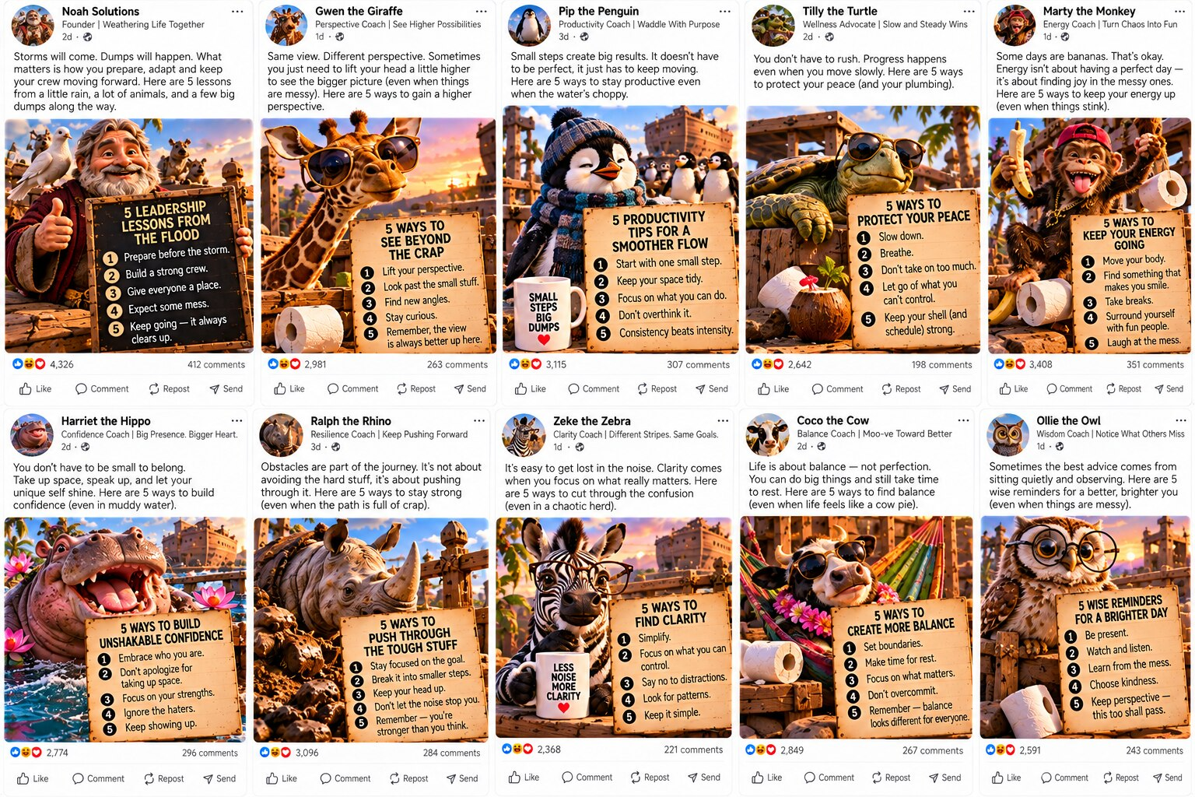
Ten accounts share one Ark backdrop and no species. Noah Solutions opens with 4,326 reactions on a post whose main claim is “dumps will happen.” A roll of toilet paper appears as a prop in four of the ten photos, and none of the 1,724 commenters mention it.
UNCORROBORATED: Whether 4,326 people agree that dumps will happen is not confirmed by any post in this collection.
Mugs as Evidence
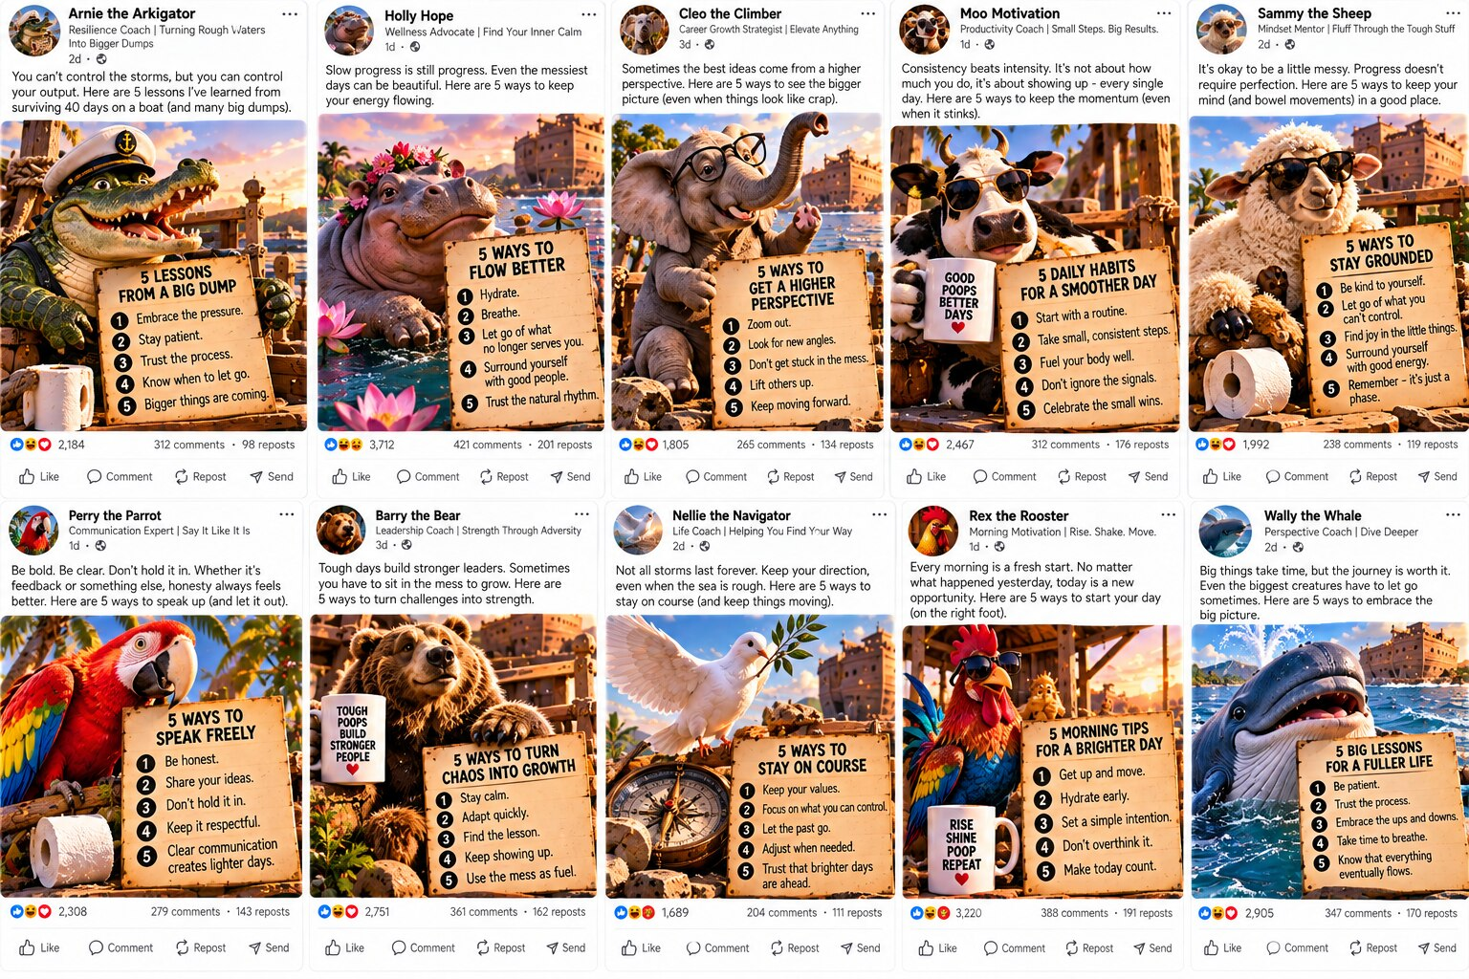
Arnie the Arkigator reports forty days adrift and “many big dumps” and turns them into a leadership framework. Moo Motivation and Rex the Rooster each cite their own coffee mug as support (“Good Poops Better Days,” “Rise Shine Poop Repeat”). A mug is not a source.
STATED: Reported by the mug, not independently tested.
The Euphemism Is Dropped
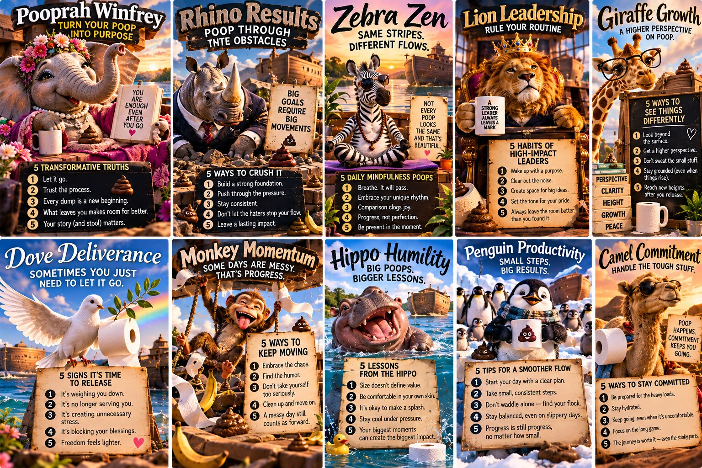
Starting around “Pooprah Winfrey,” the posts stop using the metaphor. The word itself appears in large branded type on a poster beside a lion in a crown and a camel in sunglasses, with poop emoji used as decoration.
VERIFIED: The word appears in this collection exactly as screenshotted. The text is directly observable.
The Ones Built to Pass
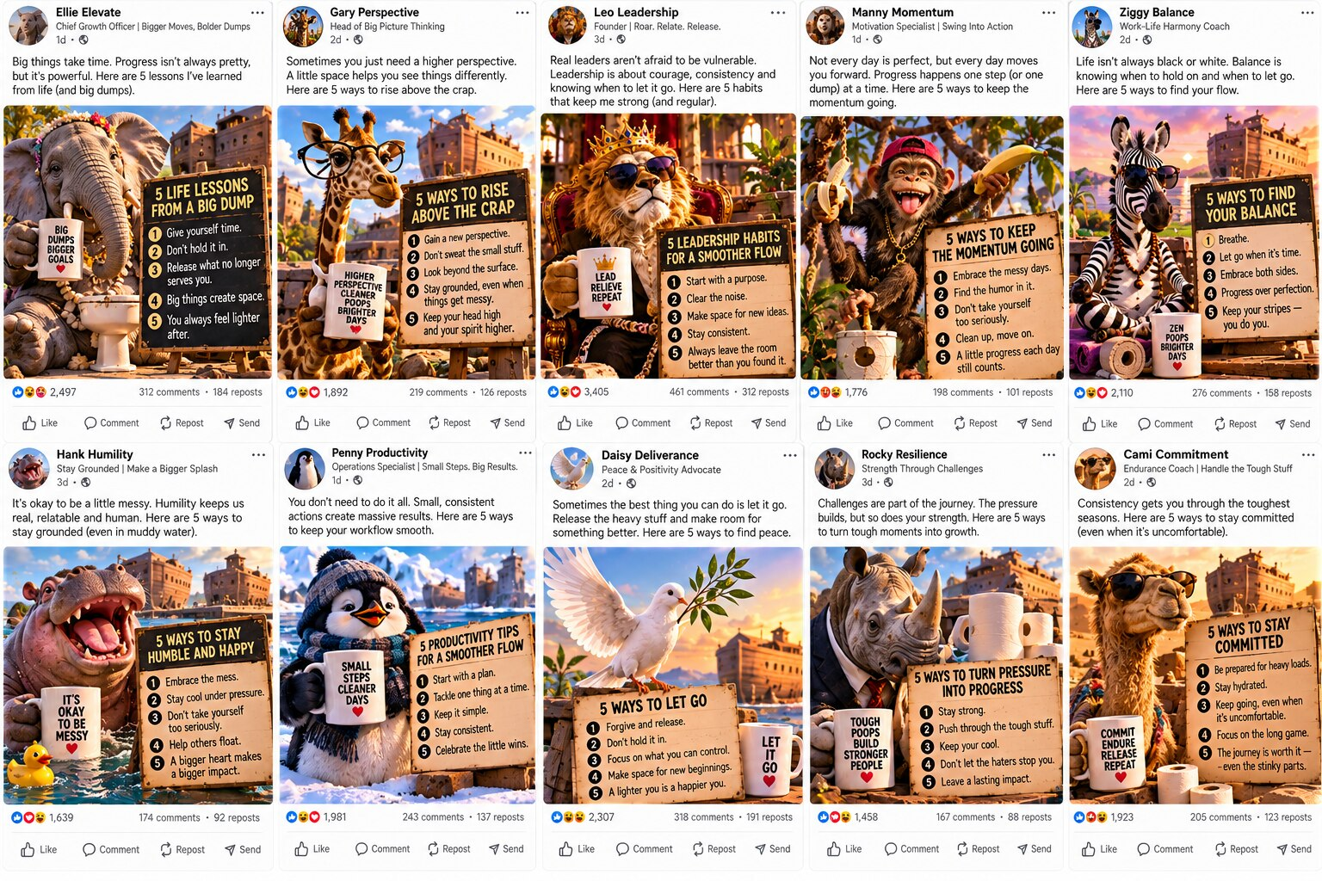
These accounts drop the cartoon handles and use the First-Name-Plus-Buzzword format (Ellie Elevate, Gary Perspective, Rocky Resilience), which is common on real LinkedIn profiles. Without the animal photo, nothing marks them as parody.
INFERENCE: A reasoned judgment, not a measured fact.
More Species

The set also includes Rex the T-Rex, who advises turning your biggest dumps into your biggest strengths, and a chicken whose message is “Early Bird Dumps First.” Both follow the same template as the other accounts.
CORROBORATED: More than one account in this set uses a “poop builds character” framing, with no evidence that one copied the other.
None of these posts is conclusive evidence. The posts in the book's main evidence record were identified because they were conspicuous: inflated round numbers, reciprocal comment groups, and templates repeated a thousand times with the find-and-replace text still visible. These fifty accounts are not conspicuous. A pod does not need a human face or a real name. It needs a template, a sign and a willing subject, and the reactions can be produced as cheaply for a cartoon walrus as for a venture capitalist.
Engagement that looks ordinary is harder to detect than engagement that looks inflated.
The Mafia Connection
The most effective operators in a crime family are the ones nobody notices. A quiet hit does not make the news, and a member who looks like an ordinary citizen can work for years without attracting attention. These fifty accounts fit that pattern. Their numbers are small, their posts look ordinary and nothing about them draws attention, so they are the harder ones to catch. The cartoon animal names also work like mob nicknames. Arnie the Arkigator is a handle that identifies a member to the group and is not meant to be a real name. As this chapter says, none of this is conclusive. It describes how quiet engagement could work, graded by the evidence tiers in Appendix B.
Mental Health Check
When it is hard to tell which accounts are real, trust wears down. Quiet fake accounts that look ordinary can make people wonder whether anyone online is genuine, and that doubt can add to loneliness and social anxiety. Connection with people you know in person, or can verify, is a good counterweight. If you or a friend feel hopeless, overwhelmed or unsafe, talk to a trusted adult. In the United States, you can call or text 988, the Suicide and Crisis Lifeline, at any time.
Doubting every account is tiring, and you do not have to do it all day. A few quick checks help, though they will not catch every fake account. Look at whether the profile has a history older than a few weeks, whether its posts mention specific people and places, and whether anyone you know in person follows it. If you cannot tell, treat what it says as unconfirmed and move on. Being careful does not require assuming the worst of everyone you meet online.

Conclusion
Without the fart jokes, every chapter uses the same few moves: claim a title nobody checks, borrow the shape of a list to fake rigor, name a pattern instead of proving one, force a binary reaction, and close on a feeling instead of a fact. If you can spot these moves here, where the stakes are zero, you can spot them on the feed, where the stakes are real.

Appendix A: Methodology
How This Was Researched
Sample size: eleven posts, one screenshot, zero independent corroboration, and no attempt to contact the authors for comment. This project does not meet its own evidentiary bar, on purpose. It shows what research looks like with no discipline applied, which is also what most of the internet looks like.

Appendix B: Evidence Tiers, Applied
- VERIFIED: “Agree?”-style phrasing appears in this collection exactly as screenshotted. The text is directly observable.
- CORROBORATED: More than one account in this set independently arrived at a “two kinds of people” framing, without evidence either copied the other.
- STATED: Sir Dumps-a-Lot describes the perfect poop as “the holy grail.” Reported by him, not independently tested.
- INFERENCE: Fartin Van Buren's claim that loud farts are “announcements” is a reasoned read of vibe, not a measured fact.
- UNCORROBORATED: Whether crop dusting actually builds team trust remains unconfirmed by any post in this collection.

Endnotes
1. The Stealth Fart → Who's Actually a Thought Leader, SPOTAPOD research
2. Crop Dusting 101 → Algorithm Strategy Advice, SPOTAPOD research
3. Know Your Poop: A Field Taxonomy → Toplist Content, SPOTAPOD research
4. Loud Farts Save Lives → The Social Proof Playbook, SPOTAPOD research
5. The Diarrhea Survival Guide → The Template That Fooled Everyone, SPOTAPOD research
6. The Perfect Poop Is an Experience → The Confidence-Industrial-Complex, SPOTAPOD research
7. A Flavor Profile, Ranked → The Smallest Category We Found, SPOTAPOD research
8. Morning Poops Hit Different → LinkedIn vs. Being Human, SPOTAPOD research
9. Two Kinds of People: A Wiping Manifesto → Agree, the Most Successful Word, SPOTAPOD research
10. Good Food, Good Farts, Good Vibes → LinkedIn's Empathy Economy, SPOTAPOD research
11. Ninety Days of Silence, Then Thunder → Bought Leadership: Your Teen's Fake Career Hero, SPOTAPOD research
12. Capo Di Tutti Toots → The CEO Who Only Admitted Half the Problem, SPOTAPOD research
13. A Follow-Up to Top 100 List of Lies on Social Media → Hall, Daniel, Mic Adam and Shari Berg. Top 100 List of Lies on Social Media. SPOTAPOD: The Truth, book 1. 2025. Amazon: a.co/d/0aQGgvsf.
14. Foreword by Lonnee Rey → Rey, Lonnee. Books by Lonnee Rey, cited in full after the foreword. Amazon author page: amazon.com/Lonnee-Rey/e/B088DJ826T.

Acknowledgments
To Stanky, Tooty, the Professor, Fartin, the Queen, Sir Dumps-a-Lot, Gaslynn, Turd, Steve, Fartsy, and Toots: thank you for your service. Nobody else was consulted.

About the Author
Daniel Hall has spent 50 years in technology and is the CEO of Dream IT Software. He is the coauthor of the bestselling Top 100 List of Lies on Social Media and the creator of the SPOTAPOD research project, a forensic analysis of manufactured engagement on LinkedIn.

The SPOTAPOD Repository
Everything underneath the jokes in this book, the datasets, the methodology, the vulnerability disclosures, and the regulatory analysis, is public. Nothing here asks you to take Daniel Hall's word for it. The full SPOTAPOD research project, built and maintained by Dream IT Software, is open at github.com/DreamITSoftware/SPOTAPOD. Go check the data yourself.

