* Install JDK 1.8.*
* Install Maven 3.5.*
* Environmental Variables.
* Set Variable JAVA_HOME to C:\Program Files\Java\jdk1.8.0_171
* Path %JAVA_HOME%\bin
* Add this to path C:\Softwares\apache-maven-3.5.4\bin

Clone your repository:

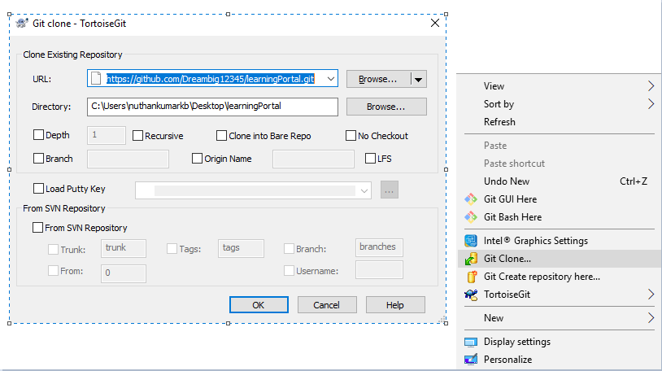

Download MySQL 5.7 server.

<https://dev.mysql.com/downloads/installer/>

Download MySQL workbench

<https://dev.mysql.com/downloads/workbench/?utm_source=tuicool>

Run mysqld

If you get an error create a folder ‘data’ inside bin

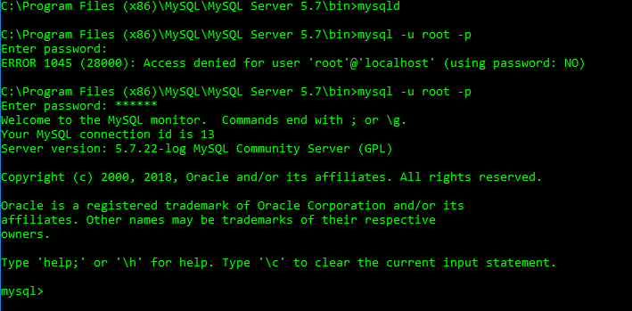

Open workbench and connect to localhost 3306 and open query browser and run the queries inside here.

C:\Users\nuthankumarkb\Desktop\learningPortal\src\main\resources\static\db

Goto project directory and give mvn clean



Mvn clean package



Mvn sprin-boot:run



Import in eclipse when needed for development or to see code

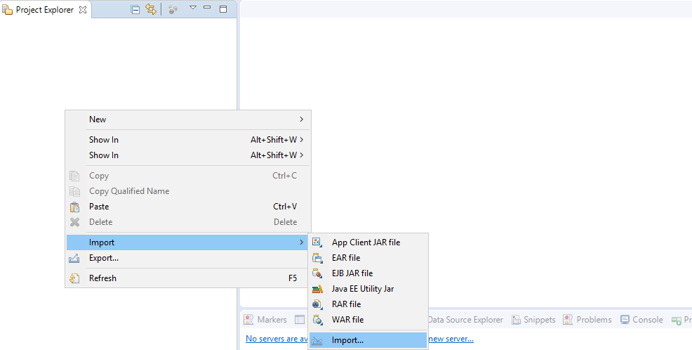

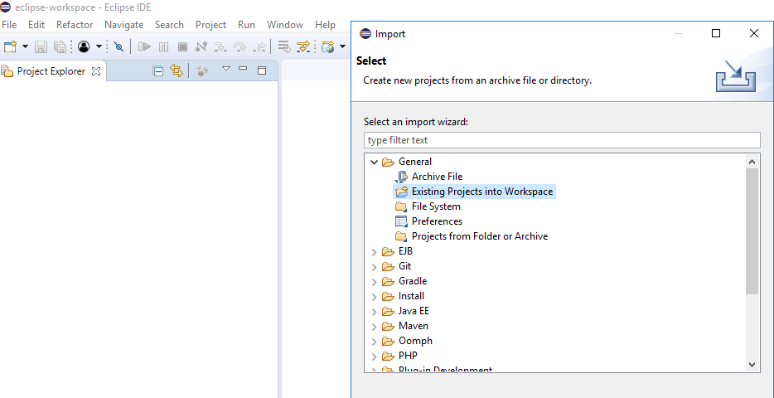

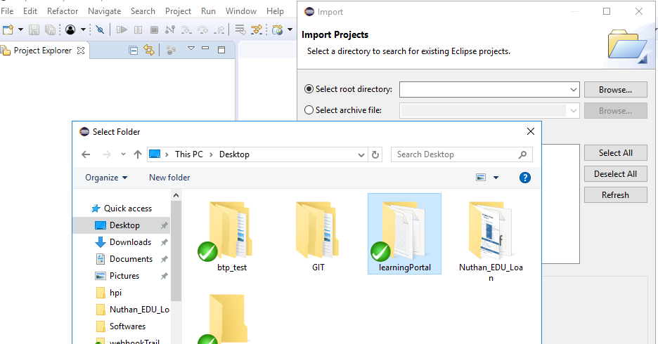

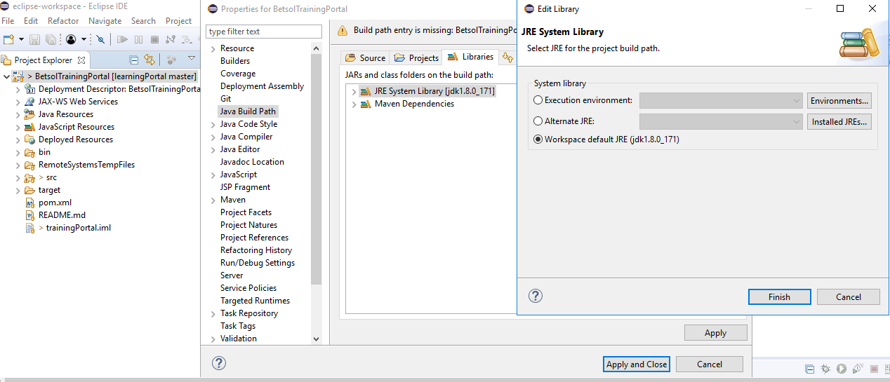

How to verify GIT commit or sync

Open git bash in the project folder

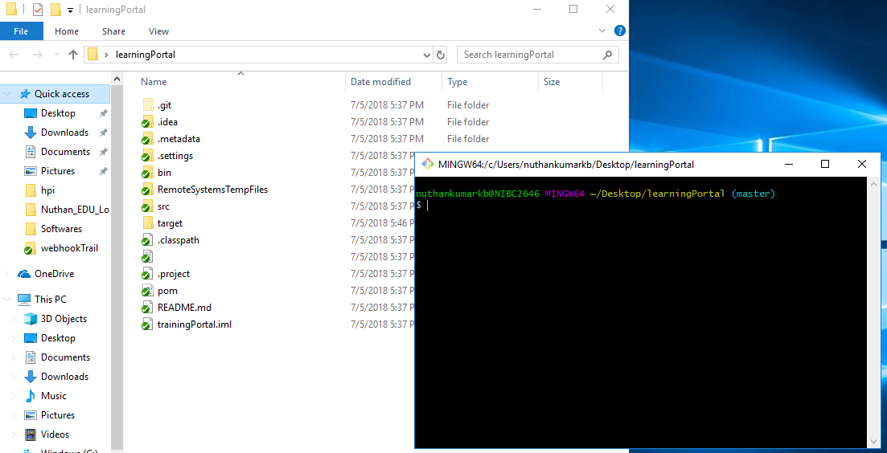

Add a file called testing

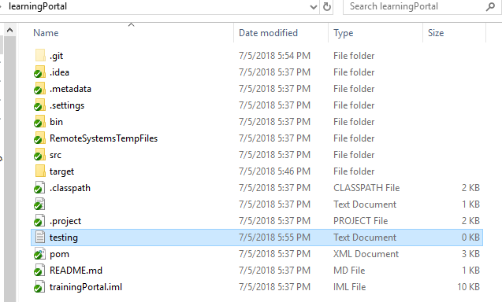

Run these commands to verfiy

nuthankumarkb@NIBC2646 MINGW64 ~/Desktop/learningPortal (master)

$ git config --global user.name "nuthankumarkb"

nuthankumarkb@NIBC2646 MINGW64 ~/Desktop/learningPortal (master)

$ git config --global user.email nuthankumarkb@gmail.com

nuthankumarkb@NIBC2646 MINGW64 ~/Desktop/learningPortal (master)

$ git status

On branch master

Your branch is up to date with 'origin/master'.

nothing to commit, working tree clean

nuthankumarkb@NIBC2646 MINGW64 ~/Desktop/learningPortal (master)

$ git status

On branch master

Your branch is up to date with 'origin/master'.

Untracked files:

(use "git add <file>..." to include in what will be committed)

testing.txt

nothing added to commit but untracked files present (use "git add" to track)

nuthankumarkb@NIBC2646 MINGW64 ~/Desktop/learningPortal (master)

$ git add .

nuthankumarkb@NIBC2646 MINGW64 ~/Desktop/learningPortal (master)

$ git status

On branch master

Your branch is up to date with 'origin/master'.

Changes to be committed:

(use "git reset HEAD <file>..." to unstage)

new file: testing.txt

nuthankumarkb@NIBC2646 MINGW64 ~/Desktop/learningPortal (master)

$ git commit -m "testing commit"

[master ad042d2] testing commit

1 file changed, 0 insertions(+), 0 deletions(-)

create mode 100644 testing.txt

nuthankumarkb@NIBC2646 MINGW64 ~/Desktop/learningPortal (master)

$ git push origin

Counting objects: 2, done.

Delta compression using up to 8 threads.

Compressing objects: 100% (2/2), done.

Writing objects: 100% (2/2), 257 bytes | 257.00 KiB/s, done.

Total 2 (delta 1), reused 0 (delta 0)

remote: Resolving deltas: 100% (1/1), completed with 1 local object.

To https://github.com/Dreambig12345/learningPortal.git

1481eb4..ad042d2 master -> master

nuthankumarkb@NIBC2646 MINGW64 ~/Desktop/learningPortal (master)

$ git status

On branch master

Your branch is up to date with 'origin/master'.

nothing to commit, working tree clean

nuthankumarkb@NIBC2646 MINGW64 ~/Desktop/learningPortal (master)

$

<http://localhost:8888/>

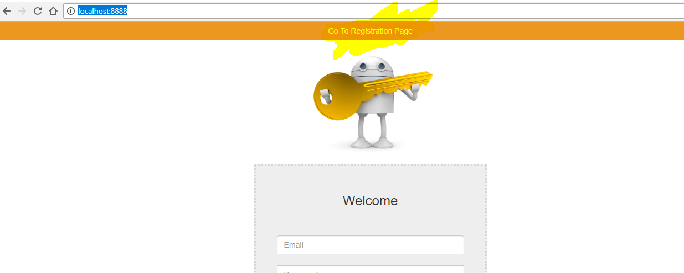

Register

