**CART REQUIRMENTS**

**Definitions**

**Product is** an item that is available for consumer’s observation and purchase on site and has its own page.

**Cart is** a storage thatkeeps track of products which are selected by customer for next visit and purchase.

**Same product** is a product that is present in cart.

**New product** is a product that is not present in cart.

**Valid quantity** is positive integer number.

**Converted number** is decimal number ignoring decimal separator.

Cart comes in two forms: modal window and cart page.

**1.1 Adding product to cart**

Cart can contain more than 4 products simultaneously.

1.1.1 Adding new product

Product is added via “Add to cart” button pushed.

1.1.1 Adding same product

After same product is added, quantity of it is increased in cart.

1.1.2 Adding product of quantity zero

Product of quantity zero is added to:

1. Empty cart – leads to: empty message window and “Continue browsing here” link are displayed.

2. Cart, where another product is present – leads to: cart content is not changed.

**1.2 Removing product from cart**

1.2.1 Removing one product  
Product is removed via any of the following actions:   
1.”Remove” button pushed  
2.Spinbox “-“ pushed  
3."Quantity" field = 0 and Tab key pressed  
 1.2.2 Removing all products  
After last product in cart is removed window "Cart is empty" is displayed.  
Link “Continue browsing here” leads to product gallery page.

**1.3 Changing quantity of product**

Quantity of product in cart is changed via any of the following actions:

1. Valid quantity in “Quantity” input typed and Tab pressed

2. Spinbox “+” or “-“ pushed

1.3.1 Changing quantity by spinbox “+”

After spinbox “+” is pushed, quantity of the product is increased on one unit in cart.

* + 1. Changing quantity by spinbox “-”

After spinbox “-” is pushed, quantity of the product is decreased on one unit in cart.

1.3.3 Invalid quantity processing

System processes invalid quantity of the following types:

1. Decimal number - changes quantity to converted number

2. Quantity that exceeds available in stock - leads to: 1) number is not accepted; 2) tooltip that says “All available stock in the cart” is displayed.

3. Other - leads to: 1) input is not accepted; 2) “Select needed format” tooltip is displayed.

**1.4 Full-page version of cart**

<Enter> pressed in “Quantity” input, opens cart page.

Cart page meets requirements in paragraph 1.3.

Quantity change on cart page is confirmed via any of the following actions:

1. <Enter> pressed

2. “Update cart” button pushed

**1.5 Browsing cart products**

Cart product is browsed via any of the following actions:

1. Product name clicked

2. Product picture clicked

**1.6 Cart icon**

After cart icon is clicked

empty cart opens window that says “Cart is empty” and contains “Continue browsing here” button.

**1.7 Closing mini cart window**

Clicking the close window icon or outside the cart closes cart.

**1.8 Cart persistence**

User cart has to be isolated from other users. User cart has to be shared between tabs of same browser. User cart has to be shared between sessions of same browser. Cart modifications have to be synchronized between tabs of same browser.

**1.9 Transferring cart content to contact form**

After “Checkout” button is pushed, contact form is opened.

Products in contact form are the same as cart content. Input in Gift note textarea

**1.10 Updating product page**

1.10.1.

1.10.2.

Adding all product stock to carts leads to: 1) the button that says “Add to cart” changes to the button that says “Sold out” on product page; 2) button that says “Email when available” is displayed on product page.

Adding product that was absent to stock leads to: 1) 1) the button that says “Sold out” changes to the button that says “Add to cart” on product page; 2) button that says “Email when available” is displayed on product page.

**1.12 Cart appearance**

The cart looks like this:

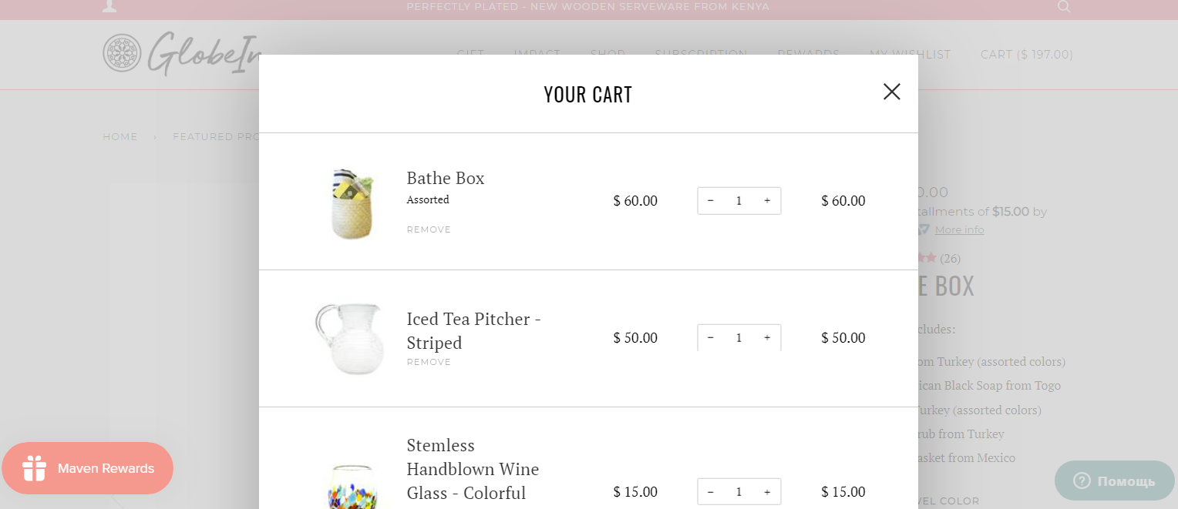

After 2 scrolling down cart looks like this:

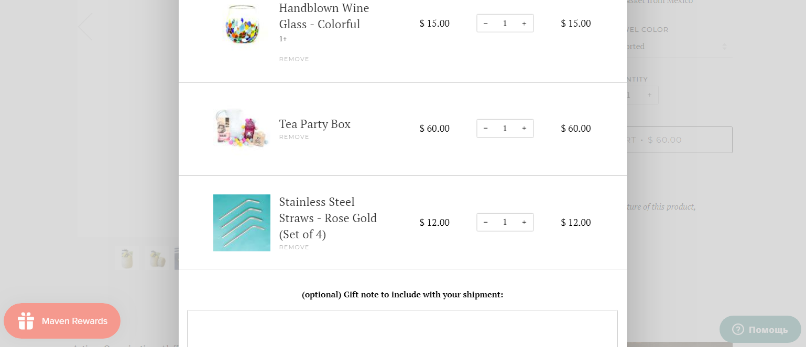

After 1 more scrolling down cart looks like this:

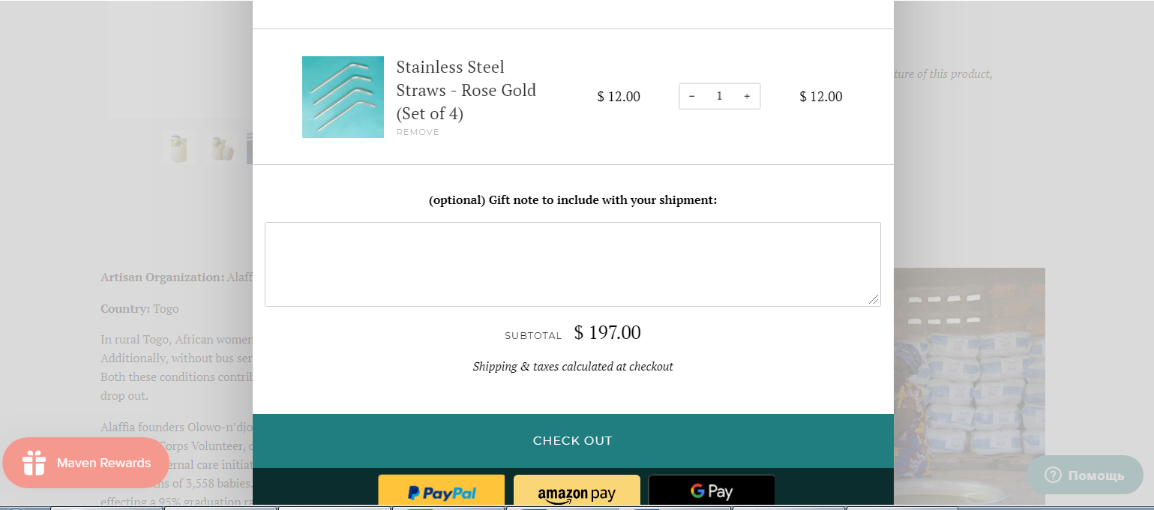

Cart header has to contain title "Your cart" (centered) and close window icon (right-aligned). Products have to be below header. Separators have to be before and after each product. Sequence of information about product has to be (from left to right): picture, name, price, spinbox button, total (table without borders). Button that says “Remove” has to be below name.

Dollar sign has to be before price and total sum. Gift note textarea has to be below products. Gift note textarea has to have title "(optional) Gift note to include with your shipment:". Textarea has to be 4 symbols height. Hovering to all buttons and Gift note textarea title, cursor has to be transformed to handtool.

Title that says "subtotal", dollar sign and subtotal sum has to be below Gift note textarea. Text that says "Shipping & taxes calculated at checkout" has to be below subtotal.

Button that says “Checkout” has to be in cart footer (background has to become darker when user hover). Payment services buttons has to be in the bottom of cart. Background of button that says “Gpay” has to become lighter when user hover.

Background of cart window has to be white (except footer). Font has to be bold (except "subtotal" text). Font of "Shipping & taxes calculated at checkout" text has to be italic.