Test Plan Document

For

<Oleksii Voronin>

1 Introduction 3
2 Test Objectives 3
3 Scope 4
4 Test APPROACH 4
5 ROLES AND RESPONSIBILITIES 5
6 ENTRY AND EXIT DATA 5
7 SUSPENSION CRITERIA AND RESUMPTION 6
8 TEST STRATEGY 7
10 RESOURCE AND ENVIRONMENT NEEDS 12
11 Test Schedule 13
12 APPROVALS 14
13 TERMS/ACRONIMS 14

Test Plan

Project “Globein User Management”

Date | Version | Description | Author | Reviewer | Approver
02.07 | 0.1 | Test plan was created | A.Sviderska

INTRODUCTION

Customer wants a perfect user profile for ecommerce website, which passed the full cycle of manual testing. Given the specificity of the site it is very important to have the same quality and the site. The Test Plan has been created to facilitate communication within the team members. This document describes approaches and methodologies that will apply to the unit, integration and system testing of the user profile of "https://globein.com/". It includes the objectives, test responsibilities, entry and exit criteria, scope, entry and exit criteria, environment needs, schedule major milestones and approach. This document has clearly identified what the test deliverables will be, and what is deemed in and out of scope.

TEST OBJECTIVES

A primary objective of testing is to: assure that the system meets the full requirements, including quality requirements (functional and non-functional requirements) and fit metrics for each quality requirement and satisfies the use case scenarios and maintain the quality of the product. At the end of the project development cycle, the user should find that the project has met or exceeded all of their expectations as detailed in the requirements. Any changes, additions, or deletions to the requirements document, Functional Specification, or Design Specification will be documented and tested at the highest level of quality allowed within the remaining time of the project and within the ability of the test team.
The secondary objectives of testing will be to: identify and expose all issues and associated risks, communicate all known issues to the project team, and ensure that all issues are addressed in an appropriate matter before release. As an objective, this requires careful and methodical testing of the application to first ensure all areas of the system are scrutinized and, consequently, all issues (bugs) found are dealt with appropriately.

SCOPE

The document mainly targets the Functional and Security testing as per Requirements Specifications provided by Client.

3.1 Inclusions

- Functional
- Security
- Integration
- GUI
- Performance

3.2 Exclusions

- Other that is not mentioned above in section 3.1.

4 TEST APPROACH

The approach, that used, is analytical. Therefore, in accordance to requirements-based strategy, where an analysis of the requirements specification forms the basis for planning, estimating and designing tests. Test cases will be created during exploratory testing. All test types are determined in Test Strategy. Team also must use experience-based testing and error guessing utilizes testers' skills and intuition, along with their experience with similar applications or technologies. The project is using an agile approach, with weekly iterations. At the end of each week the requirements identified for that iteration will be delivered to the team and will be tested.

ROLES AND RESPONSIBILITIES

Role | Staff Member | Responsibilities
Project Manager |  | 1. Acts as a primary contact for development and QA team.  2. Responsible for Project schedule and the overall success of the project.
QA | A. Sviderska | 1. Participation in the project plan creation/update process.  2. Planning and organization of test process for the release.  3. Understand requirements 4. Writing and executing Test cases  5. Preparing RTM  6. Defect reporting and tracking  7. Retesting and regression testing  8. Preparation of Test Data  9.Report progress on work assignments to the PM

ENTRY AND EXIT CRITERIA

6.1 Entry Criteria

- All test hardware platforms must have been successfully installed, configured, and functioning properly.
- All the necessary documentation, design, and requirements information should be available that will allow testers to operate the system and judge the correct behavior.
- All the standard software tools including the testing tools must have been successfully installed and functioning properly.
- Proper test data is available.
- The test environment such as, lab, hardware, software, and system administration support should be ready.
- QA resources have completely understood the requirements.
- QA resources have sound knowledge of functionality.
- Reviewed test scenarios, test cases and RTM

6.2 Exit Criteria

- A certain level of requirements coverage has been achieved.
- No high priority or severe bugs are left outstanding.
- All high-risk areas have been fully tested, with only minor residual risks left outstanding.
- Cost – when the budget has been spent.
- The schedule has been achieved

SUSPENSION CRITERIA AND RESUMPTION

7.1 Suspension criteria

- The build contains many serious defects which seriously or limit testing progress.
- Significant change in requirements suggested by client.
- Software/Hardware problems.
- Assigned resources are not available when needed by test team

7.2 Resumption criteria

Resumption will only occur when the problem(s) that caused the caused the suspension have been resolved.

TEST STRATEGY

8.1 QA role in test process

- Understanding Requirements:
• Requirement specifications will be sent by client.
• Understanding of requirements will be done by QA
- Preparing Test Cases:
QA will be preparing test cases based on the exploratory testing. This will cover all scenarios for requirements.
- Preparing Test Matrix:
QA will be preparing test matrix which maps test cases to respective requirement. This will ensure the coverage for requirements.
- Reviewing test cases and matrix:
• Peer review will be conducted for test cases and test matrix by Team Lead
• Any comments or suggestions on test cases and test coverage will be provided by reviewer respective Author of Test Case and Test Matrix
• Suggestions or improvements will be re-worked by author and will be send for approval
• Re-worked improvements will be reviewed and approved by reviewer
- Creating Test Data:
Test data will be created by QA on client's developments/test site based on scenarios and Test cases.
- Executing Test Cases:
• Test cases will be executed by QA on client's development/test site based on designed scenarios, test cases and Test data.
• Test result (Actual Result, Pass/Fail) will updated in test case document
Defect Logging and Reporting:
QA will be logging the defect/bugs in Excel document, found during execution of test cases. After this, QA will inform respective developer about the defect/bugs.
- Retesting and Regression Testing:
Retesting for fixed bugs will be done by QA once it is resolved by respective developer and bug/defect status will be updated accordingly. In certain cases, regression testing will be done if required.
- Deployment/Delivery:
Once all bugs/defect reported after complete testing is fixed and no other bugs are found, report will be deployed to client’s test site by PM.
Once round of testing will be done by QA on client’s test site if required, Report will be delivered by email to Team lead and Report group.
QA will be submitting the filled hard copy of delivery slip to respective developer.
Once Team lead gets the hard copy of delivery slip filled by QA and developer, he will send the report delivery email to client.

8.2 Bug life cycle:

All the issues found while testing will be logged into Excel document. Bug life cycle for this project is as follows:

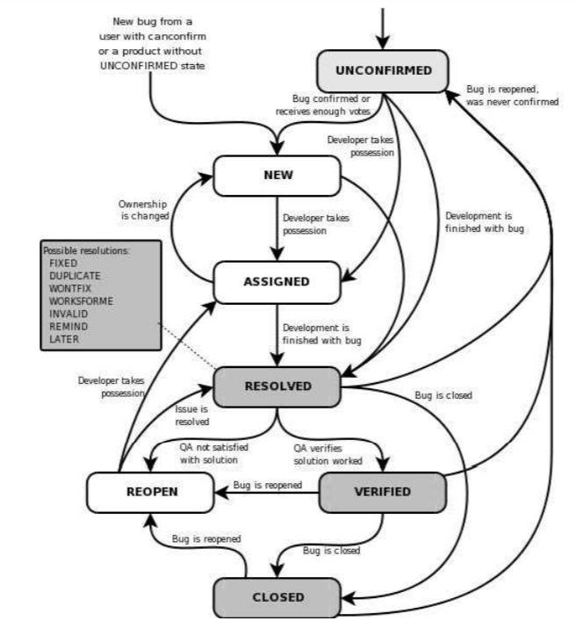
8.3 Testing types

Black box testing:
It is some time called behavioral testing or Partition testing. This kind of testing focuses on the functional requirements of the user management feature. It enables one to derive sets of input conditions that will fully exercise all functional requirements for a user management.
Integration Testing:
Test Plan Integration testing is systematic technique for constructing the program structure while conducting test to uncover errors associated with interacting. In user management, integration testing includes the testing user management from respective location(s) and transferring user data from user profile to contact order form.
System Testing:
System testing of software is testing conducted on a complete, integrated system to evaluate the system's compliance with its specified requirements.
Functional Testing:
Functional testing is carried out in order to find out unexpected behavior of the user management. The characteristics of functional testing are to provide correctness, reliability, testability and accuracy of the user management.
Performance Testing:
- Check the optimal time the page is loaded
- Check the operation of the system under load
Security testing:
Security testing is intended to reveal flaws in the security mechanisms of user management that protect user data and maintain site functionality as intended.
The characteristics of security testing security requirements are to provide confidentiality, integrity, authentication, availability, authorization and non-repudiation of the user management.
GUI Testing:
GUI testing will includes testing the UI part of user management. It covers users Report format, look and feel, error messages, spelling mistakes, GUI guideline violations.
User acceptance testing:
The purpose behind user acceptance testing is to conform that user management is developed according to the specified user requirements and is ready for operational use. Acceptance testing is carried out at one level - Alpha Testing. User acceptance testing (UAT) will be done at the Client.
Alpha testing:
The alpha test is conducted at the developer's site by client.

8.4 Bug Severity and Priority Definition

Bug Severity and Priority fields are both very important for categorizing bugs and prioritizing if and when the bugs will be fixed. The bug Severity and Priority levels will be defined as outlined in the following tables below. Testing will assign a severity level to all bugs. The Team Lead will be responsible to see that a correct severity level is assigned to each bug. The Team Lead and Project Manager will participate in bug review meetings to assign the priority of all currently active bugs. This meeting will be known as “Bug Triage Meetings”. The Team Lead is responsible for setting up these meetings on a routine basis to address the current set of new and existing but unresolved bugs.

Severity List

The tester entering a bug is also responsible for entering the bug Severity.

Severity ID | Severity | Severity Description
1 | Blocker | Problem will block progress of the project.
2 | Critical | Indicates that this issue is causing a problem and requires urgent attention.
3 | Mayor | Indicates that this issue has a significant impact.
4 | Minor | Indicates that this issue has a relatively minor impact.
5 | Trivial | Lowest priority, punctuation or any very small issues

Priority List

Priority | Priority Level | Priority Description
1 | Must Fix | This bug must be fixed immediately; the product cannot ship with this bug.
2 | Should Fix | These are important problems that should be fixed as soon as possible. It would be an embarrassment to the company if this bug shipped.
3 | Fix When Have Time | The problem should be fixed within the time available. If the bug does not delay shipping date, then fix it.
4 | Low Priority | It is not important (at this time) that these bugs be addressed. Fix these bugs after all other bugs have been fixed. Enhancements/ Good to have features incorporated just are out of the current scope.

RESOURCE AND ENVIRONMENT NEEDS

9.1 Testing Tools

Process | Tool
Test case creation | Microsoft Excel
Test case tracking | Microsoft Excel
Test case execution | Manual
Test case management | Microsoft Excel
Defect management | Microsoft Excel
Test reporting | Microsoft Word
Check list creating | Microsoft Excel
Project structure | Mind Map (.xmind)

9.2 Configuration Management

Code CM: Git

9.3 Test Environment

Support level 1 (browsers):

Windows 8: Edge, Chrome (latest), Firefox (latest), Safari (latest)

Mac OS X: Chrome (latest), Firefox (latest), Safari (latest) Test Plan 12

Linux Ubuntu: Chrome (latest), Firefox (latest)

Support level 1 (devices): x iPhone 5 / 6, iPad 3, Nokia Lumia 910, Google Nexus 7, LG
G3.

Support level 2:

Windows 7: IE 9+, Chrome (latest), Firefox (latest), Safari (latest)

Windows XP: IE 8, Chrome (latest), Firefox (latest), Safari (latest)

Support level 3:

anything else

11 TEST SCHEDULE

Task Name | Start | Finish | Effort | Comments
Test Planning | 01.07 | 03.07
Review Requirements documents | 01.07 | 02.07
Create test basis | 03.07 | 12.07
Staff and train new test resources | - | -
First deploy to QA test environment | 05.07
Functional testing – Iteration 1 | 05.07 | 09.07
Iteration 2 deploy to QA test environment | 09.07 | 10.07
Functional testing – Iteration 2 | 10.07 | 12.07
System testing
Regression testing
UAT
Resolution of final defects and final build testing
Deploy to Staging environment
Performance testing
Release to Production

12 APPROVALS

Project Manager

Name
Signature

13 TERMS/ACRONYMS

The below terms are used as examples, please add/remove any terms relevant to the document.

TERM/ACRONYM | DEFINITION
PM | Project manager
GUI | Graphical user interface
RTM | Requirements Traceability Matrix
QA | Quality Assurance
UAT | User acceptance testing
CM | Configuration Management

