# Interview

## What Skills Can You Bring to the Job

My strongest attribute is my determination. I take on every challenge head-on and do what I need to accomplish my goals, even when the challenge is difficult

My unique attribute is passion. Without a passion for what you are doing, it is not possible to ideally perform your job.

## Why Do You Want to Work Here

I believe I have the type of knowledge to succeed in this role and at the company because

## What Type of Work Environment Do You Prefer?

I have worked in many types of environments and enjoyed learning new things from each. I would say that while I don’t prefer a particular environment, I really like working with people who are committed to getting things done and who are passionate about their work.

# Company

Hi Clients

I’m full stack web developer and senior blockchain developer. I have learned and used MERN, MEVN, MEAN but now, I fall love in Vue.js

Simple structure, Easy understanding, No problem integration!!!

Passionate, driven and goal oriented are the best adjectives to describe me.

I like to be in the back and front of tech hence my passion for web and blockchain development.

I put my heart and soul into every project I work on, going non-stop till it is brought to perfection.

I also have rich experience with Mozilia Hubs and AWS.

I guarantee that you will get more than you've expected.

If you want to test my skill, I am ready for this anytime.

If you hire me, I will do my best for you

Contact me for any type of work to be done right and perfectly.

Thank you for your reading.

Best regards

If given a choice, my desired job title would be that of lead senior full stack engineer.

My seven years of experience in web, app development plus my education in professional and technical writing make me an ideal candidate for this position and have additionally prepared me to take on more leadership-oriented roles such as full stack engineer.

I like to be in the back and front of tech hence my passion for web with Laravel and Linux

I put my heart and soul into every project I work on, going non-stop till it is brought to perfection.

My strongest attribute is my determination. I take on every challenge head-on and do what I need to accomplish my goals, even when the challenge is difficult.

My unique attribute is passion. I think without a passion for what you are doing, it is not possible to ideally perform your job.

Just thinking of programming as my hobby, I started my career for software development in the companies when I was studying at the University.

This was an amazing experience for me to grow as an IT technician. I will never give up on my way. Thanks for reading!

Electronic

If given a choice, my desired job title would be that of lead senior Electronic Engineer.

My seven years of experience in Electronic development plus my education in professional and technical writing make me an ideal candidate for this position and have additionally prepared me to take on more leadership-oriented roles such as senior engineer.

I like to be in the back and front of tech hence my passion for Electrical technology with Arm and Raspberry PI

I put my heart and soul into every project I work on, going non-stop till it is brought to perfection.

My strongest attribute is my determination. I take on every challenge head-on and do what I need to accomplish my goals, even when the challenge is difficult.

My unique attribute is passion. I think without a passion for what you are doing, it is not possible to ideally perform your job.

Just thinking of programming as my hobby, I started my career for electronic development in the companies when I was studying at the University.

This was an amazing experience for me to grow as an electronic technician. I will never give up on my way. Thanks for reading!

# Discord

## Normal

[ FOR HIRE ][ FULL STACK WEB DEVELOPER ] [ APP DEVELOPER ] [ BLOCKCHAIN ][ REMOTE ]

Greeting, Everybody!

Who need some help?

Customer satisfaction is my greatest pleasure!

I am a senior developer have 7+ years of experience in Blockchain, Ethereum(Solidity), Solana(Rust), NFT, and Trading View Chart with modern, trend technology such as React, Vue, and App(Android and iOS).

I also have rich experience about AWS.

====Blockchain====

✨Chain : Bitcoin, Ethereum, Solana, BSC, Polygon, Avalanche, Tron

✨Cryptocurrency : ERC-20, ERC-721, ERC-1155, ERC-777, ERC-223, BEP-2, BEP-20, BEP-721, TRC-20

✨Wallet Connect : Meta Mask, Trust Wallet, Coinbase and more using Web3.js

✨NFT : NFT minting, Staking, marketplace, landing page, Gamesite

✨Token : Swap, bridge, staking.

✨Trading View

====Web Dev & Design====

✨PHP framework : CI, Laravel, Word press

✨Java script : jQuery, React.js(Next.JS, Gatsby), Vue.js(Nuxt.JS), AngularJS, Svelte

✨Database : MySQL, MongoDB, RDS, AWS DynamoDB, Firebase

✨Frontend Library : Bootstrap, Tailwind CSS, MUI, React Kit, Ant D

✨Other : HTML5, Figma , Shopify , Three.js

====Amazon Web Service====

✨AWS S3

✨AWS Dynamo DB

✨AWS Lambda

✨AWS IVS

✨AWS API Gateway

✨AWS RDS

✨AWS Web socket

✨AWS Amplify

✨AWS Route53

====Mobile Dev & Design====

✨React Native

✨Flutter

✨Swift

====Odoo + Vue storefront====

====Mozilla Hub====

I guarantee that you will get more than you've expected.

Please don't hesitate to contact me for further discussion.

If you want to test my skill, I am ready for this anytime.

Regular communication is really important to me, so let’s keep in touch!

If you hire me, I will do my best for you

Send DM to me pls

Best regards!

## Vue.js

[ FOR HIRE ] [ REMOTE ] [ FULL TIME ] [ PART TIME ]

Hi Clients

I’m full stack web developer and senior blockchain developer. I have learned and used MERN, MEVN, MEAN but now, I fall love in Vue.js❤️.

✨Simple structure, Easy understand, No problem intergration!!!

On this channel,I want to share my experience🌏 and looking for jobs in Vue.js💰.

Passionate, driven and goal oriented are the best adjectives to describe me.

I like to be in the back and front of tech hence my passion for web and blockchain development. ⏰

I put my heart and soul 🧠into every project I work on✍️, going non-stop till it is brought to perfection.📈

I also have rich experience with Blockchain and AWS.

====Blockchain====

✨Chain : Bitcoin, Ethereum, Solana, BSC, Polygon, Avalanche, Tron

✨Cryptocurrency : ERC-20, ERC-721, ERC-1155, ERC-777, ERC-223, BEP-2, BEP-20, BEP-721, TRC-20

✨Wallet Connect : Meta Mask, Trust Wallet, Coinbase and more using Web3.js

✨NFT : NFT minting, Staking, marketplace, landing page, Gamesite

✨Token : Swap, bridge, staking.

✨Trading View

====Web Dev & Design====

✨PHP framework : CI, Laravel, Word press

✨Java script : jQuery, React.js(Next.JS, Gatsby), Vue.js(Nuxt.JS), AngularJS, Svelte

✨Database : MySQL, MongoDB, RDS, AWS DynamoDB, Firebase

✨Frontend Library : Bootstrap, Tailwind CSS, MUI, React Kit, Ant D

✨Other : HTML5, Figma , Shopify , Three.js

====Amazon Web Service====

✨AWS S3

✨AWS Dynamo DB

✨AWS Lambda

✨AWS IVS

✨AWS API Gateway

✨AWS RDS

✨AWS Web socket

✨AWS Amplify

====Mobile Dev & Design====

✨React Native

✨Flutter

✨Swift

====Odoo + Vue storefront====

I guarantee that you will get more than you've expected.

Please don't hesitate to contact me for further discussion.

If you want to test my skill, I am ready for this anytime.

Regular communication💬 is really important to me, so let’s keep in touch!

If you hire me, I will do my best for you

Contact me for any type of work to be done right and perfectly.

Thank you for your reading.

Best regards

## React.JS

[ FOR HIRE ] [ REMOTE ] [ FULL TIME ] [ PART TIME ]

Hi Clients

I’m full stack web developer and senior blockchain developer.

I have 5years experience on MERN stack developement and 7years experience on WAMP, LAMP development.

Laravel+ React or Larave + Vue.js is my special field

I also have rich experience with Blockchain and AWS.

Timezone is no problem for me.

Passionate, driven and goal oriented are the best adjectives to describe me.

I like to be in the back and front of tech hence my passion for web and blockchain development. ⏰

I put my heart and soul 🧠into every project I work on✍️, going non-stop till it is brought to perfection.📈

====Blockchain====

✨Chain : Bitcoin, Ethereum, Solana, BSC, Polygon, Avalanche, Tron

✨Cryptocurrency : ERC-20, ERC-721, ERC-1155, ERC-777, ERC-223, BEP-2, BEP-20, BEP-721, TRC-20

✨Wallet Connect : Meta Mask, Trust Wallet, Coinbase and more using Web3.js

✨NFT : NFT minting, Staking, marketplace, landing page, Gamesite

✨Token : Swap, bridge, staking.

✨Trading View

====Web Dev & Design====

✨PHP framework : CI, Laravel, Word press

✨Java script : jQuery, React.js(Next.JS, Gatsby), Vue.js(Nuxt.JS), AngularJS, Svelte

✨Database : MySQL, MongoDB, RDS, AWS DynamoDB, Firebase

✨Frontend Library : Bootstrap, Tailwind CSS, MUI, React Kit, Ant D

✨Other : HTML5, Figma , Shopify , Three.js

====Amazon Web Service====

✨AWS S3

✨AWS Dynamo DB

✨AWS Lambda

✨AWS IVS

✨AWS API Gateway

✨AWS RDS

✨AWS Web socket

✨AWS Amplify

====Mobile Dev & Design====

✨React Native

✨Flutter

✨Swift

====Odoo + Vue storefront====

I guarantee that you will get more than you've expected.

If you hire me, I will do my best for you

I know I may not have all the accolades and experience you're looking for, but trust me, I have the creative mind, passion and commitment every recruiter or company is looking for.

Contact me for any type of work to be done right and perfectly.

Thank you for your reading.

Send DM to me please.

Best regards

## Next.js

## Business

I think it's very important let all people about your business and your clothing brand

It means advertisement

I think it'll need website and community channel

Of course you have to guarantee about your productions quality

And then if you want to build your own website, I can help you

I have rich experience about website development for startup business

let's talk about that

#### AWS

Hello @everyone

I just have developed Live video stream shopping website with AWS and React

As you know, advertisement is very important for business and product sellers

If you have AWS account or can create one, I can provide best shopping site on where seller advertise their productions via live video stream and can chat with buyers

Please don't hesitate to contact me for further discussion.

Thank you.

#### Real Estate

Hello @everyone

If you startup on Real estate or have interest in Real estate

I can provide you best Real Estate website

I have rich experience about that and already developed many real estate websites

# Profile

## Freelacner

Blockchain & MER,VN Stack & NFT & App Senior Developer

Greeting, Everybody! Customer satisfaction is my greatest pleasure!

If given a choice, my desired job title would be that of lead senior full stack engineer.

My seven years of experience in web, app development plus my education in professional and technical writing make me an ideal candidate for this position and have additionally prepared me to take on more leadership-oriented roles such as full stack engineer

I like to be in the back and front of tech hence my passion for web and blockchain development.

I put my heart and soul into every project I work on, going non-stop till it is brought to perfection.

My strongest attribute is my determination. I take on every challenge head-on and do what I need to accomplish my goals, even when the challenge is difficult.

My unique attribute is passion. I think without a passion for what you are doing, it is not possible to ideally perform your job.

I will never give up on my way.

=========Blockchain=========

✔️Chain : Bitcoin, Ethereum, Solana, BSC, Polygon, Avalanche, Tron

✔️Cryptocurrency : ERC-20, ERC-721, ERC-1155, ERC-777, ERC-223, BEP-2, BEP-20, BEP-721, TRC-20

✔️Wallet Connect : Meta Mask, Trust Wallet, Coinbase and more using Web3.js

✔️NFT : NFT minting, Staking, marketplace, landing page, Gamesite

✔️Token : Swap, bridge, staking.

✔️Trading View

=========Web Dev & Design==========

✔️PHP framework : CI, Laravel, Word press

✔️Java script : jQuery, React.js(Next.JS, Gatsby), Vue.js(Nuxt.JS), AngularJS, Svelte

✔️ Database : MySQL, MongoDB, RDS, AWS DynamoDB, Firebase

✔️Frontend Library : Bootstrap, Tailwind CSS, MUI, React Kit, Ant D

✔️Other : HTML5, Figma , Shopify , Three.js

=========Amazon Web Service============

✔️AWS S3

✔️AWS Dynamo DB

✔️AWS Lambda

✔️AWS IVS

✔️AWS API Gateway

✔️AWS RDS

✔️AWS Web socket

✔️AWS Amplify

✔️AWS Route53

====Mobile Dev & Design====

✔️React Native

✔️Flutter

✔️Swift

====Odoo + Vue storefront====

====Mozilla Hub====

I guarantee that you will get more than you've expected.

Please don't hesitate to contact me for further discussion.

If you want to test my skill, I am ready for this anytime.

Regular communication is really important to me, so let’s keep in touch!

If you hire me, I will do my best for you

Best regards!

## Upwork

Blockchain & MER,VN Stack & NFT & App Senior Developer

Greeting, Everybody! Customer satisfaction is my greatest pleasure!

I am a senior developer have 7+ years of experience in Blockchain, Ethereum(Solidity), Solana(Rust), NFT, and Trading View Chart with modern, trend technology such as React, Vue.js, and App(Android and iOS).

I also have rich experience about Unity3D and 3Dmax modeling

=========Blockchain=========

*Chain : Bitcoin, Ethereum, Solana, BSC, Polygon, Avalanche, Tron

*Cryptocurrency : ERC-20, ERC-721, ERC-1155, BEP-2, BEP-20, BEP-721, TRC-20

*Wallet Connect : Meta Mask, Trust Wallet, Coin base and more using Web3.js

*NFT : NFT minting, Staking, marketplace

*Token : Swap, bridge, staking.

*Trading View

=========Web Dev & Design==========

*PHP framework : CI, Laravel, Word press

*Java script : jQuery, React.js(Next.JS, Gatsby), Vue.js(Nuxt.JS), AngularJS, Svelte

* Database : MySQL, MongoDB, RDS, AWS DynamoDB, Firebase

*Frontend Library : Bootstrap, Tailwind CSS, MUI, React Kit, Ant D

*Other : HTML5, Shopify

I guarantee that you will get more than you've expected.

Please don't hesitate to contact me for further discussion.

If you want to test my skill, I am ready for this anytime.

Regular communication is really important to me, so let’s keep in touch! If you fire me, I will do my best for you

Best regards!

## Russia

Experience

CIO

DoubleGIS-Irkutsk, Ltd.

Mar 2006 - Feb 2012 (5 years, 11 months)

In DoubleGIS-Irkutsk we working on Google Maps desktop alternative (currently it's one of the best program in Russia) called 2GIS. My task was to control collection of data (organization and map). We have custom program (Map, Organizations and CRM all in one) running on Firebird and using VBA.

Full Stack Software Engineer

**Ooo Piktolabra**

Nov 2016 - May 2018 (1 year, 6 months)

BlockChain and JavaScript Full Stack experience

Education

bachelor of applied mathematics and informatics

Gosudarstvennyj Tehniceskij Universitet, Russian Federation

2001 - 2006(5 years)

Postgraduate in Applied Mechanics

Moskovskij Gosudarstvennyj Universitet im. M.V. Lomonosova, Russian Federation2007 - 2008

(2 years)

## Ukraine

Experience

**MERN stack developer**

**Growwwth IT Company**

Jun 2016 - Jul 2017 (1 year, 1 month)

Working with team on various projects in the following areas: Web Design, Interaction Design, IOS Applications, UI/UX Design, Branding, Identity.

Smart Contract Developer

**Chsr-Unisoft**

Apr 2020 - Feb 2022 (1 year, 10 months)

- Designed and Structured the NFT and DeFi protocols. - Rich experienced in ERC721A, ERC1155, and various EIPs - Deep experienced in Moralis and Thirdweb - Deep understanding of MakerDAO, Aave and more - Wallet integration using web3 and ethers - Designd and developed smart contracts for NFT and DeFi including upgradable ones.

Web&Mobile Design

**Shakuro**

Feb 2015 - Mar 2017 (2 years, 1 month)

- PST to HTML Design - UI/UX design and Landing page Design and the others. - Payment gateways Integration (Paypal, Square, Stripe, Crytpocurrency)

Front-end Development

**Binariks**

Jul 2017 - Apr 2019 (1 year, 9 months)

- Beautiful Web and Mobile Design - User Interactions Development - Accounting, Inventory and Product functions (some parts of LMS system)

Education

bachelor

Kyiv Engineering Technical Institute, Ukraine1997 - 2004

(7 years)

## Japan

Experience

Detection of Unstable Periodic Orbits and Chaos Control in a Passive Biped Model

Springer

In this investigation, two chaos control algorithms based on linearization of Poincare´ map (OGY method) and artificial neural networks (ANNs) are utilized to control the motion of a passive biped model.

## Research and Development Engineer

**Taraz Technologies**

Jun 2019 - Nov 2019 (5 months, 1 day)

Taraz is a power electronics R&D company where i worked as a "Power electronics R&D Engineer". i got a very good experience of power electronics circuit designing, PCB layout (upto 8 layers) and schematic designing.

Education

Ph. D.

Toho University

Japan

2009 - 2012

# Normal Bid

## Hi, how are you today?

* Are you looking for blockchain developer? *

I'm not going to explain that I'm good at this and that, like other developers.

You can check my skills on my profile

<https://github.com/Dreamfullstacker>

If you give me a chance to show my abilities, I will never disappoint.

Contact me regarding any project you're serious about. Please maintain a professional conduct.

## Hello respected client! Customer satisfaction is my greatest pleasure!

Thanks for posting. I am happy to send my proposal on this project. The field you need is my special.

I assure you if you work with me once you will WORK WITH ME AGAIN IN FUTURE

I can give you the best quality WORK AND 100% SATISFACTION on time and with a fair budget.

Looking forward to discuss it further via chat.

Thank & Regards.

## Somebody called for quality and saving time?

We have just 3 steps!

1st- Let's talk in the chat

*** I WILL CATCH YOU LESS THAN A MINUTE

2nd- Finalize exactly what we want

3rd- Start a journey to the creativity

Best regards!

## Greetings, I've thought about your job carefully – “ ”.

It feels like it is meant for me.

I have solid knowledge about programming and also have mastered in .

I guarantee that you will get more than you've expected.

Please don't hesitate to contact me for further discussion.

Best regards!

## ⭐read_the_text_929⭐✔️

Hello there,

After carefully reading your job description, I think I'm a perfect fit this position.

This is a Senior Front End Developer with 10+years strong experience in Vue.js HTML, CSS, Bootstrap and LESS..

I'm not sure what kind of website you are building now.

✅Here are my previous work with Vue.js as a Front End framework

<https://www.lulus.com/>

<https://swellpirate.com/>

<https://elfinforce.com/>

<https://www.chargebee.com/>

<https://www.pixelhop.io/>

<https://collectprime.com/>

<https://www.cricketnmore.com/>

<http://cicla.pt/>

Of course I am available for Full Time work. 8+hours per day 40+hours per week. and also I can work at your time zone.

I always make perfect result with the highest quality and have sufficient skills and ability to finish the daily task successfully as a team member.

Additionally, I have an ability to find the solution for complex problems, strong communication skills in ENGLISH, creative idea, responsibility to finish the task, good team work skills to help the other members and also sense of humor.

I think I'm a perfect fit for this opportunity. so I'd like you to discuss more about our future.

As I excited to apply on your job posting, just wondering to have a chat with you.

Thanks.

# Blockchain

## Chat

### ~~Blockchain & MER,VN Stack & NFT Senior Developer~~

Hello respected client! Thanks for posting.

I am a senior developer have 7+ years of experience in Blockchain, Ethereum(Solidity), Solana(Rust), NFT, and TradingView Chart with modern, trend technology such as React, Vue, and Node.js.

I have seen your project's requirements carefully. I am ready to start your project immediately and I really can complete your project perfectly in a short period.

As a solution:

- Using MERN Stack for frontend

- Solidity for smart contract, and integrate with website using web3.js

Best regards!

-Chain : Ethereum, Solona, BSC, Polygon, Avalanche, Tron, Eldron

-Contract : Solidity, Rust + Hardhat, Truffle / Remix. (Open Zeppelin)

-Token : ERC-20, ERC-721, ERC-1155, BEP-2, BEP-20, BEP-721, TRC-20

-Wallet Connect : MetaMask, TrustWallet, Coinbase Wallet and more using Web3.js

### ERC20

Hello, Thanks for posting. I am happy to send my proposal on this project.

I am experienced blockchain expert **💪**

ERC20 Token with Smart Contract Creation. Platform for cryptocurrency NFT trading Coin

Please first take a look at my recently developed projects using Blockchain

<https://yourmomshouse.io/>

[https://harvest.art/](https://www.freelancer.com/users/l.php?url=https:%2F%2Fharvest.art%2F&sig=a224dfb09134bf038cac4a0a80fd40963418e329c7273ddabdf28752d8b1f523)

I am here to communicate with you at any time, and I assure you that you will get your work. in a very professional way with me.

Let me tell via chat and discuss more info .

Thanks and regards. Roman L.

### Dapp

**** Blockchain Developer with Experience ****

Hello, Thanks for posting. I am happy to send my proposal on this project.

I have rich experience in Blockchain, Bitcoin, Solidity, NFT, Smart Contracts, Ethereum, Solana but also in relevant up-to-date technologies and I'm sure that I can complete this project perfectly.

I want to have a long-term partnership with you as the best employer.

Your project will always move forward on time and be completed successfully in high quality.

I am looking forward to working for you soon.

Best Regards! Roman L.

### Cryptocurrency

Hello, Thanks for posting. I am happy to send my proposal on this project.

I have read your job post very carefully and I am interested in your project.

I have rich experiences and strong skills in Blockchain and Cryptocurrency.

So I can use Solidity and Web3JS, React to complete your project.

We can discuss the project in chat more detail.

If you hire me, I will do my best for you.

Thanks, Roman L.

### NFT marketplace, Staking Farm & Pools, and Bridge

Hello, Thanks for posting. I am happy to send my proposal on this project.

As a senior blockchain developer,

I am very experienced in building NFT marketplace, Staking Farm & Pools, and Bridge(ETH/Polygon/BSC).

Since I've done a lot of works with those fields before, I can help you surely.

I'm flexible with my working hours and will be appreciated to discuss your project at your earliest convenience.

I am ready to start the work from now, so please message me.

Looking forward to hearing from you.

Kind regards.

### Staking Smart Contract

Hello, I read your requirement for building a smart contract with staking functionality.

I have already created many smart contracts on ETH and BSC.

I am a full stack developer having 5+ years of experience in Web/app/blockchain development.

My expertise includes Website Development, App development, Blockchain development, Ethereum, Bitcoin, Blockchain architecture, DAPPS, TRON, DEFI, Solidity, Smart contracts, Polkadot, ICO, Tokens, and many more.

Best Regards.

### NFT MINT COLLETION

Hello, I have rich experience in developing the NFT projects.

For the last NFT projects, I was responsible for a leading developer from start to end.

I built ERC 721 Smart Contract and deployed it to the mainnet and the testnet using Truffle and Remix.

And I built the front website for users to mint NFT and view NFT collections with React and web3.

Additionally, I developed an AI script to generate 2k+ NFT collections as I have deep knowledge of Python and Javascript libraries.

Best regards.

✋ Hi

I am the right developer you are looking for.

I m a blockchain expert and have much experience in NFT.

I'm interested to hear more about your project.

If you award me the project I'd be very happy to discuss this further and get started for you as soon as possible.

I will do my best to meet your need.

Best regards.

### Transaction

Hello, As a senior blockchain developer,

I can solve transaction issue in short time.

I'm flexible with my working hours and will be appreciated to discuss your project at your earliest convenience.

I am ready to start the work from now, so please message me.

Looking forward to hearing from you.

Kind regards.

### Fix errors

⭐⭐⭐⭐⭐ Dear Client ⭐⭐⭐⭐⭐

I can fix your issues.

As you can see my profile, I am Senior blockchain developer.

I have 2 years experience in Blockchain, Ethereum, ERC20/BEP20 Token creation, ICO, DAO,NFT, smart chain, smart contract, Dapp building...

I am sure can do your project .

Thanks you

## Site Link

✔️ NFT minting Dapp with whitelist

<https://megaprimates.io/>

✔️ NFT marketplace with Smart UI and high end functionalities.

<https://operahouse.online/>

✔️ NFT Game Development

<https://www.creepz.co/#/>

### Cryptocurrency Site

https://platform.safewojak.com

https://marketplace.auth0.com/?utm_source=blog&utm_medium=sidebar&_gl=1*ti3o3p*rollup_ga*MTQ2NTI1MDU5OS4xNjQwMzY5NDkw*rollup_ga_F1G3E656YZ*MTY0MDM2OTQ2Ny4xLjAuMTY0MDM2OTQ5MC4zNw..

https://smartmarketingtoken.com/

<https://apollocoin.io/>

<https://www.huzu.io/>

<https://ecodollar.org/>

<https://quarkcoin.info/>

<https://domoproject.me/>

<http://dynamiccoin.com/dynamiccoin.org/DMC.org/DMC_index.html>

### Smart Contract Site URL

https://candlegenie.io./

https://www.mobox.io/#/cmcairdrop?source=10389435

https://ruparnatechnology.com/redsocial/

<https://swoop.com.ng/>

### **Blockchain Game site**

https://13cards.net/

https://thefairgame.in/

[https://bholurummy.com/#](https://bholurummy.com/)

<https://onjoyride.com/>

<https://www.rummynation.com/>

https://rummykhel.com/home

### NFT

<https://yourmomshouse.io/>

[https://harvest.art/](https://www.freelancer.com/users/l.php?url=https:%2F%2Fharvest.art%2F&sig=a224dfb09134bf038cac4a0a80fd40963418e329c7273ddabdf28752d8b1f523)

[https://www.genie.xyz/](https://www.freelancer.com/users/l.php?url=https:%2F%2Fwww.genie.xyz%2F&sig=02aee625e015237b9aeaba3d880b48d76684cac088b8e806ff565bcbd905b307)

<https://www.coinexgroup.com/>

<https://eclipcityglobal.io/>

<http://tokenpow.com/>

<https://www.knownorigin.io/>

<https://www.mintable.app/>

<https://superrare.com>

<https://vethugs.com/>

<https://www.gawds.xyz>

https://shib.io/

marketplace

https://rarible.com

https://megababyinft.com

### Staking

<https://ibt.dev/en/>

<https://stakely.io/>.

This is my working history with blockchain.

~Portfolio

<https://Staking.digitalax.xyz>

~NFT market place

<https://nft-exchange.herokuapp.com/>

<https://imex-frontend.herokuapp.com/>

~BTC service in Kenya

<https://www.bitcoiva.com/>

<https://fenixtrade.co/>

<https://play.google.com/store/apps/details?id=com.ddkcommunity&hl=en_IN&gl=US>

<https://samkoin.com/>

~ Bitcoin Gift card

<https://www.mybitcards.com/>

~Vertex

<https://vertex.market/>

~Obsidiam(ICO & Core exchange)

<https://www.obsidiam.com/>

~CoinBazar(Cryptocurrency Exchange)

<http://coinbazaar.com>

~CryptoBiz(P2P exchange)

<https://www.cryptobiz.exchange/>

~Crypto based Payements web app( Cryptocurrency Exchange) https://ko.cryypto.com/payment ~ChainBytes https://www.chainbytes.com/ ~iDevEx(Bitcoin based ATMs) https://www.idevex.in/

solana

https://www.powned.co/

<http://secureex.bget.ru/gg-fe/#/market>

<https://www.brainiacnfts.com/>

<https://supernerds.club/>

https://www.sphynxnft.com/

<https://cosmicpaws.io/>

<https://roguerabbitsrabble.com/>

<https://www.thekittybutts.com/>

https://lionclub.sportsicon.co/ h

ttps://www.secretsocietyofwhales.com/

<https://bullieverisland.com/>

<https://hewerclan.com/>

<https://cryptoetsnft.io/>

<https://therubberduck.io/>

<https://galaxyfightclub.com>

https://beta.boojabaunga.com/

<https://desertedzebras.com>

Laravel + Blockchain Payment Gateway

https://gourl.io/

## Knowledge

**Blockchain type**

https://searchcio.techtarget.com/feature/What-are-the-4-different-types-of-blockchain-technology

1. Public blockchains like Bitcoin and Ethereum Bitcoin Cash , Litecoin , Monero, IOTA
2. Private blockchains like Hyperledger and R3 Corda Multichain
3. Hybrid blockchains like Dragonchain
4. consortium blockchains like Quorum, Ripple, IBM Food trust , Tradelens

**Protocol**

Hyperledger , Multichain , Enterprise Ethereum , Corda , Quorum

# Web Design

## Chat

### Fashionable Web&App Develop and Design

Greetings, I’ve checked project carefully and I am confident about that

It feels like it is meant for me( high-level, professional full stack developer)

I have 7 years of website development experience and I have deep knowledge about web&app development and design.

I guarantee that you will get more than you've expected.

Please don't hesitate to contact me for further discussion.

Kind Regards,

### Hello, Customer's satisfaction is most important.

**Your job is very interesting and I can do it on time**

**I have rich experiences about Website development**

**Let me tell via chat and discuss more info**

**I'll share my previous work on chat**

**Thank you for your interesting.**

**Best regards**

### ⭐Want a top quality website? ⭐

Well you don't need to look any further - I'm the right developer for the job.

From simple personal portfolios and brand websites all the way up to e-commerce shops and large company platforms, we've got you covered with a premium service.

I'm experienced, talented developer and obsessed with quality.

I not only offer you incredible results, but we're with you from start to finish to ensure you have an excellent experience and successfully reach your goals.

Stunning, unique designs

Fast, modern & responsive

SEO optimized (structure, URL, titles, images, metadata, etc...)

Clean, smart code

Unlimited revisions

Multilingual capabilities

Contact me for your project please!

### Theme

Hello, Thank you for your job posting.

I have seen your requirement that you are looking for an expert web developer to update your theme.

I can assist you with that.

I'm professional web developer and designer for more than 7 years

I clearly understand your requirement, follow your instruction, give suggestion, implement all their skills, and deliver you the exact end result.

Kindly check and get connected in chat.

I shall have the discussion and proceed further.

I'm readily available to start working immediately.

Best regards!

### Hello! Hiring manager.

I will Design and Develop a Fully Dynamic & Responsive Website for you that will be quite appealing and eye catchy for the audience.

Why am I the perfect fit?

✅100% original and error-free work.

✅Unlimited Revisions.

✅Free 24/7 technical and customer support.

I am excited to work with you on this project. Will be looking forward to your reply.

Best regards!

## My WebDesign

<https://the-balloon-queen.webflow.io/>

<https://www.kraftful.com/>

https://www.shipa1.com/

<https://www.autotransportcity.com/>

http://www.meinjob.ro/

<https://turn2me.org/>

Various

Portfolio

1. [http://cyclemon.com/](https://www.freelancer.com/users/l.php?url=http:%2F%2Fcyclemon.com%2F&sig=77825de8ce02346de46ab54aaf70d05ce2916960fbe3666a3f94aa3368449d44)

2. [https://www.joshrubietta.com/](https://www.freelancer.com/users/l.php?url=https:%2F%2Fwww.joshrubietta.com%2F&sig=44cfbbc44eca84edac359ed585fa832cfe192ca7742e916e63a450fef2cef1f5)

3. [https://www.thefridayhabit.com/](https://www.freelancer.com/users/l.php?url=https:%2F%2Fwww.thefridayhabit.com%2F&sig=4949b52d3705c8a6d88d357dcbc56328850829f64d01a838b4c1c79a947e0a1e)

4. [http://blacknegative.com/#!/home/](https://www.freelancer.com/users/l.php?url=http:%2F%2Fblacknegative.com%2F%23!%2Fhome%2F&sig=6750a5c5f193cb09d0bef39f837e085293e22d15606e9ad55a7757fa0523ad87)

5 [https://www.aquest.it/it/3d/](https://www.freelancer.com/users/l.php?url=https:%2F%2Fwww.aquest.it%2Fit%2F3d%2F&sig=e202300c48ea8d2f5f6649bf11b72ea1d9b558723d64bdf59318977e662a16bf)

6. [https://lockworxnorthwest.com/](https://www.freelancer.com/users/l.php?url=https:%2F%2Flockworxnorthwest.com%2F&sig=96dafd8d353ff395cb451d904fd947b71ce4f603622eb4bc070ec167d5f68822)

7.[https://rainforest.arkivert.no/](https://www.freelancer.com/users/l.php?url=https:%2F%2Frainforest.arkivert.no%2F&sig=b2a6ea0042694d31de884aaebce55094b7adadf8a816dd3f8a685673d1bd80f4)

8. [https://www.skullcandy.com/](https://www.freelancer.com/users/l.php?url=https:%2F%2Fwww.skullcandy.com%2F&sig=a70568a56b6d3580d52319c7aa1017b03e22955103455cdfdebe93971871f0f7)

9.[https://helixes.co/en/](https://www.freelancer.com/users/l.php?url=https:%2F%2Fhelixes.co%2Fen%2F&sig=4a17269768567533bf1083e66964f30a7480a519d123cd6714e1ec60754195be)

10.[https://homecult.com.ua/](https://www.freelancer.com/users/l.php?url=https:%2F%2Fhomecult.com.ua%2F&sig=77d9fae263d62d5bb2fc039fa627c9924a86594179f2d8f3da392db202683cac)

11: <http://gen4.work/>

<https://moverinventory.com/>

FIGMA UI

<https://www.figma.com/file/RzEqkqg6QEwkedvGvG5bxS/Top-Canvas?node-id=36%3A0>

<https://www.figma.com/file/cFmKM9rI1Uiwz8G3ZcHiaJ/Taswog-Application?node-id=81%3A64>

<https://www.figma.com/file/xJltCTkoAE35bNbhbrxjmm/All-Pickia?node-id=161%3A20>

<https://www.figma.com/file/86RFpOkeHFOZatT7tVZKHK/Stellar-Remodel?node-id=502%3A2>

<https://www.figma.com/file/3DvPARE75TvEhamvw8H68x/eManazel-Website?node-id=670%3A2>

<https://www.figma.com/file/HMT7Uwx9WE4CFK98tuGlYS/Quiqpro-Design-Project?node-id=122%3A2>

<https://www.figma.com/file/2SeeCGARxO6kNtqrt8XYuV/The-Insight-Hub?node-id=658%3A24>

<https://www.figma.com/file/QC7xNFVXkr6xnvMKwfb6aw/SUDS-website?node-id=0%3A1>

[https://www.figma.com/file/QC7xNFVXkr6xnvMKwfb6aw/SUDS-website](https://www.freelancer.com/users/l.php?url=https:%2F%2Fwww.figma.com%2Ffile%2FQC7xNFVXkr6xnvMKwfb6aw%2FSUDS-website&sig=137ea30ec6ef1e35095ccc85d8089bfb601258a5a9bd92fdbc7d0d0495f9614e)

## Test tool

Jest, Mocha, Enzyme, Jasmine

## CRM

Salesforce

Zendesk CRM

HubSpot

Oracle NetSuite

[**monday.com**](https://mondaycom.grsm.io/vijaykumarshinde6037-ib7mu)

[**Pipedrive**](https://www.softwaretestinghelp.com/visit/pipedrive/)

# Vue js

## Chat

Hello, I read your description carefully.

I have good experience to work with developing website using Vue.js, Nuxt.js and Node.js. 💪

Through reading your description, I'm sure that my experience will help you and your project.

I finished similar works with what you mentioned in description.

If you are interest, Please let me know and discuss your project in detail.

Best Regards

## URL

<https://www.afritickets.com>

https://helixes.co/en/ ---------- Vue & Node.js & Nuxt.js ------------

https://fastdox.co.uk/ -------------- Angular.js, Vue.js, PHP - Document Management System

https://www.takearecess.com <----------- Vue & Nuxt & Node.js ---------------->

# React

## Chat

### Hi, dear! Hope you are doing well.

Reviewing your requirement, I noticed that you are looking for a senior MERN developer.

I have read your job carefully and feel confident to deliver a perfect solution for you.

Your idea is clear and attractive for me.

I have 9+ years of experiences in building this kind of project.

I will skip my skills and working history because you can see on my profile.

Let’s discuss more in details over the chat.

Looking forward to hearing from you.

Best regards!

### Hope you are doing well.

Reviewing your requirement, I noticed that you are looking for a senior React developer.

I have read your job carefully and feel confident to deliver a perfect solution for you.

Your idea is clear and attractive for me.

Following is my solution:

- I will use React.js as front-end with a styled component and Material-UI or Tailwind CSS for a smart and live UI.

- Express for backend

Followings are my skill sets:

✔️Front-End

- React/Next JS, TypeScript, Redux, Redux Thunk, Redux Saga, Context, React Hooks, React Router (React relevant skills)

- HTML 5, CSS 3, Bootstrap, JQuery, JavaScript (basic skills)

- Material-UI, TailWind CSS, Bluprint JS (for a smart front-end UI)

- Figma, Adobe XD, AI (familiar with these design files)

✔️ Back-End - Node, Express JS (for a server)

- WebSocket (real-time data transfer)

- promise, middleware, JWT, CORS, routing

✔️ Database

- MySQL, PostgreSQL, GraphQL

- MongoDB - Google Firebase

- AWS Lambda, DynamoDB

Let’s discuss more in details over the chat.

Looking forward to hearing from you.

Best regards!

### Hello.

Thanks for your job posting.

I just checked your project carefully.

It is an ideal match for my skills and experience.

I have rich experience in JavaScript, React.js, Gatsby.js.

I can start working immediately and can deliver to tight deadlines.

Let's start the chat so that we can discuss more on the project.

Thanks for your reading.

## Site

https://vethugs.com <----------- React & jQuery --------------------------->

https://www.caratlane.com/ <----------- React --------------->

https://www.joshrubietta.com/ ---------- React -------------

https://www.aquest.it/it/3d/ ---------- React ---------------

https://www.metalpay.com/ ---------------- React & Node.js & Next.js ----------------

https://www.gawds.xyz/

# Laravel

## Chat

Hello, Laravel expert here.

I am familiar with Laravel and I have a lot of work experience in Laravel, Codeigniter, PHP, Wordpress and MySQL.

I can start right away. I want to discuss this project in detail.

For more details, Chat with me please

Best regards!

## Site

https://platform.safewojak.com

# Angular

## Chat

### Hello, I just checked your project carefully.

I have good experience to work with developing website using Angular 8, Node.js/Express JS, Mongo DB.

As a 5 years of experience with software development, have worked in many project.

Through reading your description, my experience will help you and your project.

If you are interest, Please let me know and discuss your project in detail.

Best wishes.

## Site

<http://appsninjas.com/>

# WordPress

## Chat

### Hello, I have gone through the job description and I am senior Wordpress developer and designer having more than 5 years of experience in the field of web development.

I can develop and design the website for you as per your requirements with the full functionality.

I have excellent experience in the Wordpress theme development and customization, plugins development and customization , API’s integration etc.

I can provide you an eye catchy attractive user friendly and responsive design compatible with all devices.

My Previous work examples:

<https://livewp.site/wp/md/clengo/>

<https://australiasolarconnect.com/>

<http://methodhome.com/>

Feel free to contact me back to take the conversation ahead.

Best regards!

### Hi, I have 7 Years Of experience in WordPress Website Design and Development.

I have vast experience with Google tools and SEO I have reviewed your job description as well and am very confident to handle this project perfectly.

Understood your all requirements.

Kindly Inbox me Ready To discuss More.

Best Regards,

### SEO

Hello, We are committed about assisting you in establishing and growing your business by carrying out ethical work, and we will complete the on-page and off-page SEO for your website using reducing white hat SEO techniques.

We will be provided with a report every month from our SEO Internet Marketing Company, which has been operating for 10+ years. Our Services Phases includes following: • Insightful SEO Keyword Research • Comprehensive & custom made SEO Audit • Advanced Technical SEO for your website • On-Page SEO • Off-Page SEO • Reporting Please share more information about the project requirement so we can get to know more about the work. Thank you.

## Site

<https://meinjob.ro/>

<https://turn2me.ie/>

<https://mywater.pk/>

# Shopify

## Chat

Hi, How are you? Warm greeting!

I have checked your reference and ready to start work immediately.

I am familiar to PHP, Shopify and Shopify Templates.

I have developed a lot of websites with Shopify.

I will also work for a reasonable price.

Shopify Skills:

* Hands-on experience of Shopify product, collection, order, customer API.

* Shopify Template development.

* Migrate other CMS website to Shopify.

* Shopify API integration.

* Audit& optimization.

So I can help you with my skills and experience and you will be able to get good result on time.

Please contact me and give me a chance to improve your project.

Best regards!

## url

<https://labonneattitude.com/>

<https://porscia.com/>

<https://staruniforms.com.au/>

2

https://keshiastore.com/

<https://justaf.myshopify.com/>

<https://skinncells.com/>

https://www.makevana.com.au/

# PrestaShop

## Chat

## URL

https://www.centraldelhogar.com/

# React Native

## Chat

### Hello Client

I have over 7 years of experience in mobile app development.

I am interested in your project.

I can start soon.

Best Regards.

Hi, I have 5 years of experienced on Mobile Application and Hybrid application with Android Studio ,iphone, Xcode, Swift, React Native , Flutter.

I would approach your project by starting with wireframes and getting the design completed, before starting the actual development phase.

Regarding your project if you have any reference or if you have already created a doc then please share with me, so I can check.

Looking forward with more details.

Best regards!

## Example

# Flutter

## Chat

### Hello,I have read the job description and I am interested in your job.

I have 8 years experience in developing Mobile App products using Flutter.

I have read your requirements and am ready to start working for you.

• Attractive and unique front end

•Functional backend with quick response time

•Customer support even after developing a product is awaiting your response.

Best regards!

### Hope you are doing well.

⭐I’m expert of iOS, Android. ⭐

I have developed Native Apps for various concepts like:

#E-commerce,

#Social Network,

#Chat App - Voice chat, Video Chat,

#Business App,

#GPS/Geo-location/Geo-fence,

#News/magazine apps,

#Travel Apps(Online Booking).

I support my clients to extend the features and functionality in the application in the future to explore their business.

I want to discuss more this project in order to prepare the final concept.

I’m interested to hear more about this project and if you award me the project, I would be very happy to discuss this further and get started for you as soon as possible.

Eagerly waiting for a positive response.

Thank and Regards.

## Design

[https://play.google.com/store/apps/details?id=com.gamesworld.mad.cycle.stunts](https://www.freelancer.com/users/l.php?url=https:%2F%2Fplay.google.com%2Fstore%2Fapps%2Fdetails%3Fid%3Dcom.gamesworld.mad.cycle.stunts&sig=eb5c55d9fb8d4d2e10d89291834e2a88101fabc2a6e97eedb202aba141c706d2)

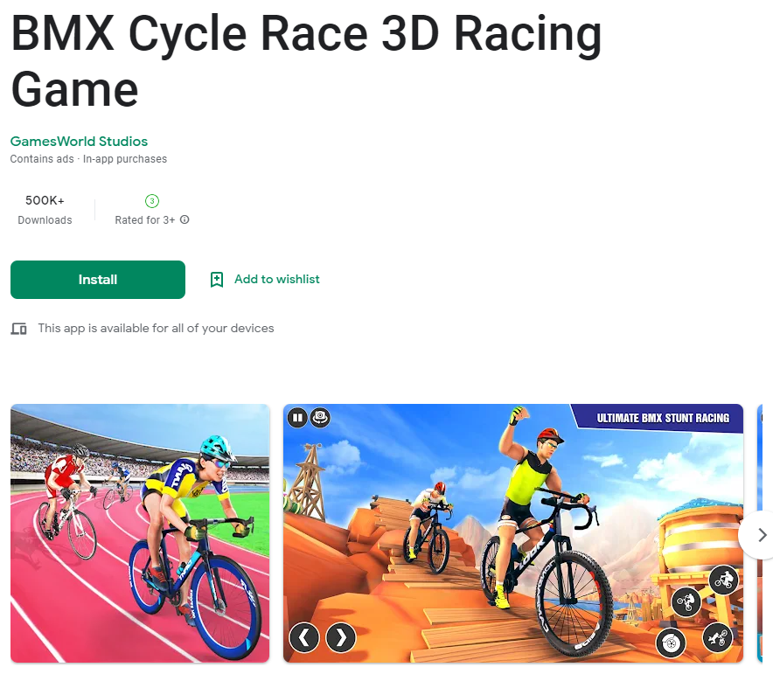 <https://play.google.com/store/apps/details?id=com.ps.animalhunter.jungle.snipershooting>

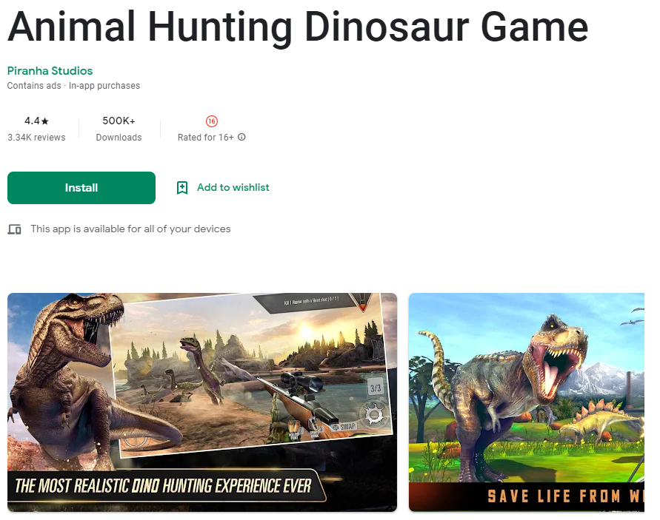 <https://play.google.com/store/apps/details?id=com.gamesworld.shark.hunting.sniper>

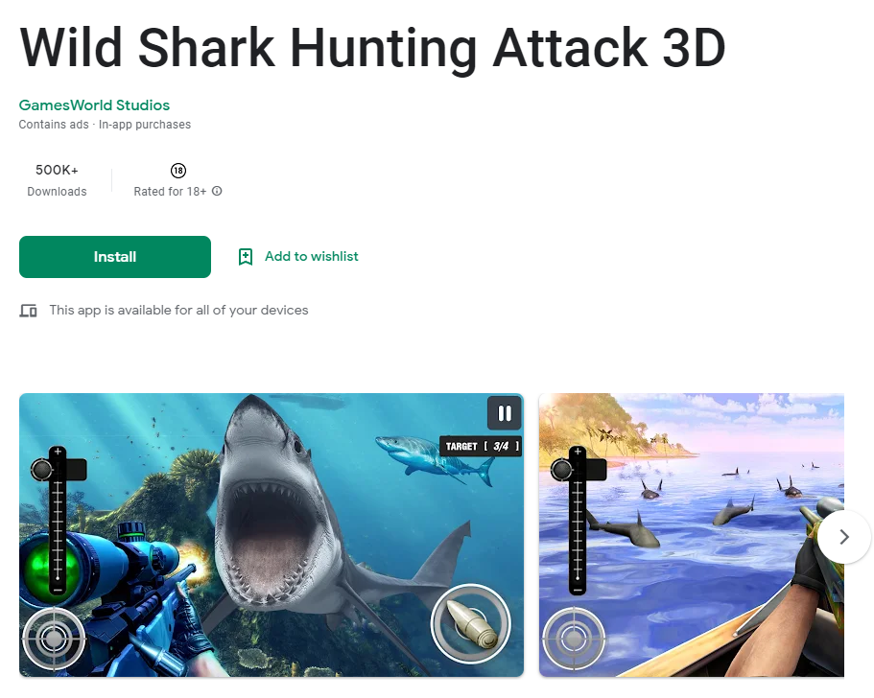 <https://play.google.com/store/apps/details?id=com.indy>

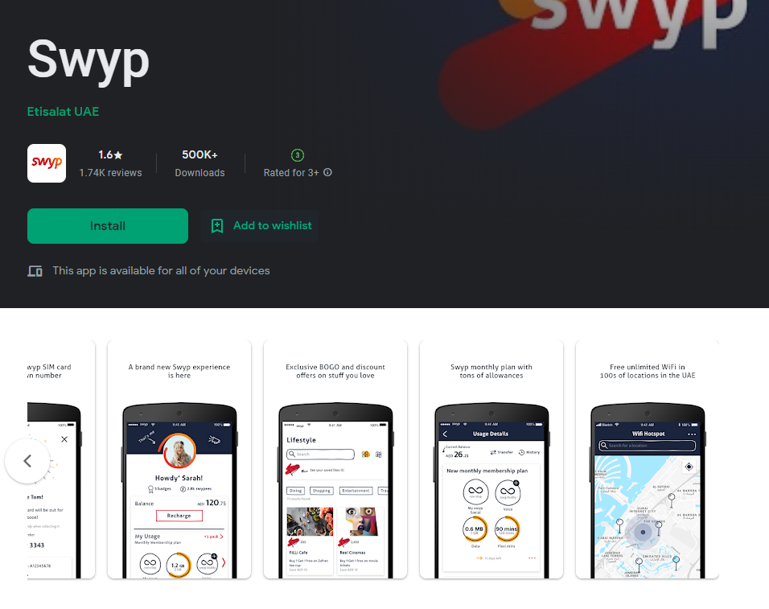 <https://play.google.com/store/apps/details?id=ae.gov.dsc>

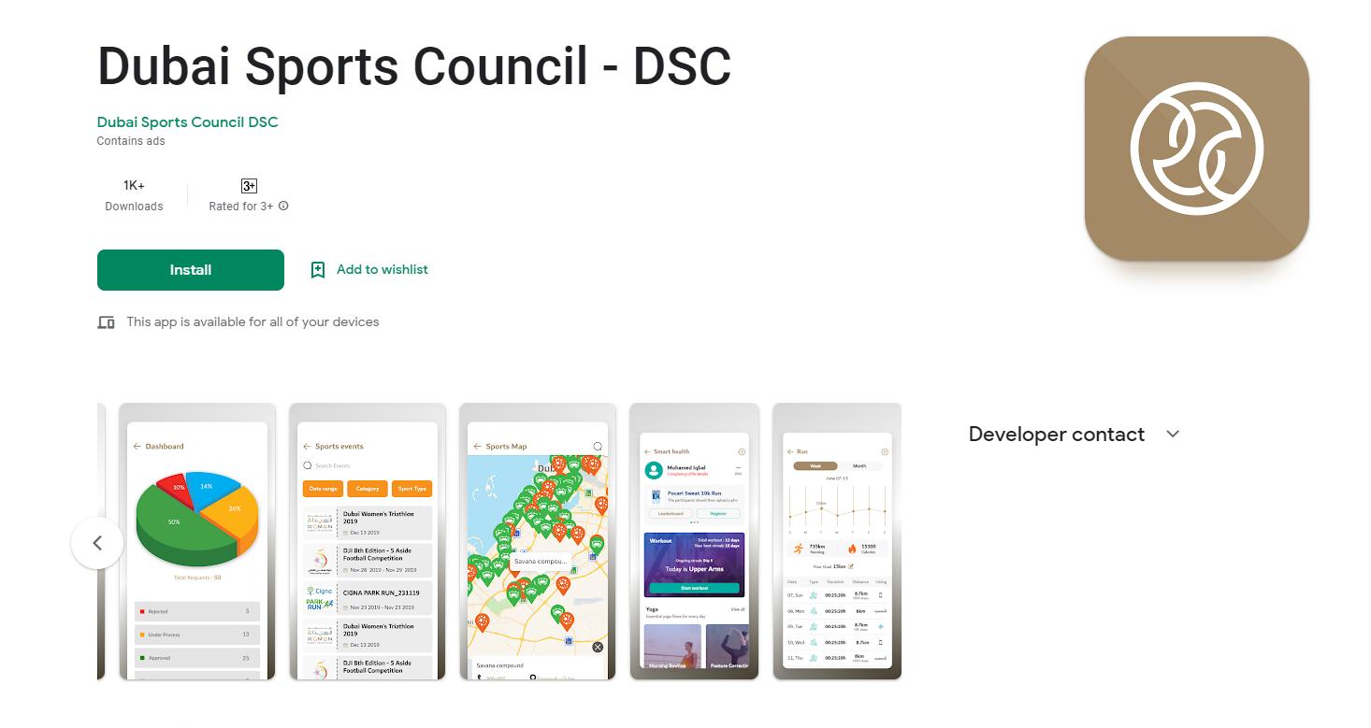

<https://apps.apple.com/us/app/livestream/id493086499>

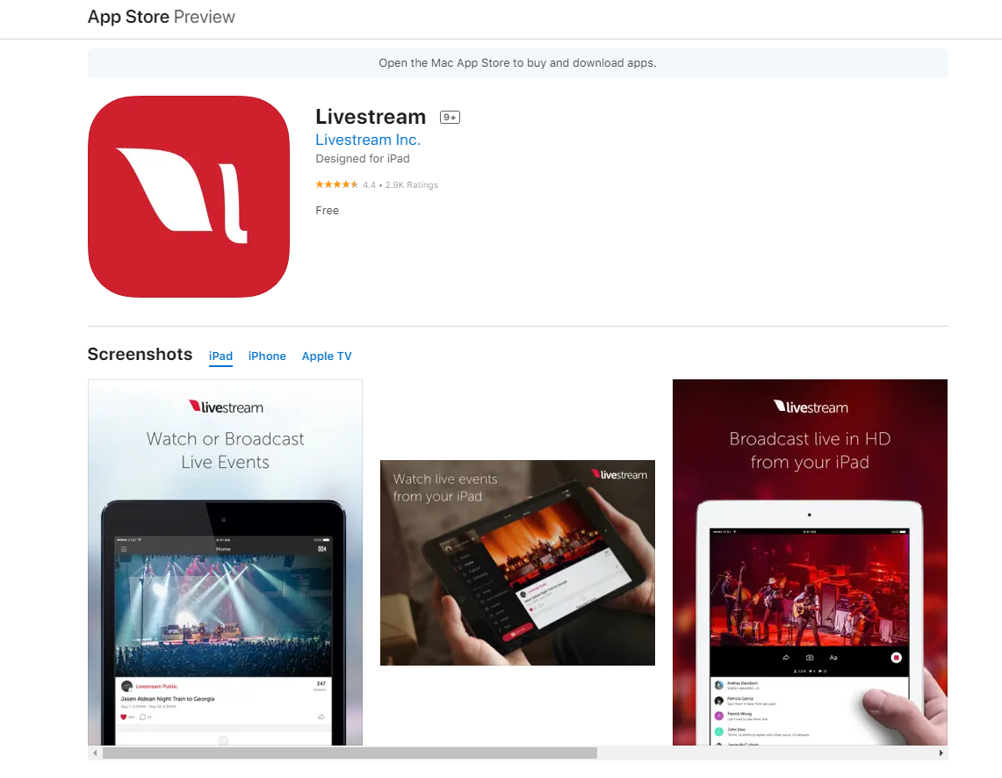

Live stream app

# Unity

## Chat

### Hello There, Have a good day,

I am a unity developer and I have experience with VR.

I have lots of experience in VR/AR and can give you an optimized output based on what you want

Please feel free to open chat and discuss.

We will give you an estimate and also will help you to better approach the project.

I can also give you example of similar work once we get into discussion

Thanks and Regards.

### Hello There, Have a good day.

I am a Unity developer and have rich experience in Unity development.

I have developed many Unity games from 2016.

I read your proposal and I thought I am best fit for this project .

Please contact me .

Thanks and Regards.

- MMORPG Games :

<https://www.youtube.com/watch?v=Lhf9jpl0Gbk>

<https://www.youtube.com/watch?v=GE3eSc4y_sQ&list=PLVnD82r60YzrrTnvmyaFEGTh2eDmuIOdQ>

## Game Web Site

[http://www.feedmusic.com](https://www.freelancer.com/users/l.php?url=http:%2F%2Fwww.feedmusic.com&sig=103499eb0fb36c55724c9ba6564c47b00d0e235504b8b68a181823db4630ffb6)

<https://www.carparts.com/>

<http://www.feedmusic.com/#/>

# Mozilla Hubs

## Chat

## Website

<https://app.scena360.com/>

Metaverse

metaverse.graphity.io

# Python

## Chat

### "Solid experience as Python Developer"

Hello There, Have a good day,

Design/Build applications. Scalability, performance, Distributed systems, Data Structure, Algorithms. Python, Django, Flask, Numpy, Scipy, Pandas. Cloud experience

I will send My previous work on personal chat then please connect with me on chat for more discussion.

Best wishes

### Hello, sir. Glad to meet you.

I'm a professional software/fullstack developer.

I'm majoring in C,C#,Java,python,Web and blockchain.

I have developed many Desktop and GUI apps.

Also I'm good at AI and ML.

Now I am majoring in blockchain.

I have developed many NFT minting and staking websites using web3 and smart contract. Please see my profile to know me in detail.

Let's discuss in detail via chat. Looking forward to your response

Best wishes.

### Hi!, I’ve carefully checked your requirements and really interested in this job.

I’m developer working at large-scale apps as a lead developer with U.S. and European teams. I’m offering best quality and highest performance at lowest price. I can complete your project on time and your will experience great satisfaction with me. I’m well versed in React/Redux, Angular JS, Node JS, Ruby on Rails, html/css as well as javascript and jquery and i have a team who can work on seo google ads and other digital marketing services I have rich experienced in PHP, SQL, Python, Perl and RESTful API. I’m ready to discuss your project and start immediately. Looking forward to hearing you back and discussing all details.. Thanks

### I have checked your project requirements and I am much confident to deliver the same.

I have 5+ year experience working on Website Development.

I am expert in below techniques:

#WIX, Shopify

# WordPress, Theme Customisation, Website Speed Optimisation

I assure you to give best quality work and 100% satisfaction work.

I am looking forward for your response.

Thanks and Regards.

## Site

Django

https://www.stud.com/

# Website Category

## Shopping

<https://the-balloon-queen.webflow.io/>

<https://takearecess.com/>

cosmetics

<https://skinncells.com/>

<https://labonneattitude.com/>

Clothes

<https://keshiastore.com/>

<https://staruniforms.com.au/>

Bags

<https://justaf.myshopify.com/>

<https://porscia.com/>

jewel

<https://www.caratlane.com/>

<https://www.makevana.com.au/>

Kitchen

<https://www.centraldelhogar.com/>

## Medical

<https://sansomeditours.com/>

## Fitness

<https://www.paddleupright.com/>

<https://www.albanyacademybahamas.com/>

<https://www.jja.co.il/english>

<https://www.practiceshraddha.com/>

<https://www.pilatesbyamanda.com/home>

<https://www.klopezpt.com/>

<https://www.heatbootcamp.com/>

<https://www.roseandstoneboxing.com/>

## Business

<https://www.kraftful.com/>

<https://helixes.co/>

<https://fastdox.co.uk/>

<https://takearecess.com/>

live video stream shopping site

<https://channelize.io/>

https://www.leeveo.tv/

## Deliver, Transport, Service

<https://www.shipa1.com/>

https://livewp.site/wp/md/clengo/

Google Map

<https://www.autotransportcity.com/>

Clean

<https://laborsolutionservices.ca>

## Job site

<https://meinjob.ro/>

<http://www.meinjob.ro/>

## Chat Website

<https://turn2me.ie/>

## Portfolio

<https://www.joshrubietta.com/>

<http://alanis.com/>

## Payment

<https://www.metalpay.com/>

## Tour

<https://bridge376.qodeinteractive.com/>

# App Category

## Health

<https://apps.apple.com/gb/app/lose-it-calorie-counter/id297368629>

<https://apps.apple.com/gb/app/lifesum-healthy-eating/id286906691>

<https://apps.apple.com/gb/app/food-calorie-macro-tracker/id927372140>

<https://apps.apple.com/gb/app/cronometer-macro-tracker/id1145935738>

<https://apps.apple.com/gb/app/hitmeal-calorie-%D1%81alculator/id1544461026>

Personal

178.20.40.24

makarov

asd123!@#

Nikita Tulupov

Important Info

Web

Slider

<https://www.sliderrevolution.com/resources/css-range-slider/>

now until solar toward tube index chief shuffle dinosaur portion begin link

If given a choice, my desired job title would be that of lead senior full stack engineer.

My seven years of experience in web, app development plus my education in professional technical make me an ideal candidate for this position and have additionally prepared me to take on more leadership-oriented roles such as full stack engineer

I like to be in the back and front of tech hence my passion for web and blockchain development.

I put my heart and soul into every project I work on, going non-stop till it is brought to perfection.

My strongest attribute is my determination. I take on every challenge head-on and do what I need to accomplish my goals, even when the challenge is difficult.

My unique attribute is passion. I think without a passion for what you are doing, it is not possible to ideally perform your job.

Just thinking of programming as my hobby, I started my career for software development in the companies when I was studying at the Waseda University.

After that, I have worked in Rikkeisoft and METHOD IT companies

This was an amazing experience for me to grow as an IT technician. I will never give up on my way. Thanks for reading!

This is my project that I want to brag about.

I have interest about eCommerce website.

I think advertisement is very important to sellers and business.

There are many ways for this but live video maybe the strongest way for that.

I have built Live video stream shopping site with Amazon Web Service and React.js.

There are many ways for live video stream but AWS is best way because AWS support ABR(Adaptive Bitrate Stream) based on cloud computing.

On this website, sellers can post their live video stream for their productions and broadcast on time as live.

While they broadcast, customers can know the purpose, useway and advantage of production.

Also they can chat as live.

For this I have used these stacks

AWS S3

AWS Dynamo DB

AWS Lambda

AWS IVS

AWS API Gateway

AWS RDS

AWS Web socket

AWS Amplify

AWS Route53

React.js

React-Bootstrap