## Overview

The goal of this activity is to help you become familiar with Bootstrap 4, a popular framework for rapidly prototyping designs.

It’s easy to start. All you need is the following link, which you’ll place in the <head> section of your HTML file:

| <link rel="stylesheet" href="https://stackpath.bootstrapcdn.com/bootstrap/4.3.1/css/bootstrap.min.css" integrity="sha384-ggOyR0iXCbMQv3Xipma34MD+dH/1fQ784/j6cY/iJTQUOhcWr7x9JvoRxT2MZw1T" crossorigin="anonymous"> |
| --- |

## Instructions

**Part 1: Link to Bootstrap**

1. Copy the link above. You can also find the link and other ways to implement Bootstrap [here (getbootstrap.com)](https://getbootstrap.com/docs/4.3/getting-started/introduction/).
   * Bookmark this useful link for future projects.
2. Open index.html.
   * **Tip:** The file is located in the zip file in the Unit 20 Activities folder.
3. Paste the Bootstrap link into the <head> section of your HTML file.
4. That’s it! With the Bootstrap link in place, you’re now free to use Bootstrap and its components on your page.
   * **Tip:** You only need to insert the link once for each website you use Bootstrap with.

**Part 2: Add the Jumbotron Component to Your Template**

1. Open [this link](https://getbootstrap.com/docs/4.3/components) to the Bootstrap component documentation.
2. Navigate to the jumbotron component. Then, copy the code listed on the page.
3. Paste the code in the <body> of index.html. Save your page and refresh to see the changes.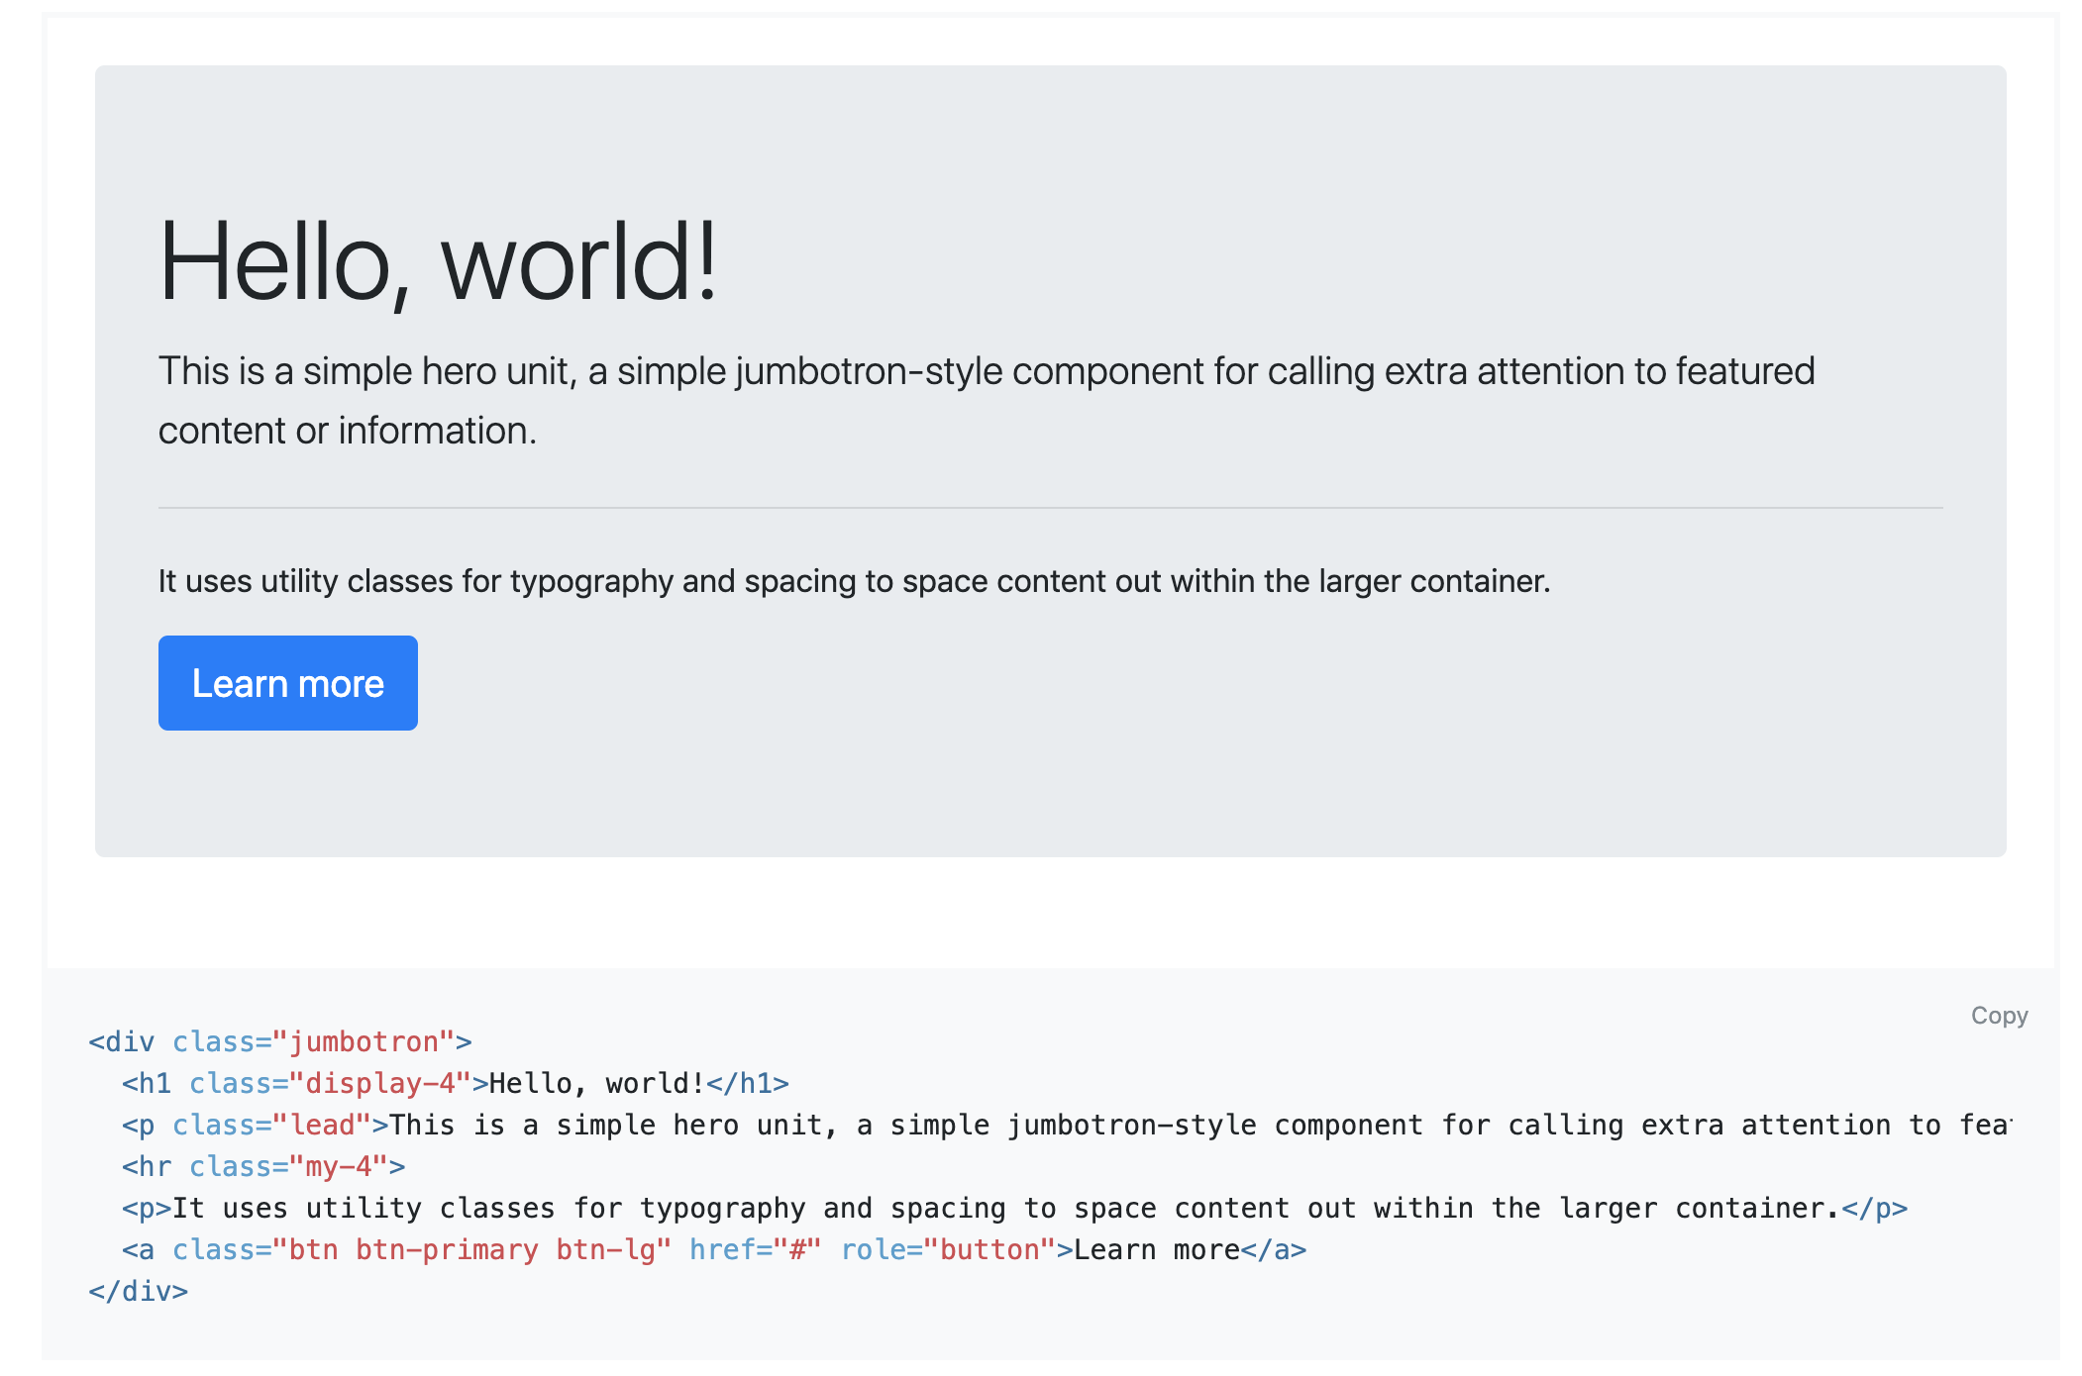

**Note:** Keep this file open, as you’ll use it during the next few activities.