In this activity, you will be working with Figma and Adobe XD’s powerful export feature.

Prepping web assets is a normal part of any developer's workflow and done prior to development work.

## Instructions

***Please Note:*** *Make sure you create the folder structure for this project before exporting the Adobe XD assets. If you need a reminder of the proper folder structure, please review the steps listed in the* [*Unit 17 Homework*](https://docs.google.com/document/d/1qza5kjzQndXKbooropUxE4nefYfpg4FezHh24TzUmOY/)*.*

1. Open the [Figma starter file](https://www.figma.com/file/a8H46DKtHkyzob1uLLvIkG/20.3-01-Travel-California-Demo-Solution?node-id=0%3A1) or .xd file for Travel California (located in the Activities folder).
2. Select the hero image of the mountains.

* Make sure you see the bezier handles before you export your image to make sure you have it selected.

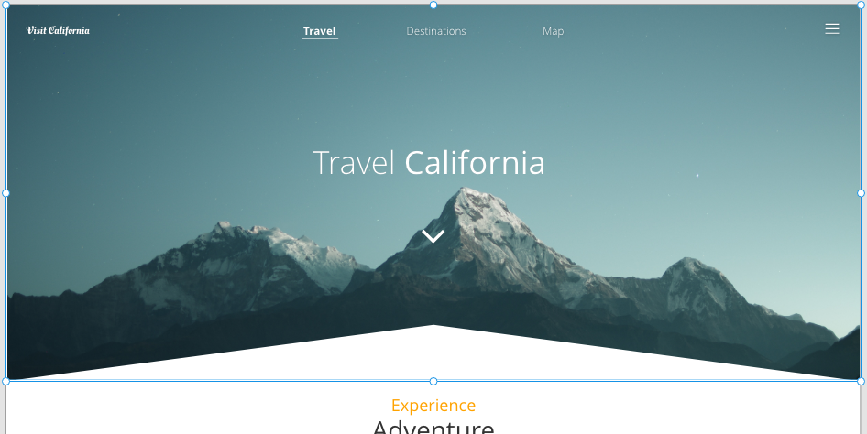

1. Click File > Export > Selected.

* Or use Ctrl + E for Windows, or CMD + E for Mac.

1. Save the image in the images folder you created as part of your folder structure.
2. Repeat this process for the following sections:

* The services section

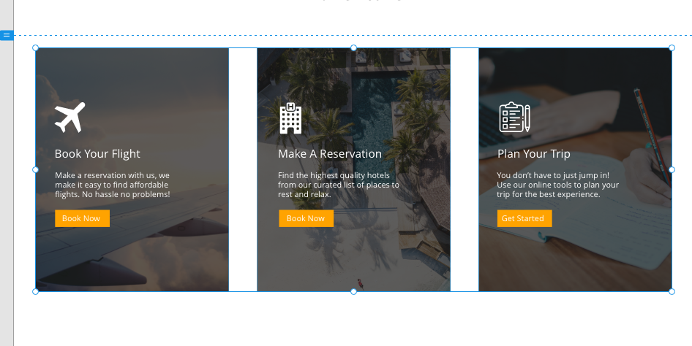

* The popular destinations section
* **Tip!** Export more than one image at a time.

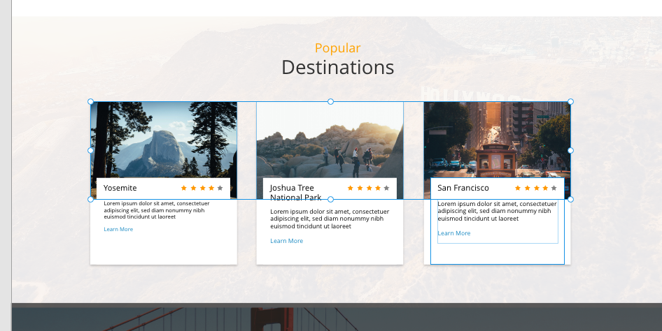

* The mailing list background

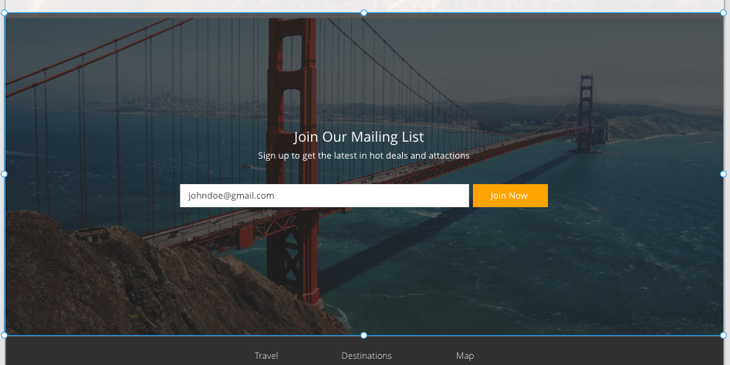

1. Export all the icons with Adobe XD to your web directory:

* The logo at the top left
* The chevron (down arrow) under Travel California
* The “book your flight” icon
* The “make a reservation” icon
* The “plan your trip” icon
* The star icon

1. Export both a gray and an orange star.
2. You have compressed and exported all your images, so you are ready to code!

Now that you have finished exporting the design assets you will need, you can start developing your webpage—that will be part of the next activity.