GlobalVariable.rootWord[12] :

http://www.etymonline.com/index.php?term=kin&allowed_in_frame=0

GlobalVariable.rootWord[13] :

GlobalVariable.rootWord[1]: kindle

------------------ sucessful goes to the Internet ---------------------------

------------------- sucessful goes into the html texts parsed ---------------------------

GlobalVariable.rootWord[1]: kindred

------------------ sucessful goes to the Internet ---------------------------

------------------- sucessful goes into the html texts parsed ---------------------------

GlobalVariable.rootWord[1]: kinetic

------------------ sucessful goes to the Internet ---------------------------

------------------- sucessful goes into the html texts parsed ---------------------------

GlobalVariable.rootWord[1]: knack

------------------ sucessful goes to the Internet ---------------------------

------------------- sucessful goes into the html texts parsed ---------------------------

GlobalVariable.rootWord[1]: knave

------------------ sucessful goes to the Internet ---------------------------

catch a exceptions : urllib3.exceptions.HTTPError

Exception in thread Thread-1:

Traceback (most recent call last):

File "H:\SoftWareInstalled\Python34\lib\threading.py", line 911, in _bootstrap_inner

self.run()

File "E:\htmlParser\htmlParser.py", line 176, in run

self.quitRootWordThread = rootWordGenerated.RootWordGenerated()

File "E:\htmlParser\RootWordGenerated.py", line 66, in RootWordGenerated

InsertOrNot = rootWordHtmlParser.RootWordHtmlParser(line)

File "E:\htmlParser\RootWordHtmlParser.py", line 92, in RootWordHtmlParser

if sourceWordHtml.data == '' or sourceWordHtml.data == ' *' or \

**UnboundLocalError: local variable 'sourceWordHtml' referenced before assignment**

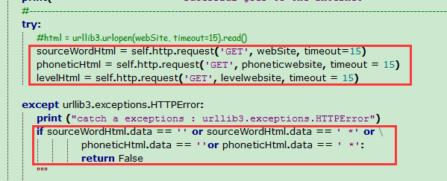

把**sourceWordHtml定义和使用的地方放到同意个缩进就可以了**