Dream Team Supreme RAD Master

SangJoon(Jeremy) Lee,

Mitchell Potague,

Robert Jacobs

Dream Team Supreme RAD Master

Master Document

Introduction 4

Meeting 1 5

Agenda 5

Ordering of Tasks 5

Task Allocation 5

Formatting Standards 5

Setup 6

Source Control snapshot 6

Project Management Plan for Sprint One 6

Testing Plan 7

Project Name 7

Stakeholder Information 7

Group/User Name: Dream Team Supreme 7

Group/User Information 7

Version History: Movie Application 7

Version History: Master Document 7

Introduction 8

Testing Purpose 8

Testing Platform 8

Testing Deliverables 8

Functional Testing 9

Load and Stress Testing 10

Conclusion and Findings 10

Sprint One 10

Analysis Report 11

Introduction 11

CITE business rules for software development 11

CITE Managed Services Quality Assurance. 12

Acme Entertainment Pty Ltd (Acme) development requirements. 13

Multi-Platform Report 14

Introduction. 14

Adaptive Design 15

Responsive Design 16

Comparison Table 17

Conclusion 17

Responsive Web Site 18

Actual Size (PC version) 18

Tablet Size (less than 768px) 19

Mobile Size (less than 375px) 20

Sprint 2 21

Introduction 21

RAD Week 2 Meeting 22

Agenda 22

Review Over week 1 22

Requirements week 2 22

Task Allocation 22

Robert’s Motion 22

Set Up 23

Source Control Snapshot 23

Project Management for Sprint two 23

Testing Plan 25

Project Name 25

Stakeholder Information 25

Group/User Name: Dream Team Supreme 25

Group/User Information 25

Version History: Movie Application 25

Version History: Master Document 25

Introduction 26

Testing Purpose 26

Testing Platform 26

Testing Deliverables 26

Sprint Deliverables 26

Functional Testing 27

Load and Stress Testing 28

Conclusion and Findings 28

Sprint Two 28

Performance Report 29

Introduction 29

Why do we need Performance Testing? 29

Private Performance Testing Options 30

Public Testing Viability 32

# Introduction

We, Jeremy Lee, Mitchell Pontague, and Robert Jacobs, have been commissioned by Acme Entertainment to develop Movie Application. For this sprint one, they want to review and update a prototype movie database so it can be used across all the major digital plat forms.

This report includes Multi-Platform Report, Analysis Report, Project Management Plan and Testing Plan for the application as their requirement.

# Meeting 1

**Date:** 27/05/21 9:45- 10:15

**Location:** South Metro TAFE Murdoch Cafeteria

### Agenda

* Ordering of tasks
* Deciding of prototype for website
* Allocation of tasks
* Defining formatting standards / default template

### Ordering of Tasks

* 1st Setup shared Gmail and GitHub account
* 2nd Upload Jeremey’s prototype website to server
* 3rd Allocation of tasks

### Task Allocation

* Testing plan – Jeremy
* Project Management/gannt Chart – Jeremy
* Analysis Report – Robert
* Multiplatform Report – Mitchell

### Formatting Standards

The team has decided to use a default template provided by Robert for all documents.

File naming convention will be “ RADweek‘number’_name of document_first letter of authors first name followed by last name_Version number”

*e.g., RADweek1_MultiplatformReport_MPontgue_V1.0.doc*

*e.g., RADweek3_TestingReport_RJacob_V2.1.doc*

# Setup

### Source Control snapshot

Our team decided to use GitHub for source control system because GitHub is most common system and is using generally in the field.

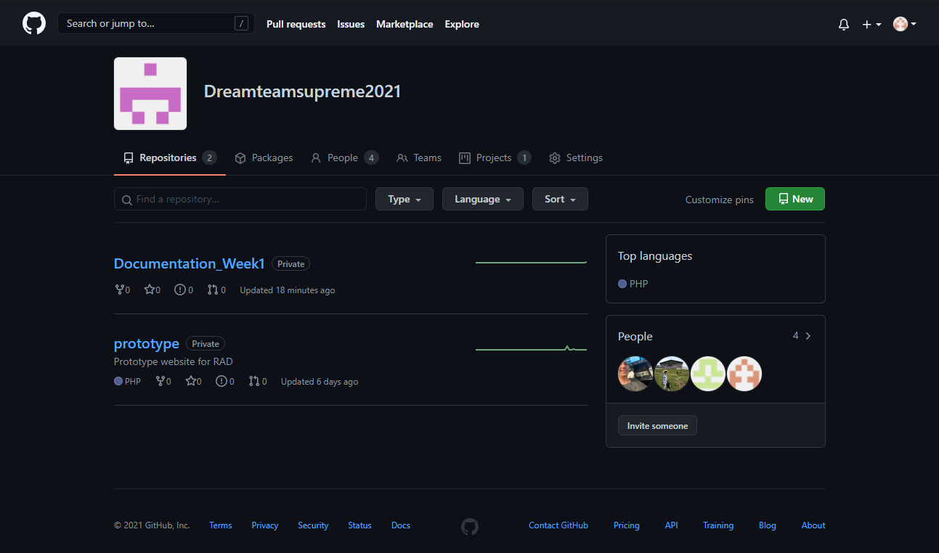

### Project Management Plan for Sprint One

I decided to use ProjecLibre for the project management software. because it is free open source and It has been using world widely in over 200 countries. ProjectLibre includes features such as Gantt charts, network diagrams, work breakdown structure charts, resource breakdown structure charts, earned value costing, and resource histograms. These are also comparable to features in Microsoft Project.

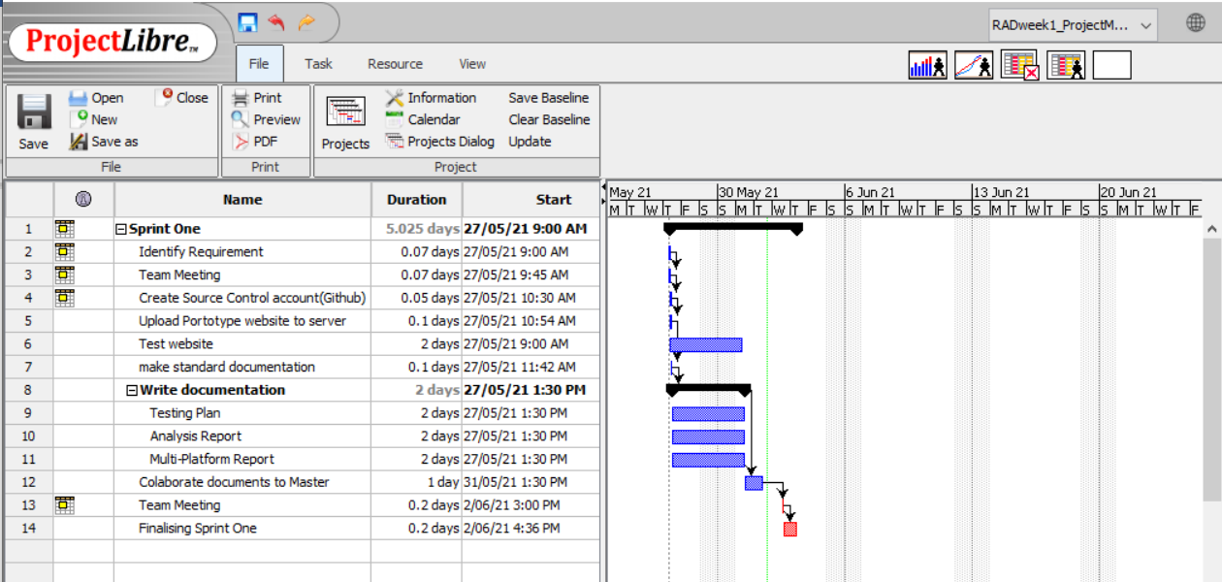

# Testing Plan

## Project Name

**Acme Entertainment Movie Database application**

### Stakeholder Information

|  |  |  |  |
| --- | --- | --- | --- |
| Name | Organisation | Position | Contact |
| Stewart | Acme Pty Ltd. | CEO | stewart.godwin@smtafe.wa.edu.au |
|  |  |  |  |

### Group/User Name: Dream Team Supreme

### Group/User Information

|  |  |  |  |
| --- | --- | --- | --- |
| Name | Project Role | Availability | Contact |
| Jeremy | 1st Manager |  | 30024165@tafe.wa.edu.au |
| Mitchell | 2nd Manager |  | 30001661@tafe.wa.edu.au |
| Robert | 3rd Manager |  | 30018755@tafe.wa.edu.au |

### Version History: Movie Application

|  |  |  |  |
| --- | --- | --- | --- |
| Date | Version | Author | Description |
| 28/05/21 | 1.0 | Jeremy Lee | Prototype Movie web site |
| 03/06/21 | 2.0 | Jeremy Lee | Responsive Movie web site |
|  |  |  |  |
|  |  |  |  |
|  |  |  |  |

### Version History: Master Document

|  |  |  |  |
| --- | --- | --- | --- |
| Date | Version | Author | Description |
| 02/06/21 | 1.0 | Jeremy Lee | Created and added Sprint one documents |
| 03/06/21 | 1.1 | Jeremy Lee | Added Responsive web site section |
|  |  |  |  |
|  |  |  |  |
|  |  |  |  |

## Introduction

### Testing Purpose

This test plan serves as a roadmap to the testing process that has all the necessary details related to the process. This serves a means of communication between the team members and stakeholders and keeps a record of what was tested in a particular release, along with any comments or conversation notes.

### Testing Platform

|  |  |  |  |  |
| --- | --- | --- | --- | --- |
| **Hardware Component** | **Minimum Requirement** | **Maximum Requirement** | **Risks** | **Testing Platform** |
| Windows | Windows 7 | Windows 10 |  |  |
| CPU | Intel or AMD processor 3 Gen | N/A |  |  |
| RAM | 4GB | 8GB or more |  |  |
| Disk Storage | 100MB of free space | N/A |  |  |
| Server | 100MB of free space | N/A |  |  |
|  |  |  |  |  |
|  |  |  |  |  |

### Testing Deliverables

#### Sprint One

There was one issue during the test the application. It is about reading CSV file from the web site for the new data. I resolved the issue by using SQL directly from the server. This need to be fixed by next test.

Without this issue, all web site is working perfectly and can be used as a prototype for the Movie application.

## Functional Testing

The purpose of this test is to validate the software system against the functional requirements and specifications. Also, it is to test each function of the application, by providing appropriate input, verifying the output against the functional requirements.

|  |  |  |  |  |
| --- | --- | --- | --- | --- |
| Test ID | Description | Expected Results | Actual Results | Verdict |
| 1.1 | Open Index page | Display index page | Displayed index page | Pass |
| 1.2 | Connect to Database | Read Movie Data from Database | Movie data is read | Pass |
| 1.3 | Check all page connection | Every links connected | Every links connected | Pass |
| 1.4 | Search Movie | Search by title, year, genre or rating | Searched movie by all types | Pass |
| 1.5 | Top 10 Movies | Display top 10 searched movies | Top 10 movies displayed | Pass |
| 1.6 | Responsive Test for Tablet size | Resize table hide some columns | Columns hided | Pass |
| 1.7 | Responsive Test for Mobile size | Resize table hide some columns | Columns hided | Pass |
|  |  |  |  |  |
|  |  |  |  |  |
|  |  |  |  |  |

## Load and Stress Testing

The purpose of this test is to demonstrate the stability of the application. Observations are made on the average RAM usage, and average CPU usage. This test also identified any issues experienced when running specific functions of the program.

|  |  |  |  |  |
| --- | --- | --- | --- | --- |
| Test ID | Description | Average RAM Usage | Average CPU Usage | Identified Issues |
| 1.1 | Loading Data | 268.2MB | 41.8% |  |
| 1.2 | Search Movie | 265.4MB | 5.7% |  |
| 1.3 | Top 10 Movies | 258.2MB | 33.7% |  |
|  |  |  |  |  |
|  |  |  |  |  |

## Conclusion and Findings

### Sprint One

In sprint one, there was simple testing for settlement of web site. As I mentioned above, there was an issue in loading CSV file, but it was not big problem.

All functions worked properly, and all team members did their job perfectly.

One thing I want to be improved is the server. The server we are using cannot access at home or any other place, it only is working in TAFE CITE system. In that reason, we have some hardship to test web site its functionalities. So, I made and tested website in XAMPP environment and committed to GitHub master and I will update this site at TAFE.

In this Sprint one, I made simple responsive functionality to test and show how it works and it can be updated when requirement is clarified.

# Analysis Report

## Introduction

This document will outline all the requirements and rules set out by CITE as well as the development requirements by Acme Entertainment Pty Ltd.

This document will be split into three individual sections:

1. CITE business rules for software development.
2. CITE Managed Services Quality Assurance.
3. Acme Entertainment Pty Ltd (Acme) development requirements.

## CITE business rules for software development

The CITE website (citems.com.au) grants a great insight into their methodology when it comes to software development. All the information presented in this section is gathered from the specific page on their website - (https://www.citems.com.au/services/application-development/methodology/, 2021)

* CITE has a big commitment to open communication with software vendors and non-software companies to make sure that there are no miss communications or ambiguity between different teams no matter the time zone, language or cultural barriers. Each step of the development process (requirement, changes, testing, coding) are all managed by CITE.
* For Distribution the AGILE framework is used in order to maintain steady communication between different agents within the project including the team, the admins and the client involved in the project. Sprints are conducted where the week is planned out, executed and feedback is provided ready the next sprint the following Monday. This allows a constant stream of communication that facilitates changes, improvements and team work.
* The advantages of this approach to software development includes:
  + Strong Project and Process Management – The managers are involved with every step of the process and provides an anchor for the entire team.
  + In-Depth Requirements Analysis – Each sprint starts off with an involved requirement analysis so that no stone is ever unturned.
  + Thorough Quality – Independent QA staff make sure that any project is fulfilling the specific requirements.
  + Knowledge to Build On – All the staff are experienced in their roles and offer a world of knowledge to apply to any projected they are working on.
  + Devops and Continuous Delivery – Ensures that all projects are scalable.
  + Transparent Communication – Constant feedback and meetings allows the team to be up to date with information as well as making sure that all the projects are on track and communicated to the Client and other stakeholders.

### CITE Managed Services Quality Assurance.

All the information presented in this section is gathered from the specific page on the CITE website - (https://www.citems.com.au/services/application-development/quality-management/, 2021)

The CITE team has an extensive QA control which is summarized below.

* Quality Planning – Extensive planning of standards, guidelines and procedures in development.
* Quality Assurance – Ensuring that all the above points are being followed.
* Quality Control – Using metrics to quantify performance and improve any defective code.
* Independent Quality Department – Separate team to complete the following tasks –
  + Full-Cycle QA Testing
  + Document and Code Reviews
  + Defect Tracking
  + Configuration Management
  + Process Monitoring
  + Risk Management
* How QA is weaved into the development life cycle – Each stage of the development process has a layer of QA to ensure that all the standards and procedures are being followed. Each sprint repeats these stages as well so there is constant QA throughout the entire process.
  + Initiation and Planning – Project Spec analysis, test planning and team assignments.
  + First Review – Initial testing.
  + Iteration Audits – Ongoing testing.
  + Final Verification and Validation – Final product testing before deployment (end of life cycle.)

## Acme Entertainment Pty Ltd (Acme) development requirements.

The prototype website was successful and will be moving onto further development by the team. The next phase in the development is to add some extra requirements and features onto the already existing website. The following additional requirements are as follows:

* Allow the same website to be used with different platforms (desktop, tablet, mobile).
* The website should be able to adjust its presentation based on the platform it is being used on i.e. desktop has a larger screen and mobile has a smaller screen. The website should be equally visible on both.
* The website should be responsive to different platforms.
* The website should be located on a server that can be accessed from anywhere in the world (with an internet connection).

# Multi-Platform Report

## Introduction.

When designing web application an important topic is highlight in development the question of either “Responsive or Adaptive Design?” is brought forward. In this document we look to analysis these two design methodologies and decide which one best suits the current project. This document will provide a detailed review of both design concepts and list the pros and cons of both and then provide a recommendation on which one to use for the current project.



## Adaptive Design

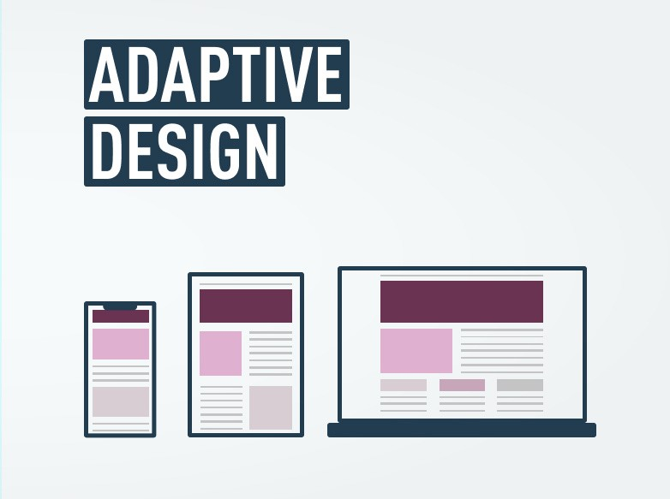

Adaptive design was first introduced by Aaron Gustafson in 2011. Adaptive design works by using multiple fixed layout sizes. On loading the site, the site will detect the available space and determine the best layout to use on the device. The main benefit of adaptive design is it allows the designer to have greater control over the page elements, but this results in a greater workload for the developers. A common concept in adaptive design is the use of breakpoints, breakpoints are used to determine the cutoff for the different layouts the standard cutoffs usually comply with the standard sizing of desktops, tablets, and then mobile phones. With this the layout design on mobile devices may differ to the layout for larger devices like tablets and desktops due to the limited screen size. Generally, a standalone mobile version is made to create a more tailored experience for mobile users.

## Responsive Design

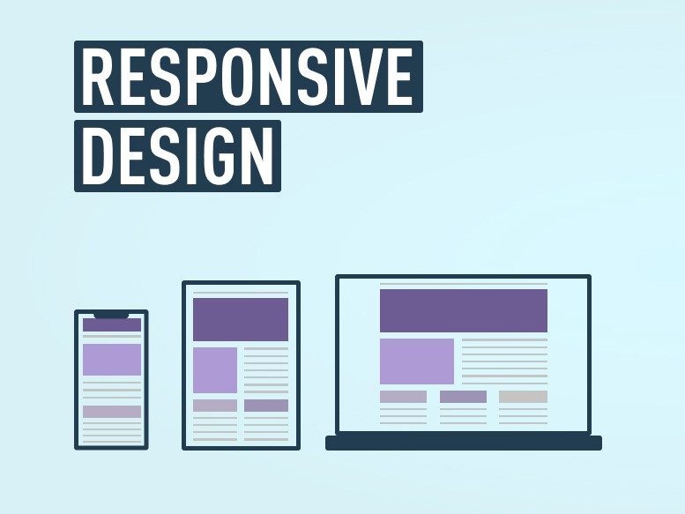

Responsive design was first coined by Ethan Marcotte. A website that uses responsive design will load the same site for all devices but will respond to the size of device to accommodate the device size and orientation. A responsive website will arrange the page elements into the most optimal layout to best suit the screen through the use of CSS Media queries. This eliminates the need to make multiple layouts for designing your website to work on multiple devices as only one framework is needed to serve all devices.

## Comparison Table

|  |  |  |
| --- | --- | --- |
|  | **Adaptive Design** | **Responsive Design** |
| Pros | * Allows for greater control of the page elements. * Better load times | * Easy Implementation * Easier maintenance * Fluid design allows it to flow with the browser when re-sizing. * Uniform layout across devices * SEO (Search Engine optimization) friendly |
| Cons | * Takes longer to design. * May not support new screen sizes. * Harder to maintain and update. * Less SEO friendly | * Less control over page elements * Longer load times |

## Conclusion

Thus, based on the information mentioned above it is recommended that a responsive design should be implemented for the website as it poses less of a drain on human resources and takes less time to implement, it also reduces maintenance time. Another benefit of utilizing responsive design over adaptive is that it easier to update and add new features to the website. Therefore, it is recommended that a responsive design be used in the project.

# Responsive Web Site

As recommended above, we applied simple responsive design into our prototype web site. The responsive function is when size is getting smaller the movie table columns are hided for user to read data comfortly.

## Actual Size (PC version)

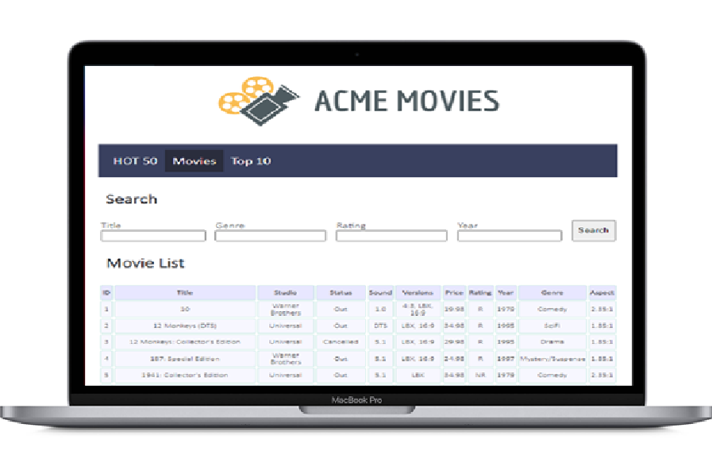

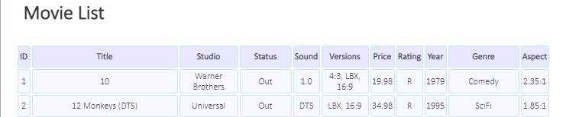

## Tablet Size (less than 768px)

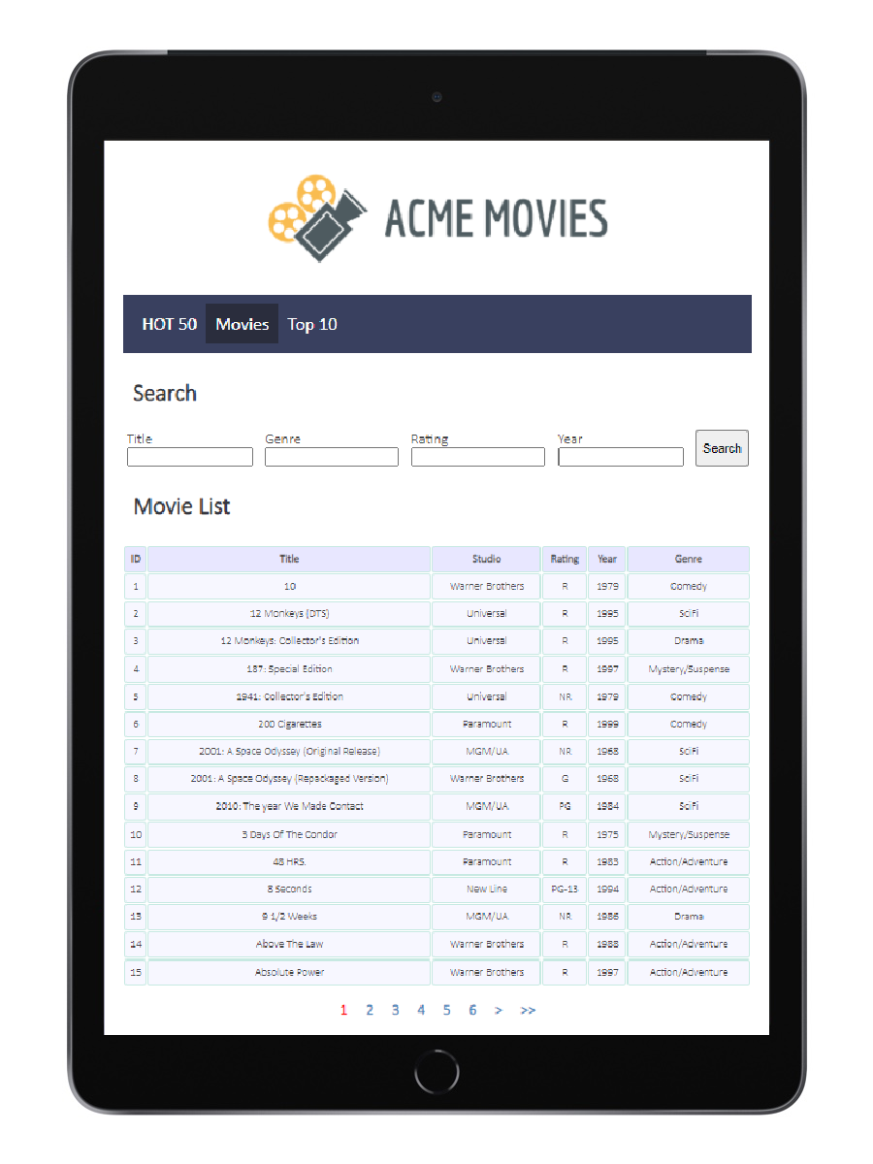

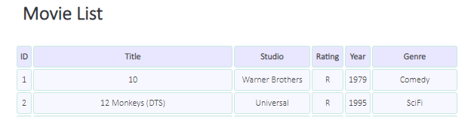

## Mobile Size (less than 375px)

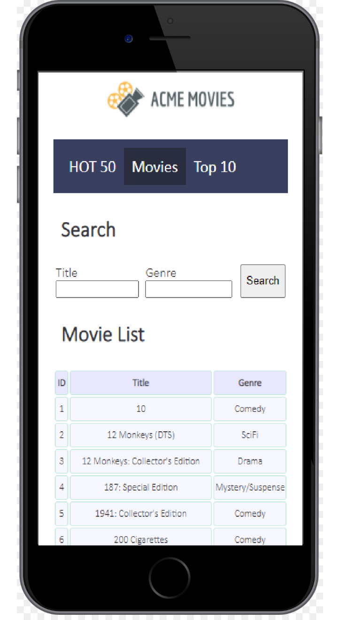

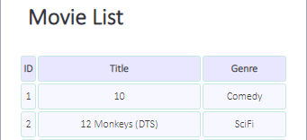

### Sprint 2

# Introduction

Moving into sprint 2 after the success of sprint one the team Jeremy Lee, Mitchell Pontague, and Robert Jacobs have now been tasked with implementing a free communications service for users who sign up with their email. This requires the creating of a membership page to allow users to subscribe which adds their information to the database. This new page should allow for the capture of a user’s full name, email address and provide two checkboxes for the users to select for which type of communications they wish to receive. Validation and filtering of inputs is also expected. Users should also have an unsubscribe button as well which sends an email to the administrators requesting removal.

# RAD Week 2 Meeting

**Date:** 03/06/21 10:21- 10:41

**Location:** South Metro TAFE Murdoch Cafeteria

### Agenda

* Review Over week 1.
* Review Requirements week 2.
* Allocation of tasks
* Robert’s Motion – Change Management software from Libre to GitHub project.

### Review Over week 1

* Passed week one on all fronts. Congrats to Jeremy for a fantastic presentation.
* Adjustments – Make the website more responsive to different hardware. Fix discussed bugs.

### Requirements week 2

* Adding new features to website – Sign up to newsletter feature.
* News Letter requirements – e-mail, new table (hold emails), cancel subscription button, error catching, send e-mail on monthly basis.
* Coding – UI for next page, Php + database implementation, email send/receive functionality.

### Task Allocation

* Source Control Snapshot - **Mitchell Pontague**
* Update Project Plan **- Mitchell Pontague**
* Software Review **- Mitchell Pontague**
* Performance report **– Robert Jacobs**
* Testing Plan Update **– Sangjoon (Jeremy) Lee**
* Coding UI Creation **– Sangjoon (Jeremy) Lee**
* Coding PHP + Database **- Mitchell Pontague**
* Coding Newsletter send / receive **– Robert Jacobs**
* Demonstrate Movie Database **- Mitchell Pontague**

### Robert’s Motion

Robert Proposed we all change the software management software from libre to the github project manager. The reason for this is Libre can only be viewed by the author unless uploaded or sent out to the team. Project on github can be viewed anytime and the viewable version will always be up to date.

Vote Results – Yay = 2, Nay = 1. Nay reason given was a preference for the gannt chart rather than the Kanban.

# Set Up

### Source Control Snapshot

The team will continue to use Github for our source control system.

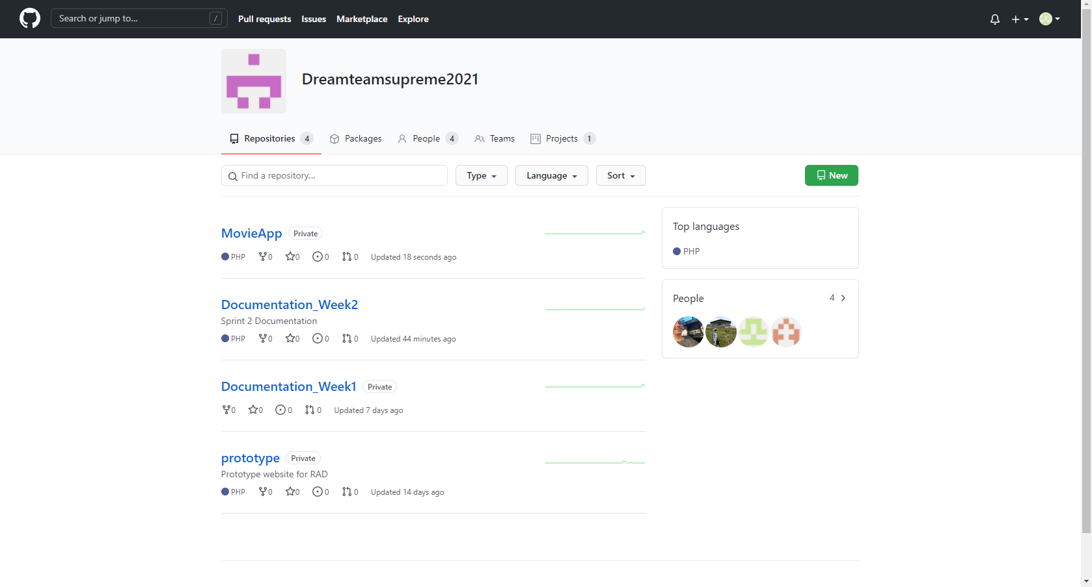

### Project Management for Sprint two

In the team meeting for sprint two, team member Robert Jacob put forward the motion to switch from project libre to using GitHub’s inbuilt project management function. This was proposed because using this allows all team members to view and access the project plan and is easy to use and update as compared to project libre. After a vote the motion was passed two to one therefore GitHub project manager shall be used for the project management plan for sprint two.

**Initial**

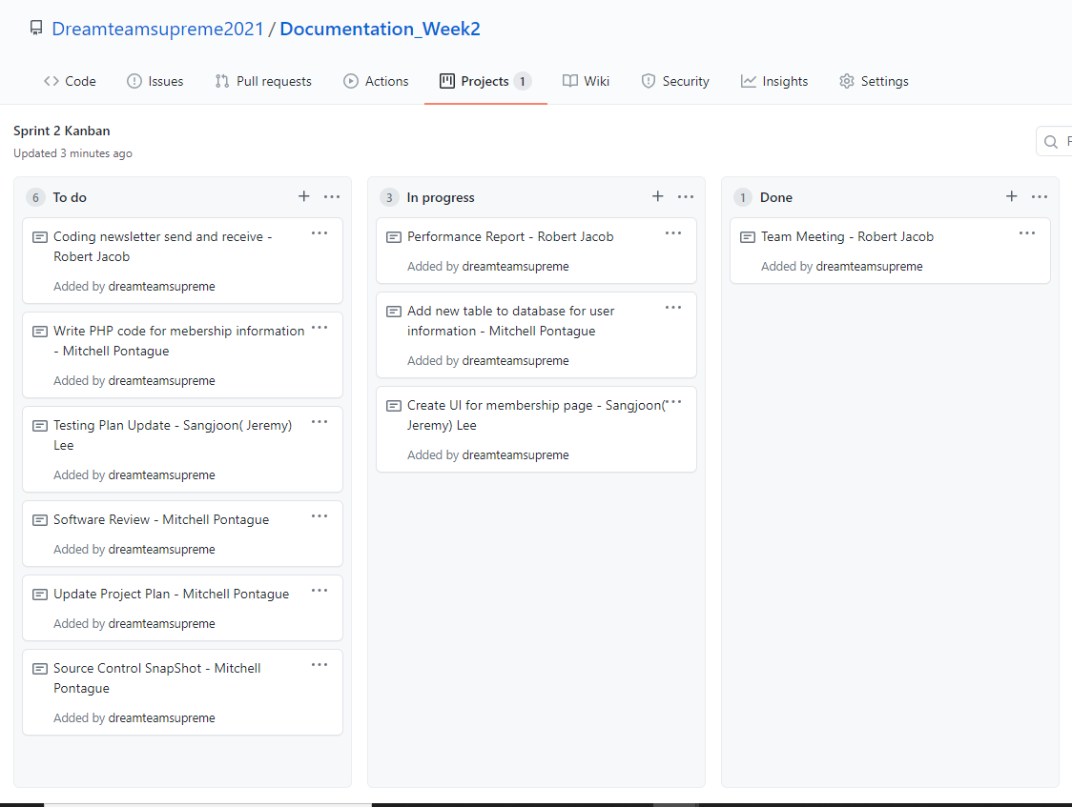

**Completed**

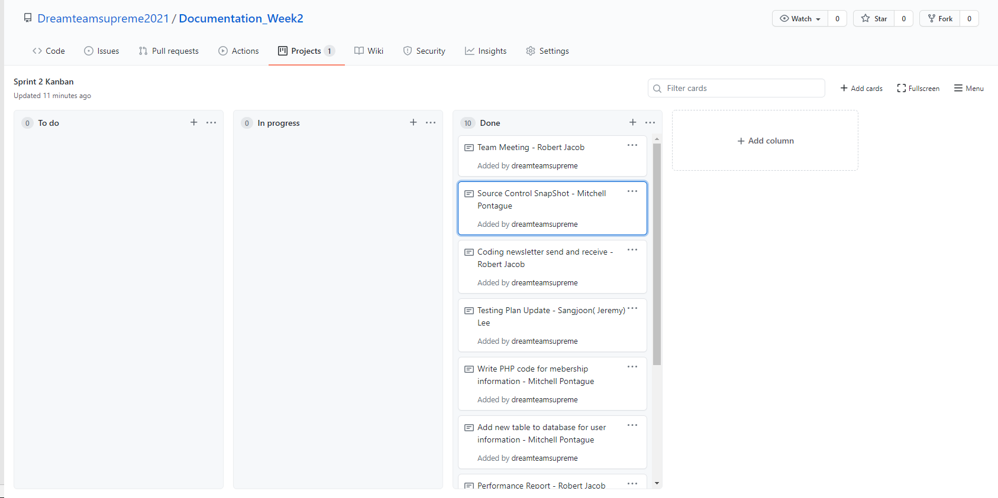

# Testing Plan

## Project Name

**Acme Entertainment Movie Database application**

### Stakeholder Information

|  |  |  |  |
| --- | --- | --- | --- |
| Name | Organisation | Position | Contact |
| Stewart | Acme Pty Ltd. | CEO | stewart.godwin@smtafe.wa.edu.au |
|  |  |  |  |

### Group/User Name: Dream Team Supreme

### Group/User Information

|  |  |  |  |
| --- | --- | --- | --- |
| Name | Project Role | Availability | Contact |
| Jeremy | 1st Manager |  | 30024165@tafe.wa.edu.au |
| Mitchell | 2nd Manager |  | 30001661@tafe.wa.edu.au |
| Robert | 3rd Manager |  | 30018755@tafe.wa.edu.au |

### Version History: Movie Application

|  |  |  |  |
| --- | --- | --- | --- |
| Date | Version | Author | Description |
| 28/05/21 | 1.0 | Jeremy Lee | Prototype Movie web site |
| 03/06/21 | 2.0 | Jeremy Lee | Responsive Movie web site |
|  |  |  |  |
|  |  |  |  |
|  |  |  |  |

### Version History: Master Document

|  |  |  |  |
| --- | --- | --- | --- |
| Date | Version | Author | Description |
| 02/06/21 | 1.0 | Jeremy Lee | Created and added Sprint one documents |
| 03/06/21 | 1.1 | Jeremy Lee | Added Responsive web site section |
|  |  |  |  |
|  |  |  |  |
|  |  |  |  |

## Introduction

### Testing Purpose

This test plan serves as a roadmap to the testing process that has all the necessary details related to the process. This serves a means of communication between the team members and stakeholders and keeps a record of what was tested in a particular release, along with any comments or conversation notes.

### Testing Platform

|  |  |  |  |  |
| --- | --- | --- | --- | --- |
| **Hardware Component** | **Minimum Requirement** | **Maximum Requirement** | **Risks** | **Testing Platform** |
| Windows | Windows 7 | Windows 10 |  | Windows 10 |
| CPU | Intel or AMD processor 3 Gen | N/A |  | Intel i5 |
| RAM | 4GB | 8GB or more |  | 16GB |
| Disk Storage | 100MB of free space | N/A |  | 256GB |
| Server | 100MB of free space | N/A |  | Webmin MySQL Database server |
|  |  |  |  |  |
|  |  |  |  |  |

### Testing Deliverables

### Sprint Deliverables

#### Sprint Two

A new page was added to the website to allow users to subscribe and unsubscribe from the membership program. New user table was added to database to capture user entered information in order to add newsletter functionality. Two buttons were also implemented. One to add subscribers to the database and another to send an email to the admin to remove a membership from the database.

## Functional Testing

The purpose of this test is to validate the software system against the functional requirements and specifications. Also, it is to test each function of the application, by providing appropriate input, verifying the output against the functional requirements.

|  |  |  |  |  |
| --- | --- | --- | --- | --- |
| Test ID | Description | Expected Results | Actual Results | Verdict |
| 1.1 | Open Index page | Display index page | Displayed index page | Pass |
| 1.2 | Connect to Database | Read Movie Data from Database | Movie data is read | Pass |
| 1.3 | Check all page connection | Every links connected | Every links connected | Pass |
| 1.4 | Search Movie | Search by title, year, genre or rating | Searched movie by all types | Pass |
| 1.5 | Top 10 Movies | Display top 10 searched movies | Top 10 movies displayed | Pass |
| 1.6 | Responsive Test for Tablet size | Resize table hide some columns | Columns hided | Pass |
| 1.7 | Responsive Test for Mobile size | Resize table hide some columns | Columns hided | Pass |
| 2.1 | Re-testing previous (1.1-1.7) | Same as previous tests | Same as previous | Pass |
| 2.2 | Membership page (subscribe) | Client email, name, and sub status is captured and entered into user database. | User information is entered into database | Pass |
| 2.3 | Membership page(unsubscribe) | User unsubscribe request is submitted using entered email | Message is displayed to user showing that there request to unsubscribe will be processed shortly | Pass |
| 2.4 | Unsubscribe email sent to admin | **Not yet implemented**, but proof of concept will display a message asking admin to unsubscribe user | Message is displayed at bottom of screen | Pass |

## Load and Stress Testing

The purpose of this test is to demonstrate the stability of the application. Observations are made on the average RAM usage, and average CPU usage. This test also identified any issues experienced when running specific functions of the program.

|  |  |  |  |  |
| --- | --- | --- | --- | --- |
| Test ID | Description | Average RAM Usage | Average CPU Usage | Identified Issues |
| 1.1 | Loading Data | 268.2MB | 41.8% | None |
| 1.2 | Search Movie | 265.4MB | 5.7% | None |
| 1.3 | Top 10 Movies | 258.2MB | 33.7% | None |
| 2.1 | Re-testing previous test(1.1-1.3) | 263.4MB/320MB/315MB | 5%/6%/15% | None |
| 2.2 | Subscribe | 323MB | 3% | None |
| 2.3 | Unsubscribe | 316MB | 4% | None |

## Conclusion and Findings

### Sprint Two

After concluding testing on the newsletter functionality that was implemented in sprint 2, the testing has provided satisfactory results. It should be noted that the email functionality is still a proof of concept at this stage and therefore proper testing on this function can’t be properly executed at this stage of the project.

# Performance Report

## Introduction

This document is to relay options in regards to testing the website in a few different ways. Due to the project still being in the pre-alpha stage of development there are some restrictions on testing options since the website is not available outside of a private network.

## Why do we need Performance Testing?

Performance testing is required to ensure that the current version of the software not only works but works with many different hardware / software that the intended clients could be using. For example, as a website there are a multitude of different browsers that people can use including Chrome, Edge and Firefox.

All these browsers work in slightly different ways and have slightly different configurations so building a website to work on all the most common browsers is a must.

Also different clients could be using different hardware such as desktops, laptops, tablets and mobile phones. As such making sure that the screen changes size in a responsive manner to fit all the screens and maintain its basic functionality is also a must.

## Private Performance Testing Options

During development the team will be using a private server to develop, test and present to the client. As of such we are unable to do any public testing due to these restrictions. But we can do extensive testing on a private snapshot of the total project. This is useful because we can do incredibly robust testing to see where the limits are, breaking the website intentionally. Even though we are breaking the website because it is private there will be no damage done to any other systems and any other risk will be mitigated. We can also control many variables in a private setting also.

There are many software’s available to test a website that are free and paid. Below is a table with some examples.

|  |  |  |  |  |  |
| --- | --- | --- | --- | --- | --- |
| **Program Number** | **Program Name** | **Description** | **Cost** | **Viability** | **Will it be used?** |
| 1 | GTMetrix | By inputting the URL of a website GTMetrix can give you all the info you need to analyse such as Ping, loading times, page size and all sorts. | Free | This site is unviable for our testing since you need a public URL to get the information. The Website we are testing will be private. | No |
| 2 | Site 24x7 | Allows a website to be monitored and to send out feedback to the developers with updates so the developers do not need to manually check if the site is working or not. | Free version (5 servers 10 alerts per month)  Paid Version (5 servers with 50 alerts per month.) | The free version allows long term testing to make sure that the website is up and running at all times. This would be awesome for a long term project but since out website development will only be 3 weeks a monthly update is not the most useful. | No |
| 3 | WebPage Test | Runs speed tests on multiple locations around the world. Allows developers to see how their website performs while being accessed from different users. | Free | Even in a private setting allowing the developers to see how their website performs with the use of VPN’s or other such means would be a great way to ensure that the website is stable. | Yes |
| 4 | Varvy Pagespeed Optimization | Allows the developer to input a URL to receive performance metrix while examining CSS delivery / Javascript usage and other such things. | Free | Due to a public URL being required to get the information this site is unviable for our testing. | No |
| 5 | Google PageSpeed Insight | Free | Allows developers to input a URL to get website speed for different devices in a simple and easy to understand format. Different browers can also be used to run the Google Pagespeed site to look at our website. | Although a URL is used to get the information I believe this is worth using to test since it will give us results for different devices such as Cell Phones and tablets. | Yes |
| 6 | PingDom | Allows 24/7 monitoring of a website and gives you minute by minute updates. | 14 day free trial followed by subscription. | The free trial fits well within our development plan and allows us to receive updates via SMS or email so that the entire team can stay up to date. | Yes |
| 7 | WebCodeSniffer | Free to use code optimizer for PHP, CSS and JavaScript that allows for you to make sure that code is up to standard with your coding conventions of choice | Free to use on web browser | IS able to be accessed from any web browser just requires that you copy the code over into the web browser | YES |

## Public Testing Viability

Since we are still in production and development we are unable to public the website at this time. Due to this constraint our testing will be limited but the above plan still has some viable options to do an alpha and beta test and when the time comes to make the website publicly available we can do a more comprehensive test at that time.