# **Introduction to Design Documentation**

We want to introduce our Voice Transformation Application. Basically, in this iteration 1, we concentrate on 4 Use cases which is Register Account, Account Login, add Friend and Transform Voice to Text. In this documentation, we will show and explain our prototype 1 for our application.

# **Design specification**

## **Architectural Design**

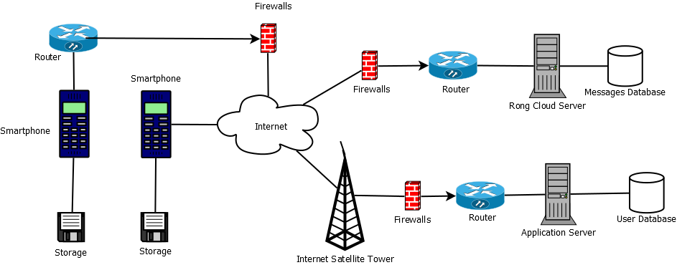***Figure 1.0 Deployment Design***

This diagram shows how our online conversation works. When user registers, the user login information will stored in Application Server Database. We still using local host to save user data but we got a attributes named token, it used to send the message online with Rong Cloud Server from sender to receive instantly. Each token represent a unique user’s identity. So when users start a conversation, two user token will link together with Rong Cloud Server and the messages will transfer by them. The storage components are refers to mobile’s storage, it used for storing the messages. For an example, all of the social application can view the history of message when they offline.