## **System design of the system**

### **Design Class Diagram**

### DesignClassDiagram.jpg**Sequence Diagram**

#### **Register Account**

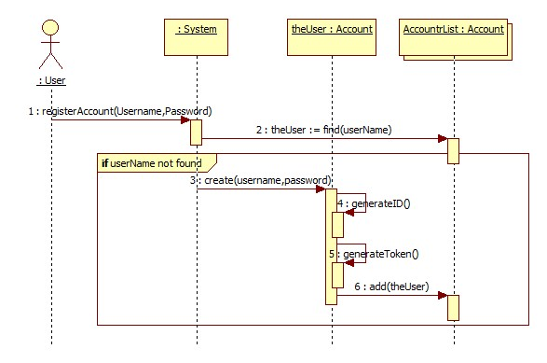

#### **Account Login**

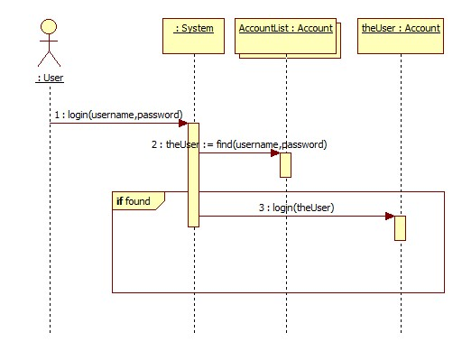

#### **Transform Voice to Text**

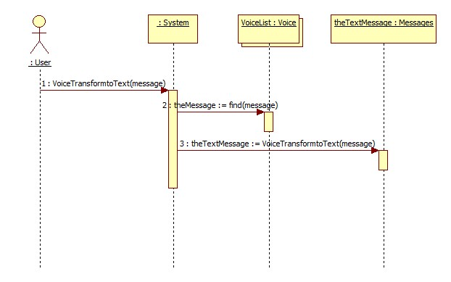

#### **Add Friend**

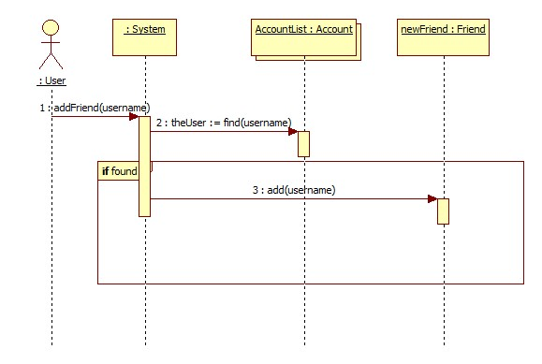

#### **Start Conversation**

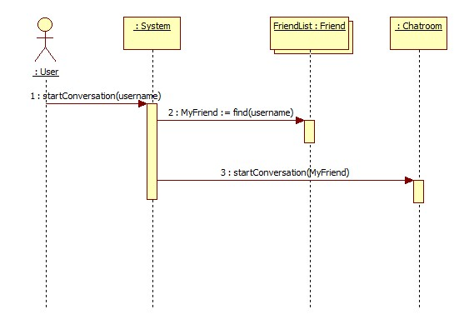

#### **Send Message**

