Team Final Report

GitHub Repository: https://github.com/Dredman72/security-log-threat-timeline
Project: Intelligent Security Log Summarization and Threat Timeline Generation
Course: CSC 482 Capstone Project 2
Team: Project Team 2
Team Members: Derrick Redman, Zion Moore, Oriah Molton-Bowman
Planning Window: June 1-July 28, 2026
Final Presentation Window: July 27-28, 2026

Project Goal
The goal of this project is to build a Flask web application that accepts pasted or uploaded security logs, sends the log content to the OpenAI API, and generates a structured security report. The report includes an executive summary, risk level, attack type, risk rationale, affected assets, indicators of compromise, key findings, a chronological threat timeline with evidence, parsed event preview, recommended actions, and downloadable JSON/HTML report output.

Milestones Achieved
Done | Week | Milestone | Brief Description
Done | Week 1 | Project kickoff and requirements | Team project topic, scope, roles, lab setup, and OpenAI API plan were established.
Done | Week 2 | Initial prototype framework and planning | Individual prototype work began. Derrick created the Flask/OpenAI prototype direction and LLM JSON output structure. Zion created the backend event schema and sample parser data. Oriah created the report/timeline wireframe.
Done | Week 3 | Parser validation and early integration planning | Derrick created the parser output validation checklist. Zion tested parser normalization. Oriah planned the parsed-event display requirements.
Done | Week 4 | LLM integration and structured summarization | Derrick improved the OpenAI prompt and fallback behavior. Zion created AI-ready parser input documentation. Oriah documented report section labels and frontend display expectations.
Done | Week 5 | Threat timeline generation | Derrick refined timeline event wording, evidence rules, and prompt requirements. Zion documented sorting/grouping logic. Oriah continued timeline/report visualization planning.
Done | Week 6 | End-to-end report generation | The app supported pasted/uploaded logs, report timestamp, risk rationale, reset workflow, downloadable JSON/HTML reports, parsed event preview, and improved report sections.
Done | Week 7 | Integration testing and quality improvement | Derrick added reusable sample logs and prompt consistency checks. Zion added integrated backend build evidence. The team reviewed the application workflow and prepared for final hardening.
 | Week 8 | Final hardening, documentation, and presentation preparation | Final report drafting has started. Remaining work is final evidence review, presentation/demo polish, and team signatures.

Subtasks Completed

Derrick Redman - Team Lead and AI/LLM Specialist
Derrick created and refined the Flask/OpenAI prototype. His work included the OpenAI prompt, structured JSON report format, fallback behavior for incomplete model output, threat timeline rules, risk rationale, report timestamp, reset workflow, downloadable JSON/HTML report output, parsed event preview improvements, and Week 7 sample log testing.

Zion Moore - Backend and Log Processing Lead
Zion created the canonical backend event schema, sample parser logs, parser prototype output, normalized JSON examples, AI-ready parser input, backend upload-to-report pipeline documentation, and Week 7 integrated backend build evidence. His work supports the parser-to-LLM handoff and ensures parsed logs contain fields needed for reporting.

Oriah Molton-Bowman - Frontend and Visualization Lead
Oriah created the report and timeline wireframe, planned the frontend report sections, identified required data fields for display, and documented the HTML report layout expectations. Her work supports the user-facing report structure, timeline display, and final presentation visuals.

Testing of Subtasks With Evidence

Test 1: Flask Homepage Loads
Purpose: Confirm the Flask prototype starts locally and displays the Analyze Logs page.
Procedure: Derrick ran the local Flask app and opened `http://127.0.0.1:5000/`.
Expected Result: The page should show the security log input area, upload field, and Analyze Logs button.
Result: Passed.
Screenshot of the Flask application homepage successfully loaded at http://127.0.0.1:5000/. The interface displays the main "Analyze Logs" section with a text area for pasting security logs, a file upload option, and the Analyze Logs button, confirming the prototype frontend is functioning as expected.

Flask app homepage
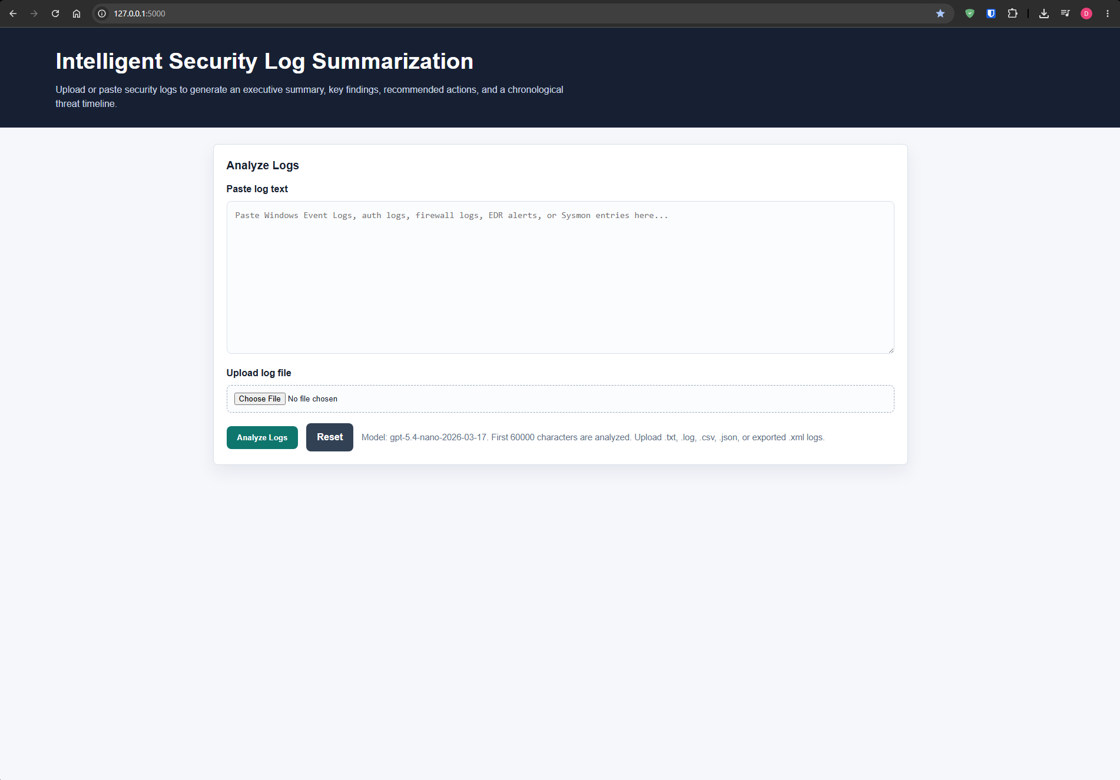

Test 2: OpenAI API Usage Confirmation
Purpose: Confirm the project connects to OpenAI through Derrick's API key and generates usage.
Procedure: Derrick ran the app, submitted sample logs, and reviewed the OpenAI usage dashboard.
Expected Result: OpenAI usage should increase after the app analyzes logs.
Result: Passed.
Screenshot of the OpenAI Usage Dashboard showing API activity after submitting sample logs through the Flask application. The dashboard displays token spend ($0.36), usage bars over time, and increased activity confirming successful connection and usage of Derrick’s OpenAI API key.

OpenAI usage dashboard
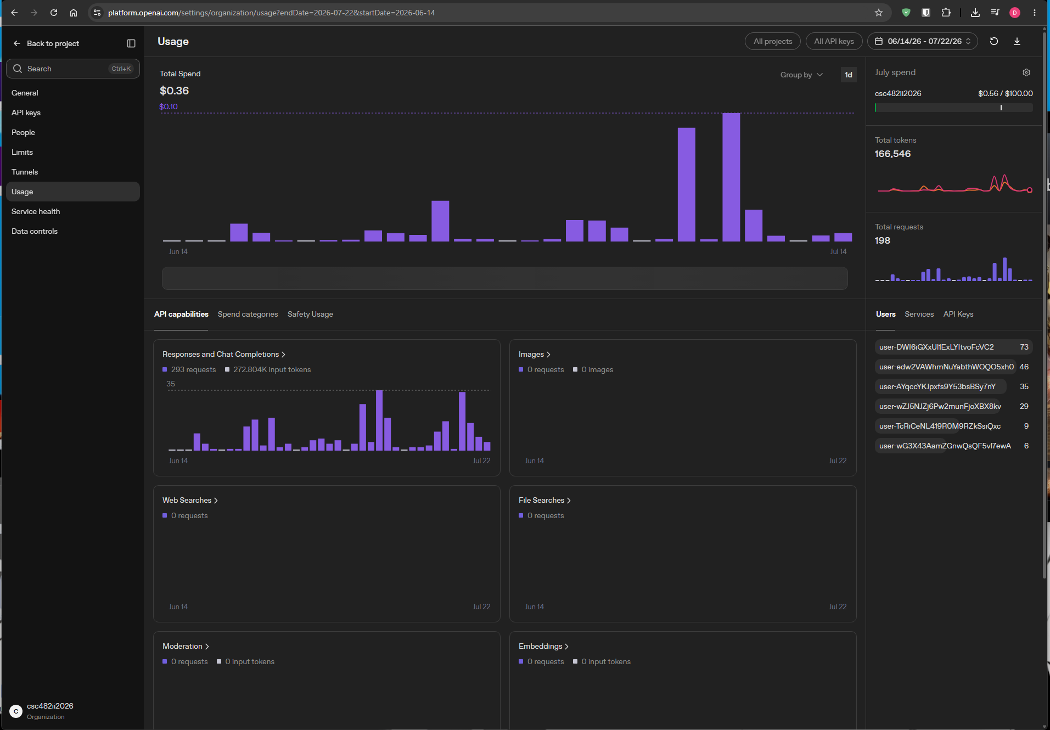

Test 3: Structured OpenAI Report Output
Purpose: Confirm the model returns structured report data that supports the required project sections.
Procedure: Derrick pasted sample SSH/security logs into the Flask app and clicked Analyze Logs.
Expected Result: The app should display a report summary, risk level, attack type, key findings, timeline, evidence, and recommended actions.
Result: Passed.
Screenshots show structured OpenAI report output displaying a complete security analysis including executive summary, Critical risk level, malware attack type, key findings, threat timeline, affected assets, indicators of compromise, and recommended actions.

OpenAI report output
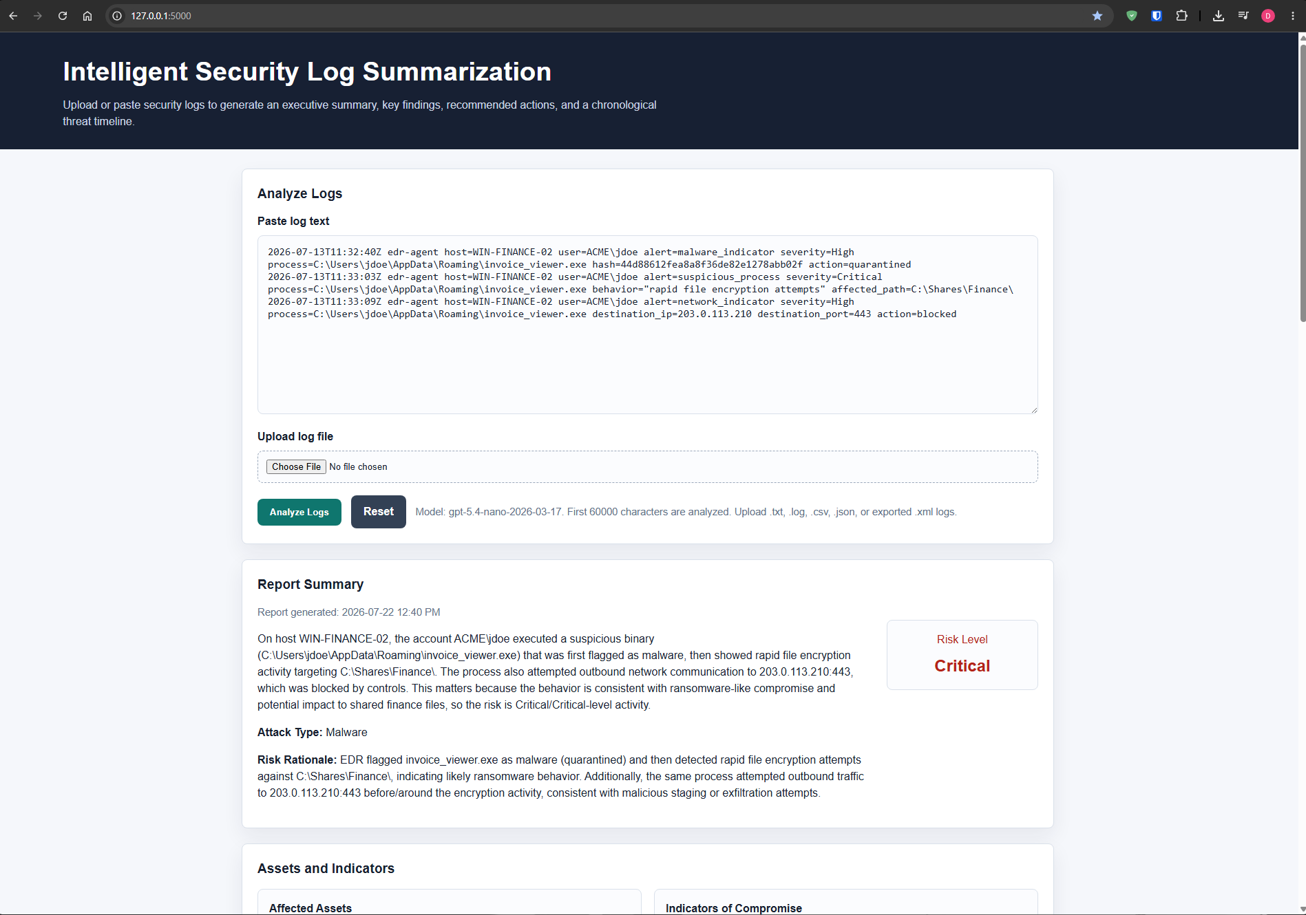
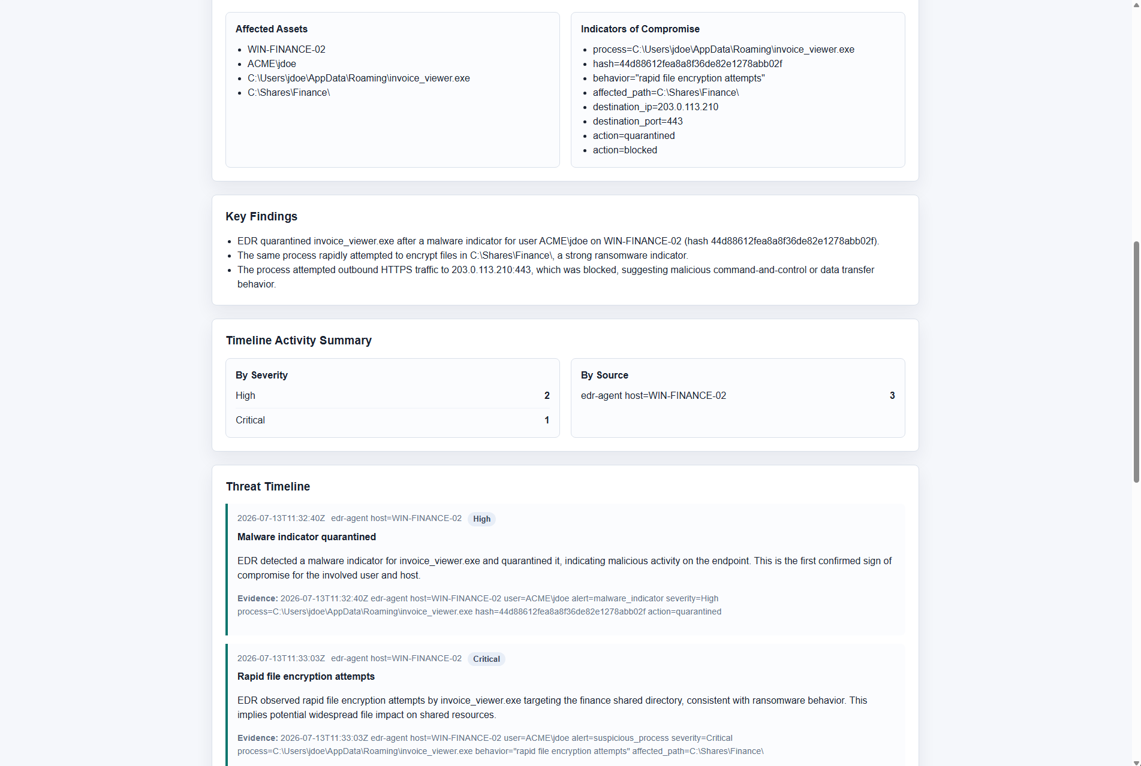
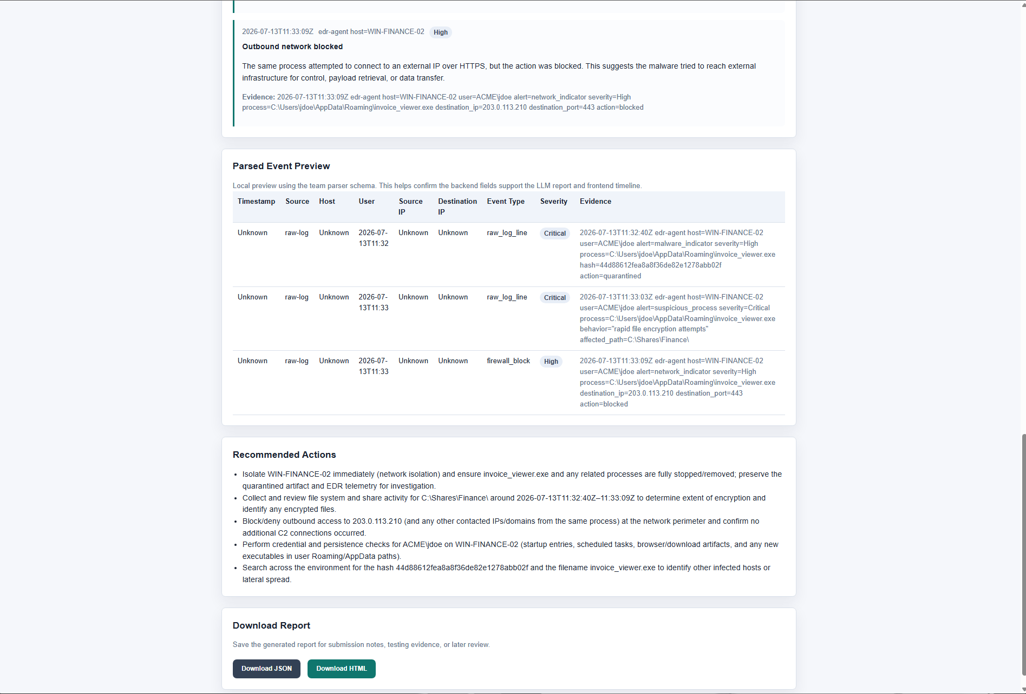

Test 4: Parser Output Validation
Purpose: Confirm Zion's parser output supports the LLM and frontend fields.
Procedure: Derrick reviewed Zion's normalized parser output against the parser output validation checklist.
Expected Result: Parser output should include timestamp, source, host, user, event type, severity, description, evidence, and raw event.
Result: Passed
Screenshots showing the parser output validation checklist and normalized JSON output. The parsed events contain the required fields (timestamp, source, host, user, event type, severity, description, evidence, etc.), confirming compatibility with the LLM and frontend.

Parser output checklist
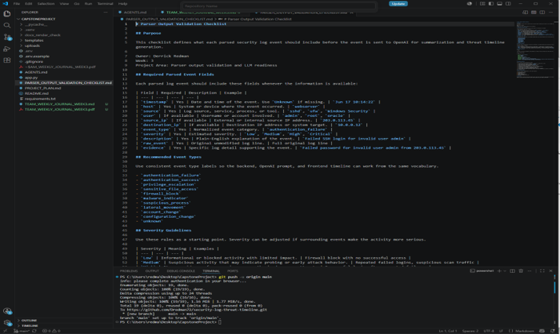
Updated normalized JSON
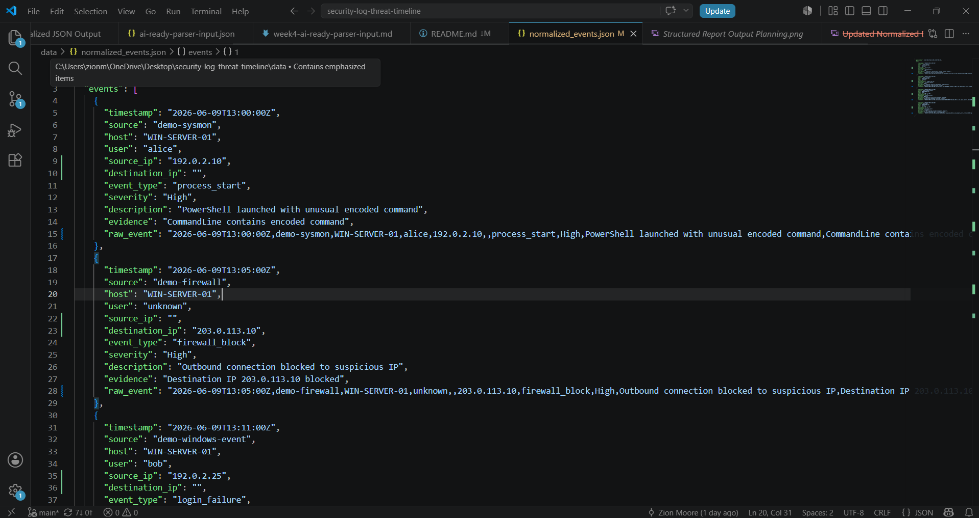

Test 5: Threat Timeline Rules and Grouping
Purpose: Confirm the prompt supports concise chronological timeline generation with evidence.
Procedure: Derrick updated and reviewed the timeline rules in the OpenAI prompt, then tested grouped timeline output.
Expected Result: Timeline events should include timestamp, source, event, severity, details, and evidence. Repeated similar events should be grouped when appropriate.
Result: Passed.
Screenshots of the updated OpenAI prompt timeline rules and the resulting grouped timeline JSON output. Events are chronologically ordered with timestamps, severity, summaries, and supporting evidence, with similar events appropriately grouped.
OpenAI prompt timeline rules
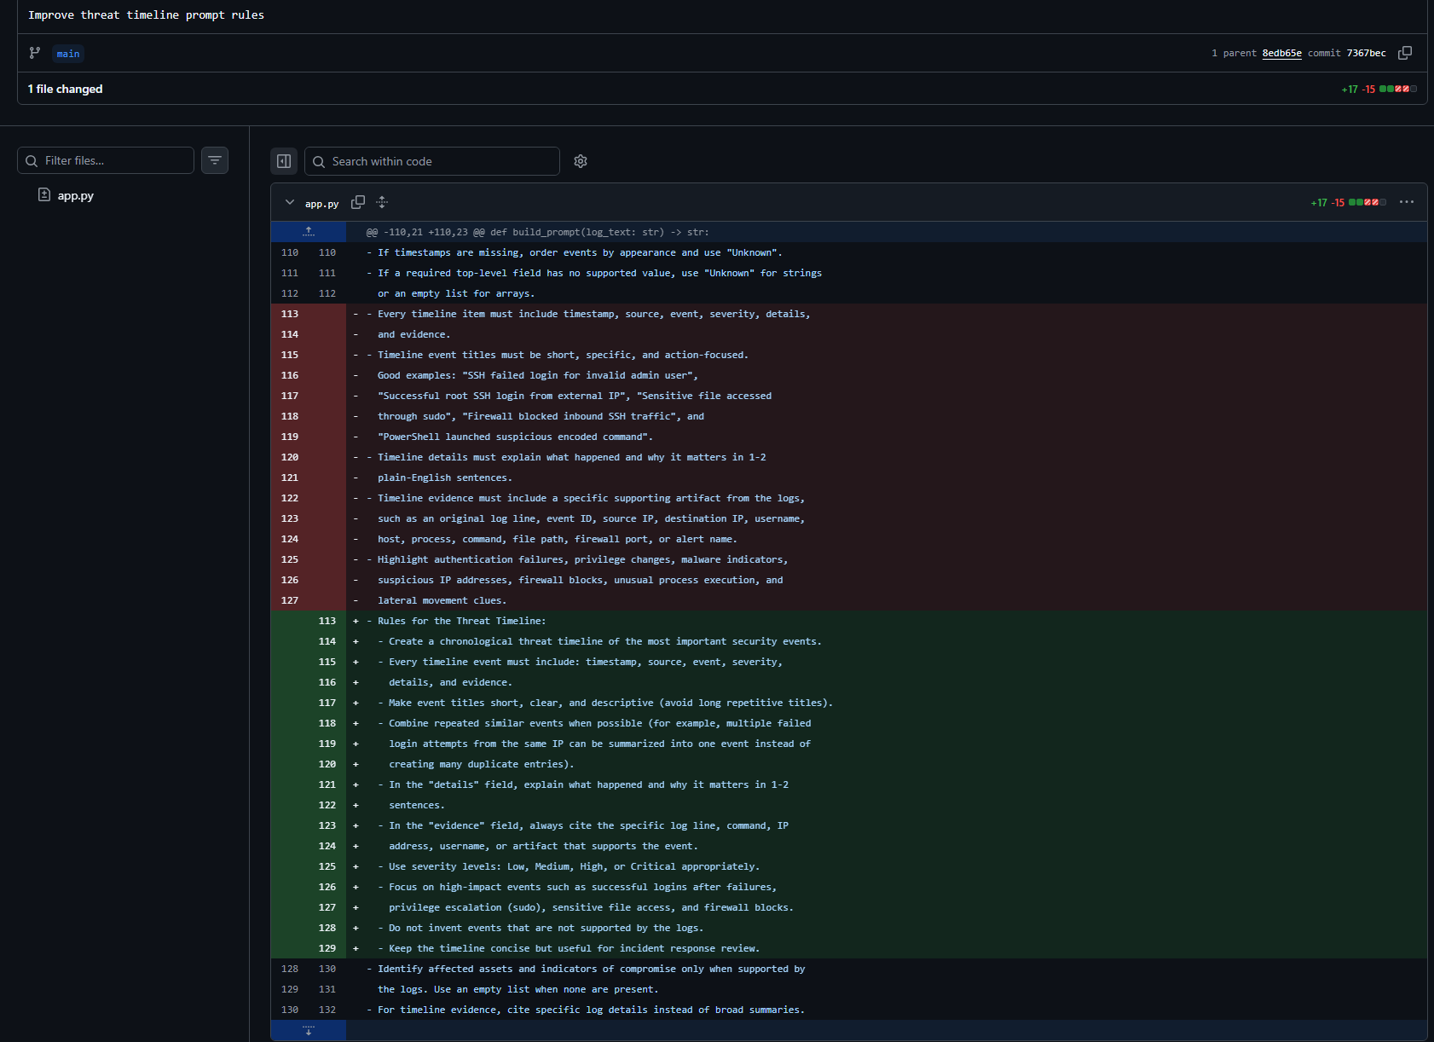
Grouped timeline JSON
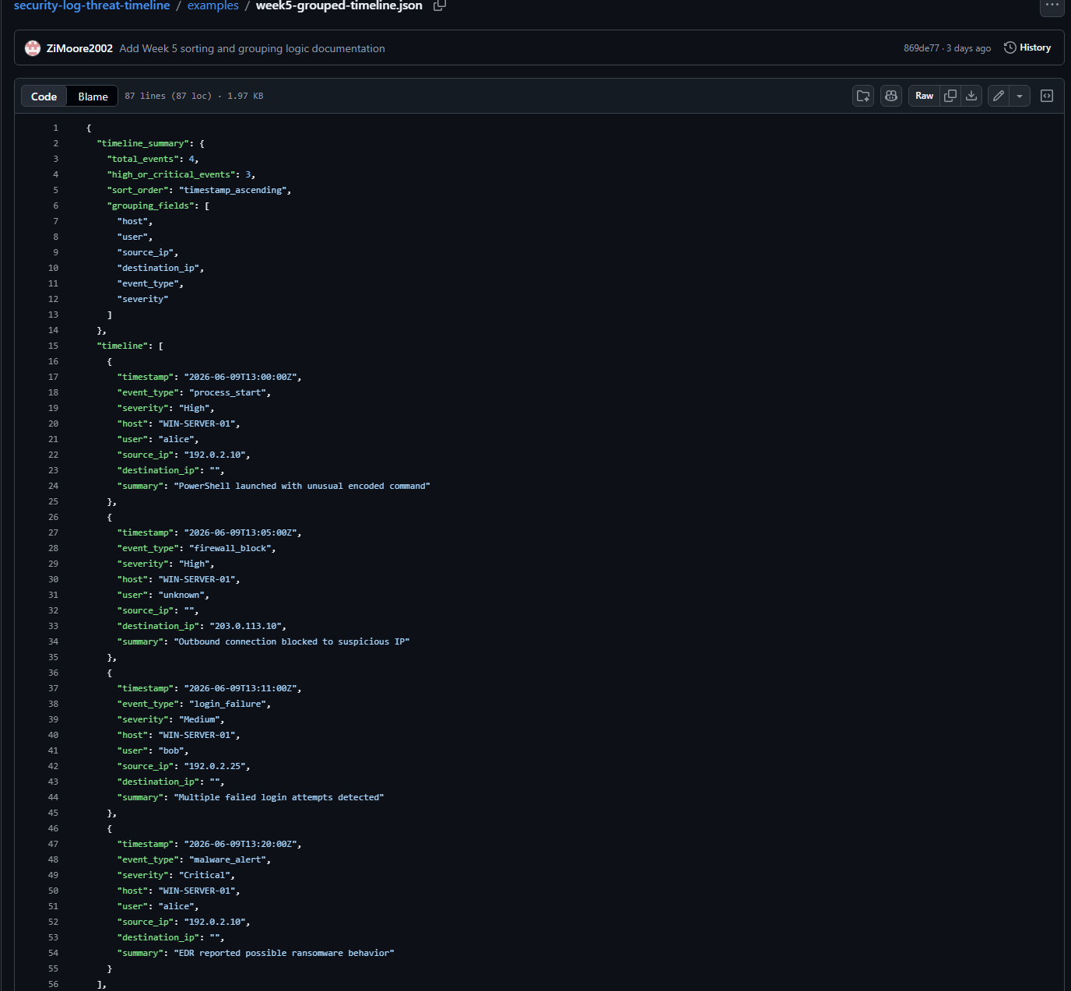

Test 6: End-to-End Report Generation
Purpose: Confirm the Week 6 workflow creates a complete report from pasted or uploaded logs.
Procedure: Derrick generated a report after the Week 6 improvements and reviewed the report sections.
Expected Result: The app should show summary, risk level, risk rationale, assets, IOCs, key findings, timeline, parsed event preview, recommended actions, and download options.
Result: Passed.

Week 6 HTML report generator
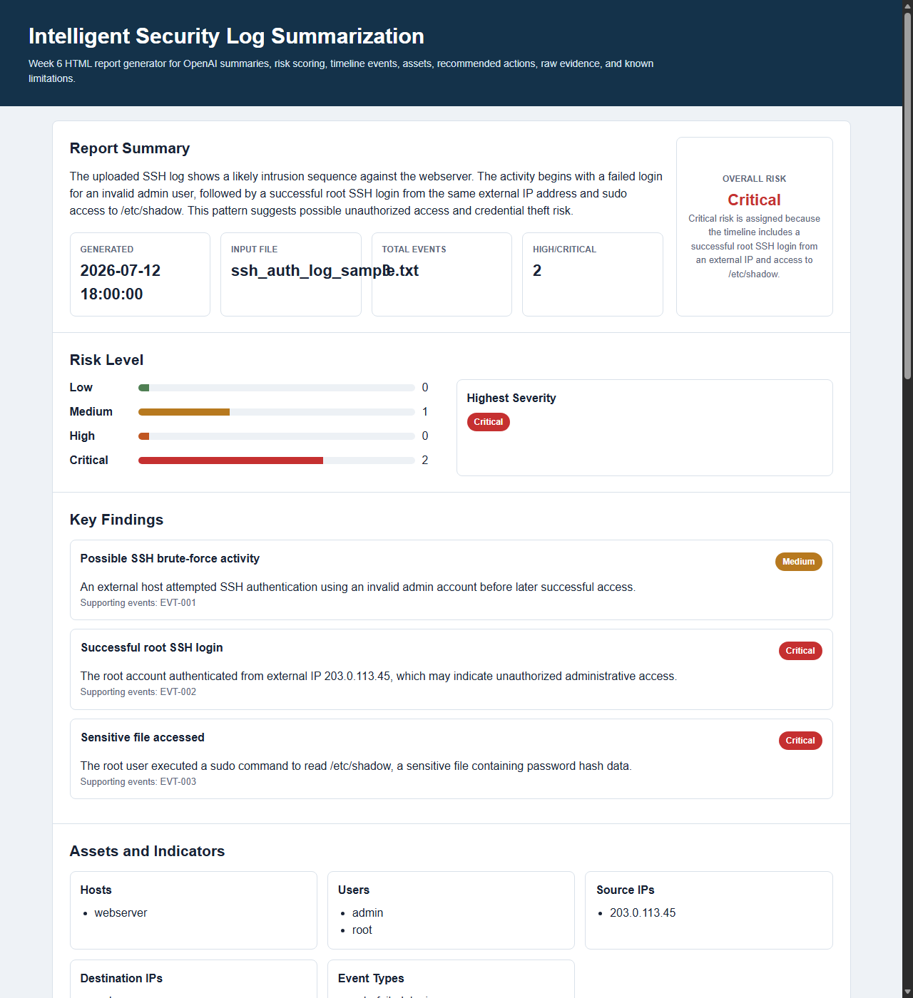

Test 7: Frontend Wireframe and Report Planning
Purpose: Confirm the frontend planning supports the report/timeline sections needed by the project.
Procedure: Oriah created report and timeline wireframe slides and listed the fields needed for display.
Expected Result: The wireframe should support summary, risk, key findings, timeline, indicators/evidence, recommendations, and raw event details.
Result: Passed
PowerPoint wireframes developed by Oriah detailing the frontend report layout and timeline design. The design includes all required sections: Executive Summary, Key Findings, Threat Timeline, Indicators/Evidence, Recommendations, and Raw Event Details.

Frontend wireframe
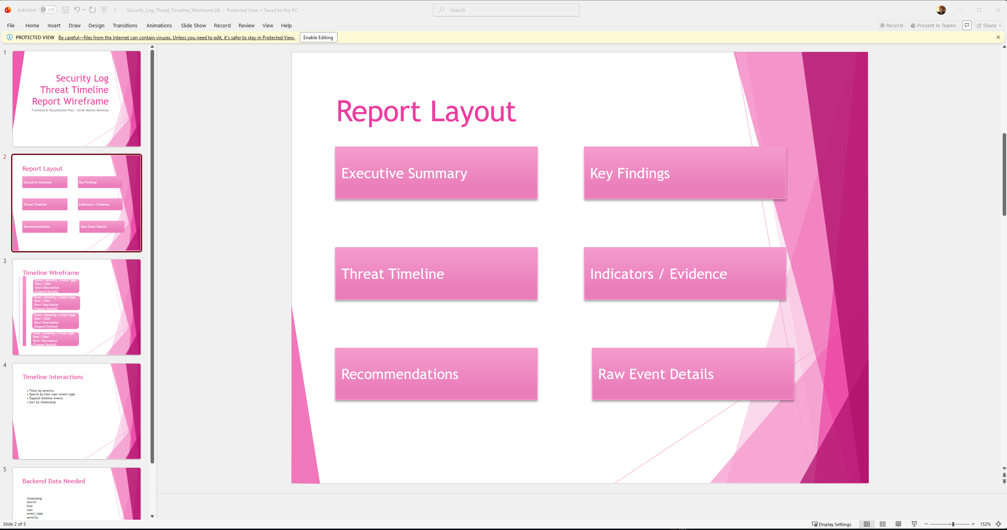
Frontend wireframe details
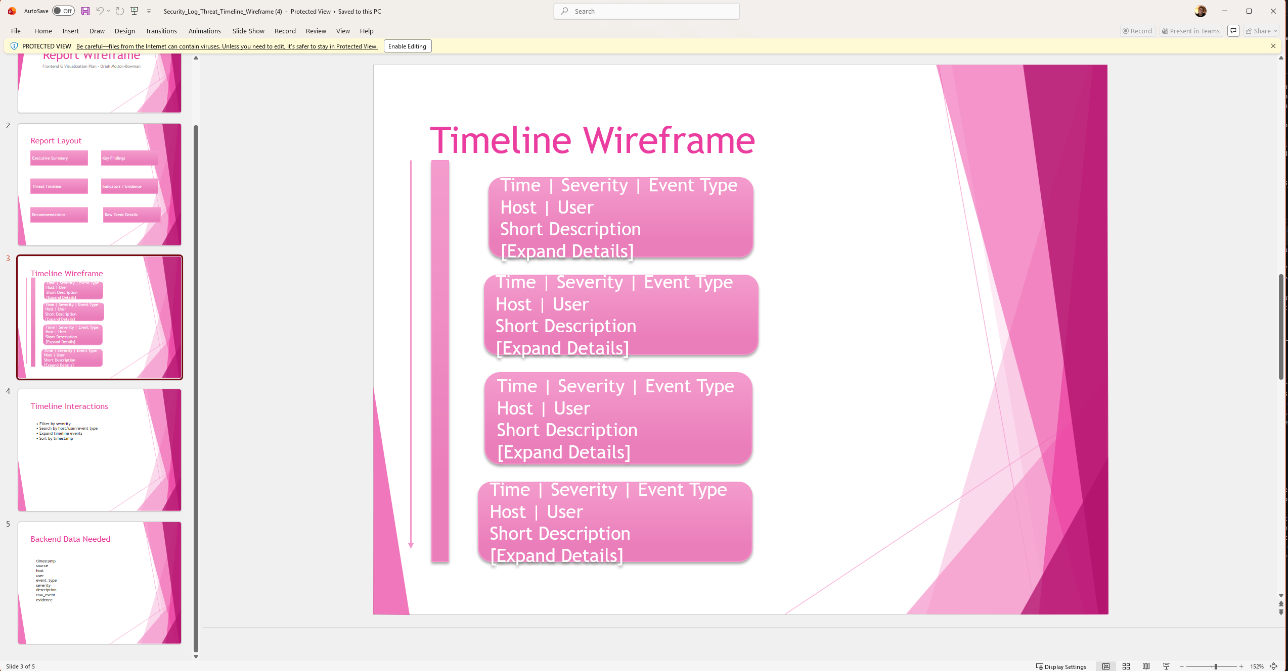

Test 8: GitHub Collaboration and Documentation
Purpose: Confirm the project repository contains the shared source code, README, milestone tracking, and supporting documentation.
Procedure: Derrick reviewed the GitHub repository after team uploads and documentation updates.
Expected Result: The repository should contain app source code, templates, README, milestone TODOs, parser validation, demo/deployment guides, examples, and documentation.
Result: Passed.
GitHub repository for the project (security-log-threat-timeline) showing organized folder structure, commit history, README documentation, and team collaboration. The repository contains all necessary components including source code, reports, templates, and documentation.

GitHub repository screenshot
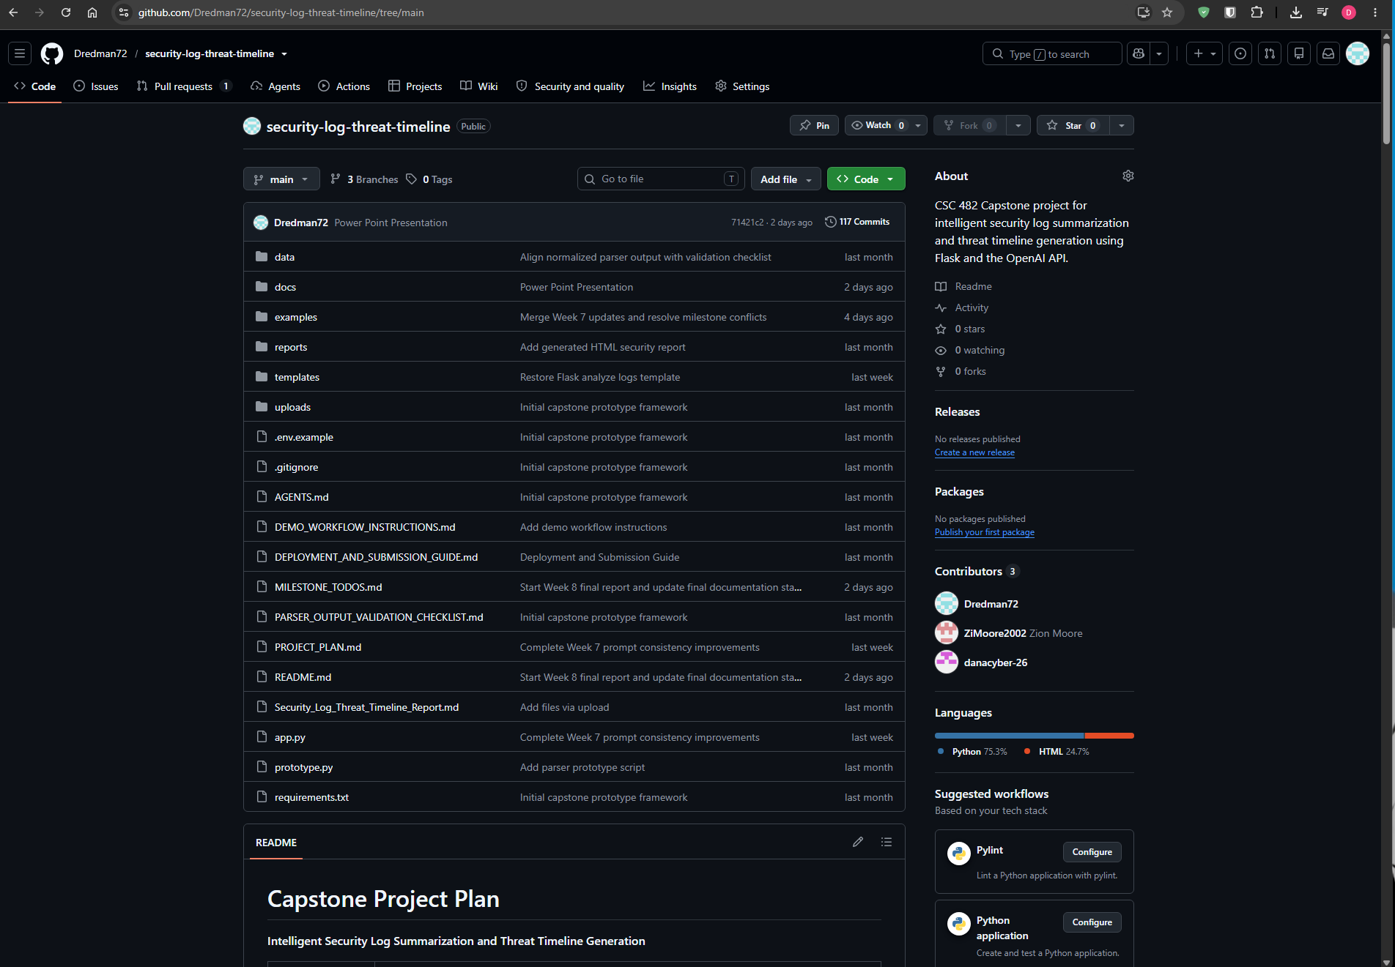

Lessons Learned
- The team learned that the LLM prompt must be specific about output fields, evidence, risk rationale, and timeline formatting to produce useful security reports.
- The team learned that backend parser fields must align with frontend report fields before integration can work smoothly.
- The team learned that repeated events, such as failed logins, should often be grouped so the timeline stays readable.
- The team learned that GitHub collaboration requires careful branching, commits, conflict resolution, and documentation updates.
- The team learned that final report evidence should be captured continuously instead of waiting until the end.

Contribution of Each Team Member
Team Member | Role | Contributions
Derrick Redman | Team Lead and AI/LLM Specialist | Led project coordination, created and refined the Flask/OpenAI prototype, designed the structured JSON output, improved timeline prompt rules, added risk rationale, added reset/download features, tested sample logs, maintained README/milestone documentation, and drafted final report documentation.
Zion Moore | Backend and Log Processing Lead | Created the backend event schema, parser prototype, sample logs, normalized JSON output, AI-ready parser input, upload-to-report pipeline documentation, and Week 7 integrated backend build evidence.
Oriah Molton-Bowman | Frontend and Visualization Lead | Created the report/timeline wireframe, planned frontend report sections, identified required display fields, and documented frontend/report layout expectations for the final HTML report.

Team Meeting Attendance
Date | Attendees | Topic | Duration
June 3, 2026 | Derrick, Zion, Oriah | Project kickoff and role discussion | 1h 1m
June 8, 2026 | Derrick, Zion, Oriah | Initial project planning and assignment review | 54m
June 10, 2026 | Derrick, Zion, Oriah | Project plan, timeline, and schedule | 1h 22m
June 17, 2026 | Derrick, Zion | Parser and LLM structure discussion | 43m
June 18, 2026 | Derrick, Zion, Oriah | Team integration planning and weekly progress | 3h 15m
June 21, 2026 | Derrick, Zion | Backend parser/schema review | 1h 9m
June 22, 2026 | Derrick, Zion | Parser validation and milestone review | 1h 43m
June 24, 2026 | Derrick, Oriah | GitHub and frontend coordination | 26m
July 11, 2026 | Derrick, Oriah | Week 6 status and report layout review | 30m
July 12, 2026 | Derrick, Zion, Oriah | Week 6 completion, roles, and next steps | 1h
Week 7/8 | Derrick, Zion | Roles, complete milestones, and next steps for final report/demo | 1h
July 21, 2026 | Derrick, Zion | Week 8 and final planning discussions | 40m
July 22, 2026 | Derrick, Zion, Oriah | Week 8 Final Hardening, Documentation, and Presentation Preparation | 1:30h

Progress Compared to Plan
The team has progressed according to the project plan overall. The core project is functional locally and supports the main workflow: users can paste or upload logs, analyze them with OpenAI, review structured report sections, inspect a chronological timeline, view parsed event previews, and download JSON/HTML report evidence.
The main remaining Week 8 items are final documentation polish, final presentation preparation, final evidence collection from Zion and Oriah, and signatures from every team member before submission.

Plan Adjustment
No major scope change is needed. The plan for Week 8 is to focus on final hardening, final documentation, final screenshots, final demo flow, and team sign-off. If any final frontend or backend changes arrive late, the team will document them in the final report and keep the README/milestones updated.

Team Sign-Off
Each team member must sign before submission. Team members without signatures may receive zero credit according to the assignment instructions.
Member | Printed Name | Signature | Date
Derrick Redman | Derrick Redman
Zion Moore | Zion Moore
Oriah Molton-Bowman | Oriah Molton-Bowman

