Forecast-based Adaptive Energy–Water Co-Optimization for PV Cleaning Robots

Yunus Emre ERDEM¹, Muhammed Furkan KOŞAR¹, Hasan Berkay ABDİOĞLU¹, Dr. İbrahim Cem BALCI¹

¹ Yıldız Technical University, Faculty of Mechanical Engineering, Department of Mechatronics Engineering, Istanbul, Turkey
¹ emre.erdem2@std.yildiz.edu.tr, furkan.kosar@std.yildiz.edu.tr, berkay.abdioglu@yildiz.edu.tr, icbalci@yildiz.edu.tr

ABSTRACT
This study presents an adaptive cleaning algorithm for photovoltaic (PV) panel cleaning robots that jointly optimizes energy and water usage based on current and forecast weather conditions. The reference cleaning robot employs a combination of mechanical brushing and water spraying, switching between dry and wet modes according to the estimated dust density. A MATLAB/Simulink testbed integrating a single-diode PV cell model, a dust attenuation model together with a robot energy/water cost model is used to evaluate the proposed strategy against periodic and threshold-based baselines on a synthetic 30-day Mediterranean dataset. The forecast-based strategy reduces the 30-day cleaning operational cost and the water consumption significantly relative to a fixed 5-day periodic baseline, while maintaining a comparable level of net energy yield, by deferring cleaning operations that would shortly be rendered redundant by forecast rainfall events.

Keywords: Photovoltaic, Cleaning Robot, Soiling, Adaptive Scheduling, Energy Efficiency

I. INTRODUCTION
Solar energy usage has grown rapidly due to maturing photovoltaic (PV) technologies, making efficiency maintenance critical for return on investment. Surface contamination by dust and debris is among the most significant efficiency degraders, with losses reported up to 70% in heavily soiled installations [1].
Proposed mitigation methods range from fixed water-spray systems to autonomous cleaning robots with intelligent path planning [2,3]. Dynamic scheduling approaches have also been explored, including rain-aware strategies [4], optimization-based scheduling [5], and precipitation-based cleaning models [6]. However, most existing systems are restricted to single arrays, assume constant cleaning parameters, and treat cleaning as an abstract event without accounting for the energy and water costs of the cleaning device itself.
This paper addresses this gap by developing a MATLAB/Simulink framework combining a single-diode PV cell model with dust-induced irradiance attenuation, an explicit energy/water cost model for a mobile brush–spray cleaning robot and a two-layer decision algorithm using rain forecasts to defer or trigger cleaning. The robot switches between dry and water-assisted brushing based on estimated dust density to minimize water usage. The framework is evaluated against periodic and threshold-based baselines on a 30-day synthetic Mediterranean weather profile, providing an integrated, transparent simulation testbed with quantifiable end-to-end costs and savings.
II. METHODOLOGY
II.1. PV Cell and Soiling Model
The single-diode equivalent circuit of a PV cell, used here as a standard reference model, comprises a current source, a diode, a shunt resistor (R_sh), and a series resistor (R_s) [4,5,6], as shown in Figure 1.
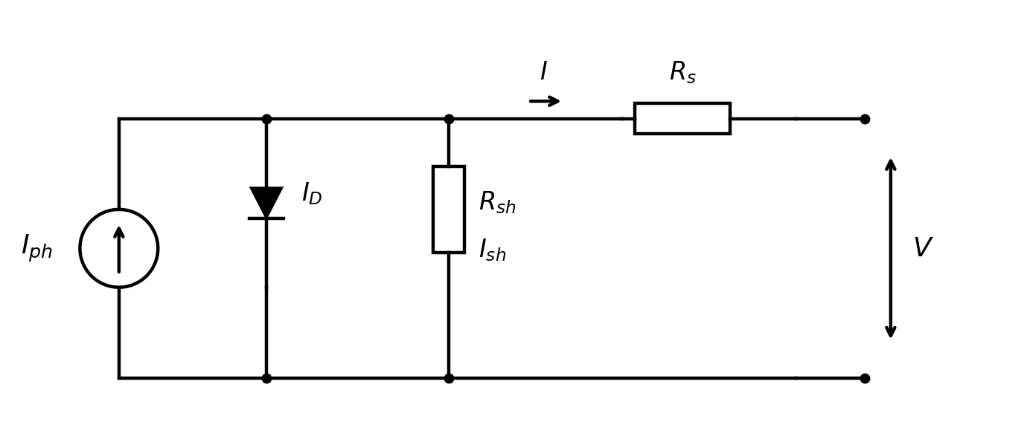
Figure 1: Equivalent circuit model of a PV cell.
The output current I can be expressed as Eq. (1) [4,7,8,9].
I = I_ph - I_s [ exp( q(V + R_s I) / (N k T) ) - 1 ] - (V + R_s I) / R_sh (1)
where I_ph is the photocurrent, I_s is the diode reverse saturation current, q is the electron charge, k is the Boltzmann constant, T is the junction temperature in Kelvin, and V is the diode voltage. The photocurrent depends on irradiance and temperature as expressed in Eq. (2) [4].
I_ph = [ I_sc + K_i (T - 298) ] * (β / 1000) (2)
where I_sc is the short-circuit current at standard test conditions (STC), K_i is the short-circuit current temperature coefficient, and β is the actual irradiance in W/m². The denominator 1000 corresponds to the STC irradiance.
The effect of dust on the panel surface is modelled as an exponential attenuation of the incident irradiance as expressed in Eq. (3) [10].
β_eff = exp( -k_a * m_d ) * β (3)
where m_d is the surface dust density (g/m²) and k_a is the attenuation coefficient. The PV model was implemented in MATLAB/Simulink (Figure 2); the parameters used in the simulations are listed in Table 1 [4,10].
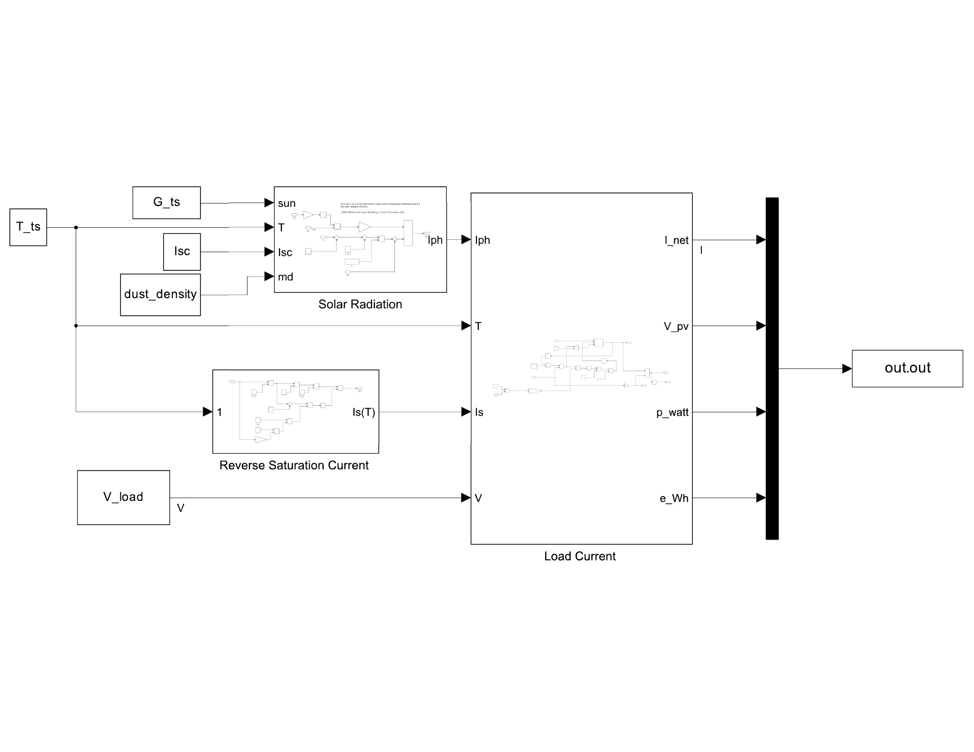
Figure 2: Simulink model of the proposed PV system.
Table 1: PV Cell Simulation Parameters
Parameter | Symbol | Value
Short-circuit current | I_SC | 5.1 A
Temperature coefficient | K_i | 0.0017 A/K
Diode ideality factor | N | 1.2
Series resistance | R_s | 4 mΩ
Shunt resistance | R_sh | 1000 Ω
Dust attenuation coeff. | k_a | 0.05

II.2. Cleaning Robot and Cost Model
The reference cleaning robot is a mobile platform designed for ground-mounted PV plants [ref_robot]. It is equipped with a 5 m wide rotating brush and a water spray system, and traverses panel rows at 60 m/min along a linear track. For a track length d = 1000 m and brush width w_brush = 5 m, the cleaned surface is 5000 m²; assuming an average panel area of A_panel = 2 m², this corresponds to N_panels = 2500 panels. The robot is powered by a P_robot = 3.84 kW electric motor.
The cleaning duration and the per-operation cost are modelled as given in Eqs. (4)–(7).
t_clean = d / v_robot (4)
C_robot = C_energy + C_water (5)
C_energy = t_clean * P_robot * p_elec (6)
C_water = d * w_brush * r_water * p_water (7)
where p_elec and p_water are the electricity and water unit prices, and r_water is the water consumption per unit area. The model accounts only for the marginal operational cost per cleaning run; capital depreciation, labor, and maintenance are excluded for clarity. The parameters and the resulting reference cost per run are summarized in Table 2. Electricity and water unit prices reflect indicative Turkish industrial tariffs as of early 2026 and can be substituted by site-specific values [17,18].
Table 2: Robot Operational Parameters
Parameter | Symbol | Value
Motor power | P_robot | 3.84 kW
Cleaning speed | v_robot | 60 m/min
Track length | d | 1000 m
Brush width | w_brush | 5 m
Water consumption | r_water | 0.5 L/m²
Electricity price | p_elec | 5.0 TL/kWh
Water price | p_water | 0.05 TL/L
Single panel area | A_panel | 2.0 m²
Total panels | N_panels | 2500
Per-operation cost | C_robot | 130.33 TL

II.3. Adaptive Cleaning Optimization Algorithm
The proposed algorithm has a two-layer architecture: hourly monitoring of energy losses through the Simulink model, and a daily decision step that uses both the cumulative loss and a short-horizon rain forecast.
II.3.1. Dust Accumulation Model
The dust density on the panel surface as a function of days since the last cleaning is approximated by a computationally efficient, logarithmically-saturating surrogate relation given in Eq. (8).
D(t) = k_d * k_t * ln(t + 1) (8)
where k_d = 0.05 is a baseline accumulation coefficient, k_t = 1.0 is a dust-type multiplier capturing specific mineralogical attenuation effects [11], and t is the elapsed time in days since the last cleaning. This form is intended strictly as a simplified proxy that preserves algorithmic convexity while producing qualitatively realistic, asymptotic saturation curves consistent with natural soiling mechanics reported in long-term field studies [12]. The coefficients are not calibrated to a specific site, and a higher-fidelity model (e.g., based on real-time PM10 deposition dynamics or panel inclination) should be substituted before any practical deployment.
The 30-day soiling profile produced by Eq. (8), together with the simulated robot cleanings and rain events, is shown in Figure 3.
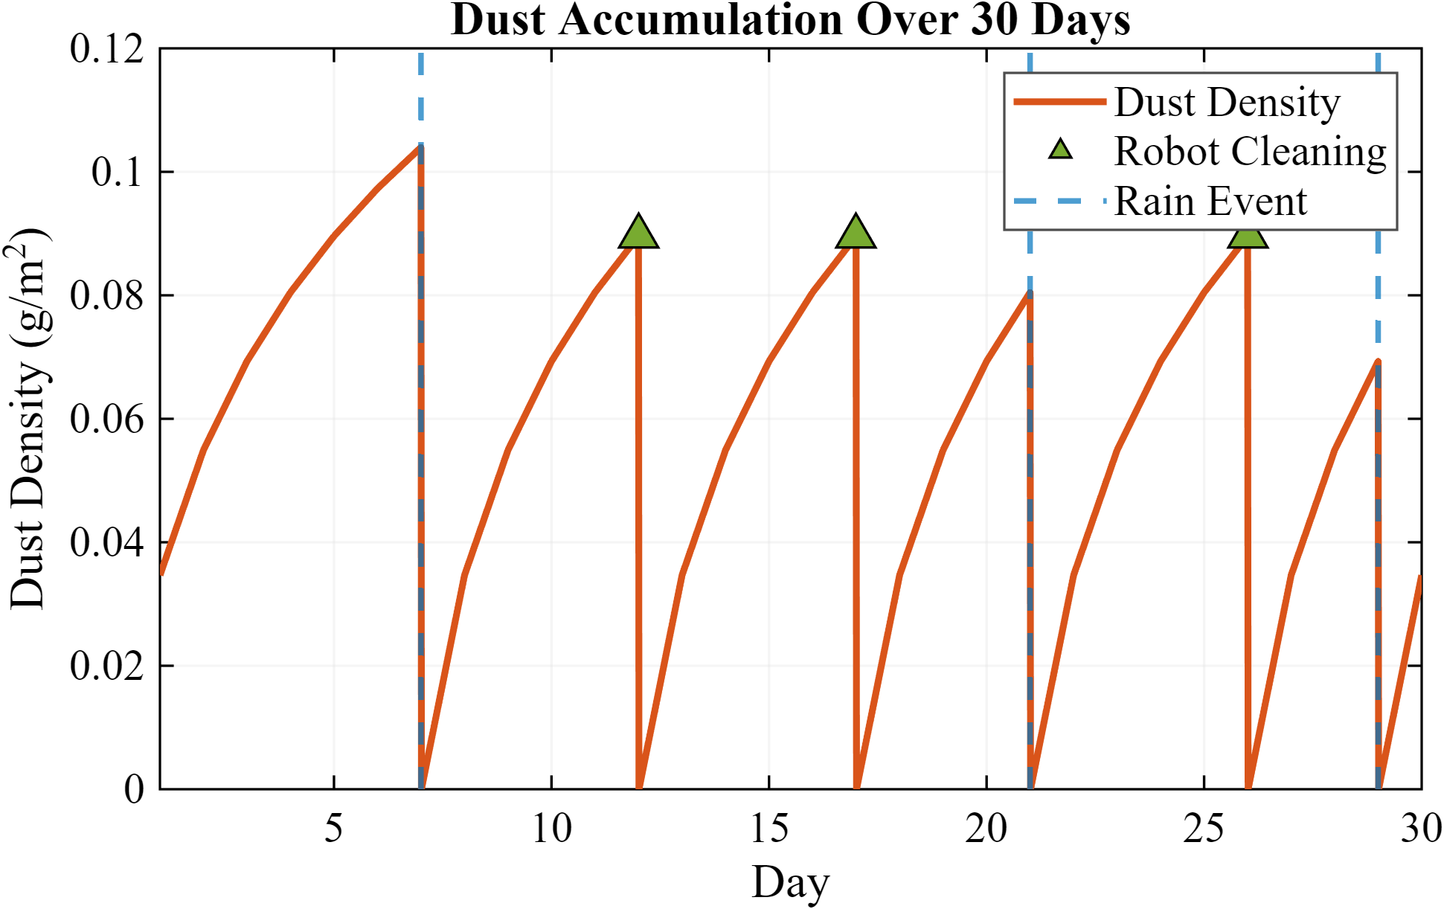
Figure 3: Dust accumulation over 30 days. Green triangles: robot cleaning events; blue dashed lines: rain events.
II.3.2. Hourly Monitoring and Daily Decision
For each day, the Simulink model is executed twice with D = 0 (ideal clean panel) and with the current dust level to compute the daily energy loss and the corresponding financial loss across the plant given in Eqs. (9)–(10).
ΔE_day = E_ideal - E_actual (9)
L_day = (ΔE_day / 1000) * p_elec * N_panels (10)
When the cumulative loss exceeds the per-operation cost C_robot, the algorithm scans the rain forecast over the next n_rain days. The total expected loss while waiting for the forecast rain is approximated as given in Eq. (11).
L_wait = Σ (i=1..n_rain) L_day * D(t_now + i) / D(t_now) (11)
The robot is deployed only if L_wait > C_robot; otherwise the system waits for natural cleaning by rain, whose effectiveness is supported by long-term field measurements [ref_rain]. After a rainfall event or a robot operation, both the cumulative loss and the days-since-cleaning counter are reset. The cumulative financial loss together with the resulting decision points is shown in Figure 4.
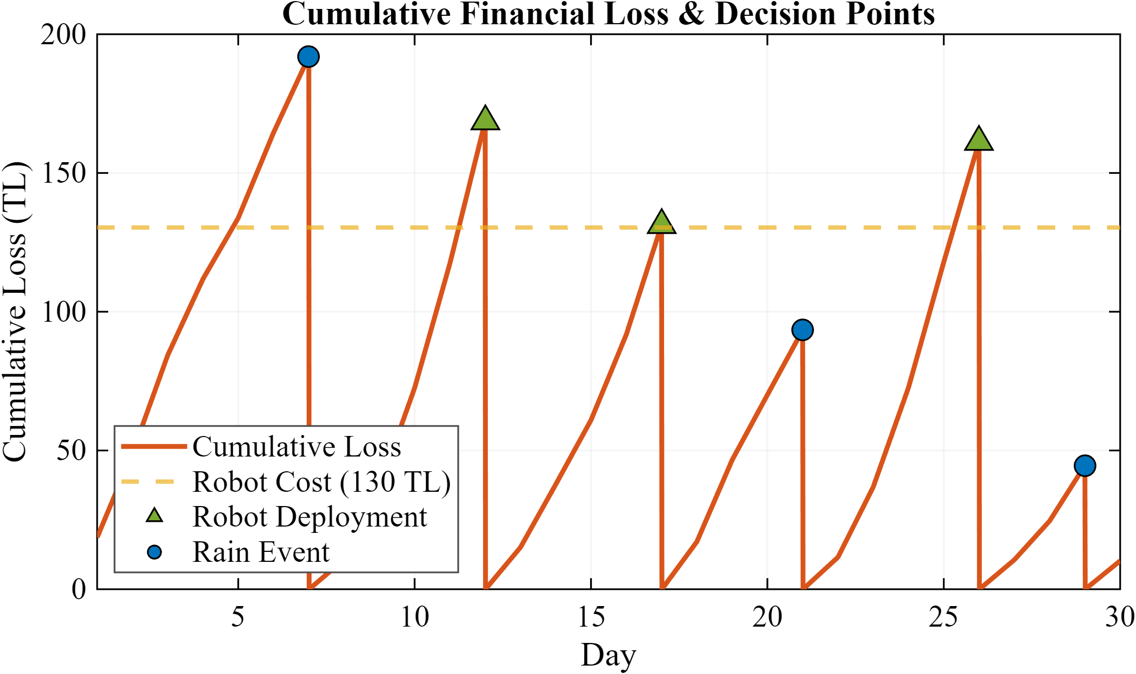
Figure 4: Cumulative financial loss with decision points. Yellow dashed line: robot cost threshold; green triangles: robot deployments; blue circles: rain events.
III. SIMULATION RESULTS
The algorithm was evaluated on a 30-day synthetic Mediterranean meteorological profile including three rainy days, peak irradiance in the range 250–1050 W/m², and ambient temperature in 21–41 °C. The daily irradiance profile is sinusoidal between 06:00 and 20:00, with morning fog and cloud transients; the temperature profile is sinusoidal with a minimum at 05:00 and a maximum near 14:30. A representative day is shown in Figure 5.
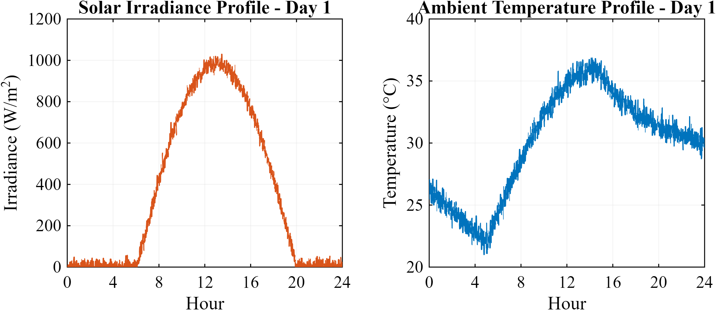
Figure 5: Daily solar irradiance (left) and ambient temperature (right) profiles for Day 1.
The actual versus ideal daily plant energy production over the simulation period is summarized in Table 3; the gap caused by dust progressively widens between cleaning events and is recovered after each robot operation or rainfall. Figure 6 shows the hourly clean-versus-dusty power output (left) and the corresponding efficiency loss (right) for the highest-loss day of the simulation. Losses are concentrated in the midday hours (12:00–14:00), where the same percentage loss translates into a much larger absolute energy loss because of peak irradiance.
Table 3: Weekly Energy Summary
Period | Ideal (kWh) | Actual (kWh) | Loss (%)
Week 1 (Days 1–7) | 10,071.5 | 10,038.6 | 0.33
Week 2 (Days 8–14) | 12,684.2 | 12,653.2 | 0.24
Week 3 (Days 15–21) | 10,327.0 | 10,302.2 | 0.24
Week 4 (Days 22–30) | 12,798.2 | 12,767.6 | 0.24
Total (30 days) | 45,881 | 45,762 | 0.26

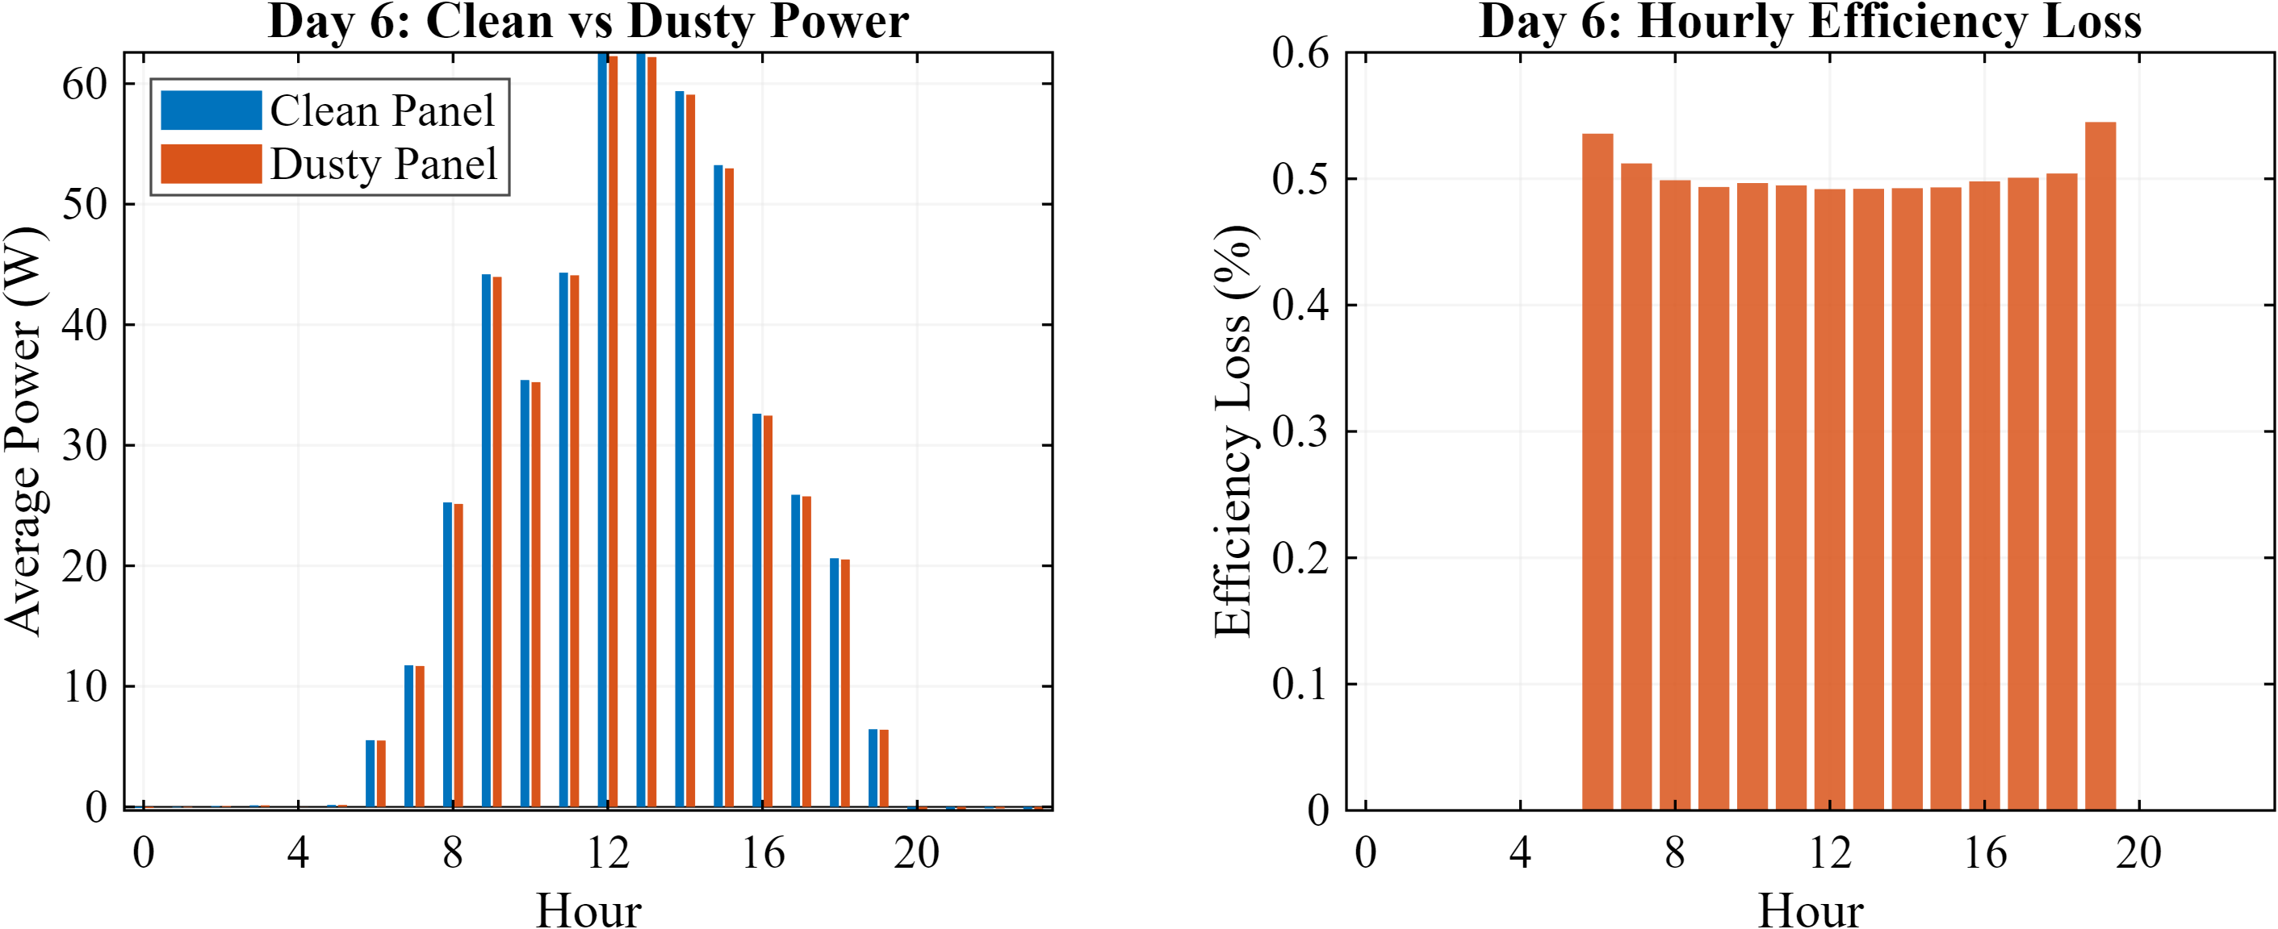
Figure 6: Highest-loss day: hourly power output (left) and efficiency loss (right) for clean and dusty panel.
The proposed forecast-based strategy was compared against two baselines on the same 30-day profile:
• Periodic: robot operates every 5 days, regardless of dust level or weather.
• Threshold (no rain): robot operates whenever the cumulative loss exceeds C_robot, ignoring rain forecasts.
• Proposed: two-layer decision with L_wait comparison against C_robot.
To compare the strategies on a single economic basis that accounts simultaneously for the robot operation cost and the dust-induced energy loss, we define the cost efficiency (CE) as:
CE = (1 - (C_op + L_dust) / R_ideal) * 100 (12)
where C_op is the total robot operational cost, L_dust is the total dust-induced energy loss converted to TL, and R_ideal is the revenue that the plant would generate under permanently clean conditions (229,404.63 TL over 30 days for the simulated configuration). The aggregated results are summarized in Table 4.
Table 4: 30-Day Comparison of Cleaning Strategies
Strategy | N | Robot | Water | Total | CE
Periodic (5-day) | 6 | 782.0 | 15,000 | 1294.4 | 99.44
Threshold (no rain) | 4 | 521.3 | 10,000 | 1076.0 | 99.53
Proposed | 3 | 391.0 | 7,500 | 987.4 | 99.57
Units: N = number of operations; Robot, Total in TL; Water in L; CE in %.

The proposed strategy reduces the 30-day total operational cost by about 24% compared to the periodic baseline and by about 8% compared to the threshold baseline, while also consuming 50% less water than periodic cleaning. The dust-induced energy loss is slightly higher under the proposed strategy because cleaning operations are deliberately deferred while waiting for forecast rainfall, but this is more than compensated by the substantially lower robot operation cost. The cost reduction comes mainly from avoiding cleaning operations that would shortly be made redundant by rain (2 deferrals over the 30 days in the present scenario). The relative gain depends on the local rainfall frequency: in arid regions the proposed strategy converges to the threshold baseline, whereas in regions with frequent precipitation it tends towards a no-cleaning policy.
IV. CONCLUSIONS
This study presented a MATLAB/Simulink testbed and a forecast-based adaptive cleaning algorithm for mobile PV cleaning robots. The two-layer decision mechanism (hourly monitoring combined with daily decisions informed by a short-horizon rain forecast) reduces the total operational cost compared to periodic and pure threshold-based strategies on a 30-day synthetic Mediterranean profile. The results in Table 4 are intended as a comparative illustration of the algorithm's behaviour rather than as predictive numbers for a specific site.
The main limitations of this work are the use of a synthetic weather profile and an uncalibrated logarithmic soiling model. Future work will focus on field validation with measured meteorological and soiling data, and on replacing the empirical soiling model with a physics-based deposition model.
V. REFERENCES
- T. Rahman, A. A. Mansur, M. S. Hossain Lipu, M. S. Rahman, R. H. Ashique, M. A. Houran, R. M. Elavarasan, and E. Hossain, "Investigation of Degradation of Solar Photovoltaics: A Review of Aging Factors, Impacts, and Future Directions toward Sustainable Energy Management," Energies, vol. 16, no. 9, 3706, 2023.
- T. Sasaki, G. E. Enriquez, T. Miwa, and S. Hashimoto, "Adaptive Path Planning for Cleaning Robots Considering Dust Distribution," Journal of Robotics and Mechatronics, vol. 30, no. 1, pp. 5–14, Feb. 2018, doi: 10.20965/jrm.2018.p0005.
- E. Üstündağ and F. O. Hocaoğlu, "Targeted and cost-efficient solar cleaning: A novel RTVA approach to robotic path planning," Applied Energy, vol. 403, Part A, 127064, 2026.
- T. Selmi, M. Bouzguenda, A. Gastli, and A. Masmoudi, "MATLAB/Simulink Based Modelling of Solar Photovoltaic Cell," International Journal of Renewable Energy Research, vol. 2, no. 2, pp. 213–218, Jun. 2012.
- H.-L. Tsai, C.-S. Tu, and Y.-J. Su, "Development of generalized photovoltaic model using MATLAB/SIMULINK," in Proc. World Congress on Engineering and Computer Science (WCECS), San Francisco, CA, USA, 2008.
- F. M. González-Longatt, "Model of photovoltaic module in Matlab," in Proc. 2nd Ibero-American Congress of Students of Electrical, Electronics and Computer Engineering, 2005, pp. 1–5.
- S. Rustemli and F. Dincer, "Modeling of Photovoltaic Panel and Examining Effects of Temperature in Matlab/Simulink," Elektronika ir Elektrotechnika, vol. 109, no. 3, pp. 35–40, Mar. 2011, doi: 10.5755/j01.eee.109.3.166.
- K. Kachhiya, M. Lokhande, and M. Patel, "MATLAB/Simulink model of solar PV module and MPPT algorithm," in Proc. National Conf. Recent Trends in Engineering and Technology, 2011.
- I. H. Atlas and A. M. Sharaf, "A photovoltaic array simulation model for Matlab-Simulink GUI environment," in Proc. Int. Conf. on Clean Power, 2007, pp. 341–345.
- S. M. Said and H. M. Walwil, "Fundamental studies on dust fouling effects on PV module performance," Solar Energy, vol. 107, pp. 328–337, Sep. 2014.
- A. Almarri, R. AlMutairi, F. Alnass, N. Alghamdi, M. M. Ghobashy, M. S. Attia, and M. Madani, "Experimental and modeling study of dust composition impact on photovoltaic performance in arid coastal environments," Journal of Materials Research and Technology, vol. 39, pp. 5455–5467, 2025.
- M. Jaszczur, J. Teneta, K. Styszko, Q. Hassan, P. Burzyńska, E. Marcinek, and N. Łopian, "The field experiments and model of the natural dust deposition effects on photovoltaic module efficiency," Environmental Science and Pollution Research, vol. 26, pp. 8402–8417, 2019.
- M. A. Jaradat, M. Tauseef, Y. Altaf, R. Saab, H. Adel, N. Yousuf, and Y. H. Zurigat, "A fully portable robot system for cleaning solar panels," in Proc. 10th IEEE Int. Symp. on Mechatronics and its Applications (ISMA), 2015, pp. 1–6.
- Istanbul Water and Sewerage Administration (ISKI), "Water Unit Prices." [Online]. Available: https://iski.istanbul/abone-hizmetleri/abone-rehberi/su-birim-fiyatlari/. Accessed: May 6, 2026.
- Energy Market Regulatory Authority (EPDK), "Tariff Tables Used as Basis for Electricity Bills." [Online]. Available: https://www.epdk.gov.tr/Detay/Icerik/3-1327/elektrik-faturalarina-esas-tarife-tablolari. Accessed: May 6, 2026.

