



**COLLEGE OF Business and Economics**

**Department**: BIT GROUP B.

Year: 2.

**Web technology**

**PROJECT: Pet adoption**

**(pets service system)**

|  |  |
| --- | --- |
| NAME | REG NO |
| ABASABEZA Honoré | 222004595 |

**Submitted to**: Dr BUGINGO Emmanuel (Lecturer)



**PETADOPTION**

***Project overview***

The **Petadoption** project is a comprehensive platform designed to cater to the needs of pet owners and service providers within the pet care industry. It offers a range of functionalities to facilitate various aspects of pet care, management, and service provision. Here's an overview of the project:

**Purpose:**

The main purpose of the **Petadoption** project is to provide a centralized platform where pet owners can easily access pet care services and manage their pets' needs efficiently. Additionally, it serves as a marketplace for pet service providers to offer their services to a wide audience of pet owners.

**Key Features:**

**User Management**: Users can register and log in to the platform, creating accounts with their personal information such as username, email, and password. This allows for personalized user experiences and secure access to the platform's features.

**Pet Management**: Pet owners can create profiles for their pets, including details such as names and breeds. This feature enables users to keep track of their pets' information and manage multiple pets within the platform.

**Service Requests**: Users can create service requests for various pet care needs, such as pet sitting, pet grooming, or veterinary care. These requests include detailed descriptions of the services required and are accessible to service providers for review and acceptance.

**Feedback System**:

The platform includes a feedback system where users can provide reviews and comments on their experiences with pet services. This feedback helps improve service quality and build trust between users and service providers.

***Target Audience****:*

*Pet owners:* Individuals who own pets and require pet care services such as pet sitting, grooming, and veterinary care.

*Pet service providers*: Businesses or individuals offering pet care services such as pet sitting, grooming, veterinary services, and pet training.

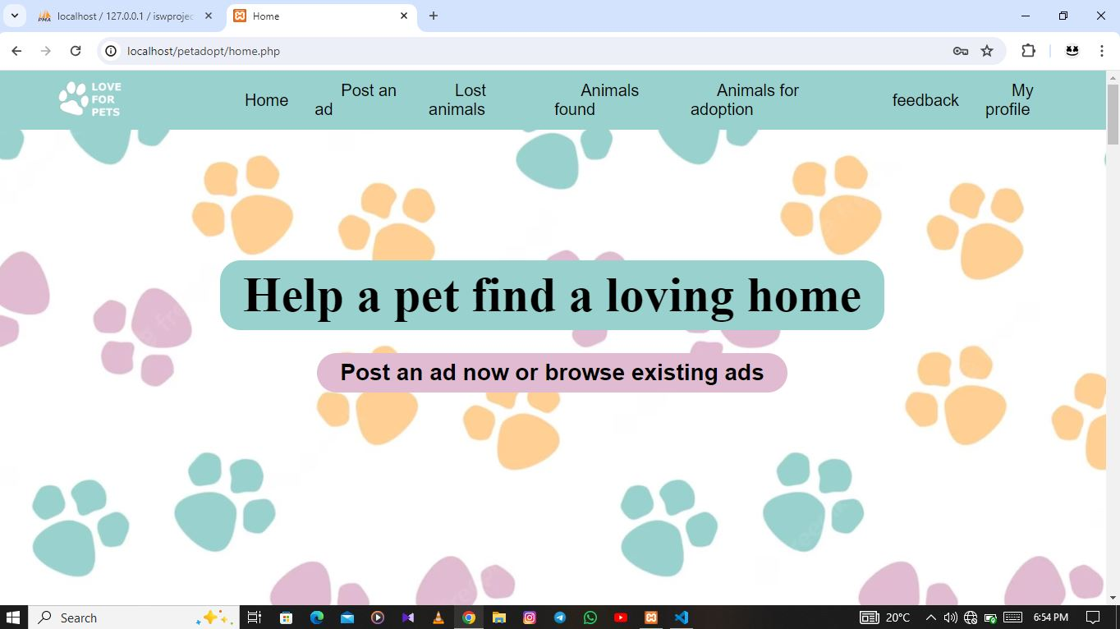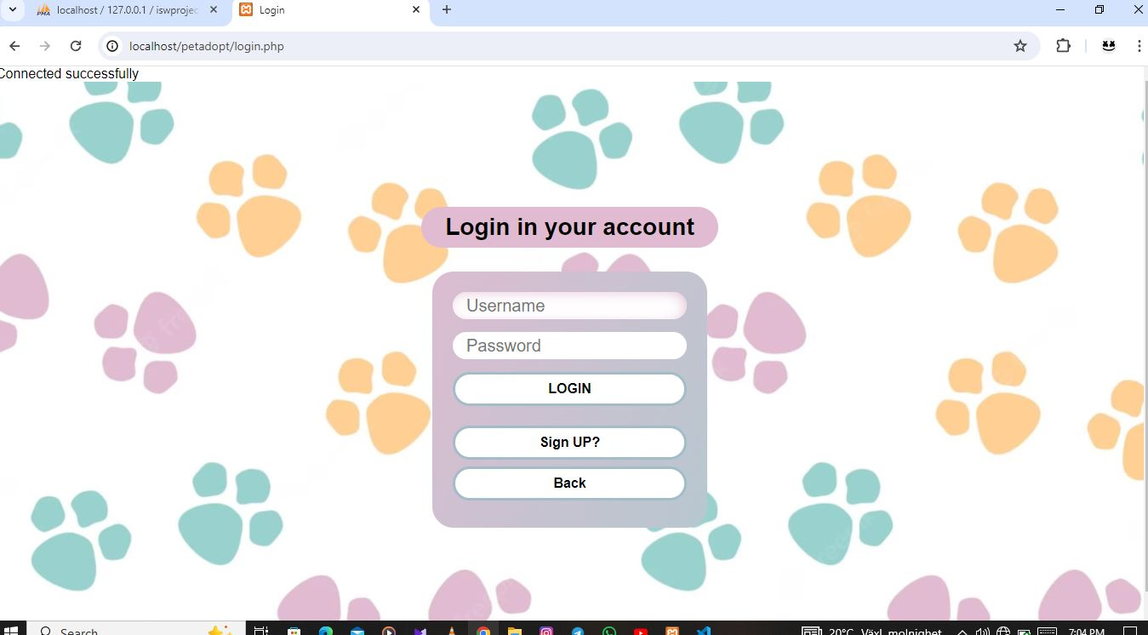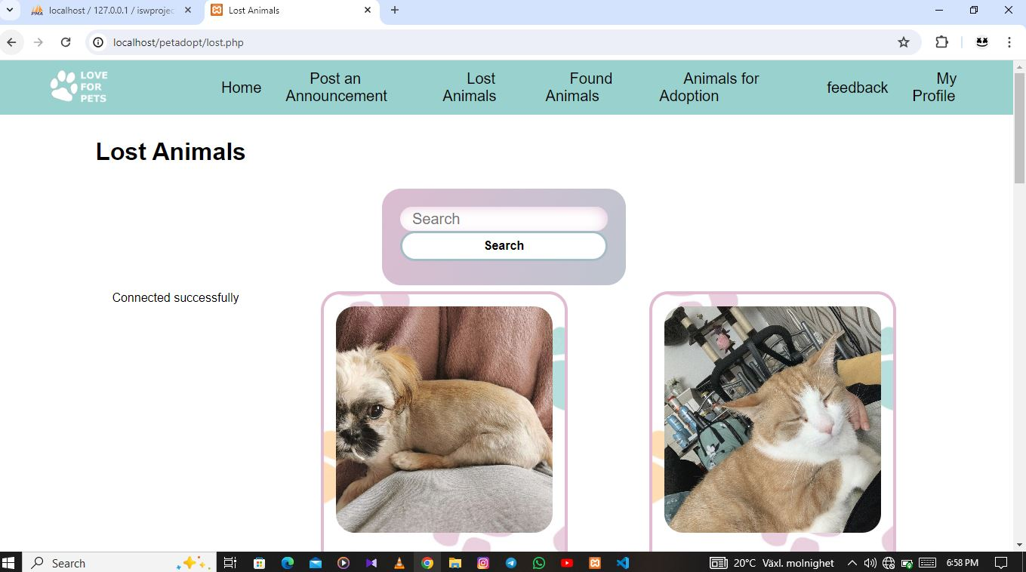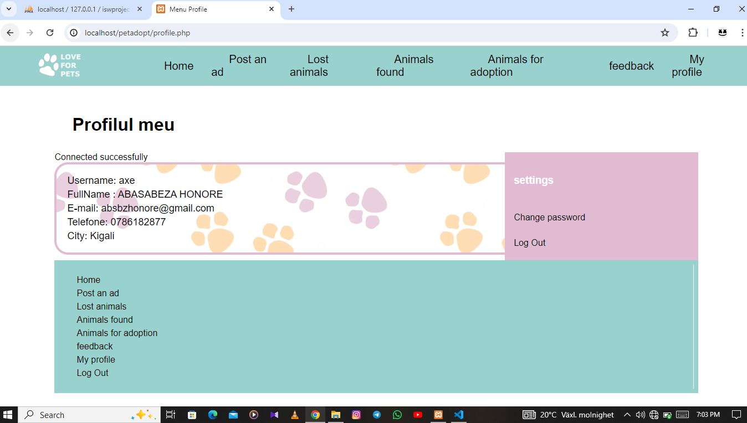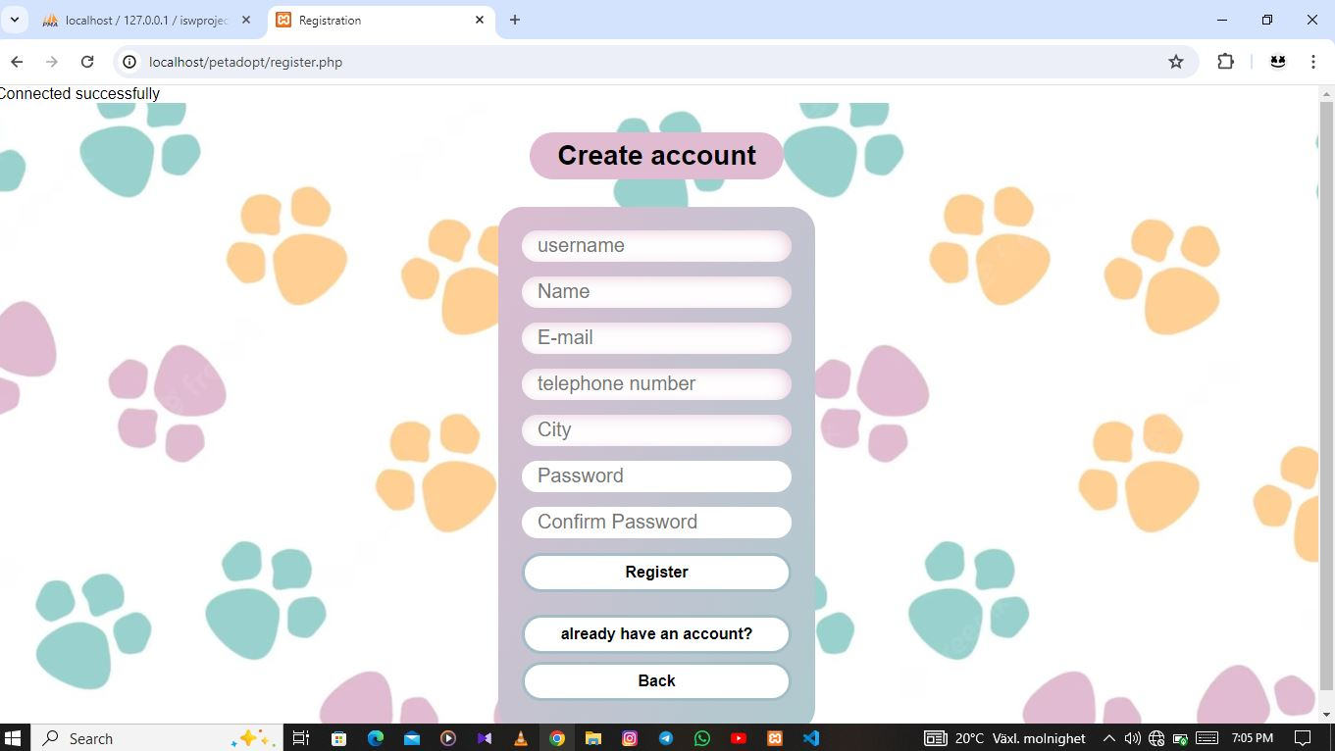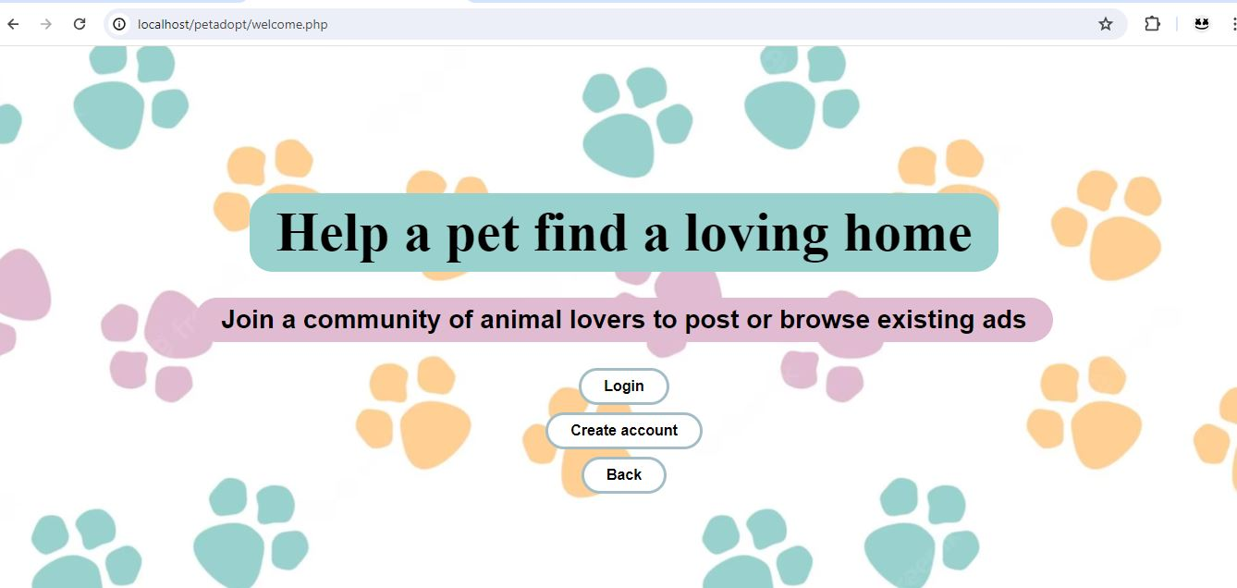

**Conclusion:**

Overall, the Pet adoption system project aims to streamline the pet care process for pet owners while providing opportunities for pet service providers to reach a wider audience and grow their businesses. With its user-friendly interface, comprehensive features, and focus on user satisfaction, Pet adoption system strives to become a trusted platform in the pet care industry.