CTRL + THINK: AN INTERACTIVE VISUAL NOVEL GAME EXPLORING AI DEPENDENCY AMONG COLLEGE STUDENTS

A Capstone Project Presented to the Faculty, College of Computer Studies
Laguna State Polytechnic University
Los Baños Campus
Los Baños, Laguna

In partial fulfillment of the requirement for the degree
Bachelor of Science in Information Technology
Specialized in Animation and Motion Graphics

JOHN LORENCE B. AMARELA
CHRISTIAN B. AÑEZ
ANDREI H. CALDEO

JONALYN JOY LABAYNE

Month and Year of Graduation
APPROVAL SHEET

The Capstone Project entitled “CTRL + THINK: AN INTERACTIVE VISUAL NOVEL GAME EXPLORING AI DEPENDENCY AMONG COLLEGE STUDENTS” prepared and submitted by John Lorence B Amarela, Christian B. Añez, and Andrei H. Caldeo in partial fulfillment of the requirements for the degree Bachelor of Science in Information Technology specialized in Animation and Motion Graphics, is hereby recommended for approval and acceptance.

JONALYN JOY LABAYNE
Adviser

Approval and Acceptance by the Committee on Oral Examination with a grade of____on ____.

MORRIS V. JEBONE CAROLINA R. JOVAL
Member Member

JOCELYN O. PADALLAN
Member

JEFFERSON L. LERIOS
Research Coordinator

Accepted as partial fulfillment of the requirements for the degree of Bachelor of Science in Information Technology.

LOYD S. ECHALAR, DIT
Associate Dean, College of Computer Studies

OFELIA MANINGAS,EdD ____________
Chairperson, Research and Development Office Date Signed

RESEARCH CONTRIBUTION NO.

ACKNOWLEDGMENT
The researchers would like to express their sincere gratitude and appreciation to everyone who contributed to the successful completion of this capstone project entitled “CTRL + THINK: An Interactive Visual Novel Game Exploring AI Dependency Among College Students.” First and foremost, the researchers would like to thank Almighty God for His guidance, strength, wisdom, and countless blessings throughout the conduct of this study. His guidance helped the researchers overcome the challenges encountered during the development of the project. The researchers would also like to extend their heartfelt appreciation to their capstone adviser, Jonalyn Joy Labayne, for her valuable guidance, patience, encouragement, and continuous support that greatly contributed to the improvement and completion of this study. Special thanks are also given to Jefferson L. Lerios for his support and assistance throughout the research process. The researchers are also grateful to Laguna State Polytechnic University, particularly the College of Computer Studies, for providing knowledge, resources, and an environment that helped the researchers enhance their skills and abilities. The researchers would also like to thank their families, and friends for their encouragement, understanding, moral support, and motivation throughout the completion of this capstone project. Lastly, the researchers, John Lorence B. Amarela, Andrei H. Caldeo, and Christian B. Añez, acknowledge their teamwork, dedication, and perseverance in completing this project successfully. The Researchers
DEDICATION
This capstone project entitled “CTRL + THINK: An Interactive Visual Novel Game Exploring AI Dependency Among College Students” is wholeheartedly dedicated to our beloved families for their unconditional love, endless understanding, sacrifices, encouragement, and unwavering support throughout our academic journey. Their guidance and motivation became our source of strength during the challenges, pressure, and hardships we encountered while completing this study. We also dedicate this project to our friends who supported and encouraged us throughout the development process. Their presence, advice, and motivation helped us continue striving despite the difficulties we faced during the completion of this capstone project.
Special dedication is given to Ms.Yvonne Tiffany S. Caliwanagan, whose support, understanding, patience, and encouragement greatly helped us throughout the entire capstone journey. Her presence became one of the inspirations that motivated us to continue working hard and remain determined in achieving our goals. Above all, we dedicate this project to Almighty God for granting us wisdom, strength, knowledge, and guidance throughout this journey. Without His blessings, this achievement would not have been possible. Lastly, this project is dedicated to future students and researchers who may continue exploring the responsible and balanced use of artificial intelligence in education. May this study serve as an inspiration and guide in developing innovative, meaningful, and educational projects in the future.
J.L.B.A
C.B.A
A.H.C

ABSTRACT
This study entitled “CTRL + THINK: An Interactive Visual Novel Game Exploring AI Dependency Among College Students” was developed to help college students become aware of the possible effects of depending too much on artificial intelligence (AI) in their academic work. The game is a 2D interactive visual novel made with Ren’Py in which the player takes the role of a student who must decide whether to rely on AI tools or on personal effort when facing academic tasks. The decisions lead to branching story routes that represent balanced use, moderate dependency, and high dependency. The game was developed through data gathering, concept and script writing, character design, background design, branching choices, and programming. To evaluate the game, the study used the Technology Acceptance Model (TAM), extended with enjoyment and engagement, and a survey questionnaire that was answered by 48 college students through Google Forms. The data were analyzed using frequency and percentage, weighted mean, standard deviation, and Cronbach’s alpha. The results showed that the respondents agreed that the game was useful (M = 3.44), easy to use (M = 4.11), and enjoyable (M = 3.82), and that they had a positive attitude toward using it (M = 3.76) and a favorable intention to use it (M = 3.49). They also agreed that the game helped them reflect on their own use of AI (M = 3.63). The reliability of the questionnaire was good (α = .873). The study concludes that CTRL + THINK is an acceptable educational game for promoting balanced and responsible AI use among college students.
Keywords: AI dependency, visual novel, serious game, Technology Acceptance Model (TAM), college students, responsible AI use
TABLE OF CONTENTS
Preliminaries Page
Title Page i
Approval Sheet ii
Acknowledgement iii
Dedication iv
Abstract v
Table of Contents vi
List of Figures viii
List of Tables ix
Definition of Terms x
Chapters
CHAPTER I INTRODUCTION 12
Project Context 12
Project Objectives 14
Project Purpose 14
Scope and Limitation of the Study 16
CHAPTER II REVIEW OF RELATED LITERATURE AND STUDIES 18
Related Literature 18
Related Literature Matrix 22
Synthesis and Relevance of the Study 27
Theoretical Framework 29
Conceptual Framework 32
CHAPTER III METHODOLOGY 34
Application Development 34
Development Approach 34
Technology Stack 35
Project Design 36
Game Narrative & Branching Structure 37
Game Mechanics 38
System Architecture 39
System Architecture Diagram 39
Layer Descriptions 40
Project Development 41
Animation Development Model 43
Data Gathering 43
Concept and Script 43
Character Design 44
Background Design 46
Branching Choices 47
Programming 47
Materials 48
Data 48
Software Specifications 49
Hardware Specifications 50
Research Design 54
Sampling Design 55
Population of the Study 56
Data Collection Instrument 56
Operational Definition of Variables 57
Statistical Instrument of Data 58
CHAPTER IV RESULT AND CONCLUSION 62
Results by Objectives 62
Profile of the Respondents 67
Level of AI Usage and Dependency 69
System Characteristics of the Game 70
Evaluation Based on the Technology Acceptance Model 72
Summary of the Technology Acceptance Model Results 75
Reliability of the Questionnaire 76
CHAPTER V SUMMARY, CONCLUSION, AND RECOMMENDATION 78
Summary 78
Conclusion 79
Recommendation 80
REFERENCES 81
APPENDICES
Appendix A. Storyboard 84
Appendix B. Character Design 91
Appendix C. Publishable Paper 103
Appendix D. Survey Questionnaire 104
Appendix E. Background Scene 120
Appendix F. Similarity Report 127
Appendix G. Grammar Report 128
Appendix H. Student Curriculum Vitae 129
LIST OF FIGURES
Figure Title Page
1 Technology Acceptance Model (TAM) of Ctrl + Think 30
2 Conceptual Framework 33
3 Ctrl + Think System Architecture Overview 40
4 Sample Character Design 45
LIST OF TABLES
Table Title Page
1 Matrix of Review of Related Literature 22
2 External Variables: System Characteristics of Ctrl + Think 31
3 External Variables: User Characteristics of the Respondents 31
4 Development Approach and Project Phases 34
5 Technology Stack and Development Tools 35
6 Branching Narrative Outcomes Based on AI Dependency 38
7 Hardware Specification of Desktop 51
8 Hardware Specification of Laptop 52
9 Hardware Specification of Laptop 53
10 Hardware Specification of Pentab 54
11 Likert Scale 57
12 Operational Definition of Variables 57
13 Statistical Tools Used for Data Analysis 59
14 Interpretation of Weighted Mean 60
15 Reliability Interpretation Scale 61
16 Overall Learning and Feedback of the Respondents 66
17 Age of the Respondents 67
18 Year Level of the Respondents 68
19 Degree Program of the Respondents 68
20 Frequency of AI Use for Academic Activities 69
21 Common Purposes of AI Use of the Respondents 69
22 Level of AI Usage and Dependency of the Respondents 70
23 System Characteristics of the Game as Rated by the Respondents 71
24 Perceived Usefulness (PU) 72
25 Perceived Ease of Use (PEOU) 73
26 Enjoyment and Engagement (EE) 73
27 Attitude Toward Using the Game (ATU) 74
28 Behavioral Intention and Overall Acceptability (BI) 75
29 Summary of Composite Mean and Standard Deviation 76
30 Reliability of the Questionnaire 77
DEFINITION OF TERMS
2D (Two-Dimensional) Style – The flat, two-dimensional visual style based on length and width, often used in games, animation, and design to create unique, non-realistic artistic styles.
AI Dependency – A growing, sometimes addictive dependence on generative AI tools to perform tasks, make decisions, and provide emotional support, potentially at the expense of critical thinking and cognitive skills. Similar to a behavioral addiction, AI dependency may lead to a decline in skills and a reduction in academic performance.
Artificial Intelligence (AI) – The area of computer science that focuses on the design and development of computers, robots, programmed devices, and software applications to mimic human intelligence and thought.
Branching Narrative – A narrative that branches and diverges, causing the story to have different paths and endings based on player choices, rather than a linear narrative.
Critical Thinking – The disciplined, active process of applying analysis, synthesis, and evaluation to information in order to guide belief and action.
Cronbach’s Alpha – A statistic that measures the internal consistency or reliability of the items in a set of questions on a questionnaire.
Enjoyment and Engagement (EE) – The extent to which using the system is enjoyable and engaging, aside from the usefulness of the system.
External Variables – Factors outside of a person’s beliefs, such as system characteristics and user characteristics, that have an effect on perceived usefulness and perceived ease of use in the Technology Acceptance Model.
Heads-Up Display (HUD) – Interface elements displayed on the screen during gameplay to provide information to the player (e.g., menus, status, scores).
Interactive Visual Novel – A narrative-driven video game that originated mainly in Japan and mixes text-based storytelling with static anime-style visuals (with character sprites and sound), often with the ability to make choices that affect the direction and ending of the story.
Likert Scale – A scale used in questionnaires where respondents indicate their level of agreement (from “Strongly Disagree” to “Strongly Agree”) with a statement.
Perceived Ease of Use (PEOU) – The degree to which one believes that using a system would be free from effort.
Perceived Usefulness (PU) – The extent to which a person believes that use of the system would enhance performance.
Python – A general-purpose programming language. Python is the language that Ren’Py uses to process game logic (score, options, etc.).
Ren’Py – A free, open-source visual novel engine that allows users to combine text, images, and sound to present interactive stories.
Sprite – A 2D image of a character or object displayed and moved on the screen.
Statistical Package for the Social Sciences (SPSS) – A software program used to organize and statistically analyze research data.
Technology Acceptance Model (TAM) – A theory used to measure the acceptance of a system or media product based on the user’s perception of its usefulness, ease of use, attitude towards usage, and behavioral intention.
User Interface (UI) – Refers to the visual elements through which players interact with the game, including menus, buttons, dialogue boxes, and choice selections.
User Experience (UX) - Refers to the overall experience of using the game, including its accessibility, navigation, interaction, and ease of use.
Weighted Mean – An average in which each response value is multiplied by the number of people who selected that response, used to calculate the general level of agreement for each item in a questionnaire.
CHAPTER 1
INTRODUCTION
PROJECT CONTEXT
In an academic setting, many school tasks and strict deadlines must be managed and the outputs have to be submitted. College students use technology for research, reading, collaboration, and managing tasks and schedules. Usual study activities include searching online for references and data, using digital libraries, and using different apps and services as tools for time management and increased productivity.
Outside of the traditional uses of digital technology such as online search engines, chat rooms, and social media, the use of artificial intelligence (AI) has become very common among students, especially college students. Free AI platforms like ChatGPT and Google Gemini are available to everyone. Most of the time, these platforms are used to help the learning process. Students use these AI-based technologies to brainstorm, summarize sources, write essays, solve problem sets, and more for school-related activities. The benefits of this type of technology include time-saving, efficiency, and finding solutions to complicated problems. Even though the overuse of technology has some bad effects, there are also many good effects of using artificial intelligence in the current situation. It is tempting to go with the convenience of AI-based services in academic learning, because students may get used to having everything automatically prepared by a machine without actively thinking in the process of learning.
This change can have negative effects on learning. Students who depend on technology to achieve their educational goals may lack the fundamental skills they will need in their future careers. Cognitive abilities such as critical thinking, creativity, analysis, and synthesis are not fully developed when students depend on artificial intelligence to accomplish tasks and activities that require complex thinking. Educational technology was developed to help people improve their performance, and these technologies were designed to help people learn more and faster. But despite the abundance of tools that make the lives and studies of students easier, there are few measures to teach them how to think about their actions.
There is a lack of tools and interventions that raise awareness of the potential implications of using certain digital technologies in education and that support students in adopting the right behaviors. Currently, there is a need to develop interactive learning environments that make students aware of these implications.
This study presents a new visual novel, named CTRL + THINK, to fill this gap for college-level learners. The main character is a student whose responsibilities are to handle academic duties and make many decisions about their academic performance. These decisions are presented in two ways: the independent path (hard-working, skill-driven, less AI) and the dependency path (convenient, heavy use of AI). It can be seen as a virtual practice game in which players see the immediate and future consequences of their actions and learn from their mistakes. The game does not tell players what to do; instead, it teaches them to make their own decisions. This game helps players train their thinking skills by means of technology.
This project is needed because students’ AI dependence is already a documented and measurable problem. For example, Zhang et al. (2024) found that students’ academic stress and performance expectations drive problematic AI usage. Also, Morales-García et al. (2024) created a scale for measuring AI dependence as a type of behavior among university students. Recent research also warns that over-reliance on generative AI can lead to cognitive offloading and undermine critical thinking ability (Si et al., 2026), and it can lead to addictive usage (Xu et al., 2026). Most schools’ responses, however, seem to limit or detect AI use instead of letting students know how harmful over-reliance is.
Interactive media can address this problem. Visual novels have been shown to increase self-directed learning, engagement, and motivation (Prayogi & Prihatin, 2024; Himes, 2022; Suryapranata et al., 2023), and serious games have been shown to be effective in educating students about academic integrity, such as plagiarism (Ade-Ibijola et al., 2022). However, few games focus specifically on the problem of AI dependency among Filipino college students. By allowing students to experience the effects of AI dependency in a safe, simulated environment before their habits affect their actual academic performance, CTRL + THINK addresses this gap.
PROJECT OBJECTIVES
Generally, this project aims to develop an interactive visual novel game that highlights AI dependency among college students. Specifically, this research seeks to:
1. Create a visual novel style game that shows the process and impact of relying on AI technology through interactive story branches, interactions between characters, player decisions, and 2D style graphics, while also considering the impact of AI technology on students’ learning, decision making skills, and problem-solving capabilities.
2. Assess the support for self-reflection and better understanding of using AI responsibly, in particular the importance of balance between AI assistance and self-thinking when doing schoolwork, in the developed visual novel game.
3. Assess the success of the developed game in terms of its usability and learning efficacy through the use of the Technology Acceptance Model (TAM). The variables include the external variables of the study, as well as perceived usefulness, perceived ease of use, enjoyment and engagement, attitude toward using, and behavioral intention to use the game as a learning tool.
PROJECT PURPOSE
The project aims to examine the growing overdependence on AI tools such as ChatGPT, Google Gemini, and other similar generative AI tools that are now frequently used for academic purposes and the importance of finding a proper balance between the use of such technological advances and developing critical thinking skills. The integration of AI technology is increasingly common among college students who rely on AI to complete various academic tasks. The current generation of learners incorporates AI to perform such functions in place of humans. A potential risk is associated with how overreliance on technology impacts the development of cognitive skills.
The proposed project aims to prove through a thorough investigation how overdependence on AI technologies reduces creativity, curiosity, problem-solving skills, and intellectual engagement overall according to existing cognitive studies. Although the phenomenon is widely discussed, there are very few innovative and engaging interventions aimed at addressing AI overreliance issues. Most efforts are centered around regulating or restricting the use of technology to prevent negative effects on cognitive processes rather than raising student awareness and encouraging reflection on behaviors. In order to attract attention from a digital native audience and make the project more effective, it is suggested to incorporate another medium to communicate with potential users and create interactive experiences. The idea behind the project is to develop an interactive game that would allow users to see the consequences of certain actions and make educated choices. The capstone project includes the development of a visual novel game "CTRL + THINK" an interactive game with several story paths, choices, characters, stylized graphics, and multiple endings.
The purpose of the project is to suggest an interactive intervention that promotes awareness about AI overreliance among college students. Using the digital native medium allows the project to address complex concepts, such as the process of cognitive dependency or decline in critical thinking abilities. The proposed intervention offers instructors a valuable tool to discuss academic integrity and independent learning issues with students.
This project is in line with the United Nations Sustainable Development Goals (SDGs), more precisely with the achievement of SDG 4 on Quality Education and SDG 9 on Industry, Innovation and Infrastructure. The SDG 4 calls for inclusive and quality education and promotion of lifelong learning opportunities for all. SDG 9 is about promoting sustainable industrialization and fostering innovation by enhancing responsible technological advancement that supplements human capabilities. The project addresses the issue of using advances in artificial intelligence technology in ways that benefit education.
SCOPE AND LIMITATION OF THE STUDY
This capstone project develops an interactive visual novel titled Ctrl + Think, designed to explore college students’ reliance on artificial intelligence in everyday academic activities. The study examines students’ responses to structured scenarios in which AI serves as a convenient tool, while highlighting the potential consequences of depending on AI instead of engaging in independent thinking. The game presents a series of predefined narrative scenarios or routes that reflect common academic situations such as completing assignments, answering quizzes, and generating original ideas. Players are given fixed decision points where they choose between using AI or relying on their own problem solving skills. These choices directly influence the flow and lead to multiple predetermined endings, allowing players to experience the cause and effect relationship between their decisions and academic outcomes. The game specifically aims to develop awareness of AI dependency, strengthen critical thinking, and encourage more intentional decision making among students.
The game is designed not only as an educational and reflective tool but also as a controlled interactive system that demonstrates how repeated reliance on AI can affect learning behavior. It incorporates human psychology such as decision-making processes, behavioral patterns, and cognitive biases to make player choices more realistic and relatable. These psychological elements are embedded through scripted scenarios and do not adapt dynamically to individual users. The AI represented in the game functions solely as a narrative element that simulates the role of tools like ChatGPT or Gemini, guiding the storyline and influencing decisions, but it does not operate as a real-time AI system and cannot generate actual responses or interact beyond the designed script.
The system includes a reflection component where players provide feedback after completing the game, allowing the researchers to gather insights into students’ perceptions and realizations regarding AI usage. This component is limited to immediate post game responses and does not measure long term behavioral changes. The game is developed using 2D graphics, dialogue systems, and user interface elements that support interactive storytelling these are constrained by the developers technical capabilities, time, and available resources, resulting in a limited number of characters, story paths, and visual variations.
The study is limited to college students and focuses exclusively on AI usage within academic contexts. It does not cover AI applications in professional environments. While the scenarios are designed to reflect realistic student experiences, they are generalized and may not fully represent all academic disciplines, institutional settings, or cultural backgrounds. The interactive visual novel provides a structured and meaningful platform for students to reflect on their academic behavior and better understand the balance between AI assistance and independent thinking within the defined scope of the project.
CHAPTER 2
THEORETICAL FRAMEWORK OF THE PROJECT
REVIEW OF RELATED LITERATURE, STUDIES, AND SYSTEMS
The expanding integration of artificial intelligence and interactive media in education has significantly transformed how students engage with learning processes. According to Prayogi and Prihatin (2024), the integration of artificial intelligence (AI) and interactive media has significantly influenced modern educational practices. As digital technologies become more accessible, instructional strategies are shifting toward immersive and interactive approaches that promote active engagement and critical thinking. In this context, visual novels are considered an emerging form of educational serious games that combine storytelling with interactive learning.
Visual novels have been shown to enhance both cognitive and affective aspects of learning. Visual novels developed using Ren’Py improve self-directed learning, especially in subjects involving complex and abstract concepts such as Natural and Social Sciences (Prayogi & Prihatin, 2024). Similarly, visual novels based on literary texts increase student engagement and improve visualization skills, allowing learners to better understand the content (Himes, 2022).
Visual novels and game-based learning environments are increasingly recognized as effective tools for developing critical thinking and ethical awareness among students. These interactive systems allow learners to engage in narrative driven scenarios where their decisions directly influence outcomes.
Stealth assessment has emerged as a significant approach in educational games, enabling the evaluation of learners’ competencies through in game behavior rather than traditional examinations. According to Yu et al. (2022), stealth assessment can be embedded within game based learning systems by analyzing continuous gameplay data to infer students’ cognitive skills and decision making abilities. This method allows educators to assess learning outcomes in real time without disrupting the flow of gameplay. Such approaches promote deeper engagement while encouraging learners to reflect on ethical issues, including academic integrity and responsible decision making, as these concepts are integrated into interactive scenarios.
The technological advancements have also created opportunities to support diverse learners. According to Atsalaki and Kazanidis (2025), virtual reality based visual novels provide structured and visually guided environments that support children with Autism Spectrum Disorder in developing social and emotional skills. Although immediate behavioral changes were limited, the study emphasized the importance of safe environments for learning. Generative AI tools can assist college students with Attention Deficit or Hyperactivity Disorder in managing academic tasks and emotional regulation. The effectiveness of these tools depends on students’ digital literacy and the availability of institutional support (Deep et al., 2026).
The increasing use of AI in education has raised several concerns. As mentioned by Klimova and Pikhart (2025), AI can support personalized learning and reduce academic stress, which contributes to improved performance. Deep et al. (2026) also noted that AI tools can enhance productivity and well-being. However, excessive reliance on AI may lead to reduced interpersonal interaction, increased anxiety about future employment, and lower emotional intelligence.
Recent research confirms the risks of AI dependence. According to Xu et al. (2026), the I-PACE model explains how users may develop dependence on AI due to its usefulness and convenience, which can lead to addictive behavior. This dependence may result in learning burnout, including emotional exhaustion and decreased academic performance. AI dependence can lead to cognitive inertia, where students avoid critical thinking and rely heavily on automated responses. These findings suggest that while AI improves efficiency, overdependence can weaken important skills such as creativity, problem solving, and independent thinking (Ma et al., 2025).
Ethical issues have also emerged due to the widespread use of AI tools in academic settings. According to Hua (2023), there is a gap between students’ understanding of academic integrity and their actual behavior, particularly in online assessments. This indicates that students may misuse AI tools despite being aware of ethical standards. AI generated outputs make it difficult to distinguish between human created and AI assisted work, challenging traditional definitions of plagiarism and authorship.
Game based approaches have been identified as potential solutions to these ethical concerns. According to Ade-Ibijola et al. (2022), serious games can help raise awareness of plagiarism by allowing students to experience the consequences of their decisions in simulated scenarios. These approaches alone may not be sufficient. Structured interventions such as the AI Dependence Inclusive Course for Transparency (AIDICT) have been proposed to promote responsible AI usage and strengthen ethical awareness. These findings highlight the importance of combining educational tools with institutional policies to address ethical challenges.
Other studies highlight both the effectiveness of visual novels and the concerns regarding AI dependency among students. According to Suryapranata et al. (2023), integrating visual novels into gamified learning environments significantly improves student motivation. Their findings revealed measurable increases in engagement and interest after the implementation of a visual novel based learning system.
Zhang et al. (2024) examined AI dependency among students and found that factors such as academic stress and performance expectations contribute to problematic AI usage. The study emphasized that excessive reliance on AI tools can lead to dependency behaviors that negatively affect students’ learning autonomy.
Morales-García et al. (2024) developed and validated a scale to measure AI dependency among university students, establishing it as a reliable instrument for assessing their level of reliance on artificial intelligence in academic settings. Their study confirmed that AI dependence is a measurable behavioral construct linked to students’ interaction with technology, reinforcing concerns about overreliance in academic environments.
Estrada-Araoz et al. (2025) found that interactive digital systems improve user engagement by combining structured content, multimedia elements, and organized presentation. The study emphasized that well designed interactive environments enhance learning and understanding, making them effective tools for both education and communication.
There is a need for innovative approaches that integrate technology while promoting responsible usage. Visual novels, in particular, allow learners to engage in decision making and reflect on the outcomes of their actions. This supports experiential learning, where knowledge is developed through experience and reflection. It is within this context that the present study, entitled “Ctrl + Think: An Interactive Visual Novel Game Exploring AI Dependency Among College Students” aims to bridge the gap between technology use and critical awareness. By using an interactive visual novel format, the project enables users to make decisions and observe their consequences, helping them understand the risks of overreliance on artificial intelligence and encouraging more responsible use of technology.
RELATED LITERATURE MATRIX
Table 1. Matrix of Review of Related Literature
Authors | Title | Year | Key Findings
Atsalaki, K., Kazanidis, I. | Combining Virtual Reality Visual Novels and Social Stories to Support Social and Emotional Development in Children with Autism Spectrum Disorder | 2025 | VR based visual novels provide structured and safe learning environments that support social and emotional skill development in children with Autism Spectrum Disorder. While immediate behavioral changes were limited, the study highlighted long term benefits in learning adaptation and emotional support.
Promethi Das Deep, Nitu Ghosh, Adam P. Natoli | Artificial Intelligence for Supporting College Students with Attention-Deficit/Hyperactivity Disorder: Cognitive, Emotional, and Ethical Perspectives | 2026 | Generative AI tools can assist students with ADHD in academic task management and emotional regulation. However, effectiveness depends heavily on digital literacy and institutional support systems.
Edwin Gustavo Estrada-Araoz, Maribel Mamani-Roque, Jhemy Quispe-Aquise, Yesenia Verónica Manrique-Jaramillo, Elizabeth Orfelia Cruz-Laricano | Academic self-efficacy and dependence on artificial intelligence in a sample of university students | 2025 | Interactive digital systems improve user engagement and comprehension by combining structured content, multimedia elements, and organized learning design. These systems enhance both communication and educational effectiveness.
Morgan Himes | Visual Novel Based Education in English Literature: A Study on Student Engagement | 2022 | Visual novels based on literary texts improve student engagement, visualization skills, and comprehension. Students exposed to both text and visual novel formats demonstrated better understanding of literary content and increased motivation in learning.
Jocelyn H. Hua | Beyond Exams: Investigating AI Tool Impact on Student Attitudes, Ethical Awareness, and Academic Dishonesty in Online College Assessments | 2023 | There is a gap between student awareness of academic integrity and their actual behavior. AI tools increase risks of misuse, making it difficult to distinguish between human written and AI generated outputs, complicating plagiarism detection.
Blanka Klimova, Marcel Pikhart | Use of Artificial Intelligence in Foreign Language Education in Higher Education Settings | 2025 | AI supports personalized learning, productivity, and stress reduction, improving academic performance. However, excessive reliance on AI may reduce emotional intelligence, interpersonal interaction, and increase anxiety about employment.
Chengxiang Ma, Zhaoxu Yang, Chenglin Gao | From Learning Aid to Learning Escape: The Commodification of AI-Powered Educational Technologies and Their Impact on Chinese International Students' Cognitive and Ethical Development | 2025 | Overdependence on AI weakens creativity, problem solving, and independent thinking, as students rely heavily on automated responses instead of engaging in critical analysis.
Wilter C. Morales García, Liset Zenaida Sairitupa Sanchez, Sandra B. Morales-García, Mardel Morales-García | Development and Validation of a Scale for Dependence on Artificial Intelligence in University Students | 2024 | The study developed and validated a reliable AI Dependency Scale for university students. It confirmed that AI dependence is a measurable behavioral construct linked to students’ academic interaction with technology.
Mochamad Danuadjie Prayogi, Titi Prihatin | Improving Students’ Self-Directed Learning through Visual Novel Games: Its Effectiveness and Potential | 2024 | Visual novel games developed using Ren’Py significantly improve students self-directed learning. The study showed strong effectiveness, especially in subjects involving complex and abstract concepts such as Natural and Social Sciences.
Louis Khrisna Putera Suryapranata, Felix Intan Bahagia, Irene Astuti Lazarusli | Gamification Using Visual Novel to Improve Chemistry Learning Motivation | 2023 | Visual novel based gamified learning significantly increases student motivation, engagement, and interest. The study shows measurable improvement in participation after implementation.
Zhongyang Xu, Zhiqian Meng, Lei Pei | Understanding GAI user addiction from an I-PACE perspective | 2026 | AI dependence develops due to convenience and usefulness of AI systems, leading to addictive usage patterns. This may cause learning burnout, emotional exhaustion, cognitive inertia, and reduced critical thinking ability.
Jiaqi Yu, Wenchao Ma, Jewoong Moon, André Denham | Developing a Stealth Assessment System Using a Continuous Conjunctive Model | 2022 | The study demonstrates that stealth assessment can be effectively embedded in game-based learning environments by analyzing continuous in game behavioral data. Instead of traditional paper-based examinations, the system evaluates learners based on their decisions, actions, and interaction patterns within the game. The findings show that this approach allows for real time inference of cognitive skills and learning competencies without disrupting gameplay. It also improves engagement and provides meaningful feedback, making assessment more seamless and integrated into the learning experience.
Shunan Zhang, Xiangying Zhao, Tong Zhou, Jang Hyun Kim | Do You Have AI Dependency? The Roles of Academic Self-Efficacy, Academic Stress, and Performance Expectations on Problematic AI Usage Behavior | 2024 | AI dependency is influenced by academic stress and performance pressure. Excessive AI use leads to reduced learning autonomy and dependency behavior, negatively affecting academic development.
SYNTHESIS AND RELEVANCE OF THE STUDY
This study “Ctrl + Think: An Interactive Visual Novel Game Exploring AI Dependency Among College Students” analyzed the interrelationship of AI with education, specifically the usage of visual novels for instruction. The literature synthesis showed that there are many examples in previous research of how visual novels positively impact self-learning and critical thinking skills development among students. The reviewed literature also indicated that interactive storytelling in education is able to cater to different types of learning preferences and disabilities and create an inclusive environment for all the participants. Learners with autism spectrum disorder and attention deficit or hyperactivity disorder were considered to have similar possibilities to benefit from the use of visual novels in class.
These barriers existed due to the fast integration of artificial intelligence technologies into the education system. According to researchers, there are many problems associated with students’ cognitive inertia, burnout, technostress, and even plagiarism. Some issues appeared because of the lack of adequate digital literacy and the absence of proper institutional help for students to acquire new important competencies regarding AI utilization. While AI has many opportunities, its inappropriate or excessive application could negatively affect the academic achievement of students and their personal growth.
The literature also identified several significant advantages offered by AI technologies. Personalization and increased efficiency of learning were considered among them when combined with proper education intervention. It means that those opportunities make it possible for students to learn more effectively and gain necessary skills in the process. The use of visual novels for analysis of AI-related psychological consequences and stealth assessment is relevant in this case, too.
The interconnected barriers and opportunities regarding the issue under consideration were revealed during the synthesis of literature. They made it clear that there was a need for certain interventions to be used for dealing with them. The proposed project called Ctrl + Think is relevant in this situation because it utilizes one of the mentioned approaches to visual novels.
THEORETICAL FRAMEWORK
This study is based on the Technology Acceptance Model (TAM) developed by Davis (1989) that specifies how people adopt and use new technology. In TAM, external variables affect two key beliefs that influence the acceptance of a new technology. These are Perceived Usefulness (PU), the degree to which a person believes that using the system will enhance their performance, and Perceived Ease of Use (PEOU), the degree to which a person believes that using the system will be free of effort.
Additionally, perceived usefulness also depends on the perceived ease of use. If a system is easy to use, it is more likely to be perceived as useful. Both influence the users’ Attitude Toward Using (ATU), which forms the Behavioral Intention to Use (BI). There is also a direct influence of perceived usefulness on behavioral intention.
Because Ctrl + Think is a game, this study extends TAM with Enjoyment and Engagement (EE), which measures the degree to which using the system is enjoyable in itself. Davis et al. (1992) identified that, along with usefulness, the level of enjoyment has an effect on a person’s motivation to use technology. The level of enjoyment and engagement may affect the students’ attitude toward using the game.
The system used in the current study is Ctrl + Think, an interactive visual novel. The extended Technology Acceptance Model is used to assess the acceptance of this game as a tool for reflecting on AI dependence and the responsible use of AI among college students, as part of the third objective of this study. Figure 1 shows the Technology Acceptance Model adapted in this study.
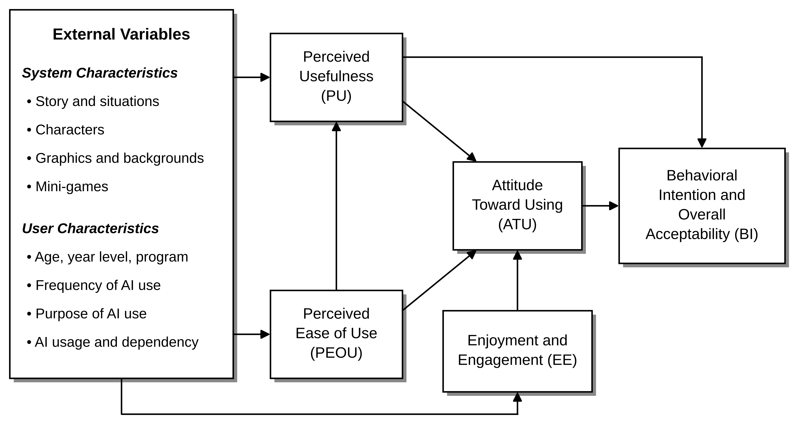
Figure 1. Technology Acceptance Model (TAM) of Ctrl + Think (Adapted from Davis, 1989; Davis et al., 1992)
As displayed in Figure 1, the external variables of the study affect the perceived usefulness, ease of use, and enjoyment of the game by the students, which later affect the attitude of the students toward using the game. In turn, this will lead to the students’ intention to use the game and their overall acceptance of the game as a learning tool.
External Variables of the Study
According to Davis (1989), external variables are those that affect the perception of the system and are outside the belief system of the user. The seven external variables identified in this study are categorized as system characteristics (features of the game) and user characteristics (background and AI usage of the respondents). System characteristics are shown in Table 2, and user characteristics are shown in Table 3.
Table 2. External Variables: System Characteristics of Ctrl + Think
External Variable | Description | TAM Construct Influenced
Story and Situations | The storyline of the game, including how understandable it is and how relevant its situations and conflicts are to student life. | Perceived Usefulness
Characters | The believability of the characters’ actions and experiences, and how well their visual designs suit their personalities and roles. | Enjoyment and Engagement
Graphics and Backgrounds | The 2D game graphics and background scenes used to present the story. | Perceived Ease of Use; Enjoyment and Engagement
Mini-games | The mini-games in the story, including their relevance to the story and its objectives and their level of difficulty. | Perceived Ease of Use; Enjoyment and Engagement

Table 3. External Variables: User Characteristics of the Respondents
External Variable | Description | TAM Construct Influenced
Demographic Profile | The age, year level, and degree program of the respondent. | Perceived Usefulness
Frequency and Purpose of AI Use | How often the respondent uses AI tools for academic activities and the academic tasks they commonly use AI tools for. | Perceived Usefulness
Level of AI Usage and Dependency | The extent to which the respondent relies on AI tools when completing academic tasks (Zhang et al., 2024; Morales-García et al., 2024). | Perceived Usefulness

The data on the user characteristics are collected from the respondent profile (Part I) and the items about AI usage and dependency (Part II) of the survey questionnaire. The system characteristics are derived from the evaluation of the story, visuals, characters, and gameplay of the game (Part IV).
CONCEPTUAL FRAMEWORK
The conceptual framework of this study, titled “Ctrl + Think: An Interactive Visual Novel Game Exploring AI Dependency Among College Students,” is anchored on the interaction between cognitive, affective, and environmental factors that influence students’ behavioral outcomes regarding artificial intelligence use in academic settings. The framework proposes that students’ perceptions and cognitive tendencies toward AI contribute to the development of AI dependency, which subsequently affects their academic and psychological outcomes.
To mitigate these negative outcomes, the framework introduces an intervention in the form of an interactive visual novel titled Ctrl + Think. Grounded in experiential learning principles, this intervention allows students to engage in decision-based scenarios involving AI use and observe the consequences of their choices. The visual novel functions as an educational tool that promotes self-reflection, responsible AI usage, and balanced technology engagement. Through this intervention, students are expected to develop awareness of AI dependency risks and improve their cognitive and behavioral responses to AI technologies.
The conceptual framework illustrates how cognitive perceptions, affective responses, and environmental pressures contribute to AI dependency, and how the proposed interactive visual novel intervention aims to reduce its negative academic and psychological effects.
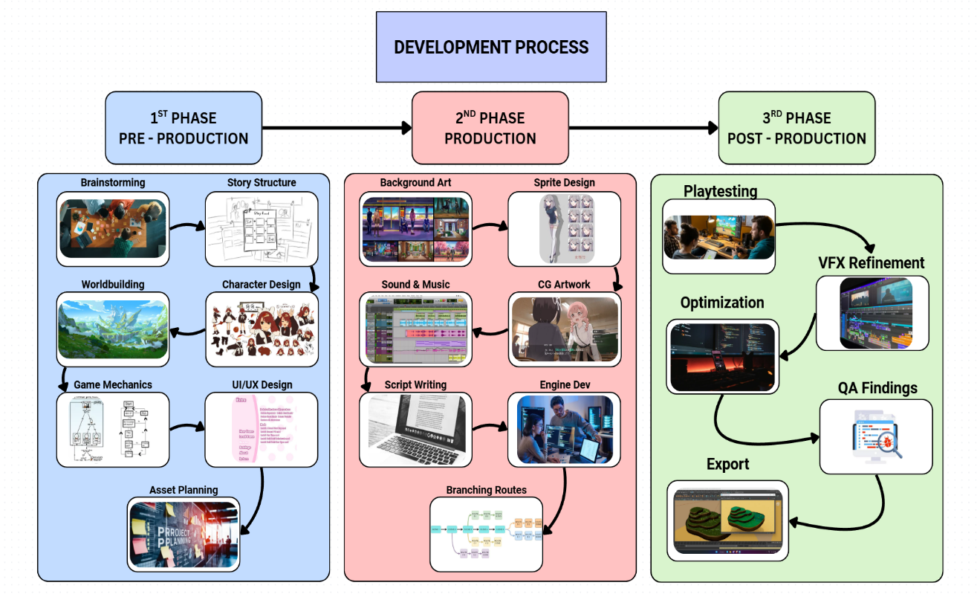
Figure 2. Conceptual Framework
CHAPTER 3
METHODOLOGY
Application Development
The Ctrl + Think game is a learning-based interactive visual novel that uses the Ren'Py Visual Novel Engine. This program is specifically designed to be used as an intervention tool for developing the knowledge of Filipino college students regarding their dependence on artificial intelligence. The decisions made by the player contribute to an invisible dependency score, leading them to different educational conclusions.
Development Approach
The application is built using an Agile iterative development model structured across four distinct phases, integrating continuous feedback, progressive refinement, and stakeholder evaluation at every stage of the lifecycle.
Table 2. Development Approach and Project Phases
Phase | Key Activities | Deliverable
Phase 1 – Planning | Requirements analysis, story scripting, character design, scenario mapping | Game Design Document, Story Flowchart
Phase 2 - Development | Ren'Py scripting, UI/UX implementation, asset integration, branching logic coding | Working prototype and all story routes
Phase 3 - Testing | Playtesting, Cognitive Walkthrough, Usability testing with student participants | Usability report, revised game builds
Phase 4 - Deployment | Final packaging, WebAssembly export, academic documentation submission | Final release and Research deliverables
Technology Stack
The development of the application utilizes a combination of specialized tools and technologies tailored for interactive visual novel production. Each component in the stack is selected to support efficient content creation, scripting, testing, and deployment while maintaining compatibility with the chosen game engine.
Table 5. Technology Stack and Development Tools
Component | Technology / Tool
Game Engine | Ren'Py 8.x — Python based Visual Novel Engine
Scripting Language | RenPy Script (.rpy) + Python 3.x for game logic
UI Framework | Ren'Py Screen Language (ATL Animation & Transform Language)
Asset Creation | Clip Studio Paint or Procreate for sprites & backgrounds, Canva is for UI mockups
Audio | Audacity for SFX editing and Royalty free BGM
Version Control | Git + GitHub for private repository
Web Deployment | Ren'Py Web Export Web Assembly (WASM) build hosted on GitHub Pages
Project Design
The current digital storytelling and educational game design approach aims to change the perception and dependence of students towards AI in academic environments. The use of a visual novel format in this approach seeks to mitigate the students’ usual behavior of dependence and passiveness with AI tools and provide them with options that necessitate a consideration of the potential academic and personal results of their choices.
The selected format allows addressing the disconnect between discussions on ethical aspects of the issue and everyday life of college students. Compared with delivering information through the usual methods of instruction, the gaming approach allows presenting risks of AI reliance such as cognitive inertia, learning burnout, and academic misconduct in an experiential manner.
The concept of a student character development in the storyline assists participants in rethinking and redefining the way they perceive AI dependence. It transforms an abstract concept into a concrete pattern of behavior. The behavioral characteristics of the player can be assessed using the stealth assessment method without the stress of taking a test, since the choice system within the game represents the true behavior (Yu et al., 2022).
Based on the interaction of the Person-Affect-Cognition-Execution (I-PACE) theoretical framework, one might assume that the use of AI tools might be driven by perceptions of usefulness and convenience, thus resulting in problematic reliance on them (Xu et al., 2026). Three possible pathways can be mapped within the storyline of the project, namely balanced use, moderate dependence, and high dependence, with outcomes that highlight negative effects associated with each of them as described by the relevant literature.
The current project focuses on developing a localized version of an experience grounded in these findings, a visual game that would raise awareness of the potential problems caused by students’ habitual use of academic assistance software. Through character development, one can create an immersive and engaging scenario in which players see the advantages AI offers alongside the cognitive disadvantages of uncritical reliance on technology.
The project encourages responsible behavior patterns through self-regulation. For each action performed by the player in the game, a certain number of points accumulates in the hidden dependency score, allowing objective evaluation of the player’s behavior at different stages of the storyline.
Game Narrative & Branching Structure
The three path branching story is at the heart of the educational design of the game. The paths correspond to real life behaviors associated with being reliant on AI. In this way, the negative experiences that occur in each path are realistic enough.

Table 6. Branching Narrative Outcomes Based on AI Dependency
Route | Design Intent & Outcome
Route A – Balance Use (Score: 0-33) | The player consistently applies critical thinking and uses AI as a tool rather than a crutch. Outcome: Strong academic performance, high self-efficacy, positive well-being. Educational message: Responsible AI use enhances rather than diminishes human capability.
Route B – Moderate Dependency (Score: 33-66) | The player shows mixed behavior, some critical engagement, some over-reliance. Outcome: Noticeable skill gaps emerge; originality is questioned; mild academic stress appears. Educational message: Even partial dependency erodes intellectual autonomy over time.
Route C – High Dependency (Score: 67-100) | The player consistently defers to AI across all academic tasks. Outcome: Cognitive inertia sets in; academic misconduct investigation is triggered; burnout and loss of self-confidence result. Educational message: Overdependence on AI has measurable, serious academic and personal consequences.

Core Game Mechanics
Branching Dialogue System
Players interact with the game script and character dialogues, where decision points highlight the moral and educational value of the game.
Choice and Consequences System
Each important decision affects the secret AI dependency score and influences the narrative and outcome.
Stealth Assessment
The behavior pattern is used as an indicator of player actions that are measured unconsciously by the game, consistent with existing research on game-based assessment.
Reflection Cards
Illustrated reflection cards will be displayed after critical events within the game, highlighting educational goals and giving players concrete evidence of what they learned from the game.
Multiple Endings and Educational Debrief
All three endings feature an educational debrief screen that explains the psychological and educational significance of their decisions throughout the game.
Game Saving Mechanism
Auto saves during each chapter checkpoint, along with ten manual save slots for players to review their previous decisions.
System Architecture
The system architecture of Ctrl + Think is structured as a Single Tier Client Side Application. All narrative logic, scoring algorithms, game state management, and asset delivery occur entirely on the player’s local device; no external server, database, or cloud infrastructure is required. For the web deployment variant, the application is compiled to Web Assembly (WASM) and serves as a fully static web application, preserving this self-contained architecture in a browser context.
System Architecture Diagram
The diagram below provides a single comprehensive overview of the entire Ctrl + Think system, illustrating all major modules and their relationships across five functional layers.
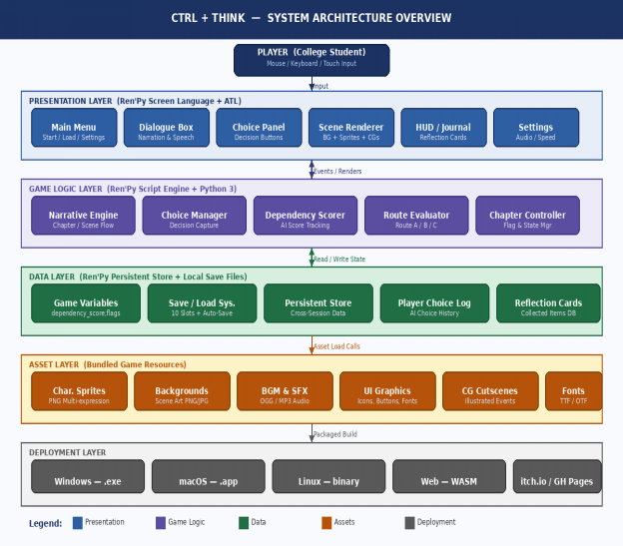
Figure 3. Ctrl + Think System Architecture Overview
Layer Descriptions
Presentation Layer
Built entirely in Ren'Py Screen Language and Animation Transform Language (ATL), this layer manages all visual output and user facing interaction. It encompasses the main menu, dialogue box, choice panel, scene renderer, HUD, and the settings screen. This layer receives player input events and dispatches them to the Game Logic Layer.
Game Logic Layer
The core intelligence of the application. Written in Ren'Py Script with embedded Python 3 functions, this layer contains five primary modules: the narrative engine, the choice manager, the dependency scorer, the route evaluator, and the chapter controller.
Data Layer
Manages all persistent and session-level data. Game variables are stored in Ren'Py’s in-memory Python store during a session, and written to local save files at chapter checkpoints. The Persistent Store retains cross session data such as unlocked endings and collected reflection cards. No external database or cloud storage is used.
Asset Layer
Contains all bundled game resources: character sprites, scene backgrounds, background music and sound effects, UI graphics and icon sets, CG (cutscene) illustrations, and custom font files. All assets are declared and indexed in dedicated images.rpy and audio.rpy files, and loaded on demand by the Game Logic Layer.
Deployment Layer
The Ren'Py build pipeline produces platform-specific packages from a single source codebase. Desktop builds are generated for Windows (.exe installer), macOS (.app bundle), and Linux (binary archive). The web build compiles the full application to Web Assembly using Ren'Py web export tool, enabling browser based
Project Development
The development of “Ctrl + Think: An Interactive Visual Novel Game Exploring AI Dependency Among College Students” followed a structured and research-driven approach that integrated narrative design with technical implementation. The project began with the conceptualization of the game core theme, focusing on the growing reliance of college students on artificial intelligence and its implications on critical thinking and independent learning.
The storyline was developed as a fictional narrative grounded in existing research and supplemented by selected student experiences. This approach ensured that the scenarios presented in the game were both engaging and reflective of the real-world academic behaviors. The narrative was designed to immerse players in relatable situations where they must decide between relying on AI tools or exercising their own abilities on their academic task.
The development process followed the waterfall model, proceeding through sequential phases including planning, design, implementation, and refinement. During the design phase, key gameplay mechanics were established, particularly the integration of branching choices, multiple endings, and a scoring system. These features were implemented to provide players with interactive decision-making opportunities and to reflect the consequences of their choices throughout the game.
The game was developed using the Ren’Py visual novel engine, which enabled efficient creation of interactive storytelling elements. Multimedia components such as 2D character illustrations, background art, sound effects, music, and basic animations were incorporated to enhance user engagement and overall gameplay experience.
A central feature of the game is its representation of AI dependency through decision-based interactions. Players encounter various academic scenarios where they must choose whether to rely on AI-generated assistance or to think independently. These choices influence the narrative progression, scoring outcomes, and ultimately lead to different endings, reinforcing the educational objective of promoting responsible AI usage.
Formal testing and evaluation have not yet been conducted; however, the system is designed to support future user testing to assess its effectiveness in raising awareness about AI dependency among college students.
Animation Development Model
The Visual Novel Development Model illustrates the framework approach taken for creating Ctrl + Think: An Interactive Visual Novel Game Exploring AI Dependency Among College Students. Taking into account the goals of producing an interactive story game that will demonstrate the problems with AI use among college students, the process includes data gathering, concept & script development, designing characters and backgrounds, story branching, adding dialogue, deciding on a visual style, coding, sound, and testing the game.
Data Gathering
Data gathering is one of the most important phases of visual novel game production that helps in making the game accurate, relevant, and relatable. In the case of our visual novel game, we were collecting data about students' behavior during their study, use of AI for writing papers, common problems with fulfilling academic tasks, and possible consequences of depending on artificial intelligence too much.
The phase is critical as it allows the developers to create a realistic, educative, and interesting game for college students that reflects the problems of today’s society and allows users to think about their own behaviors and tendencies. Thus, data gathering contributes to the educational role of the game.
Concept & Script
This phrase mainly refers to building the game plot and creating a story that will develop throughout the course of the game. The main idea involves the college student that starts to rely on artificial intelligence more and more while fulfilling Its obligations. The script describes all the consequences of such actions and the impact it makes on creative thinking. It describes various situations and pressures experienced by college students. Dialogues and inner thoughts are provided to show how even simple choices may lead to either healthy usage of AI or complete dependence. At the same time, the script allows advancing educational aspects of the game.
Character Design
During this phase, the researchers focused on developing characters that are visually appealing, believable, and appropriate to the overall theme and narrative of the game. Character development plays an important role in creating an engaging interactive experience because the characters serve as the primary medium through which players understand the story, situations, and intended message of the game. The researchers designed the characters based on common personalities, attitudes, behaviors, and experiences observed among college students in real academic environments.
Since the main objective of the study is to examine the extent of dependence on Artificial Intelligence (AI) among college students, each character was carefully conceptualized to represent different perspectives and levels of AI usage in academic tasks and decision making. Some characters were designed to heavily rely on AI tools for solving problems, completing schoolwork, and making choices, while others were created to demonstrate independent thinking, critical analysis, creativity, and balanced AI usage.
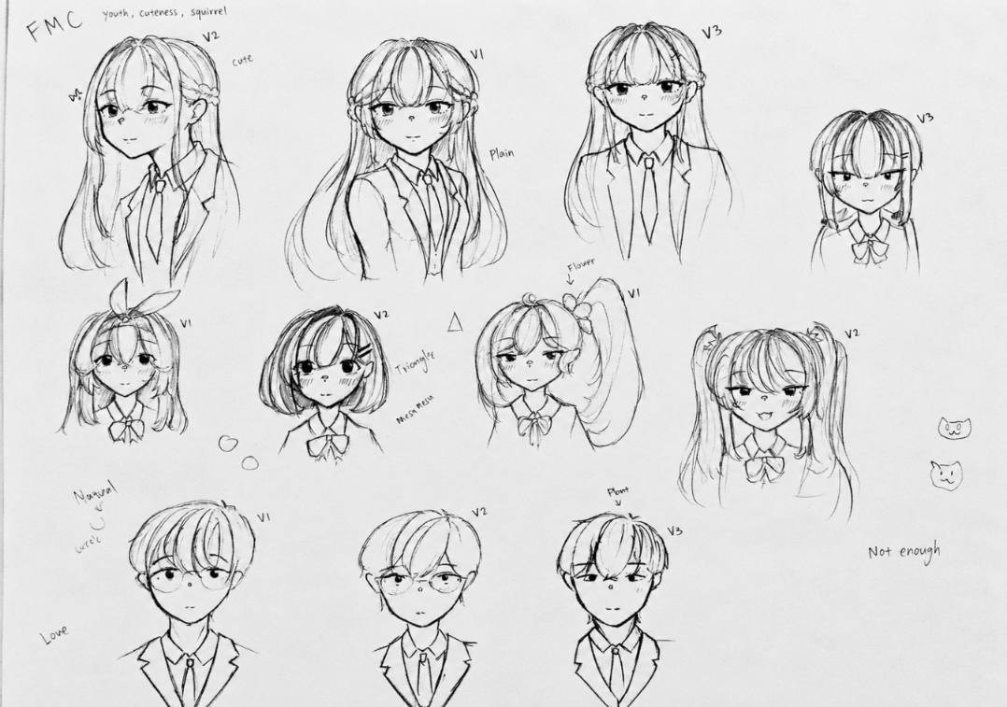
Figure 4. Sample Character Design
Ella De Guzman
The main character is intelligent but often struggles with self-doubt. Despite having great potential, they frequently question their own thoughts and abilities. They tend to rely on AI for solving problems rather than trusting their own judgment and making an effort to overcome challenges independently. They are curious and eager to learn but can also be impatient when faced with difficult tasks. Their main goals are to achieve academic success, meet deadlines, and avoid failure. As a relatable college student, they experience the pressure, anxiety, stress, and competition commonly associated with academic life.
Supporting Characters
Miguel Rivera
Friend of the main character. Introverted male character who looks tired, unmotivated, and lacks energy.
Myka Ortiz
A friend who heavily relies on AI for almost everything, often using it as her go to tool even for simple tasks. She has a playful, attention seeking, and show off personality, making her naturally lively and expressive. Her “papansin” nature means she constantly finds ways to stand out and be noticed in any group, often bringing energy, humor, and dramatic flair to everyday situations.
Sofia Andrea Cruz
The main character’s best friend is a loyal and consistently supportive companion who remains close and dependable through every situation. She is naturally energetic and often teases her friend in a playful, lighthearted way that adds humor and warmth to their interactions. Despite her playful nature, she is caring, attentive, and always present when her friend needs her, making her a reliable source of comfort and positivity
Prof. Celine Marie Santos
The professor is designed to appear strict, quiet, and mature, with a composed presence that naturally commands respect. Subtle facial lines should be included in the character design to reflect age and experience, reinforcing their role as an established academic authority. Despite a reserved demeanor, the professor carries a calm and steady confidence, maintaining professionalism at all times. Their authoritative aura is not loud or aggressive, but grounded in discipline, responsibility, and a quiet expectation of respect from students.
Mrs. & Mr. De Guzman
The parent is a rarely seen character who appears only during critical moments in the story, especially when the main character’s problems become too serious to ignore. Their presence is marked by strong emotional reactions, often showing shock upon discovering the situation and disappointment as reality sets in. The parent carries emotional weight in the narrative, reflecting concern and unresolved expectations toward the main character
Background Design
The background design should make the world plausible and believable to the user as an academic and personal environment. The two main settings are the school and home, where all the events take place. Classrooms, faculty offices, and hallways of the school reflect the stress and pressure faced by the characters academically. The home setting depicts the more intimate moments of the protagonist, especially when studying, dealing with deadlines, and feeling emotionally distressed.
Such a setting is vital since it helps develop the right atmosphere for the game. The classroom represents pressure, competitiveness, and discipline, while the home setting represents isolation, tiredness, and late hours spent on working with artificial intelligence.
Branching Choices
The branches are crucial to showing what results from the player’s actions. Each choice made influences the story’s progress and determines further dependence on AI. Thanks to such choices, the users have the opportunity to feel both the pros and cons of using artificial intelligence in their work.
Good ending responsible use of AI
In this ending, the character uses AI as support but keeps using personal work, thoughts, and reasoning. This way, the game shows the proper use of technologies.
Bad ending complete dependence on AI
This ending shows the consequences of excessive use of technology, which can lead to worse academic performance, lack of self-reliance, and even academic dishonesty.
Programming
Ren'Py is the engine chosen for creating Ctrl + Think because of Python scripting, permissiveness, and visual novel qualities, such as easy to use branching logic and sprite changes. Game development consists of scenes, menu options for making choices and persistent variables. The cross-platform game should run on Windows, Android, and the Web, allowing students to play on any device at college.
Materials
Data
The data utilized in this project were derived from a combination of primary and secondary sources to ensure the validity, relevance, and contextual accuracy of the interactive visual novel narrative and gameplay design.
Primary data were collected through surveys and semi structured interviews conducted among college students. These instruments were designed to capture students’ experiences, perceptions, and behavioral patterns regarding the use of artificial intelligence tools in academic tasks such as writing, research, and problem solving. The data gathered provided firsthand insights into the extent of AI dependency, decision making, and ethical considerations encountered by students in real life academic scenarios. Data collection will be conducted during the academic year 2025–2026.
Secondary data were obtained from scholarly articles, academic journals, and online publications focusing on artificial intelligence in education, student learning behavior, and cognitive development. References include reports and statistics from institutions such as the Commission on Higher Education (CHED), Philippine Statistics Authority (PSA), and international organizations like UNESCO. These sources include studies and reports published between 2021 and 2026, ensuring that the data reflect recent trends and developments in AI integration within educational systems.
The existing digital media such as educational simulations, narrative driven games, and interactive storytelling platforms were reviewed as supplementary references. These materials informed the structural design of branching narratives, user interaction models, and the incorporation of consequence based decision making within the game.
These data sources informed the development of the game storyline, characters, dialogue construction, and scenario design, ensuring that the interactive experience accurately represents the realities of AI usage among college students while promoting critical thinking and independent decision making
Software Specifications
Ren'Py
is a visual novel engine used as the core development platform for the game. It enables the creation of branching narratives, dialogue systems, character interactions, and decision based mechanics through Python scripting and Ren'Py built in language.
Audacity
is an audio editing tool used to clean, trim, and enhance sound effects, voice lines, and background music. It ensures that all audio assets are optimized and exported in compatible format for integration into the game.
FL Studio
is a digital audio workstation used to compose and produce original background music and ambient soundtracks. It helps establish the emotional tone of scenes and enhances the player’s experience throughout the narrative.
Figma
is a UI/UX design tool used to create wireframes, interface layouts, and visual prototypes of the game. It allows the team to plan menu systems, dialogue boxes, and user navigation before implementation in Ren’Py.
Adobe Photoshop
is a graphic design software used to create and edit visual assets such as character sprites, backgrounds, UI elements, and promotional materials. It ensures high quality visuals that match the game’s artistic style.
Visual Studio Code
is a source code editor used for writing and managing scripts, particularly Python code within Ren’Py. It provides features like syntax highlighting, extensions, and debugging support to streamline development.
GitHub
is a web-based platform used for version control and collaboration, built around Git. It allows to store the game source code, track changes, manage different versions, and collaborate efficiently. GitHub also serves as a backup repository and supports by enabling multiple contributors to work on the interactive visual novel simultaneously without conflicts.
Blurrr
is a mobile based video editing application used to create promotional content, trailers, or short clips of the game. It helps in showcasing gameplay and narrative highlights for presentations or marketing purposes.
Microsoft Word
It is used for preparing and organizing the capstone documentation, including the manuscript, research chapters, tables, references, and other written materials related to the development of the interactive visual novel game.
Canva
It was used for designing user interface mockups, presentation materials, promotional graphics, and other visual assets related to the development and presentation of the interactive visual novel game.
Procreate
Used for creating character illustrations, background designs, concept sketches, and other digital art assets incorporated into the interactive visual novel game. The application provided tools for detailed drawing, coloring, shading, and layer management, allowing the researchers to produce visually appealing graphics that support the storytelling, atmosphere, and overall visual quality of the game.
Hardware Specifications
The desktop computer was utilized as the main workstation for the development of the game, particularly for digital drawing, asset creation, and game editing. It handled intensive tasks such as 2D illustration, animation, and integration of visual and interactive elements within the game engine. The system efficiently supported creative software, enabling seamless management of large project files. This hardware played a vital role in the overall game development process, ensuring productivity and consistency throughout the creation and editing stages.
Table 7. Hardware Specification of Desktop
 | Desktop (Andrei)
Processor | AMD Ryzen 5 5600G
Memory | 16 GB RAM
GPU | AMD Radeon Graphics
SSD | 1TB HDD + 512GB SSD
OS Version | Windows 11 Home Single Language
The first laptop device was used for reviewing animation drafts, storyboards, and edited scenes. Its display quality allowed accurate checking of motion, timing, and visual consistency. It was also useful for providing feedback during the editing process.
Table 8. Hardware Specification of Laptop
 | Laptop (Christian)
Processor | AMD Ryzen 5 7520U
Memory | 16 GB RAM
GPU | AMD Radeon Graphics
SSD | 477 GB SSD
OB Version | Windows 11 Home Single Language
The second desktop device was utilized for detailed inspection of visual assets and quality control during the game development process. It supported the review of illustrations, animations, user interface elements, and transitions, ensuring consistency and visual accuracy. It allowed for precise drawing and refinement of digital assets. This device contributed to enhancing the overall quality of the game’s visuals and user experience.

Table 9. Hardware Specification of Laptop
 | Desktop (Lorence)
Processor | AMD A6-7480 Radeon R5
Memory | 16 GB RAM
GPU | AMD Radeon R5 Graphics
SSD | 240 GB SSD + 1 TB HDD
OS Version | Windows 10 Pro
The pen tablet was primarily used for digital illustration, frame-by-frame animation, and detailed asset creation. It enabled precise drawing and smooth control during intensive animation work. This tool significantly improved efficiency and accuracy in heavy editing and animation tasks.

Table 10. Hardware Specification of Pentab
Veikk A15 Pro Pen Tablet(Lorence)
Model | A15 Pro
Dimension | 358 × 200 × 9 mm
Working Area | 10 × 6 inches
Resolution | 5080 LPI
Pressure Sensitivity | 8192 levels
Reading Height | 10 mm
Report Rate | 290 PPS
Express Key | 12 customizable shortcut keys + 1 quick dial
Ports | USB-C
Research Design
The study utilizes a descriptive quantitative research design integrated with an interactive multimedia development approach. The descriptive component of the study aims to examine the perceptions, behaviors, and awareness of college students regarding artificial intelligence dependency in academic activities. The quantitative aspect focuses on collecting measurable data to evaluate the acceptability, usability, and effectiveness of the interactive visual novel game Ctrl + Think: An Interactive Visual Novel Game Exploring AI Dependency Among College Students.
The study also incorporates the Technology Acceptance Model (TAM) as the primary framework for evaluating user acceptance of the developed game. The evaluation focuses on students’ perceptions of the game in terms of its usefulness, ease of use, enjoyment and engagement, attitude toward using it, and behavioral intention toward using it as an educational and awareness tool.
The multimedia development approach enables the researchers to integrate storytelling, branching narratives, decision based gameplay, visual assets, sound design, and educational content into a single interactive learning environment. Through this approach the project aims to encourage critical thinking, self reflection, and responsible AI usage among college students.
Sampling Design
The study employs random sampling in selecting respondents for the evaluation of the interactive visual novel game Ctrl + Think. A total of 48 student respondents (n=48) from Laguna State Polytechnic University Los Baños Campus will participate in the study.
Random sampling is utilized to provide equal opportunity for students to participate in the evaluation process and to reduce selection bias. This approach allows the researchers to gather varied perspectives regarding students’ awareness, experiences, and attitudes toward artificial intelligence usage in academic settings.
The selected respondents will evaluate the game through an online survey questionnaire distributed using Google Forms. Their responses will serve as the basis for determining the usability, educational effectiveness, and user acceptance of the developed interactive visual novel game.
Population of the Study
The population of the study consists of college students from Laguna State Polytechnic University Los Baños Campus. These students were selected because they represent the primary target audience of the interactive visual novel game and are among the groups most exposed to the increasing use of artificial intelligence tools in academic activities.
The study focuses on students who commonly utilize digital technologies and AI assisted platforms for academic tasks such as research, writing, brainstorming, problem solving, and project development. Their perceptions and experiences provide relevant insights into the effects of AI dependency and the effectiveness of the game as an educational intervention tool promoting responsible AI usage and independent thinking.
Data Collection Instrument
The primary data collection instrument used in the study is a structured survey questionnaire developed using the Technology Acceptance Model (TAM). The questionnaire is designed to gather quantitative data regarding respondents’ perceptions, attitudes, and acceptance of the interactive visual novel game Ctrl + Think.
The survey questionnaire will be distributed through Google Forms and will consist of close ended questions measured using a five point Likert Scale.

Table 11. Likert Scale
Rating | Verbal Interpretation
5 | Strongly Agree
4 | Agree
3 | Neutral
2 | Disagree
1 | Strongly Disagree
Operational Definition of Variables
The survey questionnaire has five parts. Part I collects information about the respondents and how they use AI tools. Part II looks at how much they use AI and how dependent they are on it. Part III evaluates the game using the constructs of the Technology Acceptance Model. Part IV looks at the story, the visuals, the characters, and how the game plays. Part V asks about what they learned and their opinions. Table 12 shows what each variable means in the study. The full questionnaire can be found in Appendix D. The items for perceived usefulness and perceived ease of use were adapted from the Technology Acceptance Model of Davis (1989), while the items on AI usage and dependency, enjoyment and engagement, behavioral intention and overall acceptability, the game’s story, visuals, characters, and gameplay, and overall learning and feedback were developed by the researchers for the purpose of this study.
Table 12. Operational Definition of Variables
Variable / Construct | Operational Definition | Questionnaire Part
External Variables (Demographic Profile and AI Use) | The respondent’s age, year level, degree program, frequency of AI use for academic activities, and common purposes of AI use. | Part I
External Variables (AI Usage and Dependency) | The extent to which the respondent relies on AI tools in academic tasks, including checking and understanding AI-generated answers. | Part II
Perceived Usefulness (PU) | The degree to which the respondent believes the game helps them understand the effects of AI dependency and reflect on their own AI use. | Part III-A
Perceived Ease of Use (PEOU) | The degree to which the respondent finds the game’s controls, mini-game instructions, scenes, and features easy to understand and use. | Part III-B
Enjoyment and Engagement (EE) | The degree to which the respondent enjoyed the game and stayed interested in its story, mini-games, and characters. | Part III-C
Attitude Toward Using (ATU) | The respondent’s overall feeling toward using an interactive visual novel to explore AI dependency. | Part III-D
Behavioral Intention and Overall Acceptability (BI) | The respondent’s willingness to play the game again and recommend it, and their overall satisfaction with the game as an educational tool. | Part III-E
External Variables (System Characteristics) | The respondent’s rating of the game’s story, characters, graphics and backgrounds, and mini-games. | Part IV
Perceived Usefulness – Learning Outcome (Overall Learning and Feedback) | The awareness and reflection on AI use that the respondent gained after playing the game, treated as the learning outcome of the game’s perceived usefulness. This part addresses the second objective of the study. | Part V

Statistical Instrument of Data
The quantitative data gathered from the survey questionnaires will be systematically organized, encoded, and analyzed using Microsoft Excel. The collected responses will be used to evaluate the acceptability, usability, and effectiveness of Ctrl + Think: An Interactive Visual Novel Game Exploring AI Dependency Among College Students based on the Technology Acceptance Model (TAM).
To summarize and interpret the respondents’ perceptions regarding the developed interactive visual novel game, the researchers will use the following statistical tools:

Table 13. Statistical Tools Used for Data Analysis
Statistical Tool | Purpose
Frequency and Percentage Distribution | To summarize and describe the demographic profile of the respondents
Weighted Mean | To determine the average level of agreement of respondents under each TAM category
Standard Deviation | To determine how much the respondents’ answers vary from the mean
Cronbach’s Alpha Reliability Test | To measure the internal consistency and reliability of the questionnaire items
The weighted mean, in which each response value is multiplied by the number of respondents who selected it, will be used to determine how much the respondents agree about their use of AI and how much they rely on it. It will also be used for each part of the Technology Acceptance Model, which includes perceived usefulness, perceived ease of use, enjoyment and engagement, attitude toward using, and behavioral intention and overall acceptability. It will also consider the story, the visuals, the characters, and the gameplay of the game, as well as the respondents’ learning and feedback. The weighted mean is calculated for each item and for each part and is interpreted using the scale in Table 14.
Table 14. Interpretation of Weighted Mean
Mean Range | Verbal Interpretation | Level of Acceptance
4.21 – 5.00 | Strongly Agree | Very High
3.41 – 4.20 | Agree | High
2.61 – 3.40 | Neutral | Moderate
1.81 – 2.60 | Disagree | Low
1.00 – 1.80 | Strongly Disagree | Very Low

The Cronbach’s Alpha Reliability Test will be done for each part of the model to check how consistent and reliable the questions in the questionnaire are. This test helps make sure that the survey measures the Technology Acceptance Model parts correctly and reduces errors in measurement.

Table 15. Reliability Interpretation Scale
Cronbach’s Alpha | Verbal Interpretation
Above 0.90 | Excellent
0.80 – 0.89 | Good
0.70 – 0.79 | Acceptable
0.60 – 0.69 | Questionable
0.50 – 0.59 | Poor
Below 0.50 | Unacceptable
CHAPTER 4
RESULT AND CONCLUSION
In this chapter, the study presented and discussed the findings in relation to the project's goals, specifically focusing on the experiences and perceptions of college students regarding the use of Artificial Intelligence (AI) in academic activities. The results were analyzed to understand the different factors associated with AI dependency and its possible effects on students critical thinking, creativity, and independent learning, as well as to evaluate the acceptability of the interactive visual novel game using the Technology Acceptance Model (TAM).
Results by Objectives
The primary objective of this study was to develop an interactive visual novel game titled CTRL + THINK: An Interactive Visual Novel Game Exploring AI Dependency Among College Students. The game was designed to raise awareness of the possible consequences of excessive dependence on artificial intelligence (AI) in academic activities and to encourage students to maintain a balance between AI assisted learning and independent thinking. The study also sought to determine whether the developed game could support self reflection and responsible AI use, as well as assess its acceptability through the Technology Acceptance Model (TAM).

Create a visual novel style game that shows the process and impact of relying on AI technology through interactive story branches, interactions between characters, player decisions, and 2D style graphics, while also considering the impact of AI technology on students’ learning, decision-making skills, and problem-solving capabilities.
The study addressed this objective through the development of CTRL + THINK, an interactive visual novel that presents academic situations in which college students must decide whether to rely on AI assistance or use their own reasoning and problem-solving skills. The game was designed to demonstrate how repeated decisions involving AI use may influence students’ academic experiences, independent thinking, and sense of responsibility for their work. Through its narrative structure, the game allows players to experience different possible consequences based on the choices they make throughout the story.
The game features a student protagonist who faces common academic responsibilities and challenges, including completing assignments under time pressure, developing original ideas, and making decisions about the appropriate use of AI tools. These situations were incorporated to reflect circumstances in which students may be tempted to rely heavily on AI for convenience. By presenting these scenarios interactively, the game provides players with opportunities to consider the differences between using AI as a learning aid and allowing it to replace their own thinking and effort.
The storyline is organized into chapters that explore different aspects of AI use and academic responsibility. In Morning Chaos, the protagonist encounters the pressure of completing a reflection paper before a deadline. In The Blank Page, the story focuses on the difficulty of beginning academic work and the importance of developing original ideas. In Process Over Answers, the narrative emphasizes critical thinking, independent problem-solving, and information verification. Meanwhile, Whose Work Is It? explores originality, teamwork, accountability, and responsible AI use in academic situations.
The game also incorporates branching storylines in which players’ decisions affect narrative progression and the ending they receive. The designed outcomes represent different levels of AI dependence. The balance use route reflects the use of AI as a supporting tool while maintaining independent thought. The moderate dependency route presents a combination of independent effort and excessive reliance on AI, while the high-dependency route illustrates the possible consequences of consistently allowing AI to perform academic tasks on the student's behalf.
These branching outcomes provide a way to communicate the relationship between player decisions and their potential academic consequences. Rather than presenting the topic solely through explanations, the visual novel allows players to engage with the issue through choices and narrative feedback. The use of two-dimensional character artwork, backgrounds, dialogue, and interactive elements supports the presentation of these situations in an accessible story based format.

Assess the support for self-reflection and better understanding of using AI responsibly, in particular the importance of balance between AI assistance and self-thinking when doing schoolwork, in the developed visual novel game.
The second objective focused on the capacity of the developed visual novel to encourage self-reflection and promote a better understanding of responsible AI use. This objective was incorporated into the game through academic scenarios that require players to consider the consequences of relying on AI instead of engaging directly with their schoolwork. The narrative presents AI use as a decision that requires judgment and responsibility rather than treating it as automatically beneficial or harmful in every situation.
Throughout the game, players encounter situations in which using AI may appear to be the easiest way to complete an academic task. These situations reflect the pressure students may experience when managing deadlines, generating ideas, and meeting academic expectations. By presenting these choices within the storyline, the game encourages players to consider whether their decisions support learning or simply allow them to finish tasks with less personal involvement.
The narrative also emphasizes the importance of independent thinking. In the chapter The Blank Page, the protagonist faces the challenge of developing ideas for an academic reflection paper. This situation highlights the value of attempting to formulate one's own thoughts instead of immediately depending on AI-generated responses. Similarly, Process Over Answers incorporates critical thinking, logic, and fact-checking into the story, emphasizing that information provided by AI should be examined rather than accepted without evaluation.
The different story routes further support the game's reflective purpose. The balance-use route represents a pattern in which AI assists the student while the student continues to exercise personal judgment and reasoning. The moderate-dependency route illustrates the potential difficulties associated with inconsistent independent engagement, while the high-dependency route depicts the possible consequences of repeatedly delegating academic responsibilities to AI. These routes were designed to help players compare possible outcomes and reflect on how their decisions may affect their learning practices.
The game addresses academic integrity and accountability through situations involving originality, collaboration, and personal contributions to schoolwork. These scenarios emphasize that students remain responsible for the work they submit, even when AI tools are used during the process. The game therefore frames responsible AI use as a matter of balance: students may use AI to support their learning, but they should continue to participate actively in thinking, analyzing information, developing ideas, and making decisions.
The design of CTRL + THINK addressed the second objective by incorporating opportunities for reflection into its storyline, player choices, and branching outcomes. The game was intended to help students recognize the importance of responsible AI use and understand why AI assistance should complement, rather than replace, independent thinking. However, the extent to which players actually developed greater awareness or changed their perceptions must be established through the results of the participant evaluation.
To determine whether the game supported self-reflection and a better understanding of responsible AI use, the respondents rated five statements under Overall Learning and Feedback after playing the game. The results are presented in Table 16.
Table 16. Overall Learning and Feedback of the Respondents
No. | Statement | Mean | SD | Verbal Interpretation
1 | After playing the game, I became more aware of the possible risks of excessive AI dependency. | 3.44 | 0.92 | Agree
2 | The game encouraged me to think critically about how I use AI tools. | 3.73 | 0.82 | Agree
3 | The game helped me recognize the importance of understanding my own academic work. | 3.69 | 0.99 | Agree
4 | I believe the game can help other college students reflect on their AI usage habits. | 3.67 | 0.91 | Agree
5 | Overall, Ctrl + Think achieved its intended purpose as an educational game. | 3.63 | 0.89 | Agree
 | COMPOSITE MEAN | 3.63 | 0.69 | Agree

The respondents obtained a composite mean of 3.63 (SD = 0.69), interpreted as Agree, which corresponds to a high level of acceptance. The highest-rated statement was “The game encouraged me to think critically about how I use AI tools” (M = 3.73), followed by the statements that the game helped them recognize the importance of understanding their own academic work (M = 3.69) and that the game can help other college students reflect on their AI usage habits (M = 3.67). The lowest-rated statement was “After playing the game, I became more aware of the possible risks of excessive AI dependency” (M = 3.44), although it was still interpreted as Agree.
These results suggest that the respondents perceived the game as a means of reflecting on their own academic work and AI use, which supports the second objective. However, none of the statements reached the Strongly Agree level, and the learning outcomes were measured only once, after the respondents had played the game. The results therefore show how the respondents perceived their own learning and do not show a measured change in their behavior.

Assess the success of the developed game in terms of its usability and learning efficacy through the use of the Technology Acceptance Model (TAM). The variables include the external variables of the study, as well as perceived usefulness, perceived ease of use, enjoyment and engagement, attitude toward using, and behavioral intention to use the game as a learning tool.
The third objective was addressed through a survey questionnaire that was answered by 48 college students after they played the game. The questionnaire had five parts and 39 rated statements, which were answered using the five-point Likert scale in Table 11. The mean of the responses was computed for each statement and for each part, and was interpreted using the scale in Table 14. The results are presented below, starting with the profile of the respondents.
Profile of the Respondents
Tables 17 to 21 present the profile of the 48 respondents. These respondents are part of the user characteristics that serve as external variables in the study. As shown in Table 17, most of the respondents were 21 to 23 years old (23, 47.9%), followed by those aged 18 to 20 (18, 37.5%) and 24 to 26 (7, 14.6%).
Table 17. Age of the Respondents
Age | Frequency | Percentage
18–20 years old | 18 | 37.5%
21–23 years old | 23 | 47.9%
24–26 years old | 7 | 14.6%
Total | 48 | 100.0%

Table 18 shows that the fourth-year students made up the largest group (15, 31.3%), followed by the first-year students (14, 29.2%) and the second-year students (13, 27.1%). The third-year students accounted for 6 (12.5%) of the respondents.
Table 18. Year Level of the Respondents
Year Level | Frequency | Percentage
First Year | 14 | 29.2%
Second Year | 13 | 27.1%
Third Year | 6 | 12.5%
Fourth Year | 15 | 31.3%
Total | 48 | 100.0%

As shown in Table 19, the respondents came from 9 degree programs. The BS Information Technology students were the largest group (15, 31.3%), followed by the BS Nutrition and Dietetics students (6, 12.5%) and the BS Criminology and BS Fisheries students (5, 10.4% each). The rest of the respondents came from the other programs listed in the table.
Table 19. Degree Program of the Respondents
Degree Program | Frequency | Percentage
BS Information Technology | 15 | 31.3%
BS Nutrition and Dietetics | 6 | 12.5%
BS Criminology | 5 | 10.4%
BS Fisheries | 5 | 10.4%
BS Hospitality Management | 4 | 8.3%
BS Psychology | 4 | 8.3%
Bachelor of Secondary Education | 4 | 8.3%
BS Accountancy | 3 | 6.3%
BS Computer Science | 2 | 4.2%
Total | 48 | 100.0%

Table 20 presents how often the respondents used AI tools for academic activities. None of the respondents answered Never. Sixteen respondents (33.3%) used AI tools rarely and 12 respondents (25.0%) used them sometimes, while 20 respondents (41.7%) used them often or very often. This means that all of the respondents used AI tools for academic work to some extent.
Table 20. Frequency of AI Use for Academic Activities
Frequency of AI Use | Frequency | Percentage
Never | 0 | 0.0%
Rarely | 16 | 33.3%
Sometimes | 12 | 25.0%
Often | 13 | 27.1%
Very Often | 7 | 14.6%
Total | 48 | 100.0%

Table 21 shows the academic activities for which the respondents commonly used AI tools. The respondents could choose more than one answer, so the percentages are based on the 48 respondents and do not add up to 100 percent. Summarizing information was the most common purpose (37, 77.1%), followed by understanding lessons or concepts (30, 62.5%) and generating ideas (26, 54.2%). Writing essays or assignments, programming or coding, and answering academic questions were chosen less often.
Table 21. Common Purposes of AI Use of the Respondents
Purpose of AI Use | Frequency | Percentage
Summarizing information | 37 | 77.1%
Understanding lessons or concepts | 30 | 62.5%
Generating ideas | 26 | 54.2%
Writing essays or assignments | 12 | 25.0%
Programming or coding | 12 | 25.0%
Answering academic questions | 8 | 16.7%

Level of AI Usage and Dependency
Table 22 shows the respondents’ level of AI usage and dependency, which is the second user characteristic measured in the study. The composite mean was 3.12 (SD = 0.85), interpreted as Neutral, which corresponds to a moderate level. This means that, on the average, the respondents neither agreed nor disagreed that they relied heavily on AI tools in their academic work.
Table 22. Level of AI Usage and Dependency of the Respondents
No. | Statement | Mean | SD | Verbal Interpretation
1 | I rely on AI tools when completing academic tasks. | 2.94 | 1.12 | Neutral
2 | I find it difficult to complete some academic tasks without assistance from AI tools. | 2.77 | 1.19 | Neutral
3 | I sometimes accept AI-generated answers without checking their accuracy. | 2.50 | 1.22 | Disagree
4 | I use AI-generated answers even when I have not fully understood the topic. | 2.94 | 1.36 | Neutral
5 | I sometimes depend on AI tools instead of trying to solve academic problems on my own. | 2.81 | 1.36 | Neutral
6 | I make an effort to verify AI-generated information before using it in my academic work. | 3.58 | 1.23 | Agree
7 | I believe it is important to develop my own critical-thinking skills even when AI tools are available. | 4.27 | 0.96 | Strongly Agree
 | COMPOSITE MEAN | 3.12 | 0.85 | Neutral

The highest mean was for the statement “I believe it is important to develop my own critical-thinking skills even when AI tools are available” (M = 4.27), interpreted as Strongly Agree. The respondents also agreed that they made an effort to verify AI-generated information before using it (M = 3.58), but were neutral on whether they relied on AI tools when completing academic tasks (M = 2.94). The lowest mean was for the statement “I sometimes accept AI-generated answers without checking their accuracy” (M = 2.50), interpreted as Disagree. The standard deviations of all the statements except the last were above 1.00, which means that the respondents differed considerably in how much they depended on AI. The last two statements describe responsible AI use and not dependency, so the composite mean should be read with this in mind.
System Characteristics of the Game
Table 23 presents the respondents’ ratings of the story, visuals, characters, and gameplay of the game, which are the system characteristics that serve as external variables. The composite mean was 4.07 (SD = 0.57), interpreted as Agree. This is the highest rating among the parts of the questionnaire.
Table 23. System Characteristics of the Game as Rated by the Respondents
No. | Statement | Mean | SD | Verbal Interpretation
1 | The story was understandable and easy to follow. | 3.83 | 0.93 | Agree
2 | The story situations and conflicts were relevant to student life. | 3.90 | 0.90 | Agree
3 | The characters’ actions and experiences were believable. | 3.69 | 0.99 | Agree
4 | The game graphics and backgrounds were appropriate for the story. | 4.02 | 0.89 | Agree
5 | The characters’ visual designs suited their personalities and roles. | 4.38 | 0.76 | Strongly Agree
6 | The mini-games were relevant to the story and its objectives. | 4.35 | 0.84 | Strongly Agree
7 | The difficulty of the mini-games was appropriate. | 4.31 | 0.75 | Strongly Agree
8 | The game communicated its message without making the story difficult to enjoy. | 4.04 | 0.87 | Agree
 | COMPOSITE MEAN | 4.07 | 0.57 | Agree

The visual designs of the characters and the mini-games received the highest ratings. The respondents strongly agreed that the characters’ visual designs suited their personalities and roles (M = 4.38), that the mini-games were relevant to the story and its objectives (M = 4.35), and that the difficulty of the mini-games was appropriate (M = 4.31). The lowest-rated statement was “The characters’ actions and experiences were believable” (M = 3.69), interpreted as Agree. When the statements are grouped by the system characteristics, the mean was 4.33 for the mini-games, 4.03 for the characters, 4.02 for the graphics and backgrounds, and 3.92 for the story and situations.
Evaluation Based on the Technology Acceptance Model
Tables 24 to 28 present the respondents’ evaluation of the game under each construct of the Technology Acceptance Model.
Table 24 shows the perceived usefulness of the game. The composite mean was 3.44 (SD = 0.55), interpreted as Agree. The respondents agreed most with the statement that the story presented situations that are relevant to college students (M = 3.65). The statements that the game helped them better understand the effects of depending too much on AI tools (M = 3.38) and recognize the importance of independent thinking (M = 3.25) were interpreted as Neutral. This indicates that the respondents found the game useful, but not to the highest degree.
Table 24. Perceived Usefulness (PU)
No. | Statement | Mean | SD | Verbal Interpretation
1 | The game helped me better understand the possible effects of depending too much on AI tools. | 3.38 | 0.84 | Neutral
2 | The game helped me recognize the importance of independent thinking when completing academic tasks. | 3.25 | 0.73 | Neutral
3 | The game story presented situations that are relevant to college students. | 3.65 | 0.91 | Agree
4 | The game encouraged me to reflect on my own use of AI tools. | 3.50 | 0.88 | Agree
 | COMPOSITE MEAN | 3.44 | 0.55 | Agree

Table 25 presents the perceived ease of use. The composite mean was 4.11 (SD = 0.69), interpreted as Agree, which is the highest among the five constructs. All four statements were rated Agree, with means ranging from 3.98 to 4.17. The respondents found the scenes easy to navigate (M = 4.17), the game features easy to learn and use (M = 4.17), and the mini-game instructions clear (M = 4.13). This shows that the controls and the interface did not get in the way of playing the game.
Table 25. Perceived Ease of Use (PEOU)
No. | Statement | Mean | SD | Verbal Interpretation
1 | The game controls and interactions were easy to understand. | 3.98 | 0.89 | Agree
2 | The instructions provided for the mini-games were clear. | 4.13 | 0.84 | Agree
3 | I was able to navigate the game's scenes without difficulty. | 4.17 | 1.00 | Agree
4 | The game features were easy to learn and use. | 4.17 | 0.83 | Agree
 | COMPOSITE MEAN | 4.11 | 0.69 | Agree

Table 26 shows the enjoyment and engagement of the respondents. The composite mean was 3.82 (SD = 0.61), interpreted as Agree. The respondents strongly agreed that the mini-games made the gameplay more engaging (M = 4.23) and agreed that the characters and their interactions made the story more interesting (M = 4.19). The statement that the story kept them interested in continuing to play had the lowest mean (M = 3.40), interpreted as Neutral. This suggests that the mini-games and the characters contributed more to the enjoyment of the game than the story itself.
Table 26. Enjoyment and Engagement (EE)
No. | Statement | Mean | SD | Verbal Interpretation
1 | I enjoyed playing Ctrl + Think. | 3.48 | 0.82 | Agree
2 | The game story kept me interested in continuing to play. | 3.40 | 0.87 | Neutral
3 | The mini-games made the gameplay more engaging. | 4.23 | 0.88 | Strongly Agree
4 | The characters and their interactions made the story more interesting. | 4.19 | 0.96 | Agree
 | COMPOSITE MEAN | 3.82 | 0.61 | Agree

Table 27 presents the respondents’ attitude toward using the game. The composite mean was 3.76 (SD = 0.56), interpreted as Agree. The three statements had similar means, from 3.71 to 3.79. The respondents agreed that their experience in using the game was positive (M = 3.79), that they would be willing to use similar educational games in the future (M = 3.79), and that an interactive visual novel is an engaging way to explore AI dependency (M = 3.71).
Table 27. Attitude Toward Using the Game (ATU)
No. | Statement | Mean | SD | Verbal Interpretation
1 | I believe an interactive visual novel is an engaging way to explore AI dependency. | 3.71 | 0.80 | Agree
2 | I had a positive experience using the game to explore the topic. | 3.79 | 0.74 | Agree
3 | I would be willing to use similar educational games in the future. | 3.79 | 0.90 | Agree
 | COMPOSITE MEAN | 3.76 | 0.56 | Agree

Table 28 shows the behavioral intention and overall acceptability of the game. The composite mean was 3.49 (SD = 0.71), interpreted as Agree. The respondents agreed most with the statement that the game is an appropriate educational tool for raising awareness of AI dependency (M = 3.88). The lowest mean was for the statement that they would be willing to play the game again (M = 3.29), interpreted as Neutral, which also had the highest standard deviation among the statements in this part (SD = 1.11). The statement on overall satisfaction (M = 3.40) was also interpreted as Neutral. This means that the respondents’ willingness to replay the game differed more from one respondent to another than their other answers.
Table 28. Behavioral Intention and Overall Acceptability (BI)
No. | Statement | Mean | SD | Verbal Interpretation
1 | I would recommend Ctrl + Think to other college students. | 3.42 | 0.94 | Agree
2 | I would be willing to play the game again. | 3.29 | 1.11 | Neutral
3 | I believe the game is an appropriate educational tool for raising awareness of AI dependency. | 3.88 | 0.91 | Agree
4 | Overall, I am satisfied with my experience playing Ctrl + Think. | 3.40 | 0.87 | Neutral
 | COMPOSITE MEAN | 3.49 | 0.71 | Agree

Summary of the Technology Acceptance Model Results
Table 29 summarizes the results for each construct. All five constructs of the Technology Acceptance Model were interpreted as Agree, which corresponds to a high level of acceptance. Perceived ease of use had the highest composite mean (4.11), followed by enjoyment and engagement (3.82), attitude toward using (3.76), behavioral intention and overall acceptability (3.49), and perceived usefulness (3.44). The overall mean of the five constructs was 3.73 (SD = 0.40), interpreted as Agree.
Table 29. Summary of Composite Mean and Standard Deviation
Variable | Composite Mean | SD | Verbal Interpretation | Level of Acceptance
Perceived Usefulness (PU) | 3.44 | 0.55 | Agree | High
Perceived Ease of Use (PEOU) | 4.11 | 0.69 | Agree | High
Enjoyment and Engagement (EE) | 3.82 | 0.61 | Agree | High
Attitude Toward Using (ATU) | 3.76 | 0.56 | Agree | High
Behavioral Intention and Overall Acceptability (BI) | 3.49 | 0.71 | Agree | High
Overall TAM | 3.73 | 0.40 | Agree | High
External Variable: Level of AI Usage and Dependency | 3.12 | 0.85 | Neutral | Moderate
External Variable: System Characteristics | 4.07 | 0.57 | Agree | High
Perceived Learning Outcome (Overall Learning and Feedback) | 3.63 | 0.69 | Agree | High

The results show that the respondents found the game easy to use and enjoyable, and that they had a positive attitude toward using it. Perceived usefulness had the lowest mean among the constructs, which suggests that the game can still be improved in helping players understand the importance of independent thinking. In terms of the external variables, the system characteristics of the game were rated higher (4.07) than the respondents’ own level of AI usage and dependency (3.12). The respondents’ perceived learning outcome (3.63) was slightly lower than their attitude toward using the game (3.76).
Reliability of the Questionnaire
The Cronbach’s alpha for all 39 rated statements was 0.873 (N = 48), which is interpreted as Good using the scale in Table 15. Table 30 presents the reliability of each part of the questionnaire.
Table 30. Reliability of the Questionnaire
Part of the Questionnaire | No. of Items | Cronbach’s Alpha | Interpretation
Level of AI Usage and Dependency | 7 | 0.829 | Good
Perceived Usefulness (PU) | 4 | 0.556 | Poor
Perceived Ease of Use (PEOU) | 4 | 0.773 | Acceptable
Enjoyment and Engagement (EE) | 4 | 0.637 | Questionable
Attitude Toward Using (ATU) | 3 | 0.434 | Unacceptable
Behavioral Intention and Overall Acceptability (BI) | 4 | 0.717 | Acceptable
System Characteristics | 8 | 0.812 | Good
Overall Learning and Feedback | 5 | 0.816 | Good
All Items | 39 | 0.873 | Good

Five of the eight parts had alpha values of 0.70 or higher, which are Acceptable to Good. The alpha values of Enjoyment and Engagement (EE) (0.637), Perceived Usefulness (PU) (0.556), and Attitude Toward Using (ATU) (0.434) were lower. Cronbach’s alpha tends to be lower when a part has only three or four statements, and this applies to these parts. The results for these three parts should therefore be interpreted with caution, and their statements may be revised or increased in future studies.
Finally, the results of the study are limited to the 48 respondents and to their own perceptions after playing the game. The study used descriptive statistics only, so the results do not show causal relationships between the variables.

CHAPTER 5
SUMMARY, CONCLUSION, AND RECOMMENDATION
Summary
This study focused on the development and evaluation of CTRL + THINK: An Interactive Visual Novel Game Exploring AI Dependency Among College Students. The game was developed to raise awareness of the possible effects of depending too much on artificial intelligence (AI) in academic activities and to encourage students to balance AI assistance with their own thinking. It presents academic situations in which the player decides whether to rely on AI or on personal effort, and the decisions lead to branching story routes that represent balanced use, moderate dependency, and high dependency.
The game was developed using an animation development model that covered data gathering, concept and script, character design, background design, branching choices, and programming. To evaluate the game, the study used the Technology Acceptance Model (TAM), which was extended with enjoyment and engagement. A survey questionnaire with five parts and 39 rated statements, measured using a five-point Likert scale, was answered through Google Forms by 48 college students. The data were analyzed using frequency and percentage, weighted mean, and Cronbach’s alpha.
The results showed that most of the respondents were 21 to 23 years old (47.9%), that the BS Information Technology students were the largest group (31.3%), and that all of them used AI tools for academic work to some extent, most commonly for summarizing information (77.1%). Their level of AI usage and dependency had a mean of 3.12, interpreted as Neutral. The system characteristics of the game had a mean of 4.07, with the mini-games rated highest (4.33).
All five TAM constructs were interpreted as Agree. Perceived ease of use had the highest mean (4.11), followed by enjoyment and engagement (3.82), attitude toward using (3.76), behavioral intention and overall acceptability (3.49), and perceived usefulness (3.44). The overall mean of the five constructs was 3.73. The respondents’ perceived learning outcome had a mean of 3.63, interpreted as Agree. The Cronbach’s alpha of all 39 statements was 0.873, which is Good, although the alpha values of enjoyment and engagement, perceived usefulness, and attitude toward using were lower.
Conclusion
Based on the findings of the study, the following conclusions were drawn.
First, the study was able to develop CTRL + THINK, an interactive visual novel that presents the process and effects of relying on AI through academic situations, story branches, character interactions, player decisions, and 2D graphics. The branching routes made it possible to show different levels of AI dependency and their possible consequences in a story-based format.
Second, the respondents agreed that the game supported self-reflection and a better understanding of responsible AI use. The composite mean of the overall learning and feedback was 3.63, and the respondents agreed most that the game encouraged them to think critically about how they use AI tools. However, these results are based on the respondents’ own perceptions after playing the game, so they do not show an actual change in how students use AI.
Third, the game has a high level of acceptance among the respondents based on the Technology Acceptance Model. The five constructs were all interpreted as Agree, and the respondents found the game easy to use, enjoyable, and appropriate as a tool for raising awareness of AI dependency. Perceived usefulness had the lowest mean, and the respondents’ willingness to play the game again had the lowest mean among the statements on behavioral intention and was interpreted as Neutral. The overall reliability of the questionnaire was Good, but the results for the constructs with lower alpha values should be interpreted with caution.
In conclusion, CTRL + THINK is an acceptable and usable educational game for reflecting on AI dependency among college students, and it can serve as a starting point for activities that promote the balanced and responsible use of AI in learning.
Recommendation
Based on the conclusions of the study, the following recommendations are given.
1. Students: College students are encouraged to play the game and to reflect on how they use AI tools in their own schoolwork, especially in verifying AI-generated answers and in thinking through problems on their own before asking AI for help.
2. Teachers and Educational Institutions: Teachers and schools may use the game as a supplementary material in classroom discussions, orientations, or activities on academic integrity and the responsible use of AI. Discussions after playing the game can help students connect the story to their own habits.
3. Game Developers and the Project Team: Future versions of the game may improve the parts that were rated lower, such as the story’s ability to keep players interested and its message on the importance of independent thinking. Additional story routes, more varied endings, and other features that encourage players to replay the game may also be added.
4. Future Researchers: Future studies may use a larger number of respondents from different campuses and programs, since this study had only 48 respondents. Researchers may also use a pretest and posttest design to measure changes in students’ awareness and behavior, and may revise or add statements to the parts of the questionnaire with lower reliability, particularly attitude toward using, perceived usefulness, and enjoyment and engagement.
REFERENCES
Ade-Ibijola, A., Young, K., Sivparsad, N., Seforo, M., Ally, S., Olowolafe, A., & Frahm-Arp, M. (2022). Teaching students about plagiarism using a serious game (Plagi-Warfare): Design and evaluation study. JMIR Serious Games, 10(1), Article e33459. https://doi.org/10.2196/33459
Atsalaki, K., & Kazanidis, I. (2025). Combining virtual reality visual novels and social stories to support social and emotional development in children with autism spectrum disorder. Applied Sciences, 15(12), 6584. https://doi.org/10.3390/app15126584
Brand, M., Young, K. S., Laier, C., Wölfling, K., & Potenza, M. N. (2016). Integrating psychological and neurobiological considerations regarding the development and maintenance of specific Internet-use disorders: An Interaction of Person-Affect-Cognition-Execution (I-PACE) model. Neuroscience & Biobehavioral Reviews, 71, 252–266. https://doi.org/10.1016/j.neubiorev.2016.08.033
Cronbach, L. J. (1951). Coefficient alpha and the internal structure of tests. Psychometrika, 16(3), 297–334. https://doi.org/10.1007/BF02310555
Davis, F. D. (1989). Perceived usefulness, perceived ease of use, and user acceptance of information technology. MIS Quarterly, 13(3), 319–340. https://doi.org/10.2307/249008
Davis, F. D., Bagozzi, R. P., & Warshaw, P. R. (1992). Extrinsic and intrinsic motivation to use computers in the workplace. Journal of Applied Social Psychology, 22(14), 1111–1132. https://doi.org/10.1111/j.1559-1816.1992.tb00945.x
Deep, P. D., Ghosh, N., & Natoli, A. P. (2026). Artificial intelligence for supporting college students with attention-deficit/hyperactivity disorder: Cognitive, emotional, and ethical perspectives. International Journal on Social and Education Sciences, 8(1), 1–17. https://doi.org/10.46328/ijonses.5915
Estrada-Araoz, E. G., Mamani-Roque, M., Quispe-Aquise, J., Manrique-Jaramillo, Y. V., & Cruz-Laricano, E. O. (2025). Academic self-efficacy and dependence on artificial intelligence in a sample of university students. Sapienza: International Journal of Interdisciplinary Studies, 6(1), Article e25008. https://doi.org/10.51798/sijis.v6i1.916
Himes, M. (2022). Visual novel based education in English literature: A study on student engagement. Press Start, 8(2), 1–20. https://press-start.gla.ac.uk/press-start/article/view/206
Hua, J. H. (2023). Beyond exams: Investigating AI tool impact on student attitudes, ethical awareness, and academic dishonesty in online college assessments. International Journal of Educational Management and Development Studies, 4(4), 160–185. https://doi.org/10.53378/353030
Klimova, B., & Pikhart, M. (2025). Use of artificial intelligence in foreign language education in higher education settings. In Social robots and artificial intelligence in education (pp. 327–351). Springer Nature Switzerland. https://doi.org/10.1007/978-3-032-03977-4_13
Kolb, D. A. (1984). Experiential learning: Experience as the source of learning and development. Prentice Hall.
Likert, R. (1932). A technique for the measurement of attitudes. Archives of Psychology, 22(140), 5–55.
Ma, C., Yang, Z., & Gao, C. (2025). From learning aid to learning escape: The commodification of AI-powered educational technologies and their impact on Chinese international students' cognitive and ethical development. ACM. https://doi.org/10.1145/3770177.3770192
Morales-García, W. C., Sairitupa-Sanchez, L. Z., Morales-García, S. B., & Morales-García, M. (2024). Development and validation of a scale for dependence on artificial intelligence in university students. Frontiers in Education, 9, Article 1323898. https://doi.org/10.3389/feduc.2024.1323898
Prayogi, M. D., & Prihatin, T. (2024). Improving students' self-directed learning through visual novel games: Its effectiveness and potential. Indonesian Journal of Curriculum and Educational Technology Studies, 12(1), 45–56. https://doi.org/10.15294/ijcets.v12i1.15307
Shute, V. J. (2011). Stealth assessment in computer-based games to support learning. In S. Tobias & J. D. Fletcher (Eds.), Computer games and instruction (pp. 503–524). Information Age Publishing.
Si, S., Qi, Y., Xu, J., & Qi, X. (2026). When thinking is outsourced: Cognitive offloading and the heterogeneity of critical thinking among Chinese university students using generative artificial intelligence. Journal of Intelligence, 14(7), Article 116. https://doi.org/10.3390/jintelligence14070116
Suryapranata, L. K. P., Bahagia, F. I., & Lazarusli, I. A. (2023). Gamification using visual novel to improve chemistry learning motivation. Journal of Games, Game Art, and Gamification, 8(1), 13–17. https://doi.org/10.21512/jggag.v8i1.9411
Xu, Z., Meng, Z., & Pei, L. (2026). Understanding GAI user addiction from an I-PACE perspective. Information Technology & People, 1–24. https://doi.org/10.1108/itp-07-2025-1047
Yu, J., Ma, W., Moon, J., & Denham, A. (2022). Developing a stealth assessment system using a continuous conjunctive model. Journal of Learning Analytics, 9(3), 11–31. https://doi.org/10.18608/jla.2022.7639
Zhang, S., Zhao, X., Zhou, T., & Kim, J. H. (2024). Do you have AI dependency? The roles of academic self-efficacy, academic stress, and performance expectations on problematic AI usage behavior. International Journal of Educational Technology in Higher Education, 21, Article 34. https://doi.org/10.1186/s41239-024-00467-0

APPENDIX A

STORYBOARD

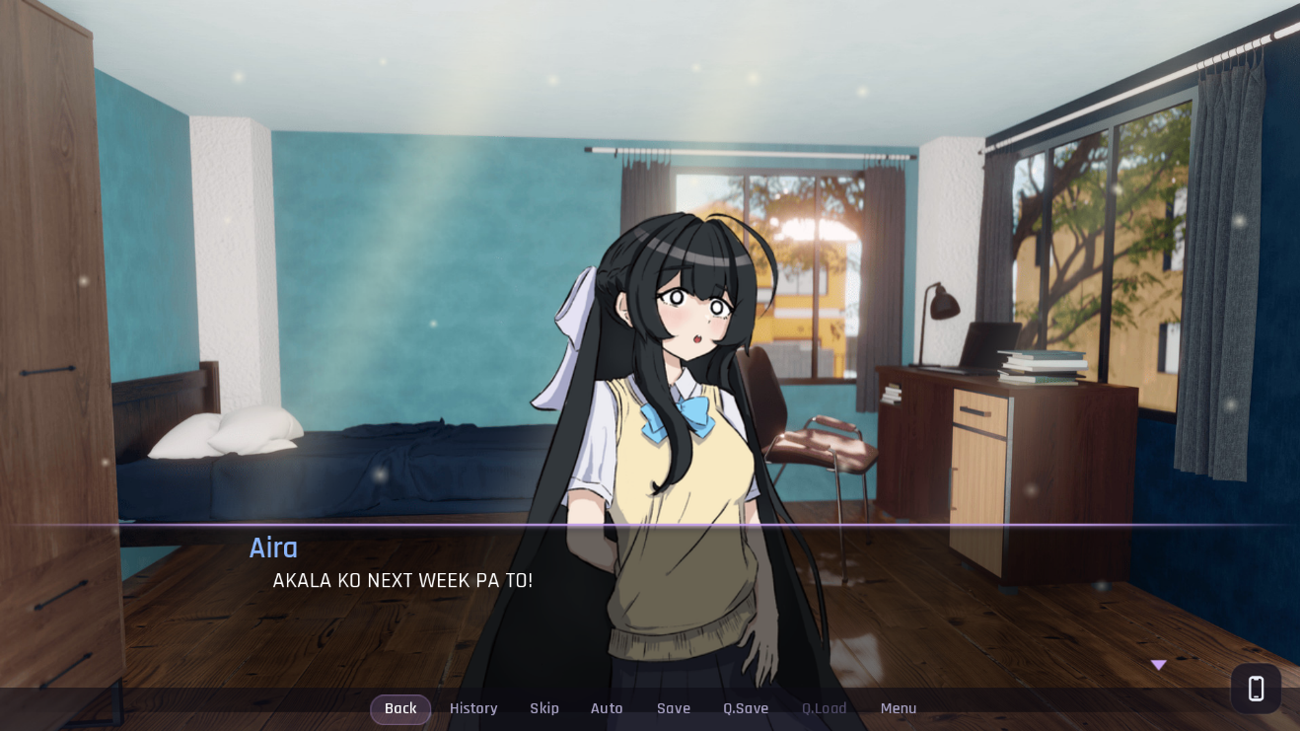
Chapter 1. Morning Chaos
The protagonist begins the day overwhelmed by academic responsibilities after discovering that a 2,000 word reflection paper is due before the end of the day. As the pressure increases, the protagonist faces the temptation to take shortcuts instead of completing the task independently

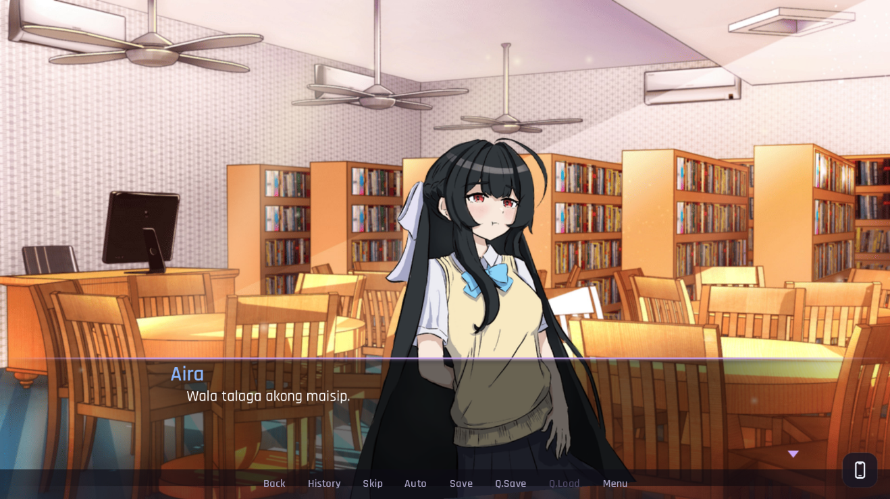
Chapter 2: The Blank Page
The protagonist struggles to begin the reflection paper while facing a tight deadline in the college library. Through the character decisions and reflection activities, the chapter explores the challenges of starting academic work and the importance of developing one own ideas.

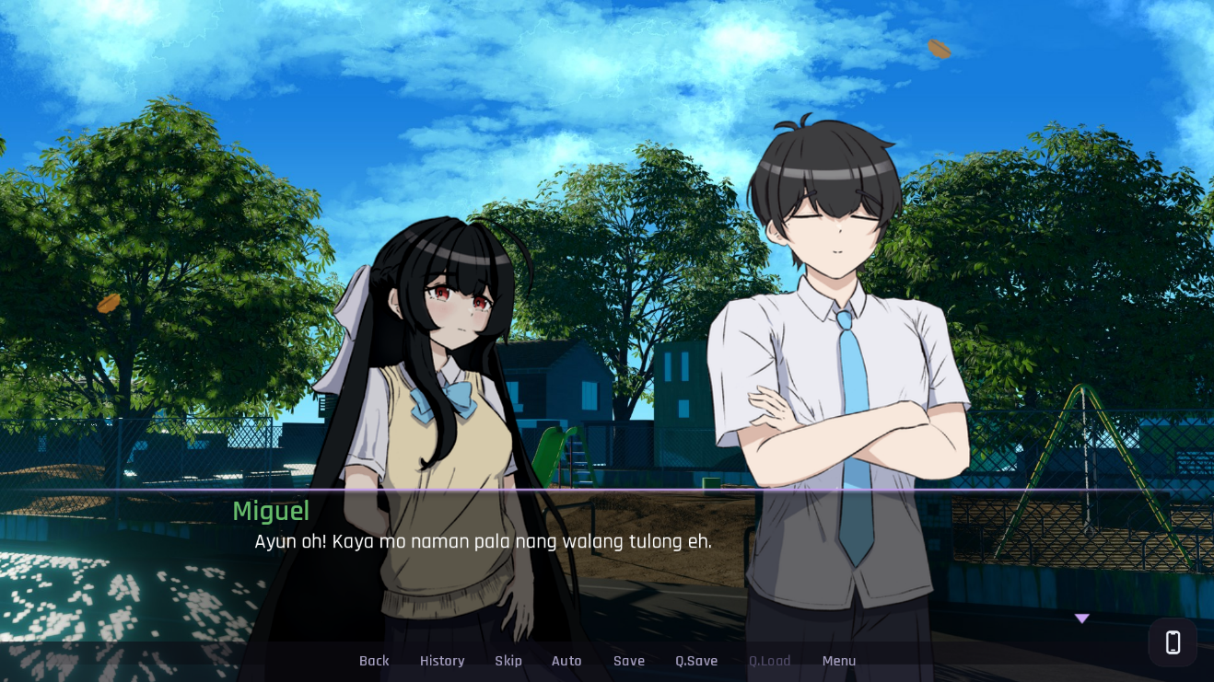
Chapter 3: Process Over Answers
After completing the reflection paper, the protagonist begins reconsidering the role of AI in academic work. Through conversations with friends and interactive activities involving logic and fact checking, the chapter emphasizes critical thinking, independent problem solving, and verifying information.

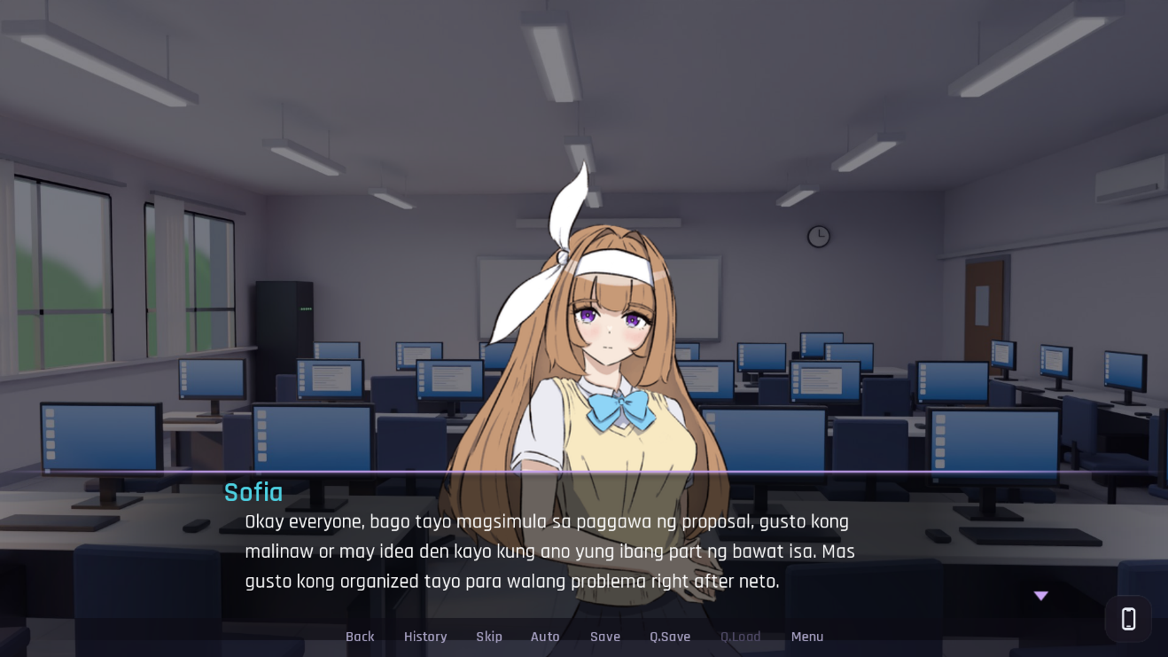
Chapter 4: Whose Work Is It?
The protagonist and friends face academic challenges that raise questions about originality, teamwork, and responsible AI use. As they work through their responsibilities and personal disagreements, they begin recognizing the importance of accountability and contributing their own ideas.

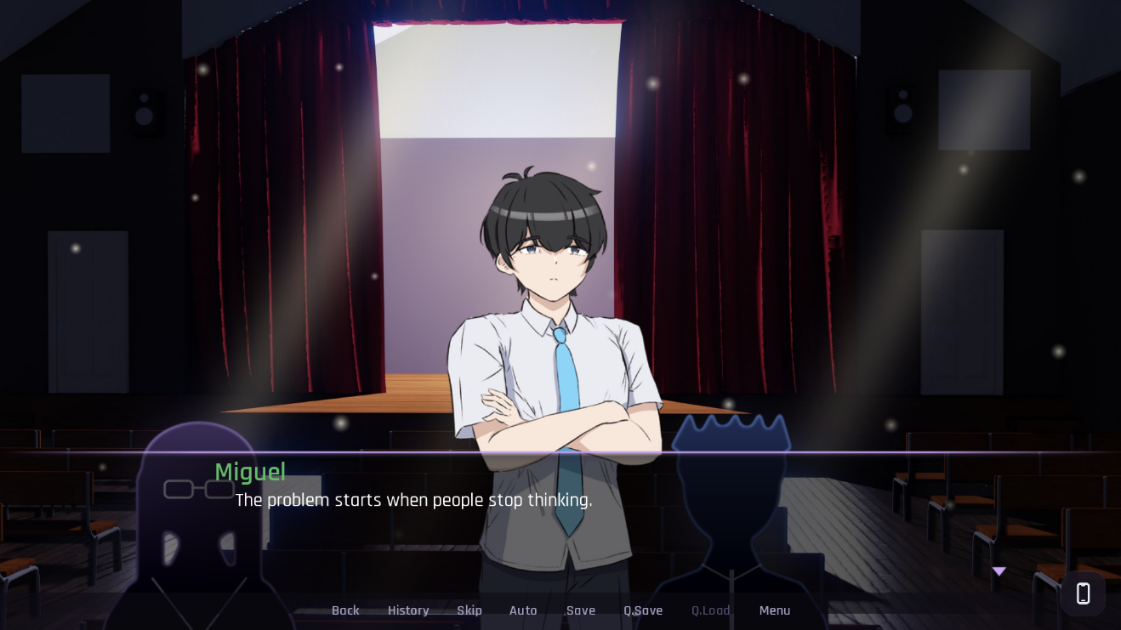
Chapter 5: The Final Challenge
The protagonist and the group prepare for a major academic challenge that tests their knowledge, collaboration, and decisions regarding AI assistance. Their final presentation becomes an opportunity to demonstrate their understanding of responsible AI use and the value of independent thinking.

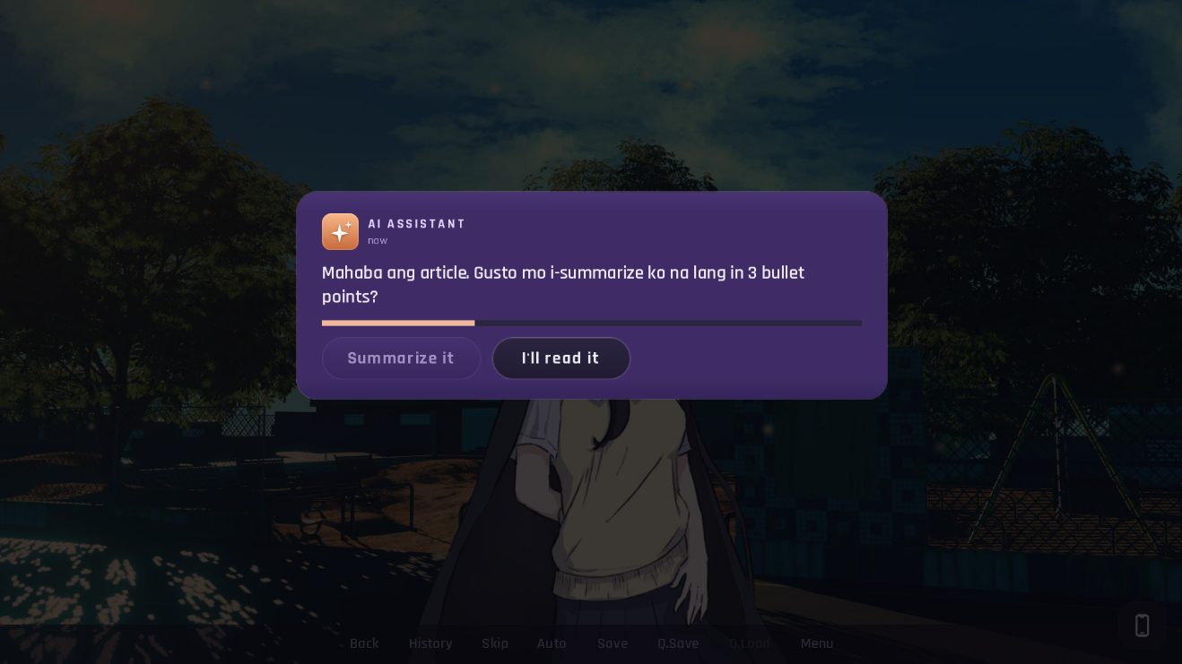
Chapter 6: What We Carry
After the final presentation, the protagonist reflects on the lessons learned throughout the semester and recognizes the importance of thinking independently. The chapter concludes with a final decision about whether to approach future academic challenges independently or rely on AI, leading to different outcomes based on the player choices

APPENDIX B
CHARACTER DESIGN


Figure 1. Male & Female Main Character
An ordinary college student who gradually becomes dependent on AI to finish academic tasks. Throughout the story, he learns to think independently, make his own decisions, and use AI responsibly.


Figure 2. Sofia
A straightforward and practical student who values balance, responsibility, and genuine understanding. She often calls out her friends' mistakes but genuinely wants them to improve.


Figure 3. Miguel
A logical, observant, and supportive friend of the main character. He encourages independent thinking and reminds others that learning from mistakes is more important than simply getting the correct answer.


Figure 4. Myka
A cheerful, playful, and attention-seeking student who loves joking around with her friends. She sometimes takes shortcuts with AI for academic tasks, showing how convenience can lead to overdependence.


Figure 5. Ethan
A hardworking student who gradually becomes dependent on AI because of academic pressure and exhaustion. His experience serves as a warning of what can happen when AI shifts from being helpful to feeling necessary.


Figure 6. Angelica
A responsible, kind, and hardworking working student who struggles to balance her studies and personal responsibilities. She represents students who face financial and academic pressure while striving to achieve their goals.


Figure 7. Kyle ( Angelica Twin Brother)
Angelica's energetic and funny twin brother. He loves teasing his friends and lightening the mood, but he also cares about his sister and the people around him.


Figure 8. Chloe
A shy and polite campus journalism student who interviews other students about their use of AI. Her questions encourage the characters to reflect on whether AI strengthens or weakens students' independent thinking.


Figure 9. James
A quiet and seemingly unmotivated student who often appears uninterested in his surroundings. His reserved personality makes him less expressive, even when he is dealing with academic challenges.


Figure 10. Jared
A reserved student who prefers keeping to himself. He represents students who tend to stay in the background rather than actively participate or express their opinions.


Figure 11. Prof Santos & Prof Elena
A professional and knowledgeable faculty member who encourages students to develop their academic abilities and take responsibility for their work, A composed and observant professors who guides students in their academic journey. They emphasizes the importance of genuine learning, critical thinking, and responsible technology use.

APPENDIX C
PUBLISHABLE PAPER

APPENDIX D
SURVEY QUESTIONNAIRE
Ctrl + Think: An Interactive Visual Novel Game Exploring AI Dependency Among College Students
Dear Respondents:
We are conducting a capstone study entitled “Ctrl + Think: An Interactive Visual Novel Game Exploring AI Dependency Among College Students.”
This study aims to determine the level of AI dependency among college students and understand their experiences, behaviors, and awareness regarding the use of Artificial Intelligence (AI) tools in academic activities. The findings will serve as the basis for developing Ctrl + Think, an interactive visual novel game designed to raise awareness about AI dependency and encourage responsible use of AI tools. The study also aims to assess the acceptability of the proposed game using the Technology Acceptance Model (TAM).
In accordance with Republic Act No. 10173, or the Data Privacy Act of 2012, all information gathered through this questionnaire will be handled with respect for the respondents’ privacy. The collected data will be used solely for academic and research purposes related to this capstone project. Participation is voluntary, and respondents are encouraged to answer honestly. The researchers will take reasonable measures to protect the collected information and maintain its confidentiality. Please avoid providing unnecessary personal information in your responses.
Respectfully yours,
Proponents:
CHRISTIAN B. AÑEZ
JOHN LORENCE B. AMARELA
ANDREI H. CALDEO
Informed Consent
Before proceeding, please read the information above carefully. By participating, you acknowledge that you understand the purpose of the study and agree to participate voluntarily.
☐ Yes, I agree to participate. ☐ No, I do not agree to participate.
Part I. Respondent Profile
Instructions: Please provide the information requested below to help us understand the demographic profile of the respondents. Kindly ensure that your answers are accurate and complete. All information gathered will be used for academic research purposes only.
1. Name (optional): ________________________________
2. What is your age?
☐ 18–20 years old
☐ 21–23 years old
☐ 24–26 years old
☐ 27 years old and above
☐ Prefer not to say
3. What is your current year level? ________________
4. What is your degree program/course? ________________
5. How often do you use AI tools for academic activities?
☐ Never ☐ Rarely ☐ Sometimes ☐ Often ☐ Very Often
6. What do you commonly use AI tools for? (Select all that apply.)
☐ Generating ideas
☐ Understanding lessons or concepts
☐ Summarizing information
☐ Writing essays or assignments
☐ Answering academic questions
☐ Programming or coding
☐ Others: ________________
Part II. AI Usage and Dependency
Instructions: The following statements concern your experiences with AI tools in academic activities. Please indicate your level of agreement based on your actual habits. Rating Scale: 5 – Strongly Agree, 4 – Agree, 3 – Neutral, 2 – Disagree, 1 – Strongly Disagree.
Statement | 5 | 4 | 3 | 2 | 1
1. I rely on AI tools when completing academic tasks.
2. I find it difficult to complete some academic tasks without assistance from AI tools.
3. I sometimes accept AI-generated answers without checking their accuracy.
4. I use AI-generated answers even when I have not fully understood the topic.
5. I sometimes depend on AI tools instead of trying to solve academic problems on my own.
6. I make an effort to verify AI-generated information before using it in my academic work.
7. I believe it is important to develop my own critical-thinking skills even when AI tools are available.

Part III. Game Evaluation
Instructions: Answer the following statements based on your experience playing Ctrl + Think. Select one response for each statement. Rating Scale: 5 – Strongly Agree, 4 – Agree, 3 – Neutral, 2 – Disagree, 1 – Strongly Disagree.
Statement | 5 | 4 | 3 | 2 | 1
A. Perceived Usefulness
1. The game helped me better understand the possible effects of depending too much on AI tools.
2. The game helped me recognize the importance of independent thinking when completing academic tasks.
3. The game story presented situations that are relevant to college students.
4. The game encouraged me to reflect on my own use of AI tools.
B. Perceived Ease of Use
1. The game controls and interactions were easy to understand.
2. The instructions provided for the mini-games were clear.
3. I was able to navigate the game’s scenes without difficulty.
4. The game features were easy to learn and use.
C. Enjoyment and Engagement
1. I enjoyed playing Ctrl + Think.
2. The game story kept me interested in continuing to play.
3. The mini-games made the gameplay more engaging.
4. The characters and their interactions made the story more interesting.
D. Attitude Toward Using the Game
1. I believe an interactive visual novel is an engaging way to explore AI dependency.
2. I had a positive experience using the game to explore the topic.
3. I would be willing to use similar educational games in the future.
E. Behavioral Intention and Overall Acceptability
1. I would recommend Ctrl + Think to other college students.
2. I would be willing to play the game again.
3. I believe the game is an appropriate educational tool for raising awareness of AI dependency.
4. Overall, I am satisfied with my experience playing Ctrl + Think.

Part IV. Story, Visuals, Characters, and Gameplay
Instructions: Rate the following aspects of the game based on your experience. Rating Scale: 5 – Strongly Agree, 4 – Agree, 3 – Neutral, 2 – Disagree, 1 – Strongly Disagree.
Statement | 5 | 4 | 3 | 2 | 1
1. The story was understandable and easy to follow.
2. The story situations and conflicts were relevant to student life.
3. The characters’ actions and experiences were believable.
4. The game graphics and backgrounds were appropriate for the story.
5. The characters’ visual designs suited their personalities and roles.
6. The mini-games were relevant to the story and its objectives.
7. The difficulty of the mini-games was appropriate.
8. The game communicated its message without making the story difficult to enjoy.

Part V. Overall Learning and Feedback
Instructions: Please rate the following statements based on your overall experience. Rating Scale: 5 – Strongly Agree, 4 – Agree, 3 – Neutral, 2 – Disagree, 1 – Strongly Disagree.
Statement | 5 | 4 | 3 | 2 | 1
1. After playing the game, I became more aware of the possible risks of excessive AI dependency.
2. The game encouraged me to think critically about how I use AI tools.
3. The game helped me recognize the importance of understanding my own academic work.
4. I believe the game can help other college students reflect on their AI usage habits.
5. Overall, Ctrl + Think achieved its intended purpose as an educational game.

Thank you for your participation!

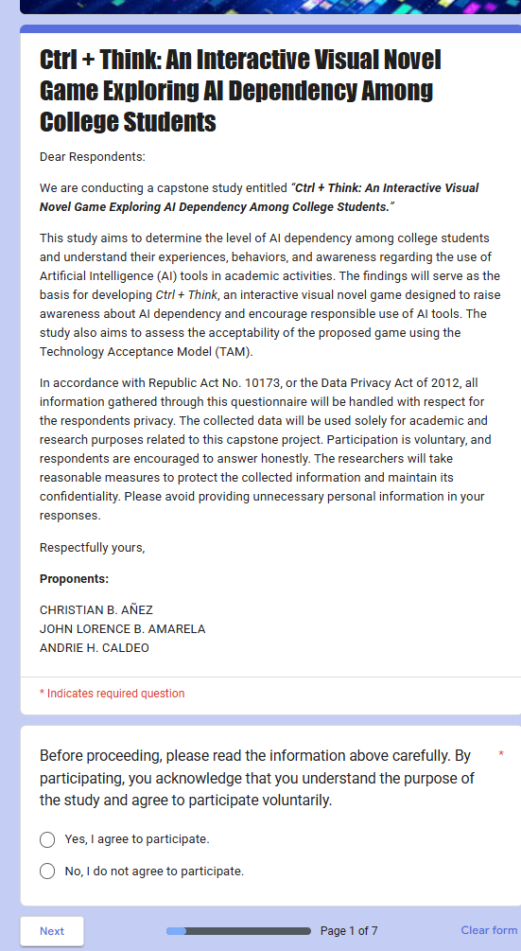
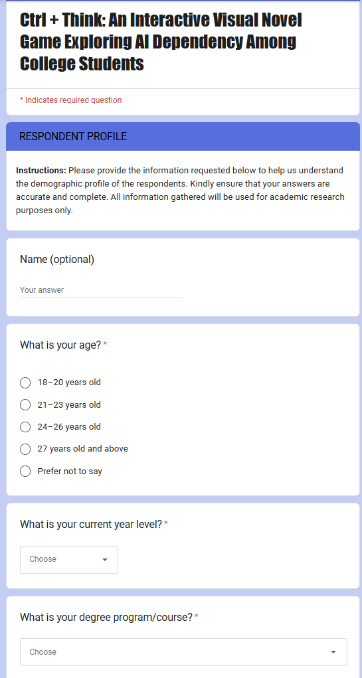
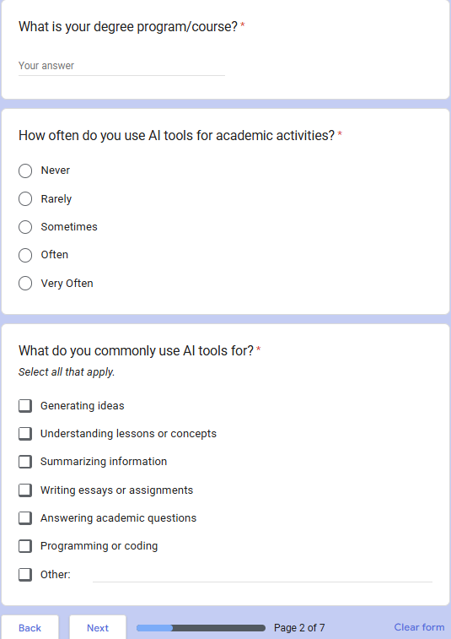
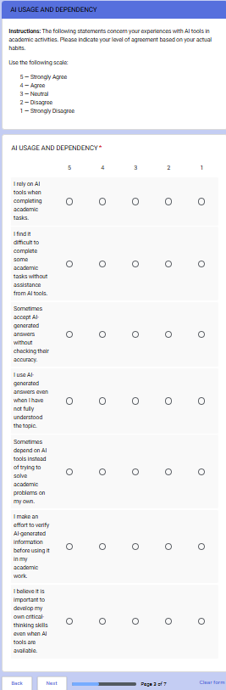
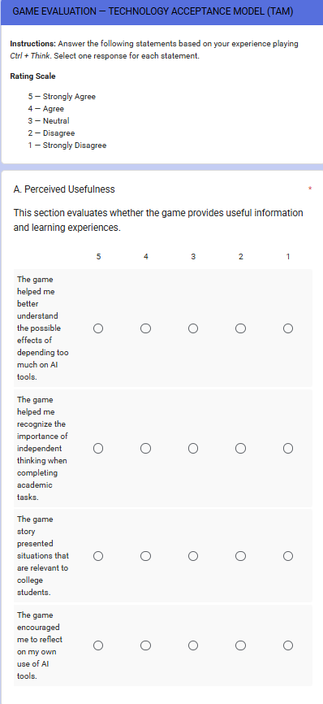
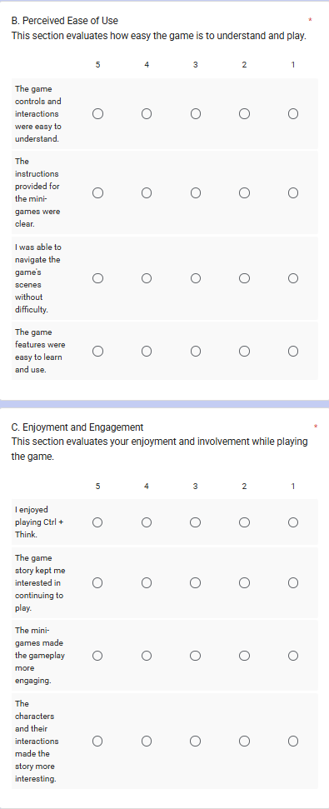
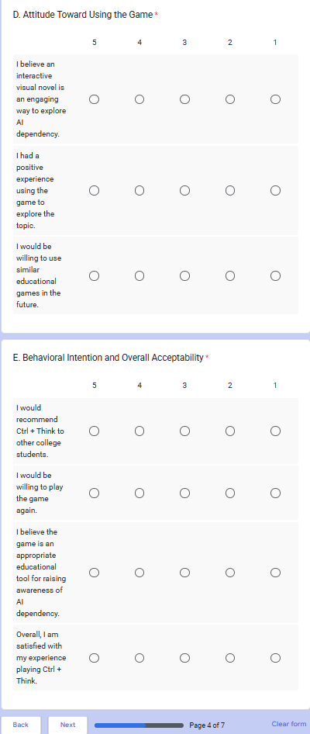
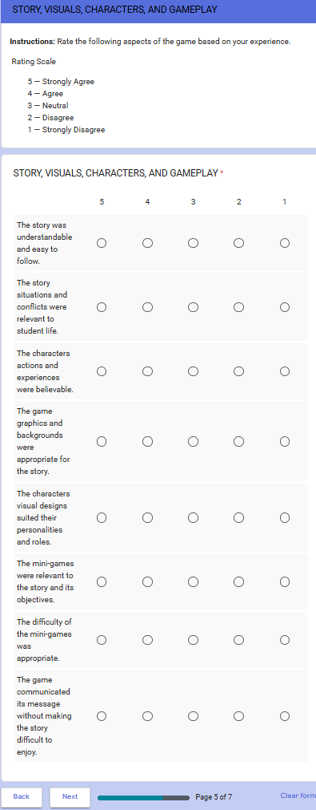
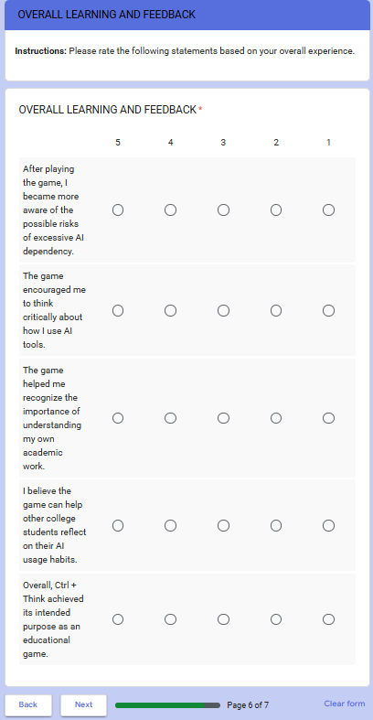

APPENDIX E
BACKGROUND SCENE

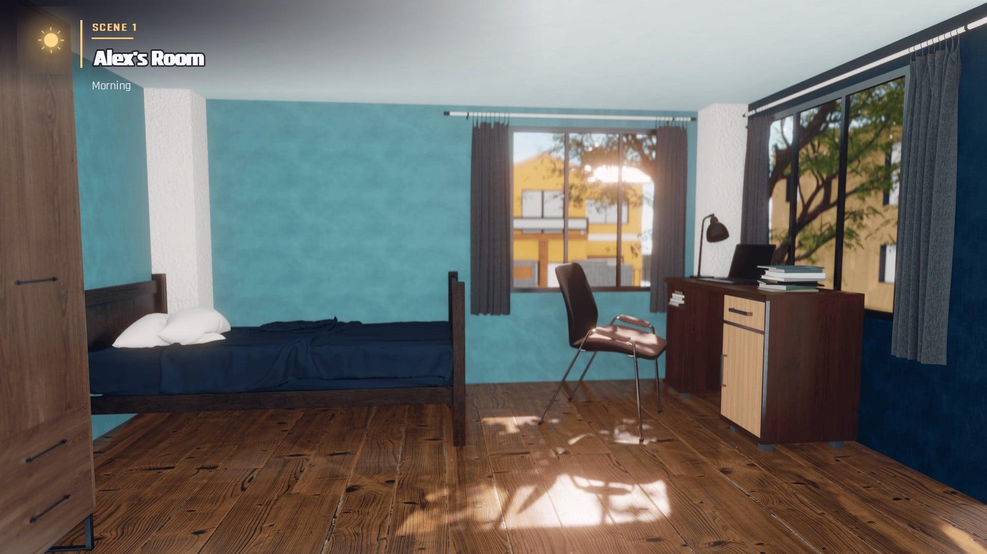
Figure 1. Main Character Bedroom
Figure 2. Campus Gate


Figure 3. Classroom
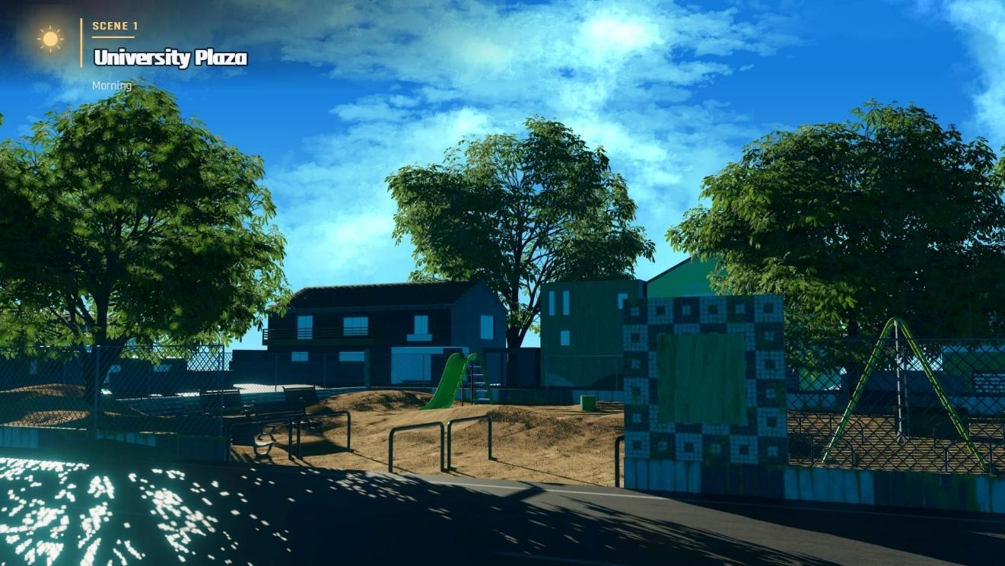Figure 4. University Plaze


Figure 5. College Library
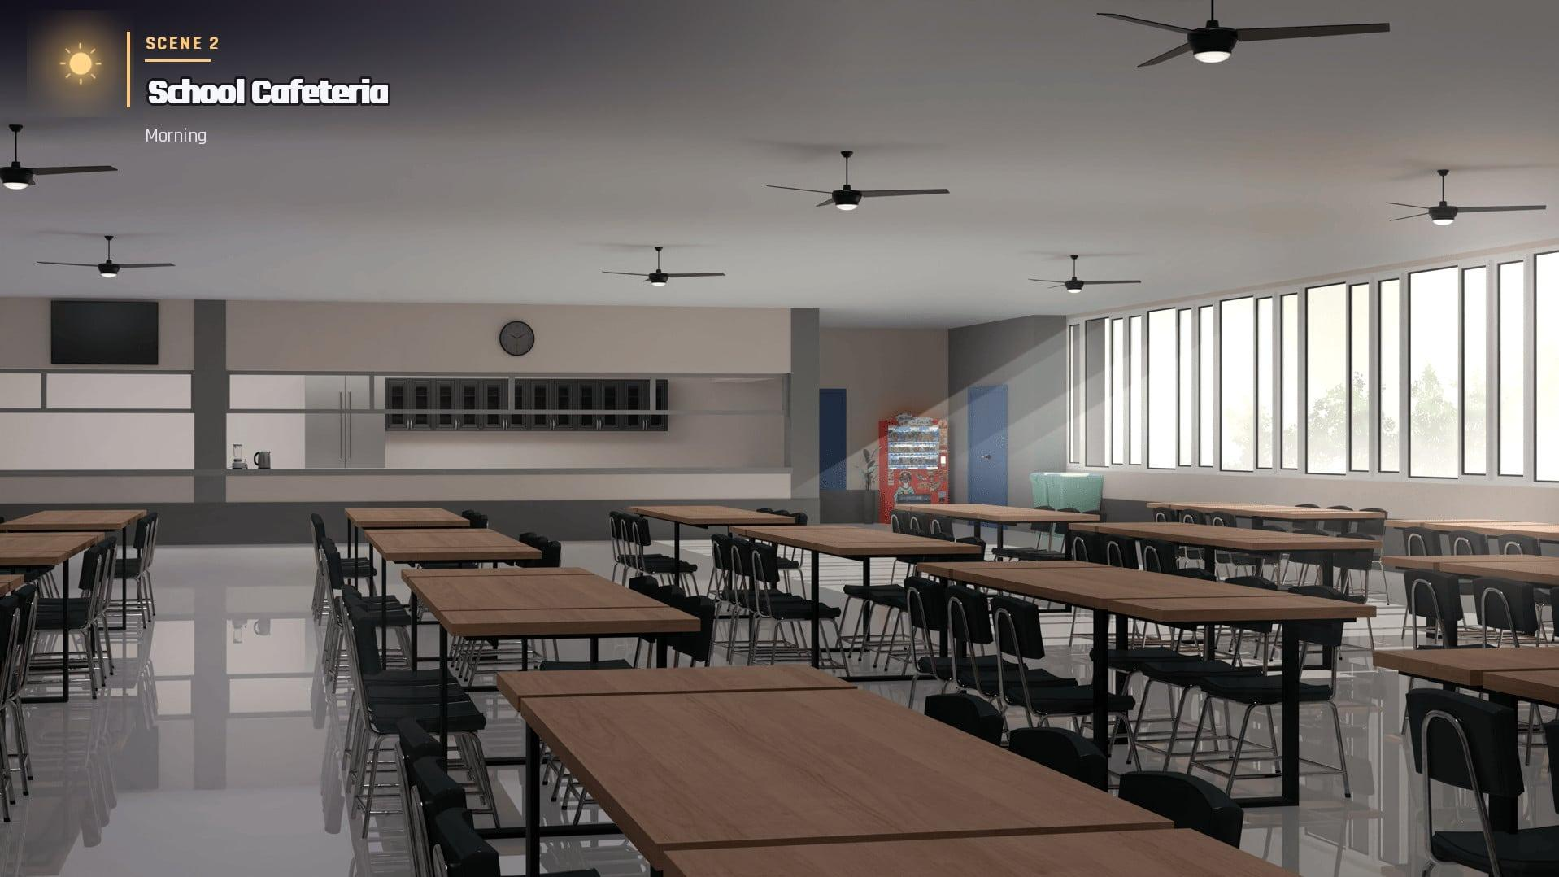
Figure 6. School Cafeteria

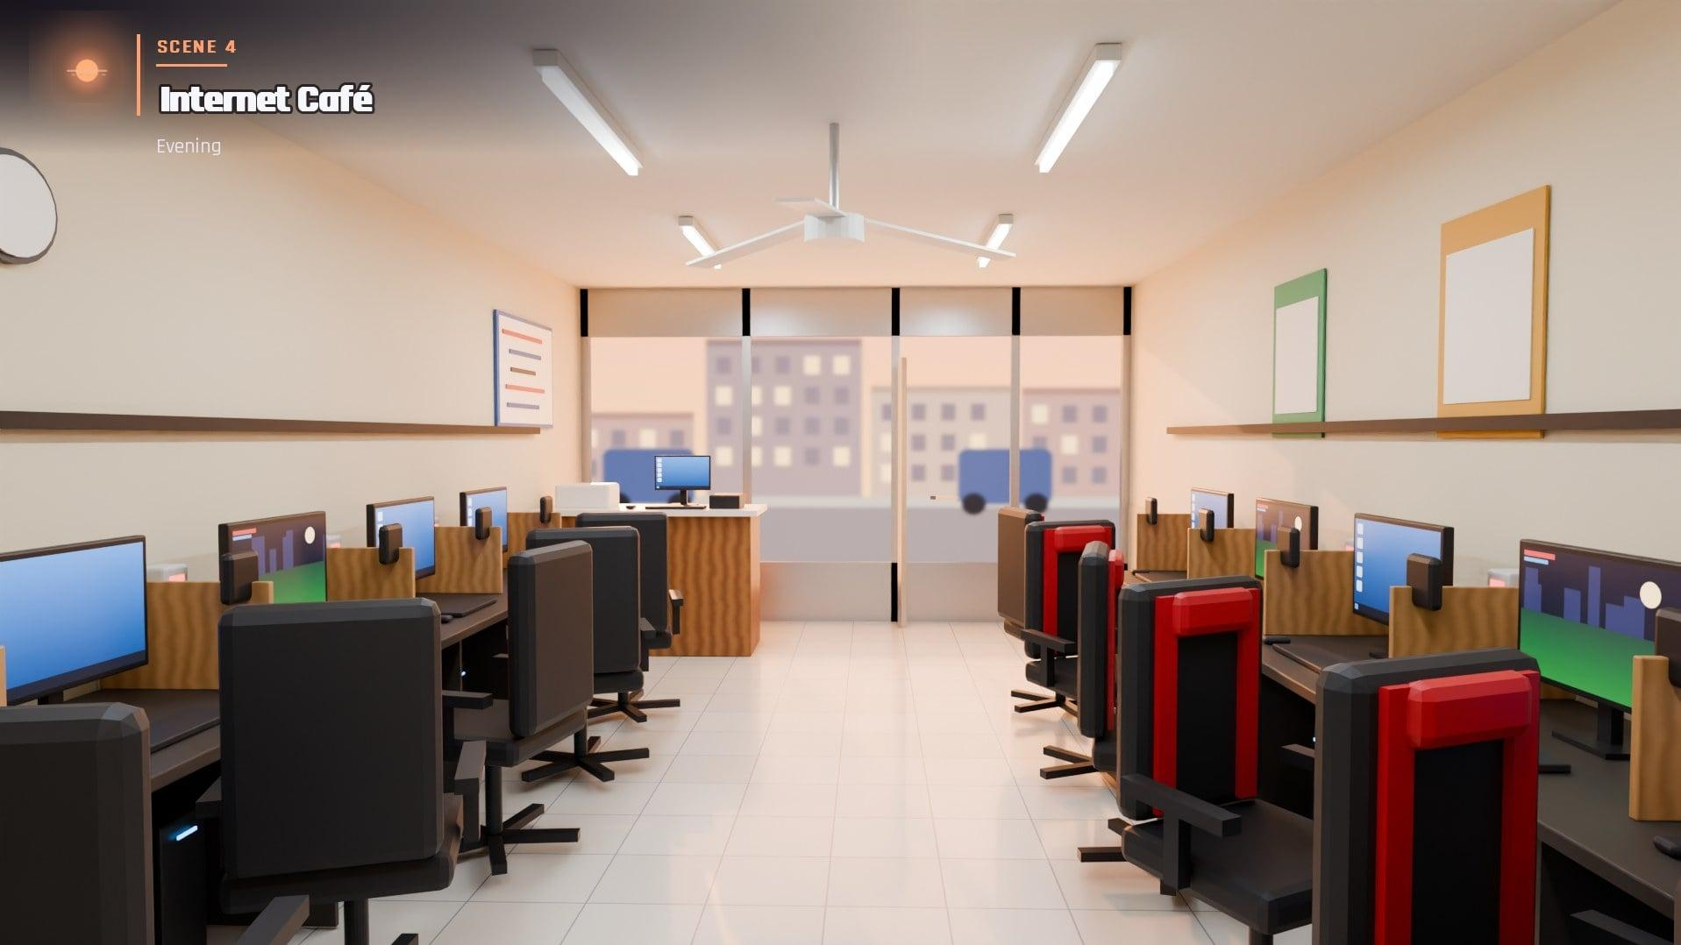
Figure 7. Internet Café

Figure 8. Computer Laboratory


Figure 9. School Lobby

Figure 10. Multimedia Presentation Room


Figure 11. College Building Hallway
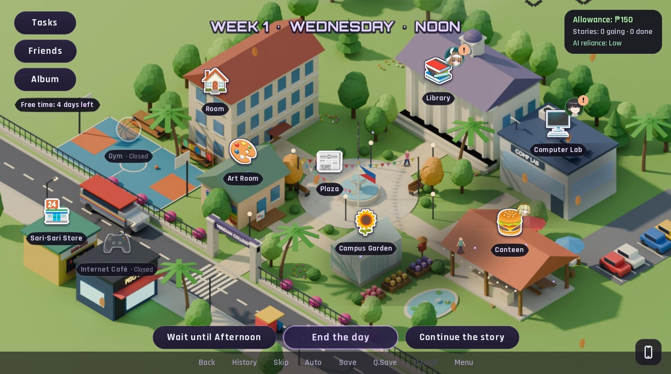
Figure 12. Map

APPENDIX F
SIMILARITY REPORT

APPENDIX G
GRAMMAR REPORT

APPENDIX H
STUDENT CURRICULUM VITAL

