BACT7507 – Project
Week 4 Lab – Project Timeline & Risk Deep Dive (3 Hours)

Lab Objectives
- Break project into structured tasks.
- Create realistic Gantt chart.
- Write detailed risk register.
- Define team roles clearly.
- Update proposal planning section.

Part 1 – Task Breakdown (45 minutes)
- List all major project tasks.
- Divide tasks into phases (Design, Development, Testing, Documentation).
- Assign estimated duration for each task.

2D Interior Design Customizer
- Requirements
- Design
- Development
- Testing
- Documentation
  - Login System Module
  - Favourites List Module
  - Blank Canvas Module
  - Drag and Drop Module
  - User Upload Module
  - Save and Load Module

Part 2 – Create Gantt Chart (45 minutes)
- Use Excel, Google Sheets or simple table.
- Include task start week & end week.
- Mark milestones clearly.
- Export screenshot or PDF.
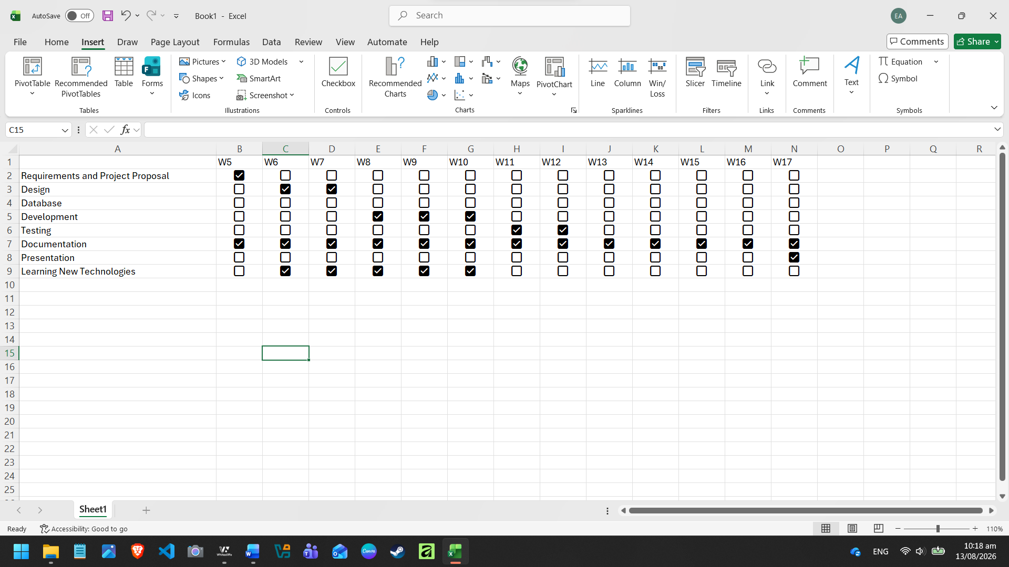

Part 3 – Risk Register (45 minutes)
For each risk include:
- Risk description
- Impact level (Low/Medium/High)
- Likelihood
- Mitigation strategy
Write at least THREE strong risks.
Risk | Impact | Mitigation
Time Constraint / Poor Time Management | Unfinished tasks, not being able to reach milestones. | Clear and concise timetable
Complexity when learning new technologies | Time constraints with timetable and scope | Set milestones in timetable for when we learn the technologies.
Database not secured | Stakeholders’ information will be breached and not secured. | Learn database (e.g. MySQL)

Part 4 – Team Roles (30 minutes)
- Define responsibilities for each member.
- Identify shared responsibilities.
- Ensure balanced workload.
- Commit updated document to GitHub (Week 4 Planning).
Maisha – Frontend Development, Documentation
Ethan – Designing, Supporting Programmer
Matia – Backend Development
Shared responsibilities – Edit Word File, Version in GitHub (Commits in repository), giving feedback to each other.

Submission (Upload to Canvas)
- Task breakdown list.
- Gantt chart file or screenshot.
- Risk register table.
- Team role document.
- Updated GitHub commit screenshot.

