BACT7507, Project
Week 3 Lab Activity – Solution Design & Proposal Draft Development
Ethan Andrei Rivera
ID: 20251303
August 6, 2026

Lab Objectives
- Finalise project groups.
- Define functional & non-functional requirements.
- Create simple system design diagram.
- Select and justify technology stack.
- Start structured draft for Assessment 1.

Part 1 – Functional Requirements (45 minutes)
- List 3–5 core features your system will include.
- Clearly describe what each feature does.
- Define at least 2 non-functional requirements.

Functional Requirements | Non-Functional Requirements
Login System | Secure database & strong password encryption.
Add to Favourites button for each product or item. | Store and access data and information immediately.
Drag and drop furniture and items / room customization. | 2D Quality Models, color customization for furniture and other kitchen items.
Categories Carousel (Appliances, accessories, plates.) | Smooth animation on carousel and drag & drop feature. Responsive design.

Part 2 – Scope Confirmation (30 minutes)
- List features that will NOT be included.
- Confirm project scope is achievable within 12 weeks.
- Ensure equal workload distribution between group members.

List of features that will not be included
- 3D Models for furniture and other kitchen items
- Online Payment System
- Other Room Types (e.g., Bedroom, Toilet, Living room)
- AI Recommendations / Automation
- Chat box / Contact Form

This kitchen interior design web application is achievable within 12 weeks if there are no delays and all three members of the group will be able to complete the shared workload and accomplish them within a certain period.

Part 3 – System Design Diagram (45 minutes)
- Draw a simple block diagram (User → Interface → Logic → Database).
- Create a flowchart of main user actions.
- Include diagram draft in GitHub repository.

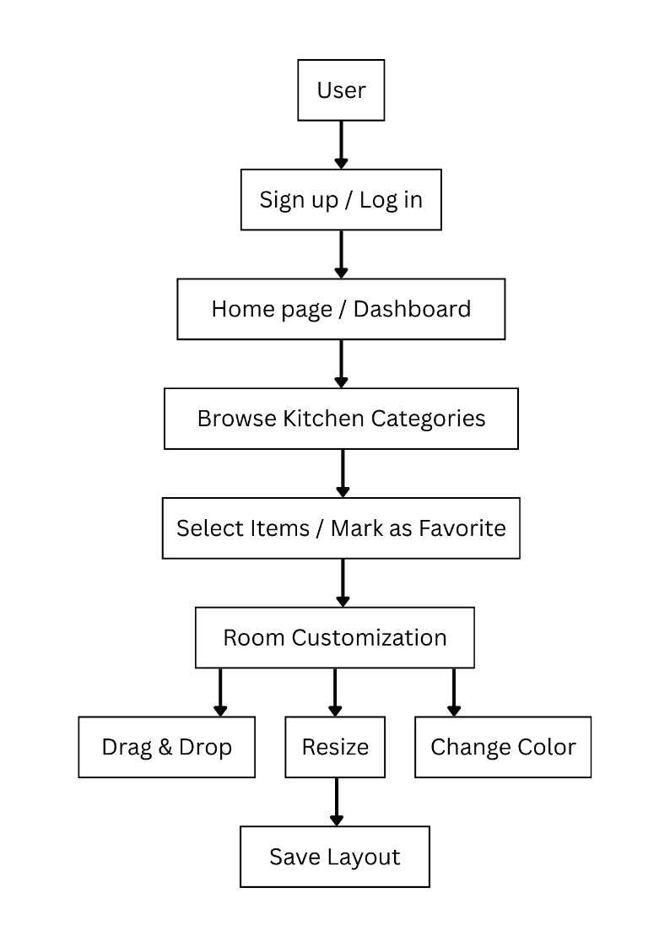

Part 4 – Technology Selection & Justification (30 minutes)
- Select programming language & framework.
- Select database (if required).
- Write short justification (Why this tech?).
- Commit update to GitHub (Week 3 Draft).

List of Technologies / Languages / Database | Justification
HTML5 | Structure of the web application.
CSS3 | For styling the layout of the web application, responsive design, and animations.
JavaScript | For added functionalities and interactivity to the web application.
Fabric.js | Creates a canvas to allow the functionalities when the user drag & drops, resizes, changes the color, and layer the items.
JSON | Stores the data for all the kitchen items/products like description, categories, colours, etc.
SVG | A file format used to display 2D images with vector graphics. This will be the format for all the digital illustrations of the kitchen items/products.
Node.js | Used to run JavaScript and build the backend of the web application.
Express.js | Server framework that supports Node.js.
MySQL | Database for the web application to store user information, kitchen products, and items.
bcrypt | Secure passwords by using hashes.
JWT (JSON Web Token) | Secure login and authentication functionality.
Git & GitHub | Version control while also allowing for collaboration and repository access to other group members.
Figma | Wireframe and prototyping tool.
Canva | Design visualization and assets library.
Adobe Photoshop | Tool to illustrate the vector images.

Submission (Upload to Canvas)
- Functional requirement list.
- Non-functional requirement list.
- Scope statement.
- System diagram (image or PDF).
- Technology justification paragraph.
- Updated GitHub screenshot.

