|  |
| --- |
| RESEARCH PROJECT “QR-Code Based Client Monitoring System  Digital Transformation Center – Palawan” - 2025-2026 CAREER OBJECTIVE Dedicated and passionate fourth-year BSIT student with strong front-end web development and UI/UX design skills, eager to apply and grow technical expertise in a professional setting, with a willingness to learn, adapt, and contribute to team success. Seeking opportunities that offer career development and hands-on experience in the IT industry. KEY SKILLS  * **Web & Programming:** HTML5, CSS3, JavaScript, Python, C#, Java, PHP, SQL (basic) * **Design & Tools**: VS Code, Visual Studio, IntelliJ, Blender, Canva, Photoshop, CapCut, DaVinci Resolve * **AI Tools:** ChatGPT, DeepSeek, Cursor, Github Copilot, Perplexity, Gemini, Claude Code * **Others:** UI/UX Design, Graphic Design (basic), Microsoft Office, Video Editing  SOFT SKILLS  * Eagerness to Learn & Adaptability * Communication & Team Collaboration Skills * Problem-Solving & Critical Thinking * Attention to Detail * Time Management * Creativity * Work Ethic  EDUCATION and QUALIFICATION **STI College Puerto Princesa**  Bachelor of Science in Information Technology  2022 – 2026 (Expected)  Dean’s List  **Aborlan National High School**  Senior High School – HUMSS Strand  2021 – 2022  **WPU - Agricultural Science High School**  Senior High School – HUMSS Strand  2020 – 2021  **WPU - Agricultural Science High School**  Junior High School  2016 – 2020  **WPU - Basic Laboratory Science High School**  Primary Education  2010 – 2016 |

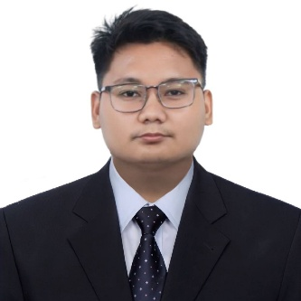

# CERTIFICATIONS & SEMINARS

SAP S/4HANA – 2023-2024

DICT Network Technology – 2024

Cyber Security Awareness – 2023

Systems Administration – 2023

Java Fundamentals – 2023

CISCO HMTL Essentials

CISCO CSS Essentials

Web Developer | UI & UX Designer

# CONTACT

|  |  |
| --- | --- |
|  | 0993-723-2644 |
|  | [escalante.christopherandrei@gmail.com](mailto:escalante.christopherandrei@gmail.com) |
|  | https://dreinosaurus.github.io/ |
|  | www.linkedin.com/in/escalante-andrei |
|  | Brgy. San Miguel, Puerto Princesa, Palawan |

CHRISTOPHER ANDREI, A. ESCALANTE