

Version: 0.1.0

Members

Dane Miller

Justen Morgan

Travis Smith

# Overview

Poat is essentially a student companion. Its primary feature is its assignment tracker. Other features will be timetable….

# Functional Requirements

* The app should be able to save courses.
* The app should be able to save assignments to corresponding courses.
* The app should allow for assignments to be split up into sub tasks.
* The app should have dynamic priority increasing priority closer to due date.
* App should be able to send and retrieve data from online server.
* User should be able to sign up and login.

# Relationship Diagram

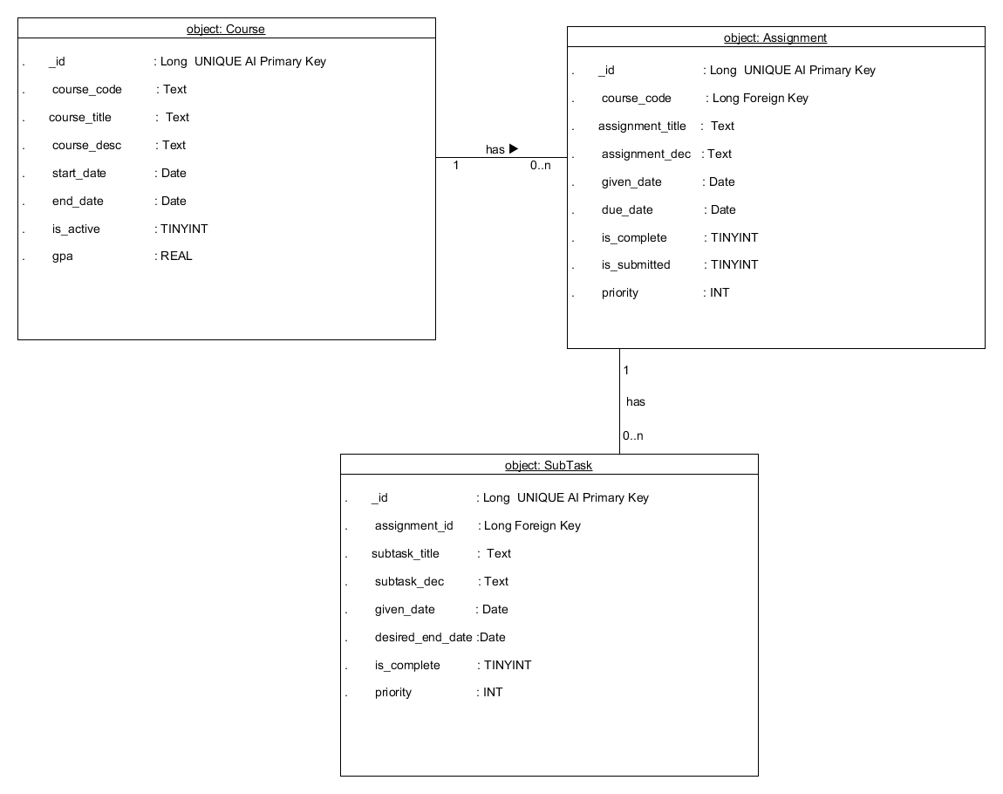

# Platforms

* Android – API 11 and upwards
* Web – Using angular and html or Ruby

# Database

* SQLite – Local Android Database
* Parse (Maybe) – For central Db
* Other(Still Looking)

Functional Requirements

* App should be able to CRUD a course.
* App should be able to CRUD an assignment.
* User should be able to login
* App should push changes to the server.
* Should link assignment to a course.
* Add subtasks to an assignment.