PTS tools:

The PTS tools plugin adds some algorithms to the processing toolbox.

Plugin is for QGIS 3 only.

Access through processing toolbox.

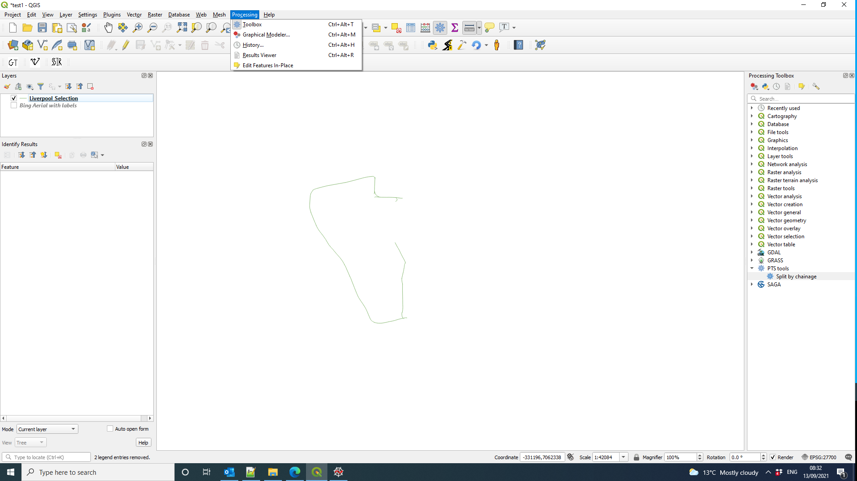

Split by chainage:

- Produces output layer containing features of input layer split by chainage into a length of step

- New Features will have start_chainage and end_chainage fields added.

- Last part may be shorter eg 25 m feature split into 10m will become 0-10m 10-20m,20-25m pieces

- Section length is treated as field when set, otherwise geometry length.

2D vs 3D geometry:

- Split by chainage can work with 2D and 3D geometries.
- Networks supplied by clients usually have 2D geometries(no altitude).
- Section lengths calculated from 2D geometry will be shorter than the actual 3D length of the road.
- Chainage along actual 3D road > chainage from 2D geometry

