**Used Cars For Final In Machine Learning**

**Exploratory Analysis**

Drew Buhr, [dbuhr@bellarmine.edu](mailto:dbuhr@bellarmine.edu)

Joshua Dow, [jdow@bellarmine.edu](mailto:jdow@bellarmine.edu)

1. **INTRODUCTION**

On Kaggle, we were able to find a used car dataset that described over 20,000 used cars for sale. The dataset included information from a car’s manufacturer, price, year, and transmission. We decided to choose this dataset because it offered a fair mix of categorical and numerical data, and we thought it would be an interesting dataset to work with.

1. **DATA SET DESCRIPTION**

The data set originally contained over 10,000 samples with 25 columns, but after cleaning unnecessary columns and samples with incomplete entries we narrowed the data set down to slightly over 4000 samples with 18 columns. A complete listing is shown in **Table 1**.

**Table 1: Data Types and Missing Data**

|  |  |  |
| --- | --- | --- |
| *Variable Name* | *Data Type* | *Missing Data (%)* |
| 1) Region | Nominal / object | 0% |
| 2) Price | Ratio / int64 | 0% |
| 3) Year | Interval / int64 | 0% |
| 4) Manufacturer | Nominal / object | 0% |
| 5) Model | Nominal / object | 0% |
| 6) Condition | Ordinal / object | 0% |
| 7) Cylinders | Nominal / object | 0% |
| 8) Fuel | Nominal / object | 0% |
| 9) Odometer | Ratio / int64 | 0% |
| 10) Title | Nominal / object | 0% |
| 11) Transmission | Nominal / object | 0% |
| 12) Drive | Nominal / object | 0% |
| 13) Size | Nominal / object | 0% |
| 14) Type | Nominal / object | 0% |
| 15) Color | Nominal / object | 0% |
| 16) Description | Nominal / object | 0% |
| 17) State | Nominal / object | 0% |

1. **Data Set Summary Statistics**

Below tables that describe some overview statistics of our dataset.

**Table 2: Summary Statistics for Used_Cars**

|  |  |  |  |  |  |  |  |  |
| --- | --- | --- | --- | --- | --- | --- | --- | --- |
| *Variable Name* | *Count* | *Mean* | *Standard Deviation* | *Min* | *25th* | *50th* | *75th* | *Max* |
| Price | 4125 | 10,945 | 9,227 | 265 | 4,950 | 7,990 | 14,989 | 135,000 |
| Year | 4125 | 2008 | 7 | 1917 | 2005 | 2009 | 2013 | 2020 |
| Odometer | 4125 | 115,418 | 59,858 | 22 | 74,097 | 116,783 | 152,000 | 417,000 |

Table 3: Proportions for Used_Cars

|  |  |  |
| --- | --- | --- |
| *Category* | *Frequency* | *Proportion (%)* |
| Region | 4125 | *100%* |
| Manufacturer | 4125 | 100% |
| Model | 4125 | 100% |
| Condition | 4125 | 100% |
| Cylinders | 4125 | 100% |
| Fuel | 4125 | 100% |
| Title | 4125 | 100% |
| Transmission | 4125 | 100% |
| Drive | 4125 | 100% |
| Size | 4125 | 100% |
| Type | 4125 | 100% |
| Color | 4125 | 100% |
| Description | 4125 | 100% |
| State | 4125 | 100% |

Table 4: Correlation Table/Tables

|  |  |  |  |
| --- | --- | --- | --- |
|  | Price | Year | Odometer |
| Price | 1.00000 | .409356 | -.502527 |
| Year | .409356 | 1.00000 | -.340117 |
| Odometer | -.502527 | -.340117 | 1.00000 |

We found a heatmap to be nonhelpful with this particular dataset. A heatmap was very difficult to read and did not show very distinct information about the dataset.

1. **DATA SET GRAPHICAL EXPLORATION**

We included below the most helpful visualizations we found while working with the data. With our data set, since we had so much categorical data, bar graphs were commonly used. We found that distribution graphs and scatterplots informed us a lot about the data as well.

**Figure 1: Distribution of the Cars’ Manufactured Year**

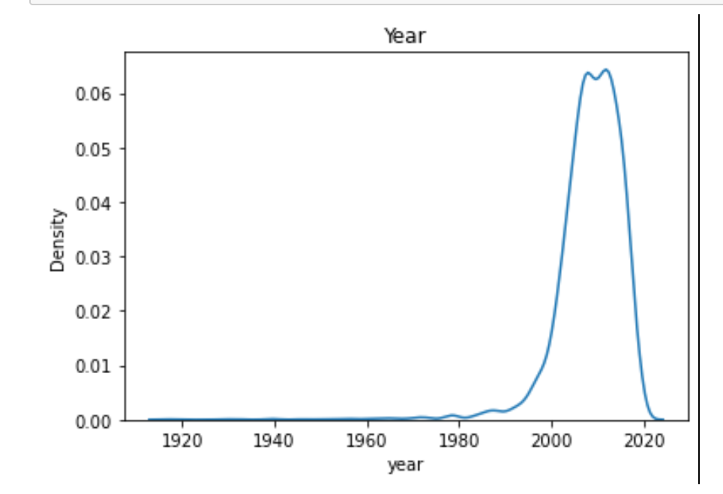

**Figure 2: Scatterplot of Price Compared to Miles on the Odometer**

**Figure 3: Scatterplot of Price Compared to the Cars’ Manufacturer**

**Figure 4: Bar Graph Showing Max Price of Each Condition Type**

**Figure 5: Bar Graph Showing Max Price for Each Transmission Type**

**Figure 6: Distribution of Prices**

**Figure 7: Bar Graph Showing Comparison Between a Car’s Manufactured Year and Odometer Reading**

1. **SUMMARY OF FINDINGS**

In conclusion, we found that the price of a used car is affected by multiple aspects of the car. The year a car was manufactured, the number of miles driven on the car, and the transmission of the car had the effects of the cars’ prices that we expected. For the most part, the more recently the car was produced the higher the resale price would be. However, in some rare instances if a vintage or old collection car were being resold, the price could still be higher than the mean and the median. We also found the smaller number of miles on the cars’ odometer readings the seller was able to sell the car for a higher price and vice versa. Automatic transmitted cars were also sold at a higher value than manually transmitted cars. The description of the cars’ conditions impacted the price as we expected, the better the condition resulted in a higher price. We surprisingly found that the manufacturer of the car did not have a noticeable impact on the resale price of the car. Overall, we found that the resale price of a car is impacted mostly by when it was produced, the number of miles on the car, and the type of transmission.