

Constipation/Encopresis in Toddlers and Children
Constipation and soiling is a common diagnosis in preschool and early school age children. Usually the problem starts with a dietary issue—too much cheese or bread for a day or two, leading to constipation. The child gets a bit constipated for whatever reason and has a hard or painful bowel movement. Thus starts a cycle of withholding, where a child will clench their anal sphincter and hold in their stool for as long as possible. Obviously this withholding can only go on for so long. Eventually the child has another bowel movement and it will hurt more than the last, further reinforcing the child’s desire to hold in their stool. Why a child can have thousands of bowel movements that are normal and comfortable but remember the one or two that are hard or painful is a mystery. But, that is what happens, and so the cycle continues and subsequently gets worse.
Eventually the child withholds their stool to the point where they get increasingly “backed up”. They may have bowel movements every few days—despite the child’s best efforts to avoid it, but each time they pass less than what they need to and their colon fills up more and more.
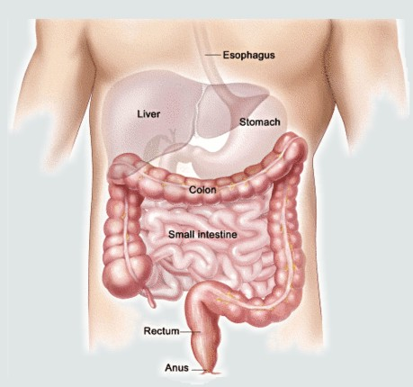
Normally, when the last part of the colon, the rectum, fills with stool, the bowel sends a signal to the brain telling it to relax the sphincter, tense the abdomen and have a BM. This happens with newborns, small children and adults. Eventually, the brain tires of the constant “signal” from the bowels and starts to ignore this message. This process is caused habituation and is similar to what our brain does when our neighbor is having their house re-roofed. Every morning, the hammering begins and the brain hears this input. After a few hours, however, the brain is able to block out this extraneous stimuli and “ignore” the signal. After a while, the brain no longer hears the noise and the pounding is no longer bothersome.
The same thing happens with the bowels. The rectum sends a constant signal to the brain. After a while, the brain gets tired of hearing the same “gotta go, gotta go” signal and eventually stops listening. The child loses the ability to recognize when he/she needs to have a BM. Subsequently, the sphincter remains ‘clenched’ and the child starts the withholding cycle. When the child eats, things start to cramp up and from time to time, despite their best efforts, the rock hard stool works its way out. The child usually doesn’t even realize that they are ‘going’ until it is halfway out. An older child in underwear will have frequent soiling accidents and will lose the ability to control when they will have bowel movements.
Because the brain can no longer recognize when the bowel needs to empty, the child loses the ability to have a normal eating/bowel movement cycle. In order to re-establish the normal physiologic cycle, the bowels need to clean out and the connection between the rectum and brain needs to resume. This can only occur with the help of a stool softener or laxative. Most of the time, Miralax, an osmotic stool softener is used. Occasionally Milk of Magnesia or Mineral Oil may be used. In any event, the goal is to facilitate the child in having 1-2 soft, comfortable bowel movements every day. Initially the child may resist the need to poop and higher doses may be needed. After a short while of having comfortable BM’s, the dose may be decreased and then maintained for a while.
It may take several months of remaining on the stool softener for the bowels to clean out and for the signal between the rectum and the brain to reconnect. It will eventually, though this takes time. The most common mistake that parents make is to stop the stool softener too early. Often time, the parents will give Miralax for a few days, the child will have several large BM’s and the parents then think that things are fixed. But remember, there is a lot of back up to empty out, and it takes a while for the brain to start listening (and believing) what the colon is telling it. Be patient. The stool softener has no side effects and children don’t get “dependent” on it. Kids are stubborn though, and habits can be hard to break.
Occasionally, when it is not totally clear that this is what is going on, I will order a KUB (or one view abdominal x-ray). Retained stool is easy to see and can help quantify just how “full of it” the child is. Once the stool softener is started I generally want the parent to call me in about a week to “check in” on how things are going. An office visit in about a month is also usually recommended to assess the situation and to reiterate or tweak the plan as needed.
This problem can be frustrating for parents. One of life’s most basic functions has gotten out of rhythm and it is hard from our perspective to understand why. Rest assured that this situation is fairly common in pediatrics and with the right plan, is easy to fix.
--Be Well
Drew Nash, M.D.

