Pitchboard – Drew Nicklowitz – MI349

earshot.com

Earshot is a space for music players and lovers alike to promote themselves and find others to perform for, teach, inspire, or jam with them.

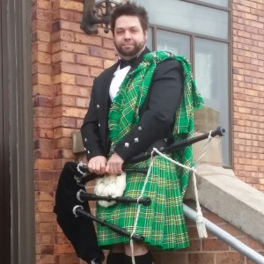Earshot is a website created for spreading the love of music. The website is designed to bring people with similar music tastes together and use that initial passion as a spark for real social activity. There are social medias that focus on a lot of different types of media, but a social media that is designed around music has yet to be implemented in an impressionable way. The goal is to have a space that feels just as easy to use as mainstream social media platforms in terms of finding other people while also celebrating and providing musical content in a way that progresses the musicians of society.

**Hamish -Male -26**

“I’m tired of not being able to share the joy I get from playing and listening to music”

Hamish is a casual bagpipe player that has talents unseen by many people. Having skills in producing music as well as performing it using the bagpipe, Hamish feels that having others who could see his work and reach out to him to collaborate would be a great way to further his musical experiences.

--Casual artist, experienced music advocate. Uses earshot as a personal social tool.

Concerned about not being able to find others with his specific tastes, but also needs an outlet for this part of his identity.

**Alexis – Female – 21**

“I really do appreciate the praise and support I get on other social media platforms, but I find it never helps me with my ‘writer’s block.’”

Alexis has been playing guitar since before she could walk, and is constantly looking for new genres and styles to get into with her production. With a vast library of music she has created under her belt, being able to promote her work and share tutorials with her fans is something she has always had to do using media sites that aren’t catered to music. As important as her career is to her, she is always looking for new people to play with and learn from.

--Expert artist, expert music advocate and teacher. Uses earshot to promote her work and connect with fans and peers in separate fashions.

Wants a media outlet designed for people that can help further her as an artist and vice versa.

**Comparative/Competitive websites:**

<https://bandcamp.com/> ; <https://www.instagram.com/> ; <https://www.ultimate-guitar.com/>

Below are the comps of the three pages I plan to have in my website

Above is the flow sheet for my website