Andrew Sosanya

Dartmouth College

Caltech Wave Fellow

Physics, Mathematics, and Astronomy Department

Advisors: Fiona A. Harrison and Scholar Murray Brightman

**A Systematic Search for Absorption Features in the X-Ray Spectra of Ultraluminous X-ray Sources**

Our high-energy astrophysics group studies energetic phenomena ranging from gamma-ray bursts, black holes on all mass scales, to neutron stars, supernovae remnants and collapsed stars. We are especially interested in X-ray sources in numerous galaxies.

**Project Description**

Ultraluminous X-ray sources (ULXs) are variable, non-nuclear bright X-ray sources in nearby galaxies not associated with the central supermassive black hole. These ULXs are brighter than black hole systems in our galaxy––these sources show pulsations. They have super-Eddington luminosities the accretion limit of a black hole of 10 solar masses. The Eddington limit of a star is the maximum luminosity a star can achieve due to the hydrostatic equilibrium between the force of radiation acting outward and the gravitational force acting inward. This constraint on radiation from the star limits its accretion flow, and therefore its luminosity. These ULXs break the Eddington theory because there are extreme accretion rates onto a compact stellar remnant, or an intermediate mass black hole. Before recently, most ULXs were thought to be powered by intermediate-mass black holes. The discovery of X-ray pulsations suggests that these ULXs may be powered by accretion from overly magnetized neutron stars (Bachetti et al. 2014). Bachetti et al also found that these neutron stars may not be rare within ULXs. The distinguishing factors between neutron star-powered ULXs and intermediate-mass (∼100−105 M⊙) black hole powered ULXs remains uncertain, as the luminosities of ULXs can imply either as a cause. The neutron star surface field is very high, on the order of ${{10}^{14}-10}^{15}$, which suppresses the electron scattering cross section, which reduces the force of radiation from the star. Therefore, it reduces the accretion rate for high luminosities. We seek to find signatures magnetic fields through the detection of cyclotron resonance scattering features (CRSFs) in ULX-abundant galaxies. These CSRFs are more likely to be found in absorption rather than emission[1].

**Progress**

**Methods**

Scripts were created to cross-reference a catalogue of XMM telescope observations to find 10,000+ count ULXs. Using the spectral fitting software XSPEC v12.9 and pre-reduced data from past observations, we systematically searched for CSRFs. Our favorable candidates surpassed a $ℵ^{2}>7$ threshold. To further investigate these ULXs, we used XMM’s Spectral Analysis System (SAS), turned to raw data reduction to analyze further their characteristics. We corrected for background flaring with a photon rate cutoff of 0.4 photons $s^{-1}$. Later we varied the photon rate cutoff to get more counts. We tested patterns 0 and 1-4 to account for X-ray events that are split between pixels. Using the astronomical imaging software DS9, we selected our centroid, and picked a uniform background region to serve as a baseline background spectra for our reduction. We then normalized that spectra via the BACKSCAL value which is computed as:

$$\frac{Total detector area from which the spectrum is extracted}{Total detector area}$$

Lastly, we created the response and auxiliary matrix files and then grouped the spectrum.

The systematic search through our newly reduced data was similar to the search through pre-reduced data. We fit within the 2.0-10.0 keV energy range using several models: an absorbed power-law model with a high-power cutoff, contour plot, the Tuebingen-Boulder ISM absorption model, and a Gaussian absorption model. Goodness-of-fit was determined with the chi-squared statistic $ℵ^{2}$ generally around 10 and larger. Power-law index was set to $Γ=2$ with norm ~1E-4. We switched had three varied parameters for our tests: the energy at which we predicted CSRFs [5, 6, 7 keV]; the Gaussian width of those CRSFs [0.1, 0.3 keV]; the detector radius, which could increase incoming flux counts, but could potentially compromise the signal-to-noise ratio [30, 40, 50, 60].

**Results**

The most favorable data reduction parameters were a ds9 radius of 60, photon detection of 0 (although 0-4 gave almost identical results). Rates were set based on the flaring present in each observation. The search narrowed down to three strong absorption-line ULX candidates that had potential to be powered by neutron stars: Holmberg II X-1, M32, and IC-342. Holmberg II’s promising pre-reduced $ℵ^{2}$ ~ 11 decreased to $ℵ^{2}$ ~ 8 in the secondary data reduction. We checked for CSRFs in observations 0112520701 and 0200470101, and an absorption line at $E=3.3 keV$ was detected in the former, while no features were detected in the latter, statistically and visually. For 0112520701, we used a rate of 5 to hedge against intense background flaring that initially masked counts, thereby increasing the total amount of counts necessary. We detected an absorption feature at $E=3.3 keV$ with a $ℵ^{2}$ ~ 7 with 95% confindence. The feature had an appreciable dip in the continuum. 0200470101 had more reasonable characteristics, but there was nothing significant to show.

For IC-342, we detected an absorption feature at $E=5 keV$ with a $∆ℵ^{2}$ ~ 8 with 95% confidence.

For M32, we needed to use XMM data, as well as Chandra data for spatial resolution. With XMM (obs id 06720701), we detected an absorption feature at $E=6 keV$ with a $∆ℵ^{2}$ ~ 8 with 99% confidence. With Chandra (5630) detected an absorption feature at $E=6.5 keV$ with a ${∆ℵ}^{2}$ ~ 12 with 95% confidence.

We speculate four different reasons for the discrepancy between the XMM and Chandra observations of M32. First, if the features detected are indeed cyclotron lines, then it is possible to have different magnetic fields strengths at the time at each observation, since the observations do not occur simultaneously. The field strength may change and cause a different transition between energy states. Secondly, one or both lines may be due to atomic absorption. The lines occur at near the iron K-edges, which could imply a ultrafast iron outflow, such as that found in ULX NGC 1313. Third, a statistical fluctuation may be the cause of the line discrepancies. Lastly, contributions from the other proximate X-Ray sources in M32 may be detected in the XMM observation, as opposed to Chandra’s. The radiation from the proximates may be time-dependent, and have unknown behavior.

**Conclusion**

In addition to this project, I have been working on NuDetect, a software and hardware collaboration consisting of NuStar engineer Hiromasa Miyasaka, graduate student Sean Pike, and SURF student Julian Sander. We are testing new x-ray detectors for the NuStar Telescope. We write software to test for electronic noise, leakage current and inter-pixel conductivity within the detector apparatus to filter for the most ideal detector.

Links to scripts:

• NuStar ULX Analysis Github: https://github.com/DrewSosa/NuStar

• Github: https://github.com/cyangiraffe/nudetector

**References**

**An Iron K Component to the Ultrafast Outflow in NGC 1313 X-1**

Walton, D. J et al. *The Astrophysical Journal*. 826, no. 2. July 29, 2016): L26.

**An ultraluminous X-ray source powered by an accreting neutron star**

Bachetti et al. *Nature*; London Vol. 514. Oct 9, 2014.

**Cyclotron resonant scattering feature simulations. II. Description of the CRSF simulation process**   
F. -W. Schwarm*et al.*. 11 pp.  *Astron.Astrophys*. 601 (2017) Jan 26, 2017 A99

**Magnetic field strength of a neutron-star-powered ultraluminous X-ray source**

M. Brightman et al.

Nature Astronomy; Vol 2. April 2018

**New Observations of the Cyclotron Absorption Feature in Her X-1.**

Mihara, T.

*Nature*, n.d. Vol. 346 19 July 1990.

**Soft extragalactic X-ray binaries at the Eddington Threshold.**

Earnshaw H.M and Roberts T.P. Mon. Not. R.

Astron. Soc., 467, 2690-2705 3 May 2017

**Figures**

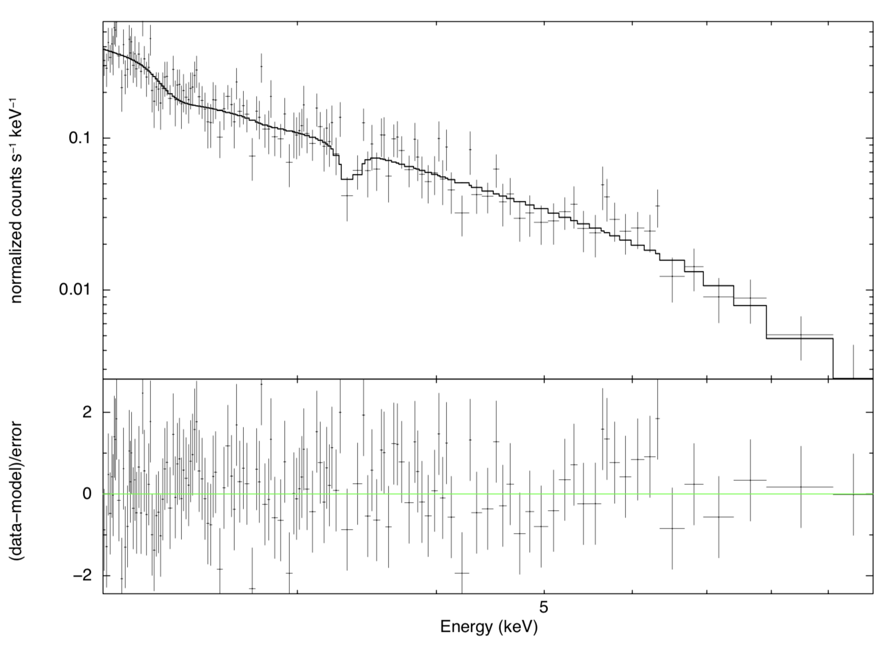

Figure . Folded spectrum of Holberg II, obsid 0112520701.

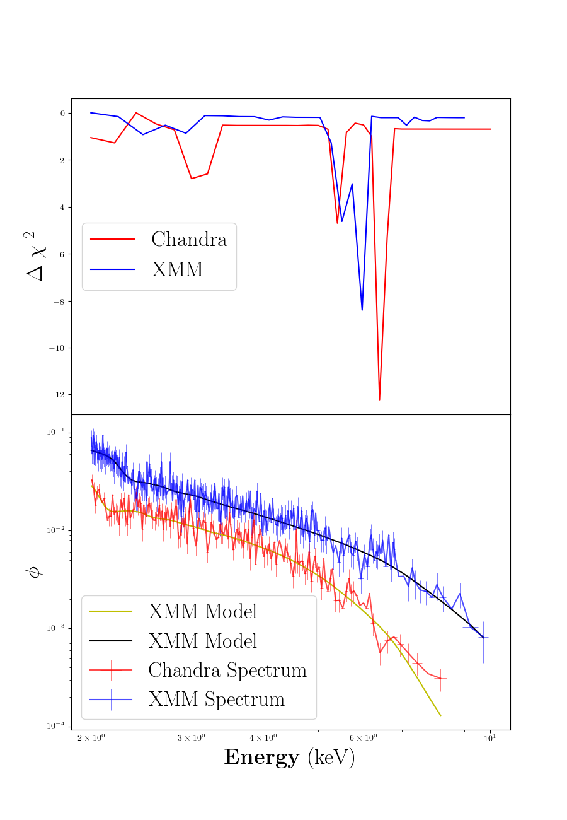

Figure . Folded spectrum and contour plot of M32.

1. Mihara et al.