TAP- TAP BOXING HTML5

**Game Overview**

“Tap-Tap Boxing” is a role playing clicker game intended for the mobile market. Using basic tap and swipe motions to effectively defeat your opponent with properly timed dodges and punches. As you progress through enemies gaining Experience and wealth you must purchase upgrades to better your performance. It will be an endurance game where you will work to progress further and further through the scaling bosses.

**Team Personnel**

* Andrew Van Dyke
* Matt Agostino
* Robert Duncan

**Plot & Setting Information**

The game takes place inside a underground boxing league run by Jeff “The Demo Man” Gauvan.

**Core Game Play**

**Fighting through Enemies to advance your character-**

After each fight is concluded the player will receive Xp and money based off if they won or loss and the time it took to defeat the opponent.

**Purchasing Items-**

Upon completing fights your character will be awarded with money. The opponents will scale with the player which will require the player to better their fighter. Through the store menu we will have a Variety of boost items available.

**Learning the timing of the fights-**

Each boss will have a different fight style the player will have to learn and adapt to. Learning these mechanics will greatly increase the number of resources the player will receive after the fight.

**Balancing Attack and Defence-**

With each opponent having a different fighting style the player must learn to balance between punching and dodging. The opponent will move their gloves up and down randomly in an attempt to block the players incoming attacks. The opponent will also attack on random intervals forcing the player to use the dodge effectively to maintain the incoming damage.

**Environment Elements (environments, characters, weapons, etc.)**

**Environment**

* Boxing Ring

**Weapons**

* Heavy Glove - +5 atack
* Glove packed with pellets - + 10 attack
* Barbwire Glove - + 20 attack

**Items**

* Water bottle - refill stamina quicker
* New Shorts - extra health
* New Trainer - Gain more xp

**Characters**

* Jeff “The Demo Man” Gauvan - The Big boss does most damage and has most health
* “Slow Poke” Steve Boston - First fight slow attacking easiest fight
* Dic Glare - Larger healthpool and slightly faster
* Ron C’ya - Fast and decent fighter
* Macho “Stan the Van” Savage - large health pool and powerful hitter

**Interface Usage (mouse, keyboard, etc.)**

The game is navigated using the mouse to click through with consideration of being

Ported to a mobile platform using a touch interface. The player will fight by clicking

Different target areas along the opponent's body 2 for each side of the head left and

right and 2 for the body left and right. By clicking in these zones the player will

perform a different punch targeting that zone. The player can dodge but clicking

2 different buttons on the bottom of the screen 1 to dodge left and 1 to dodge right.

By clicking the dodge button at the right time the player will dodge successfully

avoiding any damage. The opponents gloves will move around the attack zone

to land a successful punch the player must attack the zones were the gloves are not.

**Menu and General Game Usage**

Game Screen-

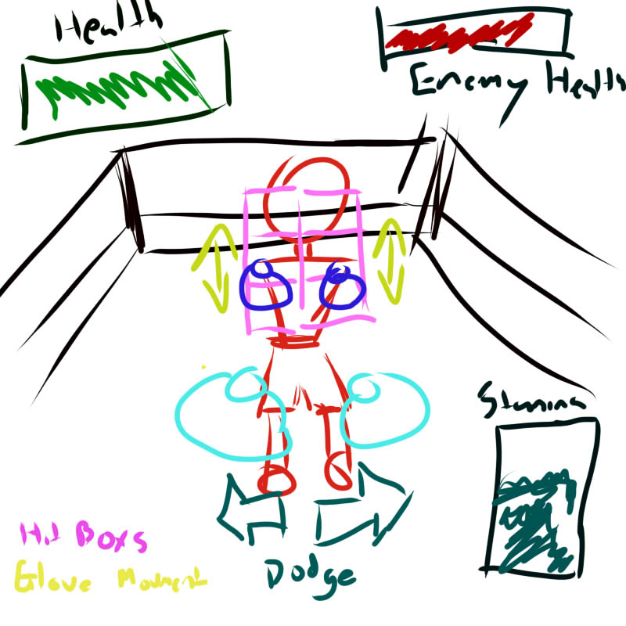

Menu Bar

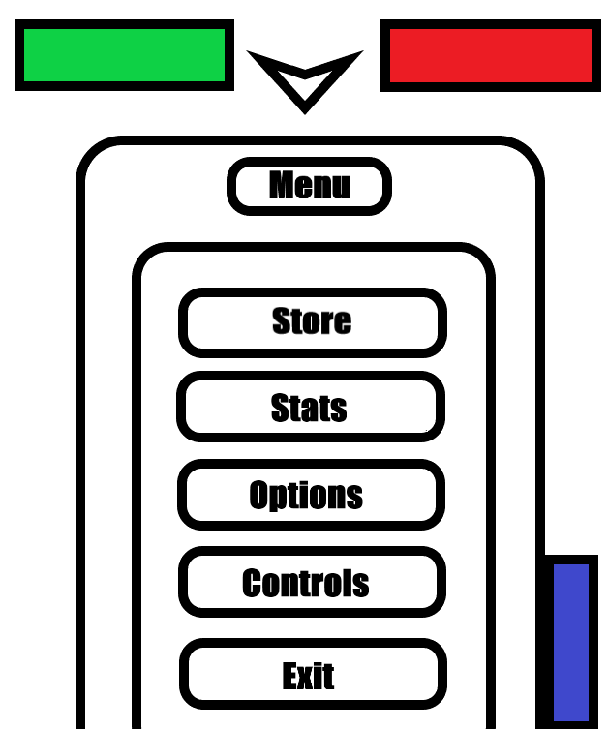

Store Prototype

