## horizontal line

Emergency Response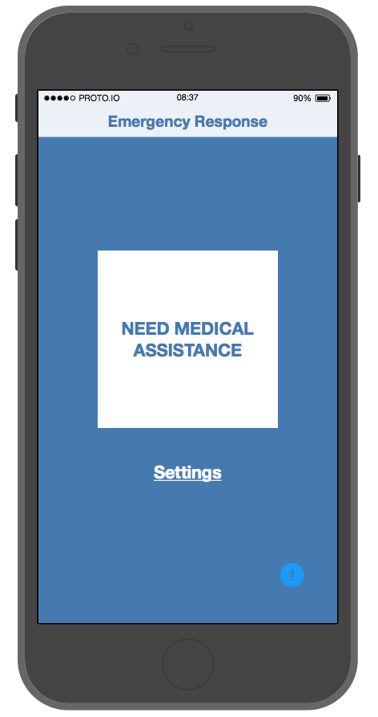

[Prototype App](https://nancytran.proto.io/share/?id=1f3e3c90-d591-4e41-9186-4c9a7135f7f3&v=2)

May 25, 2016

**─**

**INFO 102 AA**

Information Technology Project

**Lane Van Elderen, Brady Schneider, Drew Scott, Nancy Tran, Emily Zhai**

# Overview

## The Problem

Every second is precious when the situation you are in is a matter of life and death. Unfortunately, the average response time for a 911 call in the United States is 10 minutes, and many of the smaller (though equally as important) details get lost in favor of speed and efficiency.

## **Proposed Solution**

According to a Pew Research study, the number of U.S. adults with smartphones has nearly doubled in the last four years with a 6% increase in just the past year. Our app leverages this fact to support a network of medically trained volunteers with medical information about users and more accurately pinpoint their location using GPS infrastructure, which is built into every smartphone since 2008. This app is meant to be a compliment to 911, not a replacement for it.

# 

# 

# Marketing

## Competitive Framework

|  |  |  |  |  |
| --- | --- | --- | --- | --- |
|  | Minimal Features/Ease of Use | Provides Help | Leverages Immediate Proximal Network | Broadcasts Emergency/ Disaster Information |
| Emergency Response | X | X | X |  |
| 911 | X | X |  |  |
| Disaster Apps |  |  |  | X |

911 works on a much larger scale with medical professionals whose entire occupation is to help. However, our app has the added benefit of leveraging medically trained volunteers who may be able to help alleviate the situation before 911 responders arrive.

There are a number of emergency/natural disaster apps available to users, but they are made to provide individuals with information about disasters, so they can avoid them and where to find aid. Our app, like 911, aims to *bring* assistance to the person in need, not have the person in need come find assistance, like the disaster apps.

## Audience

We are targeting medically trained volunteers and individuals with pre-existing medical conditions as our users in an effort to connect individuals who need additional medical support with the individuals that can best provide it to them.

## Outreach

We will aim for partnerships with hospitals like Swedish and Harborview. All will introduce the app to their employees, who will then recommend it to the patients with pre-existing medical conditions, whose familial medical histories put them at risk. Funding for our app will come from partnerships with philanthropic organizations, local/state government, and charitable donations.

# Operations

## Features

|  |  |
| --- | --- |
| Lockscreen ID | A unique 10 digit number to identify the individual is located in the lock screen, so it is easily accessible to emergency responders and medically trained volunteers. |
| Medical Information | Users will be responsible for entering their own allergies, medication, current and family history, etc. when in a non emergency situation. |
| Broadcast Information | If a person needs help, a short description of the issue will be broadcasted to medically trained volunteers who have signed up to receive notifications. The medical information entered by the user in need will not be broadcasted and can only be accessed once the volunteer reaches them and enters their ID. |
| GPS Location | Location data will be collected during emergencies through the GPS functionality of users’ smartphones to give responders approximate location information in addition to user supplied specifics such as building and room numbers, along with other details about the situation. |

## 

## 

## Data Flow

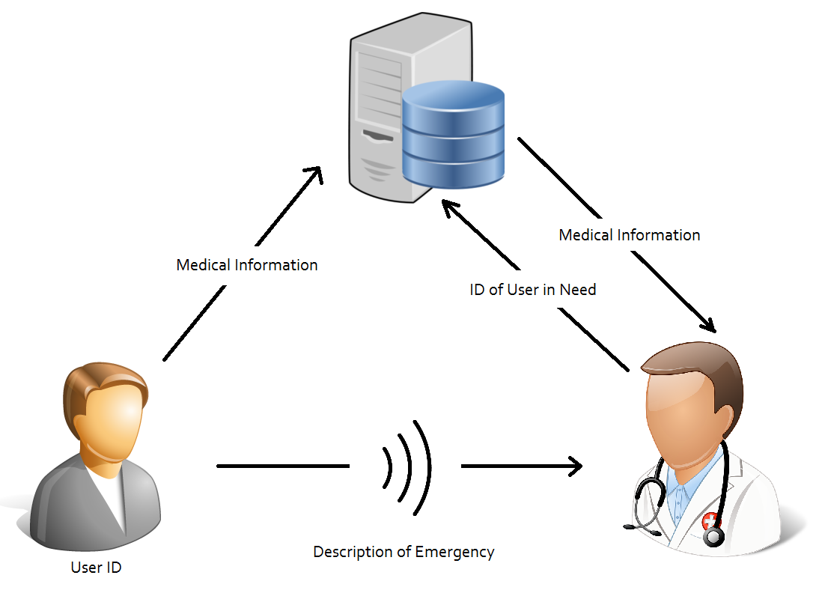

This app has the potential to carry highly sensitive data, specifically users’ medical information. As such, the app will only ever display vital data to the authorized receivers of the data, and can only be modified by the owner via the app. The only personal information stored on a secured server will be the user’s ID and their supplied information, making it anonymous in the event of a security breach and to ensure user privacy.

## The Team

We would essentially need an app developer to kickstart the app, an app designer to structure the app, and an app development and maintenance manager to oversee the overall app development.

A small marketing team (2 to 5 people) would be needed to reach out to hospitals and philanthropic companies. A legal consultant would be needed on call and for the initial draft of how to keep the app protected legally.

# Costs

**Development**

App Developer: $50/hour (15 hours for initial start-up = $750)

Marketing & Outreach: $25/hour (10 hours a week = $250 per week)

Legal Consultation: $1,000 - $5000 (Depending on how much of burden of law is on us)

**Maintenance**

App Maintenance: $50/hour (Roughly 10 hours a week at maximum = $500 a week)

Overall, initial kickoff for the app would come out to roughly $5000, a rather small amount of money to help get the app started. After this the product can be presented to companies to earn funding to continue maintenance and performance updates.

*All prices are just estimates and projections. Actual prices may vary depending on per basis needs (some areas may need more attention than others)

## Cost Analysis

|  |  |  |  |
| --- | --- | --- | --- |
| **One Time Costs** | | | |
|  | **Time** | **Rate** | **Total** |
| **Legal Consultation** | - | $1000 | $1000 |
| **App Developer** | 15 hrs | $50/hr | $750 |
| **Initial Cost:** | | | $1750 |

|  |  |  |  |
| --- | --- | --- | --- |
| **Monthly Operating Cost** | | | |
| **VPS Cost** | - | $25/month | $25/month |
| **App Maintenance** | 5 hrs/month | $50/hr | $250/month |
| **Marketing & Outreach** | 5 hrs/week | $25/hr | $500/month |
| **Monthly Cost:** | | | $775/month |

# Schedule

|  |  |  |  |  |
| --- | --- | --- | --- | --- |
|  | **Week 1** | **Week 2** | **Week 3** | **Week 4 and after** |
| **Tasks** | Begin initial development | Form Marketing Plan  Continue app development | Legal Consultation  Continue app development  Make pitch to hospitals and philanthropic organizations | Final polishes on app  Acquire consistent app maintenance  Have full time App Manager |
| **Players** | App Developer  App Designer | App Developer  App Designer  Marketing & Outreach | Legal Consultant  App Development Manager  Marketing | General Manager  App Developer |
| **Projected Cost(s)** | $750 | $1,000 | $3,500 | $750 initial  Month to month cost varies |

# Conclusion

This app will work as a compliment to 911, taking advantage of modern technology to save the lives of those in dire need. The low overhead of this system keeps costs low, making it a small investment with huge payoff. To create this program from a technical perspective might only take a month, but what is crucial is rapid adoption rates encouraged by existing aid networks. By supporting this project through monetary contributions along with technical, social, and legal expertise, this program can thrive and grow to take advantage of today’s technology to save the lives of countless individuals.