Outputs:

1. Key finds: <https://ambitiontoaction.net/wp-content/uploads/2019/04/Key_findings_final.pdf>

1. Web Tool: <https://ambitiontoaction.net/scan_tool/>

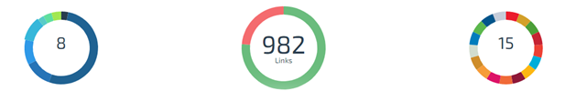

Policies

Health Outcomes

