Title: Understanding the Health of Philadelphia’s City Council Districts
Authors: Tamara Rushovich, Amber Bolli, Alina Schnake-Mahl, Stephanie Hernandez
Journal: Journal of Urban Health

Introduction
The use of geopolitical units in public health has increased in recent years. There have been several studies reported investigating health metrics by US congressional districts – for example, reporting COVID-19 disparities (CITE), cancer mortality (CITE)…. There are also numerous dashboards including for XX, XX, and XX. There have also been several studies reporting on the methods for estimating public health metrics by district as most public health data are not commonly available using district boundaries. The motivation for these studies are both to provide elected officials with data for the districts they represent, as well as to provide residents with data on the health of their own districts and city.

Almost all studies using geopolitical districts have been conducted using US congressional districts, with X number of studies using state districts. However, to our knowledge no studies have been published reporting health metrics using city council district boundaries. It is important to understand the jurisdiction and influence that each level of government can have. City council districts are important as council members have control over policies and resources affecting the health and lives of their constituents. In Philadelphia, there are ten City Council districts, each represented by a single councilor. The City council is comprised of these ten City Councilors and 7 at large members, who all serve X year terms.
To both understand the health status and existing inequities in Philadelphia and to better inform city council members as well as their constituents, we created a dashboard that displays health and related metrics by council district. In this paper, we investigate and present two health metrics from the dashboard, tree canopy coverage and health uninsurance, and assess their magnitude and distribution across the city.
Dashboard: https://drexel-uhc.github.io/philadelphia-council-districts-and-health/?metric=hs_grad_pct
Other articles using council districts: http://www.rvadirt.com/s/RVA-Health-Inequality-by-District.pdf (this one is not actually published)

Methods
In this paper we describe two out of ## metrics that are displayed on the Philadelphia Council District Health Dashboard: the percentage of residents lacking health insurance and the percentage tree canopy cover. Data for Philadelphia council districts was obtained from the American Community Survey 5-year estimates for 2018-2022. Calculating metrics by council district is challenging because health data are not commonly provided by that geographic unit. To calculate data by district, a multi-step process is used. ACS data are obtained by census tract, which is the smallest geographic unit available for the health insurance variable. However, because census tracts do not nest perfectly into council districts, they are weighted by census block population and then aggregated to the district level. This is a method that has been used and described elsewhere (CITE).
Data on tree canopy coverage was obtained from the Urban Health Collaborative at Drexel University at the census tract level for 20XX(?). The aggregation process described above was used to estimate tree coverage at the district level, however census block area values were used instead of population values.
The estimates of the percentage of residents lacking health insurance and percentage tree canopy coverage were reported for each district. Then, to understand the degree of heterogeneity both between and within districts, we calculate and report the standard deviation of the census tract values within each district and the city-wide value for the standard deviation between district level values. We also provide maps of the district and census tract values of the percentage of residents lacking health insurance.
Results
There are ten city council districts in Philadelphia, each have a population of approximately 160,000 people and are represented by a single elected council member. The percentage of residence that lack health insurance ranged from 4.9% in district 4 to 11.7% in district 7. Across the city, the standard deviation between council districts was 2.1, which means that most districts fell within 2.1 points of the average. However, within districts there was more variation. The district with the highest internal variation was district 6, which had a standard deviation of 5.5 and the district with the lowest was district 4, which had a standard deviation of 2.8.
For tree canopy coverage, the districts with the most tree canopy coverage were districts 4 and 19, which both had 19% coverage. The district with the least tree coverage was district 1 with only 1.8% coverage. There was a fairly high degree of variation between districts with a standard deviation of 6.4, which is higher than the standard deviation for lacking health insurance. There were also some districts with high internal variation, specifically, districts 4 and 8 had the highest while district 1 had the lowest.

DISTRICT | Lacking health insurance (%) | Standard deviation of tract health insurance within district | Standard deviation between districts
1 | 7.4 | 5.7 | 2.1
2 | 5.7 | 3.7
3 | 6.7 | 4.3
4 | 4.9 | 2.7
5 | 5.5 | 3.7
6 | 7.4 | 5.8
7 | 11.7 | 5.7
8 | 6.2 | 3.9
9 | 10.1 | 4.9
10 | 6.6 | 4.4

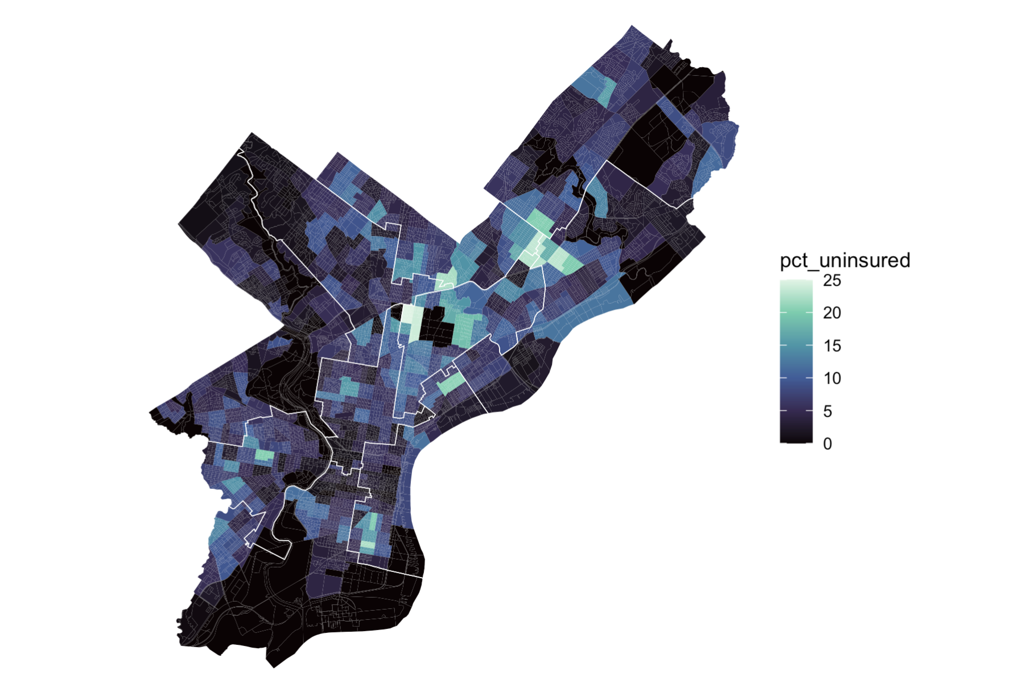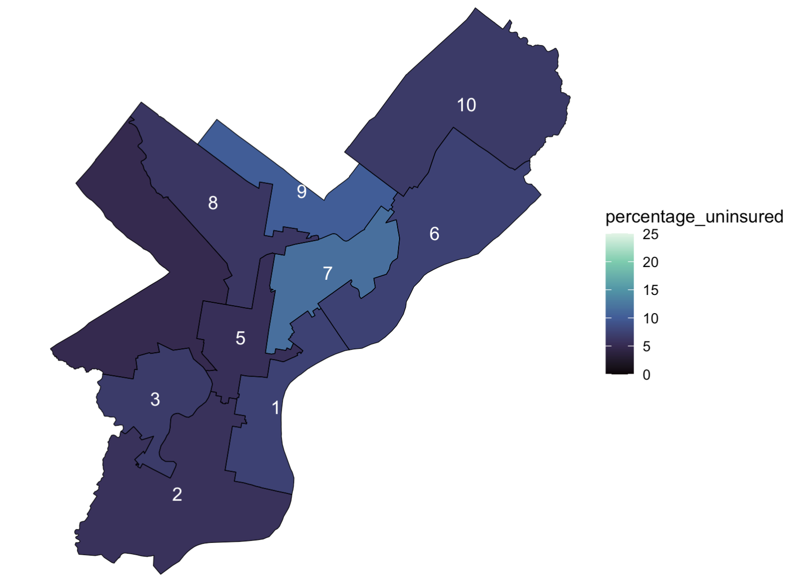
DISTRICT | District Tree Coverage (%) | Standard deviation of tract tree coverage within district | Standard deviation of tree coverage between districts
1 | 1.8 | 2.3 | 6.4
2 | 5.1 | 6.6
3 | 8.1 | 7.5
4 | 19.0 | 18.5
5 | 4.9 | 3.0
6 | 8.3 | 11.4
7 | 5.5 | 6.2
8 | 18.0 | 14.8
9 | 8.7 | 7.0
10 | 19.0 | 11.5

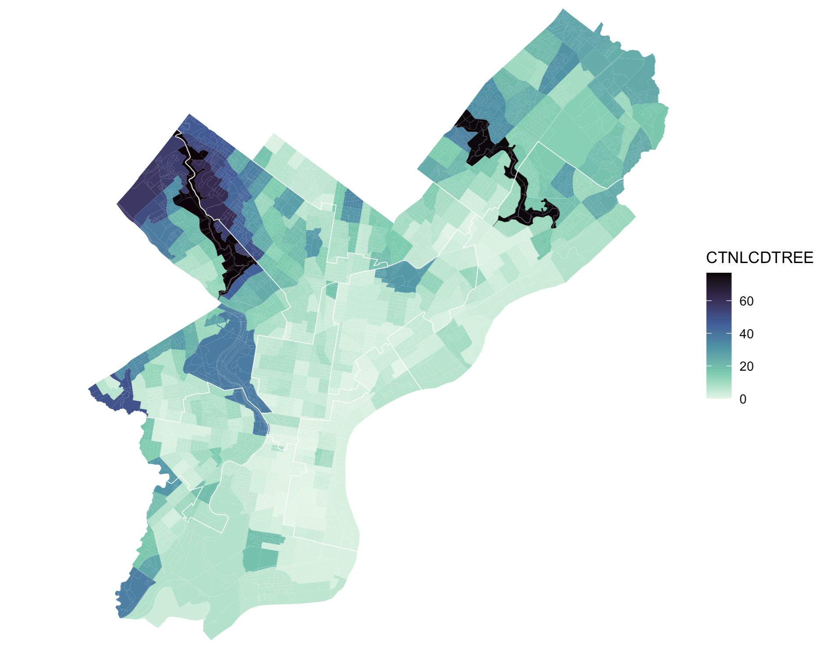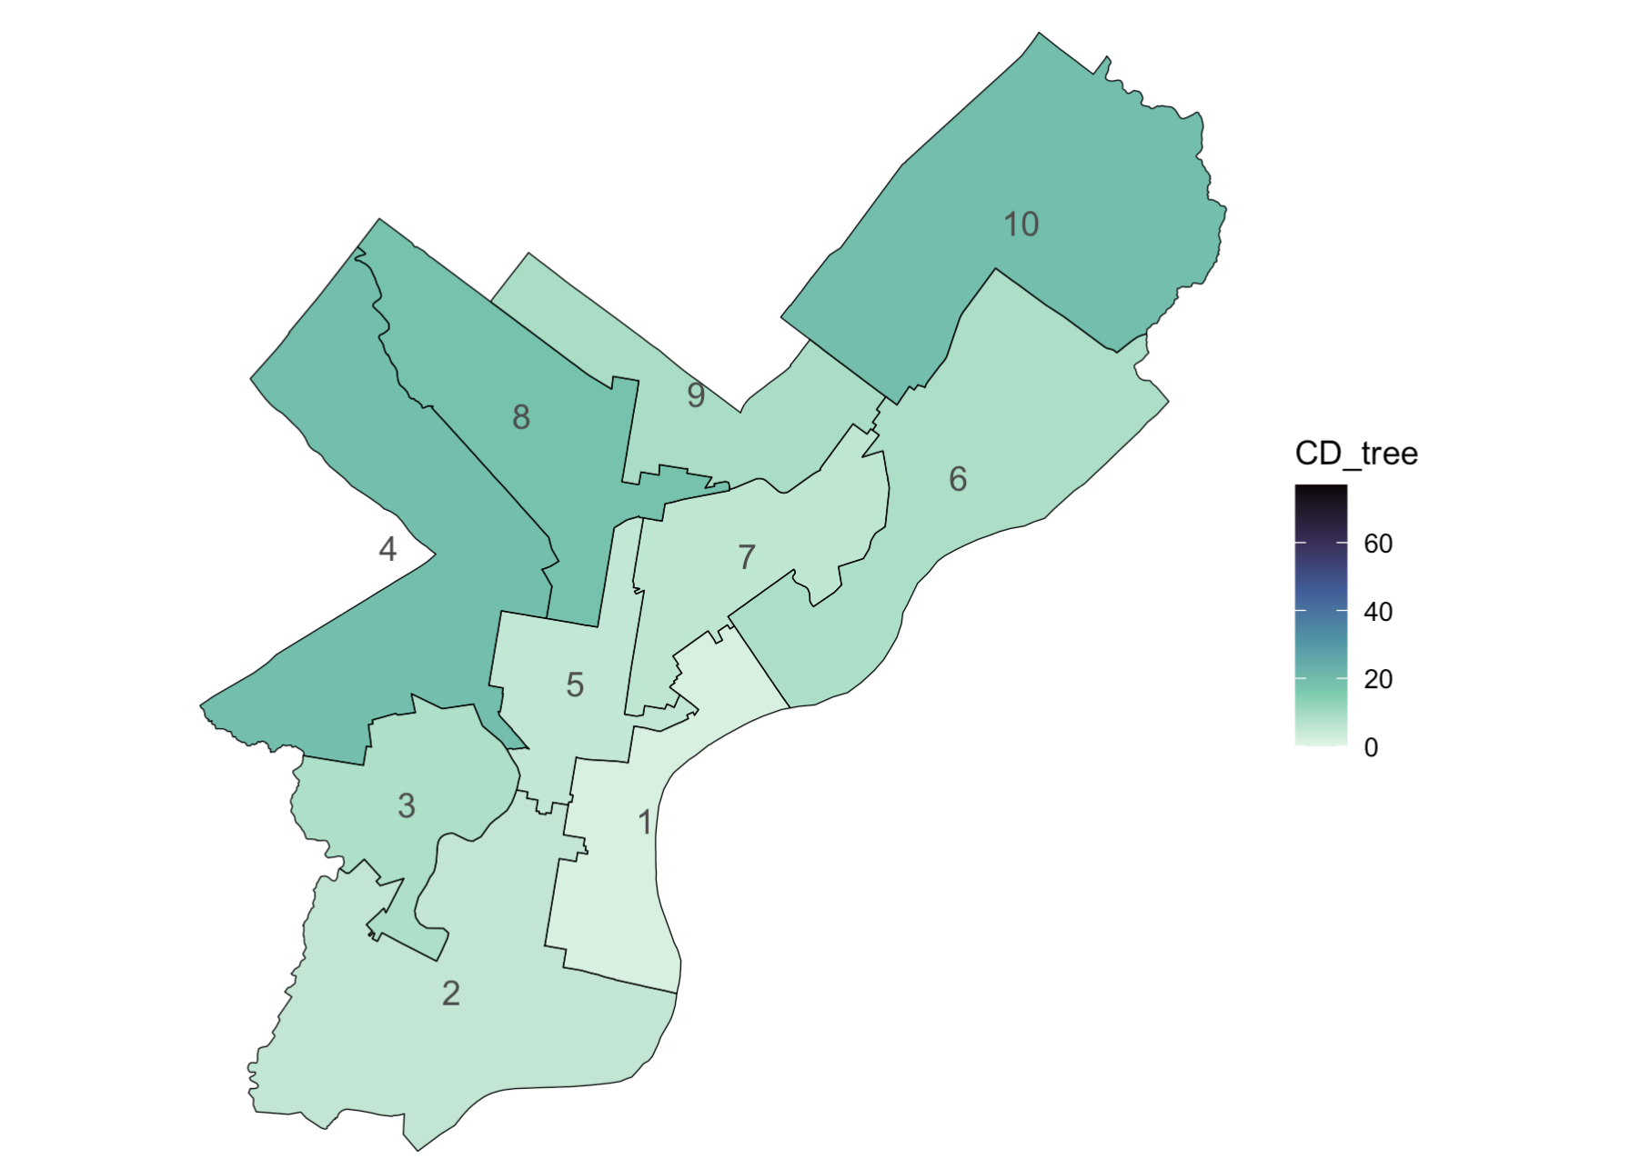

Discussion
Calculating and presenting tee canopy coverage and health insurance coverage by council district reveals distinct disparities both across and within districts. Tree canopy coverage varies from the least dense district (district 1) having less than 2% coverage on average to the most dense districts (10 and 4) having almost 20% coverage on average. One driver of this variation are large wooded parks, for example, district 4 contains a large portion of Wissahickon Valley Park, which is a 2000 acre park of woods and hiking trails . However, outside of those that contain parks, there are districts with higher coverage. For example, district 3, which does not contain any major parks has 8% coverage. Tree canopy coverage is of high public health importance as trees can both mitigate some of the effects of high temperatures as well as being associated with XX, XX (add in some social outcomes). Tree canopy coverage is important for city council members to understand as they can have influence over resources to mitigate health effects of heat – for example resources for cooling centers, tree planting, etc. (CITE).

Health insurance is distributed differently across Philadelphia. The district with the lowest percent of residents lacking coverage was district 4, the same district with high tree canopy coverage, but the district with the highest percentage of residents lacking health insurance was district 7. District 7 is also the district with the highest percentage of Hispanic residents, which may contribute to the high percentage of people without health insurance if some residents are undocumented and therefor ineligible for public health insurance. Hispanic people make up the largest ethnicity of undocumented people in the US currently (cite). While city councilors do not have influence directly over federal health insurance policies, they do have influence over local efforts to provide health care for city residents. For example, they can lobby for more resources for mobile healthcare outreach (? Cite), or push state lawmakers to create a public health insurance option for undocumented residents (cite, is this true?)

Understanding both the aggregate metric at the district level as well as the underlying distribution of the metric at a smaller geographic level within a district (e.g., the census tract level) is important. The district level value gives an understanding where the district stands overall and in comparison to other districts. The sub district level helps identify if the need is spread evenly across the district as well as where the areas of highest need are within the district. Furthermore, it has been shown that the political phenomenon of gerrymandering, that is, when politicians draw district boundaries for their own (or their political parties) benefit, can lead to districts with higher internal and or between district variation (cite tamara and alinas papers). Understanding the underlying distribution of the health metric, at the census tract or zip code level, which is often presented in standard public health analyses, along side the council district level metrics can show areas with similar levels of exposure or health burden that may be split up between districts. This can help to encourage council members to work across districts to address issues that impact members of multiple districts. Furthermore, understand the average burden across a whole district is important for….
Conclusion
Analyzing and reporting public health metrics by local city council districts is feasible using publicly available data and illuminates inequities at politically relevant geographies.

