Name: Arbie Z. Ancheta BSIT-3A
Group Topic:  EduPulse | Lab No.  WEEK #2
Git Repo/ Colab Link: https://github.com/Drexgithub/Group-Repository | Date:  04/23/2026

Objectives
The goal of this task was to acquire a dataset containing at least 500,000 rows from a single source while strictly following ethical data procurement standards. After collecting the data, the next step involved thorough cleaning and processing to ensure the dataset is accurate, consistent, and suitable for analysis.
Tasks Completed

1. Data Procurement
- A Student Performance dataset with 1,000,000 rows was obtained from a structured CSV file.
- The dataset was reduced to exactly 500,000 rows to meet the task requirement.
- Ethically sensitive columns, namely attendance_percentage and class_participation, were removed.
- The final dataset was saved as student_performance_clean.csv, containing four columns: student_id, weekly_self_study_hours, total_score, and grade.

2. Load Dataset into a Spark DataFrame
The cleaned CSV file was imported into a Spark DataFrame using PySpark. The schema was automatically inferred, and the dataset was distributed across executors to enable parallel processing.

from pyspark.sql import SparkSession
spark = SparkSession.builder.appName('StudentPerformance').getOrCreate()
df = spark.read.csv('student_performance_clean.csv', header=True, inferSchema=True)
df.printSchema()
df.show(5)

3. Exploratory Data Analysis (EDA)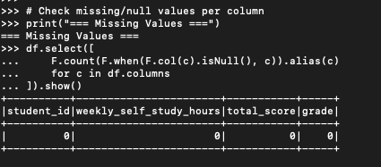

EDA was conducted to examine the dataset’s structure, distribution, and completeness.
Missing Values
No missing values were detected in any of the four columns across all 500,000 records, indicating a complete dataset that does not require imputation.

4. Filtering Invalid Records
Filtering rules were applied to remove logically invalid records from the dataset:
- Removed records where total_score > 100 (impossible score) — 0 records found.
- Removed records where weekly_self_study_hours < 0 (negative hours) — 0 records found.
Result: All 500,000 records passed validation. The dataset is clean and logically consistent.
df_filtered = df.filter((df.total_score <= 100) & (df.weekly_self_study_hours >= 0))
print(f'Records after filtering: {df_filtered.count()}')

Tasks to be Completed
- Develop visualizations (histograms, scatter plots, and box plots) using matplotlib or seaborn to analyze grade distribution and identify outliers.
- Conduct time-series analysis if future datasets include timestamped data.

Results and Analysis

Grade Distribution
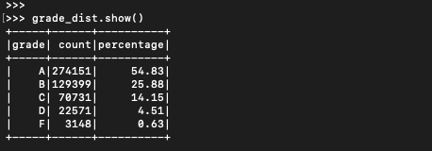
A significant portion of students (54.83%) achieved an A grade, indicating a generally high-performing dataset. The distribution is right-skewed, with fewer students in lower grade categories.

Data Quality
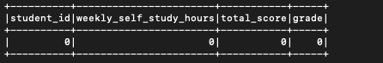
The dataset showed zero missing values and zero invalid records after filtering, demonstrating high data quality and reliability for downstream analysis and model training.

Challenges and Solutions
Challenge: The initial dataset exceeded the required size with 1,000,000 rows.
Solution: Reduced the dataset to 500,000 rows using pandas.head(500000) before loading into Spark.
Challenge: Presence of ethically sensitive variables (attendance and participation) that could introduce bias.
Solution: Removed these columns during preprocessing to align with ethical standards.
Challenge: Memory limitations when handling the full dataset.
Solution: Leveraged Spark’s distributed processing and used pandas sampling for efficient initial inspection.

Conclusion
All objectives of the lab were successfully achieved. A dataset with exactly 500,000 rows was collected, cleaned, and validated. Sensitive attributes and invalid records were removed, and the refined dataset was loaded into a Spark DataFrame for scalable processing.
EDA confirmed that the dataset is complete and of high quality. The analysis also indicates that weekly self-study hours strongly correlate with academic performance, with students earning A grades studying significantly more than those receiving F grades. Overall, the lab highlights the critical role of data preprocessing in big data workflows. By utilizing Apache Spark, large datasets can be efficiently managed through distributed computing, while EDA ensures that insights and models are built on dependable and well-prepared data.

