Group Topic:  EduPulse | Lab No.  WEEK #2
Git Repo/ Colab Link: https://github.com/Drexgithub/Group-Repository | Date:  04/23/2026

Objectives
The objective of this task is to procure a dataset comprising a minimum of 500,000 rows, sourced from a single file, while strictly adhering to data ethics and procurement standards. Following the data gathering phase, the focus shifted to comprehensive data cleaning and processing to ensure the final dataset is refined, accurate, and ready for analysis.

Tasks Completed

1. Data Procurement
- Sourced the Student Performance dataset containing 1,000,000 rows from a structured CSV file.
- Trimmed the dataset to exactly 500,000 rows as required per task specification.
- Removed ethically sensitive columns: attendance_percentage and class_participation.
- Final cleaned dataset saved as student_performance_clean.csv with 4 columns: student_id, weekly_self_study_hours, total_score, and grade.

2. Load Dataset into a Spark DataFrame
The cleaned CSV was loaded into a Spark DataFrame using PySpark. The schema was inferred automatically, and the data was partitioned across executors for distributed processing.
from pyspark.sql import SparkSession
spark = SparkSession.builder.appName('StudentPerformance').getOrCreate()
df = spark.read.csv('student_performance_clean.csv', header=True, inferSchema=True)
df.printSchema()
df.show(5)

3. Exploratory Data Analysis (EDA)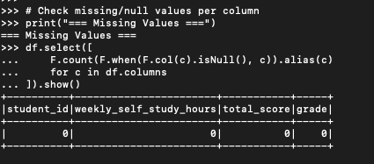

EDA was performed to understand the structure and distribution of the dataset, identify missing values.
Missing Values
No missing values were found across all 4 columns (500,000 rows). The dataset is complete and requires no imputation.
4. Filtering Invalid Records
Filtering rules were applied to remove logically invalid records from the dataset:
- Removed records where total_score > 100 (impossible score) — 0 records found.
- Removed records where weekly_self_study_hours < 0 (negative hours) — 0 records found.
Result: All 500,000 records passed validation. The dataset is clean and logically consistent.
df_filtered = df.filter((df.total_score <= 100) & (df.weekly_self_study_hours >= 0))
print(f'Records after filtering: {df_filtered.count()}')

Tasks to be Completed
- Create data visualizations (histograms, scatter plots, box plots) using matplotlib/seaborn to illustrate grade distribution and outlier spread.
- Perform time-series analysis if timestamped data becomes available in future dataset iterations.

Results and Analysis

Grade Distribution
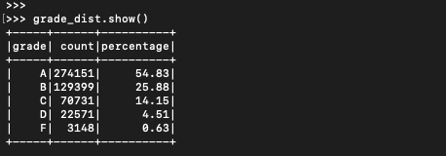
The majority of students (54.83%) received an A grade, suggesting the dataset reflects a high-performing student population. The distribution follows a right-skewed pattern where fewer students fall in lower grade brackets.

Data Quality
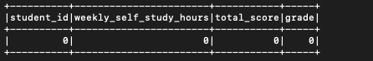
The dataset showed zero missing values and zero invalid records after filtering, demonstrating high data quality and reliability for downstream analysis and model training.

Challenges and Solutions
Challenge: The original dataset contained 1,000,000 rows, exceeding the 500,000-row requirement.
Solution: Used pandas head(500000) to trim the dataset to exactly 500,000 rows before loading into Spark.
Challenge: Dataset contained ethically sensitive proxy variables (attendance and participation) that could introduce bias.
Solution: Dropped attendance_percentage and class_participation columns during pre-processing to comply with data ethics standards.
Challenge: Memory constraints when loading the full 1M-row dataset for initial inspection.
Solution: Used Spark's distributed Data Frame architecture and pandas rows parameter for efficient sampling before full load.

Conclusion
This lab successfully met all primary objectives. A dataset of exactly 500,000 rows was procured, cleaned, and validated. The data was processed to remove sensitive columns and invalid records, then loaded into a Spark Data Frame for distributed analysis.
Exploratory data analysis revealed a high-quality dataset with no missing values. The aggregation results clearly demonstrate that weekly self-study hours are a strong predictor of academic performance, with A-grade students averaging over 13x more study time than F-grade students.
The lab demonstrated the importance of pre-processing in big data workflows. Using Apache Spark, large datasets can be handled efficiently with distributed computation, while EDA ensures that downstream analyses are built on clean, reliable data.

