# IMY 310

# Group Assignment 3:

## Final designs

# Group members:

## Henri David Haasbroek

## Christiaan L. Dreyer

## Idrian van der Westhuizen

# Core Pages:

## Landing pages: Movie list:

## 

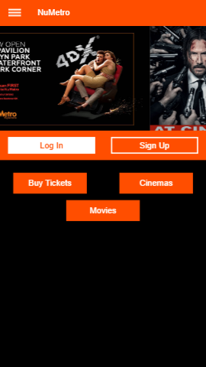

# Movie details: Ticket purchase:

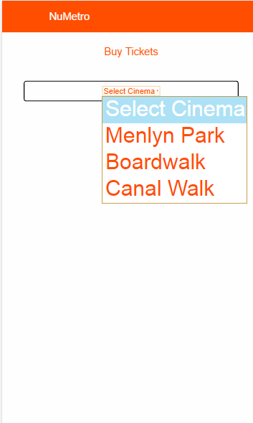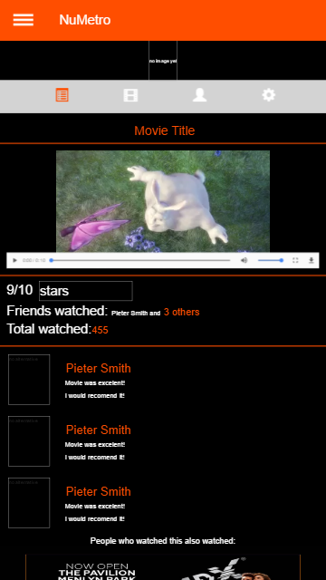

# Profile Edit page: Sign up page:

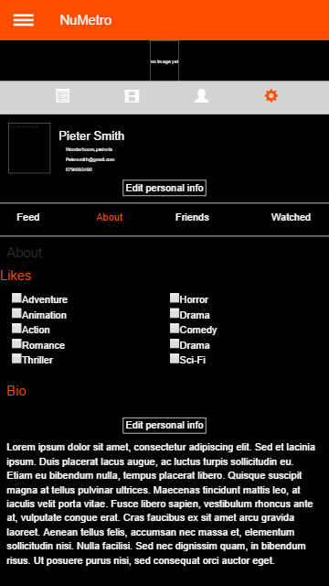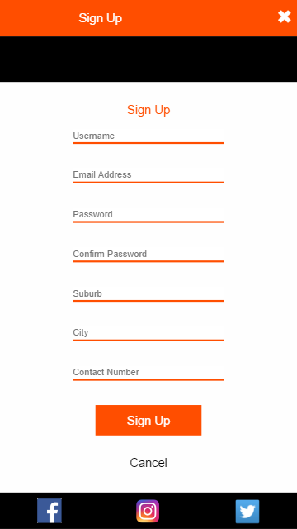

# 

# User needs tasks:

## Normal needs:

1. Search for a movie.
2. Sort movie list according to various criteria such as rating or release date.
3. Be able to buy tickets conveniently from the app.
4. Be able to view individual movie details.

## Specialist needs:

1. Create a profile in order to save liked movies and purchased ticket details.
2. Social feature, to chat to others online about particular movies.
3. Contact page, for people who wish to deliver a complaint or even compliment.
4. Snack menu ordering, so that you can order your snacks along with your tickets to avoid longer lines.
5. Movie trailer viewing, so that users can view trailers without navigating to third party sites.
6. Navigation to IMDB page so user can explore movie in more detailed descriptions done by expert reviewers.

# Tasks screenshots:

## Normal tasks:

## N.1 Search for a movie:

## 

## N2. Sort movie list:

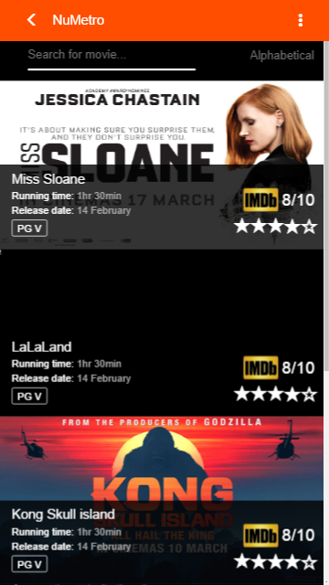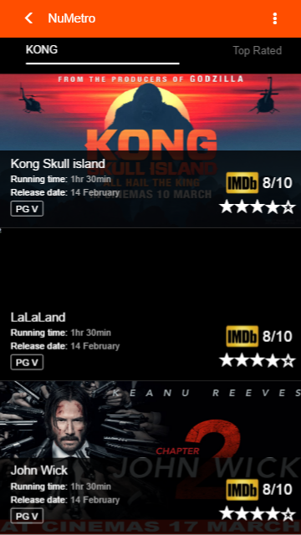

N3. Be able to buy tickets:



N4. individual movie details:

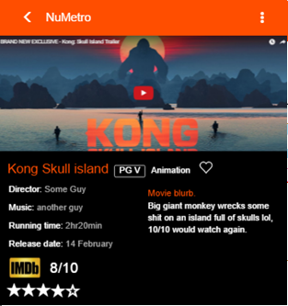

## Specialist task:

## S1. Create a profile:

## 

## s2. Social feature (searching friends and viewing their profiles):

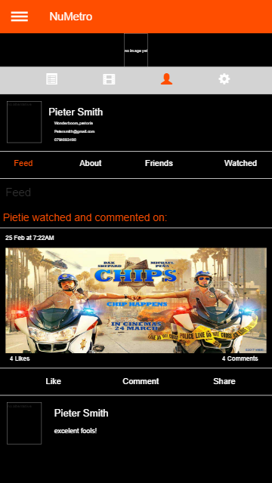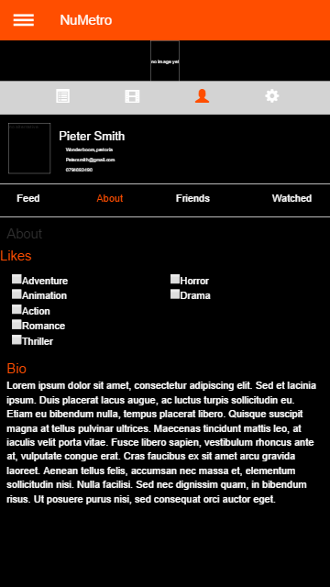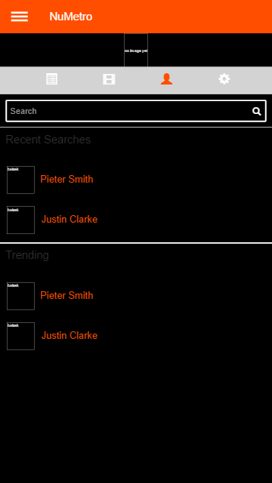

## S4. Contact page:

## 

## S4. Snack menu:

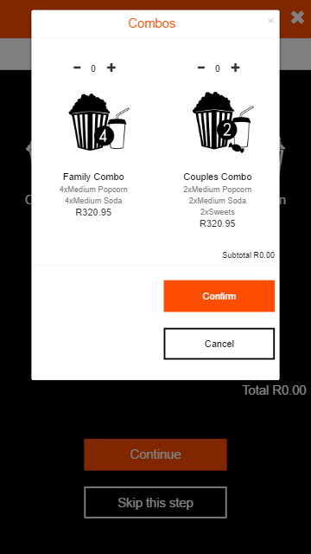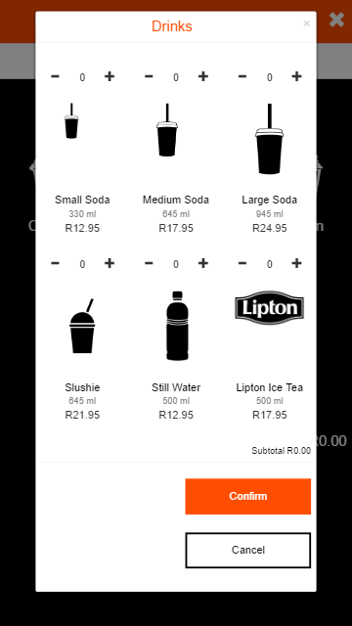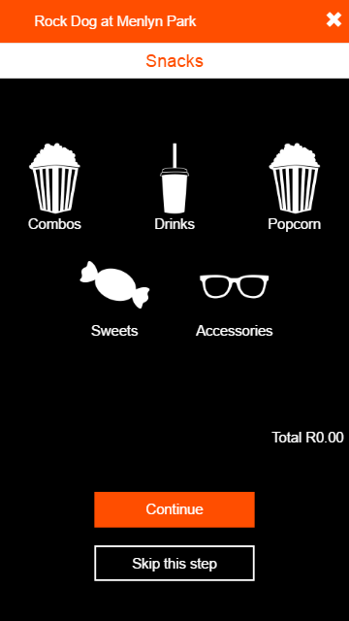

## S5. View movie trailers (Both in social movie list and main movie list):



## S6. IMDB page link for detailed expert reviews: