Start to MES(Monitoring And Enforcement Section)
- They are the one who receives (Mod: Apprehended, Abandoned, and Turnovered)
- Apprehended – there is an ongoing Case or not
- Abandoned – Automatic will have confiscation order
- Turndover
- Encoding and recording of details (like where it is apprehended, what agencies caught these, what kind of trees and equipment or vehicles used that has been confiscated, is this been turn over by someone or abandoned)
- Then the MES will write an Acknowledgement receipt (within the system like a form, where it is printable, where the MES will print it)

Going to the Property
- On the dashboard of the property, they will see the encoded report
- The property custodian will check the documentation if it is complete or if it’s correct.
- Then the acknowledgement receipt will be signed by the property
- The property will now print a qr code
- Before the Logs or any equipment or vehicle that to be putted on the storage, the acknowledgement receipt has to be already signed. Then it will be putted on the storage after tagging. All logs, conveyance or the tools
- Regardless of ongoing case
- If with Case (Steady) they will not go to the property/accounting
- If with confiscation order/forfeiture order (then they will go to the property and accounting)
Property and Accounting
- What the Accounting will do is put Journal Entry Voucher (JEV)or JEV Creation (JEV Number) or JEV Form
- Then it will go to the MES, where the MES will upload the JEV
- Then the status will be updated to indicate that it is for disposal whether it is a Lumber, Conveyance(Vehicles use), and Tools
- Lumber
- Donation
- Post Requirement (Kung anong gagawin sa kahoy na ni-request nila)
- Deed of Donation
- Request
- Release

- Decayed
- Report (Then babawas sa Inventory)
- Mod of Disposal is Decayed
- Fabricated (Ginawang Gamit ex. Chair or table)
- Report
- JEV (Journal Entry Voucher)
- ICS (Inventory Cutodian Slip)
- PAR (Property Acknowledgement Receipt)
- Conveyance
- The release or dismissal of the conveyance to the owner who has appealed to the court within 15 Days. But it still depends on the judge if it’s a case or the regional office on how to dispose of the conveyance because the penro Catanduanes do not have the Jurisdiction
- But almost everytime, these are confiscated and forfeited in favor of the government
- Tools
- Chainsaw – it should be damage so that it will never be use for illegal cutting of timber trees

- Intake at MES (Monitoring and Enforcement Section)

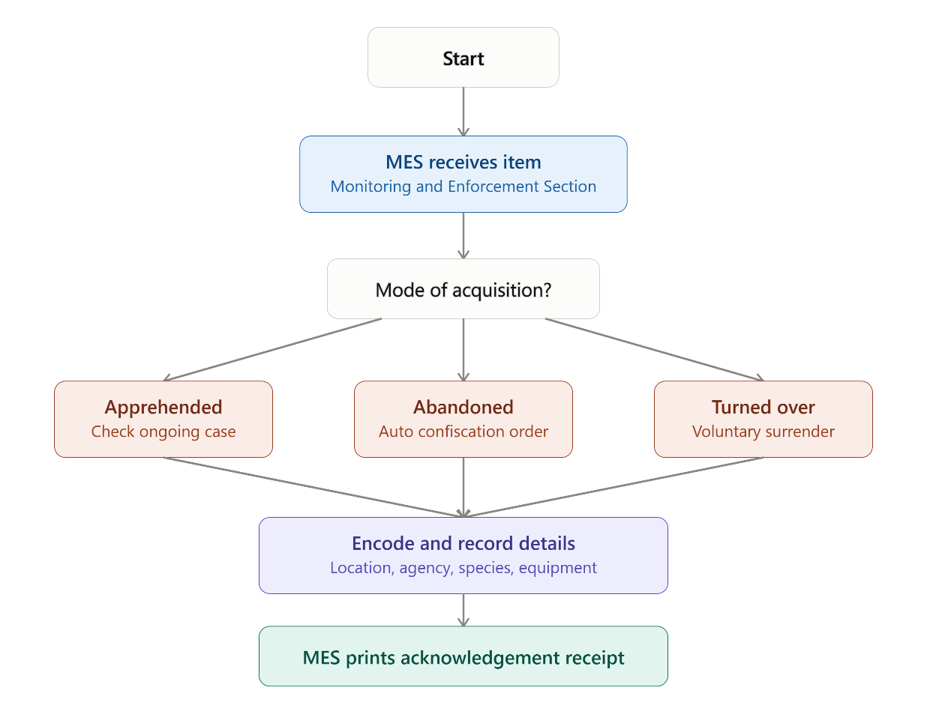

Once the acknowledgement receipt is printed, the item moves to the Property custodian for verification and storage.

2. Property handling
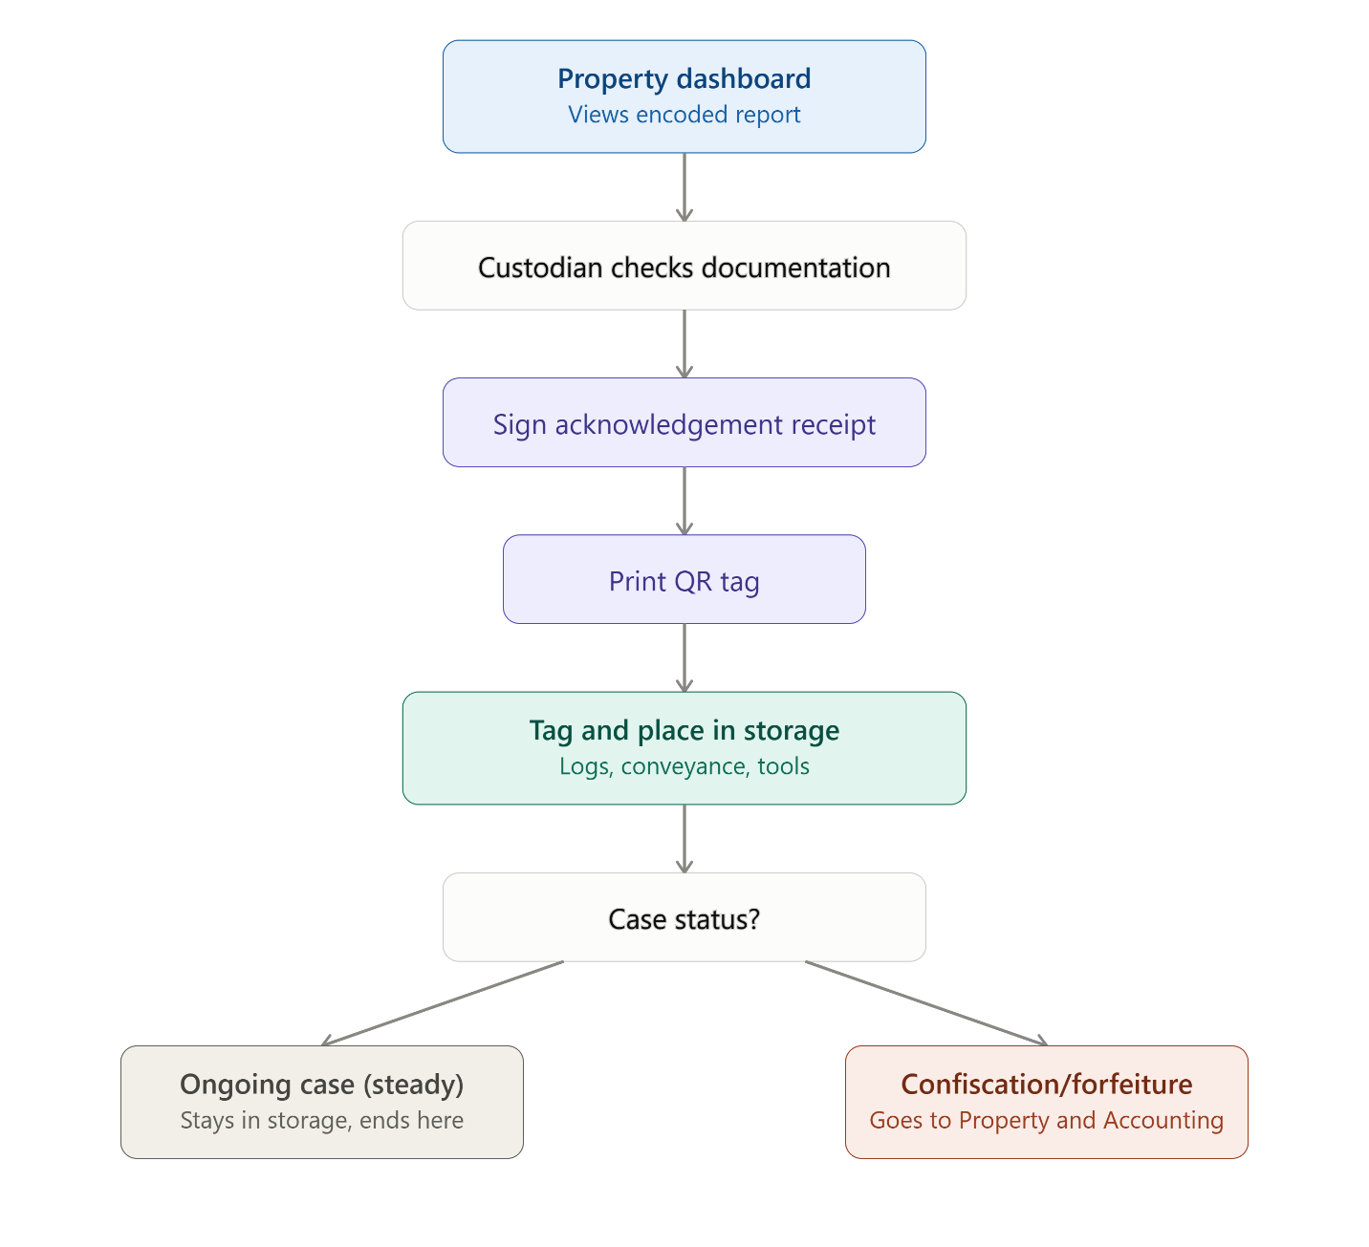

Items with a confiscation or forfeiture order proceed to Property and Accounting for JEV processing, then branch into disposal paths by item type — with Lumber having three further sub-paths.

3. Property and Accounting → disposal

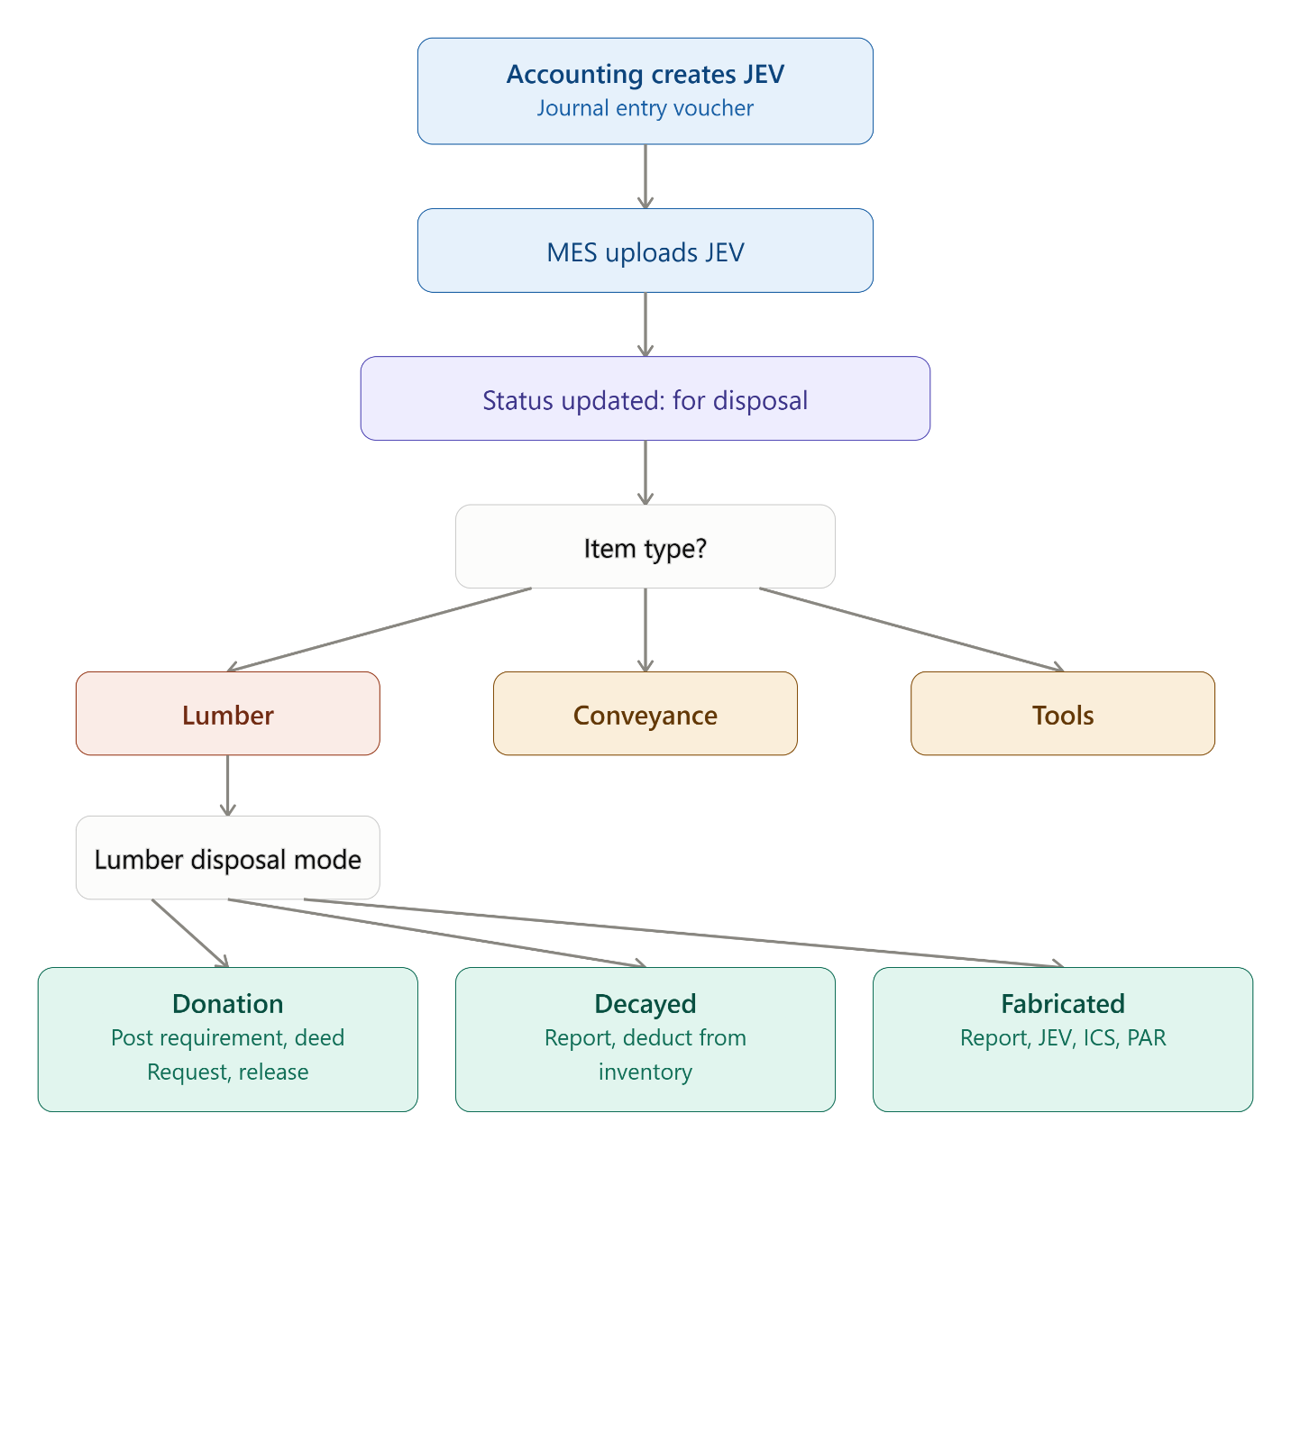

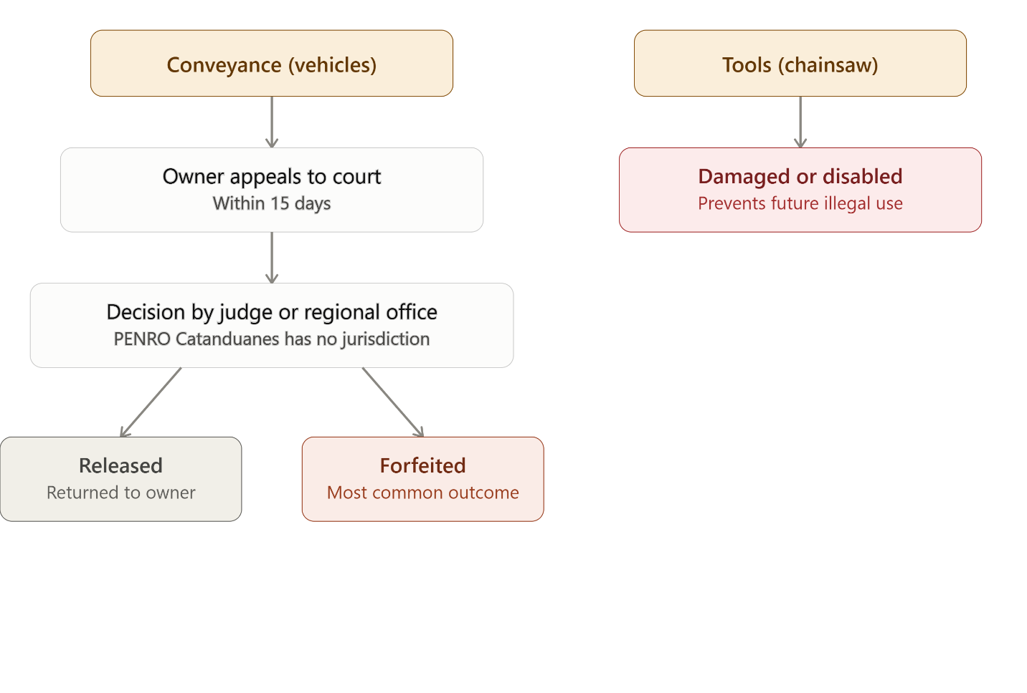
This adds the missing detail for the Conveyance and Tools branches alongside the existing Lumber breakdown: conveyance can be released back to the owner if appealed within 15 days (pending a judge or regional office decision, since PENRO Catanduanes lacks jurisdiction) but is most often forfeited to the government, while tools like chainsaws are simply damaged or disabled to prevent reuse for illegal cutting.

