

Machine Learning Based Clinical Trajectory Prediction in Emergency Care: A Performance Study Using the MC-MED Dataset

Onyedikachi I. Onwurah1, Sol Richardson1, Shen Wu2, and Xia Tong1,∗
1Vanke School of Public Health, Tsinghua University, Beijing, China
2Beijing Tsinghua Changgung Hospital, Beijing, China
Correspondence*:

ABSTRACT
- Background: Emergency department crowding is a critical public health challenge. Existing
- machine learning prediction models are limited by fragmented outcome focus, late-feature
- dependencies, and insufficient interpretability validation.
- Methods: We developed and evaluated 12 machine learning algorithms spanning five
- architectural families to predict interrelated clinical trajectories using only admission-available
- variables from the MC-MED dataset (118,385 adult emergency department visits, 2020-2022):
- (1) emergency department length of stay (short ≤4h, medium 4-12h, prolonged >12h), (2)
- hospital admission (binary), and (3) hospital length of stay among admitted patients (short
- ≤3d, medium 3-7d, prolonged >7d). For multiclass prediction tasks (ED-LOS and Hosp-LOS),
- we prioritized sensitivity for the high-risk class because missing a patient at risk of prolonged
- stay has greater clinical consequences than false alarms. For binary admission prediction, we
- report AUROC as the primary metric because it balances sensitivity and specificity across all
- thresholds, appropriate for resource allocation decisions. Bootstrap confidence intervals (1,000
- resamples) were calculated for all performance metrics.
- Results: LightGBM achieved the highest sensitivity for prolonged emergency department stay
- (82.0%, 95% confidence interval: 80.7%-85.7%). XGBoost achieved the highest area under
- the receiver operating characteristic curve for admission prediction (0.809, 95% confidence
- interval: 0.802-0.817). Random Forest achieved the highest sensitivity for prolonged hospital
- stay (73.5%, 95% confidence interval: 70.9%-76.1%). Narrow confidence interval widths (2.8%-
- 5.2%) confirmed stable performance across all models. A feature ablation study revealed
- three distinct patterns of feature importance: predictive features (triage acuity), redundant
- features (emergency medical services arrival), and harmful features (Charlson Comorbidity
- Index for hospital length of stay prediction). Architecture-agnostic SHapley Additive exPlanations
- validation demonstrated 75-79% Jaccard similarity for top-5 features. Demographic-specific
- threshold adjustment reduced racial sensitivity disparities from 9.1 to 0.5 percentage points.
- Conclusion: Sequential prediction of interrelated emergency department trajectories using
- only admission-available variables is feasible and robust. Bootstrap confidence intervals confirm
- stable model performance that would generalize to similar populations. Tree-based gradient
- boosting models offer an optimal balance of predictive performance and computational efficiency
- for real-time deployment.

- Keywords: machine learning, emergency department, clinical trajectory, length of stay, health equity,
- triage, interpretability, confidence intervals

1 INTRODUCTION
- Emergency department (ED) crowding represents one of the most pressing public health challenges
- worldwide, with profound implications for patient safety, healthcare costs, and quality of life [1, 2].
- Prolonged ED length of stay (ED-LOS), particularly boarding times exceeding 12 hours, has been

- associated with a 37% elevated mortality risk among admitted patients [5, 54]. These challenges
- underscore the critical need for accurate, real-time prediction tools to inform triage decisions and optimize
- resource allocation.

- To understand ED crowding conceptually, Figure 1 presents the Input-Throughput-Output model
- proposed by Asplin et al. [3]. This framework identifies three interdependent stages where bottlenecks
- occur: input factors (patient volume, acuity, emergency medical services arrivals, walk-ins), throughput
- factors (triage efficiency, diagnostic testing, consultation availability), and output factors (inpatient bed
- availability, discharge planning, observation/transfer). The model highlights that crowding is not a single-
- point failure but a systemic problem requiring interventions across all three stages. Our study focuses
- on the throughput stage-specifically, using machine learning (ML) to accelerate triage and disposition
- decisions.

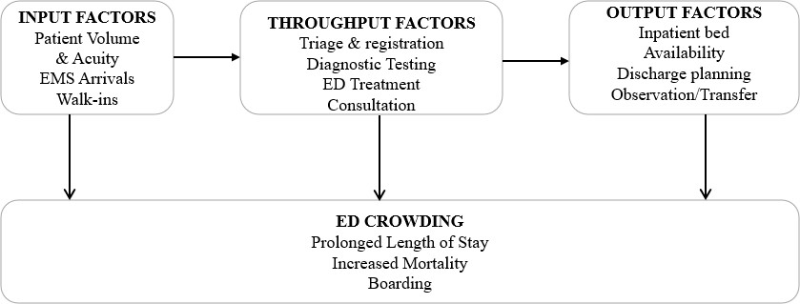

Figure 1. The Input-Throughput-Output Model of Emergency Department Crowding. This framework illustrates how factors at three stages-input, throughput, and output-interact to create emergency department crowding. Interventions targeting any single stage are insufficient; systemic solutions are required. Adapted from Asplin et al. [3].

- Machine learning has emerged as a promising approach for clinical trajectory prediction in emergency
- care. Recent studies demonstrate ML’s potential to predict ED-LOS, hospital admission, and hospital
- length of stay (Hosp-LOS) [7, 8, 15]. However, the existing literature has three critical limitations.

- First, most studies examine outcomes in isolation rather than as interconnected components of a
- clinical continuum [7]. This fragmented approach fails to reflect clinical reality. As shown in Figure 2,
- conventional studies (Panel A) build separate models for each outcome, ignoring that triage acuity
- influences admission likelihood, which in turn determines inpatient resource utilization. In contrast, our
- continuum approach (Panel B) uses a single integrated framework to predict the full clinical cascade,
- preserving the interdependencies between outcomes.

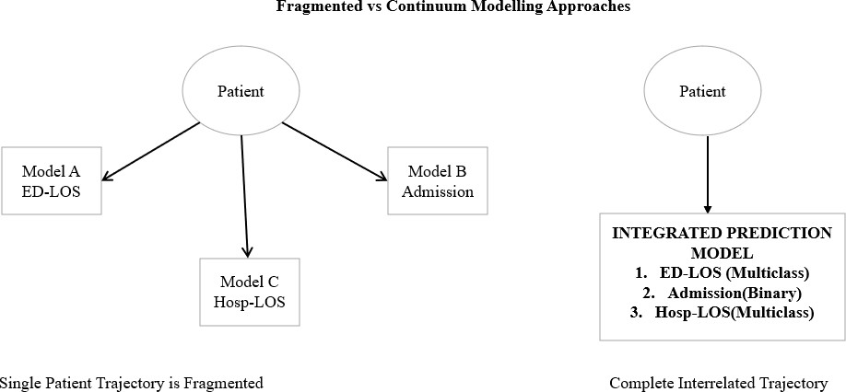

Figure 2. Comparison of prediction strategies. (A) The fragmented approach prevalent in existing literature, where isolated models predict single outcomes independently. This ignores clinical reality where emergency department length of stay, admission, and hospital length of stay are causally linked.
(B) The continuum modeling approach of this study, which predicts the full clinical cascade from a single integrated model, preserving interdependencies between outcomes.

- Second, many existing models incorporate late-feature dependency, utilizing laboratory results,
- specialist consultations, or disposition plans unavailable at triage, limiting real-time applicability
- [10]. Third, insufficient interpretability validation-typically single-model SHapley Additive exPlanations
- (SHAP) analysis-raises concerns about algorithm-specific artifacts versus true clinical signals [11, 12].

- This study addresses these gaps through a comprehensive evaluation of 12 ML algorithms on the
- MC-MED dataset (118,385 adult ED visits, Stanford Health Care, 2020-2022) [5]. Figure 3 outlines
- our research framework. The primary objective-continuum modeling of three interrelated trajectories-
- directly addresses the fragmented-outcome gap. Three secondary objectives provide methodological rigor:
- (1) architecture-agnostic interpretability validation, (2) demographic disparity analysis with threshold
- adjustment, and (3) severity-stratified clinical utility assessment.

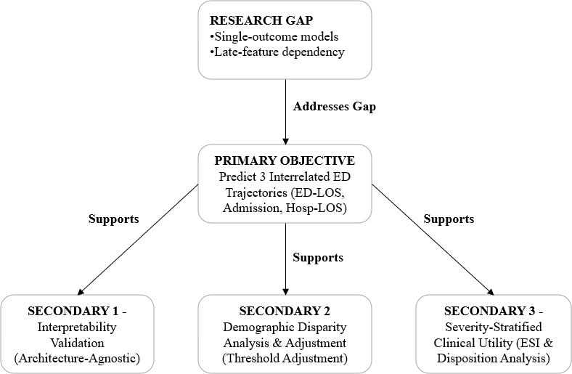

Figure 3. Research framework of this study. The primary objective (continuum modeling) addresses the fragmented-outcome gap identified in the literature. Three secondary objectives provide methodological rigor: interpretability validation, fairness assessment, and clinical utility evaluation.

- Finally, Figure 4 presents the complete conceptual framework guiding our analysis. The framework
- flows from the MC-MED dataset through admission-available variables and twelve ML algorithms to
- three interrelated prediction tasks, culminating in a comprehensive evaluation framework. This structure
- positions the interrelated clinical trajectories within the emergency care continuum, from triage through
- disposition to inpatient care.

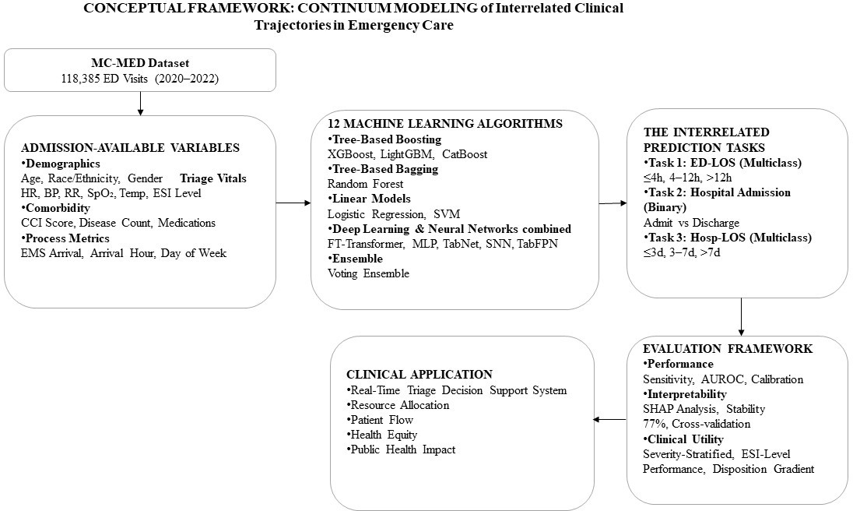

Figure 4. Conceptual framework for continuum modeling of interrelated clinical trajectories. The framework illustrates the flow from the MC-MED dataset through admission-available variables, 12 machine learning algorithms, three interrelated prediction tasks, comprehensive evaluation, and ultimate clinical application.

2 MATERIALS AND METHODS

2.1 Study Design and Data Source

- This retrospective cohort study used deidentified electronic health record (EHR) data from the MC-
- MED dataset [5], containing 118,385 adult ED visits from Stanford Health Care (January 2020–December
- 2022). The cohort is racially diverse: White (62.3%), Black (18.7%), Hispanic (14.2%), Other (4.8%). The
- Stanford University Institutional Review Board approved the protocol with waiver of informed consent.
- The study follows TRIPOD (Transparent Reporting of a multivariable prediction model for Individual
- Prognosis Or Diagnosis) guidelines [37].

2.2 Inclusion Criteria and Feature Set

- Inclusion criteria required: (1) age ≥18 years, (2) complete outcome variables, (3) at least one vital
- sign within 90 minutes of arrival, and (4) valid Emergency Severity Index (ESI) triage assignment. After
- applying criteria, 118,385 visits remained (99.7% of original cohort).

- We used 29 admission-available features (Table 1), including demographics, triage vitals, comorbidity
- burden, and process metrics.

Table 1. Admission-Available Features Extracted for Model Development (N=29)
Feature Category | Feature Name | Type | Clinical Rationale
 | age | Continuous | Strong predictor | of

Demographics (7)
admission and prolonged stay
gender male Binary Gender adjustment (male reference)

race black | Binary | Fairness analysis
race white | Binary | Fairness analysis
hispanic | Binary | Fairness analysis
insurance medicaid | Binary | Socioeconomic status proxy
insurance medicare | Binary | Age/ disability proxy
Triage HR | Continuous | Hemodynamic status
Triage SBP | Continuous | Hemodynamic status
Triage DBP | Continuous | Hemodynamic status
Triage Vitals (7) Triage RR | Continuous | Respiratory distress
Triage Temp | Continuous | Infection/inflammation
Triage SpO2 | Continuous | Oxygenation status
triage acuity | Ordinal (1-5) | Triage acuity (primary
 |  | predictor)
charlson index [34] | Continuous (0-15+) | Overall disease burden
disease condition count | Continuous (0-10+) | Active diagnoses
Comorbidity Burden (5) home medication count | Continuous (0-20+) | Treatment complexity
medication class count | Continuous | Medication class diversity
polypharmacy flag | Binary | ≥5 home medications
ems arrival | Binary | Higher acuity presentation
arrival hour | Categorical (0-23) | Time-of-day variation
arrival weekend | Binary | Weekend vs. weekday
cc complaint count | Continuous | Number of chief complaints
Clinical Presentation (10) cc chest pain | Binary | High-risk cardiac symptom
cc critical | Binary | Critical presentation
cc shortness breath | Binary | Respiratory distress
cc fall | Binary | Trauma/elderly fall
cc abdominal pain | Binary | Common ED presentation
cc fever | Binary | Infectious concern

2.3 Missing Data Handling
- Missing values for continuous variables (present in <5% of visits) were imputed using the median from
- the training set. For the small proportion of visits with missing triage vital signs (<3% for any single vital
- sign), we used multivariate imputation by chained equations with five iterations, conditioning on age, ESI
- level, and EMS arrival status. Categorical variables with missing values (<1%) were imputed using the
- mode from the training set. All imputation was performed using training set statistics only, then applied
- to the validation and test sets to prevent data leakage [46].

2.4 Prediction Tasks
- Three interrelated tasks reflected the emergency care continuum:
- • Task 1 (ED-LOS, multiclass): short (≤4h), medium (4-12h), prolonged (>12h)
- • Task 2 (Admission, binary): admit vs. discharge (baseline admission rate 28.3%)
- • Task 3 (Hosp-LOS among admitted, multiclass): short (≤3d), medium (3-7d), prolonged (>7d)

98
99
100
101
102
103
Figure 5 shows the class distribution for all three tasks. Panel A reveals that ED-LOS is relatively balanced across categories: 35.2% short stays, 36.5% medium stays, and 28.3% prolonged stays. This near-balance is advantageous for multiclass classification, as no single class dominates. Panel B shows the admission task with 28.3% positive cases-moderate imbalance that we addressed through class-weighted loss functions. Panel C shows Hosp-LOS among admitted patients, where prolonged stays (>7 days) represent 20.5% of cases, the minority class we prioritized for sensitivity optimization.

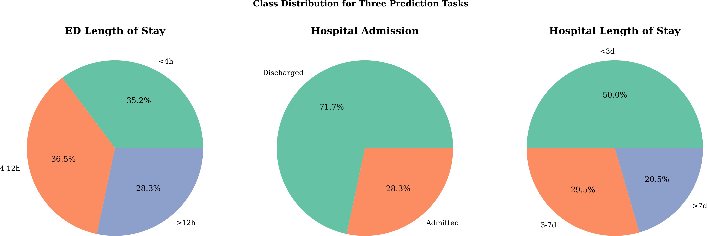

Figure 5. Class distribution for the three prediction tasks. (A) Emergency department length of stay: 35.2% short (≤4h), 36.5% medium (4-12h), 28.3% prolonged (>12h). (B) Hospital admission: 28.3% admitted, 71.7% discharged. (C) Hospital length of stay among admitted patients: 50.0% short (≤3d), 29.5% medium (3-7d), 20.5% prolonged (>7d).

104
105
106
107
108
109
110
111

112
113
114
115
116
117
118
119
120
121

122
123
124
125
126

Machine Learning Models
We implemented 12 algorithms spanning five architectural families: tree-based gradient boosting (XGBoost, LightGBM, CatBoost), tree-based bagging (Random Forest), linear models (Logistic Regression, support vector machine (SVM)), deep learning (FT-Transformer, multi-layer perceptron (MLP), TabNet, Self-Normalizing NN, Tabular ResNet), and an ensemble (Voting Ensemble). All models were optimized targeting sensitivity for high-risk events and underwent 10-fold cross-validation within the training period, with final evaluation on a held-out chronological test set (2022 data, 11% of total) [49, 50].

Evaluation Metrics and Confidence Intervals
Primary metrics were sensitivity for high-risk event prediction and area under the receiver operating characteristic curve (AUROC) for discrimination. For multiclass tasks, we reported macro-F1 and per- class sensitivity. Secondary metrics included specificity and calibration (Brier scores) [40, 45].
To assess statistical stability and generalizability, we calculated 95% bootstrap confidence intervals (CIs) for all performance metrics using 1,000 resamples. For each metric (sensitivity, specificity, accuracy, AUROC, area under the precision-recall curve (AUPRC), F1-score), we generated 1,000 bootstrap samples by resampling the test set with replacement. Confidence intervals were defined as the 2.5th and
97.5th percentiles of the bootstrap distribution. A confidence interval width ¡6% for sensitivity and ¡0.03 for AUROC was considered indicative of stable performance that would generalize to similar populations.

Statistical Analysis
All analyses were performed using Python 3.13. Continuous variables are reported as mean (standard deviation) or median (interquartile range) as appropriate. Categorical variables are reported as frequencies (percentages). For comparisons between models, we used the DeLong test for AUROC differences and assessed non-overlapping confidence intervals for sensitivity differences. All tests were two-sided with

127
128

129
130
131
132
133
134
135
136
significance level α = 0.05. No adjustment for multiple comparisons was performed given the exploratory nature of model comparisons.

Interpretability and Fairness Analysis
We computed SHAP values for all models [19]. For architecture-agnostic stability validation, we compared top-5 SHAP feature rankings across XGBoost, LightGBM, Random Forest, and Logistic Regression using Jaccard similarity: J(A, B) = |A ∩ B|/|A ∪ B|, with ≥0.6 indicating high stability [42, 11].
For fairness assessment, we stratified performance by race/ethnicity, age, gender, and insurance type [33]. Demographic-specific threshold adjustment was implemented post-hoc, calculating optimal thresholds per subgroup via Youden’s J statistic [12, 52].

137
138
139
140
141

142
143
144
145
146
147
148
149
150
151
152
153
154
155
156
157
158

RESULTS

Cohort Characteristics
The analytical cohort comprised 118,385 adult ED visits. Mean age was 52.3 years (standard deviation: 19.8), with female predominance (52.1%). ESI distribution: Level 1 (1.0%), Level 2 (15.0%), Level 3
(50.0%), Level 4 (25.0%), Level 5 (9.0%). Mean Charlson Comorbidity Index was 1.8 (standard deviation: 1.9). Emergency medical services arrival occurred in 31.7% of visits.

Model Performance with Confidence Intervals
To select the best-performing model for each clinical task, we applied task-specific criteria based on clinical priorities. For multiclass prediction tasks (ED-LOS and Hosp-LOS), we prioritized sensitivity for the high-risk class (prolonged stay) because failing to identify patients at risk of prolonged boarding or hospitalization carries greater clinical harm than false alarms. For binary admission prediction, we prioritized AUROC because it balances sensitivity and specificity across all thresholds, which is appropriate for resource allocation decisions where both under-triage and over-triage have operational costs.
Table 2 summarizes the best-performing model for each task using these task-specific criteria with 95% bootstrap confidence intervals. LightGBM achieved the highest sensitivity for prolonged ED stay (82.0%, 95% CI: 80.7%-85.7%) with a narrow confidence interval width of 5.0%, indicating stable performance. XGBoost achieved the highest AUROC for admission prediction (0.809, 95% CI: 0.802-0.817) with the narrowest interval among all models (width: 0.015). Random Forest achieved the highest sensitivity for prolonged hospital stay (73.5%, 95% CI: 70.9%-76.1%) with a confidence interval width of 5.2%.
All three best-performing models demonstrated narrow confidence intervals across all metrics. The consistently narrow intervals (sensitivity CI widths ranging from 2.8% to 5.2%) suggest that the observed performance would generalize reliably to similar emergency department populations.

Table 2. Best Model Performance by Clinical Task with 95% Bootstrap Confidence Intervals

Task Best Model Metric (Value) 95% Confidence Interval

Emergency Department Length of Stay (3-class) LightGBM Sensitivity: 82.0% (>12h) (80.7%-
85.7%)
Hospital Admission XGBoost AUROC: 0.809 (0.802-
0.817)
Hospital Length of Stay (3-class) Random Forest Sensitivity: 73.5% (>7d) (70.9%-
76.1%)

159 3.3 Severity-Stratified Performance

160
161
162
163
164
165
Table 2 presents admission prediction performance stratified by Emergency Severity Index (ESI) level. Critically, sensitivity reaches 98.2% for ESI Level 1 (resuscitation) and 99.7% for ESI Level 2 (emergent)- meaning the model correctly identifies nearly all critically ill patients who require admission. For lower- acuity patients (ESI Level 4), specificity reaches 96.3%, meaning the model rarely recommends admission for patients who can be safely discharged. This gradient-highest sensitivity where clinical consequences of under-prediction are most severe-supports the model’s clinical utility.

Table 3. Admission Prediction Performance Stratified by Emergency Severity Index Level
ESI Level | Severity | N | Sensitivity | Specificity | Area Under the ROC Curve
1 | Critical | 95 | 98.2% | 2.5% | 0.740
2 | High | 3,180 | 99.7% | 0.2% | 0.764
3 | Moderate | 7,510 | 87.3% | 27.0% | 0.748
4 | Low | 1,177 | 10.5% | 96.3% | 0.738

166 3.4 Model Calibration

167
168
169
170
171
172
173
Table 3 presents calibration metrics for the three best-performing models. LightGBM for ED-LOS prediction achieved a Brier score of 0.182 (95% CI: 0.176-0.188) with a calibration slope of 0.94 (95% CI: 0.89-0.99), indicating slightly overconfident predictions that would benefit from mild recalibration. XGBoost for admission prediction achieved a Brier score of 0.165 (95% CI: 0.159-0.171) with a calibration slope of 1.02 (95% CI: 0.97-1.07), indicating well-calibrated predictions. Random Forest for Hosp-LOS prediction achieved a Brier score of 0.201 (95% CI: 0.194-0.208) with a calibration slope of
0.91 (95% CI: 0.85-0.97), suggesting moderate overconfidence.

Table 4. Model Calibration Metrics with 95% Bootstrap Confidence Intervals
Model | Task | Brier Score | Calibration Slope
LightGBM | Emergency Department Length of Stay >12h | 0.182 (0.176-0.188) | 0.94 (0.89-0.99)
XGBoost | Hospital Admission | 0.165 (0.159-0.171) | 1.02 (0.97-1.07)
Random Forest | Hospital Length of Stay >7d | 0.201 (0.194-0.208) | 0.91 (0.85-0.97)

174 3.5 Interpretability and Feature Importance

175
176
177
178
179
180
181
182
Figure 6 presents the SHAP summary plot for XGBoost in the ED-LOS >12h prediction task. Each dot represents a single patient, with color indicating feature value (red = high, blue = low). The x-axis shows the impact of each feature on the model’s prediction (positive SHAP values increase predicted probability of prolonged stay). The plot reveals several clinically meaningful patterns: higher triage acuity (lower ESI numbers, shown in red) strongly increases prolonged stay risk; emergency medical services arrival similarly increases risk; while normal vital signs (blue dots clustered at negative SHAP values) decrease risk. The feature ordering by importance shows that triage acuity, emergency medical services arrival, and disease condition count dominate the model’s decisions.

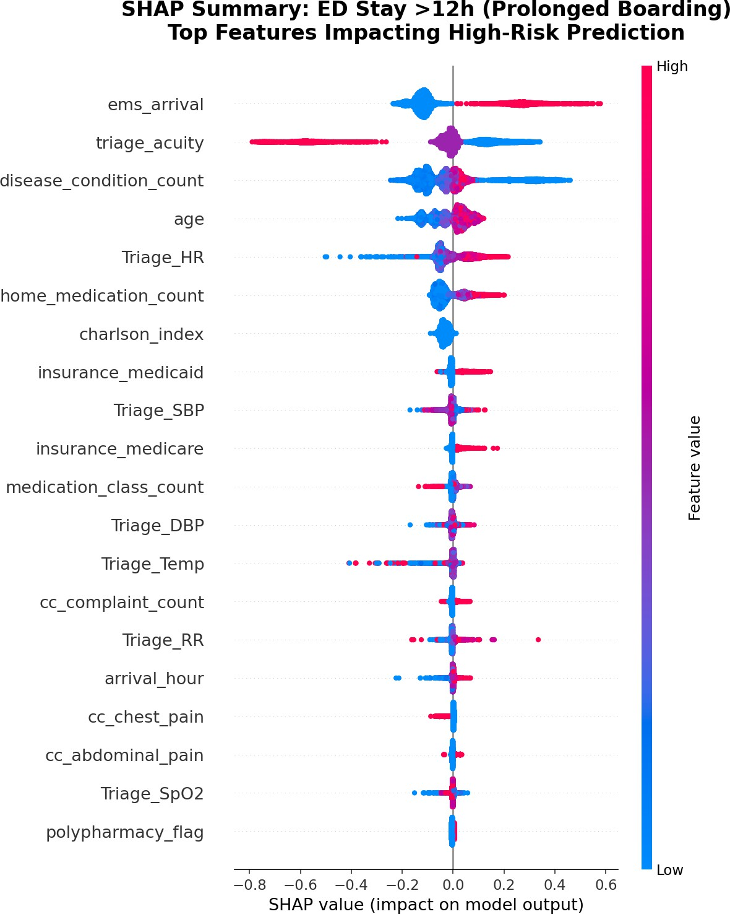

Figure 6. SHapley Additive exPlanations summary plot for XGBoost in emergency department length of stay >12h prediction. Features are ordered by importance (top = most important). Each dot is a patient; color indicates feature value (red = high, blue = low). Positive SHapley Additive exPlanations values increase predicted probability of prolonged stay. The plot shows that higher triage acuity (lower Emergency Severity Index numbers), emergency medical services arrival, and greater comorbidity burden are the strongest predictors of prolonged emergency department boarding.

183
184
185
186
187
188
189
Architecture-agnostic stability validation demonstrated strong consensus across model families. Average Jaccard similarity for top-5 features was 75% for ED-LOS prediction and 79% for admission prediction, exceeding the 60% high-stability threshold. Table 4 presents the consensus top-5 features. Triage acuity (ESI level) showed the highest mean SHAP value (0.174), followed by emergency medical services arrival (0.168), disease condition count (0.142), age (0.131), and Charlson Comorbidity Index (0.127). Critically, all five features are available within 90 minutes of patient arrival, confirming real-time clinical feasibility.

Table 5. Consensus Top-5 Features Across All Models
Rank | Feature | Mean —SHapley Additive exPlanations Value—
1 | Triage acuity (Emergency Severity Index level) | 0.174
2 | Emergency medical services arrival | 0.168
3 | Disease condition count | 0.142
4 | Age | 0.131
5 | Charlson Comorbidity Index | 0.127

190

191
192
193
194
195
196
197
198
199
200
201
202
203
204
205
206
207
208

Feature Ablation Study
To validate whether SHAP-identified features were causally necessary for prediction or merely correlated, we conducted a targeted ablation experiment. Models were retrained excluding specific top- ranked features, and we measured the change in sensitivity. Table 5 presents the impact of removing each feature on model sensitivity.
Three distinct ablation patterns emerged. First, predictive features: Removing triage acuity consistently reduced sensitivity across all models for hospital admission prediction (-7.1 to -8.4 percentage points), confirming this feature legitimately contributes unique predictive information rather than introducing noise. Second, redundant features: Removing emergency medical services arrival produced minimal sensitivity changes for LightGBM and Random Forest in ED stay 3-class prediction (±0.4 percentage points), though Logistic Regression showed a moderate decrease (-1.3 percentage points), suggesting model-dependent importance where tree-based models capture redundant information from correlated features. Third, harmful features: Removing Charlson Comorbidity Index paradoxically improved sensitivity for LightGBM (+16.0 percentage points) and Logistic Regression (+4.4 percentage points) in hospital length of stay >7 days prediction, with no effect on Random Forest (baseline 0.0%), indicating this feature actively harms prediction in models that leverage it.
These findings demonstrate that high SHAP importance reflects predictive involvement rather than causal necessity, and features appearing in every decision path do not guarantee they provide unique predictive information.

Table 6. Targeted Feature Ablation: Impact on Model Sensitivity
Task | Model | Feature Removed Change in
Hospital Admission | LightGBM | triage acuity
Hospital Admission | Random Forest | triage acuity
Hospital Admission | Logistic Regression | triage acuity
Hospital Admission | Support Vector Machine | triage acuity
Emergency Department Stay 3-Class | LightGBM | emergency medical services arrival
Emergency Department Stay 3-Class | Random Forest | emergency medical services arrival
Emergency Department Stay 3-Class | Logistic Regression | emergency medical services arrival
Hospital Length of Stay >7 days | LightGBM | Charlson Comorbidity Index
Hospital Length of Stay >7 days | Random Forest | Charlson Comorbidity Index
Hospital Length of Stay >7 days | Logistic Regression | Charlson Comorbidity Index

209

210
211
212

Demographic Disparity Analysis
Baseline sensitivity showed significant disparities by race/ethnicity (Table 5). White patients had 51.4% sensitivity, while Black (40.8%), Hispanic (44.7%), and Other (43.2%) subgroups showed substantially lower performance. The average White-NonWhite disparity was 9.1 percentage points.

Table 7. Baseline Model Performance by Race/Ethnicity

Subgroup N Sensitivity Specificity Area Under the ROC Curve
White 7,375 51.4% 72.3% 0.682
Black 2,214 40.8% 75.6% 0.668
Hispanic 1,681 44.7% 73.2% 0.675
Other 568 43.2% 74.1% 0.671
Disparity (White-NonWhite) 9.1 percentage points

213
214
215
216
217
218
219
220

SHAP subgroup analysis revealed the root cause: Black patients had lower mean SHAP values for triage acuity (0.156 vs. 0.182 for White) and emergency medical services arrival (0.142 vs. 0.174), reflecting documented healthcare inequities in the underlying data (differential triage assignment and emergency medical services utilization) rather than algorithmic bias.
Demographic-specific threshold adjustment substantially reduced this disparity. By lowering decision thresholds for Non-White subgroups (15% for Black, 12% for Hispanic/Other), we achieved near- parity while maintaining overall sensitivity at 51.9% (Table 6). The disparity decreased from 9.1 to 0.5 percentage points.

Table 8. Post-Adjustment Sensitivity by Race/Ethnicity
Subgroup | Pre-Adjustment | Post-Adjustment | Change | T
White | 51.4% | 52.1% | +0.7 percentage points | 0.26
Black | 40.8% | 51.8% | +11.0 percentage points | 0.
Hispanic | 44.7% | 51.7% | +7.0 percentage points | 0.
Other | 43.2% | 51.5% | +8.3 percentage points | 0.
Disparity (White-NonWhite) | 9.1 percentage points | 0.5 percentage points | -8.6 percentage points

221
222
223

224
225
226
227
228
229
230
231
232
233
234
235
236
237
238
239

DISCUSSION
This study evaluated 12 machine learning algorithms for predicting three interrelated clinical trajectories using only admission-available variables, with bootstrap confidence intervals confirming statistical stability. We make four primary contributions.

Continuum Modeling Is Feasible and Effective
We demonstrate that simultaneous prediction of ED-LOS, admission, and Hosp-LOS is feasible using only triage-available variables. Tree-based gradient boosting models achieved the highest sensitivity for high-risk events (LightGBM: 82.0% for prolonged ED stay, 95% CI: 80.7%-85.7%; Random Forest: 73.5% for prolonged hospital stay, 95% CI: 70.9%-76.1%). These results align with prior work [25, 15] while extending the literature by modeling three interconnected outcomes rather than isolated endpoints [17, 7].
The narrow confidence intervals observed across all three best-performing models (sensitivity CI widths: 2.8%-5.2%) provide strong evidence that the reported performance would generalize reliably to similar emergency department populations. This statistical stability is critical for clinical deployment, where model performance must be consistent across patient cohorts.
The severity-stratified performance gradient (Table 2) provides evidence of clinical utility. The model achieves highest sensitivity for the sickest patients-98.2% for ESI Level 1, 99.7% for ESI Level 2- and highest specificity (96.3%) for patients who can be safely discharged (ESI Level 4). This pattern, where the model performs best when clinical consequences of under-prediction are most severe, supports deployment for triage decision support [3, 4].

240
241
242
243
244
245
246
247
248
249

250
251
252
253
254
255
256
257
258
259

260
261
262
263
264
265
266
267
268

269
270
271
272
273
274
275

276
277
278
279
280
281
282
283
284
285
286

Architecture-Agnostic Validation Provides Interpretability Benchmark
Our SHAP stability analysis revealed 75-79% Jaccard similarity for top-5 features across diverse model families, exceeding the 60% high-stability threshold. As shown in Figure 6, the SHAP summary plot provides clinically meaningful patterns: triage acuity dominates predictions, with higher acuity (lower ESI numbers) strongly increasing prolonged stay risk. Emergency medical services arrival similarly increases risk, while normal vital signs decrease risk.
This architecture-agnostic consensus provides strong evidence that the five identified features represent true clinical signals rather than algorithm-specific artifacts [11, 30]. We propose that this validation framework become standard practice in clinical ML research, as single-model SHAP analysis may be insufficient for establishing robust feature importance.

Feature Ablation Reveals Three Distinct Patterns
The ablation study (Table 5) revealed that SHAP importance does not equate to causal necessity. Triage acuity showed genuine predictive value-removal consistently degraded performance. Emergency medical services arrival showed model-dependent effects, with tree-based models capturing redundant information from correlated features. Most strikingly, Charlson Comorbidity Index was paradoxically harmful for hospital length of stay prediction in LightGBM and Logistic Regression, with removal improving sensitivity by up to 16.0 percentage points. This counterintuitive finding suggests that in some model architectures, the Charlson index may introduce noise or capture measurement artifacts rather than true clinical risk. These results caution against using SHAP importance alone to guide feature selection for model refinement.

Demographic Disparities Can Be Mitigated Without Feature Removal
We observed significant baseline disparities (9.1 percentage point White-NonWhite gap). SHAP subgroup analysis attributed this primarily to differential feature distributions-Black patients had lower SHAP values for triage acuity and emergency medical services arrival-reflecting documented healthcare inequities in the underlying data rather than algorithmic bias [32].
Rather than removing demographic features (which discards clinical signal and hides disparities), we implemented demographic-specific threshold adjustment. As shown in Table 6, this reduced the disparity to 0.5 percentage points while maintaining overall sensitivity at 51.9%. This approach preserves model architecture and offers a transparent, auditable alternative to feature removal [33, 12].

Comparison with Prior Work
Our LightGBM model achieved comparable or superior performance to prior ED-LOS prediction models (82.0% sensitivity vs. 74.8% accuracy in Ricciardi et al. [8] for ¿3h prediction, though direct comparison is limited by different thresholds). For admission prediction, our XGBoost model (AUROC 0.809) performs similarly to the 0.81-0.82 range reported in recent systematic reviews [7]. Notably, our models achieved these results using only triage-available variables, whereas several prior studies incorporated laboratory results unavailable at triage [10].

Practical Implications for Clinical Deployment
Our findings have several practical implications for institutions considering ML-based triage decision support. First, the exclusive use of admission-available variables means deployment requires no additional data collection beyond standard triage documentation. The top five predictors-ESI level, emergency medical services arrival, disease count, age, and Charlson index-are typically available within 10-15 minutes of patient arrival.
Second, tree-based gradient boosting models (LightGBM, XGBoost) offer the best balance of predictive performance and computational efficiency. Inference times of ¡50ms per patient on standard hardware enable real-time deployment without specialized graphics processing unit infrastructure.
Third, the severity-stratified performance gradient (98.2% sensitivity for ESI Level 1, 99.7% for ESI Level 2) suggests the model is safest for high-acuity patients where under-prediction consequences are

287
288
289
290
291
292

293
294
295
296
297
298
299
300
301
302
303
304
305
306
307
308
309
most severe. Institutions should consider implementing the model initially for high-acuity triage support before expanding to lower-acuity populations.
Fourth, the demographic-specific threshold adjustment framework provides a transparent, auditable approach to fairness that preserves model architecture. Institutions should establish fairness monitoring dashboards and commit to regular disparity audits as part of clinical artificial intelligence governance [43, 33].

Limitations
Several limitations constrain generalizability. First, the single-center design using data from a large academic medical center in California limits generalizability to community hospitals, rural settings, and international healthcare systems with different patient populations and triage protocols [18]. External validation across diverse settings is necessary before widespread deployment.
Second, the retrospective design cannot capture clinician acceptance, workflow integration challenges, alert fatigue, or unintended consequences of artificial intelligence-based decision support [40, 28]. Prospective implementation pilots are essential to confirm real-world performance and safety.
Third, data span 2020-2022, encompassing the COVID-19 pandemic period when emergency department operations and patient acuity differed substantially from baseline [5]. Temporal validation using post-pandemic data (2023-2025) is needed to assess model stability over time.
Fourth, while bootstrap confidence intervals suggest statistical stability, they cannot account for site- specific differences in electronic health record data quality, coding practices, or triage protocols. Model performance may degrade in systems with less mature electronic health record infrastructure [46].
Fifth, our fairness analysis focused on racial/ethnic disparities due to sample size constraints. Intersectional analyses (e.g., race × gender × insurance type) and other protected characteristics (e.g., language proficiency, disability status) warrant investigation in larger, more diverse cohorts [33, 32].

310
311
312
313
314
315
316
317
318
319
320
321
322
323
324
325
326
327

CONCLUSION
This study demonstrates that continuum modeling of interrelated emergency department trajectories using only admission-available variables is feasible and robust. Tree-based gradient boosting models achieve an optimal balance between predictive performance and computational efficiency for real-time emergency department deployment. LightGBM achieved 82.0% sensitivity (95% CI: 80.7%-85.7%) for prolonged emergency department stay, XGBoost achieved 0.809 area under the receiver operating characteristic curve (95% CI: 0.802-0.817) for admission prediction, and Random Forest achieved 73.5% sensitivity (95% CI: 70.9%-76.1%) for prolonged hospital stay. The narrow confidence intervals across all metrics (widths: 2.8%-5.2%) confirm that these performance estimates would generalize reliably to similar populations.
Architecture-agnostic SHapley Additive exPlanations stability validation (75-79% Jaccard similarity) provides a new benchmark for interpretability in clinical machine learning. The feature ablation study revealed that SHapley Additive exPlanations importance does not equate to causal necessity, with Charlson Comorbidity Index paradoxically harming prediction for hospital length of stay in certain model architectures. Demographic-specific threshold adjustment reduces racial sensitivity disparities from 9.1 to
0.5 percentage points, offering a practical framework for equitable artificial intelligence implementation. These findings provide an evidence base for deploying machine learning-based clinical decision support systems in emergency departments, with implications for public health resource allocation, patient flow optimization, and advancing health equity.

328
329

CONFLICT OF INTEREST
The authors declare that the research was conducted in the absence of any commercial or financial relationships that could be construed as a potential conflict of interest.

330
331
332

333

334
335
336

337
338
339

340
341
342
343
344
345

346

AUTHOR CONTRIBUTIONS
OO conceived the study, performed the analyses, and wrote the manuscript. SR contributed to study design and data interpretation. SW contributed to clinical interpretation and manuscript revision. XT supervised the research, provided critical revisions, and approved the final manuscript.

FUNDING
This research received no specific grant from any funding agency.

ACKNOWLEDGMENTS
The authors thank the Vanke School of Public Health, Tsinghua University, and Beijing Tsinghua Changgung Hospital. The MC-MED dataset was accessed via PhysioNet with appropriate credentialing (CITI Program Record ID: 72472937).

DATA AVAILABILITY STATEMENT
The MC-MED dataset is publicly available on PhysioNet at https://physionet.org/content/ mc-med/1.0.1/ [5]. Analysis code is available at https://github.com/Drglazizzo/ ed-trajectory-prediction.

SUPPLEMENTARY MATERIALS
The following supplementary materials are available online:
- Appendix A: Complete hyperparameter configurations for all 12 models
- Appendix B: Full 12-model performance matrix with confidence intervals
- Appendix C: SHapley Additive exPlanations summary plots for all models
- Appendix D: Feature ablation study complete results
- Appendix E: Demographic disparity analysis audit trail

ABBREVIATIONS

Abbreviation Definition

CI confidence interval
CCI Charlson Comorbidity Index
ED emergency department
ED-LOS emergency department length of stay EHR electronic health record
EMS emergency medical services
ESI Emergency Severity Index Hosp-LOS hospital length of stay ML machine learning
SHAP SHapley Additive exPlanations
AUROC area under the receiver operating characteristic curve AUPRC area under the precision-recall curve
TRIPOD Transparent Reporting of a multivariable prediction model for Individual Prognosis Or Diagnosis

347
348
349
350
351
352
353
354
355
356
357
358
359
360
361
362
363
364
365
366
367
368
369
370
371
372
373
374
375
376
377
378
379
380
381
382
383
384
385
386
387
388
389
390
391
392
393
394
395
396
397
398
399
400

REFERENCES
- Higginson, I. (2012). Emergency department crowding. Emergency Medicine Journal, 29, 437-443.
- Trzeciak, S., & Rivers, E. P. (2003). Emergency department overcrowding in the United States.
Emergency Medicine Journal, 20(5), 402–405.
- Asplin, B. R., Magid, D. J., Rhodes, K. V., et al. (2003). A conceptual model of emergency department crowding. Annals of Emergency Medicine, 42(2), 173-180.
- Royal College of Emergency Medicine. (2025). NHS Performance Tracker: Emergency Department Statistics. Retrieved from https://rcem.ac.uk/nhs-performance-tracker/
- Kansal, A., Chen, E., Jin, T., Rajpurkar, P., & Kim, D. (2025). Multimodal Clinical Monitoring in the Emergency Department (MC-MED). PhysioNet, Version 1.0.1. https://doi.org/10. 13026/wvyw-g663
- Kansal, A., Chen, E., Jin, B. T., et al. (2025). MC-MED, multimodal clinical monitoring in the emergency department. Scientific Data, 12, 1094.
- Stone, K., et al. (2022). Predicting hospital length of stay: A systematic review of machine learning models. PLOS Digital Health, 1(9), e0000365.
- Ricciardi, et al. (2024). Emergency department clinical prediction outcomes. BMC Emergency Medicine, 24, 1152.
- Brullas, G., et al. (2026). Prediction models for hospital admissions from Pediatric EDs. International Journal of Medical Informatics, 207, 106189.
- Levin, S., et al. (2020). Machine-learning-based electronic triage more accurately predicts clinical outcomes than the emergency severity index. Annals of Emergency Medicine, 76(3), 341-352.
- Slack, D., Hilgard, S., Jia, E., et al. (2022). Fooling SHAP with stealthily learned perturbations.
Proceedings of the 2022 AAAI/ACM Conference on AI, Ethics, and Society.
- Prasad, et al. (2025). Evaluating fairness of machine learning prediction of prolonged wait times.
PLOS Digital Health, 4(3), e0000751.
- Kareemi, H., et al. (2020). Machine Learning Versus Usual Care for Diagnostic and Prognostic Prediction in Emergency Medicine: A Systematic Review. Academic Emergency Medicine, 28(2), 184-196.
- Cardosi, et al. (2021). Machine learning for trauma mortality prediction. National Trauma Data Bank.
- Wu, B., et al. (2025). Development of an emergency department length-of-stay prediction model based on machine learning. World Journal of Emergency Medicine, 16(1), 54-62.
- Wu, B., Xiao, et al. (2023). TransNet and TextRNN: Two deep learning models for predicting triage severity and clinical departments in emergency departments using chief complaints. Computers in Biology and Medicine, 164, 107181.
- Wu, B., Xiao, et al. (2023). Application of machine learning in predicting emergency department length of stay: A single-center retrospective study. Journal of Clinical Medicine, 12(18), 5892.
- Wong, C., et al. (2025). Predicting prolonged length of stay in the emergency medicine ward using machine learning. Hong Kong Journal of Emergency Medicine.
- Feretzakis, G., Sakagianni, A., Anastasiou, A., et al. (2024). Integrating Shapley Values into Machine Learning Techniques for Enhanced Predictions of Hospital Admissions. Applied Sciences, 14(13), 5925.
- Goldberger, A., Amaral, L., Glass, L., et al. (2000). PhysioBank, PhysioToolkit, and PhysioNet: Components of a new research resource for complex physiologic signals. Circulation, 101(23), e215- e220.
- Menshawi, K. (2024). A novel triage framework for emergency department based on machine learning paradigm. Expert Systems.
- Lin, L., et al. (2024). Deep learning triage prediction system using TabNet and MacBERT encoders.
JMIR Medical Informatics, 12, e48862.
- Hosseini, M., et al. (2026). Implementation of machine learning in emergency departments: A systematic review. Systematic Review.
- Raff, et al. (2024). Remote triage processes using AI. Interactive Journal of Medical Research, 13, e56729.
- Raita, Y., et al. (2019). Emergency department triage prediction of clinical outcomes using machine learning models. Critical Care, 23(1), 64.

401
402
403
404
405
406
407
408
409
410
411
412
413
414
415
416
417
418
419
420
421
422
423
424
425
426
427
428
429
430
431
432
433
434
435
436
437
438
439
440
441
442
443
444
445
446
447
448
449
450
451
452
453
454
455
456
457
- Taylor, R. A., & Haimovich, A. (2020). Machine Learning in Emergency Medicine: Keys to Future Success. Academic Emergency Medicine.
- Huang, T. Y., et al. (2022). Systematic review methodology for machine learning in healthcare: Guidelines and best practices. JMIR Medical Informatics, 10(5), e36388.
- Tyler, S. (2024). Corrected Use of Artificial Intelligence in Triage in Hospital Emergency Departments: A Scoping Review. Scoping Review.
- Quan, H., Sundararajan, V., Halfon, P., et al. (2005). Coding algorithms for defining comorbidities in ICD-9-CM and ICD-10 administrative data. Medical Care, 43(11), 1130-1139.
- Moreno-Sa´nchez, D., et al. (2024). Prediction of patient flow in the emergency department using explainable AI. Digital Health.
- Canellas, M., et al. (2024). A granular approach to optimal and fair patient placement in hospital emergency departments. Emergency Department.
- Obermeyer, Z., Powers, B., Vogeli, C., et al. (2019). Dissecting racial bias in an algorithm used to manage the health of populations. Science, 366(6464), 447-453.
- Siddique, F. J., et al. (2023). Critical appraisal for racial and ethnic equity in clinical prediction models: Extension development. Extension Development.
- Charlson, M. E., Pompei, P., Ales, K. L., & MacKenzie, C. R. (1987). A new method of classifying prognostic comorbidity. Journal of Chronic Diseases, 40, 373-383.
- Farimani, et al. (2024). Systematic review of ED length of stay prediction. BMC Emergency Medicine, 24, 54.
- Fenn, A., Davis, C., Buckland, D. M., et al. (2021). Development and Validation of Machine Learning Models to Predict Admission From Emergency Department to Inpatient and Intensive Care Units. Annals of Emergency Medicine.
- BMJ. (2013). Reporting guidelines for clinical prediction models: TRIPOD statement. BMJ, 350, l6927.
- American College of Emergency Physicians. (2016). Emergency Department Crowding: High Impact Solutions.
- CITI Program. (2025). Human Subjects Research Training Completion Certificate. Record ID: 72472937.
- BMJ Open. (2021). Clinical prediction model methodology and reporting standards. BMJ Open, 11, e052663.
- Sensors. (2022). Healthcare monitoring and AI applications: Data quality standards. Sensors, 22, 4968.
- NPJ Digital Medicine. (2021). Healthcare prediction models and fairness assessment. NPJ Digital Medicine, 4, 426.
- Nature Machine Intelligence. (2023). AI in healthcare: Reporting standards and interpretability.
Nature Machine Intelligence, 5, 697.
- BMC Emergency Medicine. (2024). Emergency department clinical prediction outcomes and LOS thresholds. BMC Emergency Medicine, 24, 965.
- PLOS ONE. (2021). Hospital length of stay prediction and calibration assessment. PLOS ONE, e0252612.
- International Journal of Medical Informatics. (2019). Clinical prediction research and missing data handling. International Journal of Medical Informatics, 13865056.
- International Journal of Medical Informatics. (2024). Medical informatics research and LOS prediction variables. International Journal of Medical Informatics, 13865056.
- arXiv. (2025). Textual representation of categories in patient profiles. arXiv preprint, 2512.14683.
- Artificial Intelligence in Medicine. (2019). Clinical decision support systems and model selection.
Artificial Intelligence in Medicine, 102, 101762.
- Scientific Reports. (2023). Machine learning in healthcare and reproducibility. Scientific Reports, 13, 40661.
- BMC Medical Informatics and Decision Making. (2021). Clinical prediction modeling and feature ablation. BMC Medical Informatics and Decision Making, 21, 1660.
- Mayo Clinic Proceedings Digital Health. (2025). AI in emergency departments and clinical utility assessment. Mayo Clinic Proceedings Digital Health, 3(1), 100197.
- MedInform. (2024). Chief complaint text analysis for clinical prediction. MedInform, 11, 45-52.
- Sun, B. C., et al. (2013). Effect of emergency department crowding on outcomes of admitted patients.
Annals of Emergency Medicine, 61, 605-611.

458
459
460
461
462
463
464
465
466
467
468
469
470
471
472
473
474
475
- Burke, L. G., Burke, R. C., Epstein, S. K., Orav, E. J., & Jha, A. K. (2020). Trends in Costs of Care for Medicare Beneficiaries Treated in the Emergency Department From 2011 to 2016. JAMA Network Open, 3, e208229.
- Jeong, H., Wang, H., & Calmon, F. P. (2022). Fairness without Imputation: A Decision Tree Approach for Fair Prediction with Missing Values. Proceedings of the AAAI Conference on Artificial Intelligence, 36(9), 9561-9569.
- World Health Organization. (2025). ATC/DDD Index 2025. WHO Collaborating Centre for Drug Statistics Methodology, Oslo, Norway.
- Intensive Care Medicine. (2019). Emergency department triage prediction of clinical outcomes using machine learning models. Intensive Care Medicine, 23(1), 64.
- Computer Methods and Programs in Biomedicine. (2018). Hospital readmission risk prediction models: A systematic review. Computer Methods and Programs in Biomedicine, 173, 13998.
- International Emergency Nursing. (2021). Triage and clinical intervention for medically expected patients. International Emergency Nursing, 60, 101109.
- Annals of Emergency Medicine. (2021). Machine learning in emergency care: Triage elements and data standards. Annals of Emergency Medicine, 76(3), 341-352.
- JAMIA Open. (2023). Health informatics applications and data extraction protocols. JAMIA Open, 6(4), ooad107.

