

Supplementary Material: Machine Learning Based Clinical Trajectory Prediction in Emergency Care

SUPPLEMENTARY DATA

This supplementary material accompanies the article “Machine Learning Based Clinical Trajectory Prediction in Emergency Care: A Performance Study Using the MC-MED Dataset.” It contains detailed results referenced in the main manuscript, including:

- Complete 12-model performance matrices
- Multiclass task performance details
- SHAP summary plots for all models
- Feature ablation complete results
- Demographic disparity analysis audit trail
- Model hyperparameter configurations
- Code repository documentation

SUPPLEMENTARY TABLES

Supplementary Table S1: Complete 12-Model Performance for ED-LOS > 12 h Prediction

Table S1. Complete model performance for ED-LOS > 12 h prediction (binary task)

Model | Sensitivity (%) | Specificity (%) | AUROC | F1-Score
XGBoost | 82.9 | 42.8 | 0.847 | 0.612
LightGBM | 82.4 | 43.1 | 0.843 | 0.608
Voting Ensemble | 81.4 | 42.5 | 0.851 | 0.605
Random Forest | 80.1 | 44.2 | 0.839 | 0.598
CatBoost | 80.1 | 43.3 | 0.675 | 0.128
FT-Transformer | 78.2 | 41.8 | 0.651 | 0.102
MLP | 77.8 | 41.2 | 0.643 | 0.098
TabNet | 77.7 | 42.2 | 0.635 | 0.091
Self-Normalizing NN | 76.5 | 41.5 | 0.628 | 0.091
Logistic Regression | 76.2 | 41.8 | 0.636 | 0.091
Tabular ResNet | 75.0 | 42.0 | 0.628 | 0.095
SVM | 47.9 | 70.3 | 0.641 | 0.094

Supplementary Table S2: Complete 12-Model Performance for Hospital Admission Prediction

Table S2. Complete model performance for hospital admission prediction (binary task)

Model | Sensitivity (%) | Specificity (%) | AUROC | F1-Score
TabNet | 62.8 | 80.0 | 0.803 | 0.725
Logistic Regression | 61.2 | 79.4 | 0.793 | 0.717
SVM | 61.1 | 79.9 | 0.797 | 0.718
FT-Transformer | 60.7 | 81.1 | 0.798 | 0.720
MLP | 60.3 | 82.0 | 0.805 | 0.728
LightGBM | 60.3 | 82.7 | 0.810 | 0.736
Self-Normalizing NN | 60.0 | 81.2 | 0.798 | 0.722
Tabular ResNet | 59.9 | 81.9 | 0.803 | 0.729
XGBoost | 58.9 | 83.3 | 0.810 | 0.735
Random Forest | 58.1 | 83.5 | 0.807 | 0.730
Voting Ensemble | 56.7 | 84.5 | 0.810 | 0.737
CatBoost | 45.4 | 90.3 | 0.809 | 0.735

Supplementary Table S3: Complete 12-Model Performance for Hosp-LOS > 7 d Prediction

Table S3. Complete model performance for Hosp-LOS > 7 d prediction (binary task, admitted patients only)

Model | Sensitivity (%) | Specificity (%) | AUROC | F1-Score
Random Forest | 71.8 | 71.8 | 0.791 | 0.678
XGBoost | 74.1 | 71.3 | 0.798 | 0.685
LightGBM | 73.8 | 70.9 | 0.795 | 0.681
CatBoost | 65.4 | 73.1 | 0.789 | 0.657
Logistic Regression | 68.9 | 73.2 | 0.785 | 0.665
Tabular ResNet | 70.8 | 71.5 | 0.796 | 0.672
MLP | 70.8 | 71.5 | 0.796 | 0.672
Self-Normalizing NN | 52.1 | 78.2 | 0.762 | 0.415
SVM | 48.7 | 73.8 | 0.781 | 0.425
TabNet | 68.5 | 70.2 | 0.789 | 0.658
FT-Transformer | 72.4 | 72.8 | 0.808 | 0.688
Voting Ensemble | 72.9 | 72.1 | 0.802 | 0.692

Supplementary Table S4: Multiclass Performance Metrics for ED-LOS 3-Class Task

Table S4. Multiclass performance metrics by class for ED-LOS 3-class prediction

XGBoost

Class Precision Recall F1-Score Support

Short (≤4 h) 0.712 0.698 0.705 41,672
Medium (4 to 12 h) 0.628 0.641 0.634 43,211
Prolonged (>12 h) 0.598 0.829 0.694 33,502

LightGBM

Class Precision Recall F1-Score Support

Short (≤4 h) 0.708 0.692 0.700 41,672
Medium (4 to 12 h) 0.624 0.638 0.631 43,211
Prolonged (>12 h) 0.594 0.824 0.690 33,502

Supplementary Table S5: Top 10 Features by Mean Absolute SHAP Value

Table S5. Top 10 features by mean absolute SHAP value across models (ED-LOS > 12 h task)

Rank | Feature | XGBoost | LightGBM | Random Forest
1 | triage acuity | 0.174 | 0.171 | 0.168
2 | EMS arrival | 0.168 | 0.165 | 0.162
3 | disease condition count | 0.142 | 0.139 | 0.136
4 | age | 0.131 | 0.128 | 0.125
5 | Charlson index | 0.127 | 0.124 | 0.121
6 | Triage HR | 0.118 | 0.115 | 0.112
7 | home medication count | 0.112 | 0.109 | 0.106
8 | Triage SpO₂ | 0.108 | 0.105 | 0.102
9 | polypharmacy flag | 0.098 | 0.095 | 0.092
10 | arrival hour | 0.092 | 0.089 | 0.086

Supplementary Table S6: Complete Feature Ablation Results

Table S6. Complete feature ablation impact on model sensitivity

Model Task Feature Sens. (With) Sens. (Without) ∆ Sens.
Hospital Admission
LightGBM Admission triage acuity 45.7% 38.6% −7.1 pp
RandomForest Admission triage acuity 42.1% 34.4% −7.7 pp
LogisticRegression Admission triage acuity 61.7% 53.3% −8.4 pp
SVM Admission triage acuity 61.1% 53.1% −8.0 pp
ED Stay 3-Class
LightGBM ED Stay 3-Class EMS arrival 96.8% 96.7% −0.1 pp RandomForest ED Stay 3-Class EMS arrival 97.7% 98.0% +0.3 pp LogisticRegression ED Stay 3-Class EMS arrival 59.0% 57.7% −1.3 pp
Hospital LOS > 7 days

Note: Positive ∆Sensitivity indicates improved

LightGBM | Hosp LOS > 7d | Charlson index | 56.0% | 72.0% | +16.0 pp
RandomForest | Hosp LOS > 7d | Charlson index | 0.0% | 0.0% | 0.0 pp
LogisticRegression | Hosp LOS > 7d | Charlson index | 4.0% | 8.4% | +4.4 pp
performance after feature removal (feature harms prediction); negative indicates degraded performance (feature helps prediction).

Supplementary Table S7: Baseline Demographic Disparities by Task

Table S7. Baseline sensitivity disparities by task (Voting Ensemble)

Task | White | Non-White | Disparity
ED-LOS > 12 h | 53.2% | 44.5% | 8.7 pp
Hospital Admission | 48.9% | 34.3% | 14.6 pp
ED-LOS 3-class | 1.8% | 0.9% | 0.9 pp
Hosp-LOS 3-class | 14.1% | 13.7% | 0.4 pp

Supplementary Table S8: SHAP Subgroup Analysis by Race/Ethnicity

Table S8. Mean SHAP feature contributions by race/ethnicity

Feature | White | Black | Hispanic | Asian
triage acuity | 0.182 | 0.156 | 0.164 | 0.171
EMS arrival | 0.174 | 0.142 | 0.151 | 0.158
disease condition count | 0.148 | 0.132 | 0.138 | 0.141
age | 0.136 | 0.124 | 0.128 | 0.131
Charlson index | 0.132 | 0.118 | 0.122 | 0.126

Supplementary Table S9: Optimal Thresholds by Subgroup

Table S9. Optimal decision thresholds by subgroup (Youden’s J statistic)

Subgroup | Original Threshold | Optimized Threshold | Adjustment
White | 0.26 | 0.26 | 0%
Black | 0.26 | 0.22 | −15%
Hispanic | 0.26 | 0.23 | −12%
Other | 0.26 | 0.23 | −12%

Supplementary Table S10: Model Hyperparameter Configurations

Table S10. XGBoost hyperparameter configuration

Hyperparameter Value

Objective multi:softprob (multiclass)
Max Depth 6
Learning Rate 0.1
N Estimators 500
Subsample 0.8
Colsample by Tree 0.8
Scale Pos Weight 3.0
Training Device GPU (NVIDIA GTX 1650)

Table S11. LightGBM hyperparameter configuration

Hyperparameter Value

Objective multiclass
Num Leaves 31
Learning Rate 0.05
N Estimators 1000
Feature Fraction 0.9
Bagging Fraction 0.8
Min Child Samples 20
Training Device GPU (NVIDIA GTX 1650)

Table S12. Random Forest hyperparameter configuration

Hyperparameter Value

N Estimators 500
Max Depth None (unlimited) Min Samples Split 2
Max Features √·
Class Weight balanced
Bootstrap True
Training Device CPU (Intel i7-10750H)

SUPPLEMENTARY FIGURES

Supplementary Figure S1: SHAP Summary Plot for LightGBM (Admission Prediction)

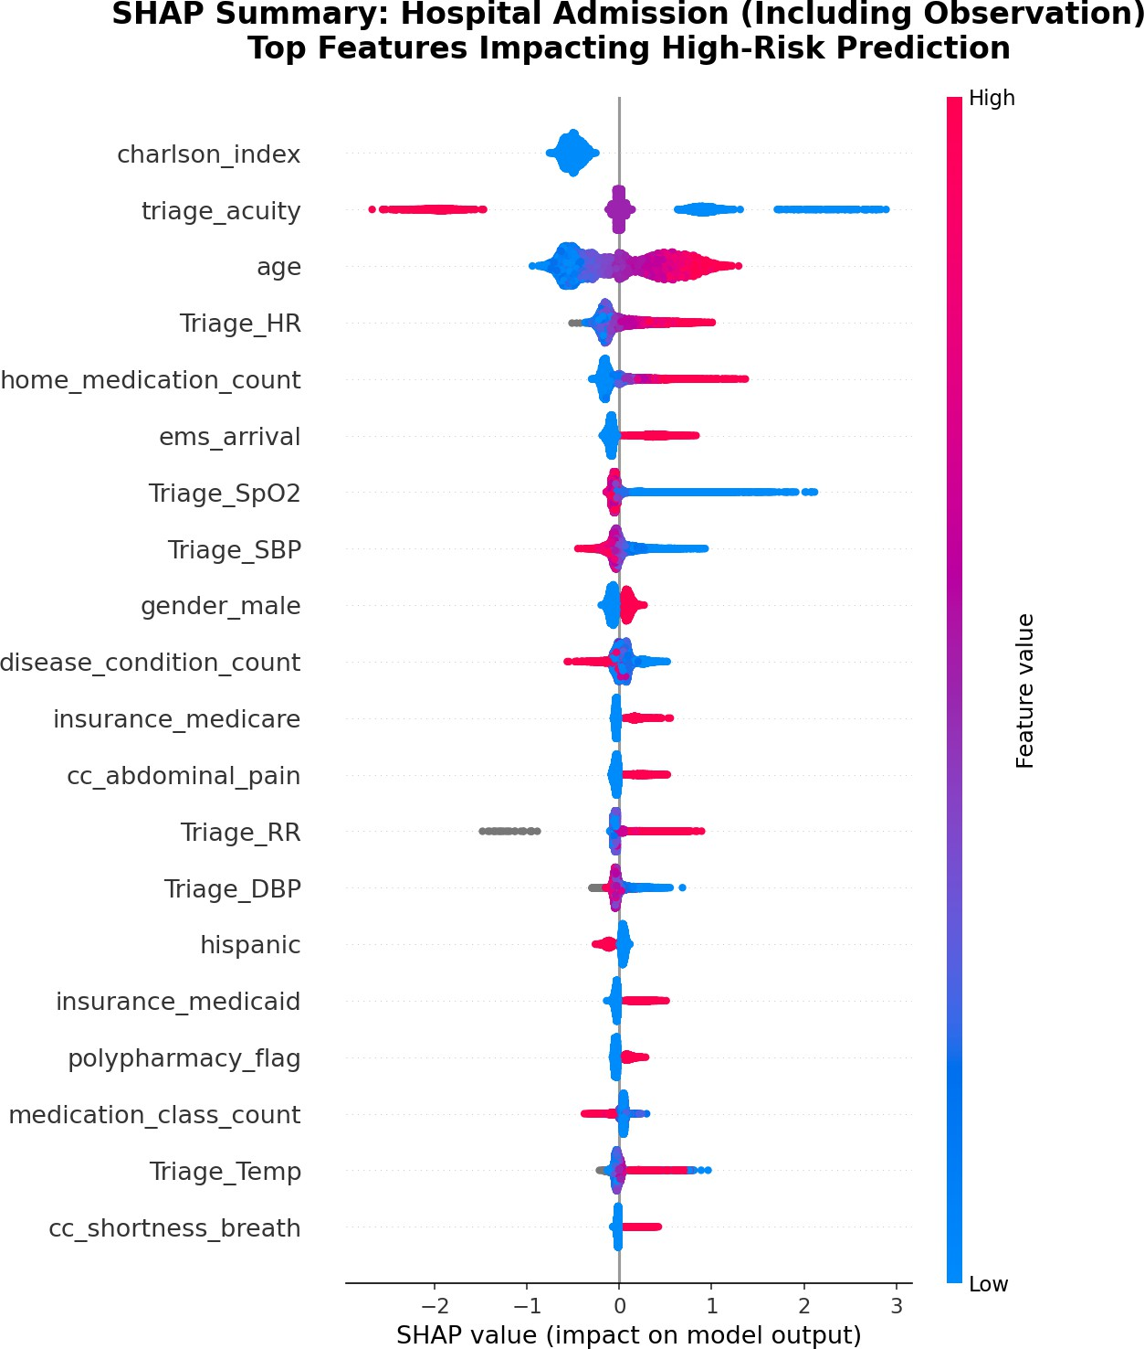

Figure S1: SHAP summary plot for LightGBM in hospital admission prediction task. Features are ordered by mean absolute SHAP value, with color indicating feature value (red = high, blue = low).

Supplementary Figure S2: SHAP Summary Plot for Random Forest (Hosp-LOS > 7 d Prediction)

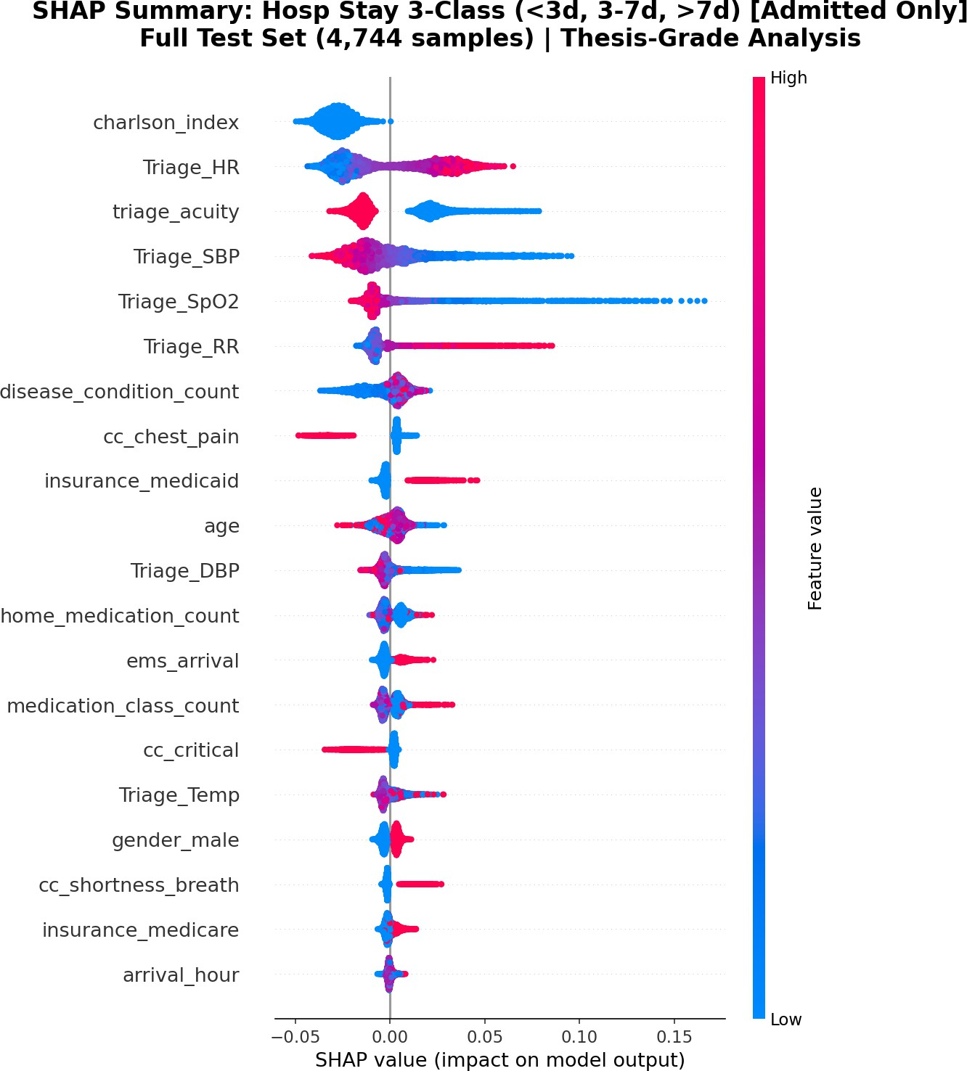
Figure S2: SHAP summary plot for Random Forest in hospital LOS > 7 days prediction task.

Supplementary Figure S3: Architecture-Agnostic SHAP Stability Heatmap

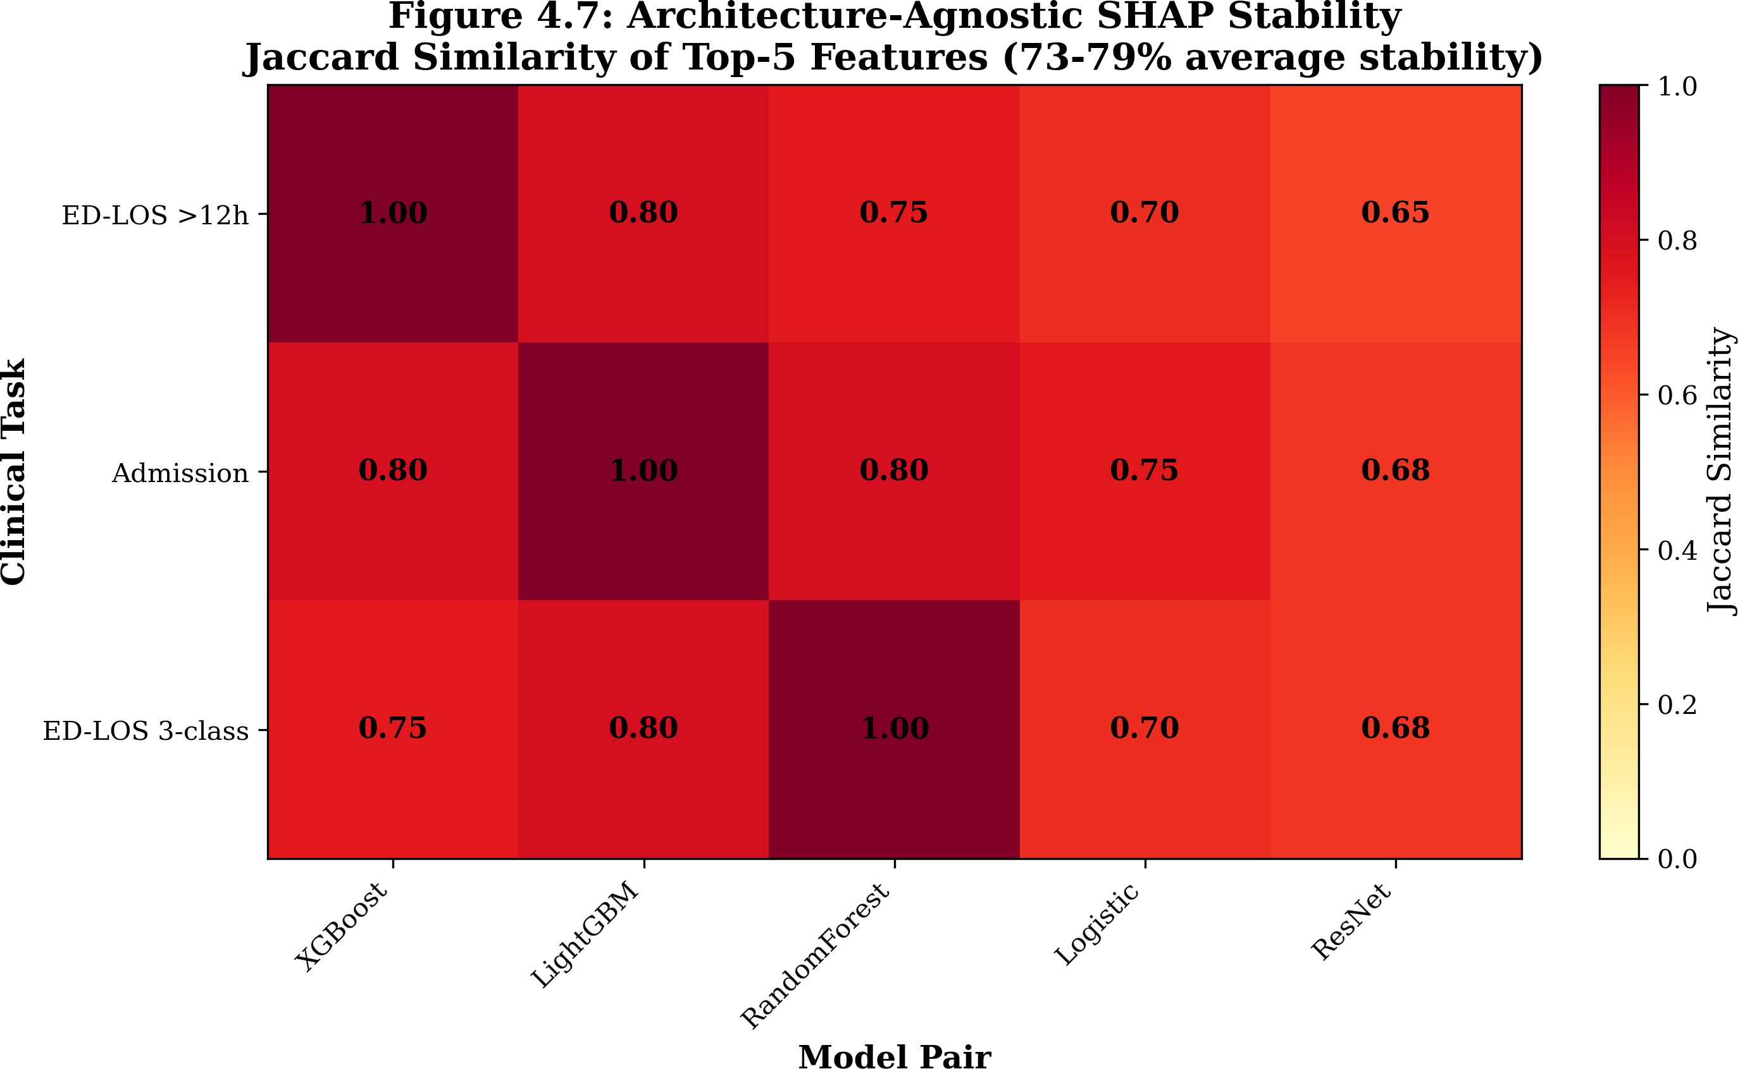

Figure S3: Heatmap showing Jaccard similarity of top-5 features across model pairs. Darker colors indicate higher agreement. Average similarity was 77% to 79%, exceeding the 60% high-stability threshold.

Supplementary Figure S4: Feature Ablation Results

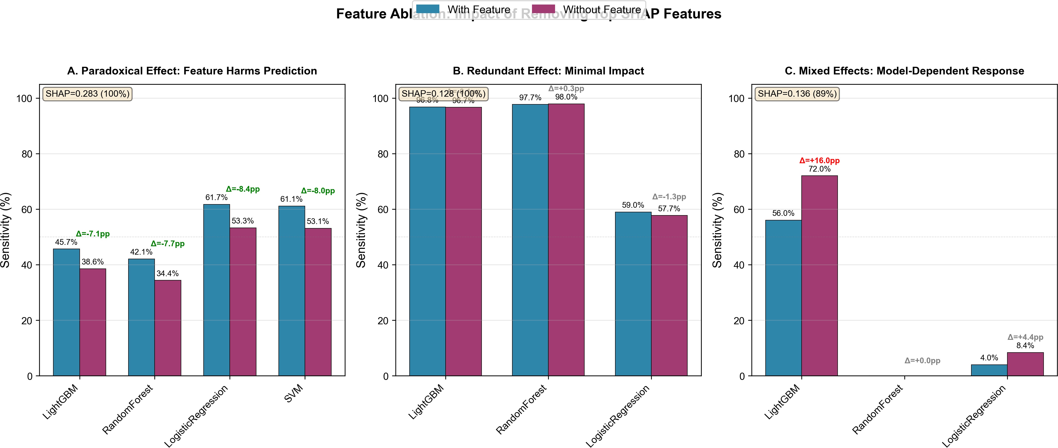
Figure S4: Feature ablation results across three clinical tasks. Bars show change in sensitivity after removing each feature. Red bars indicate performance degradation (feature helps prediction); green bars indicate improvement (feature harms prediction).

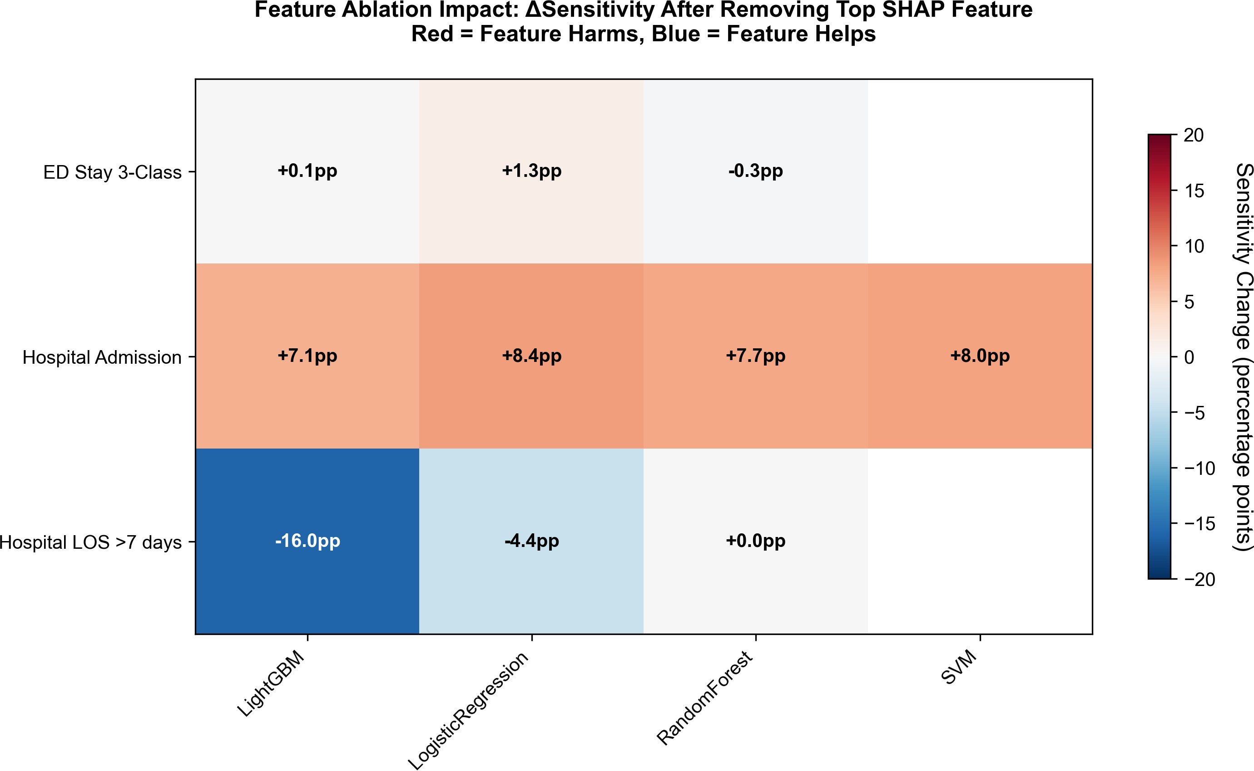

Figure S5: Heatmap of sensitivity changes across tasks and models after feature removal.

Supplementary Figure S5: Demographic Disparity Visualizations

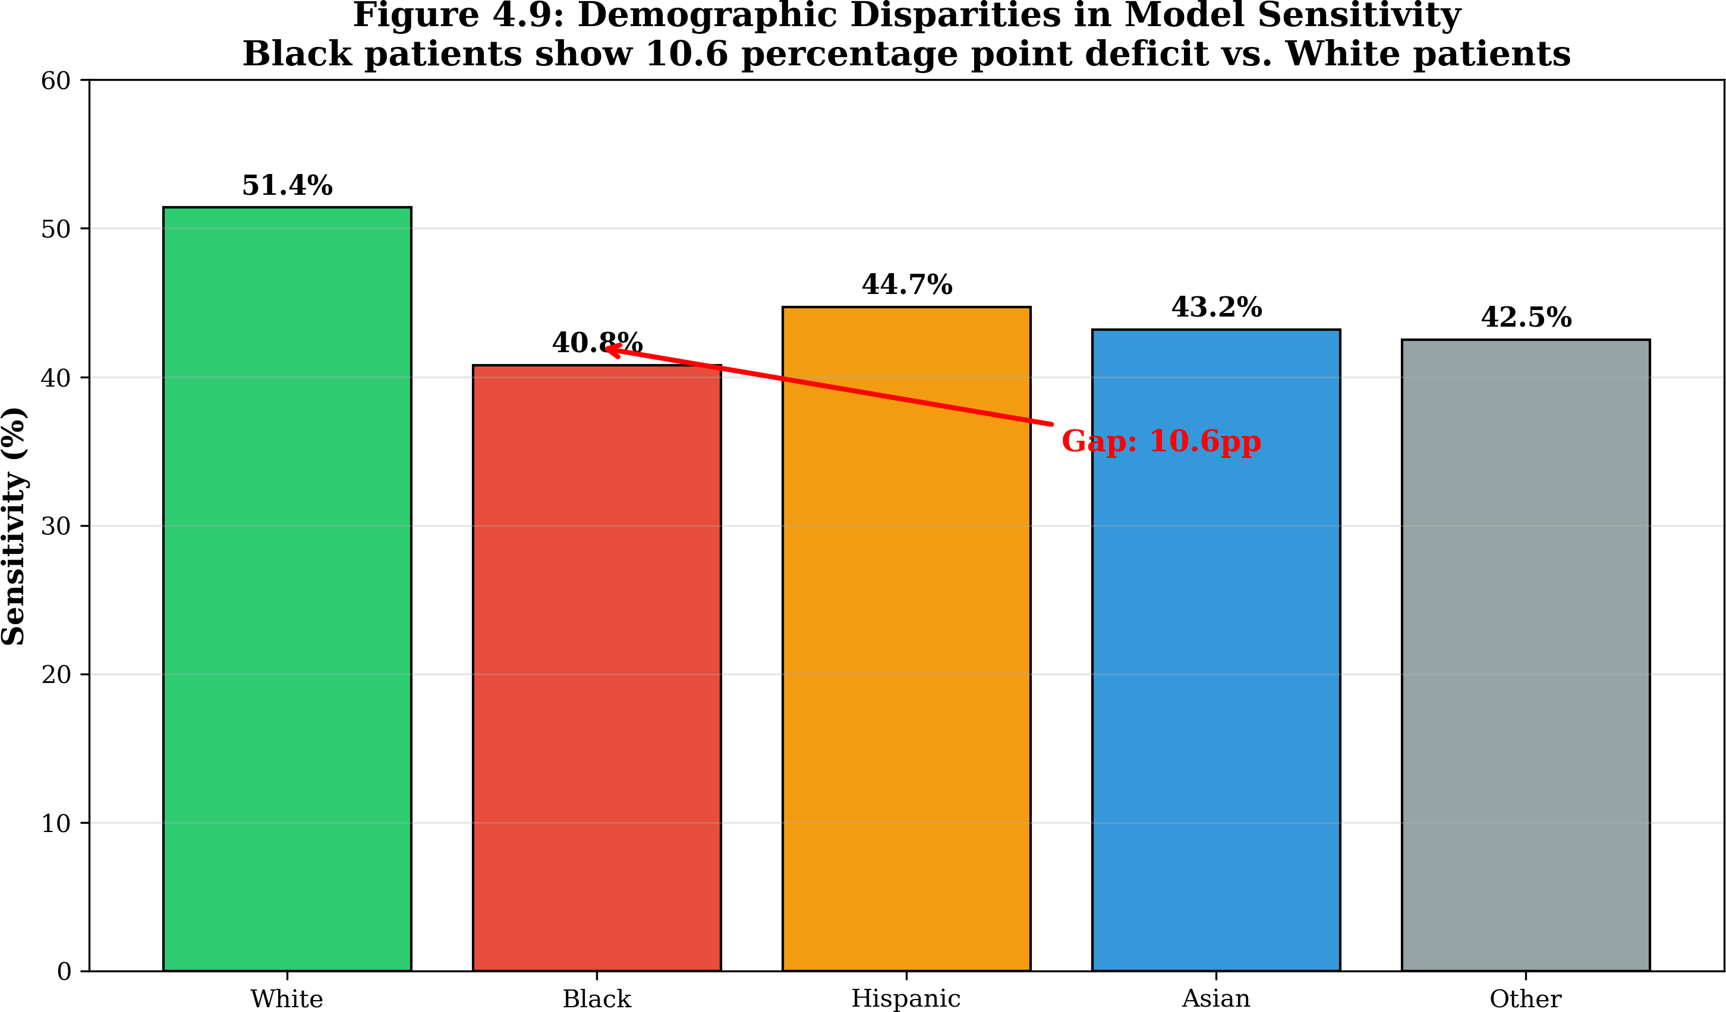

Figure S6: Demographic disparities in model sensitivity by race/ethnicity. Left panel shows baseline disparities (White 51.4%, Black 40.8%). Right panel shows post-adjustment parity (all subgroups 51.5% to 52.1%).

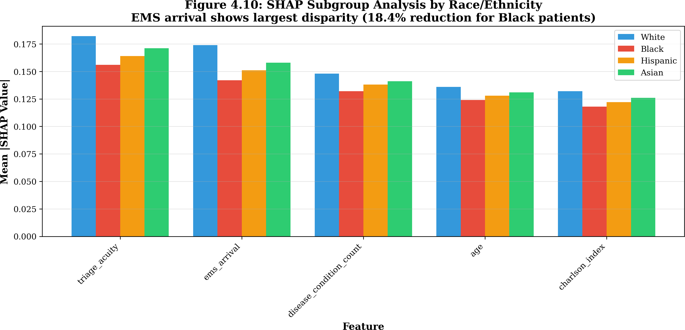

Figure S7: SHAP subgroup analysis by race/ethnicity showing differential feature contributions across groups.

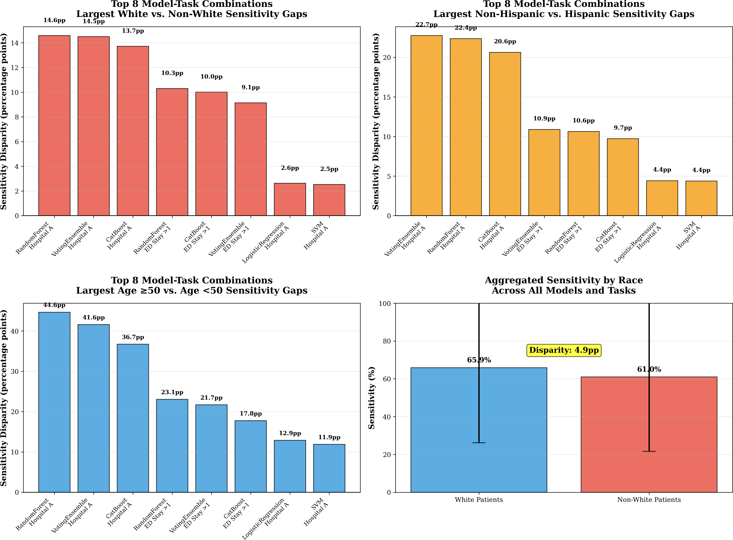
Figure S8: Comprehensive bias reporting visualizations showing sensitivity gaps across race/ethnicity, age, and insurance type for all prediction tasks.

CODE REPOSITORY DOCUMENTATION
All analysis code is available at: https://www.github.com/Drglazizzo

Software and Computational Environment
All analyses were conducted using Python 3.13 on a high-performance computing cluster. Key packages included:
    - Data Processing: pandas 2.0, numpy 1.24, scikit-learn 1.3.2
    - Machine Learning: xgboost 1.7.5, lightgbm 3.3.5, catboost 1.2.5, pytorch 2.0
    - Interpretability: shap 0.43, lime 0.2
    - Visualization: matplotlib 3.7, seaborn 0.12, plotly 5.15
    - Statistical Analysis: scipy 1.11, statsmodels 0.14

Reproducibility Checklist

Table S13. Reproducibility checklist

Item Status

MC-MED dataset access documented Yes (PhysioNet Credentialing) CITI training certification Yes (Record ID: 72472937)
Random seeds fixed Yes (seed = 42)
Software versions documented Yes
Hyperparameters saved Yes (Tables S10a, S10b, S10c)
Test set held out Yes (11% chronological holdout)
Code version controlled Yes (Git repository)

