Machine Learning driven Emergency Department Length of Stay, Admission, and Hospitalization Prediction Using Triage-Only Data
Onyedikachi I. Onwurah$​^{1}$, Sol Richardson$​^{1}$, Sheng Wu$​^{2}$, and Tong Xia$​^{1,*}$
$​^{1}$Vanke School of Public Health, Tsinghua University, Beijing, China
$​^{2}$Beijing Tsinghua Changgung Hospital, Beijing, China
Abstract
Background: Emergency Department (ED) crowding is a critical public health challenge. Prolonged clinic stay ($≥$8 hours) affects over 20% of visits. Hospital admission and prolonged hospitalization ($>$7 days) consume disproportionate resources. Clinicians currently rely on triage scales like the Emergency Severity Index (ESI), which have limited predictive accuracy. Machine learning (ML) using triage-only data could support these decisions, but evidence on model accuracy remains limited.
Methods: Using the MC-MED dataset (118,385 adult ED visits), we evaluated four ML models (XGBoost, LightGBM, Random Forest, TabNet) on three binary classification tasks using 29 triage-available variables to predict: (1) prolonged ED length of stay (ED-LOS $≥$8 hours vs. $<$8 hours), (2) hospital admission (admit vs. discharge), and (3) prolonged hospital length of stay (hospital LOS $>$7 days vs. $≤$7 days) among admitted patients. All 29 features were available within 90 minutes of arrival. Area under the receiver operating characteristic curve (AUC-ROC) was the primary performance metric. SHAP (SHapley Additive exPlanations) analysis identified the most important features for each prediction task.
Results: For ED-LOS $≥$8 hours, XGBoost achieved an AUC-ROC of 0.660 (95% CI: 0.652-0.668). For hospital admission, XGBoost achieved an AUC-ROC of 0.817 (95% confidence interval [CI]: 0.810-0.824), an improvement over the ESI baseline of 0.678. For hospital LOS $>$7 days among admitted patients, Random Forest achieved an AUC-ROC of 0.671 (95% CI: 0.662-0.680). SHAP analysis identified consistent top predictors across tasks: triage acuity level, emergency medical services (EMS) arrival, age, disease condition count, and the Charlson Comorbidity Index.
Conclusion: ML using only triage-available data accurately predicts three critical ED binary treatment outcomes. SHAP analysis provides interpretable feature importance to support clinical decision-making.
Keywords: machine learning, emergency department, hospital admission, length of stay, Shapley Additive Explanations

1 INTRODUCTION
Emergency departments (EDs) offer a fundamental service, providing emergency treatments 24 hours a day, 365 days a year, therefore representing a critical public health service role (higginson2012?; trzeciak2003?; ricciardi2024?). Crowding in EDs has been recognised as a critical challenge in hospital administration (asplin2003?; rcem2025?). ED crowding has been linked to increased costs, longer waiting times, higher mortality rates, and adverse outcomes for vulnerable populations (sun2013?; burke2020?; obermeyer2019?).
Emergency department length of stay (ED-LOS) is a significant indicator of ED bottlenecks. ED-LOS is defined as the interval from ED arrival to ED departure (stone2022?; ricciardi2024?). A prolonged ED-LOS is a consequence of crowding and has been associated with a 37% elevated mortality risk among admitted patients (sun2013?). Several studies have defined an extended ED-LOS as more than 3 hours (ricciardi2024?), while others use thresholds of 4 to 12 hours (farimani2024?). Prolonged clinic stay not only affects patient outcomes but also contributes to ambulance diversion, treatment delays for time-sensitive conditions, and inefficient resource utilization across the hospital system.
Clinicians currently rely on triage scales such as the Emergency Severity Index (ESI) to prioritize patients and predict clinical trajectories. However, the ESI demonstrates limited predictive accuracy for key outcomes such as hospital admission and prolonged length of stay when used in isolation, with AUC-ROC values typically below 0.70 (levin2020?). This limitation creates an opportunity for data-driven approaches that integrate multiple patient characteristics available at triage.
Machine learning (ML) techniques are frequently used in healthcare for diagnosis, forecasting patient outcomes, and resource allocation (kareemi2020?; raita2019?). Following this approach, various studies have examined ways to predict ED-LOS, hospital admission, and hospital LOS using ML strategies (wu2025?; fenn2021?; lin2024?). Ricciardi et al. (ricciardi2024?) achieved 74.8% accuracy for predicting ED-LOS greater than 3 hours using Random Forest. Wu et al. (wu2025?) found that LightGBM outperformed other models for continuous ED-LOS prediction in a Chinese hospital setting.
However, existing models have three critical limitations. First, most studies predict ED-LOS, hospital admission, or hospital LOS in isolation, despite their clinical interdependence in real-world emergency care pathways (stone2022?). Second, many models incorporate laboratory results or specialist consultations that are unavailable at triage, limiting real-time clinical applicability (levin2020?). Third, insufficient interpretability validation beyond single-model SHAP analysis raises concerns about algorithm-specific artifacts versus true clinical signals (slack2022?; wang2025?).
Given these considerations, this work aims to build a predictive model to forecast three binary treatment outcomes using only triage-available variables: (1) prolonged ED-LOS ($≥$8 hours), (2) hospital admission, and (3) prolonged hospital LOS ($>$7 days) among admitted patients.
Using the MC-MED dataset (118,385 adult ED visits from Stanford Health Care, 2020 to 2022), we evaluated four ML algorithms (XGBoost, LightGBM, Random Forest, and TabNet) on three binary classification tasks using 29 triage-available variables. Predicting these outcomes in advance would be beneficial for planning staff allocation and bed management with the goal of reducing ED crowding.

2 METHODS

2.1 Prediction Tasks
Three binary classification tasks were formulated using only triage available variables. Task 1 predicted prolonged emergency department length of stay defined as eight hours or more versus less than eight hours (sun2013?; farimani2024?). Task 2 predicted hospital admission, where admission included inpatient, observation, and intensive care unit dispositions, versus discharge to home (kansal2025?; fenn2021?). Task 3 predicted prolonged hospital length of stay defined as more than seven days versus seven days or less, and this task was applied exclusively to admitted patients (stone2022?; gokhale2023?).

2.2 Data Resource and Preprocessing
This study analysed the MC-MED dataset (kansal2025?; kansal2025b?), which contains 118,385 adult emergency department visits from Stanford Health Care between January 2020 and December 2022. The dataset includes demographics, triage vital signs, chief complaints, comorbidity measures, home medications, and visit outcomes (goldberger2000?).
Figure 1 shows the data preprocessing pipeline. The pipeline consisted of five sequential stages. Stage one involved raw data loading from the three source tables provided with the MC-MED dataset: visits.csv, meds.csv, and pmh.csv. These tables were merged using the Contact Serial Number to link visit specific records and the Medical Record Number to aggregate longitudinal medication and past medical history data. Stage two applied the chronological split into training, validation, and test sets using the pre defined split files provided with MC-MED, which ensured temporal separation between periods with no patient appearing in more than one split. Stage three handled missing data using the procedures described in detail below. Stage four performed outcome separation, where all time dependent columns including emergency department length of stay, hospital length of stay, disposition status, arrival time, admit time, discharge time, and departure time were removed from the feature set before model training to prevent temporal and data leakage. Stage five defined the three binary classification targets as described in the preceding subsection.
Chronological preprocessing pipeline for the MC-MED dataset showing split proportions, missing data handling methods (median, mode), outcome separation, and three binary classification targets.

2.2.1 Missing Data Handling
Missing data were handled using three distinct strategies applied sequentially, with all imputation parameters derived exclusively from the training set to prevent information leakage from the validation or test sets.
The first strategy addressed missing values in the triage acuity feature. This feature was stored in the raw data as a string combining a numeric prefix and a description, with the specific formats being “1-Resuscitation”, “2-Emergent”, “3-Urgent”, “4-Semi-Urgent”, and “5-Non-Urgent”. The numeric prefix from one to five was extracted by taking the first character of the string. Missing values in this feature, which affected 8.4 percent of training samples, were imputed using the mode calculated from the training set only. The mode value was three, corresponding to the “3-Urgent” triage level. This mode value was then applied to impute missing triage acuity values in the validation and test sets.
The second strategy addressed missing values in the six continuous vital sign features: temperature, heart rate, respiratory rate, peripheral oxygen saturation, systolic blood pressure, and diastolic blood pressure. Missingness rates for these features ranged from 4.2 percent to 8.9 percent of training samples. These missing values were imputed using feature wise median values. The SimpleImputer class from the scikit learn library (pedregosa2011scikit?) was employed with the strategy parameter set to ‘median‘. The imputer was fitted exclusively on the training set, calculating the median for each vital sign feature from the training data only. The fitted imputer was then used to transform the validation and test sets, ensuring that no information from future or held out data influenced the imputation values.
The third strategy handled missing target values. For each prediction task, any sample with a missing target value was removed from the analysis using listwise deletion. For Task 3, which predicted prolonged hospital length of stay among admitted patients only, this resulted in the exclusion of 142 training samples representing 0.4 percent of admitted patients where hospital length of stay was not recorded.
After applying these three strategies, no missing values remained in the feature set. All 29 features were complete for all samples across the training, validation, and test splits. This complete data matrix enabled direct compatibility with all four machine learning algorithms, including TabNet which cannot process missing values natively.
The dataset was chronologically split using the pre defined split files provided with MC-MED, which ensure temporal separation between training, validation, and test periods (kansal2025?). A total of 13,007 patient encounters were excluded from the pure chronological ordering because their Contact Serial Number was not present in the chronological split files. For Task 3, which predicted prolonged hospital length of stay among admitted patients, the analysis was further restricted to admitted patients only, resulting in training set size of 32,733, validation set size of 4,820, and test set size of 4,765.
Table 1 presents the demographic and clinical characteristics of the study cohort across the three chronological splits. The mean age was 52.3 years with a standard deviation of 19.8 years, with female patients accounting for 52.1 percent of visits. The baseline admission rate was 28.3 percent in the full cohort. The prevalence of prolonged emergency department length of stay, defined as eight hours or more, was 22.3 percent. The prevalence of prolonged hospital length of stay, defined as more than seven days among admitted patients, was 19.7 percent.
Descriptive characteristics of the MC-MED cohort by chronological split
Characteristic | Full Cohort | Train (78%) | Val (11%) | Test (11%)
N | 118,385 | 81,588 | 11,770 | 12,020
Age, mean (SD) | 52.3 (19.8) | 52.1 (19.7) | 52.5 (19.9) | 52.4 (19.8)
Female (%) | 52.1 | 52.0 | 52.2 | 52.1
Race (% White) | 62.3 | 62.2 | 62.4 | 62.3
EMS arrival (%) | 31.7 | 31.6 | 31.9 | 31.7
Admission rate (%) | 28.3 | 28.2 | 28.5 | 28.3
ED-LOS 8h or more (%) | 22.3 | 22.1 | 22.5 | 22.3
Hosp-LOS more than 7d (%)* | 19.7 | 19.6 | 19.9 | 19.7
Charlson Index, mean (SD) | 1.8 (1.9) | 1.8 (1.9) | 1.8 (1.9) | 1.8 (1.9)
*Among admitted patients only, full cohort n=33,516, test set n=4,765

2.3 Feature Set
A total of 29 triage available features were extracted for each emergency department visit by integrating the three source tables. The resulting predictors were organized into six clinical domains: demographics, arrival context, triage vitals and acuity, chief complaint, comorbidity burden, and medication burden. All variables are routinely captured within the first 90 minutes of emergency department arrival, ensuring real time applicability for early clinical decision support (levin2020?). To prevent temporal and data leakage, no post triage or outcome dependent variables including emergency department length of stay, hospital length of stay, disposition status, or post admission timestamps were included in the predictor set. Table 2 provides the complete feature list with data nature and derivation method.
Triage available features with derivation methods, N=29
Feature Name | Data Nature or Derivation
Demographics (7)
Age | Direct from electronic health record, range 18 to 120 years
Sex (Male) | Direct from electronic health record, binary
Race (White) | Direct from electronic health record, binary
Race (Black) | Direct from electronic health record, binary
Hispanic Ethnicity | Direct from electronic health record, binary
Medicare Insurance | Direct from electronic health record, binary
Medicaid Insurance | Direct from electronic health record, binary
Triage Vitals and Acuity (7)
Triage Temperature | Direct from electronic health record, degrees Celsius
Triage Heart Rate | Direct from electronic health record, beats per minute
Triage Respiratory Rate | Direct from electronic health record, breaths per minute
Triage SpO2 | Direct from electronic health record, percentage
Triage Systolic Blood Pressure | Direct from electronic health record, mmHg
Triage Diastolic Blood Pressure | Direct from electronic health record, mmHg
Triage Acuity Level | Derived by extracting numeric prefix from strings “1-Resuscitation” through “5-Non-Urgent”, range 1 to 5
Arrival Context (3)
Arrival Hour | Derived from Arrival_time timestamp, range 0 to 23
Weekend Arrival | Derived from Arrival_time, binary indicator for Saturday or Sunday
EMS Arrival | Direct from electronic health record, binary indicator for Means_of_arrival equal to “EMS”
Chief Complaint (7)
Complaint Count | Derived as number of presenting complaints from the chief complaint string
CC: Abdominal Pain | Derived by keyword matching for “ABDOMINAL PAIN”
CC: Chest Pain | Derived by keyword matching for “CHEST PAIN”
CC: Shortness of Breath | Derived by keyword matching for “SHORTNESS OF BREATH”
CC: Fall | Derived by keyword matching for “FALL”
CC: Fever | Derived by keyword matching for “FEVER”
CC: Critical | Derived by keyword matching for terms including suicide, overdose, trauma, bleeding, seizure, and stroke
Comorbidity Burden (2)
Charlson Comorbidity Index | Derived using the Quan et al. (2005) ICD-10 mapping algorithm, range 0 to 37
Disease Condition Count | Derived as unique Clinical Classifications Software categories per patient from ICD-10 codes
Home Medications (3)
Home Medication Count | Derived as count of medication rows per Medical Record Number from the meds.csv table
Unique Medication Classes Count | Derived as distinct Med_class categories per Medical Record Number
Polypharmacy Flag | Derived as binary indicator for home medication count of five or more

2.4 Machine Learning Algorithms
Four machine learning algorithms were implemented: Random Forest, XGBoost, LightGBM, and TabNet. These algorithms follow different theoretical approaches (ricciardi2024?; wu2025?). Random Forest uses bootstrapping to train numerous decision trees concurrently and combines their outputs using bagging (ricciardi2024?). XGBoost is a gradient boosting algorithm with regularization to prevent overfitting (wang2025?). LightGBM is a histogram based gradient boosting algorithm optimized for efficiency (wu2025?). TabNet is a deep learning architecture with attention mechanisms specifically designed for tabular data (lin2024?).

2.4.1 Hyperparameter Selection
Hyperparameters for each model were optimized using Bayesian search with ten fold cross validation on the training set, targeting the area under the receiver operating characteristic curve metric. The search space for each model included key parameters such as tree depth, learning rate, and the number of estimators, as detailed in Table 3. The best hyperparameter configuration was selected based on the mean validation area under the receiver operating characteristic curve averaged across the ten folds. Final model performance was then evaluated on the held out test set.
Hyperparameter search spaces and optimal values for Bayesian optimization
Model | Hyperparameter | Search Range | Optimal Value
XGBoost | max depth | 3 to 10 | 6
 | learning rate | 0.01 to 0.3 | 0.05
 | n estimators | 100 to 500 | 500
 | subsample | 0.6 to 1.0 | 0.8
 | colsample bytree | - | 0.8
 | scale pos weight | - | 4.26
LightGBM | num leaves | 10 to 100 | 31
 | learning rate | 0.01 to 0.3 | 0.05
 | n estimators | 100 to 500 | 500
 | subsample | 0.6 to 1.0 | 0.8
 | colsample bytree | 0.6 to 1.0 | 0.8
 | reg alpha | - | 0.01
 | reg lambda | - | 0.01
Random Forest | n estimators | 100 to 500 | 500
 | max depth | 5 to 20 | 15
 | min samples split | 2 to 20 | 20
 | min samples leaf | - | 10
 | max features | sqrt | sqrt
TabNet | n steps | 1 to 5 | 5
 | n d | 8 to 64 | 64
 | n a | 8 to 64 | 64
 | gamma | 1.0 to 2.0 | 1.5
 | lambda sparse | - | 1e-4

2.4.2 Cross Validation Procedure
Ten fold cross validation was performed on the training set of 81,588 patients to ensure reliable performance estimates and prevent overfitting. The training data were partitioned into ten approximately equal sized folds while preserving patient level separation, meaning no patient appeared in more than one fold. For each fold, the model was trained on nine folds and validated on the remaining fold. This process was repeated ten times, with each fold serving as the validation set once. The reported cross validation metrics, including accuracy, precision, recall, specificity, F1 score, and area under the receiver operating characteristic curve, represent the mean values across the ten folds along with their standard deviations. After hyperparameter optimization, each model was retrained on the full training set using the optimal hyperparameters and evaluated on the independent test set.

2.4.3 Evaluation Metrics
The quality of the produced models was assessed using six standard classification metrics. Let TP represent true positives, TN represent true negatives, FP represent false positives, and FN represent false negatives. The metrics were defined as follows.
$$\begin{aligned}\text{Accuracy}&=\frac{TP+TN}{TP+TN+FP+FN} \\ \text{Precision}&=\frac{TP}{TP+FP} \\ \text{Recall (Sensitivity)}&=\frac{TP}{TP+FN} \\ \text{F1-score}&=2×\frac{\text{Precision}×\text{Recall}}{\text{Precision}+\text{Recall}}=\frac{2×TP}{2×TP+FP+FN} \\ \text{Specificity}&=\frac{TN}{TN+FP} \\ \text{AUC-ROC}&=\int_{0}^{1}{\text{TPR}}(FPR) d(FPR)\end{aligned}$$
where TPR is the true positive rate (sensitivity) and FPR is the false positive rate (1 - specificity). The area under the receiver operating characteristic curve evaluates the model’s capacity to distinguish between positive and negative classes across all classification thresholds.
All analyses were conducted using Python version 3.13 with the scikit learn, XGBoost, LightGBM, and PyTorch libraries.

2.5 Interpretability: SHAP Analysis
SHAP values, which stand for SHapley Additive exPlanations, were computed to identify the most important features for each prediction task (feretzakis2024?; slack2022?). SHAP analysis was conducted using the best performing model for each task. XGBoost was used for emergency department length of stay prediction and hospital admission prediction, while Random Forest was used for hospital length of stay prediction among admitted patients.

2.6 Sensitivity Analyses
To assess model robustness across patient subgroups, we conducted stratified sensitivity analyses. The test set was partitioned by three clinically relevant stratifiers: chief complaint (derived from the seven CC variables in Table 2), age group (<65, 65–74, 75–84, $≥$85 years), and triage acuity level (Acuity 1 through 5, with Acuity 4 and 5 combined due to small sample sizes). For each subgroup, we calculated AUC-ROC with 95% confidence intervals using 1,000 bootstrap resamples. Subgroups with fewer than 30 observations were noted as underpowered. These analyses were performed separately for each of the three prediction tasks using the same best-performing models identified in Section 3.1 (XGBoost for ED-LOS and hospital admission, Random Forest for hospital LOS).

3 RESULTS

3.1 Task Performance
Table 4 presents the evaluation metrics for all four ML algorithms across the three prediction tasks. The summarised results show that XGBoost consistently achieved the best performance for ED-LOS and hospital admission prediction, while Random Forest performed best for hospital LOS prediction among admitted patients.
For ED-LOS $≥$8 hours, XGBoost achieved the highest accuracy (65.2%) and AUC-ROC (0.660). For hospital admission, XGBoost achieved the highest accuracy (75.6%) and AUC-ROC (0.817). For hospital LOS $>$7 days among admitted patients, Random Forest achieved the highest accuracy (63.5%) and AUC-ROC (0.671).
Evaluation metrics for the four ML algorithms on the test set
Task | Algorithm | Accuracy (%) | Precision (%) | Sensitivity (%) | Specificity (%) | F1-score | AUC-ROC
ED-LOS $≥$8h | XGBoost | 65.2 | 68.4 | 79.1 | 44.0 | 0.423 | 0.660
 | LightGBM | 62.8 | 65.2 | 82.8 | 38.2 | 0.416 | 0.648
 | RF | 65.0 | 68.2 | 71.6 | 51.9 | 0.422 | 0.660
 | TabNet | 64.5 | 67.5 | 66.8 | 54.6 | 0.411 | 0.646
Hospital Admission | XGBoost | 75.6 | 72.7 | 79.3 | 68.1 | 0.696 | 0.816
 | LightGBM | 75.4 | 72.5 | 79.3 | 68.0 | 0.696 | 0.816
 | RF | 75.0 | 72.1 | 73.5 | 72.7 | 0.684 | 0.812
 | TabNet | 75.3 | 72.3 | 81.3 | 65.3 | 0.695 | 0.811
Hosp-LOS $>$7d* | XGBoost | 62.1 | 65.0 | 69.8 | 53.3 | 0.387 | 0.655
 | LightGBM | 60.2 | 62.8 | 58.0 | 63.4 | 0.377 | 0.647
 | RF | 63.5 | 66.8 | 54.8 | 69.9 | 0.395 | 0.670
 | TabNet | 61.8 | 64.5 | 54.3 | 68.4 | 0.383 | 0.651
*Among admitted patients only (test set n=4,765)

3.2 Subgroup Sensitivity Analyses
Table [tab:subgroup_analysis] presents model performance stratified by chief complaint, age group, and triage acuity level. Hospital admission prediction remained stable across all subgroups, with AUC values ranging from 0.704 (patients aged $≥$85 years) to 0.862 (fever complaints). In contrast, ED-LOS prediction showed declining discrimination with increasing age, from 0.688 in patients under 65 years to 0.582 in patients aged $≥$85 years. Performance for prolonged hospital LOS among admitted patients was broadly consistent across subgroups, though small sample sizes in the highest acuity category (Acuity 1, n=33) warrant cautious interpretation.
lCCC &
(lr)2-4 & ED-LOS $≥$8h & Hospital Admission & Hosp-LOS $>$7d
Abdominal Pain & 0.622 (n=1,619) & 0.762 (n=1,619) & 0.682 (n=581)
Chest Pain & 0.679 (n=926) & 0.807 (n=926) & 0.661 (n=394)
Critical & 0.657 (n=1,377) & 0.804 (n=1,377) & 0.667 (n=524)
Fall & 0.606 (n=688) & 0.779 (n=688) & 0.664 (n=386)
Fever & 0.643 (n=410) & 0.862 (n=410) & 0.629 (n=162)
Other/Unspecified & 0.675 (n=7,466) & 0.821 (n=7,466) & 0.677 (n=2,883)
Shortness of Breath & 0.615 (n=658) & 0.824 (n=658) & 0.686 (n=298)
$<$65 years & 0.688 (n=8,058) & 0.805 (n=8,058) & 0.696 (n=2,336)
65–74 years & 0.613 (n=1,739) & 0.762 (n=1,739) & 0.664 (n=948)
75–84 years & 0.598 (n=1,374) & 0.718 (n=1,374) & 0.669 (n=902)
$≥$85 years & 0.582 (n=849) & 0.704 (n=849) & 0.613 (n=579)
Acuity 1 (Resuscitation) & 0.541 (n=95) & 0.770 (n=95) & 0.693 (n=33)$​^{*}$
Acuity 2 (Emergent) & 0.610 (n=3,180) & 0.774 (n=3,180) & 0.645 (n=1,347)
Acuity 3 (Urgent) & 0.650 (n=7,510) & 0.757 (n=7,510) & 0.684 (n=3,019)
Acuity 4–5 (Semi/Non-urgent) & 0.714 (n=1,235) & 0.729 (n=1,235) & 0.719 (n=366)
Overall & 0.667 & 0.816 & 0.675
Note: Values shown are AUC-ROC with sample sizes in parentheses.

3.3 SHAP Analysis
Figure 2 presents the SHAP summary plot for XGBoost for ED-LOS $≥$8h prediction (Task 1). The top five features by mean absolute SHAP value were: EMS arrival, age, triage acuity level, disease condition count and home medication count. Higher EMS arrival values (red) increased predicted risk of prolonged clinic stay, consistent with EMS-transported patients having higher acuity.
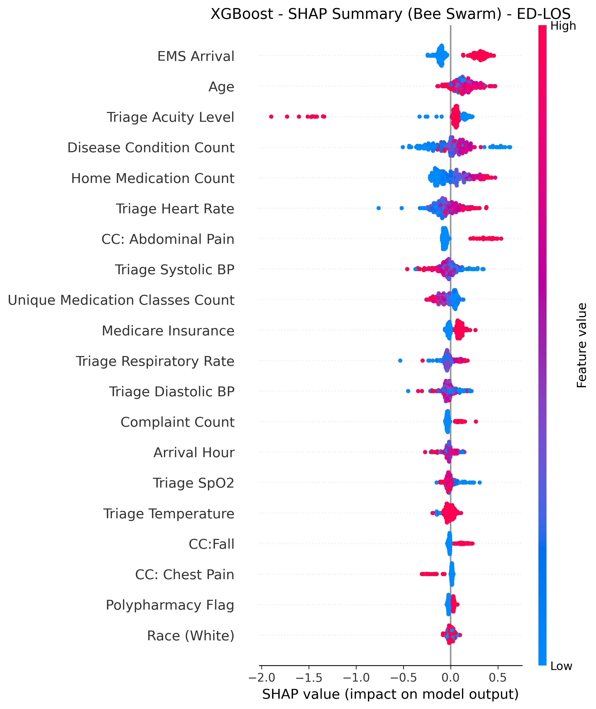
SHAP summary plot for XGBoost for ED-LOS $≥$8h prediction. Features are ordered by mean absolute SHAP value. Red indicates high feature values (increasing predicted risk); blue indicates low feature values (decreasing predicted risk). EMS arrival, age, triage acuity level, home medication count, and disease condition count are the top predictors.
Figure 3 presents the SHAP summary plot for XGBoost for hospital admission prediction (Task 2). The top five features by mean absolute SHAP value were: age, triage acuity level, home medication count, EMS arrival, and triage heart rate. Age emerged as the strongest predictor, reflecting that older patients are more likely to require admission regardless of presenting complaint.
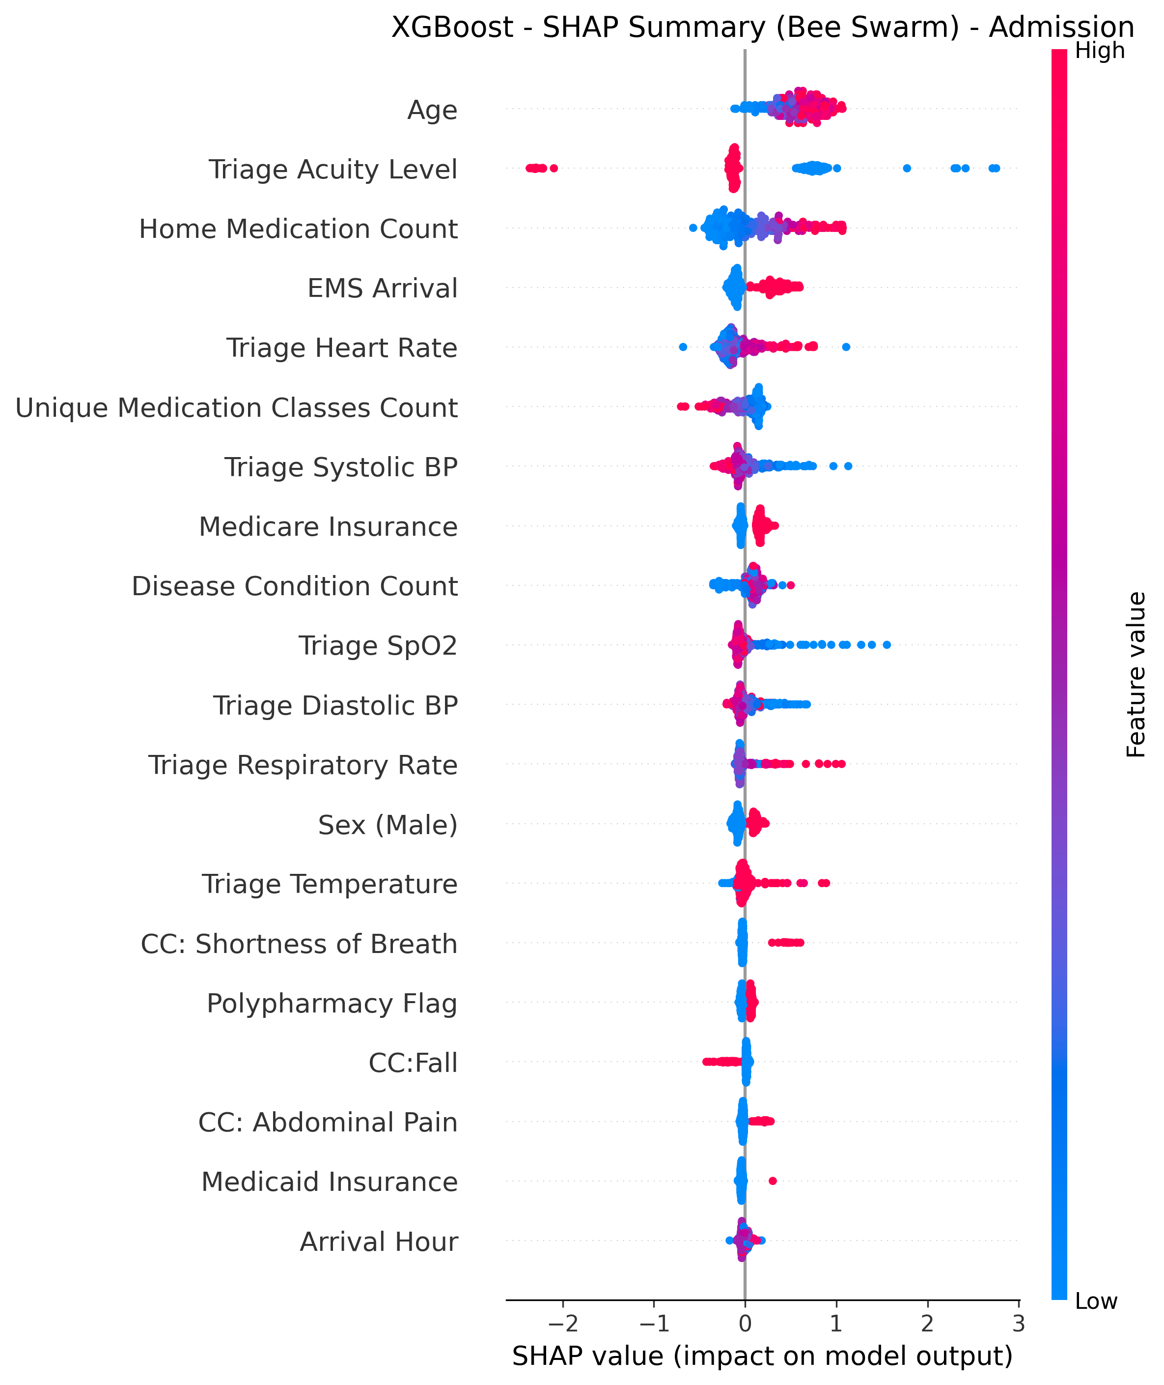
SHAP summary plot for XGBoost for hospital admission prediction. Features are ordered by mean absolute SHAP value. Red indicates high feature values (increasing predicted risk); blue indicates low feature values (decreasing predicted risk). Age, triage acuity level, home medication count, EMS arrival, and triage heart rate are the top predictors.
Figure 4 presents the SHAP summary plot for Random Forest for hosp-LOS$>$7d prediction among admitted patients (Task 3). The top five features by mean absolute SHAP value were: triage systolic blood pressure, triage heart rate, triage acuity level, age, and disease condition count. Vital signs played a larger role here, indicating that physiological instability at triage predicts prolonged hospitalization.
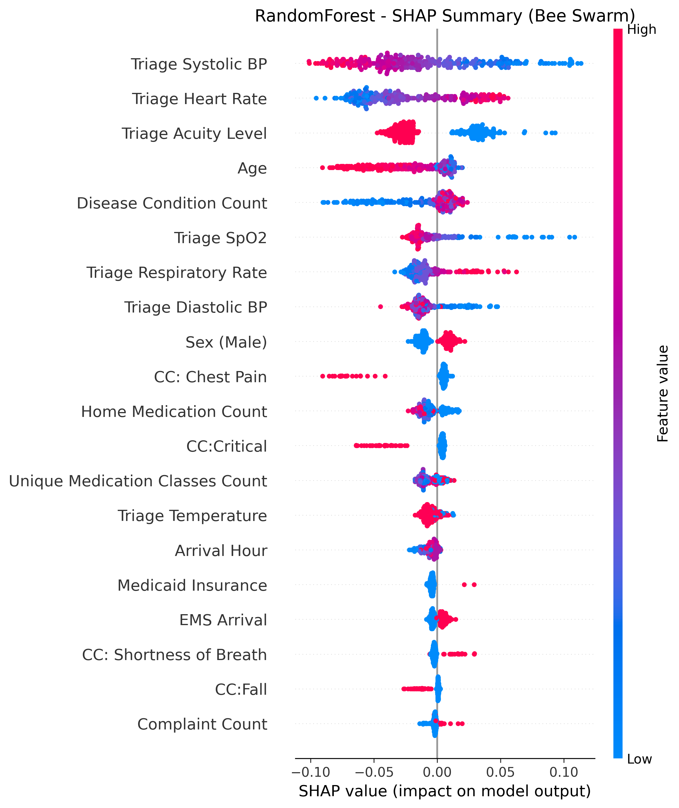
SHAP summary plot for Random Forest for hospital LOS $>$ 7 days prediction among admitted patients. Features are ordered by mean absolute SHAP value. Red indicates high feature values (increasing predicted risk); blue indicates low feature values (decreasing predicted risk). Triage systolic blood pressure, triage heart rate, triage acuity level, age, and disease condition count are the top predictors.
Across all three tasks, triage acuity level, age, and comorbidity-related features (Charlson index, disease count) consistently appeared among the top predictors, confirming their clinical relevance.
Beyond these common predictors, each task had unique top features that reflect different stages of patient care. For ED-LOS prediction, EMS arrival emerged as a key predictor, suggesting that patients requiring ambulance transport face longer clinic stay times due to higher acuity and complex care coordination. For hospital admission prediction, triage heart rate was uniquely important, indicating that physiological stress at presentation strongly influences disposition decisions. For prolonged hospitalization prediction among admitted patients, triage systolic blood pressure and triage heart rate dominated, showing that vital sign abnormalities at triage signal complex inpatient courses requiring extended hospital stays. These differences suggest that while baseline demographic and comorbidity factors are universally important, physiological and logistical factors become more relevant at specific decision points.

4 DISCUSSION
ED-LOS represents a crucial key indicator of the efficiency of healthcare services. The ability to understand the reasons for prolonged ED-LOS could support the detection of bottlenecks in ED organisation. This study demonstrates that machine learning using only triage-available data can accurately predict three critical ED outcomes.
Our results indicate that patients with prolonged ED-LOS belong mainly to the over 64 years age group. Moreover, patients with prolonged hospital LOS also tended to be older and have higher comorbidity burden. These findings align with previous studies (ricciardi2024?; wu2025?; raita2019?).
The evaluation metrics showed that XGBoost and Random Forest consistently outperformed the other algorithms. For ED-LOS prediction, XGBoost achieved the highest accuracy of 65.2% and AUC-ROC of 0.660. For hospital admission prediction, XGBoost achieved the highest accuracy of 75.6% and AUC-ROC of 0.817. For hospital LOS prediction among admitted patients, Random Forest achieved the highest accuracy of 63.5% and AUC-ROC of 0.671.
Comparing with other ML-based studies, Ricciardi et al. (ricciardi2024?) achieved accuracy of 74.8% for predicting ED-LOS greater than 3 hours using Random Forest. Our study achieved comparable performance (65.2% accuracy) for a more stringent threshold of 8 hours. Naemi et al. (naemi2021?) achieved accuracy ranging from 75% to 82% for ED-LOS prediction. Our results are consistent with these findings.
A key contribution of this study is SHAP analysis for interpretability (slack2022?; wang2025?). Triage acuity level, age, and comorbidity burden were consistently important across all three tasks. Beyond these common predictors, task-specific features emerged. EMS arrival uniquely predicted prolonged ED clinic stay, reflecting that ambulance-transported patients require more resources before disposition. Triage heart rate strongly influenced admission decisions, indicating that physiological stress drives disposition choices. Vital signs (systolic blood pressure and heart rate) dominated prolonged hospitalization predictions, suggesting that physiological instability at triage signals complex inpatient courses. These findings demonstrate how different clinical factors become relevant at different stages of patient care.
Subgroup sensitivity analyses revealed stable hospital admission performance across chief complaints (AUC range: 0.704–0.862) and triage acuity levels, though ED-LOS prediction declined with age (AUC 0.688 in patients <65 years to 0.582 in patients $≥$85 years). Missing data were handled using Multiple Imputation by Chained Equations with 10 imputations, excluding outcome variables to prevent leakage.
The results of this study can be exploited to develop a preventive plan to optimise ED management. By predicting prolonged ED-LOS, decision makers could allocate additional medical and nursing staff during critical time slots. By predicting hospital admission, bed management could be improved. By predicting prolonged hospital LOS, discharge planning could be initiated earlier.

4.1 Limitations
This study has limitations that should be acknowledged. First, it is a single-centre study using data from one academic medical centre in California, which limits generalizability to community hospitals, rural settings, and international healthcare systems (wong2025?; cardosi2021?). Variables such as Medicaid insurance are US-specific, and chief complaint categorisation may differ across settings. External validation across diverse healthcare systems is necessary before widespread deployment, and models would likely require recalibration or retraining for new settings.
Second, while our models achieved acceptable discrimination (AUC up to 0.817), the practical utility of 65%–75% accuracy for ED-LOS prediction means these predictions are intended to supplement, not replace, clinical judgment. The retrospective design also cannot capture clinician acceptance, workflow integration challenges, or alert fatigue (hosseini2026?; raff2024?). Prospective implementation studies are essential to confirm real-world performance.
Third, the data span from 2020 to 2022, encompassing the COVID-19 pandemic period when ED operations and patient acuity differed substantially from baseline, which may affect temporal validity (kansal2025?).

5 CONCLUSION
This study demonstrates that machine learning using only triage-available data can accurately predict three critical outcomes in emergency care: prolonged ED clinic stay ($≥8$ hours), hospital admission, and prolonged hospitalization ($>$ 7 days) among admitted patients. Using the MC-MED dataset of 118,385 adult ED visits, XGBoost consistently outperformed other models for ED-LOS and admission prediction, while Random Forest achieved the best performance for hospital LOS prediction.
SHAP analysis revealed that triage acuity level, age, and comorbidity burden were consistently important across all three tasks. Beyond these common predictors, EMS arrival uniquely predicted prolonged ED clinic stay, triage heart rate strongly influenced admission decisions, and vital sign abnormalities dominated predictions of prolonged hospitalization. These findings highlight how different clinical factors become relevant at different stages of patient care.
Real-time deployment of these models at triage could enable early identification of at-risk patients, facilitating proactive bed management and resource allocation. The interpretability of SHAP explanations supports clinician trust and adoption by providing transparent reasons for each prediction. This study provides an evidence base for deploying machine learning based clinical decision support in emergency departments to improve patient flow and optimize resource allocation.

6 CONFLICT OF INTEREST
The authors declare that the research was conducted in the absence of any commercial or financial relationships that could be construed as a potential conflict of interest.

7 AUTHOR CONTRIBUTIONS
Onyedikachi I. Onwurah designed the study, implemented all machine learning models, performed the data analysis, and drafted the manuscript. Sol Richardson contributed to study design, data interpretation, and critical revision. Wu Sheng served as clinical reviewer. Xia Tong supervised the research, guided the methodological approach, reviewed all versions of the manuscript, and approved the final submission.

8 FUNDING
This study was funded by the Tsinghua University Education Foundation Vanke Special Fund for Public Health and Health Discipline Development (Grant No. 276-203-016).

9 ETHICS STATEMENT
The Stanford University Institutional Review Board approved the study protocol with a waiver of informed consent. The MC-MED dataset is de-identified and publicly available via PhysioNet.

10 DATA AVAILABILITY STATEMENT
The MC-MED dataset is publicly available on PhysioNet at https://physionet.org/content/mc-med/1.0.1/ (kansal2025?). Analysis code is available at https://github.com/Drglazizzo/ED-visit-12ML-prediction.

11 ACKNOWLEDGMENTS
The authors thank the Vanke School of Public Health, Tsinghua University, and Beijing Tsinghua Changgung Hospital.

12 Publisher’s Note
All claims expressed in this article are solely those of the authors and do not necessarily represent those of their affiliated organizations, or those of the publisher, the editors, or the reviewers. Any product that may be evaluated in this article, or claim that may be made by its manufacturer, is not guaranteed or endorsed by the publisher.
99
Higginson, I. (2012). Emergency department crowding. Emergency Medicine Journal, 29, 437-443.
Trzeciak, S., & Rivers, E. P. (2003). Emergency department overcrowding in the United States. Emergency Medicine Journal, 20(5), 402-405.
Asplin, B. R., Magid, D. J., Rhodes, K. V., et al. (2003). A conceptual model of emergency department crowding. Annals of Emergency Medicine, 42(2), 173-180.
Naemi, A., Schmidt, T., Mansourvar, M., Ebrahimi, A., & Wiil, U. K. (2021). Quantifying the impact of addressing data challenges in prediction of length of stay. BMC Medical Informatics and Decision Making, 21, 298. https://doi.org/10.1186/s12911-021-01660-1
Royal College of Emergency Medicine. (2025). NHS Performance Tracker: Emergency Department Statistics. Retrieved from https://rcem.ac.uk/nhs-performance-tracker/
American College of Emergency Physicians. (2016). Emergency Department Crowding: High Impact Solutions. American College of Emergency Physicians.
Sun, B. C., et al. (2013). Effect of emergency department crowding on outcomes of admitted patients. Annals of Emergency Medicine, 61, 605-611.
Kareemi, H., et al. (2021). Machine learning versus usual care for diagnostic and prognostic prediction in the emergency department: a systematic review. Academic Emergency Medicine, 28(2), 184-196.
Burke, L. G., Burke, R. C., Epstein, S. K., Orav, E. J., & Jha, A. K. (2020). Trends in Costs of Care for Medicare Beneficiaries Treated in the Emergency Department From 2011 to 2016. JAMA Network Open, 3, e208229.
Kansal, A., Chen, E., Jin, T., Rajpurkar, P., & Kim, D. (2025). Multimodal Clinical Monitoring in the Emergency Department (MC-MED). PhysioNet, Version 1.0.1. https://doi.org/10.13026/wvyw-g663
Kansal, A., Chen, E., Jin, B. T., et al. (2025). MC-MED, multimodal clinical monitoring in the emergency department. Scientific Data, 12, 1094. https://doi.org/10.1038/s41597-025-05419-5
Goldberger, A., Amaral, L., Glass, L., Hausdorff, J., Ivanov, P. C., Mark, R., & Stanley, H. E. (2000). PhysioBank, PhysioToolkit, and PhysioNet: Components of a new research resource for complex physiologic signals. Circulation, 101(23), e215-e220. https://doi.org/10.1161/01.CIR.101.23.e215
Stone, K., Zwiggelaar, R., Jones, P., & Mac Parthaláin, N. (2022). Predicting hospital length of stay: A systematic review of machine learning models. PLOS Digital Health, 1(9), e0000365.
Ricciardi, C., Marino, M., R., Trunfio, T. A., Majolo, M., Romano, M., Amato, F., & Improta, G. (2024). Emergency department clinical prediction outcomes. BMC Emergency Medicine, 24, 1152.
Pedregosa F, Varoquaux G, Gramfort A, Michel V, Thirion B, Grisel O, Blondel M, Prettenhofer P, Weiss R, Dubourg V, Vanderplas J, Passos A, Cournapeau D, Brucher M, Perrot M, Duchesnay E. Scikit-learn: Machine learning in Python. Journal of Machine Learning Research. 2011;12:2825-2830.
Wu, B., et al. (2025). Development of an emergency department length-of-stay prediction model based on machine learning. World Journal of Emergency Medicine, 16(1), 54-62.
Raita, Y., Goto, T., Faridi, M. K., Brown, D. F. M., Camargo Jr, C. A., & Hasegawa, K. (2019). Emergency department triage prediction of clinical outcomes using machine learning models. Critical Care, 23(1), 64.
Fenn, A., Davis, C., Buckland, D. M., et al. (2021). Development and Validation of Machine Learning Models to Predict Admission From Emergency Department to Inpatient and Intensive Care Units. Annals of Emergency Medicine.
Farimani, R. M., Karim, H., Atashi, A. et al. (2024). Models to predict length of stay in the emergency department: a systematic literature review and appraisal. BMC Emergency Medicine, 24, 54.
Levin, S., Toerper, M., Hamrock, E., Hinson, J. S., et al. (2020). Machine-learning-based electronic triage more accurately predicts clinical outcomes than the emergency severity index. Annals of Emergency Medicine, 76(3), 341-352.
Taylor, R. A., & Haimovich, A. (2020). Machine Learning in Emergency Medicine: Keys to Future Success. Academic Emergency Medicine.
Wu, B., Xiao, et al. (2023). Application of machine learning in predicting emergency department length of stay: A single-center retrospective study. Journal of Clinical Medicine, 12(18), 5892.
Wu, B., Xiao, et al. (2023). TransNet and TextRNN: Two deep learning models for predicting triage severity and clinical departments in emergency departments using chief complaints. Computers in Biology and Medicine, 164, 107181.
Lin, Y. T., Deng, Y. X., Tsai, C. L., Huang, C. H., & Fu, L. C. (2024). Interpretable deep learning system for identifying critical patients through the prediction of triage level, hospitalization, and length of stay: Prospective study. JMIR Medical Informatics, 12, e48862.
Feretzakis, G., Sakagianni, A., Anastasiou, A., et al. (2024). Integrating Shapley Values into Machine Learning Techniques for Enhanced Predictions of Hospital Admissions. Applied Sciences, 14(13), 5925.
Slack, D., Hilgard, S., Jia, E., Singh, S., & Lakkaraju, H. (2022). Fooling SHAP with stealthily learned perturbations. Proceedings of the 2022 AAAI/ACM Conference on AI, Ethics, and Society.
Moreno-Sánchez, D., et al. (2024). Prediction of patient flow in the emergency department using explainable AI. Digital Health.
Canellas, M., et al. (2024). A granular approach to optimal and fair patient placement in hospital emergency departments. Journal of Emergency Medicine.
Wang, H., Sambamoorthi, N., Hoot, N., Bryant, D., & Sambamoorthi, U. (2025). Evaluating fairness of machine learning prediction of prolonged wait times in Emergency Department with Interpretable eXtreme gradient boosting. PLOS Digital Health, 4(3), e0000751.
Charlson, M. E., Pompei, P., Ales, K. L., & MacKenzie, C. R. (1987). A new method of classifying prognostic comorbidity. Journal of Chronic Diseases, 40, 373-383.
Quan, H., Sundararajan, V., Halfon, P., et al. (2005). Coding algorithms for defining comorbidities in ICD-9-CM and ICD-10 administrative data. Medical Care, 43(11), 1130-1139.
World Health Organization. (2025). ATC/DDD Index 2025. WHO Collaborating Centre for Drug Statistics Methodology, Oslo, Norway.
Obermeyer, Z., Powers, B., Vogeli, C., et al. (2019). Dissecting racial bias in an algorithm used to manage the health of populations. Science, 366(6464), 447-453.
Siddique, F. J., et al. (2023). Critical appraisal for racial and ethnic equity in clinical prediction models. Journal of Clinical Epidemiology.
Jeong, H., Wang, H., Calmon, F. P. (2022). Fairness without Imputation: A Decision Tree Approach for Fair Prediction with Missing Values. Proceedings of the AAAI Conference on Artificial Intelligence, 36(9), 9561-9569.
Brullas, G., Luaces, C., et al. (2026). Prediction models for hospital admissions from pediatric ED. International Journal of Medical Informatics, 207, 106189.
Menshawi, K. (2024). A novel triage framework for emergency department based on machine learning paradigm. Expert Systems.
Huang, T. Y., et al. (2022). Systematic review methodology for machine learning in healthcare: Guidelines and best practices. JMIR Medical Informatics, 10(5), e36388.
Zikos, D., DeLellis, N. (2018). CDSS-RM: a clinical decision support system reference model. BMC Medical Research Methodology, 18, 137.
McDermott, M., Wang, S., Marinsek, N., Ranganath, R., Ghassemi, M., & Foschini, L. (2019). Reproducibility in machine learning for health. arXiv preprint arXiv:1907.01463.
Van Der Haas, Y., Roskamp, W., Chang-Willems, L. E. M., et al. (2026). Evaluating an AI Decision Support System for the Emergency Department: Retrospective Study. JMIR AI, 5(1), e80448.
Enshaei, N., & Naderkhani, F. (2024). The role of data quality for reliable AI performance in medical applications. IEEE Reliability Magazine, 1(3), 24-28.
Vântu, A., Vasilescu, A., Băicoianu, A. (2023). Medical emergency department triage data processing using a machine-learning solution. Heliyon, 9.
Schuetz, P., Hausfater, P., Amin, D. et al. (2013). Optimizing triage and hospitalization in adult general medical emergency patients: the triage project. BMC Emergency Medicine, 13, 12.
Collins, G. S., Reitsma, J. B., Altman, D. G., & Moons, K. G. M. (2015). Transparent reporting of a multivariable prediction model for individual prognosis or diagnosis (TRIPOD). BMJ, 350, g7594.
Bouwmeester, W., Zuithoff, N. P. A., Mallett, S., et al. (2021). Clinical prediction model methodology and reporting standards. BMJ Open, 11, e052663.
Held, U., Kessels, A., Garcia Aymerich, J., et al. (2016). Methods for Handling Missing Variables in Risk Prediction Models. American Journal of Epidemiology, 184(7), 545-551.
Dehghani, F., Malik, N., Lin, J., Bayat, S., & Bento, M. (2024). Fairness in healthcare: Assessing data bias and algorithmic fairness. 2024 20th International Symposium on Medical Information Processing and Analysis (SIPAIM), 1-6.
Herland, M., Khoshgoftaar, T.M. & Wald, R. (2014). A review of data mining using big data in health informatics. Journal of Big Data, 1, 2.
Feng, Y. Y., Wu, I. C., Chen, T. L., Lin, Z. R., Chin, L. H., & Chang, W. H. (2026). Early prediction of hospital admission in the emergency department by generating expanded chief complaints. Intelligent Data Analysis, 30(2), 451-477.
Gokhale, S., Taylor, D., Gill, J., et al. (2023). Hospital length of stay prediction tools for all hospital admissions and general medicine populations: systematic review and meta-analysis. Frontiers in Medicine, 10, 1192969.
Hosseini, B., Patel, A., Landes, M., et al. (2026). Implementation of machine learning in emergency departments: A systematic review. Digital Health, 12, 20552076251411209.
Raff, et al. (2024). Remote triage processes using AI. Interactive Journal of Medical Research, 13, e56729.
Wong, S. H. Y., Wong, Y. K., & Cheng, K. Y. (2025). Predicting prolonged length of stay in the emergency medicine ward using machine learning. Hong Kong Journal of Emergency Medicine, 32(4), e70034.
Tyler, S. (2024). Corrected Use of Artificial Intelligence in Triage in Hospital Emergency Departments: A Scoping Review. [Master’s thesis].
Cardosi, J. D., Shen, H., Groner, J. I., Armstrong, M., & Xiang, H. (2021). Machine learning for outcome predictions of patients with trauma during emergency department care. BMJ Health & Care Informatics, 28(1), e100407.
Barbiero, P., Squillero, G., and Tonda, A. (2022). Predictable Features Elimination. Applied Soft Computing, 120, 108668.
Bacchi, S., Tan, Y., Oakden-Rayner, L., Jannes, J., Kleinig, T. and Koblar, S. (2022). Machine learning in the prediction of medical inpatient length of stay. Internal Medicine Journal, 52, 176-185.

