Ping another computer in my home. Ping a PC from a mac.

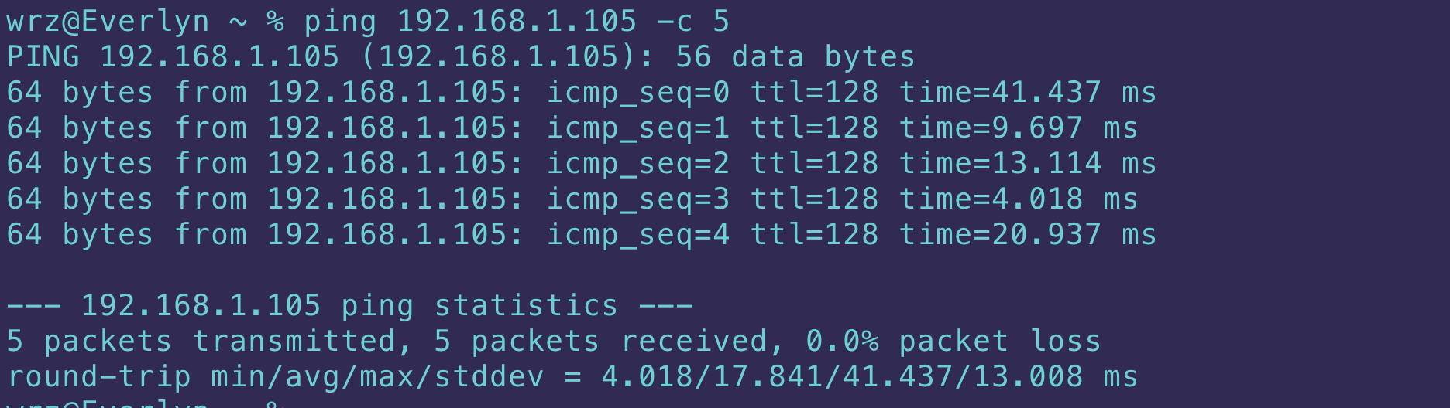

Using Traceroute command to find the passing routers.

