Tesseract 4.0 comparison with Capitec OCR system

Using the vm:
It takes approximately 30 seconds for Tesseract to do OCR one 1 tif page.

Results

Capitect generated (All 3980 statements)
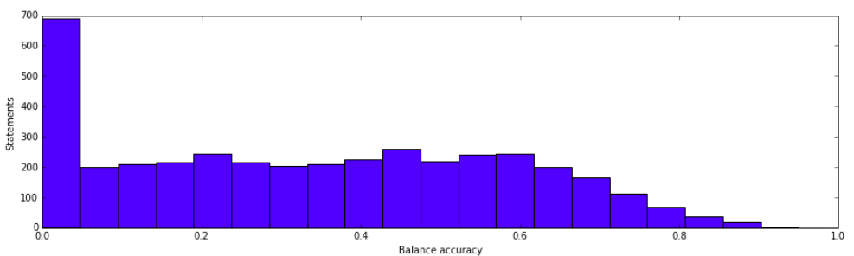
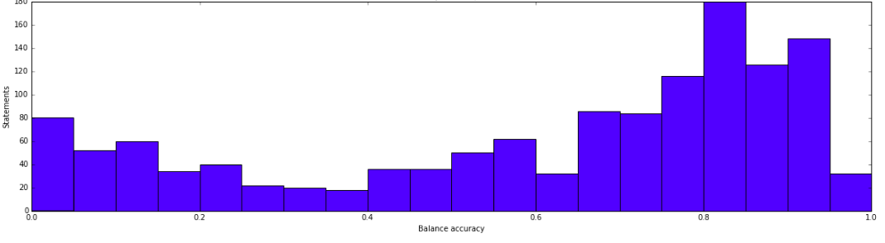

Praelexis results (1314 statements)

