Rough Notes

ame: absolute mean error
rms: root mean square

Please refere to the Presentation.odp file for an explanation on each of the algorithms. To view the notes open the Presentation.odp file, click on view and then notes. If the image for a given slide is blurry go to normal view and then back to the notes view.

Euclidean_similarity
--------------------
This algorithm works surprisingly well on the smaller datasets. This might be due to the almost consistent number of movies rated in the dataset. This algorithm is bad at estimating ratings if one person consistently rates harsher than a other person.

Pearson_similarity
------------------
This algorithm finds strong correlation even if one person rates consistently harsher or kinder than the other. The algorithm only considers commonly ranked items without a penalty for the amount of commonly ranked items. This means a person with only two movies rated can significantly influence another persons recommendations. The systems also scores perfect correlation if there is two or less commonly score items, which will have to be compensated for.

SVD

SVD does training and inference in one step.

When the unknown table values is initialised to 0 the SVD generalises badly. When the initial unknown table values are set to the average of both the movie and user average ratings the SVD model is much more accurate. From 2.96 to 0.8 accuracy. Using a training set of 90 000 entries the SVD has a test accuracy of 0.8 with the second best algorithm achieving 0.85 ame.

The SVD allows you to compute features. This features are components that best seperate the data. For example 2 features in the data might be male or female. Then how connected the user is to each feature allows the prediction of how the user will rate items.

By doing the final multiplication of the aproximate SVD in the run step the whole table does not need to be created. This saves memory and processing time. The algorithm thus only calculates the values for the current item user combo using a dot product in runtime. (This has been implemented in the latest code)

SVD Incremental

As the amount of users grow one might need to go over to an incremental SVD algorithm. This allows you to update your SVD incrementally even with new items or users being added or removed. The data tables also does not need to be preprocessed by adding in artificial data.

Running the SVDInc for 5000 steps on the 100k database resulted in:

Mean Absolute Error(mae) of SCDInc on training data: 0.352

Pearson SVDFull SVDInc Popularity
Results: [ 0.88626982 0.80898546 0.89611215 0.90576609]

SVD Full Incremental

Now if we combine the SVDFull and SCDinc the following results gets produced:

Pearson SVDFull SVFInc SVDFullInc Popularity
Results: [ 0.84408325 0.7539544 0.81657918 0.73568855 0.81473659]

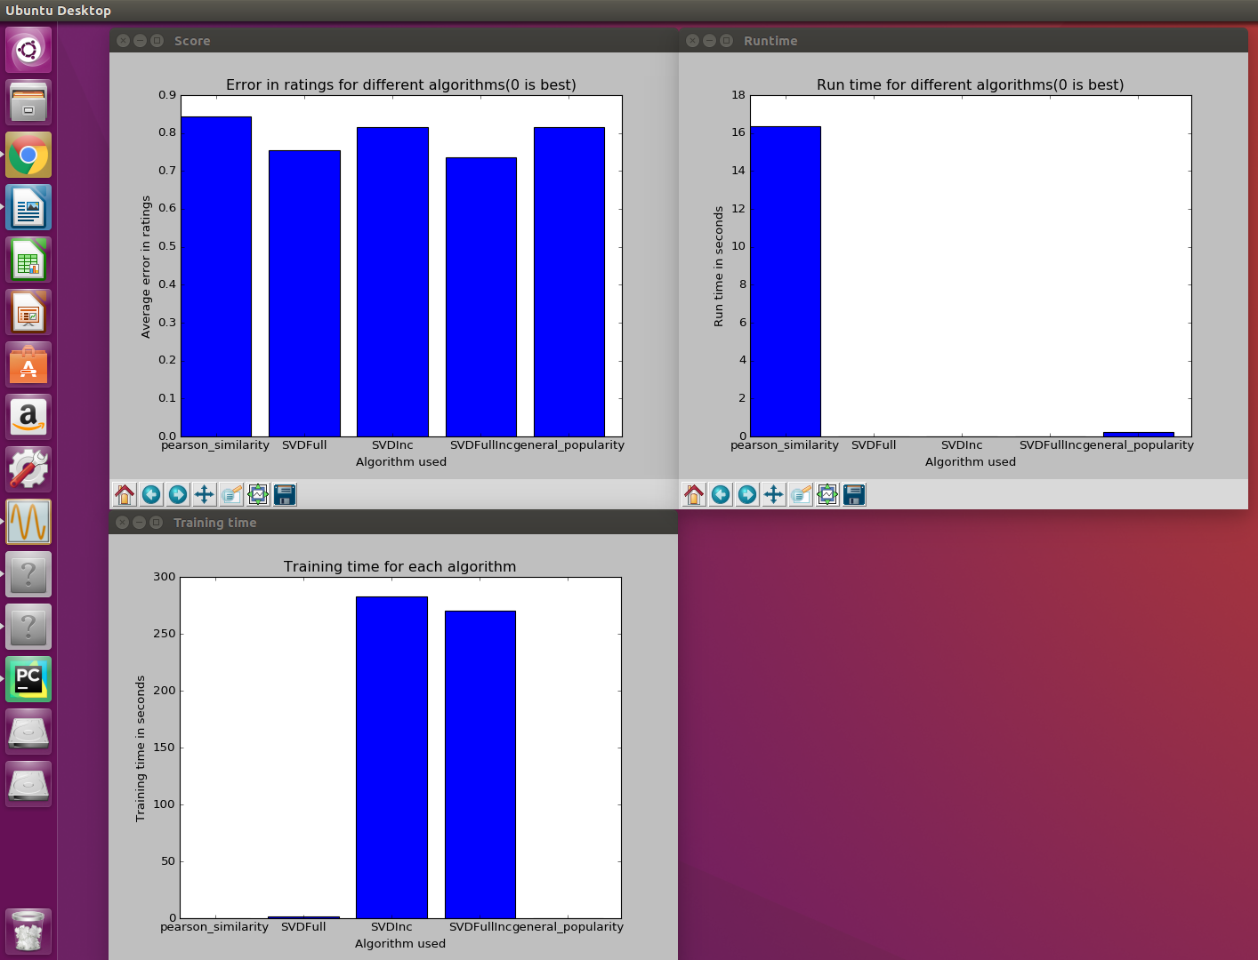
It can now be seen that the SDVFullInc works better than the solo SDVFull. The SDVFull arives at the most optimal answer, but for the matrix which has artificial data in it. Thus the solution is good, but not the best possible matrix answer. To further improve this answer the SVDInc algorithm gets used afterwards to further decrease the error betwean the true ratings and those the algorithm predicts, while not needing the unkonwn ratings. This generalises better and produces the final result. Thus the results shows that the SDVFull is much faster(on 100k dataset), but less accurate. The SDVInc is slower, but more accurate. Improvements to the SDVInc will now be attempted to create a fast and accurate algorithm.

For this algorithm demeaning has to be taken out. It might be possible to used demeaning
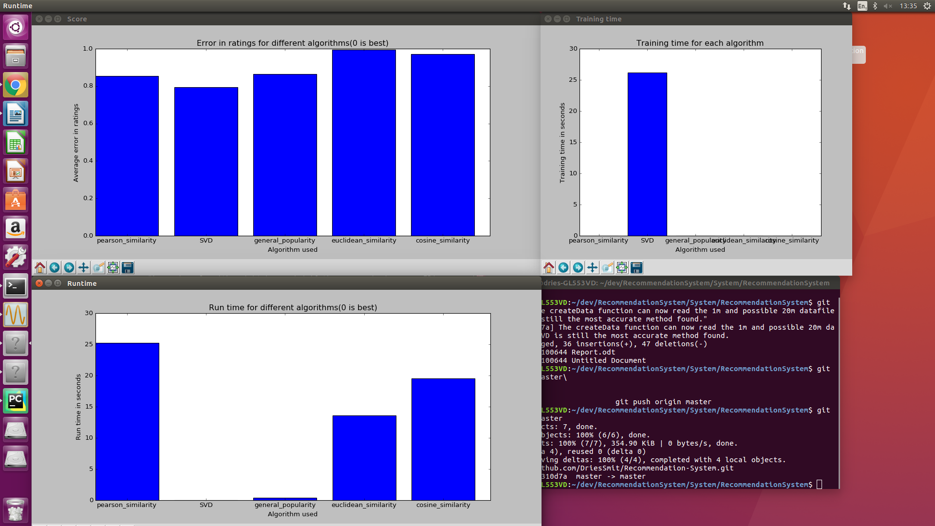

SDVFull demeaning matrix
There is a small improvement found in demeaning the data. This test was done with 5000 random test cases
SVDDemeaned SVDNormal Pearson
Results: [ 0.76163134 0.76234008 0.82690635]

SVD Incremental alpha regulation
Next we will look at alpha regulation to increase the efficiency.

SVDIncWithReg SVDIncWithoutReg

Results: [0.81297121 0.82292722]

It is seen that regulating alpha does decrease the training time of the SVDInc algorithm. Each algorithm was given 50 update steps on the 100k movieLens database.

Increasing incremental SVD speed

The first thing that was change was to map the non zero values instead of checking for them each time.

The processing results increased as follows(seconds) for 50 steps using the 100k database:

SVDIncOld SVDIncNew

Results: [210 189]

For bigger matrixes this time difference is expected to increase.

Now for 1 milion ratings the following could be calculated:

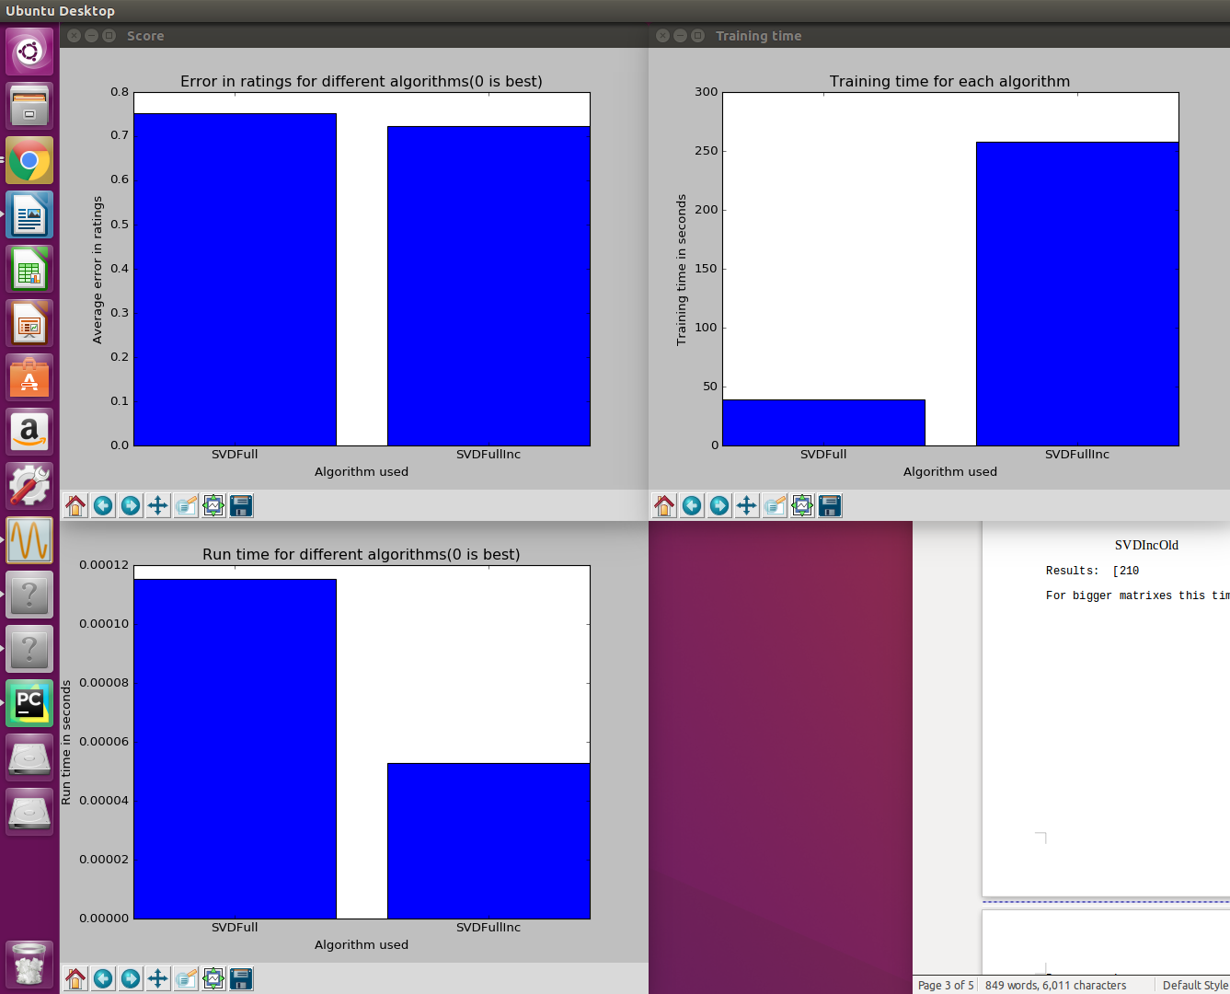

SVDFull SVDFullInc
Results: [ 0.7513948 0.72294599]

SVDFullInc does much better. But lets try SVDInc:

After 200 iterations of training the SVDInc also does better that the usual SVDFull. This is due to the system only training on known data.

SVDFullInc SVDInc
Results: [ 0.74362658 0.71553858]

After 200 iterations training the SVDInc also does better that the SVDFullInc. This is due to the system being trained on only known data and not started of with incorrect data.
SVDFullInc SVDInc
Results: [ 0.76733106 0.6901964 ]
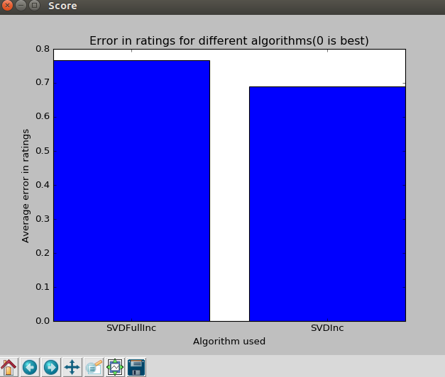

Now to 20 million ratings

For 1 iteration the algorithm scores
SVDInc popularity
0.77073299 0.76

For 2 iterations the algorithm scores:
SVDInc popularity
[ 0.7594114 0.77620048]
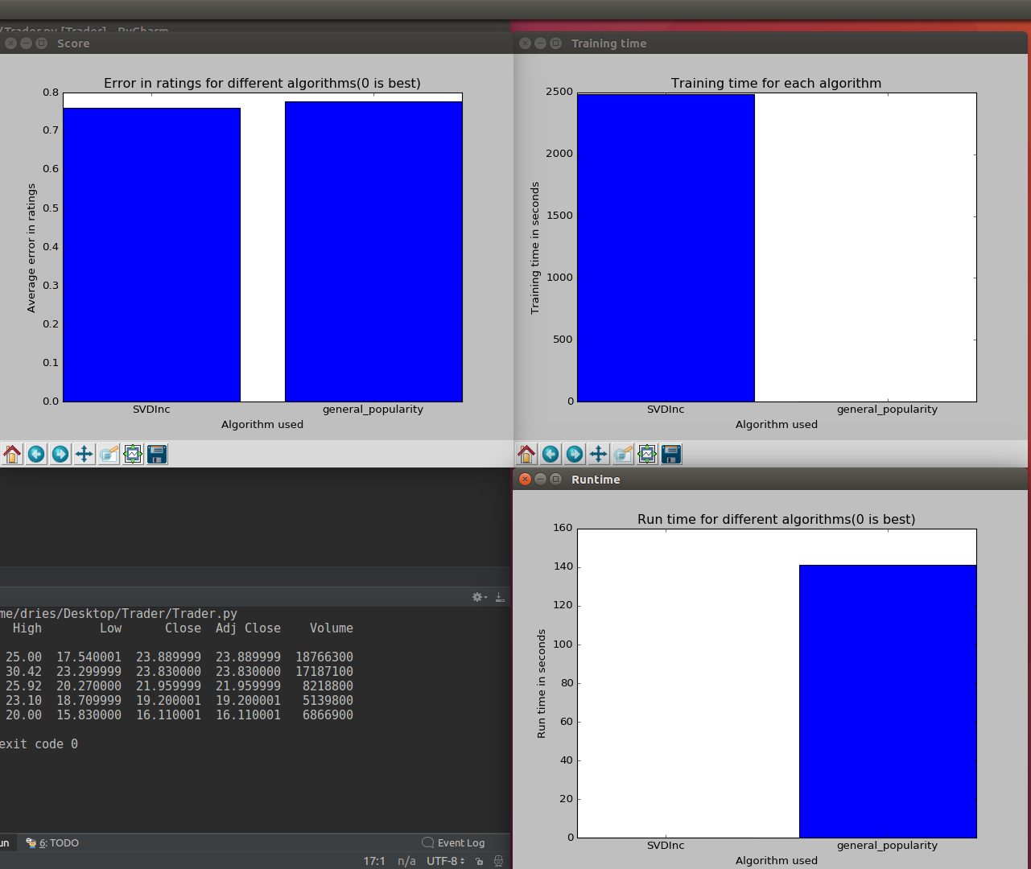
Preprocessing

For the SVD initial values needs to be guessed for any possible rating. The initial algorithm used was:

user_item_rating = (average_rating(item)+average_rating(user))/2.0

The new algorithm used is:

user_item_rating = average_rating(item)+average_rating(user)- average_rating_for_all_users

Future work

For a final model one might consider combining a popularity model and SVD model. The popularity model can be used initially when no recommendations of the user is known yet. Then by looking at the user profile a popularity of items given that profile can be created e.g. 40 year old males normally like the movie Bourne Supremacy. Then as the user rates more movies the system can make more use of the SVD collaberative filter.

Next also investigate the lastest clustering algorithms such as KNN.

Websites

Netflix leaderboard:

https://web.archive.org/web/20090926213457/http://www.netflixprize.com:80/leaderboard

Improvement on normal SVD:

ttps://research.fb.com/fast-randomized-svd/
Thus computing the SVD of A immediately yields the PCA of A

https://www.sciencedirect.com/science/article/pii/S0022000014001706

Explanation of SVD:

https://hpi.de/fileadmin/user_upload/fachgebiete/naumann/lehre/SS2011/Collaborative_Filtering/first_seminar.pdf

https://www.quora.com/What-is-an-intuitive-explanation-of-singular-value-decomposition-SVD

Netflix contestant coding advice:
http://sifter.org/~simon/journal/20061211.html

Quotes

If meaningful generalities can help you represent your data with fewer numbers, finding a way to represent your data in fewer numbers can often help you find meaningful generalities. Compression is akin to understanding and all that.

Python code for incremental SVD

http://www.quuxlabs.com/blog/2010/09/matrix-factorization-a-simple-tutorial-and-implementation-in-python/

https://stackoverflow.com/questions/8847548/howto-create-recommendations-with-a-incremental-svd-recommender-system

