Netflix leaderboard

https://web.archive.org/web/20090926213457/http://www.netflixprize.com:80/leaderboard

Improvement on normal SVD:

https://www.sciencedirect.com/science/article/pii/S0022000014001706

Explanation of SVD:
https://www.quora.com/What-is-an-intuitive-explanation-of-singular-value-decomposition-SVD

Results

Euclidean_similarity
--------------------
Works surprisingly well on the smaller datasets. This might be due to the almost consistent number of movies rated
Not good if one person consistently rates harsher than a other person.

Pearson_similarity
------------------
This allows the system to find stronger correlation even if one person rates consistently harsher or kinder than the
other. The system only considers commonly ranked items without a penalty for the amount of commonly ranked items. This means a person with only two movies rated can significantly influence another persons recommendations. The systems also scores perfect correlation if there is two or less commonly score items, which will have to be compensated for.

SVD
---
When the unknown table values is initialised to 0 the SVD generalises badly. The inisial values are now set to the average of both the movie and user average ratings. This new SVD model is much more accurate. From 2.96 to 0.8 accuracy. Using a training set of 90 000 entries the SVD has a test accuracy of 0.8 with the second best being 0.85.

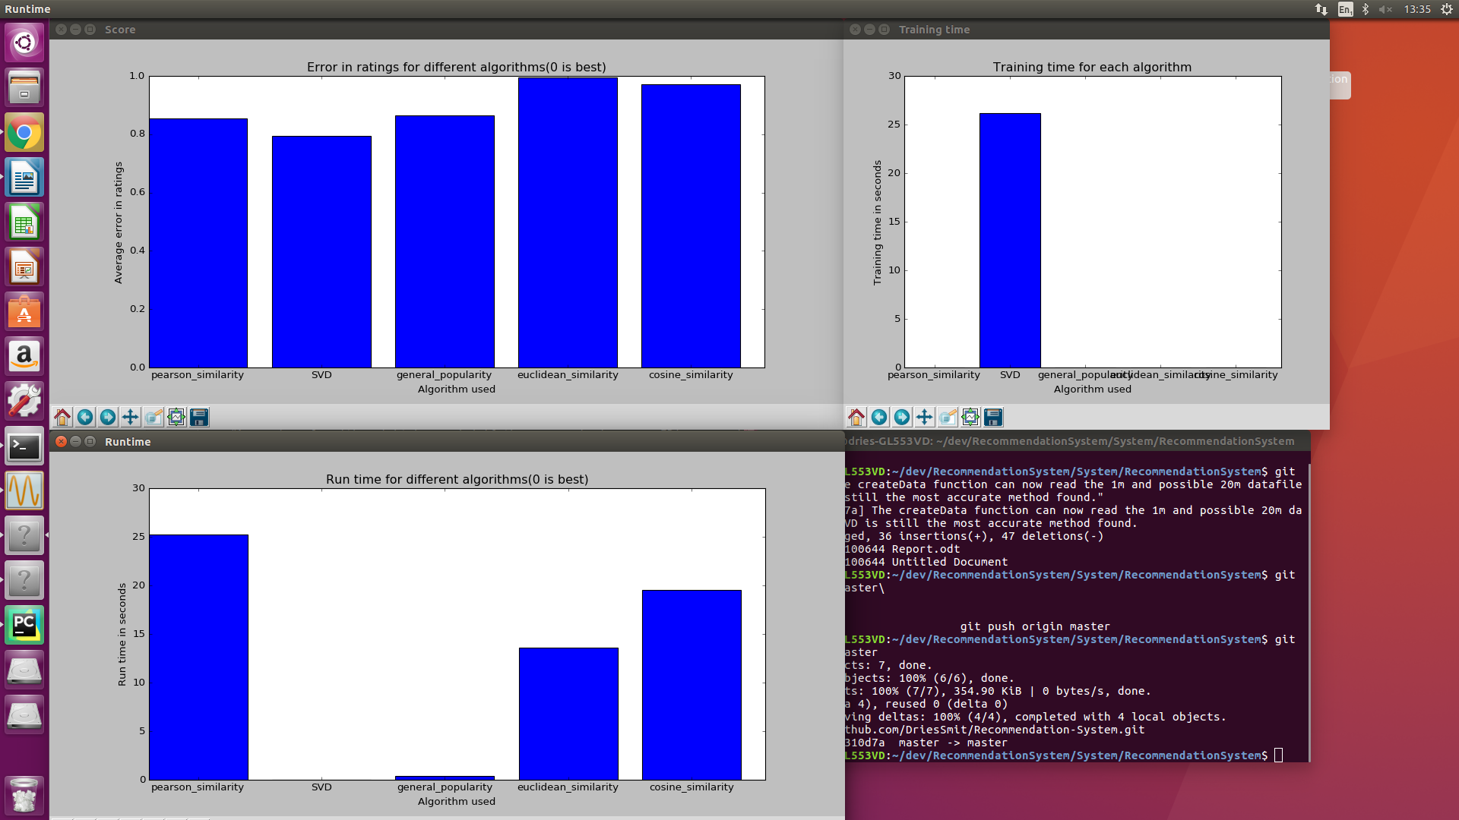
Future work
-----------
For a final model one might consider combining a popularity model and SVD model. The popularity model can be used initially when no recommendations of the user is known yet. Then by looking at the user profile a popularity of items given that profile can be created e.g. 40 year old males normally like the movie Bourne Supremacy. Then as the user rates more movies the system can make more use of the SVD collaberative filter.

Preprocessing

20m

https://research.fb.com/fast-randomized-svd/
Thus computing the SVD of A immediately yields the PCA of A

