Round 5 — your eyes were right. Here’s the redesign.
Shipped already this morning: the sidebar scrolls (replace App.tsx from the chat, refresh, done — nothing gets trapped again). The rest of this doc is the design conversation you asked for: what went wrong, what I own, and a coherent proposal built from your own four instincts — which, put together, are better than what we shipped. Five boxes.

1. What I own, and the diagnosis
Two of the problems in your screenshots are mine. First: I implemented "national darkest" without flagging that the darkest steps land within a whisker of the background — a near-black brown or maroon on a near-black sky is a hole, not a node. Second, and this is the one behind your "the rim on the shapes is rediculous": a fresnel rim is physics that only works on smooth surfaces. It brightens where the surface curves away from the camera — on a sphere that traces a perfect ring. A cube, octahedron or tetrahedron has flat faces, each with one normal, so instead of a ring you get whole faces flashing on and off as they tilt. The rim system predates the shapes and the two were never reconciled; when I built the bold-rim machinery on top I should have caught that they fundamentally fight. You caught it by looking.
The third ingredient of the mess is the edges: 816 lines, each blending its two endpoints’ fill colours, which at tier 4 is hundreds of muddy two-tone strands crossing each other — visual static that says nothing at a glance. And one honest non-bug: your screenshots run glow at 100%, spread at 375%, and haze off — at those extremes everything bright blooms into blobs. That’s the slider doing what it says. But the standard I accept is that the design should survive your settings, not just my defaults.

2. The proposal — one sphere, one ink per family
Your four notes ("go to all orbs", "line color should equal the rim color", "rims need to contrast the background", "the sidebar is a pissoff") assemble into one clean system, and I’m endorsing it nearly wholesale:
Every node a sphere. Shapes retire — they had their fair chance and the fresnel physics vetoed them. Spheres give every family a clean, identical ring, which is exactly what the rim-heavy design needs. Level doesn’t vanish: the fills still ramp dark→light down the ladder, the coming single-country recolour spreads levels into loud distinct colours on demand, the by-level chips (below) slice by level directly, and the hover card always says it. Level becomes an on-demand channel instead of an always-on shape — that’s the trade, stated plainly.
Edges drawn in family ink — your line-equals-rim idea, with one twist. Every edge takes its endpoints’ RIM colours instead of their fills: within a family that collapses to one clean ink (all-EU chains read as lime thread, Canada as pink), and across families it becomes a two-tone rim→rim gradient — which means the cross-border edges, the whole point of the graph, become the visually loudest lines automatically, without anyone tuning anything. Pulses ride in the upstream family’s ink. Opacity comes down a notch since rim colours are brighter than fills. The 57-edge EU→ESA trunk gets the log-scaled weight on top.
Rims for everyone, floors lifted. Every family gets a light, background-contrasting ring — including Africa. The rimless experiment answered itself in your screenshots: dark violet with no ring on a dark sky just disappears, and once line-ink = rim-ink, a family with no rim colour would have invisible edges too. Africa keeps its violet fills and takes a pale lavender ring. And your dark-first ramp ORDER stays — I lift only the floor, so the darkest national shades sit clearly above the background instead of dissolving into it.
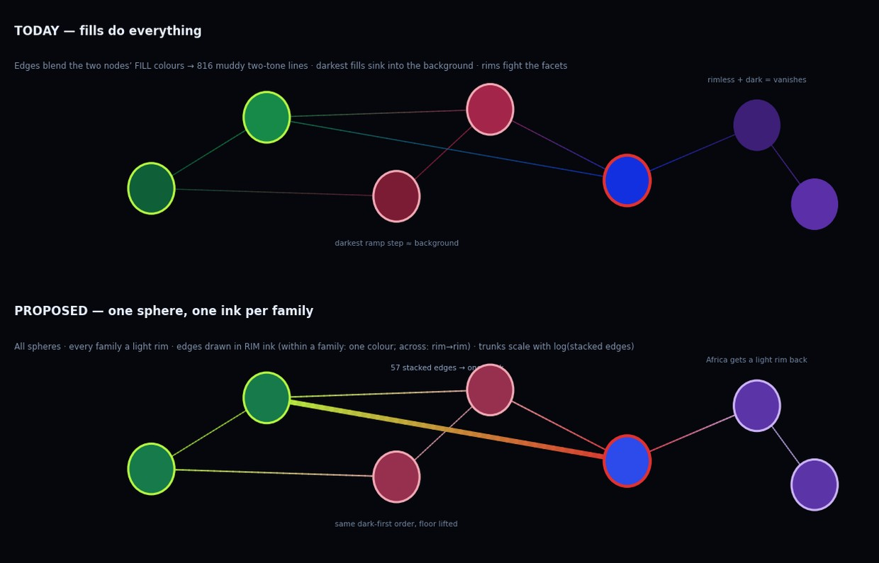

3. The out-of-the-box part
You: should we have an invert colours button?
Yes — but not a naive invert, because bloom dies on white and the palette was born for the dark. Two honest options. Option A, "Light room": flip the background to paper-white, swap rims to dark inks, kill bloom and fog. Cheap, functional, a bit flat — it’s the same scene with the lights on. Option B, "Blueprint mode" — the one I’d build: a deliberate second look, not an inversion. Paper background, every node a pale disc, and EVERYTHING drawn in the family inks — rims and edges carry the whole picture like a technical drawing, authority stays as size, no glow at all. It falls out almost free once edges are family-ink (§2), it’s dramatically better for screenshots, printing, and showing people in daylight, and it gives the project a second aesthetic identity instead of a washed-out copy of the first.
You: think big picture and out of the box — what should we do to the ui?
Merge the filter into one chip bar and let the left panel just inform. The sidebar died trying to be five things: title, stats, top-3, a two-level filter tree, and help text. The scroll fix makes it usable; the redesign makes it right. Across the top (or bottom, by the tiers): one row of family chips — Canada, US, EU, Africa… — click one and it ISOLATES (your one-click model: "the one I want isolated I click and it happens"), click more to build a combo, click the last off to return to all. Hold or right-click a chip and its level flyout opens — "Canada’s municipal level" is chip + flyout tick, two clicks worst case. The chips ARE the legend (they wear their family ink), the flyout IS the by-level filter, and when one family is isolated the flyout shows the recolour mapping — three planned features become one surface. The left panel then carries only what informs: stats, most-depended-upon, the tracing block when you click a node. Nothing to scroll, nothing trapped.

4. What happens on your word
If the boxes come back yes: Batch B becomes the redesign batch — all-spheres + rims-for-all + lifted floors + family-ink edges land together (they’re one visual system, shipping them separately would look half-painted), then the chip bar, then relations dotted + trunks on the new ink, then Blueprint mode. Perf HUD and bundle split ride along. The calendar export, share links, doc-drift session and Africa branch queue behind, unchanged.
Q14 — All spheres, shapes retired for good? (yes / keep shapes anyway) — your answer:

Q15 — Edges in family ink (rim colours, two-tone across families)? (yes / tweak) — your answer:

Q16 — Rims for every family incl. Africa + lift the dark floors, keeping your dark-first order? (yes / tweak) — your answer:

Q17 — Invert: Blueprint mode / plain Light room / skip for now? — your answer:

Q18 — Sidebar: chip bar as described / keep the (now scrollable) sidebar with just a by-level row added? — your answer:

