Round 6 — the redesign, part 1: the visual system is live
Your yes-to-all turned into code the same afternoon. This doc is short: what shipped, two screenshots from the running app, and what lands next. One box.

1. What shipped (replace the six files from chat, refresh)
All spheres. The tier shapes are gone — every node is a sphere again, so every ring is a clean ring. The per-tier size correction table went with them: a sphere of radius r is just its authority, no adjustments. The onboarding card no longer teaches shapes; it teaches the ink system (and it will show itself once more to say so).
Family-ink edges. Every line is drawn in its endpoints’ RIM colours — one clean ink inside a family, a two-tone blend across families, pulses riding in the upstream ink. Line opacity came down a notch to pay for the brighter inks.
Trunks, log-scaled. Parallel edges between the same pair now merge into ONE line whose width and brightness grow with the logarithm of the count — your "quell the effect" equation. The EU→ESA trunk (57 edges) reads about 3.6× an ordinary line, unmistakable without glowing like a pipe. Side bonus: up to 56 overlapping draw calls per pair just vanished, so tier 1 got faster too.
Rims for everyone, floors lifted. Africa wears a pale lavender ring; every family now contrasts the background. Your dark-first order is untouched — only the darkest steps came up off the floor so a national node never reads as a hole in the sky. The hollow one-off instruments wear the family ink too now, for consistency with everything else on screen.
And from earlier this morning: the sidebar scrolls — nothing gets trapped.

2. From the running app, default sliders
Tier 1: the EU trunk system is now the loudest thing on the opening screen — which is correct, because it is the loudest thing in the data. Then tier 4.
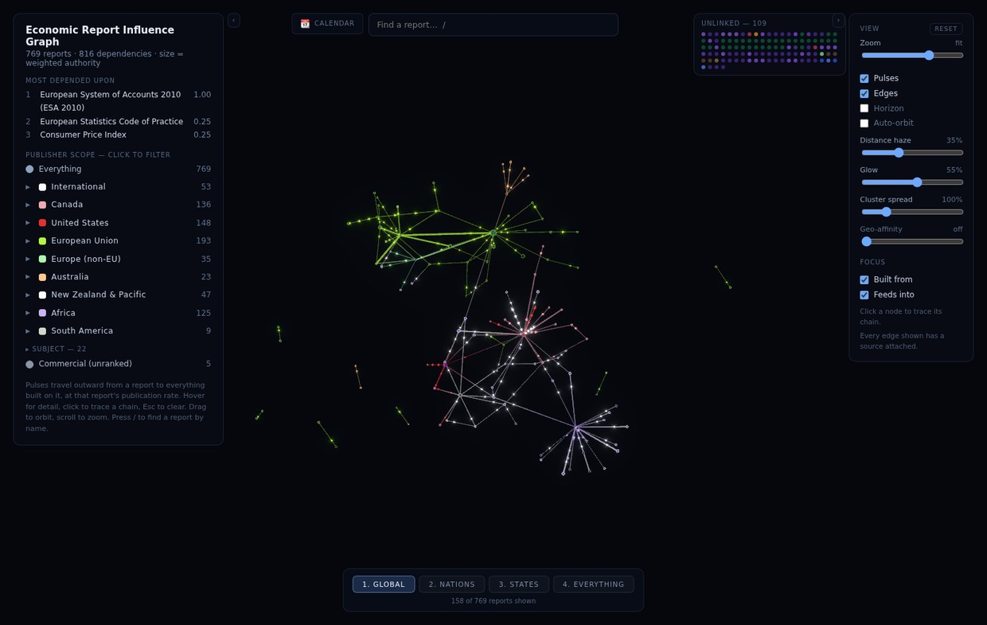
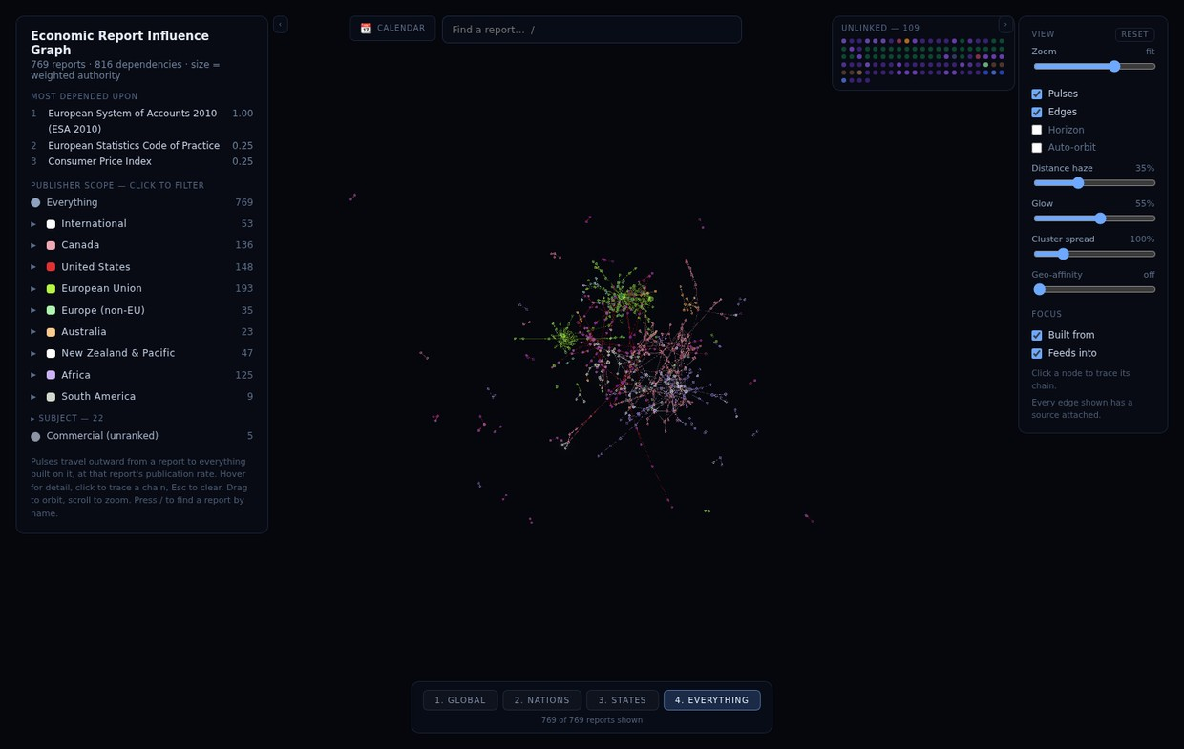
Sandbox renders — your monitor at your settings is the real test.

3. What lands next, in order
The chip bar (family chips = legend = isolate-first filter, level flyouts, left panel goes info-only) · relations drawn dotted + relation-connected nodes pulled off the shelf · Blueprint mode (paper background, everything in family inks — near-free now that edges already are the inks) · perf HUD · bundle split. Then the calendar export, share links, the doc-drift session, and Africa starting with Nigeria’s monthly CPI node.
Q19 — Verdict on the new look at your settings, and anything to tune (ink opacity, trunk weight, floor brightness) — your answer:

